OPEN

www.nature.com/scientificreports

Received: 09 February 2016
Accepted: 02 June 2016
Published: 22 June 2016

Sorghum Dw1, an agronomically

important gene for lodging resistance, encodes a novel protein involved in cell proliferation
Miki Yamaguchi¹, Haruka Fujimoto¹, Ko Hirano¹, Satoko Araki-Nakamura¹, Kozue Ohmae-Shinohara¹, Akihiro Fujii¹, Masako Tsunashima², Xian Jun Song^{1,†}, Yusuke Ito¹, Rie Nagae¹, Jianzhong Wu³, Hiroshi Mizuno³, Jun-ichi Yonemaru³, Takashi Matsumoto³, Hidemi Kitano¹, Makoto Matsuoka¹, Shigemitsu Kasuga⁴ & Takashi Sazuka¹

Semi-dwarfing genes have contributed to enhanced lodging resistance, resulting in increased crop productivity. In the history of grain sorghum breeding, the spontaneous mutation, dw1 found in Memphis in 1905, was the first widely used semi-dwarfing gene. Here, we report the identification and characterization of Dw1. We performed quantitative trait locus (QTL) analysis and cloning, and revealed that Dw1 encodes a novel uncharacterized protein. Knockdown or T-DNA insertion lines of orthologous genes in rice and Arabidopsis also showed semi-dwarfism similar to that of a nearly isogenic line (NIL) carrying dw1 (NIL-dw1) of sorghum. A histological analysis of the NIL-dw1 revealed that the longitudinal parenchymal cell lengths of the internode were almost the same between NIL-dw1 and wildtype,
while the number of cells per internode was significantly reduced in NIL-dw1. NIL-dw1dw3, carrying both dw1 and dw3 (involved in auxin transport), showed a synergistic phenotype. These observations demonstrate that the dw1 reduced the cell proliferation activity in the internodes, and the synergistic effect of dw1 and dw3 contributes to improved lodging resistance and mechanical harvesting.

A C4 crop, sorghum [Sorghum bicolor (L.) Moench] is the fifth most important cereal crop and is the dietary sta- ple of more than 500 million people in 98 countries1,2. This crop is drought tolerant and can be grown in semi-arid conditions, where maize, wheat, and rice cannot be grown because of water scarcity3.
Recently, some agronomically important genes of sorghum have been isolated using comparative genome studies between the sorghum and other crops. In the case of flowering time, PSEUDORESPONSE REGULATOR PROTEIN (SbPRR37)/Ma14, PHYTOCHROME B (SbPHYB)/Ma35, PHYTOCHROME C (SbPHYC)/Ma5, EARLY HEADING DATE 1 (SbEHD1), FLOWERING LOCUS T (sbFT)/SbCN15, SbCN8, SbCN126, CONSTANS (SbCO)7,
and GRAIN NUMBER, PLANT HEIGHT AND HEADING DATE 7 (SbGHD7)/Ma68, have been identified based on their synteny or homology with the genes of other plant species. In contrast, however, the cloning and analysis of dwarfing genes has not advanced. It may be that their causal genes, except Dw3, do not correlate to previ- ously identified genes in other plants (see below). In sorghum breeding, the four major unlinked dwarfing genes, Dw1-Dw4, have been combined to reduce plant height to increase lodging resistance and improve mechanized harvesting9. Among these dwarfing genes, Dw3 has been cloned. It is syntenic to maize Brachytic2, which is involved in auxin transport10. The remaining dwarfing genes have not been cloned.
The origin of the dw1 mutation is described in detail11. In brief, Dwarf Yellow Milo, a spontaneous mutant derived from Standard Milo, was found in a field at Memphis in 1905, and then the seeds were distributed to

¹Bioscience and Biotechnology Center, Nagoya University, Furou-cho, Nagoya, Aichi 464-8601, Japan. ²Plant
Innovation Center, Japan Tobacco Inc., Iwata, Shizuoka 438–0802, Japan. ³National Institute of Agrobiological Sciences, Kannondai, Tsukuba, Ibaraki 305-8602, Japan. ⁴Education and Research Center of Alpine Field Science, Faculty of Agriculture, Shinshu University, Minamiminowa, Nagano 399-4598, Japan. †Present address: Key Laboratory of Plant Molecular Physiology, Institute of Botany, the Chinese Academy of Sciences, Beijing 100093, China. Correspondence and requests for materials should be addressed to T.S. (email: sazuka@agr.nagoya-u.ac.jp)

famers11. The mutant and its derivatives were widely accepted from 1906 until the 1920s in the United States11,12. Now, many cultivars of grain sorghums carry the dw1 mutation, indicating its importance for lodging resistance and improved mechanized harvesting. Genetic analyses of dw1 have been performed by several groups13–17, and it was hypothesized that a gibberellin (GA) catabolizing gene, GA 2-oxidase (Sobic.009G230800) might correspond to dw1 because this gene locates to the dw1 locus15–17. More recently, however, we revealed that there were no differences in the sequences or expression levels of this GA2ox gene between the two cultivars ‘Tall White Sooner Milo’, carrying Dw1, and ‘Dwarf White Milo’, carrying dw118. We also revealed that a deficiency in GA induces not only dwarfism of culm, but also culm bending, inevitably leading to abnormal plant architecture, which is unsuit- able for breeding18. These results indicated that the sorghum dwarfing genes used for its breeding might have no relation to GA deficiency or insensitivity, unlike the rice and wheat dwarfing genes that contributed to the ‘green revolution’, which encode GA synthesis enzymes and signaling proteins19,20. Thus, the cloning of Dw1 would aid in the understanding of a novel molecular mechanism for dwarfism that is useful in breeding. Here, we isolated the Dw1 gene using a QTL analysis and positional cloning, and revealed that Dw1 encodes a novel protein. The loss-of-function in rice and Arabidopsis homologs also induces semi-dwarfism in these plants. A histological analysis of a nearly isogenic line carrying dw1 (NIL-dw1) revealed that the longitudinal parenchymal cell lengths of the internode were almost the same between NIL-dw1 and wildtype, while the number of cells per internode was significantly reduced in NIL-dw1. Furthermore, NIL-dw1dw3, carrying both dw1 and dw3 (involved in auxin transport), showed a synergistic phenotype. Based on these observations, we discuss the interaction between dw1 and dw3 from a view point of crop breeding and cell proliferation.

Results
QTL analysis. For the QTL analysis, we used two sorghum cultivars, bmr-6 and SIL-05, showing different culm lengths (CLs). bmr-6, which carries three dwarfing genes, including dw1, has a ~80 cm CL at the heading stage, whereas SIL-05, which probably carries no dwarfing gene, has a CL of ~365 cm (Fig. 1a,d). When we com- pared the elongation pattern of internodes, the elongation defect in bmr-6 occurred at all internodes in com- parison with the SIL-05 internodes (Fig. 1b,c; Supplementary Fig. S1). We produced F₂ plants by crossing bmr-6 and SIL-05. The CL values of 185 F₂ plants were broadly distributed from 37 to 421 cm (Fig. 1d). We performed a QTL analysis on 96 F₂ plants using 162 molecular markers and detected three major QTLs, which were located on chromosomes 6 (qCL-6), 7 (qCL-7), and 9 (qCL-9) (Fig. 1e and Table 1). The bmr-6 allele of all three QTLs shortened the CL (Table 1).
The locations of these three qCLs correspond to those already reported for dw1-dw3; that is, qCL-6 to dw2, qCL-7 to dw3, and qCL-9 to dw1. We sequenced the Dw3 gene and confirmed that the bmr-6 allele has the same mutation previously reported, indicating that qCL-7 depends on the dw3 mutation (Supplementary Fig. S2a). The situation for qCL-6 is more complex because the dw2 mutation is tightly linked to a maturation gene, ma117,21,22, which affects the flowering time and consequently the CL. In fact, a strong QTL of flowering time overlaps this region in the same F₂ plants (Supplementary Fig. S3), and bmr-6 carries the mutation allele of ma1, as previously reported4 (Supplementary Fig. S2b), indicating that qCL-6 might be affected by Ma1. Therefore, we focused on the isolation of Dw1 in this study.

Positional cloning. For the positional cloning of Dw1, we generated heterozygous inbred families (HIFs), which are kinds of recombinant inbred lines (F₅ and F₆), carrying a segregating locus of Dw1. In this exper- iment, we used two HIFs showing clear differences in CL, dependent on Dw1 segregation, for further map- ping. The genetic analysis, which used ~10,000 plants in two years, narrowed down a candidate region to 18 kb between markers located at 57.209 Mb and 57.227 Mb (Fig. 2a). To compare the genomic sequences of bmr-6 and SIL-05, we constructed bacterial artificial chromosome (BAC) libraries derived from the two cultivars and screened the clones containing the candidate region. Both sequences predicted five genes in the region (Fig. 2a). In Sobic.009g229800, there was one single nucleotide polymorphism (SNP) inducing a premature stop codon in bmr-6 (Fig. 2a). In Sobic.009g230200, there were four amino acid differences, while the predicted amino acid sequences of the three other genes, Sobic.009g229900, Sobic.009g230000, and Sobic.009g230100, were identical.
We compared the expression levels of these genes using semi-quantitative RT-PCR and RNA-seq analyses on RNAs extracted from elongating internodes (Fig. 2b). The RT-PCR analyses revealed that the expression of Sobic.009g229800 in bmr-6 was slightly lower than that in SIL-05, while the expression of the other genes was almost same in these cultivars, with no detection of Sobic.009g229900 or Sobic.009g230200. The results of RNA-seq supported the above RT-PCR observations. There were similar expression levels of Sobic.009g230100, no, or very low levels, of Sobic.009g229900, Sobic.009g230000, and Sobic.009g230200, and ~50% expression of Sobic.009g229800 in bmr-6 in comparison with SIL-05.
To confirm that Sobic.009g229800 corresponds to qCL-9, we carried out a complementation experiment using cv. Tx430, which carries the allele of bmr-6 at qCL-9. A 4.5 kb DNA fragment containing Sobic.009g229800 of SIL-05 was introduced into Tx430 by Agrobacterium-mediated transformation. The transformants showed the rescued phenotype, whereas the plants transformed with the empty vector showed dwarfism (Fig. 2c–e). These results strongly suggest that Sobic.009g229800 is the causal gene for qCL-9.
Next, we examined sequences of the candidate 18 kb region in ‘Tall White Sooner Milo’, carrying Dw1, and ‘Dwarf White Milo’, carrying dw1, because the genotypes of Dw1 in both cultivars were described in detail pre- viously12,21. Surprisingly, there were only two SNPs in the region between the two cultivars (Supplementary Fig. S4). One was the causal SNP (the loss-of-function allele) of qCL-9 in Sobic.009g229800, which also existed in ‘Dwarf White Milo’, however, ‘Tall White Sooner Milo’ and ‘Standard Milo’ (mother cultivar of Dwarf Milo) contained the SIL-05 allele (the WT allele). Another SNP was found in an intergenic region. There was no SNP

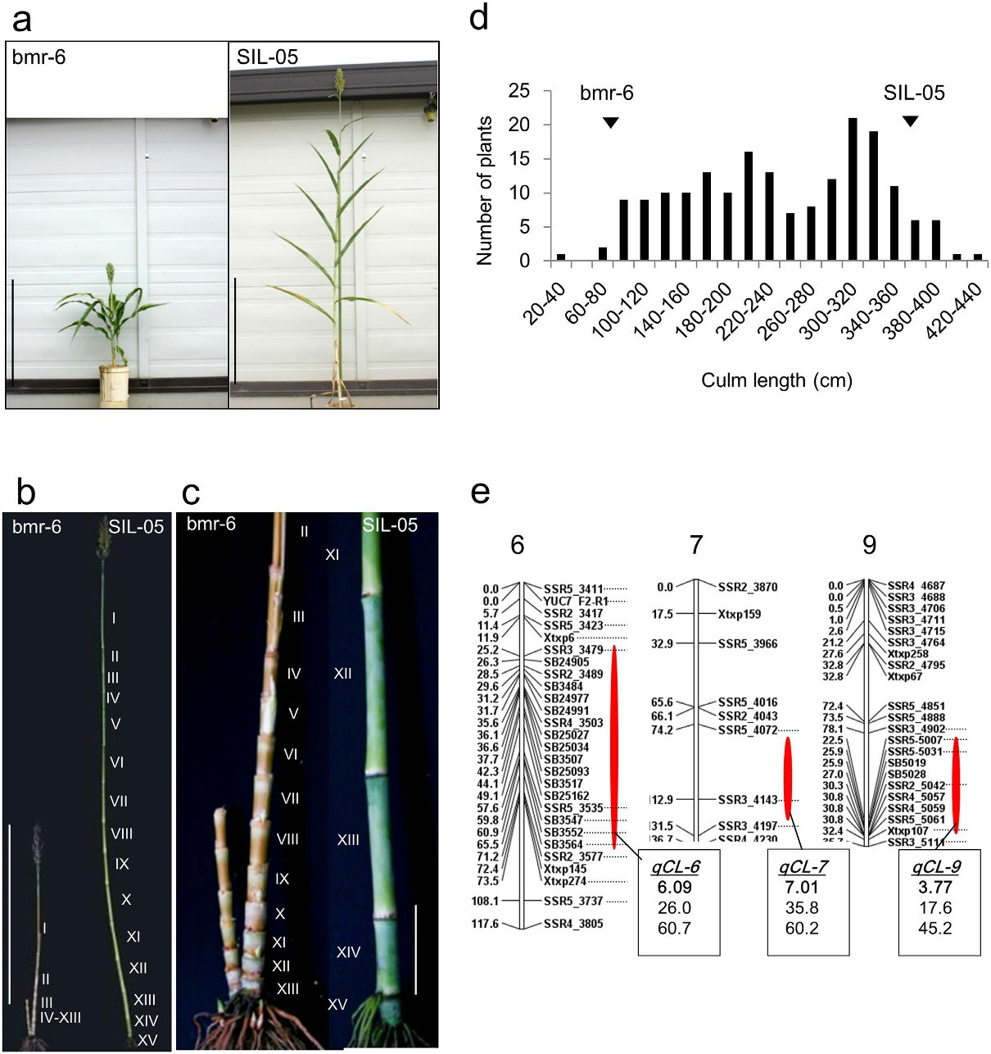
Figure 1. QTL analysis of CL. (a) Plant stature of two cultivars used in this study; (Left) Three-dwarf cultivar carrying three dwarfing genes, bmr-6, and (Right) zero-dwarf cultivar carrying no dwarfing genes, SIL-05.
Bar = 1 m. (b) An elongation pattern of internodes. Bar = 1 m. (c) The enlarged views of the basal regions of (b). Bar = 10 cm. (d) Distribution frequency of CL among 185 F₂ plants from a cross between bmr-6 and SIL-05.
Phenotypic values for bmr-6 and SIL-05 are indicated by arrowheads. (e) QTL analysis of CL using 96 F₂ plants. Only chromosomes 6, 7, and 9, which had log-likelihood value (LOD) score > 3, were presented. The positions and names of the DNA markers used for the analysis are indicated at the left and right sides, respectively. Red ellipses indicate the positions of the QTLs for CL. Boxes contain, in order, the QTL name (bold and underlined), LOD score (bold), percentage of variance-explained, and additive effect, a positive value indicates that the allele from SIL-05 increases CL.

QTL | Chr. | Nearest markers | LODa | PVEb | ac | DOMd | d/a | DPEe
qCL-6 | 6 | SB3484 | 6.09 | 26.0 | 60.7 | 37.9 | 0.62 | SIL-05
qCL-7 | 7 | SSR3_4143 | 7.01 | 35.8 | 60.2 | 69.7 | 1.16 | SIL-05
qCL-9 | 9 | SSR2_5041 | 3.77 | 17.6 | 45.2 | 29.7 | 0.66 | SIL-05
Table 1. QTLs for CL identified in the F₂ population of a crossing between bmr-6 and SIL-05. aLOD threshold = 3.0. bPercentage of Variance-explained; Percent of total phenotypic variation explained by the QTLs. cAdditive effects are associated with the SIL-05 allele. dDominance effect in the Het. eDirection of phenotypic effect is the parent whose additive value of a marker allele increased the trait value.

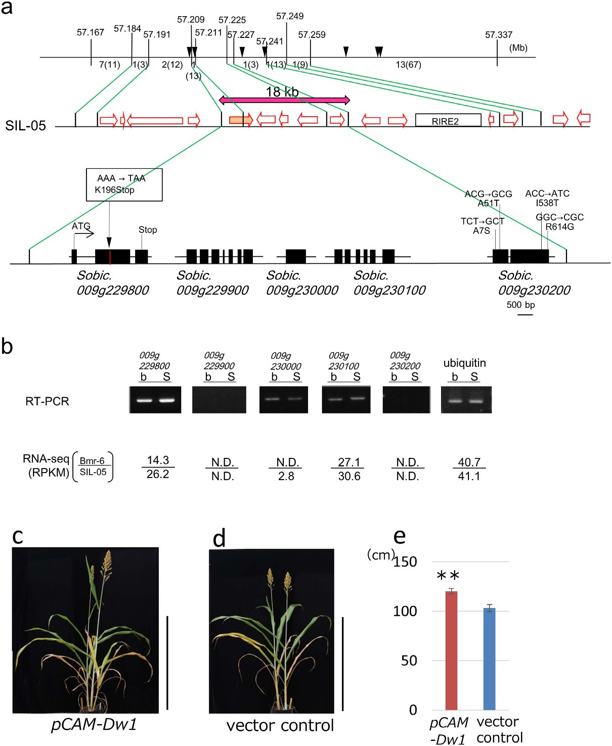

Figure 2. Positional cloning and Phenotypic complementation of the corresponding gene of qCL-9.
(a) High-resolution physical map of qCL-9. On the upper horizontal line, vertical lines indicate the positions of DNA markers with their physical positions (Mb) in Phytozome ver.9.1 (Sorghum bicolor ver.1.4). Numbers of recombinants are shown between markers. The number of progeny examined in the next generation is presented in parentheses. Arrowheads indicate the physical positions of the DNA markers used in Table 2. The middle horizontal line is a schematic representation of the gene arrangement near the candidate region, which was predicted by the BAC sequence of SIL-05. Open arrows indicate the positions of predicted genes. The mapping analysis narrowed the candidate region to the 18 kb shown by a red double-headed arrow. RIRE2 indicates a gypsy-type retrotransposon. The bottom horizontal line represents an enlarged map of the 18 kb region. There are five predicted genes, whose exons are represented as black boxes. A premature stop codon
detected in the bmr-6 genome is indicated in the box. (b) The expression level of each gene determined by semi- quantitative RT-PCR. The reads per kilo-base per million reads (RPKM) scores are also shown. N.D. means
the sequence was not detected. (c) Introduction of DNA fragment encompassing the Dw1 gene (SIL-05 allele) (pCAM-Dw1) into NIL-dw1 plant Bar = 1 m. (d) Empty vector introduced NIL-dw1 plant was used as a control (vector control). Bar = 1 m. (e) The culm lengths of the transgenic plants with Dw1 gene (left) and empty vector (right). Error bars represent the standard deviation. Double asterisk indicates a significant difference at 1%
(P <0.01) as determined by t-test.

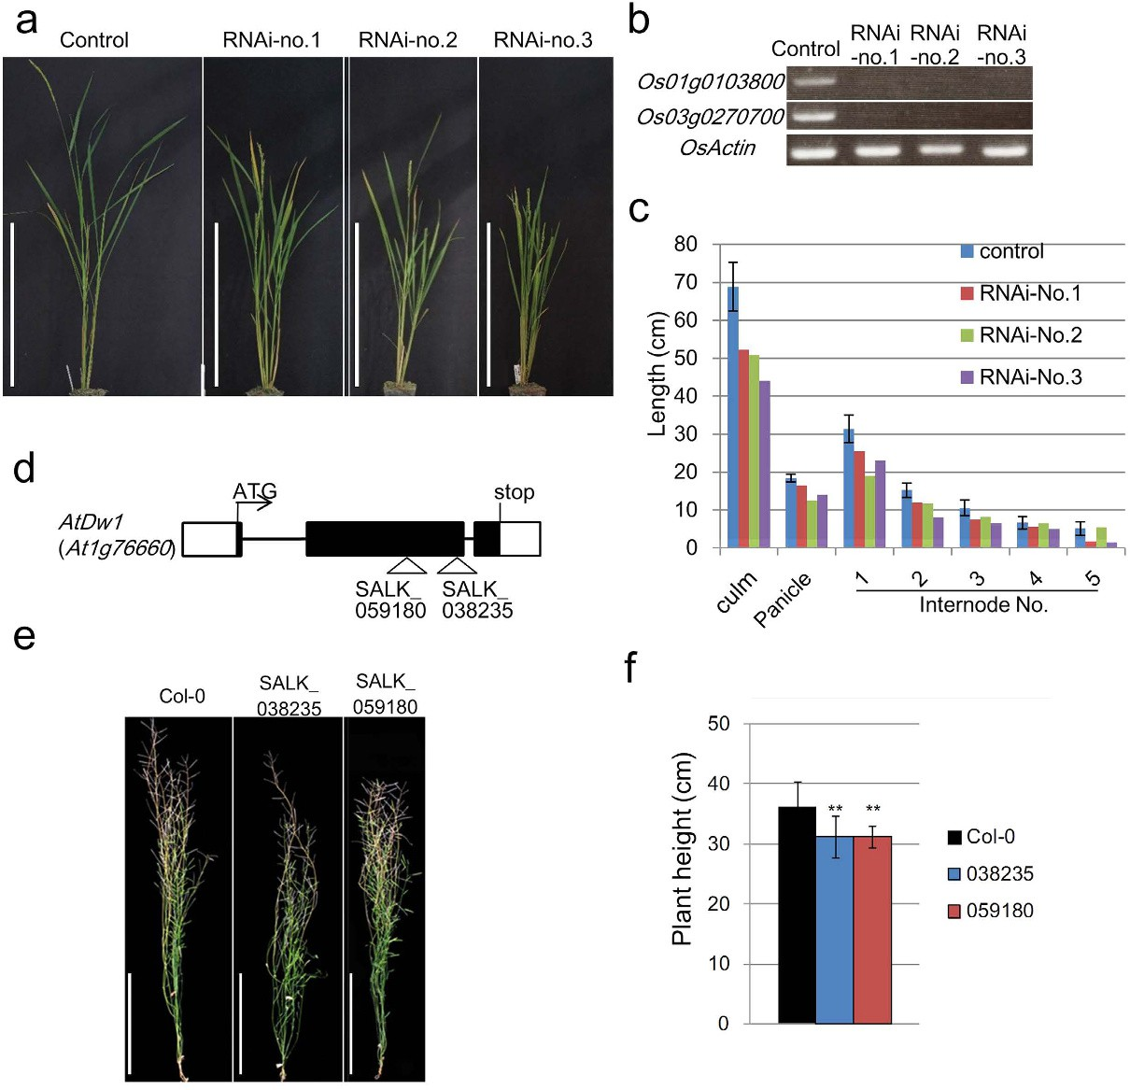
Figure 3. Semi-dwarf phenotypes of Os01g0103800 and Os03g0270700 rice RNAi lines, and of At1g76660 Arabidopsis T-DNA insertion lines. (a) Plant stature of Os01g0103800 and Os03g0270700 RNAi lines. From left: vector control, RNAi-no.1, RNAi-no.2, and RNAi-no.3. Bar = 50 cm. (b) Expression levels of Os01g0103800, Os03g0270700, and actin (control) in the RNAi and vector control plants. (c) Length of culm, panicle, and each internode of the RNAi and vector control plants. (d) Positions of T-DNA insertions in At1g76660 (AtDw1), forming two lines (038235 and 059180). Protein coding regions and UTRs are represented by black and white boxes, respectively. Introns are indicated by black bars. ‘ATG’ and ‘Stop’ indicate the initiation and stop codon sites. (e) Phenotypes of the T-DNA insertion lines: left, 038235 and right, 059180. Scale bar = 10 cm. (f) Plant heights of the T-DNA insertion lines. Error bars represent the standard deviation. Double asterisks indicate significant differences at 1% (P < 0.01) as determined by t-test.

in Sobic.009g230200. This result strongly suggests that Sobic.009g229800 is the causal gene for not only qCL-9 but also Dw1.
Molecular analysis and biological activity of DW1. Next, we analyzed the characteristics of Sobic.009g229800/ Dw1. Although its predicted amino acid sequence does not contain any significant characterized domains or sequences, a phylogenetic analysis revealed that there are homologs among Zea mays, Oryza sativa, Brachypodium distachyon, Arabidopsis thaliana, Selaginella moellendorffii, and Physcomitrella patens (Supplementary Fig. S5), indicating that DW1 is widely conserved among land plants. The amino acid alignment demonstrates that there are several conserved domains in these proteins (Supplementary Fig. S6), although none of them have been char- acterized. In the sorghum genome, there are two homologous genes, Sobic.004G349900 and Sobic.002G138500, which the phylogenetic analysis categorized into a different sub-group of Sobic.009g229800 (Supplementary Fig. S5), suggesting that there are at least two sub-groups of this protein family. As Sobic.009g229800 is the sole member of Sub-group 1 in sorghum, its mutation may induce the dwarf phenotype even if its homologs in sub-group 2 still function.
We examined the biological functions of the putative orthologs to sorghum Dw1, Rice transgenic lines car- rying an RNAi construct that targeted the overlapping sequences of Os01g0103800 and Os03g0270700 showed semi-dwarf phenotypes with reduced internodes (Fig. 3a–c). Furthermore, the two T-DNA insertion lines of

 | genotypeb | Position (Mb)a
 | genotypeb | 57.208 | 57.211c | 57.229 | 57.240 | 57.266 | 57.2721 | 57.2729
Parental linesd |  |  | (dw1 )
SIL-05 |  | S | S | S | S | S | S | S
bmr-6 |  | b | b | b | b | b | b | b
 |  |  | ↓dw1 emergence
Original milo (1-dwarf cultivars)e
Tall white Sooner Milo (SA1170) | Dw1 | b | S | b | b | b | b | b
Standard Milo |  | b | S | b | b | b | b | b
 |  |  | ↓used for breeding
2-dwarf cultivarsf
Dwarf White Milo | dw1 | b | b | b | b | b | b | b
3-dwarf cultivarsg
D.D. Yellow Sooner Milo | dw1 | b | b | b | b | b | b | b
Martin 3dw | dw1 | b | b | b | b | b | b | b
Plainsman 3dw | dw1 | b | b | b | b | b | b | b
38 M |  | b | b | b | b | b | b | b
44 M |  | b | b | b | b | b | b | b
58 M |  | b | b | b | b | b | b | b
60 M |  | b | b | b | b | b | b | b
80 M |  | b | b | b | b | b | b | b
90 M |  | b | b | b | b | b | b | b
100 M |  | b | b | b | b | b | b | b
SM60 |  | b | b | b | b | b | b | b
SM80 |  | b | b | b | b | b | b | b
SM90 |  | b | b | b | b | b | b | b
SM100 |  | b | b | b | b | b | b | b
ATx 623 | dw1 | b | b | b | b | b | b | b
BTx 623 | dw1 | b | b | b | b | b | b | b
4-dwarf cultivarsg
3121A 4dw Martin | dw1 | b | b | b | b | b | b | b
3127A 4dw Kafir | dw1 | b | b | b | b | b | b | b
4dw 380B |  | b | b | b | b | b | b | b
Other cultivarsh
Texas Blackhull Kafir |  | S | S | S | S | S | S | S
Pink Kafir |  | S | S | S | S | S | S | S
Hegari |  | S | S | S | S | S | S | S
Early Hegari |  | S | S | S | S | S | S | S
Black Spanish Standard Broom Corn |  | S | S | S | S | S | S | S
Japanese Dwarf Standard Broom Corn |  | S | S | S | S | S | S | S
Sumac |  | S | S | S | S | S | S | S
Bonita |  | S | S | S | S | S | S | S
Table 2. The graphical view of haplotypes around Dw1 among cultivars. aThe physical positions of seven SNPs, which were also presented as arrowheads on the top line in Fig. 2a. bThe genotype of Dw1 reported by Quinby et al.21. cThe SNP in Dw1 that forms the premature stop codon in bmr-6 (b highlighted with bold font), while SIL-05 contains its WT allele (S highlighted with italics). dSNPs of SIL-05 and bmr-05 presented as S and b, respectively (highlighted with italic and bold font, respectively). eOriginal milo such as ‘Tall White Sooner Milo’ (SA1170) carrying Dw1, and Standard milo contain the same haplotype of ‘Dwarf White Milo’ with one exception, the SNP in Dw1. fThe 2-dwarf type ‘Dwarf White Milo’ carrying dw1 contains the same haplotype as bmr-6. gAll 3- or 4-dwarf cultivars contain the same haplotype as bmr-6 or ‘Dwarf White Milo’. hOther cultivars, including Kafir and Hegari, contain the same haplotype as SIL-05.

At1g76660 showed reduced plant heights in comparison with the background plants (Fig. 3d–f). These results confirm the above hypothesis that defects in the Dw1 orthologs of rice and Arabidopsis cause semi-dwarfism in these plants.
Importance of dw1 and selection in sorghum breeding. Next, we studied how widely the dw1
mutation was used in the breeding of sorghum. There are many SNPs between SIL-05 and bmr-6 within the

candidate region of qCL-9. We randomly selected seven SNPs, including the causal SNP of dw1 from 57.208 Mb to 57.273 Mb (Fig. 2a). When we examined the genotypes of these SNPs in ‘Tall White Sooner Milo’ (Dw1) and ‘Dwarf White Milo’ (dw1) (Table 2), the SNPs of ‘Dwarf White Milo’ were identical to those of bmr-6, suggest- ing that the causal SNP of dw1 might be used in the selection process of ‘Dwarf White Milo’. In fact, the 18 kb sequence of the candidate region from ‘Dwarf White Milo’ was completely the same in bmr-6 and in BTx623 (Supplementary Fig. S4).
Interactions between Dw1 and Dw3. To compare the effects of dw1 and/or dw3 on dwarfism, we pro- duced two NILs, dw3 alone (NIL-dw3) and the double mutant (NIL-dw1dw3) in addition to NIL-dw1 (see above), by the introgression of these mutations into SIL-05 (Supplementary Fig. S7). Interestingly, both NIL-dw1 and NIL-dw3 showed a similar elongation pattern, except at the upper (I) and lower (XII) internodes, where dw3 did not affect the upper internodes but had a greater effect than dw1 at the lower internodes (Fig. 4a, b). More importantly, dw1 and dw3 synergistically function to reduce the internode length, especially in the middle inter- nodes IV–VII. We also performed a histological analysis on these internodes. The longitudinal cell length of the parenchyma was almost the same among the four NILs, while the number of cell per internode was significantly reduced in NIL-dw1 and NIL-dw3, and especially in NIL-dw1dw3 (Fig. 4c–h). These observations suggest that the mutations of dw1 and dw3 decreased the cell proliferation rates, whereas the double mutation had a synergistic effect on the cell proliferation rate.

Discussion
Semi-dwarfism is tightly associated with lodging resistance and mechanized harvesting, which are important factors in determining crop productivity. To date, some important genes involved in growth processes have been identified to elucidate their mechanisms and applications for molecular breeding. For example, mutations of semi-dwarf1 (sd1) in rice19,23 and Reduced height (Rht) in wheat20, which encode a GA biosynthesis enzyme and a dominant suppressor protein of GA signal transduction, respectively, have been widely used to improve lodg- ing resistance in these crops, resulting in the success of the “green revolution”. It has also been reported that the semi-dwarfism of barley, sdw1/denso, widely introgressed into cultivars grown in Europe, probably results from a defect in an ortholog of rice SD124–26. That GA-related mutations have been used for improving lodging resistance in rice, wheat, and barley, demonstrates the importance of decreasing the GA level, or sensitivity to GA, in reduc- ing plant heights. However, in the case of sorghum, such strategies may not be applicable because they induce culm bending, which inevitably causes abnormal plant architecture18.
In this study, we isolated a causal gene for the semi-dwarfism of sorghum, which has been widely introgressed into many cultivars, especially those of grain sorghum, using a QTL analysis and positional cloning. We con- cluded that Dw1 corresponds to Sobic.009g229800 due to the following: First, within the candidate region, there is only one gene, Sobic.009g229800, which is expressed in elongating internodes and that encodes different amino acid sequences between the parental cultivars, due to a premature stop codon in the bmr-6 gene (Fig. 2a,b). Second, although there are four amino acid differences in Sobic.009g230200 between the parental cultivars, its expression was hardly detected in elongating internodes by RT-PCR or RNA-seq (Fig. 2a,b). Third, ‘Dwarf White Milo’ (dw1) also contains a premature stop codon identical to bmr-6 in Sobic.009g229800, whereas ‘Tall White Sooner Milo’ (Dw1) does not, while the genome sequences of Sobic.009g230200 are identical in the two cultivars. Fourth, knockdown or T-DNA insertion lines of orthologous genes in rice and Arabidopsis showed semi-dwarfism similar to that of the NIL-dw1 sorghum (Supplementary Fig. S7; Fig. 3). Fifth, the complemen- tation experiment showed that transformation of Dw1 gene rescued dwarfing phenotype of the cultivar Tx430 having dw1.
How did the dw1 mutation appear and spread? We also examined the genotypes of these SNPs in 3- and 4-dwarf (meaning that they carry three or four dwarf genes) cultivars, and confirmed that these cultivars con- tained the identical genome segment to ‘Dwarf White Milo’ carrying the causal SNP of dw1 (Table 2), whereas, non-dwarf Kafir, Hegari, Broomcorn, and some other non-dwarf cultivars contained the same genome segment as SIL-05 (Table 2). These results coincide with the classic description that dw1 mutation occurred only once in Memphis in 1905, which resulted in the appearance of Dwarf White Milo12. Subsequently, dw1 on the genomic segment of Dwarf White Milo should have spread into various cultivars. It should be noted that the 4-dwarf Kafir also contains it in the Kafir genomic background. This demonstrates that the dw1 mutation has been widely used not only for Milo, but also for Kafir cultivars. These results suggest this single allele has been important, precious, and valuable for the lodging resistance and mechanical harvesting during the history of sorghum breeding.
A synergistic interaction was observed between DW1 and DW3, which is involved in auxin transport. The pyramiding of dwarf genes should be useful in reducing sorghum to a suitable height, because sorghum is orig- inally a tall plant that requires a significant height reduction without inducing detrimental side effects. In this situation, it might have been important to combine a few semi-dwarfing genes, which have no effects on any other traits but have synergistic or additive effects on height. The comparative study of the internode elongation pat- tern among NIL-dw1, NIL-dw3, and NIL-dw1dw3 plants revealed that the effects of dw1 and dw3 are synergetic especially in the middle internodes IV–VII. (Fig. 4). Considering that many modern sorghum dwarf cultivars contain mutations in both Dw1 and Dw3, the two genes have been selected in modern breeding as one of the ideal combinations. In this context, although DW1 and DW3 are interacting during the process of cell prolifer- ation in the internode, they might function in two different molecular mechanisms or pathways. The finding of this novel factor, DW1 might be a good bridge to study not only breeding but also the interaction of auxin and dw1 -mediated mechanisms for cell proliferation in the internode.

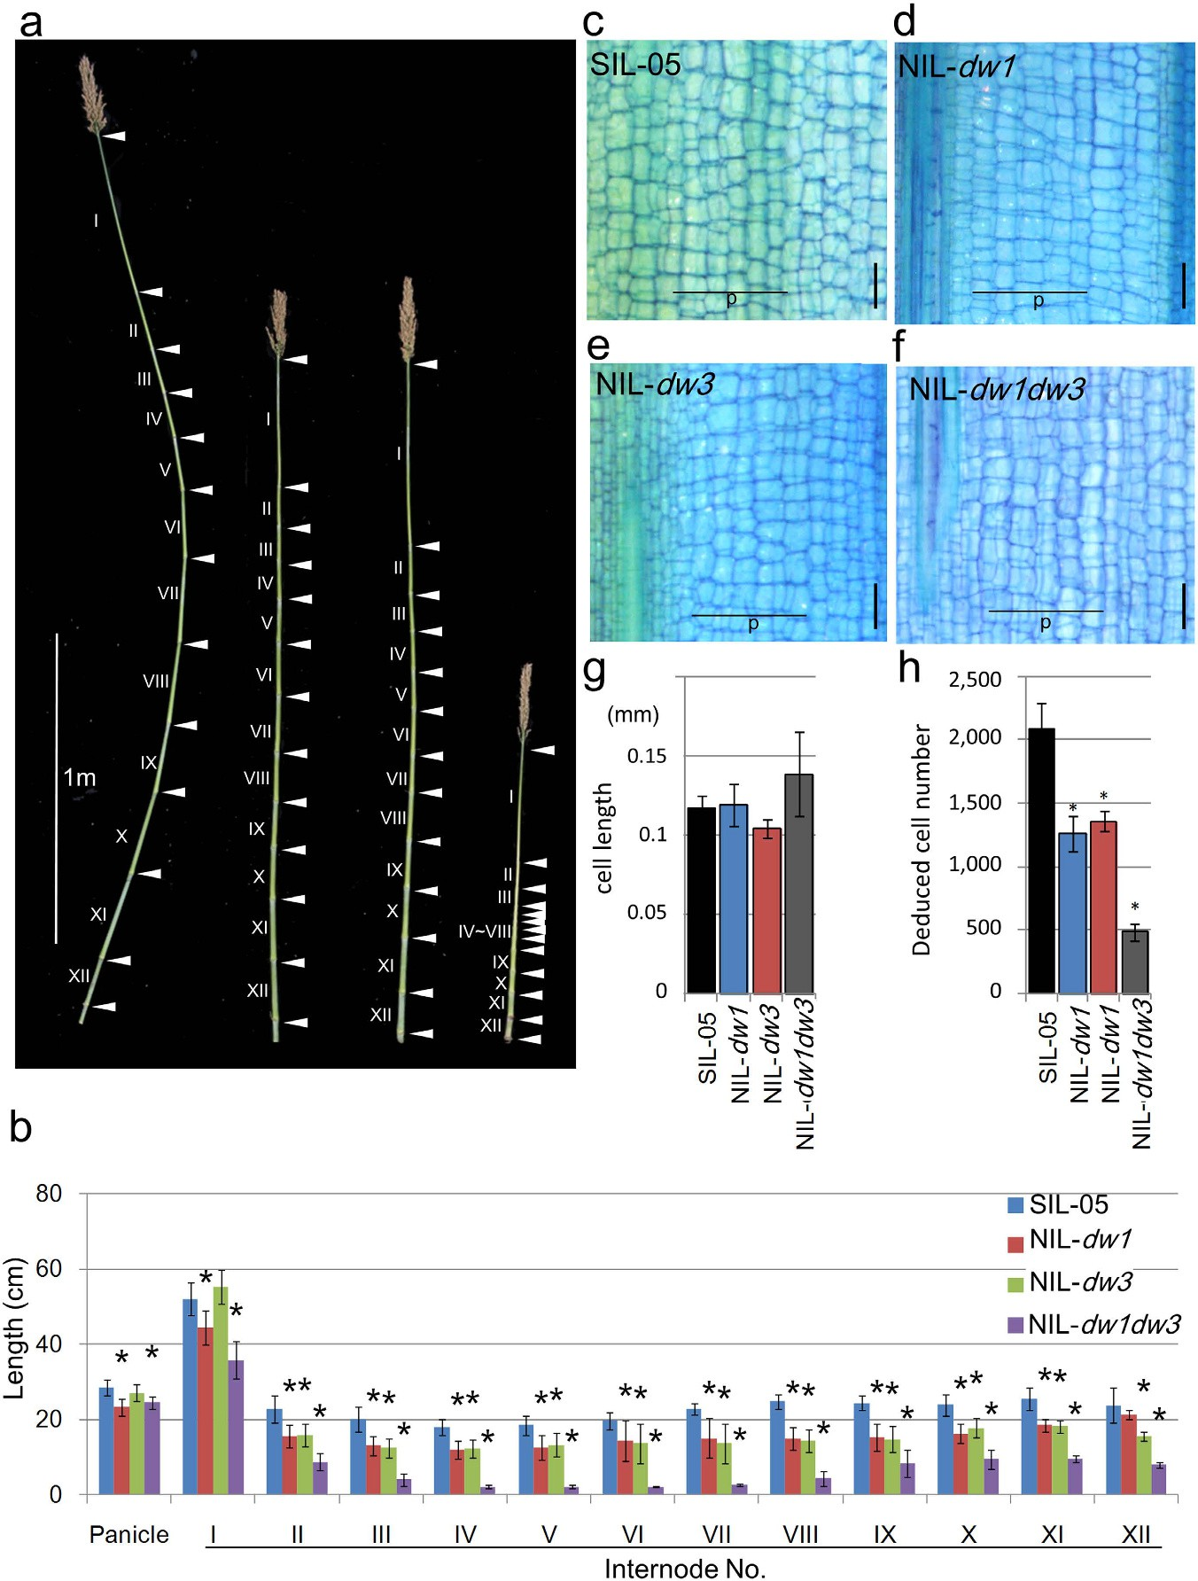
Figure 4. Genetic interactions between Dw1 and Dw3. (a) The internode elongation patterns of the NILs and their background lines. From left to right: SIL-05, NIL-dw1, NIL-dw3, and NIL-dw1dw3. Leaves were removed to observe nodes and internodes. Roman numbers indicate the position of the internode (counted from the top).
Arrowheads indicate nodes. (b) The average lengths of each internode calculated using seven plants. From left to right: SIL-05, NIL-dw1, NIL-dw3, and NIL-dw1dw3. (c–f) Longitudinal sections of the middle of internode IX from NILs and SIL-05. The parenchyma cells were examined. Vertical bars = 200 μm. (g,h) Length and deduced number of parenchyma cells of internode IX calculated from five cell files of parenchyma cells (shown as “p” in panels c–f). Error bars represent the standard deviation. Single and double asterisks indicate significant differences at 5% (P < 0.05) and 1% (P < 0.01) levels of significance, respectively, as determined by t-test.

Methods
Plant materials and growth conditions. The F₂ plants of sorghum were grown under natural field condi- tions at the Faculty of Agriculture Education and Research Center of Alpine Field Science of Shinshu University (Ina, Japan) in 2008. Seeds were directly sown, and established one plant per hill with an 8 cm inter-hill spacing and 75 cm inter-row spacing. HIF plants were grown at the Togo Field Science and Education Center of Nagoya University (Aichi, Japan), and in the experimental field in Okinawa (Ohgimi, Japan) in 2010 and 2011. Seeds were sown in a nursery bed in a greenhouse, and 4-week-old seedlings were transplanted to the field with 15 cm spacing between each plant in two rows (30 cm in spacing) per hill (100 cm in width). The furrow was 80 cm in width. Genomic DNA was isolated from leaves of ~6-week-old field-grown plants using a cetyltrimethyl ammo- nium bromide extraction protocol27 with minor modifications. The SALK T-DNA insertion lines (SALK_038235 and SALK_059180) of Arabidopsis were obtained from the Arabidopsis Biological Resource Center (Columbus, OH, USA). Arabidopsis plants for mutants and WT were cultivated in a temperature-controlled chamber at 22 °C under continuous light (for plant height analysis).
DNA simple-sequence repeat (SSR) markers. The SSR markers for sorghum, as reported by Brown et al.28, Bhattramakki et al.29, Kong et al.30, and Yonemaru et al.31 were screened, and SSR markers showing pol- ymorphisms between the two parents were chosen. One SSR marker, SbYUC7, was additionally developed on chromosome 6. Thus, 162 SSR markers were used in this analysis.
QTL analysis. A F₂ population consisting of 185 individual plants derived from a cross between bmr-6 (a 3-dwarf short cultivar)32 and SIL-05 (a Japanese tall cultivar) was used for the distribution analysis of CL, and 96 plants were selected for the QTL analysis. The CL was measured from the ground to panicle node, and the flow- ering date was set as the number of days from sowing to flowering on the main panicle.
Linkage analyses and QTL identifications were performed using the MAPMAKER/QTL program33,34 based on genotypic data, while recombination frequencies were converted to genetic distances in centiMorgans (cM) using the Kosambi function35. The linkage map in Fig. 1 was created using Q-gene36. Primers used in this study are listed in Supplementary Table S1.
Positional cloning of Dw1. HIFs were used in the positional cloning. For the generation of HIFs, one plant of each genotype, bmr-6 homozygous, SIL-05 homozygous, and bmr-6 heterozygous on qCL-6, qCL-7, and qCL-9, respectively, was selected from the F₃ population, because the progeny plants were clearly segregated. The F₄ and F₅ were generated using the Single Seed Descent method, with a DNA marker selected from the same genotype as the parent. Thus, the progenies (F₅ and F₆), which are RILs containing a heterozygous fragment of qCL-9, were used to generate HIFs.
RNA extraction, semi-quantitative RT-PCR analyses and RNA-seq. For semi-quantitative RT-PCR analysis, total RNAs were extracted from elongating internodes of sorghum at the vegetative stage (6 weeks after sowing) from SIL-05 and bmr-6 using TRIzol reagent (Invitrogen), or from leaves of transgenic rice using an RNeasy plant mini kit (Qiagen). The first-strand cDNA was synthesized using an Omniscript RT kit (Qiagen). The PCR parameters for the detection of Sobic.009g229800, Sobic.009g229900, Sobic.009g230000, Sobic.009g231000, and Sobic.009g232000. genes were 94 °C for 5 min followed by 35 cycles of 94 °C for 30 sec, 56 °C for 30 sec, and 72 °C for 30 sec. Sorghum ubiquitin (Sobic.001G311100; SbUbi) was used as the internal reference for all analyses. The parameters for SbUbi, Os01g0103800, Os03g0270700, and OsActin (Os03g0718100) genes were 27, 30, 30 and 25 cycles, respectively. The primers used for PCR are shown in Table S1. The extracted RNAs from the elongating internodes were subjected to RNA-seq experiments as described previously37. Primer sequences are listed in Supplementary Table S1.
Phylogenetic tree analysis. DW1 protein homologs were screened using a BLAST search of Phytozome
v.9.1 (http://www.phytozome.net/). The phylogenetic tree analysis and amino acid alignment were carried out using CLUSTALW38 under default settings and boxshade ver. 3.21 (http://www.ch.embnet.org/software/BOX_ doc.html). Maximum likelihood tree based on the JTT model39 was obtained using Mega software. Bootstrap values were obtained by 1,000 bootstrap replicates.
Agrobacterium-mediated rice transformation. To construct RNAi transgenic plants for simultaneous knockdowns of two genes, Os01g0103800 and Os03g0270700, a common sequence in the two genes was ampli- fied using PCR and fused using fusion PCR in both the sense and antisense directions (primers are listed in Supplementary Table S1). The RNAi construction is based on a previously described method40. The constructs were introduced into A. tumefaciens strain EHA105 and used to infect callus of rice cv. Taichung 65 as described by Ozawa41. Transformed cells and plants were selected using hygromycin resistance, and regenerants were grown to maturity in pots in a greenhouse. Transgenic plants of the T0 (for CL), and T₁ or T₂ (for seed length) genera- tions were used for the analysis.
Agrobacterium-mediated sorghum transformation. A binary vector with bar gene driven by maize ubiquitin promoter (ubipro), pBVubibar-Dw1 was constructed as follows. A digested 4.5 kb genomic DNA fragment containing Sobic.009g229800 of SIL-05 was ligated in BamHI/PstI site of pCAMBIA1380 (Cambia) (pBV-Dw1). Next, a PCR amplified a DNA fragment of bar gene (without promoter) with rbc terminator sequence (ter) was swapped for LUC gene (without a bar promoter region) of pUC-LUC vector42 using in-fusion HD kit (Clontech). Finally, a DNA fragment of ubipro-bar-ter was amplified by PCR using the constructed DNA as a tem- plate, and swapped for the hygromycin resistance gene of pBV-Dw1 by in-fusion HD kit. Agrobacterium-mediated transformation of sorghum cv. Tx430 was performed according to Wu et al.43 with a slight modification.

Immature embryos of sorghum were inoculated with A. tumefaciens strain EHA105 harboring pBVubibar-Dw1. Following a 2 days co-cultivation, the immature embryos were transferred to a resting medium and cultured at 25 °C in the dark for 12 days. For selection transformed cells, the immature embryos were subcultured on a selection medium containing phophinothricin (PPT) at 25 °C in the dark for 4 weeks. The selection pressure was gradually increased from 5 to 15 mg l−1 PPT. Obtained PPT-resistant calluses were cultured on a regeneration medium at 25 °C under continuous illumination (ca. 35 μmol m−2s−1) for 4 weeks and regenerated plantlets were cultured on a root induction medium for further 4 weeks. Both media contained 5 mg l−1 PPT. Well-rooted plants were transplanted to soil in pots and grown to maturity in a greenhouse. For DNA analysis, total genomic DNA was extracted from leaves using the E.Z.N.A. SP Plant DNA Kit (Omega Biotek).

Microscopic analysis. Culm longitudinal slices (110-μm in thickness) of the NILs were prepared using a vibrating microslicer (D.S.K DTK-3000), followed by toluidine blue staining. Photographs were taken using an Olympus stereoscopic microscope connected to a CCD camera (Olympus DP20). To quantify the length and number of the cells in parenchyma, we measured them in five cell files within a 2.1-mm long region of the ninth internode and then estimated the total number of cells in the internode.

References
- Pennisi, E. How sorghum withstands heat and drought. Science 323, 573 (2009).
- Wang, Y. H., Upadhyaya, H. D. & Kole, C. Genetics, Genomics and Breeding of Sorghum, 233 (CRC Press, 2014).
- Wu, Y., Yuan, L., Guo, X., Holding, D. R. & Messing, J. Mutation in the seed storage protein kafirin creates a high-value food trait in sorghum. Nat. Commun. 4, 2217 (2013).
- Murphy, R. L. et al. Coincident light and clock regulation of pseudoresponse regulator protein 37 (PRR37) controls photoperiodic flowering in sorghum. Proc. Natl. Acad. Sci. USA 108, 16469–16474 (2011).
- Childs, K. L. et al. The sorghum photoperiod sensitivity gene, Ma3, encodes a phytochrome B. Plant Physiol. 113, 611–619 (1997).
- Yang, S. et al. Sorghum phytochrome B inhibits flowering in long days by activating expression of SbPRR37 and SbGHD7, repressors of SbEHD1, SbCN8 and SbCN12. PloS one 9, e105352 (2014).
- Yang, S., Weers, B. D., Morishige, D. T. & Mullet, J. E. CONSTANS is a photoperiod regulated activator of flowering in sorghum.
BMC Plant Biol. 14, 148 (2014).
- Murphy, R. L. et al. Ghd7 (Ma6) represses sorghum flowering in long days: alleles enhance biomass accumulation and grain production. Plant Genome 7, doi: 10.3835/plantgenome2013.11.0040 (2014).
- Quinby, J. R. & Karper, R. E. Inheritance of height in sorghum. Agron. J. 46, 211–216 (1954).
- Multani, D. S. et al. Loss of an MDR transporter in compact stalks of maize br2 and sorghum dw3 mutants. Science 302, 81–84 (2003).
- Karper, R. E. & Quinby, J. R. The history and evolution of Milo in the United States. Agron. J. 38, 441–453 (1946).
- Smith, C. W. & Frederiksen, R. A. Sorghum: Origin, history, technology, and production (ed. Frederiksen, R.) 191–223 (John Wiley & Sons, 2000).
- Pereira, M. G. & Lee, M. Identification of genomic regions affecting plant height in sorghum and maize. Theor. Appl. Genet. 90,
380–388 (1995).
- Brown, P. J., Rooney, W. L., Franks, C. & Kresovich, S. Efficient mapping of plant height quantitative trait loci in a sorghum association population with introgressed dwarfing genes. Genetics 180, 629–637 (2008).
- Morris, G. P. et al. Population genomic and genome-wide association studies of agroclimatic traits in sorghum. Proc. Natl. Acad. Sci. USA 110, 453–458 (2013).
- Thurber, C. S., Ma, J. M., Higgins, R. H. & Brown, P. J. Retrospective genomic analysis of sorghum adaptation to temperate-zone grain production. Genome Biol. 14, R68 (2013).
- Higgins, R. H., Thurber, C. S., Assaranurak, I. & Brown, P. J. Multiparental mapping of plant height and flowering time QTL in partially isogenic Sorghum families. G3: Genes Genomes Genetics 4, 1593–1602 (2014).
- Ordonio, R. L. et al. Gibberellin deficiency pleiotropically induces culm bending in sorghum: an insight into sorghum semi-dwarf breeding. Sci. Rep. 4, 5287 (2014).
- Sasaki, A. et al. Green revolution: a mutant gibberellin-synthesis gene in rice. Nature 416, 701–702 (2002).
- Peng, J. et al. ‘Green revolution’ genes encode mutant gibberellin response modulators. Nature 400, 256–261 (1999).
- Quinby, J. R. Sorghum Improvement and the Genetics of Growth (College Station, Texas A&M University Press, 1974).
- Klein, R. R. et al. The effect of tropical sorghum conversion and inbred development on genome diversity as revealed by high- resolution genotyping. Crop Sci. 48, S12–S26 (2008).
- Khush, G. S. Green revolution: the way forward. Nature Rev. Genet. 2, 815–822 (2001).
- Dahleen, L. S., van der Wal, L. J. & Franckowiak, J. D. Characterization and molecular mapping of genes determining semidwarfism in barley. J. Heredity 96, 654–662 (2005).
- Jia, Q. et al. GA-20 oxidase as a candidate for the semidwarf gene sdw1/denso in barley. Funct. Integr. Genomics 9, 255–262 (2009).
- Jia, Q. et al. Expression level of a gibberellin 20-oxidase gene is associated with multiple agronomic and quality traits in barley. Theor. Appl. Genet. 122, 1451–1460 (2011).
- Murray, M. G. & Thompson, W. F. Rapid isolation of high molecular weight plant DNA. Nucleic Acids Res. 8, 4321–4326 (1980).
- Brown, S. M. et al. Multiple methods for the identification of polymorphic simple sequence repeats (SSRs) in sorghum [Sorghum bicolor (L.) Moench]. Theor. Appl. Genet. 93, 190–198 (1996).
- Bhattramakki, D., Dong, J., Chhabra, A. & Hart, G. E. An integrated SSR and RFLP linkage map of Sorghum biocolor (L.) Moench.
Genome 43, 988–1002 (2000).
- Kong, L., Dong, J. & Hart, G. E. Characteristics, linkage-map positions, and allelic differentiation of Sorghum bicolor (L.) Moench DNA simple sequence repeats (SSRs). Theor. Appl. Genet. 101, 438–448 (2000).
- Yonemaru, J. et al. Development of genome-wide simple sequence repeat markers using whole-genome shotgun sequence of sorghum (Sorghum bicolor (L.) Moench). DNA Res. 16, 187–193 (2009).
- Porter, K. S., Axtell, J. D., Lechtenberg, V. L. & Colenbrander, V. F. Phenotype, fiber composition, and in vitro dry matter disappearance of chemically induced brown midrib (bmr) mutants of sorghum. Crop Sci. 18, 205–208 (1978).
- Lander, E. S. & Botstein, D. Mapping mendelian factors underlying quantitative traits using RFLP linkage maps. Genetics 121,
185–199 (1989).
- Lander, E. S. et al. MAPMAKER: an interactive computer package for constructing primary genetic linkage maps of experimental and natural populations. Genomics 1, 174–181 (1987).
- Kosambi, D. D. The estimation of map distance from recombination values. Ann. Eugenics 12, 172–175 (1944).
- Joehanes, R. & Nelson, J. C. QGene 4.0, an extensible Java QTL-analysis platform. Bioinformatics 24, 2788–2789 (2008).

- Mizuno, H. et al. Global transcriptome analysis reveals distinct expression among duplicated genes during sorghum-Bipolaris sorghicola interaction. BMC Plant Biol. 12, 121 (2012).
- Larkin, M. A. et al. Clustal W and Clustal X version 2.0. Bioinformatics 23, 2947–2948 (2007).
- Jones, D. T., Taylor, W. R. & Thornton, J. M. The rapid generation of mutation data matrices from protein sequences. Comput. Appl. Biosci. 8, 275–282 (1992).
- Hirano, K. et al. Survey of genes involved in rice secondary cell wall formation through a co-expression network. Plant Cell Physiol.
54, 1803–1821 (2013).
- Ozawa, K. Establishment of a high efficiency Agrobacterium-mediated transformation system of rice (Oryza sativa L.). Plant Sci.
176, 522–527 (2009).
- Hirano, K. et al. The suppressive function of the rice DELLA protein SLR1 is dependent on its transcriptional activation activity.
Plant J. 71, 443–453 (2012).
- Wu, E. et al. Optimized Agrobacterium-mediated sorghum transformation protocol and molecular data of transgenic sorghum plants. In Vitro Cell Dev. Biol Plant 50, 9–18 (2014).

Acknowledgements
This work was partially supported by a grant from the Core Research for Evolutional Science and Technology (CREST) Program “Novel techniques of tailor-made breeding for energy crop improvement using high- throughput genotyping” of Japan Science and Technology Agency (JST); Grants-in-Aid from the NC-CARP project, the Ministry of Education, Science, Sports and Culture of Japan, and the Ministry of Agriculture; Forestry and Fisheries of Japan (Genomics for Agricultural Innovation), QTL5501. We thank K. Yano and T. Hosaki for handling DNA- and RNA-seq results, and Y. Tahara, S. Mizuno, T. Yamamura, and M. Yamamura for plant cultures in the field.

Author Contributions
M.Y., H.F., A.F., Y.I., H.K., S.K. and T.S. performed field experiments of sorghum; M.Y., H.F., S.A.-N., K.O.-S.,
X.J.S. and R.N. performed genotyping and plasmid constructions; J.Y. and T.M. performed a design of SSR markers; X.J.S. and T.S. performed QTL analyses; J.W. performed isolation and sequencing of BAC clones; H.M. performed RNA-seq experiments; M.T. performed transgenic experiments of sorghum; S.A.-N., K.O.-S. and H.F. performed rice experiments; K.O.-S. and R.N. performed Arabidopsis experiments; S.A.-N. and H.F. performed histological analyses; M.Y., K.H., M.M. and T.S. wrote the paper.

Additional Information
Supplementary information accompanies this paper at http://www.nature.com/srep
Competing financial interests: The authors declare no competing financial interests.
How to cite this article: Yamaguchi, M. et al. Sorghum Dw1, an agronomically important gene for lodging resistance, encodes a novel protein involved in cell proliferation. Sci. Rep. 6, 28366; doi: 10.1038/srep28366 (2016).
This work is licensed under a Creative Commons Attribution 4.0 International License. The images or other third party material in this article are included in the article’s Creative Commons license,
unless indicated otherwise in the credit line; if the material is not included under the Creative Commons license, users will need to obtain permission from the license holder to reproduce the material. To view a copy of this license, visit http://creativecommons.org/licenses/by/4.0/

