The Spark of Life

Electricity in the Human Body

Frances Ashcroft

For Charles and Rose

‘Man is no more than electrified clay’

Percy Bysshe Shelley

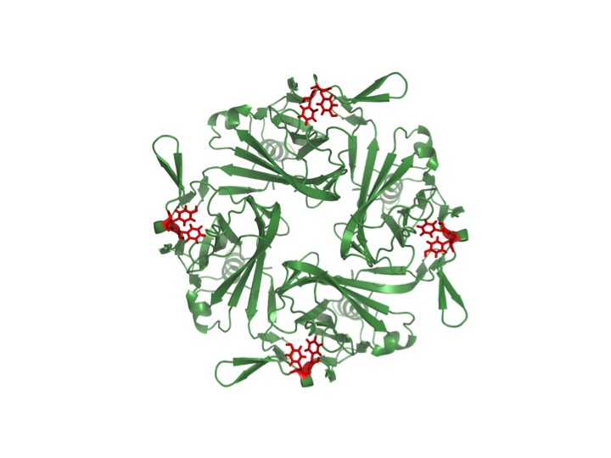Contents

Introduction I Sing the Body Electric

Chapter 1 The Age of Wonder

Chapter 2 Molecular Pores

Chapter 3 Acting on Impulse

Chapter 4 Mind the Gap

Chapter 5 Muscling in on the Action

Chapter 6 Les Poissons Trembleur

Chapter 7 The Heart of the Matter

Chapter 8 Life and Death

Chapter 9 The Doors of Perception

Chapter 10 All Wired Up

Chapter 11 Mind Matters

Chapter 12 Shocking Treatment

Notes

Further Reading

Acknowledgements

Index

Cautionary Note

Electricity is highly dangerous when used incorrectly. The author and publishers advise the reader that they should not try any of the experiments described in this book on themselves, on others, or on animals: and that they accept no responsibility for any harm incurred if the reader should fail to heed this warning.

Introduction: I Sing the Body Electric

Then felt I like some watcher of the skies

When a new planet swims into his ken;

Or like stout Cortez when with eagle eyes

He star’d at the Pacific – and all his men

Look’d at each other with a wild surmise –

Silent, upon a peak in Darien.

John Keats, ‘On first looking into Chapman’s Homer’

When he was just a few months old, James suddenly developed diabetes so severe that it required hospitalization. He faced a lifetime of insulin injections. Over the course of the next few months it also became clear that he was developing more slowly than most children and that he had problems with walking and talking. By the time he was five years old, he had only just started to walk, he was still unable to communicate and he had the temper tantrums of a two-year-old. Life was far from easy for his anxious parents.

It was later discovered that James has a very rare form of diabetes caused by a genetic defect (a mutation) in a protein known as the KATP channel that is important for both insulin secretion and brain function. Some mutations in the KATP channel simply cause diabetes, but around 20 per cent of them, including the one James has, also produce a constellation of neurological difficulties, including developmental delay, hyperactivity, behavioural problems and muscle dysfunction. All of these symptoms arise because the KATP channel influences the electrical activity of the insulin-secreting cells as well as that of the muscles and brain. It turns out that James’s story is closely entwined with my own, for the KATP channel has been my life’s work and understanding how it operates has enabled James to replace the multiple daily insulin injections he needed to control his diabetes with just a few pills.

Diabetes occurs when the beta-cells of the pancreas do not release enough insulin for the body’s needs, so that the blood sugar level rises. Back in 1984, I discovered that the KATP channel sits in the membrane that envelops the beta-cell and regulates its electrical activity and thereby insulin release. The channel functions as a tiny, molecular pore that is indirectly opened and closed by changes in the blood sugar concentration: when the pore is closed insulin secretion is stimulated and when it is open insulin release is inhibited.[1]

I vividly remember the day I made that discovery. As so often happens, the breakthrough came late at night when I was working alone. I had hypothesized that adding glucose to the solution bathing the beta-cells would cause the channel to shut. Yet when it did, I felt certain it must be a technical error. So certain, in fact, that I almost ended the experiment. But just in case I was wrong, I tested the effect of removing the sugar, reasoning that if glucose were indeed regulating the channel activity its removal should cause the pore to reopen, whereas if it were simply a technical problem the channel should remain closed. After several agonizingly long minutes the channel opened once again. I was ecstatic. I was dancing in the air, shot high into the sky on the rocket of excitement with the stars exploding in vivid colours all around me. Even recalling that moment sends excitement fizzing through my veins, and puts a smile on my face. There is nothing – nothing at all – that compares to the exhilaration of discovery, of being the first person on the planet to see something new and understand what it means. It comes all too rarely to a scientist, perhaps just once in a lifetime, and usually requires years of hard grind to get there. But the delight of discovery is truly magical, a life-transforming event that keeps you at the bench even when times are tough. It makes science an addictive pursuit.

That night I felt like stout Cortez, silent upon his peak in Darien, gazing out across not the Pacific Ocean, but a landscape of the mind. It was crystal clear where my mental journey must take me, what experiments were needed and what the implications were. Next morning, of course, all certainty swept away, I felt sure my beautiful result was merely a mistake. There was only one way to find out. Repeat the experiment – again and again and again. That is the daily drudgery of a scientific life: it is very far from the ecstasy of discovery.

Even all those years ago, it was obvious that if the channel failed to close when the blood glucose level rose, insulin secretion would be prevented and the result would be diabetes. To prove it, we needed to find mutations in the DNA sequence that encodes the KATP channel protein in people with diabetes. It took ten years of work by many people throughout the world to identify that DNA sequence, and when we finally screened it for mutations we found . . . nothing!

It was my friend Andrew Hattersley who eventually found the first mutations, another ten years later. Andrew is a very special person. Tall, slim and sandy-haired, with an incisive mind and a warm compassionate nature, he is both a wonderful doctor and a brilliant scientist. He not only recognized that the mutations we were seeking would be more likely to be found in people who were born with diabetes (rather than those who developed it later in life); he also instigated a worldwide search to find them. When he and his associate Anna Gloyn identified the first mutation in 2003, he phoned me and invited us to collaborate with him. It was a call I will never forget.

Working together, we showed that the KATP channel mutations cause diabetes because they lock the channel permanently open, preventing electrical activity and insulin secretion. Even more excitingly, we found that the defective channels can be shut by drugs known as sulphonylureas that have been safely used for more than fifty years to treat type 2 (adult-onset) diabetes and which we already knew closed normal KATP channels.

In the past, patients who were born with diabetes were treated with insulin injections, as their symptoms suggested they had an unusually early-onset form of type 1 (juvenile) diabetes. In this disease the beta-cells are destroyed by the body itself and lifelong insulin is essential. Thus James and others like him were not given drugs, but immediately started on insulin. Our research suggested that instead such patients could be treated with sulphonylurea tablets and to everyone’s delight the new therapy not only worked, but actually worked much better than insulin. Over 90 per cent of people with neonatal diabetes have been able to make the switch.

It is a rare privilege for a research scientist to see one’s work translated into clinical practice, and even rarer to meet the people whose lives have been affected, so I have been extremely fortunate. Words cannot convey the extraordinary emotional experience of meeting the children and families whom your work has helped. To have, for example, a pretty young teenager turn to you and say ‘Thanks to you I can wear a dress’. ‘Why?’ I inquired, puzzled. ‘Because,’ she replied, ‘I no longer need a skirt or trouser waistband from which to hang my insulin pump.’ An insulin pump, I quickly appreciated, is something of a constraint. Dashing in and out of the waves in the summer sea is simply not possible – each time the pump must be removed and reattached – and its bulky shape ruins the line of figure-hugging clothes. Drug therapy obviates these problems and banishes painful injections. But it also has more important benefits. For reasons still unclear (but which we are of course exploring), sulphonylureas produce a far more stable blood glucose level than insulin. Dramatic fluctuations in blood sugar become a thing of the past, and hypoglycaemic attacks are much less frequent (and in some cases virtually vanish). Unexpectedly, the average blood sugar level also decreases so that the risk of diabetic complications (kidney disease, heart disease, blindness and amputations) is reduced.

Chapter 1: The Age of Wonder

I am attacked by two very opposite sects – the scientists and the know-nothings.

Both laugh at me – calling me ‘the Frog’s Dancing-Master’,

but I know that I have discovered one of the greatest Forces in Nature.

Luigi Galvani

‘It was on a dreary night of November, that I beheld the accomplishment of my toils. With an anxiety that almost amounted to agony, I collected the instruments of life around me, that I might infuse a spark of being into the lifeless thing that lay at my feet. It was already one in the morning; the rain pattered dismally against the panes, and my candle was nearly burnt out, when, by the glimmer of the half-extinguished light, I saw the dull yellow eye of the creature open; it breathed hard, and a convulsive motion agitated its limbs.’ Thus did Victor Frankenstein, in Mary Shelley’s great gothic novel Frankenstein, written in 1818, record his creation of a monstrous being.

It is widely believed that electricity, in the form of a lightning bolt, was used to waken Frankenstein’s creature to life. But this is a misconception that probably originates with the famous 1931 film in which Boris Karloff played the monster. Shelley herself was far more circumspect and refers only to the ‘instruments of life’. Nevertheless, the novel leads us to infer that electricity was used to instill the monster with ‘a spark of being’, for Frankenstein gives a dramatic description of a lightning strike he witnessed as a young man that blasted an ancient oak tree to smithereens; and on inquiring about the nature of lightning from his father, he was informed it was ‘Electricity’. Shelley also uses her preface to make a marriage of physiology and electricity – ‘perhaps a corpse would be reanimated; galvanism had given a token of such things’.

Indeed, both Mary and her lover Percy Bysshe Shelley took a keen interest in the emerging science of electricity and its effects on the human body. Percy was a particular enthusiast having experimented with electricity at Eton, at Oxford and even at home – his sister recounts how she was terrified of being ‘placed hand-in-hand round the nursery table to be electrified’. Percy was eventually sent down from Oxford for his atheist views and in 1810, during the winter vacation before his last term, he wrote to his tutor that he supposed man to be ‘a mass of electrified clay possessing the power to confine, fetter and deteriorate the omnipresent intelligence of the universe’. Over two hundred years later, ‘electrified clay’ remains a fair description of the human brain.

Although we may scoff at the idea that electricity could animate a lifeless creature and know that a lightning strike is often lethal, even today we are not immune from the idea that electricity is the spark of life. A late-night arts programme on British television (The South Bank Show) is introduced by a modified version of Michelangelo’s famous painting of God creating Adam in which an electric spark leaps from God’s outstretched finger. Nor is the idea entirely fanciful for, like almost all organisms, humans are electrical machines. As this chapter shows, the development of our knowledge of ‘the body electric’ is intimately entwined with our understanding of electricity itself.

The Dawn of Understanding

On a dry wintry day you may receive a sharp electric shock when you open the car door or grab a metal doorknob, and find that sparks fly and crackle when you pull off a nylon shirt. Petticoats that cling to your legs, clothes fresh from the tumble dryer that stick together, hair that stands on end when you remove your hat, an electric jolt when you kiss someone, the faint battle-rattle of electric sparks, like ‘tiny ghosts shooting’, as you comb your hair – all these phenomena happen because static electricity builds up on our bodies. In humid atmospheres the charge dissipates quickly, but under dry conditions it can build up to thousands of volts. Close proximity to metal, however, or even another person, will cause it to discharge. Direct contact is unnecessary, as the electricity will jump the gap, generating a spark in the process. The ‘electricity’ between two people, that special spark, may be more than just lovers’ talk.

The science of static electricity starts with the ancient Greeks’ fascination with amber. It is from their word for amber, electrum, which derives from elector, meaning ‘the shining one’, that we get the word electron, and hence electricity. Because it was usually found washed up on the seashore, amber’s origin was always considered mysterious. The historian Demostratus supposed it the crystallized urine of lynxes. Ovid tells a different story. He relates how Phaethon drove Apollo’s chariot (the Sun) too close to the Earth and was struck down by Zeus to prevent a catastrophe. His grief-stricken sisters were transformed into poplar trees and shed golden tears of amber that fell into the River Eridanus in which Phaethon drowned.

Snatching Lightning from the Sky

Franklin is widely believed to have been the first to show that lightning is a form of electricity. His most famous experiment was carried out in June 1752, when he flew a kite as a thunderstorm approached to prove that lightning is a stream of electrified air. He connected a short, stiff, pointed wire to the top of the kite, tied a metal key to the end of the kite string and attached the key to a silk ribbon, so insulating it from the ground. Whenever a thundercloud passed overhead, Franklin observed that the loose fibres of the hemp string would stand on end, suggesting that the twine became electrified. He even noted that a stream of sparks would leap from the key to his fingers, and that it was possible to charge a Leyden jar by touching it to the key. Franklin was fortunate not to have been struck by lightning, as this was a very dangerous experiment.

But Franklin was not the first to demonstrate that lightning is an electrical discharge. That accolade goes to a Frenchman, Thomas-François D’Alibard. In May of the same year, Dalibard erected an inch-thick 40-foot-high iron pole, carefully insulating it from the ground by standing it on a plank balanced on three wine bottles and securing it with silken ropes. Sparks could be drawn from the rod with a Leyden jar when lightning was in the area. As Dalibard acknowledged, his experiment was inspired by Franklin’s paper describing his ‘Experiments and Observations’ on electricity, in which the American conjectured that such a pointed rod should draw lightning from the cloud and advised on how harm to the experimenter might be avoided. Dalibard’s demonstration created a sensation throughout Europe and was rapidly repeated by many other experimenters. Alas, not all were as careful or as lucky as Dalibard. The Swedish scientist Georg Wilhelm Richman was electrocuted a year later while experimenting with lightning conductors; his death is commemorated in a rather flowery poem by Erasmus Darwin (uncle of the more famous Charles), whose narrator –

eyed with fond amaze

The silver streams, and watch’d the sapphire blaze;

Then burst the steel, the dart electric sped

And the bold sage lay number’d with the dead!

The Franklin Memorial in Philadelphia is inscribed with some of the statesman-scientist’s words of wisdom: ‘If you would not be forgotten as soon as you are dead and rotten, either write things worth reading or do things worth the writing.’ Franklin, of course, did both. One of his lasting legacies is the lightning conductor. Being aware that lightning was simply a form of electricity, and knowing that lightning strikes the tallest objects, he advised fixing on the ‘highest Parts of those Edifices upright Rods of Iron, made as sharp as a Needle and gilt to prevent Rusting, and from the Foot of those Rods a Wire down the outside of the Building into the Ground’. These pointed rods, he surmised, would conduct the strike safely to the ground so the building would not be damaged – or as he more poetically phrased it, ‘secure us from that most sudden and terrible Mischief!’

Acting on Impulse

Nerve cells transmit information by means of electrical signals known as nerve impulses or action potentials. These race along the nerve fibre at speeds of up to 400 kilometres per hour (250 miles per hour). The fastest nerves of all are those that are enveloped in an insulating myelin sheath. This is formed from layer upon layer of membranes of a specialized cell (the Schwann cell) that wraps itself tightly around the axon like the layers of a Swiss roll, or the paper layers enveloping a toilet roll tube. This insulating myelin sheath enables nerve fibres to conduct electrical impulses more rapidly. When it is damaged, nerve conduction is disrupted.

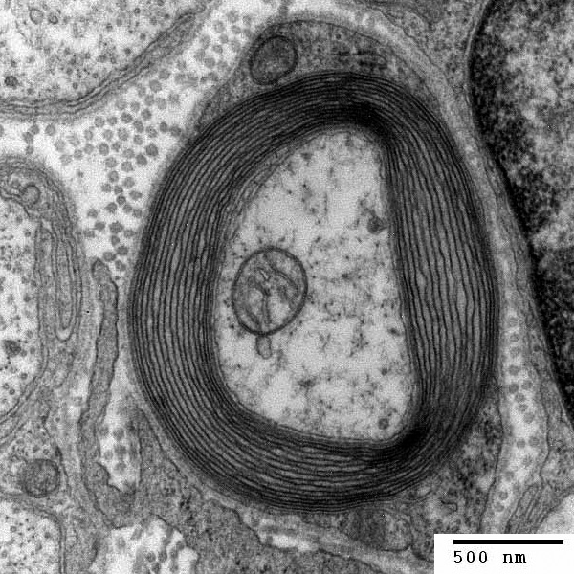

A myelinated nerve, showing the layers of insulating myelin wrapped around the nerve axon. The small organelle in the centre of the nerve is a mitochondrion, one of the cell’s power plants.

Multiple Schwann cells are strung out along the length of the axon. Every few micrometres, adjacent Schwann cells are separated by small gaps known as the nodes of Ranvier, which allow the naked nerve membrane to contact the extracellular fluid. Because the myelin sheath is such a good insulator, it is only at the nodes that electric current can flow from the nerve cell to the extracellular fluid. The nodes thus serve as repeater stations, boosting the action potential and enhancing its speed. In effect, the nerve impulse travels faster in myelinated nerves because its leading edge leaps forward one node at a time. This explains why myelinated nerves conduct action potentials much faster than unmyelinated nerve fibres.

A dramatic example of the crucial importance of myelin is afforded by Guillian-Barré syndrome. This rare autoimmune disease usually begins with tingling and weakness in the feet, and is followed with frightening speed by paralysis of the lower limbs, then the hands and arms, and subsequently the chest muscles, so that the victim is unable to breathe and must be kept alive by artificial respiration. Ultimately, almost all the nerves may be affected, including those of the face, so that the person may be unable to speak and can only communicate by eye blinks. In the worst case you can go from normal nerve function to near-total paralysis within a day.

Guillian-Barré syndrome is caused by antibodies produced by the body against foreign proteins that for unknown reasons also attack its own tissues, in a form of cellular friendly fire. This leads to loss of myelin and destruction of the nerve sheath, which prevents impulse conduction. The brain and spinal cord are spared because the antibodies cannot cross the protective blood-brain barrier that surrounds them, and are thus are barred from reaching the myelinated fibres within the brain. Fortunately the paralysis is usually not permanent and once the antibodies have been cleared from the system, the myelin grows back. But it is a slow process, taking about a centimetre a day, and in a tall person it can take well over a year for some muscles to be fully reinnervated. In many cases, full function is never regained.

Similarly, multiple sclerosis is caused by a gradual and inexorable autoimmune attack on the myelin sheath, which results in progressive impairment of nerve conduction and eventually loss of coordination and difficulty in walking. It can also cause blindness, due to damage to the optic nerves. One of its most celebrated victims was the gifted and charismatic young British cellist, Jacqueline du Pré. When she was only twenty-six, she started to lose sensitivity in her fingertips and soon she was unable to feel the strings of her cello at all. She ceased performing two years later.

1.