

**CSE2004**

**DATABASE MANAGEMENT SYSTEMS**

**FINAL REVIEW**

**Submitted to**

**Prof. Pradeep Kumar Roy**

**Topic: *Hospital Management System***

**Team Members:**

Shreyansh Srivastava (18BEC0438)

Shelly Mohanty (19BCE0820)

Shyam Ranjan Bharti (19BCE0784)

**ACKNOWLEDGEMENT**

We are highly indebted to our respected professor Mr. Pradeep Kumar Roy and our institution VIT, Vellore for giving us the opportunity to complete our DBMS project and successfully create a Hospital Management system catering to the needs of needs of patients and doctors during the current pandemic situation.

**DECLARATION**

We hereby declare that project titled “Covid-19 Hospital Management System” is a bonafide original record done by our group members Shreyansh Srivastava, Shelly Mohanty and Shyam Ranjan Bharti for the J component of our course CSE2004 Database Management Systems.

**ABSTRACT**

The purpose of the project entitled as “Covid-19 Hospital Management System” is to computerize the Management of Hospital during this pandemic situation to develop software which is user friendly simple, fast, and cost – effective.

It deals with the collection of patient’s information, diagnosis details, etc. Traditionally, it was done manually. The main function of the system is register and store patient details and doctor details and retrieve these details as and when required, and also to manipulate these details meaningfully. System input contains patient details, diagnosis details, while system output is to get these details on to the screen.

The Hospital Management System can be entered using a username and password. It is accessible either by an administrator or receptionist. Only they can add data into the database. The data can be retrieved easily. The data are well protected for personal use and makes the data processing very fast.

Home quarantined and hospitalized patient’s details are stored separately and invoice is generated as and when required.

**INDEX**

1. INTRODUCTION

1.1 Introduction

1.2 Problems in the current system and our solutions to them

1.3 Flowchart

2. DATABASE DESIGN

2.1 ER Diagram

2.2 Relational Schema

2.3 Data Collection

2.4 Database Creation

3. REQUIREMENTS SPECIFICATION

3.1 Introduction

3.2 Hardware requirements

3.3 Software requirements

3.4 Steps to run the code

4. SYSTEM IMPLEMENTATION

4.1 Introduction

4.2 Sample code

5. SAMPLE SCREENSHOTS

6. CONCLUSION

7. BIBLOGRAPHY

1. **INTRODUCTION**

**1.1 Introduction:**

The project Hospital Management system includes registration of patients, storing their details into the system, and also computerized billing in the pharmacy, and labs. The software has the facility to give a unique id for every patient and stores the details of every patient and the staff automatically. It includes a search facility to know the current status of each room. User can search availability of a doctor and the details of a patient using the id.

**1.2 Problems in current system and our solutions to them:**

* The hospital management system is suitable for normal conditions but during this time of pandemic the hospital needs to use efficient techniques to provide help to its patients. In the time of pandemic, the number of patients has drastically increased and there are not enough beds for all the patients so it is difficult to keep a track of all the patients

**Solution-** The website keeps record of patients in the hospital as well as the home quarantined patients so that the doctors could recommend medication to all the patients even though they are not in the hospital. The doctors can schedule their meeting in the website so that they can help the patients in an effective way

* Some of the hospitals do not have a very efficient way of management of all the data. A good and simple graphic interface is needed for the staff so they can provide instant care to the patients.

**Solution-** The website has a simple design so that it can be easily used by the Doctors, Staffs and the Patients.

* People who do not get space in the hospital will have to go to other private hospitals for treatment so the hospital needs to do something by which it can help more and more patients.

**Solution-** The patients can get the medications through the website so that they do not have to come the hospital

* The lockdown is going on so many people cannot go to the hospital for minor problems

**Solution-** The website allows them to contact the Doctors and the doctors can recommend them medication through the website.

* 1. **Flow chart:**

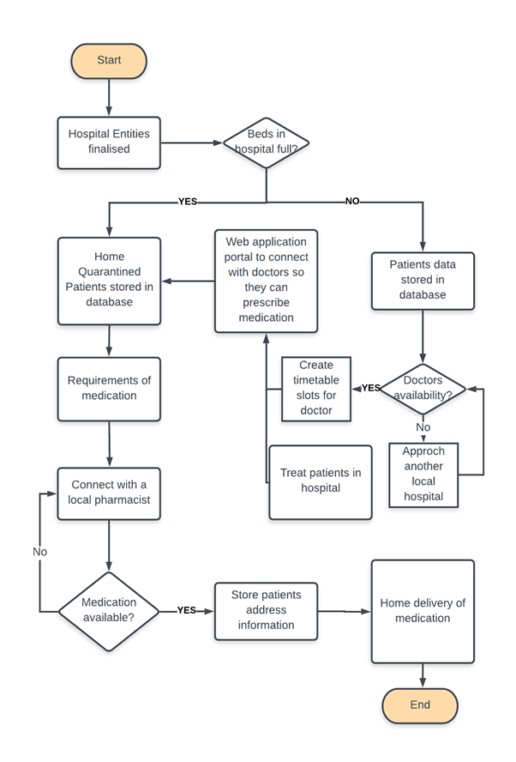

* 1. **Unique features of our project**

1. Login system by checking if username, password is matching in database.
2. Insertion of patients and staff information into database.
3. Modification of any of the patient or staff information through super admin login.
4. Checking for room availability by assigning all admitted patients with their own room.
5. Generation of invoice for home quarantined and admitted patients by adding details in database.
6. Deletion of any information as and when required.
7. **DATABASE DESIGN**

**2.1 ER Diagram**

ER diagram is made to show the complete logical structure of a database. It shows the relationship among entity sets. An entity is a table or attribute of a table in database and thus ER diagram shows the relationship among tables and their attributes.

We have come up with the following ER diagram (consisting of 5 tables) for our database:

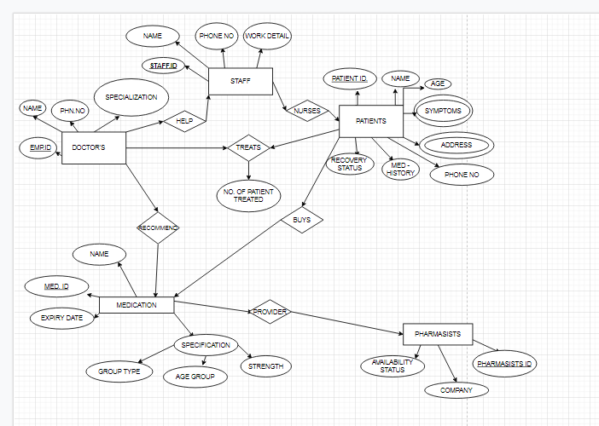

**2.2 Relational Schema**

A relational schema for a database is an outline of how data is organized. It specifies which columns in which tables contain references to data in other tables, including primary keys from other table records so that rows can be easily joined.

The ER diagram for our database is as follows:

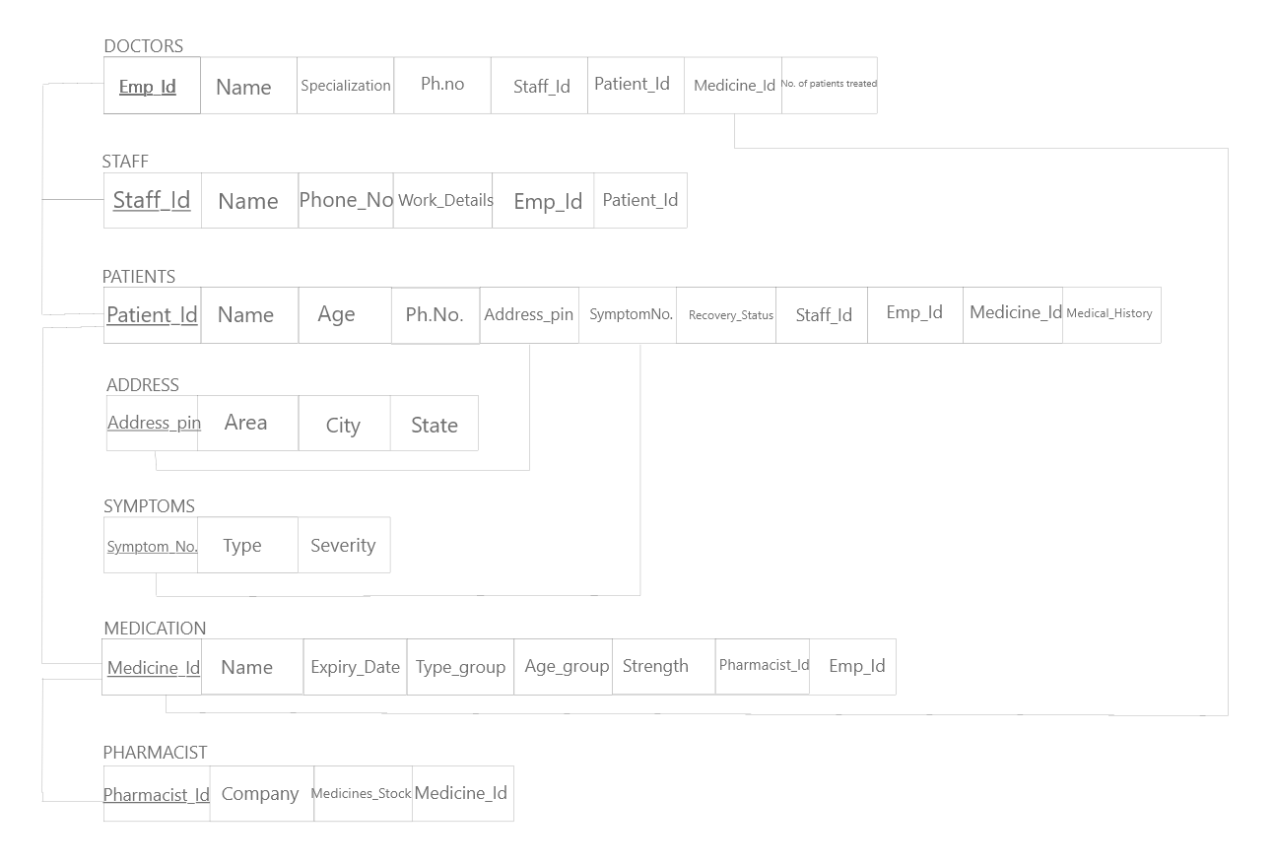

**2.3 Data collection**

We collected around 20-30 sample entries for each of the tables in our database and stored it in excel sheets.

Sample data for one of the tables is given below:

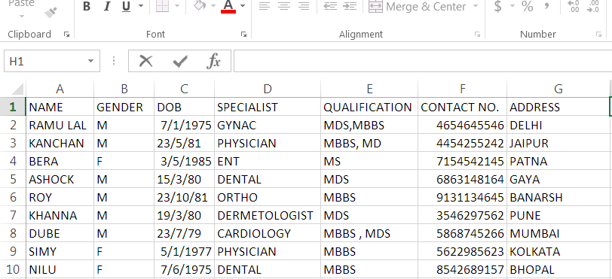

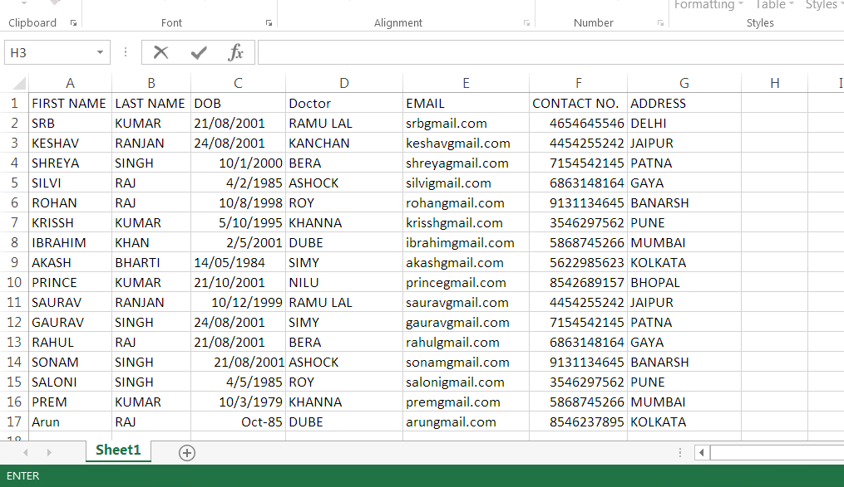

**2.4 Database Creation**

We created the database on phpMyAdmin and added all the tables and data entries here.

Some sample screenshots are as follows:

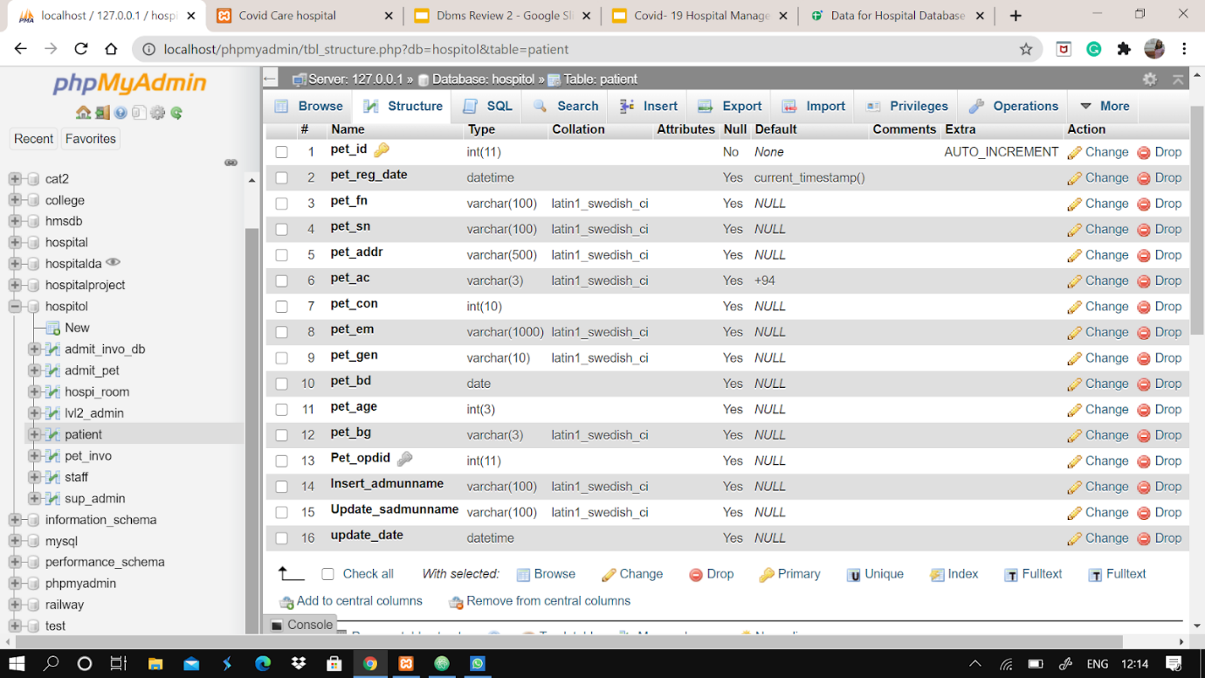

1. **REQUIREMENT SPECIFICATION**

**3.1 Introduction:**

There are certain hardware and software pre-requisites to run our project successfully.

**3.2 Hardware Requirements:**

PROCESSOR: Intel dual Core, i3 or above

RAM: 1 GB or more

HARD DISK: 80 GB or more

**3.3 Software Requirements:**

Operating System should be Windows 7 or above.

Xampp server must be installed.

**3.4 Steps to Run code:**

1. Download the entire source code in zipped format from our Github link given here:

<https://github.com/shellymohanty09/Covid19HospitalManagement>

1. Unzip the folder and save in the following file location: C:\xampp\htdocs
2. Start Apache and Mysql on your Xampp server.
3. Open phpMyAdmin on your browser and create the database named Hospitol. Import hospital.sql file from the project folder into this database.
4. Open the following on your browser to run project: <http://localhost/HospitalManagement/Hospital%20Management%20System/>
5. **SYSTEM IMPLEMENTATION**

**4.1 Introduction**

The following technologies were used to make our application:

Frontend- Html, Css

HTML (the Hypertext Markup Language) and CSS (Cascading Style Sheets) are two of the core technologies for building Web pages. HTML provides the structure of the page, CSS the (visual and aural) layout, for a variety of devices.

Backend- Php

PHP is a general-purpose scripting language especially suited to web development. It has been widely ported and can be deployed on most web servers on almost every operating system and platform, free of charge.

Database- Mysql

MySQL is a freely available open source Relational Database Management System (RDBMS) that uses Structured Query Language (SQL). SQL is the most popular language for adding, accessing and managing content in a database. It is most noted for its quick processing, proven reliability, ease and flexibility of use.

**4.2 Sample Code**

**The backend code for login page:**

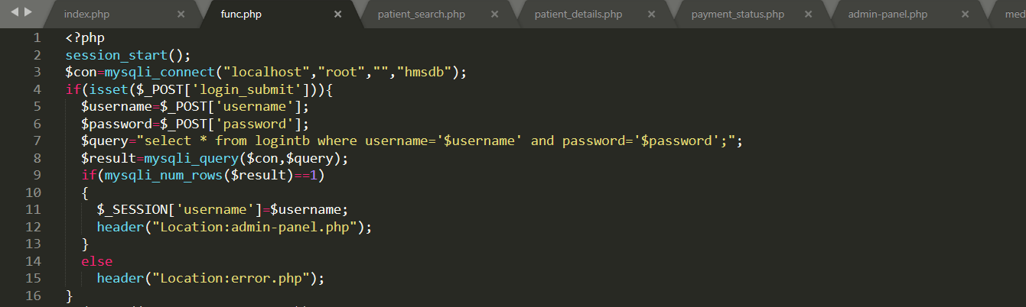

**The code for patient details stored in database:**

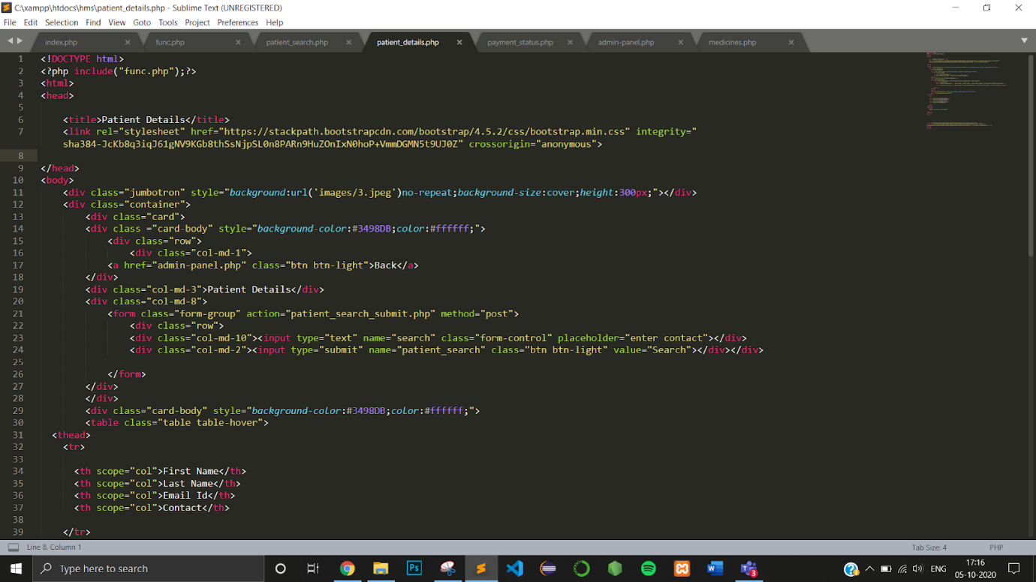

**The code for updating payment status of patient**

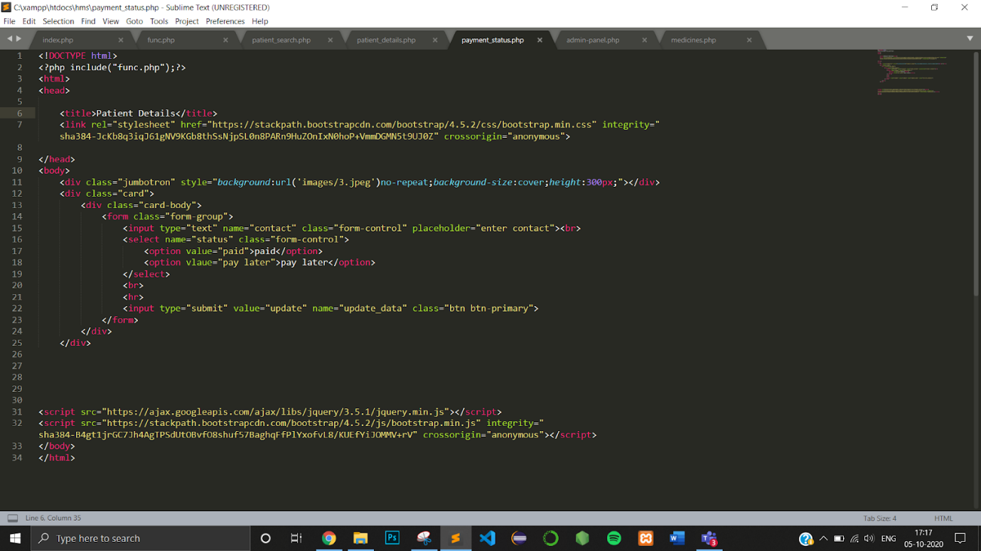

1. **SAMPLE SCREENSHOTS**

**Login Page:**

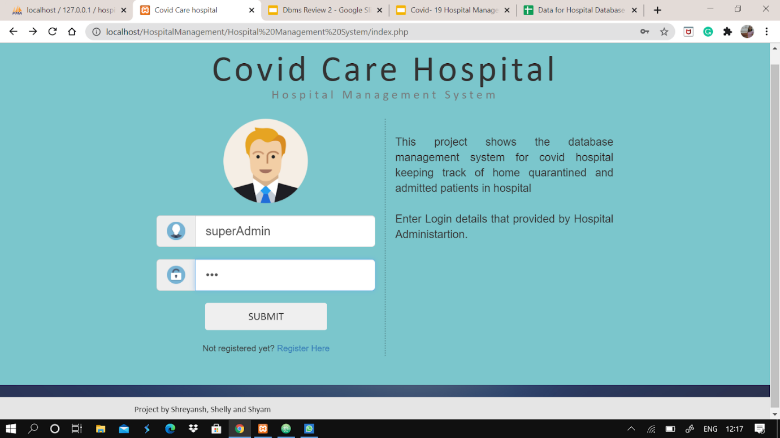

**Home Screen:**

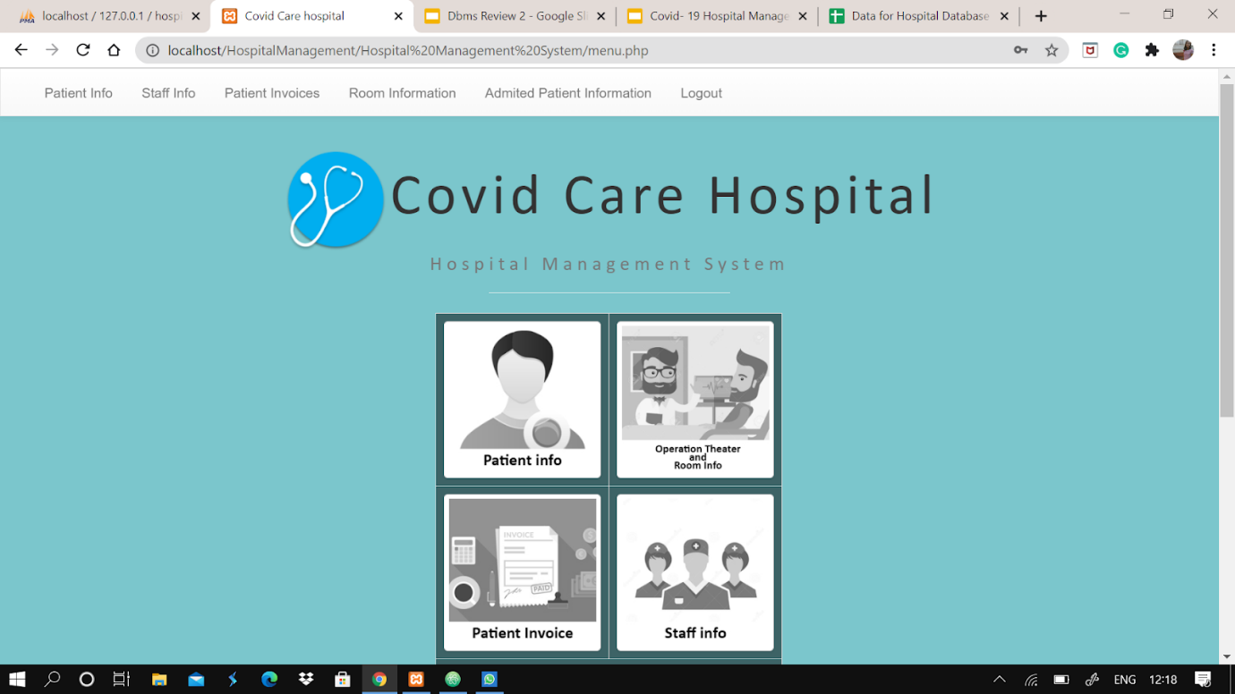

**Patient Registration:**

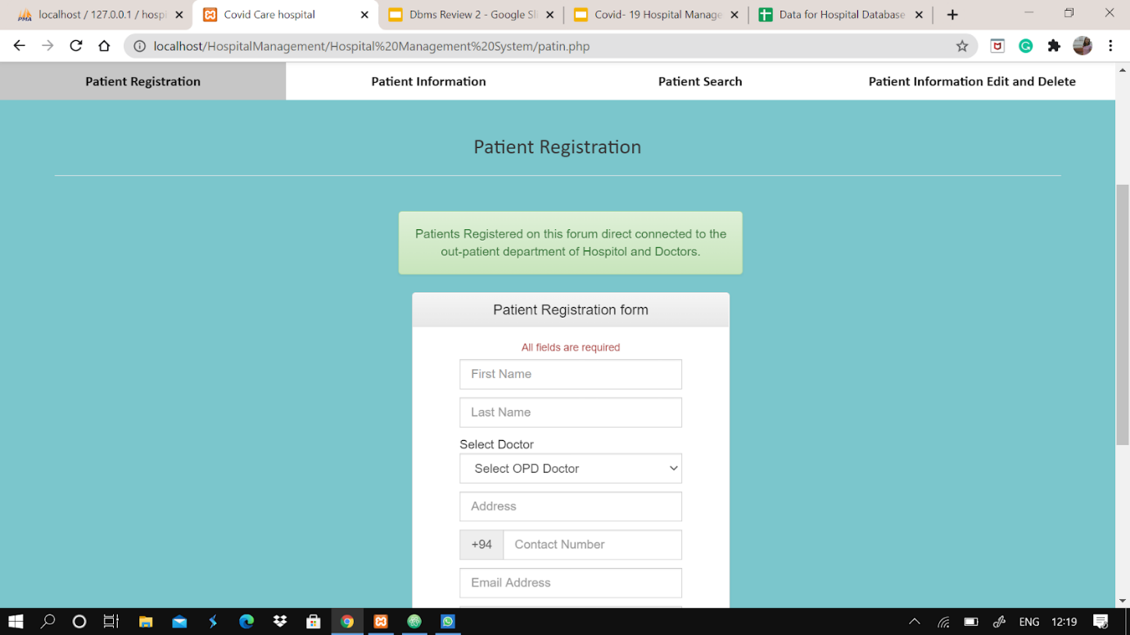

**Room Availability:**

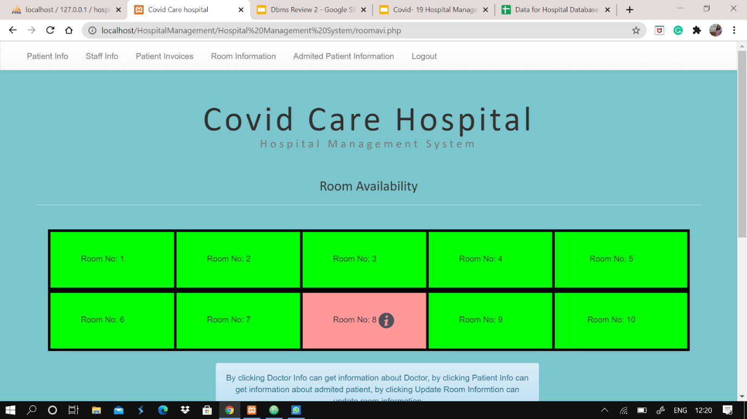

**Invoice generation:**

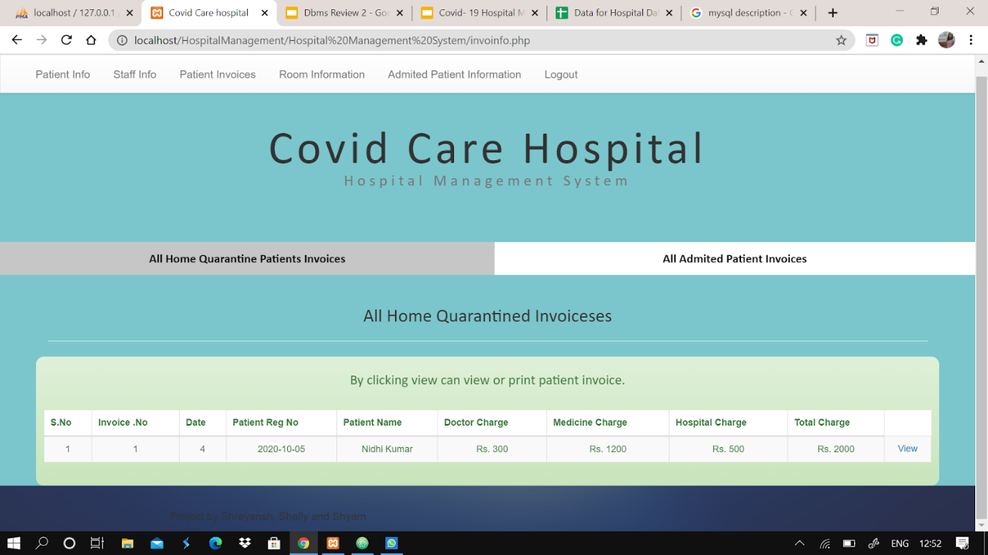

1. **CONCLUSION**

Since we are entering details of the patients electronically in the “Covid-19 Hospital Management System”, data will be secured. Using this application, we can retrieve patient’s history with a single click. Thus. processing information will be faster. It guarantees accurate maintenance of Patient details. It easily reduces the book keeping task and thus reduces the human effort and increases accuracy speed, helping hospitals manage both admitted and home quarantined patients needs even in tough pandemic times.

1. **BIBLOGRAPHY**

1. PHP MySQL Website Programming: Problem - Design – Solution byChris

Lea, Mike Buzzard, Dilip Thomas, Jessey White-Cinis

2. Beginning PHP5, Apache, and MySQL Web Development (Programmer to

Programmer) by Elizabeth Naramore

3. MySQL/PHP Database Applications, 2nd Edition by Brad Bulger

4. How to Do Everything with PHP and MySQL by Vikram Vaswani