 | Original Software | Mapping Software | Remarks
- MASTER
1 | Data Kelompok Barang | Master Kategori
 | 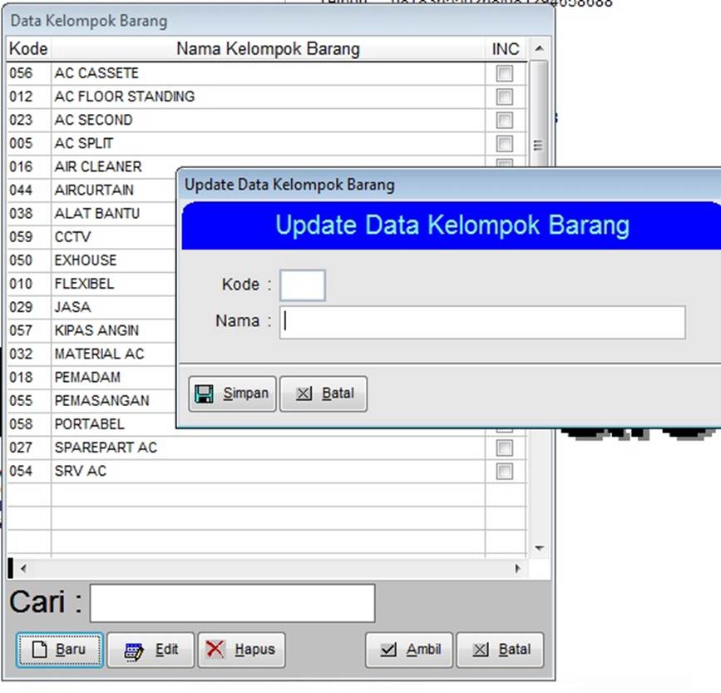 | 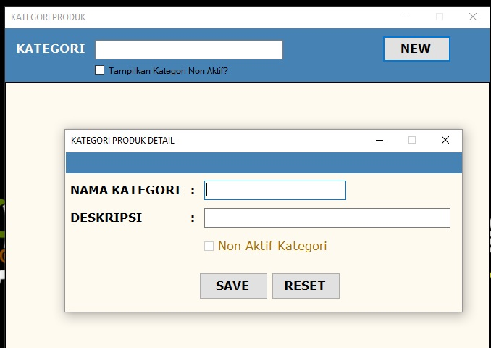
2 | Data Nama Barang | Master Produk
 | 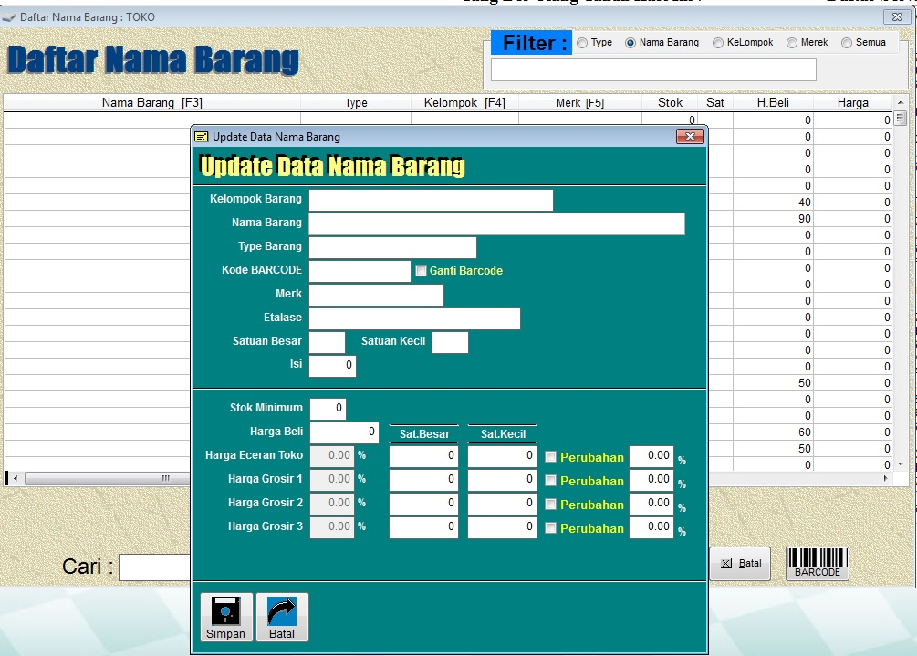 | 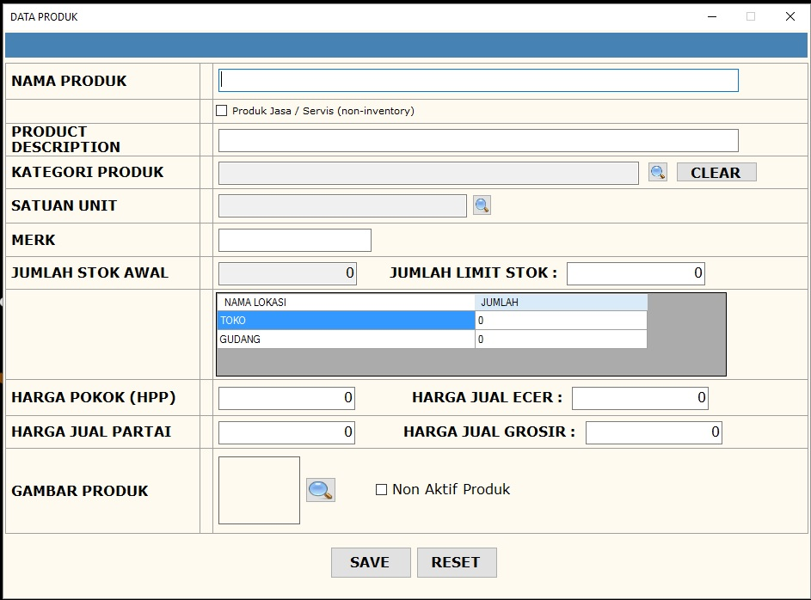
3 | Data Supplier | Master Supplier
 | 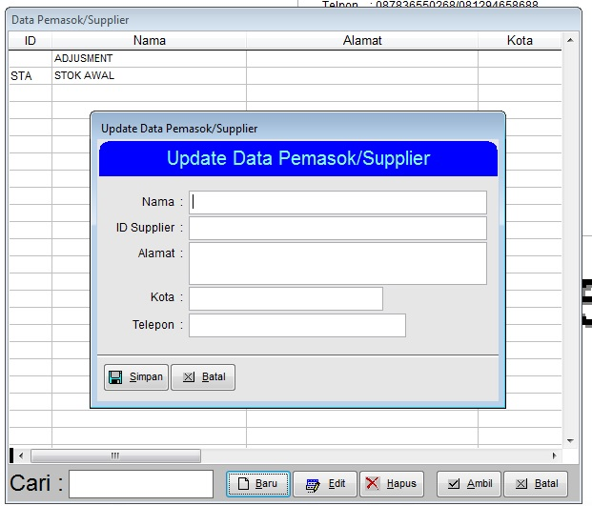 | 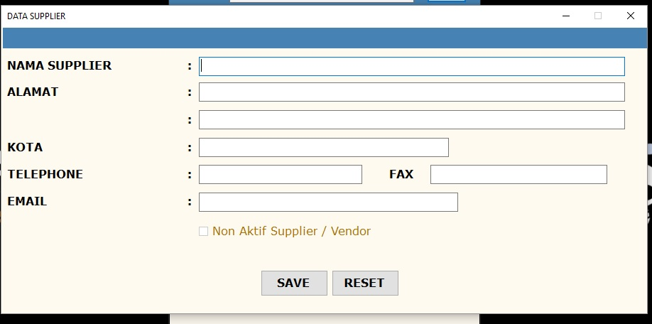
4 | Data Pelanggan | Master Pelanggan
 | 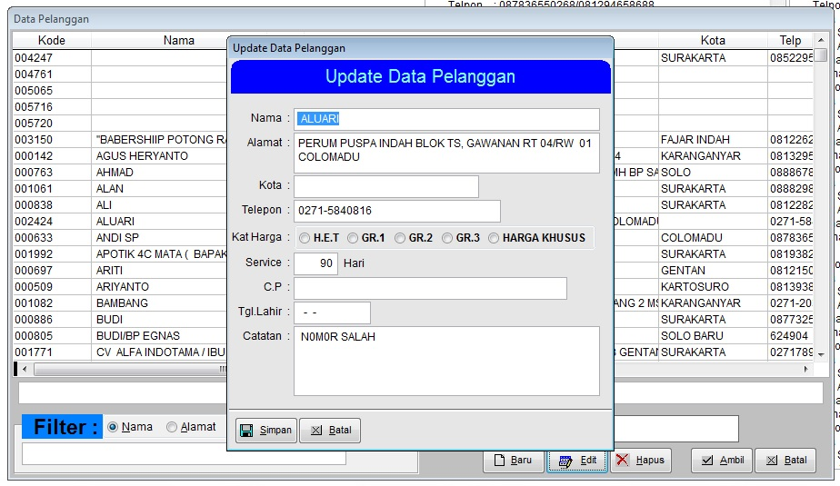 | 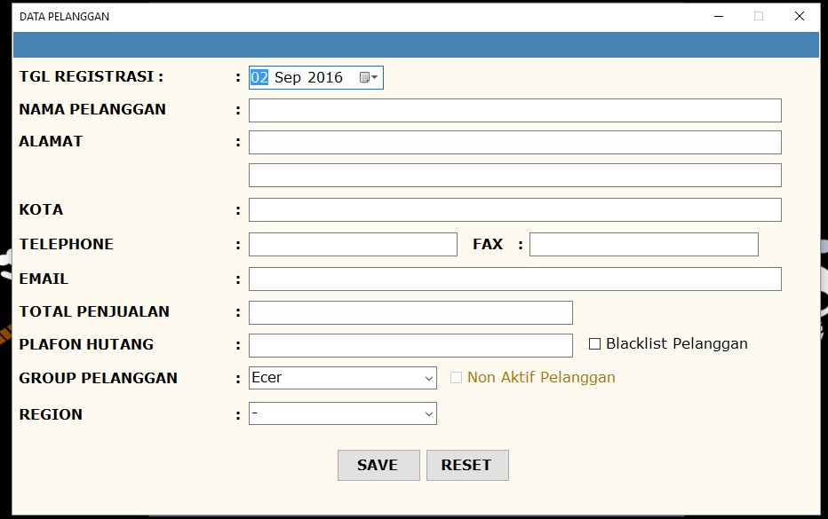
5 | Data Gudang | Master Gudang | New modules
 | 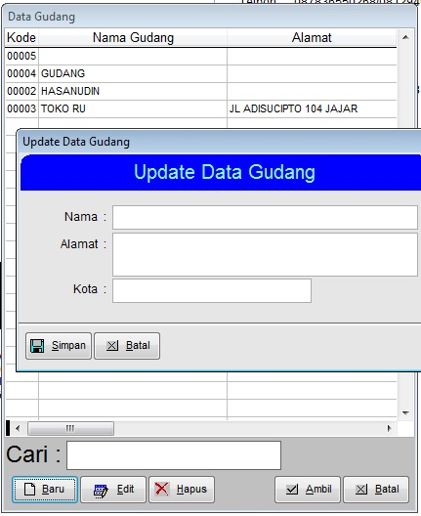
6 | Data Sales | Master User
 | 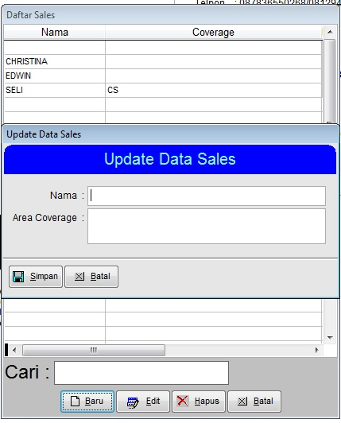 | 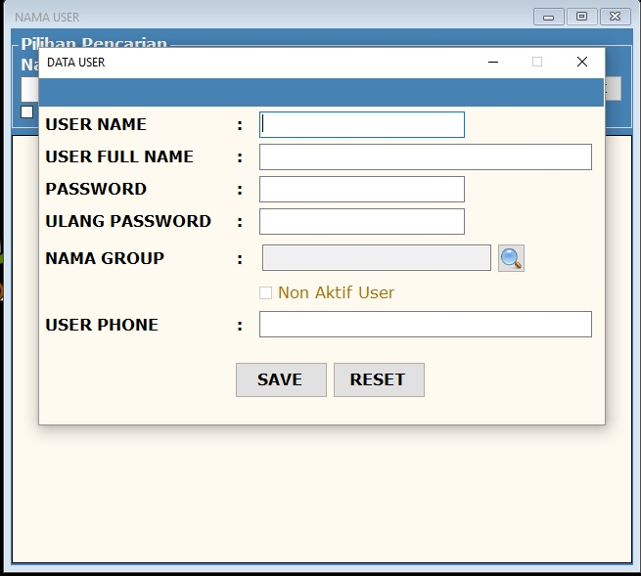 | Set User with Access to Sales Module
7 | Data Perkiraan Biaya
 | 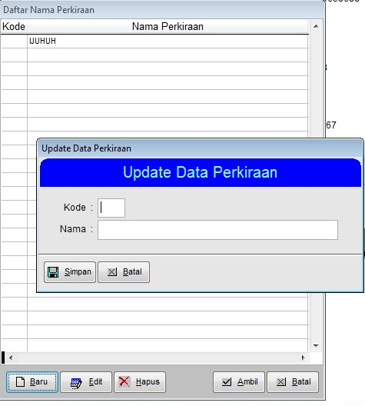 |  | ????
8 | Data Merek Barang | Master Product | Integrated inside Master Product
9 | Page Setup | Pengaturan Printer
 |  | 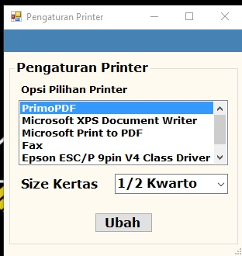
- TRANSAKSI

