Application of ILP to a Breast Cancer Recurrence Data Set with Aleph
CS 731: Advanced methods in artificial intelligence with biomedical applications
Fall 2009
Caden Howell

Background

Inductive logic programming (ILP)
Logic programming describes facts and rules. These facts and rules can be used to deduce results to specific queries. Inductive logic programming uses logic programming languages, such as Prolog, to induce general rules from facts and suggested rule structures. ILP attempts to find a rule which will be consistent with the positive and negative examples of given facts. In ILP terminology, a rule covers the set of facts if it is consistent with every positive and negative example.

ILP is a fairly recent development in machine learning. Plotkin’s article, “A Note on Inductive Generalization,” published in 1970, suggested the theoretical foundation for ILP. However, ILP programs did not emerge until the 1990’s.

The algorithm used by the Aleph implementation of ILP begins by selecting one example in the given database. Then the algorithm builds the most specific clause from this example that can be determined from all of the facts given in the database. The resulting clause is usually too long and specific to be useful as a powerful deductive rule. The algorithm determines the set of clauses that are more general than the original clause. This subset of clauses is a set of least general generalizations: clauses that are only one “step” more general than the original clause. Then, the algorithm selects the clause with the best coverage of examples in the database from the subset. This generalization step is repeated on the best clause as long as coverage improves. When one example is exhausted, the algorithm proceeds to the next example in the database, attempting to build a clause with better coverage. Each clause is added to the resulting theory as the algorithm proceeds, and after each example is processed, redundant clauses are pruned from the theory.

Compared to other learning algorithms, ILP is unusual in incorporating logic programming, which is traditionally associated with top-down, non-probabilistic systems and clear-cut rules. The scoring of ILP clauses can be adjusted to handle contradictory data, similarly to a neural network. The difference between ILP and a neural net is that the model created by ILP has transparent rules that enable the observer to see how it reaches conclusions. In this respect, ILP has more similarity to a decision tree, the difference lying in how an ILP model is constructed.

Aleph
Aleph evolved from a project called P-Progol by Ashwin Srinivasan and Rui Camcho at Oxford University. P-Progol was influenced by Stephen Muggleton’s earlier work in Progol, another implementation of Inductive Logic Programming. As implied by this lineage, Aleph and Progol are implemented in Prolog.

A successful Aleph induction requires the preparation of several data files. Aleph is given a list of background facts using Prolog syntax which describe the domain of the data being generalized. Background facts encode valid attribute values, such as male and female values for a gender attribute, and rules which are taken as valid, such as “It is a car if it has four wheels and a motor.”

In addition to conventional Prolog predicates, Aleph requires that some restrictions are placed on the structure of the rule or rules being induced. These are introduced with the special predicates modeh and modeb. modeh describes the format of the target predicate, and modeb describes the format of background knowledge predicates. Aleph also requires the use of the special predicate determination. determination restricts possible valid relationships between target and background predicates. The background information and format restrictions are given to Aleph in a .b file. In addition, the user must supply a list of positive examples in a separate .f file. Optionally, the user may also supply a list of negative examples in an additional .n file.

Aleph can be launched from within a Prolog interpreter, such as yap, and induction can be performed with a few commands from the interpreter command line.

Breast cancer data set
The data set used in this induction was provided by Matjaz Zwitter and Milan Soklic at the University Medical Center Institute of Oncology in Ljubljana, Yugoslavia. The data set describes breast cancer recurrences. It includes 286 data points. There are nine attributes and two classes: recurrence events, and no recurrence events. All of the attributes have been grouped into nominal buckets. For example, age is segmented into groups of 10-19, 20-29, and so on. This treatment of continuous values simplified the logic predicate format restrictions required by Aleph, and made this an attractive data set.

Additionally, this data set has been very popular in published machine learning results. The accuracy of existing machine learning algorithms on this data set is well known.

- Application

Data conversion
The original data file was in a format suited for the Weka Explorer tool. That is, attributes were described at the top of the file, and each data instance was given as a comma-delimited set of attribute values.

Translating the attributes manually into Prolog predicates was straightforward. In order to translate the data instances, I wrote a Perl script (predicates.perl) that converted each instance into a Prolog predicate representing each value, such as irradiated(data1). A predicate for each data point was also written into either the file of positive or negative examples, depending on whether the instance was had recurrence events.

Aleph induction
I created an additional Perl script (tenfold.perl) to create ten random groups and perform the induction the ten-fold cross-validation. Because ten-fold validation created test sets of only 28 data instances, I also used the script to perform three-fold validation.

To measure the effect of noise on the induction, I ran the script with different values for minimum training set accuracy, ranging from 50 to 97 percent. The results are discussed in the next section.

Each induction resulted in a theory similar to this one. Because it is difficult to consolidate the theories from many different runs, I am including this example from a run with 75% minimum training set accuracy, 85% training set accuracy, and 77% test set accuracy.

[Rule 1] [Pos cover = 3 Neg cover = 1]
recurrent(A) :-
has_age(A,age40_49), has_tumor_size(A,tumor_size15_19).

[Rule 2] [Pos cover = 2 Neg cover = 0]
recurrent(A) :-
has_tumor_size(A,tumor_size40_44), has_deg_malig(A,deg1), left_breast(A).

[Rule 3] [Pos cover = 6 Neg cover = 2]
recurrent(A) :-
has_age(A,age30_39), has_deg_malig(A,deg3), left_breast(A).

[Rule 4] [Pos cover = 14 Neg cover = 2]
recurrent(A) :-
node_caps(A), has_deg_malig(A,deg3), left_breast(A).

[Rule 7] [Pos cover = 3 Neg cover = 0]
recurrent(A) :-
has_tumor_size(A,tumor_size30_34), has_inv_nodes(A,inv_nodes3_5), has_breast_quad(A,left_up).

[Rule 8] [Pos cover = 7 Neg cover = 1]
recurrent(A) :-
has_tumor_size(A,tumor_size25_29), has_deg_malig(A,deg3), left_breast(A).

[Rule 10] [Pos cover = 2 Neg cover = 0]
recurrent(A) :-
has_tumor_size(A,tumor_size20_24), has_deg_malig(A,deg1), has_breast_quad(A,left_up).

[Rule 11] [Pos cover = 3 Neg cover = 0]
recurrent(A) :-
node_caps(A), has_deg_malig(A,deg3), has_breast_quad(A,right_up).

[Rule 13] [Pos cover = 6 Neg cover = 1]
recurrent(A) :-
has_inv_nodes(A,inv_nodes3_5), has_deg_malig(A,deg3), has_breast_quad(A,left_low).

[Rule 15] [Pos cover = 4 Neg cover = 0]
recurrent(A) :-
has_age(A,age50_59), has_menopause(A,premeno), has_breast_quad(A,right_up).

[Rule 20] [Pos cover = 3 Neg cover = 1]
recurrent(A) :-
has_tumor_size(A,tumor_size20_24), has_inv_nodes(A,inv_nodes3_5), left_breast(A).

[Rule 25] [Pos cover = 2 Neg cover = 0]
recurrent(A) :-
has_age(A,age40_49), has_inv_nodes(A,inv_nodes3_5), has_breast_quad(A,right_up).
Figure: Sample theory produced by Aleph

In addition to the noisy runs, I did one ten-fold validation set requiring 100% accurate coverage. It resulted in 39 rules, 26 of which were of the form recurrent(dataXX). where dataXX represents a single data instance.

Results

Other machine learning studies using this data set have ranged from 75-80% The following results for well-known classification algorithms on the breast cancer data set appeared in Kononeko (1997).

Naïve Bayes | Semi-Naïve Bayes | Backpropagation | k-NN
77.3+-4.2 | 78.9+-3.6 | 76.4+-4.1 | 79.5+-2.7
Table: Classification accuracy of learning systems (Kononeko 1997).

The following graphs and tables illustrate the accuracy of the models created by ILP. These models fared slightly worse than the Kononeko data. The three-fold validation results are a more fair comparison, because the Kononeko studies also partitioned the data into 70% for learning and 30% for testing. The ILP model reached about 70% accuracy on test data. ILP faired best in the ten-fold validation run with an 85% minimum accuracy training, where it reached 73% accuracy on test data.
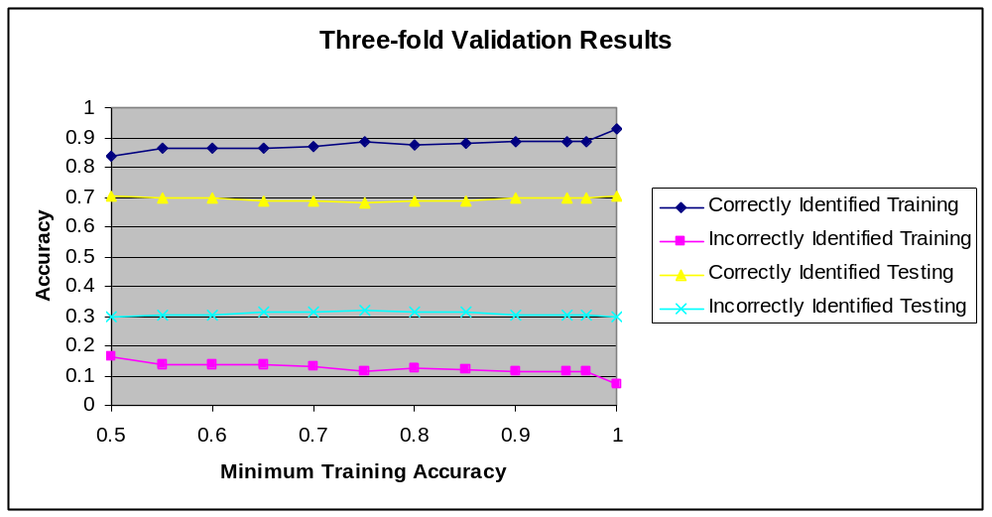

Minimum Training Accuracy | Correctly Identified Training | Incorrectly Identified Training | Correctly Identified Testing | Incorrectly Identified Testing
0.5 | 0.83573069 | 0.164269312 | 0.702741228 | 0.297258772
0.55 | 0.8653991 | 0.1346009 | 0.699232456 | 0.300767544
0.6 | 0.8653991 | 0.1346009 | 0.699232456 | 0.300767544
0.65 | 0.8671443 | 0.132855699 | 0.68870614 | 0.31129386
0.7 | 0.8706347 | 0.129365298 | 0.68870614 | 0.31129386
0.75 | 0.88635069 | 0.113649307 | 0.681688596 | 0.318311404
0.8 | 0.87759713 | 0.122402866 | 0.68870614 | 0.31129386
0.85 | 0.88283274 | 0.117167264 | 0.68870614 | 0.31129386
0.9 | 0.88461468 | 0.115385322 | 0.699232456 | 0.300767544
0.95 | 0.88461468 | 0.115385322 | 0.699232456 | 0.300767544
0.97 | 0.88461468 | 0.115385322 | 0.699232456 | 0.300767544
1 | 0.93013686 | 0.06986314 | 0.702741228 | 0.297258772
Grand Average | 0.87792245 | 0.122077554 | 0.694846491 | 0.305153509

Table: Three-fold Validation Results

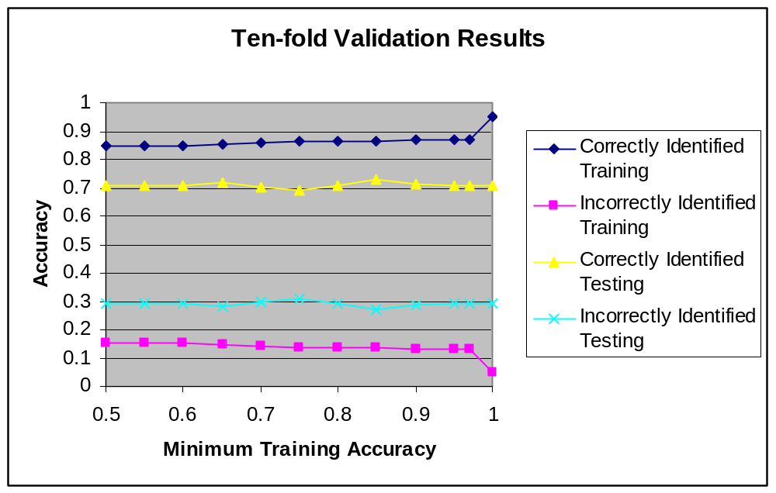

Minimum Training Accuracy | Correctly Identified Training | Incorrectly Identified Training | Correctly Identified Testing | Incorrectly Identified Testing
0.5 | 0.848851749 | 0.151148251 | 0.705829228 | 0.294170772
0.55 | 0.848851749 | 0.151148251 | 0.705829228 | 0.294170772
0.6 | 0.849242374 | 0.150757626 | 0.709162562 | 0.290837438
0.65 | 0.852744355 | 0.147255645 | 0.719162562 | 0.280837438
0.7 | 0.858571905 | 0.141428095 | 0.705238095 | 0.294761905
0.75 | 0.864790069 | 0.135209931 | 0.691321839 | 0.308678161
0.8 | 0.864784013 | 0.135215987 | 0.709417077 | 0.290582923
0.85 | 0.864793062 | 0.135206938 | 0.730599343 | 0.269400657
0.9 | 0.871786419 | 0.128213581 | 0.716190476 | 0.283809524
0.95 | 0.872947702 | 0.127052298 | 0.705599343 | 0.294400657
0.97 | 0.872947702 | 0.127052298 | 0.705599343 | 0.294400657
1 | 0.948707307 | 0.051292693 | 0.705829228 | 0.294170772
Grand Average | 0.868251534 | 0.131748466 | 0.709148194 | 0.290851806

Table: Ten-fold Validation Results

Conclusions and Discussion
Given that this ILP program was slightly less accurate than other known algorithms I wondered if ILP compared favorably to other algorithms in other ways. As mentioned earlier, ILP has the advantage of a model with rules that the user can follow, unlike a neural network. In this respect, ILP is more like a decision tree.

For comparison, I loaded the original .arff file into Weka and generated a decision tree using the J48 algorithm, ten-fold cross validation, and a 45% confidence factor. The resulting tree was 75% accurate. Because both decision trees and ILP generate human-readable models, I wanted to see if there were any interesting comparisons between the tree and the rules generated by Aleph.

node-caps = yes
| deg-malig = 1: recurrence-events (1.01/0.4)
| deg-malig = 2: no-recurrence-events (26.2/8.0)
| deg-malig = 3: recurrence-events (30.4/7.4)
node-caps = no
| inv-nodes = 0-2: no-recurrence-events (203.4/42.6)
| inv-nodes = 3-5
| | breast = left: recurrence-events (3.0)
| | breast = right
| | | tumor-size = 0-4: no-recurrence-events (0.0)
| | | tumor-size = 5-9: no-recurrence-events (0.0)
| | | tumor-size = 10-14: no-recurrence-events (1.0)
| | | tumor-size = 15-19: no-recurrence-events (0.0)
| | | tumor-size = 20-24: no-recurrence-events (4.0/1.0)
| | | tumor-size = 25-29: no-recurrence-events (3.6/1.0)
| | | tumor-size = 30-34: recurrence-events (3.0)
| | | tumor-size = 35-39: no-recurrence-events (0.0)
| | | tumor-size = 40-44: no-recurrence-events (2.0)
| | | tumor-size = 45-49: no-recurrence-events (0.0)
| | | tumor-size = 50-54: no-recurrence-events (0.0)
| | | tumor-size = 55-59: no-recurrence-events (0.0)
| inv-nodes = 6-8: no-recurrence-events (3.0/1.0)
| inv-nodes = 9-11: recurrence-events (3.4/1.6)
| inv-nodes = 12-14: no-recurrence-events (1.0)
| inv-nodes = 15-17: no-recurrence-events (1.0)
| inv-nodes = 18-20: no-recurrence-events (0.0)
| inv-nodes = 21-23: no-recurrence-events (0.0)
| inv-nodes = 24-26: no-recurrence-events (0.0)
| inv-nodes = 27-29: no-recurrence-events (0.0)
| inv-nodes = 30-32: no-recurrence-events (0.0)
| inv-nodes = 33-35: no-recurrence-events (0.0)
| inv-nodes = 36-39: no-recurrence-events (0.0)
Figure: J48 Decision tree generated with Weka Explorer

The top choices in the decision tree, node-caps and deg-malig, appear as Rule 4 (with left_breast) in the sample Aleph theory listed earlier. This illustrates how, as a model, the ILP theory is a more compact representation. For example, rules do not have to be defined for all of the tumor-size values that are not associated with any positive examples, as are branches in the tree above. The ILP rules can be viewed as shortcuts into the conclusions drawn by the decision tree. Additionally, they do not impose a hierarchy on rule importance as the decision tree would. This would be important in the case of missing data. If “node-caps” were a missing attribute in a query, the usefulness of a decision tree with that attribute at its root would be compromised.

It remains to be known what factors caused the slightly lower accuracy of the ILP theory in classifying this data set. What tuning parameters exist that are analogous to the degree of pruning on a decision tree or the number of nodes and layers in a neural network? Are there different types of data for which ILP is more accurate than other machine learning algorithms? Natural next steps would be to apply the algorithm to known data sets with quantifiably different characteristics, and to observe the effects of the tuning parameters available in Aleph on these sets.

References
Bratko, I., & Muggleton, S. (1995). Applications of inductive logic programming. Communications of the ACM, 38(11), 65-70.

Džeroski, S., & Lavrač, N. (2001). Relational data mining. Springer: Heidelberg.

Kononenko, I., Bratko, I., & Kukar, M. (1997). Application of machine learning to medical diagnosis. In Michalski R.S., I. Bratko & M. Kubat (Eds.), Machine learning, data mining and knowledge discovery: Methods and applications. John Wiley & Sons.

Lavrač, N., & Džeroski, S. (1994). Inductive logic programming: Techniques and applications. New York: Ellis Horwood.

Muggleton, S. (1994). Inductive logic programming: Derivations, successes and shortcomings. SIGART Bull., 5(1), 5-11.

Muggleton, S. (1995). Inverse entailment and progol. New Generation Computing, 13(3&4), 245-286.

Muggleton, S., & Raedt, L. D. (1994). Inductive logic programming: Theory and methods. J.Log.Program., 19/20, 629-679.

Page, D., & Srinivasan, A. (2003). Ilp: A short look back and a longer look forward. J.Mach.Learn.Res., 4, 415-430.

Plotkin, G. D. (1970). A note on inductive generalization. Machine Intelligence, 5, 153-163.

Zwitter, M., & Soklic, M. (1988). Breast cancer data set. Institute of Oncology, University Medical Center, Ljubljana, Yugoslavia. <http://archive.ics.uci.edu/ml/datasets/Breast+Cancer>

