**Andrico Mauludi Junianto**

**081811633052**

**Pembangunan Perangkat Lunak**

1. **Usecase Diagram**

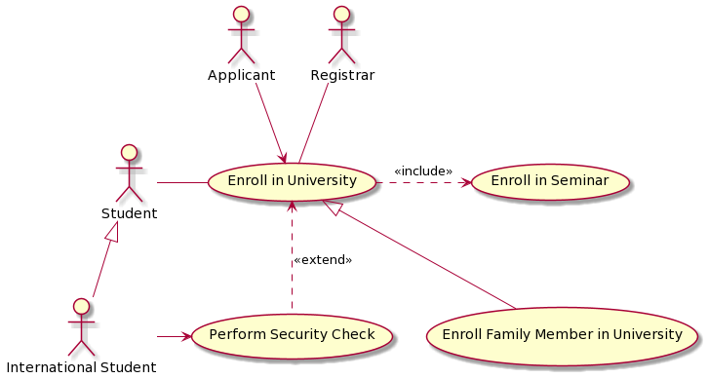



**PlantUML Script**

@startuml

actor Applicant as ap

actor Registrar as rg

actor Student as st

actor "International Student" as in

Usecase "Enroll in University" as UC1

Usecase "Enroll in Seminar" as UC2

Usecase "Perform Security Check" as UC3

Usecase "Enroll Family Member in University" as UC4

UC1 <-up- ap

UC1 -up- rg

st -right- UC1

in -right-> UC3

UC1 .right.> UC2 : <<include>>

UC3 .up.> UC1 : <<extend>>

UC4 -up-|> UC1

in -up-|> st

@enduml

1. **Sequence Diagram**

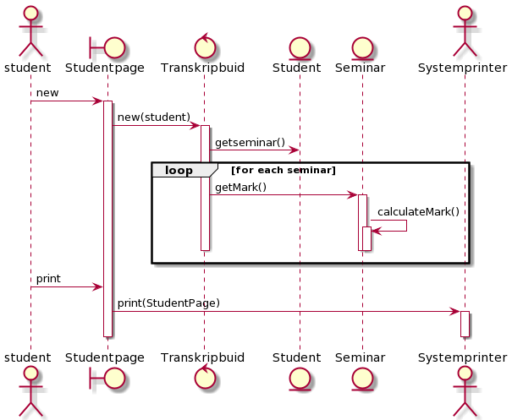



**PlantUML Script :**

@startuml

actor student as Foo1

boundary Studentpage as Foo2

control Transkripbuid as Foo3

entity Student as Foo4

entity Seminar as Foo5

actor Systemprinter as Foo6

Foo1 -> Foo2 : new

activate Foo2

Foo2 -> Foo3 : new(student)

activate Foo3

Foo3 -> Foo4 : getseminar()

loop for each seminar

Foo3 -> Foo5: getMark()

activate Foo5

Foo5 -> Foo5 : calculateMark()

activate Foo5

deactivate Foo5

deactivate Foo5

deactivate Foo3

end

Foo1 -> Foo2 : print

Foo2 -> Foo6 : print(StudentPage)

activate Foo6

deactivate Foo6

deactivate Foo2

@enduml

1. **Class Diagram**

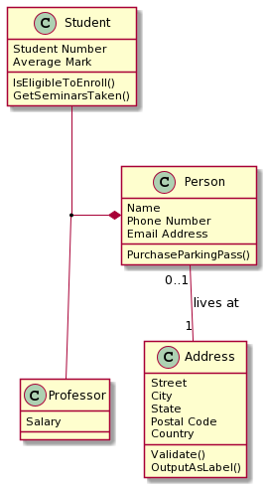



**PlantUML Script:**

@startuml

class Person{

Name

Phone Number

Email Address

PurchaseParkingPass()

}

class Address{

Street

City

State

Postal Code

Country

Validate()

OutputAsLabel()

}

class Professor{

Salary

}

class Student{

Student Number

Average Mark

IsEligibleToEnroll()

GetSeminarsTaken()

}

Person "0..1" - - "1" Address : lives at

(Student, Professor) -up-* Person

@enduml