**Google hangouts chat is only available to paid G Suite custommers.**

Access website below:

<https://console.developers.google.com/projectselector2/apis/dashboard?authuser=2&supportedpurview=project>

Create a new project (maybe omitted this step if the project already exists)

Click select a project

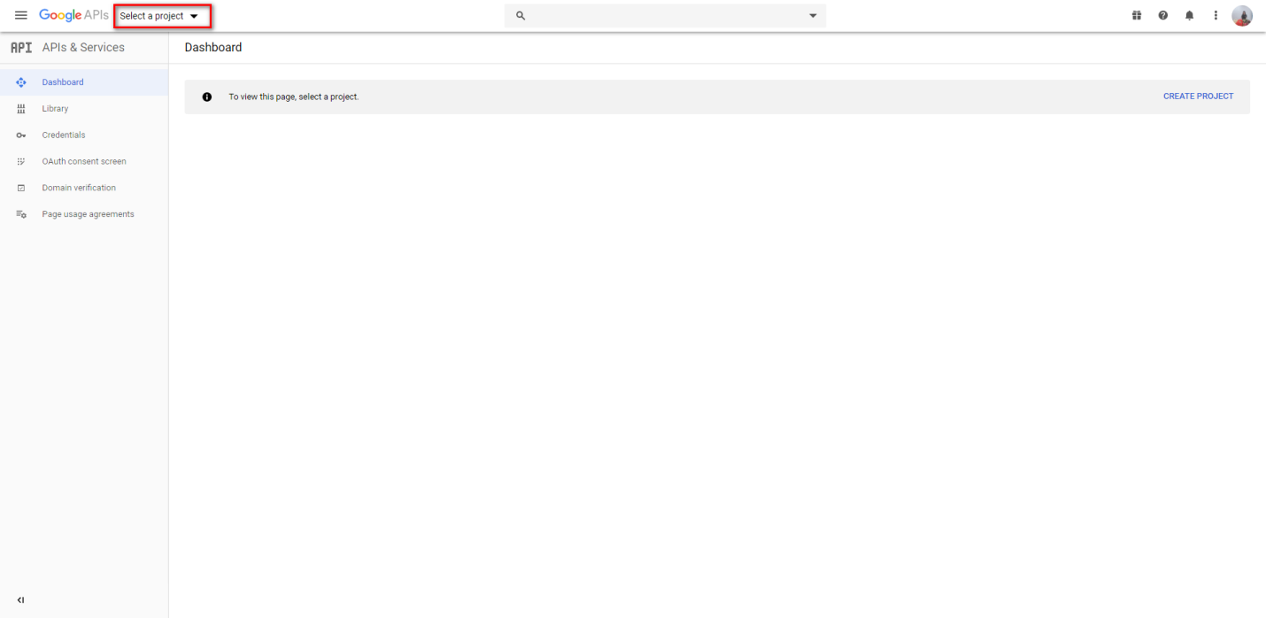

Click new project to create new project

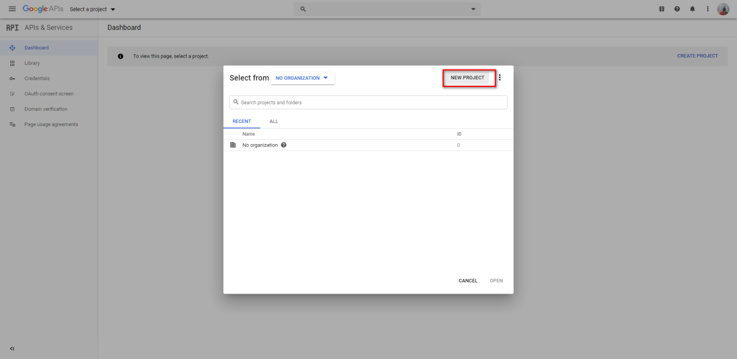

Fill the name, organization, location. After that, click Create to create a new project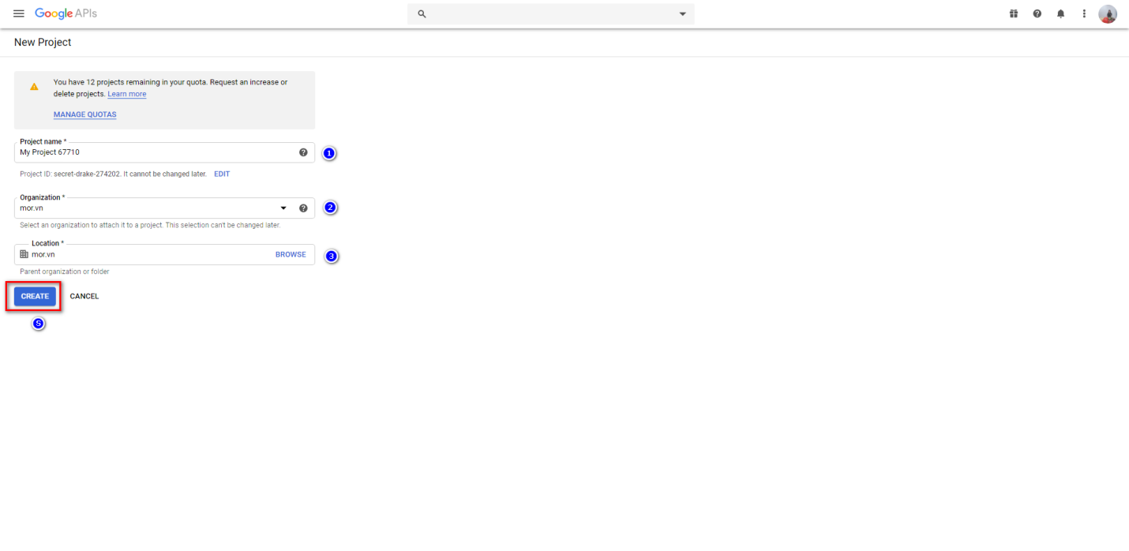

After creating a new project successfully, the project will create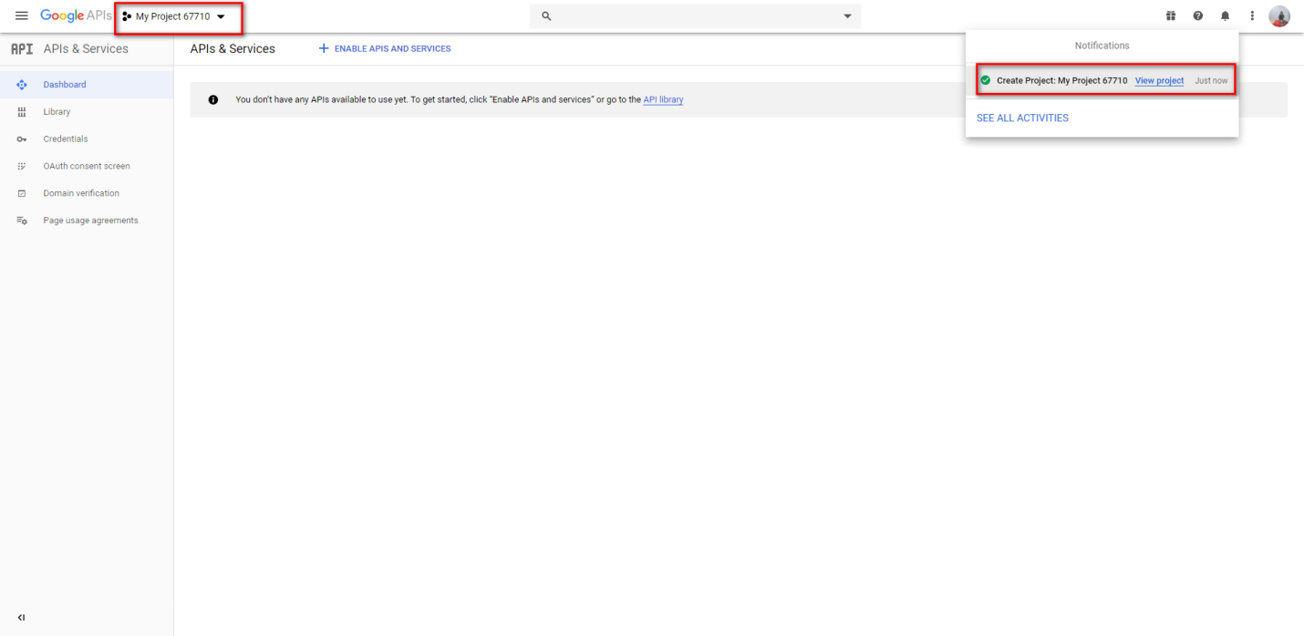

Enable Hangouts chat API

Click button Enable APIs and Services

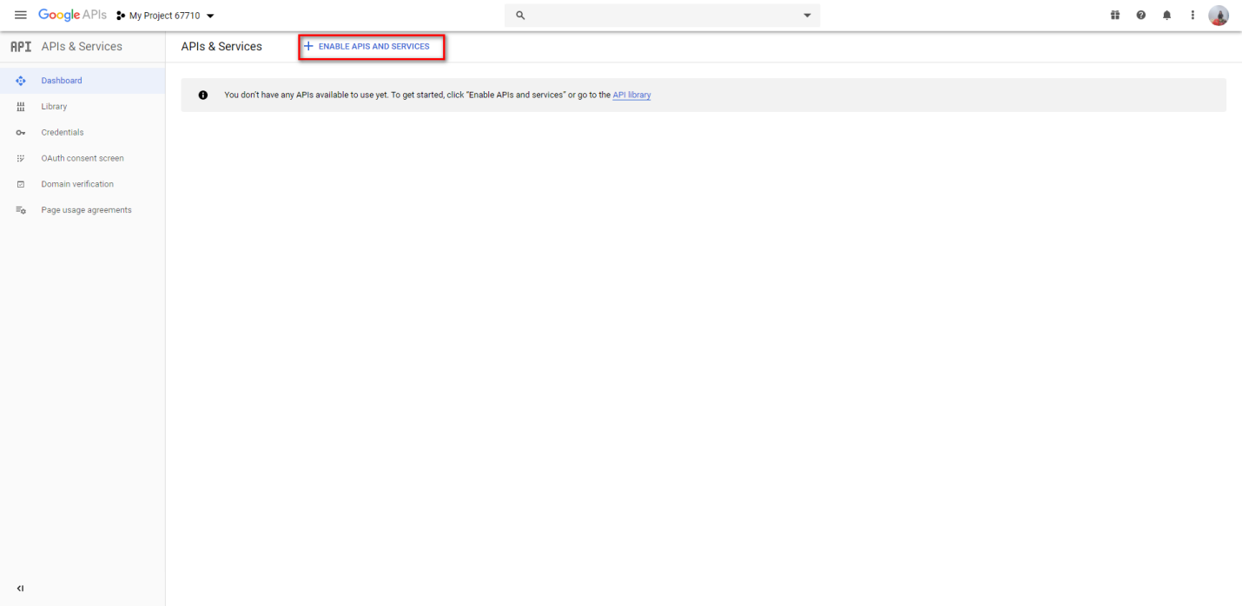

Search with key words “hangout chat”. After that, choose Hangouts Chat API

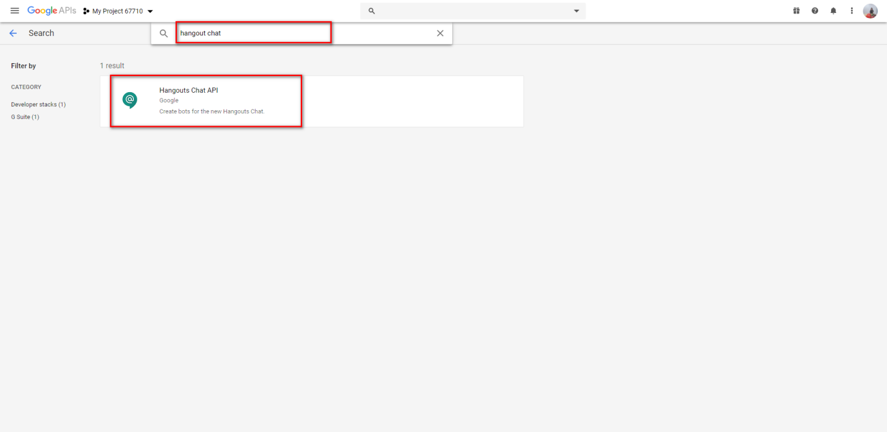

Click Enable to enable Hangouts Chat API

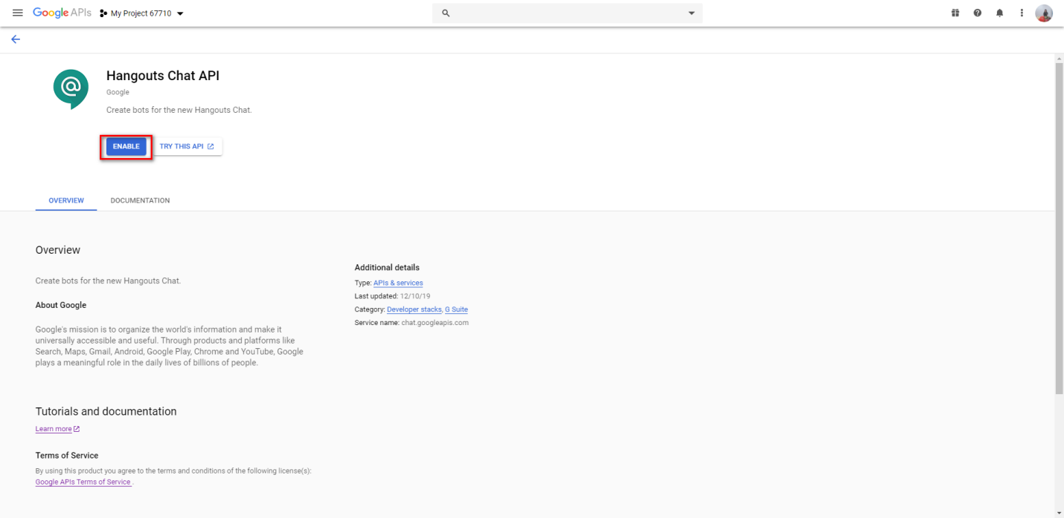

After enable successfully, this screen will display as below picture

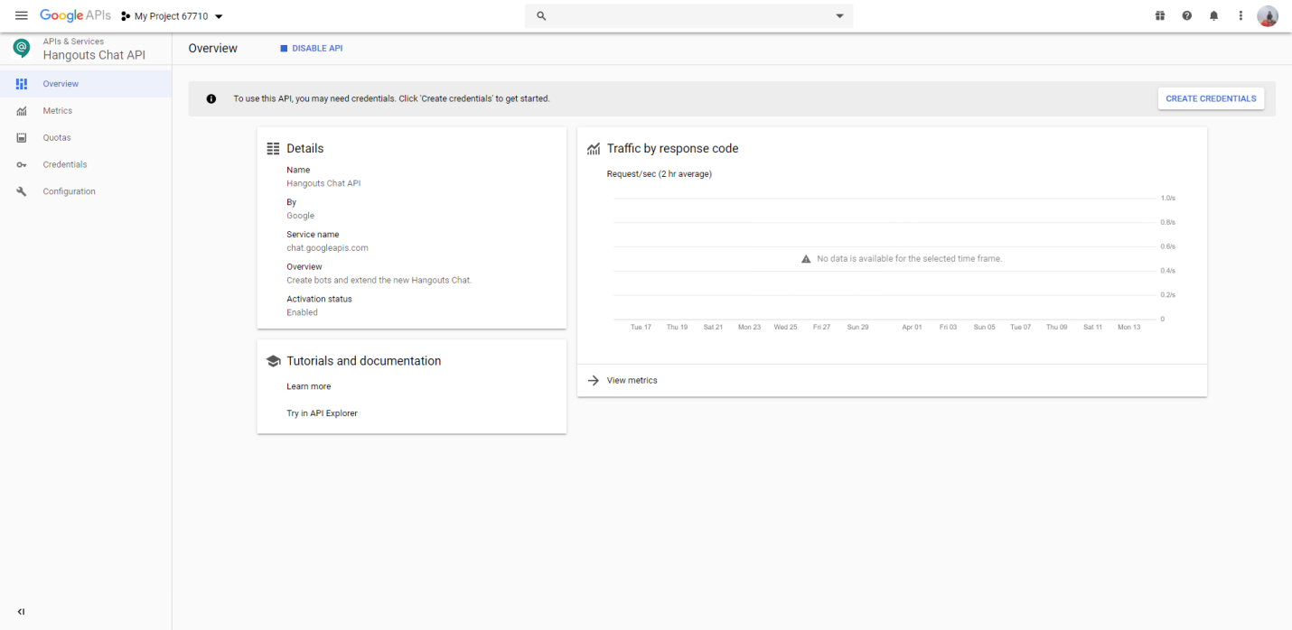

Create Service Account

Click Credentials in side bar

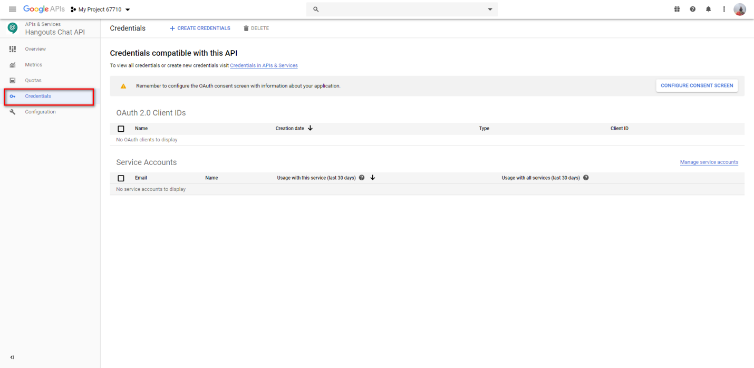

Click button create credentials. After that, choose Service account

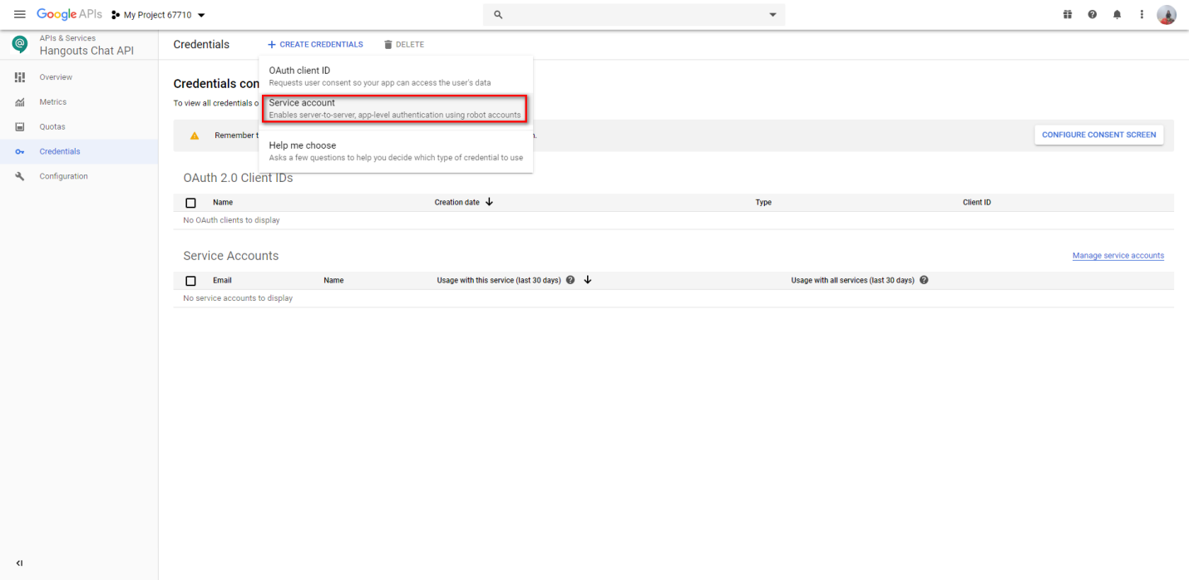

Fill name service in Service account name. After that, click button create to continue

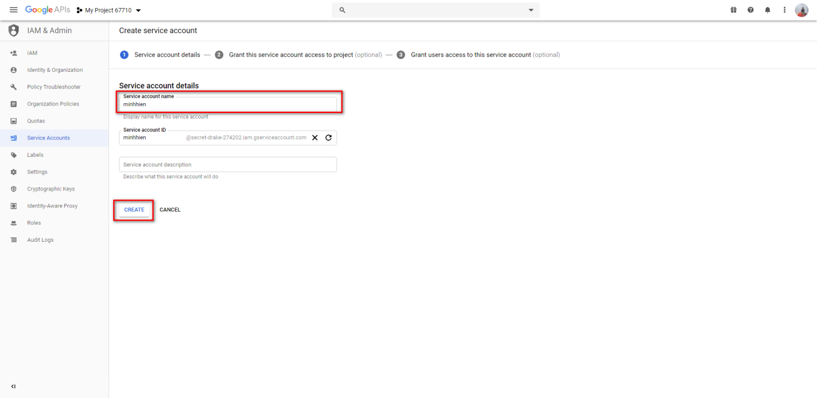

Choose role Owner to provide full access to all resources. After that, click continue to continue

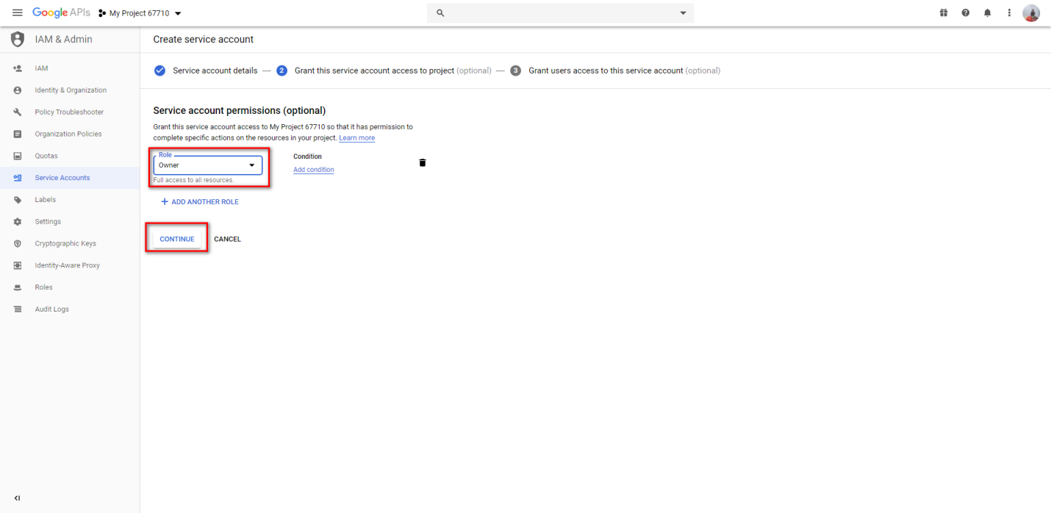

Click button done to complete

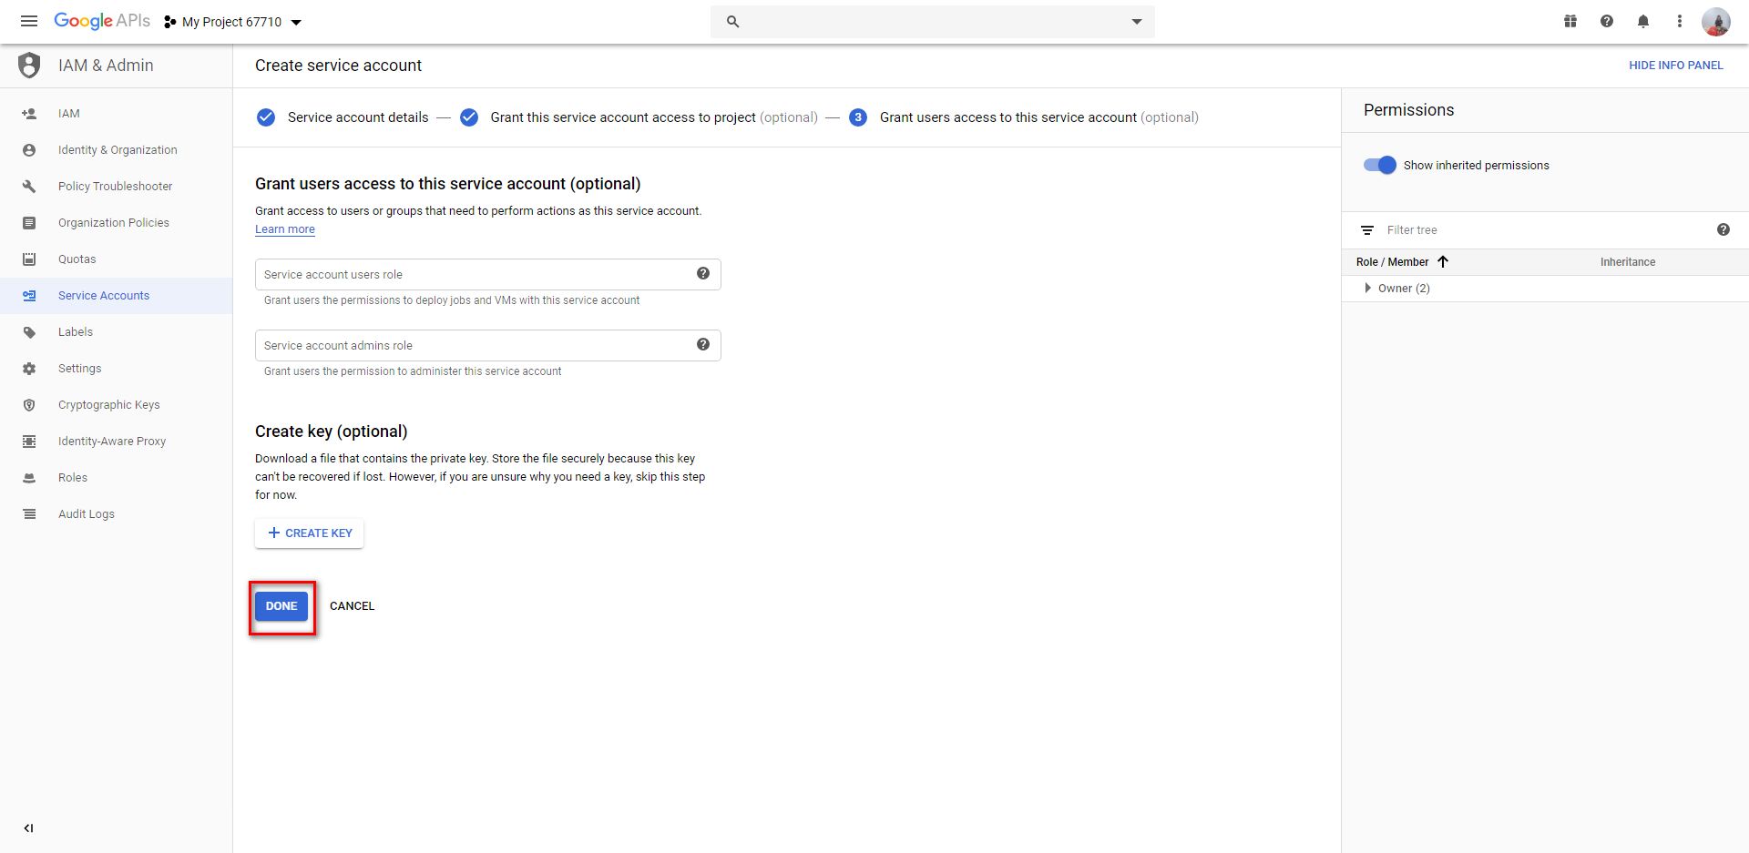

Create key

Choose service account that you have just created

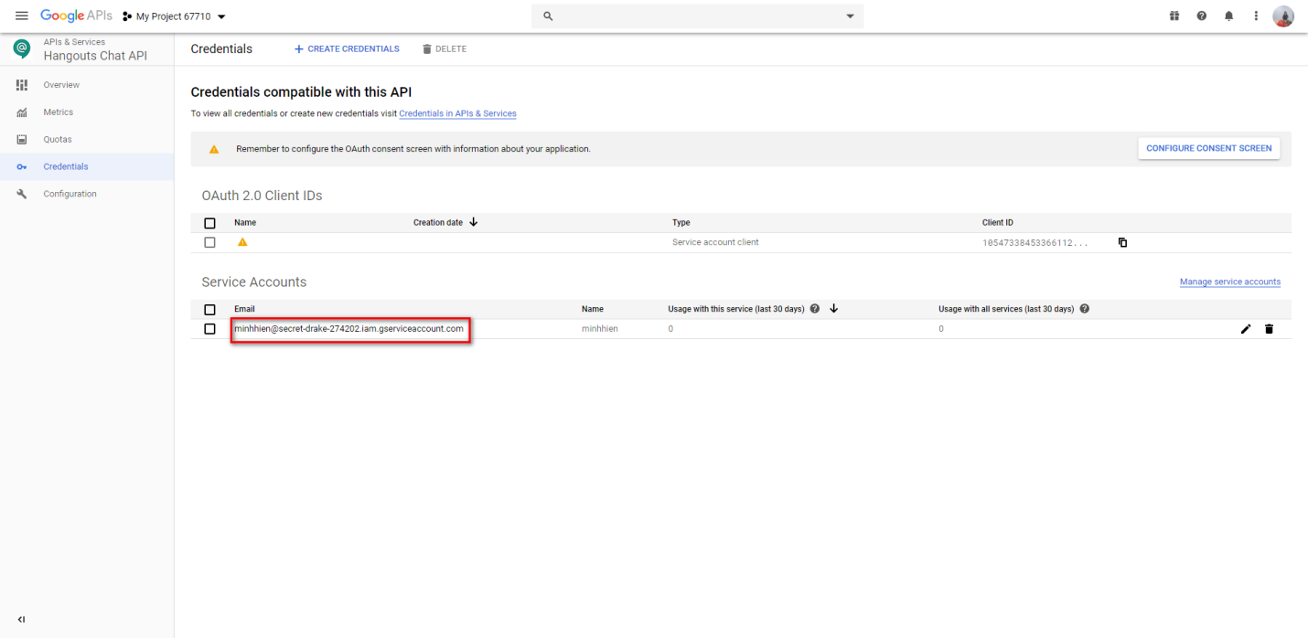

Click button create key

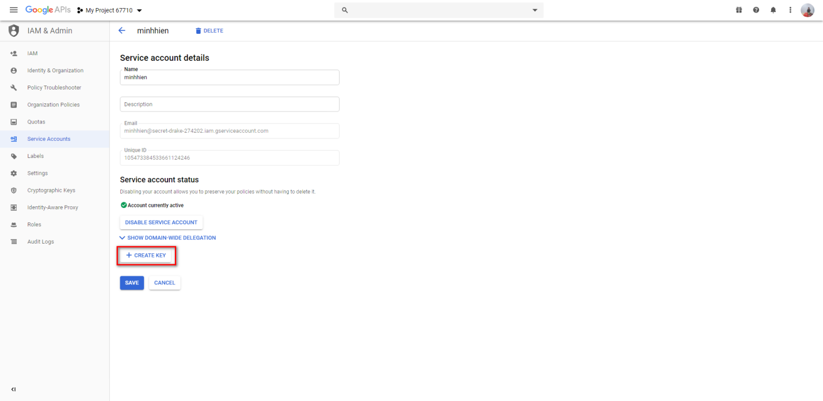

Choose JSON and click button create to download key to local PC

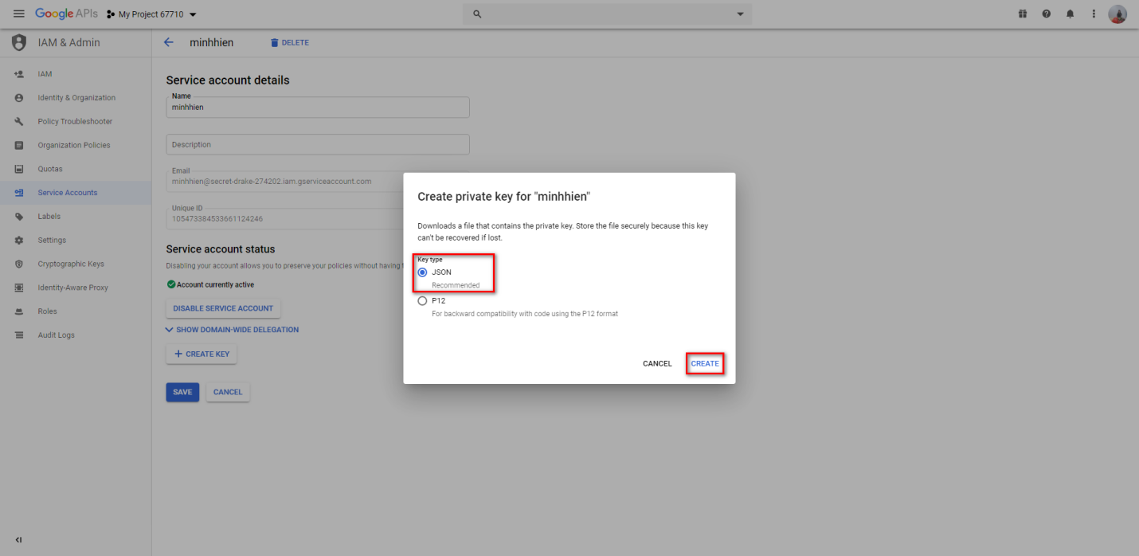

After your key has downloaded successfully, click close to back service account details

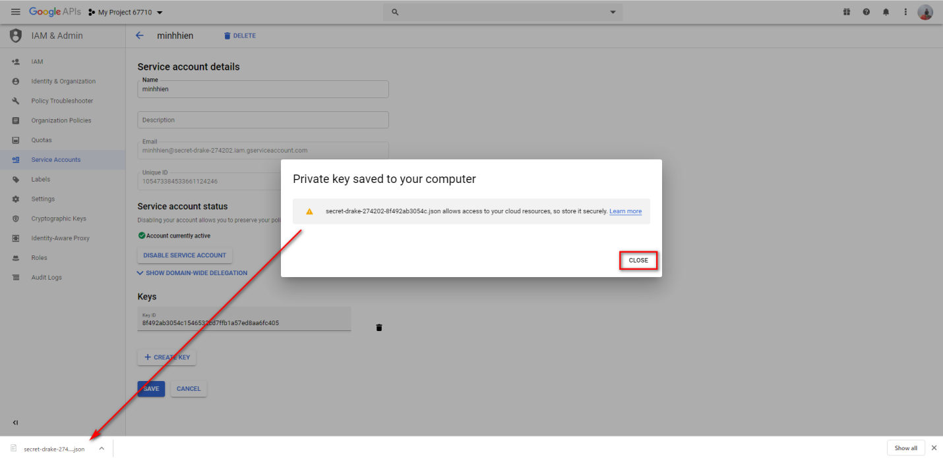

Click button save to complete

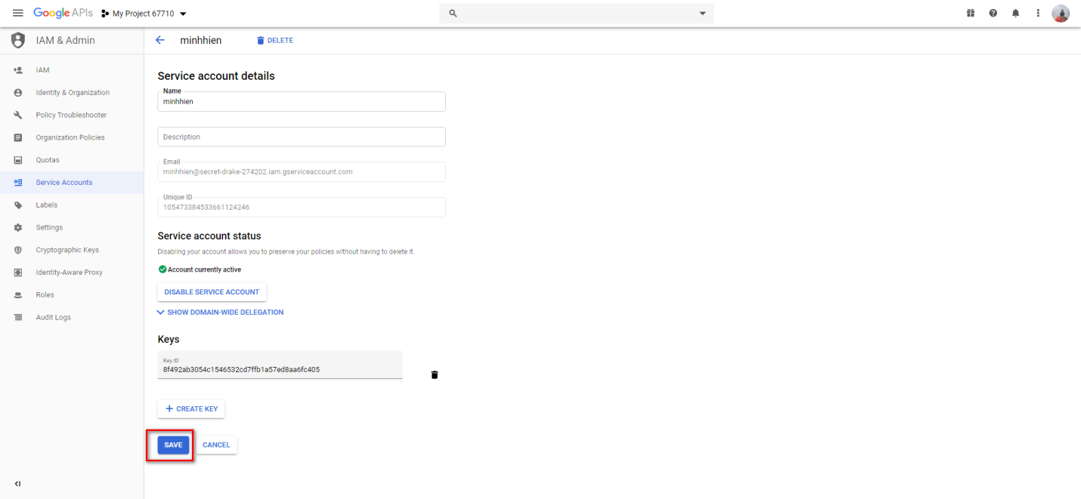

Configure bot

Search hangout and choose hangouts chat API

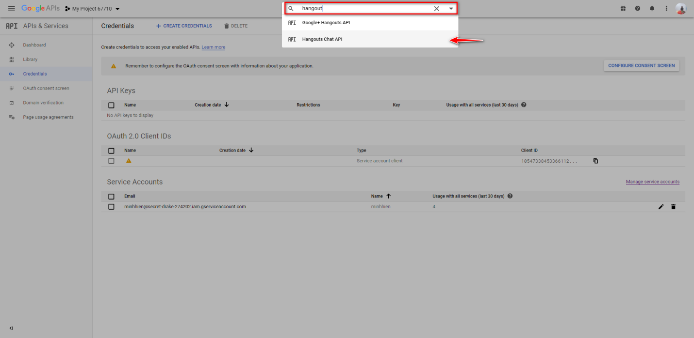

Click Configuration in side bar

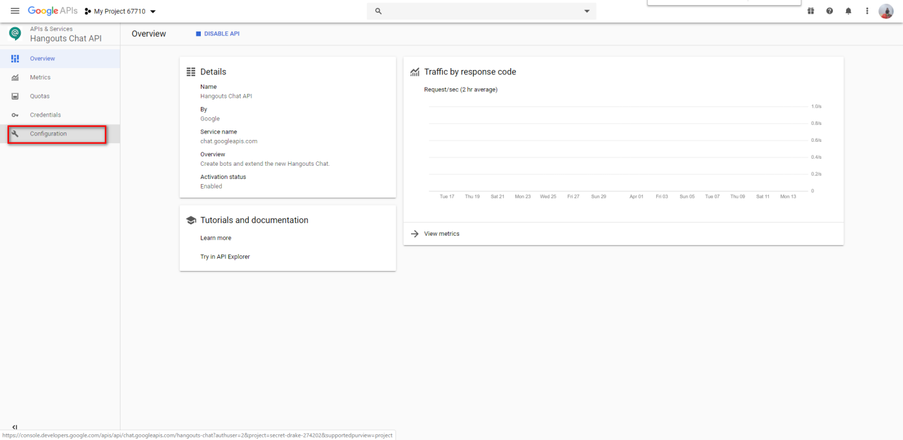

Fill information bot from 1 -> 7 and click save to complete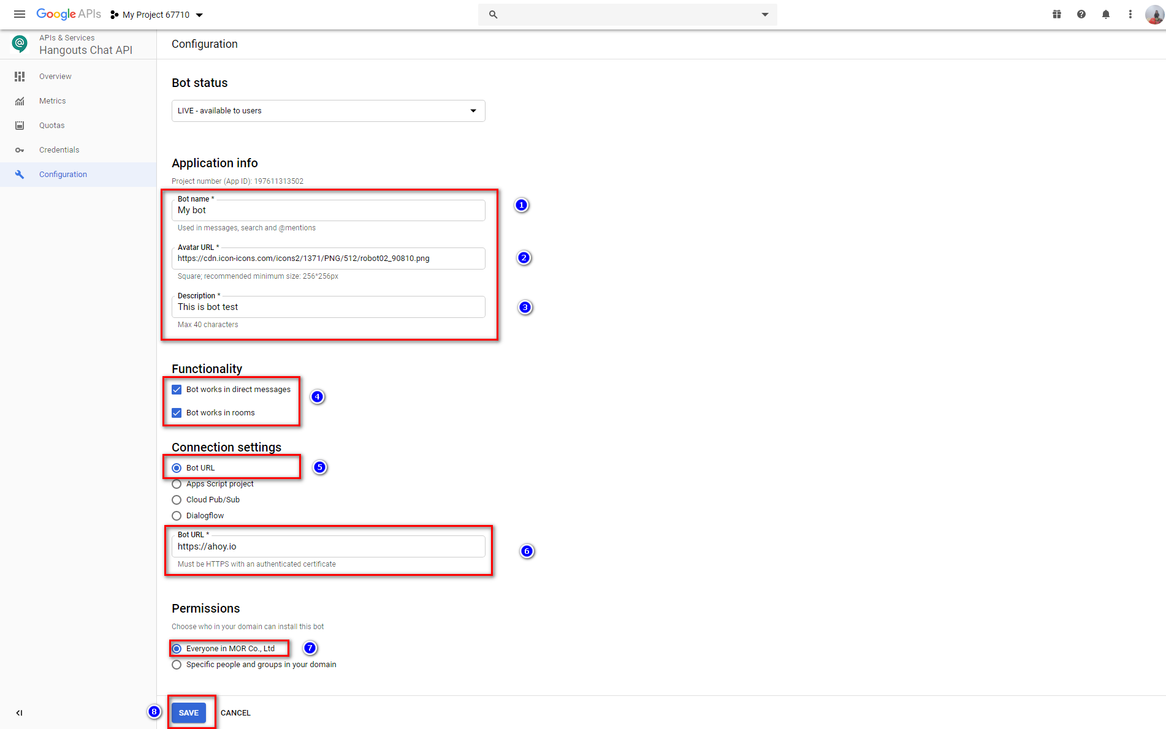

1. Name bot: optional. Example “My bot”
2. Avatar Url: optional. Example “<https://cdn.icon-icons.com/icons2/1371/PNG/512/robot02_90810.png>”
3. Description: optional. Example: “This is bot test”
4. Functionality: Choose the place that bot works. In this case, choose both
5. Connection settings: Choose “Bot URL” to add bot by link Bot URL
6. Bot URL: get link bot in link <https://chat.google.com/u/2/botcatalog/category/4>. In this case, choose [https://ahoy.io](https://ahoy.io/en/privacy-policy.html" \t "https://chat.google.com/u/2/botcatalog/details/_blank)
7. Permissions: choose user that can use this bot. In this case, choose Everyone in Company
8. Click button Save to complete

Create new bot

Access chat google to link <https://chat.google.com/>.

In side bar, click icon plus

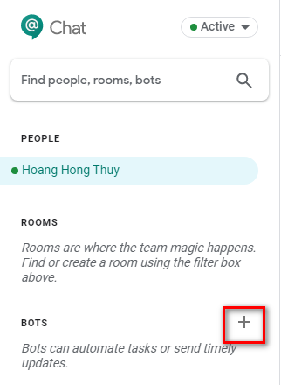

Choose bot that you have just created before

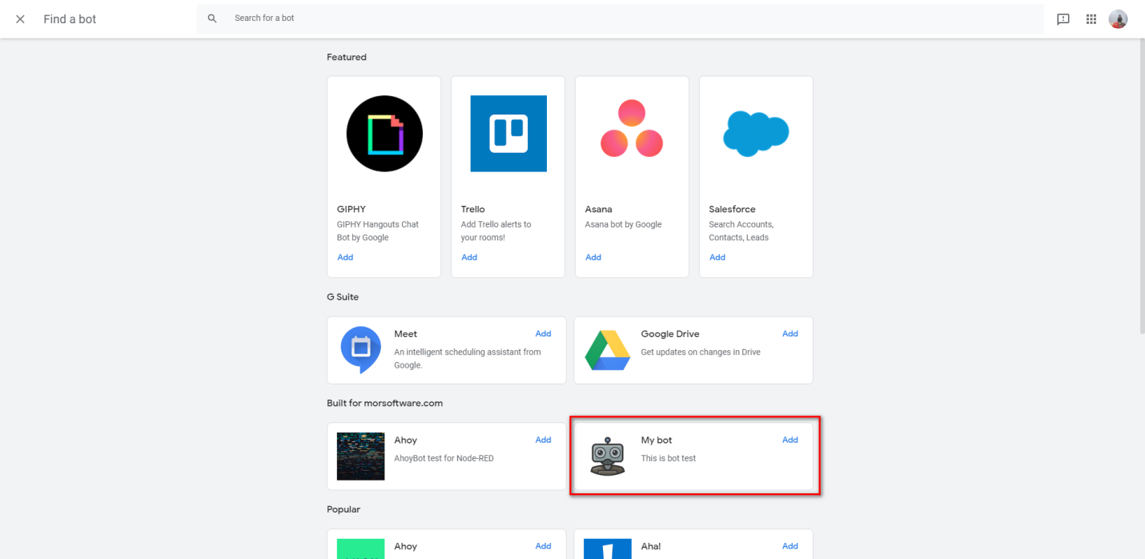

Choose number 1 (message) or number 2 (add to room)

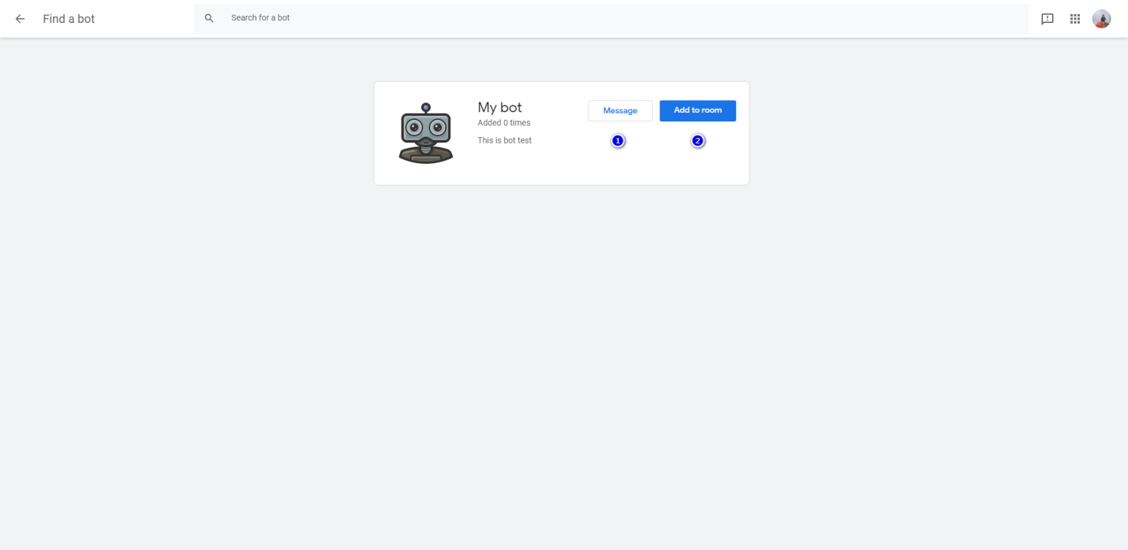

After choose message, bot will display as below picture

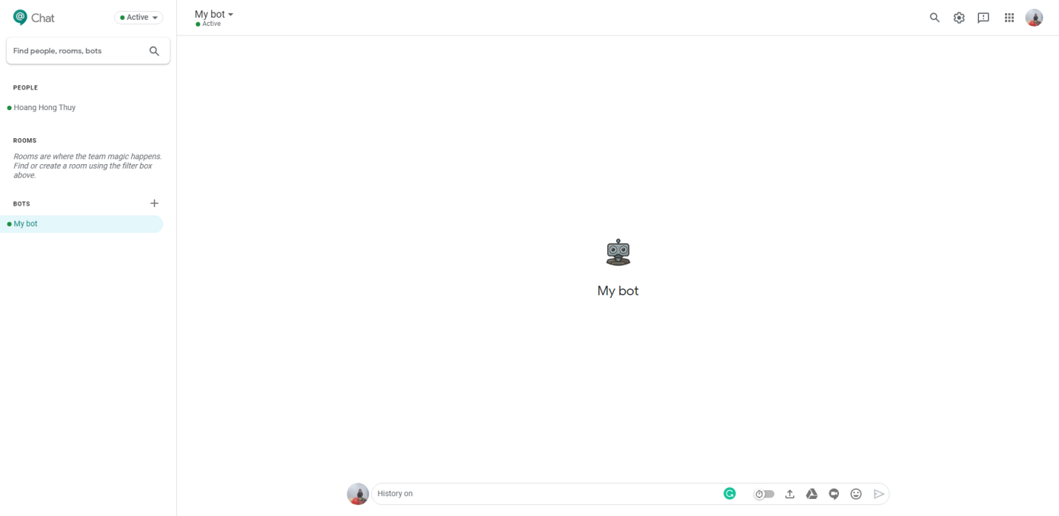



Copy room Id in url: jJ5RegAAAAE

Install node

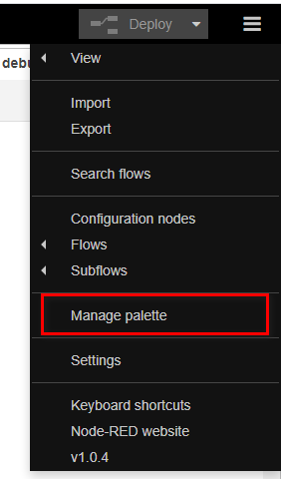

Choose install tab. After that, search with key word “hangout” and click button install node-red-contrib-hangouts-chat-sensor

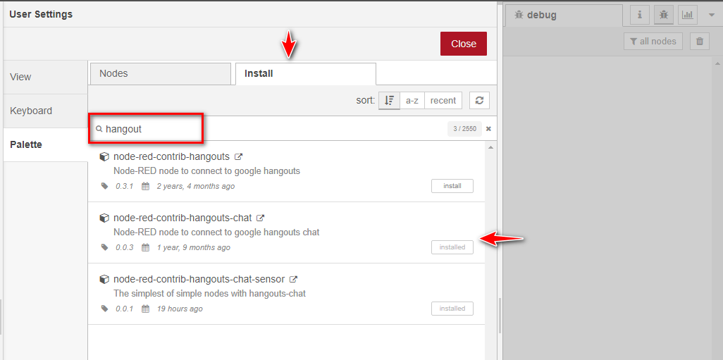

Drag node inject, function, debug and hangouts chat to your flow

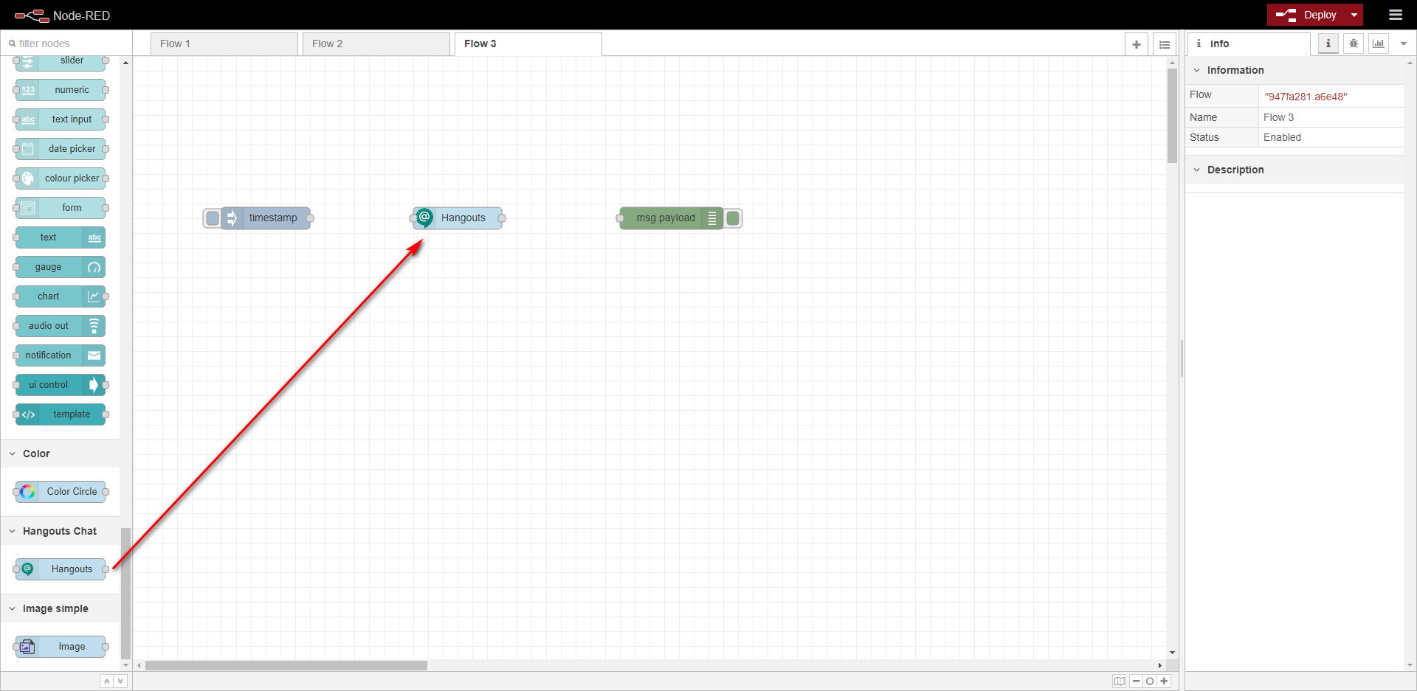

Wire node and click to deploy

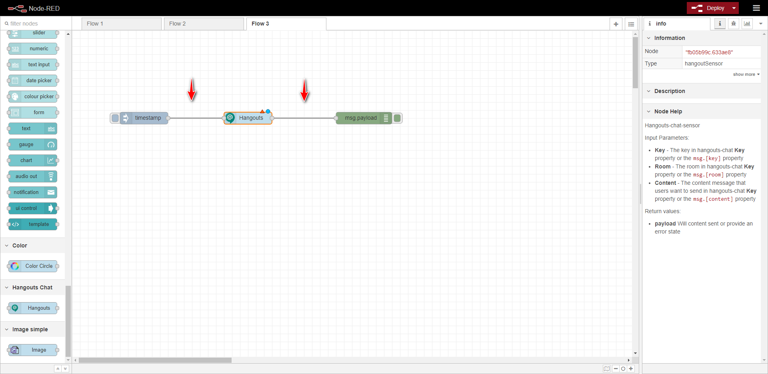

Using node

Click node hangouts to edit hangouts node. After that, click icon edit to add new hangouts Certificate

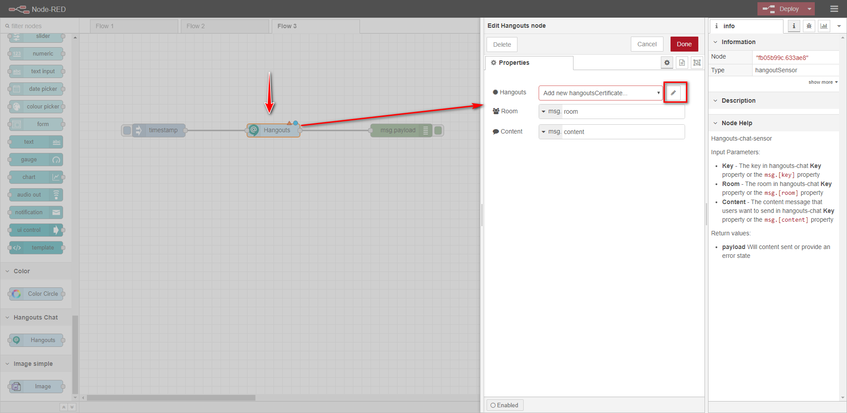

Input client Email and private key from the file downloaded in part “create key”. After that, click button add to save the certificate

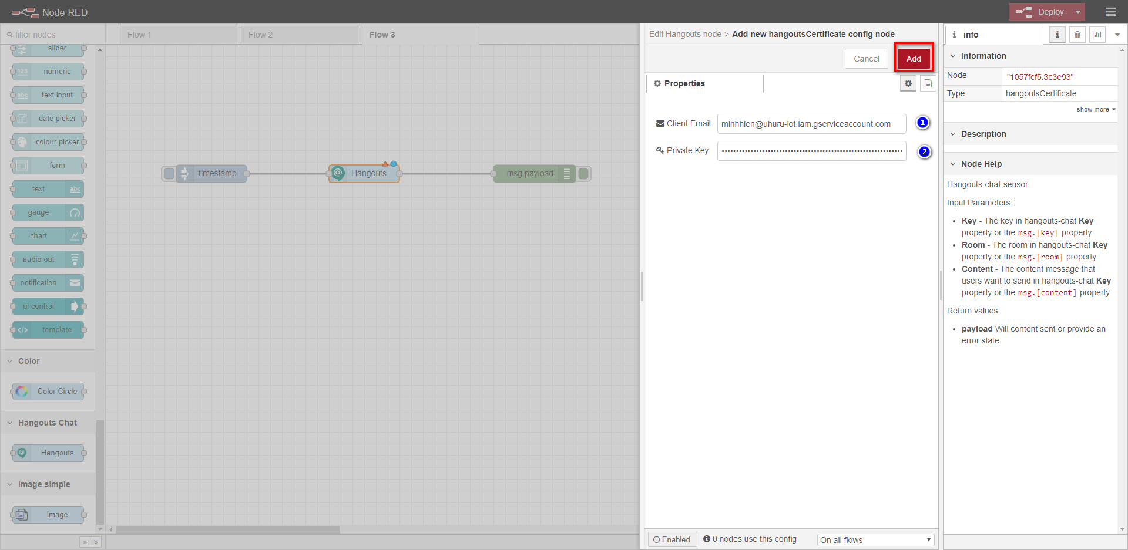

In room, choose the string and input the room Id from the “Create new bot”

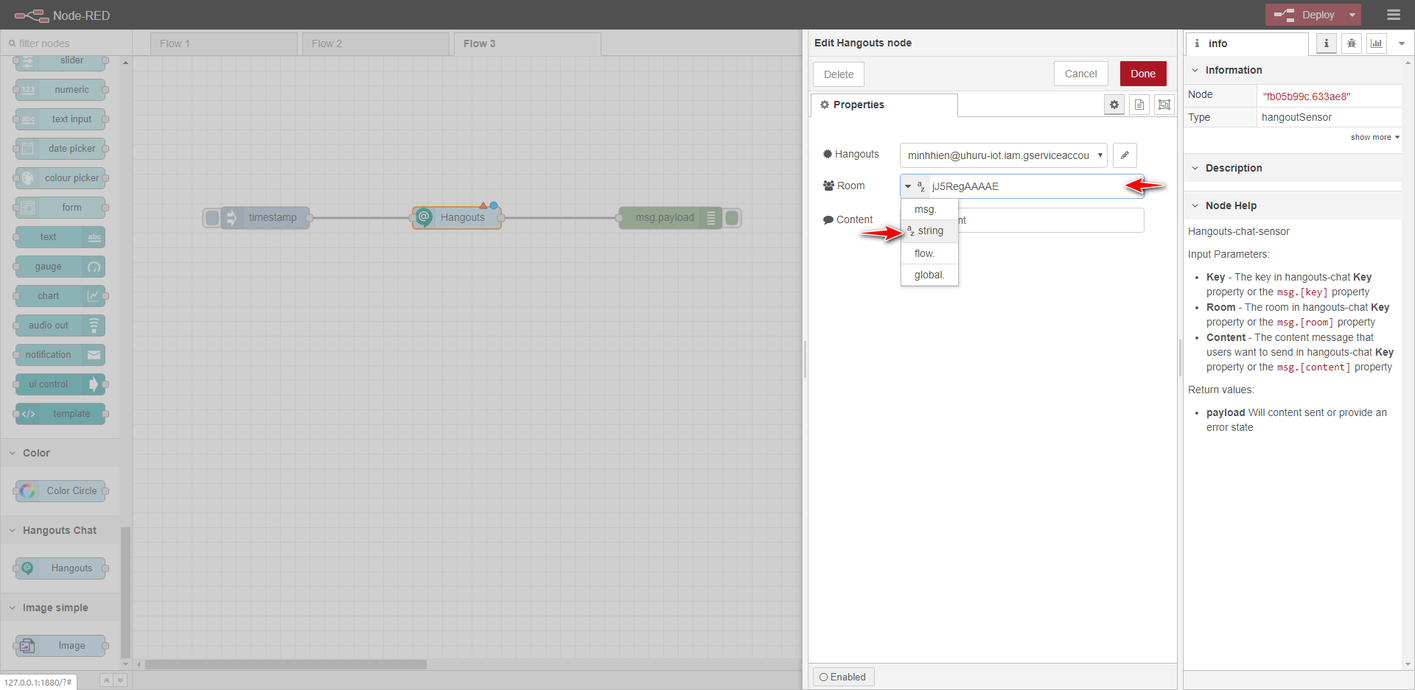

In content, choose the string and input the content that you want send to your bot and click Done to save

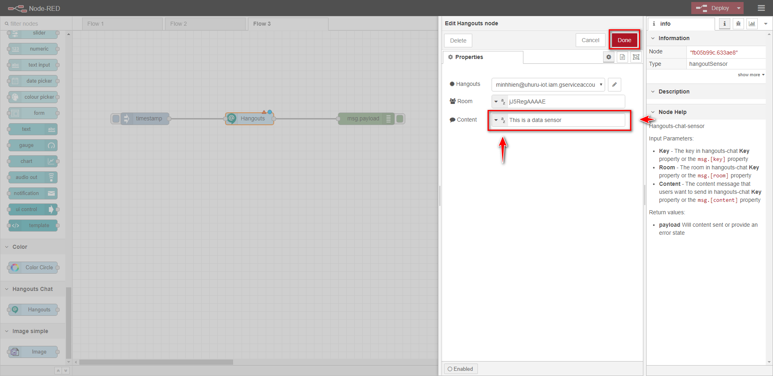

Run this node

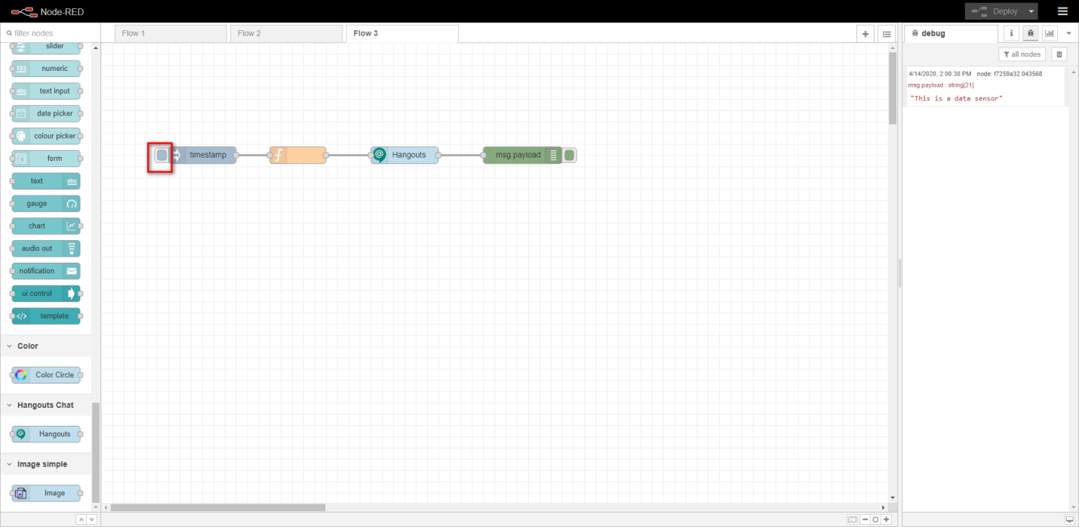

In chat, display message successfully

