This is a cloth segmentation demo page. The idea is to segment different types of cloth.

The model receives images with a person and gives segmented cloth on the image.

You can upload your own image and see how it works.

**USER GUIDE**

**STEP 1:** Go to [demo page](http://3.66.131.245:8000/)

**STEP 2:** Select photo (jpg, JPG, jpeg, JPEG, png, PNG formats)

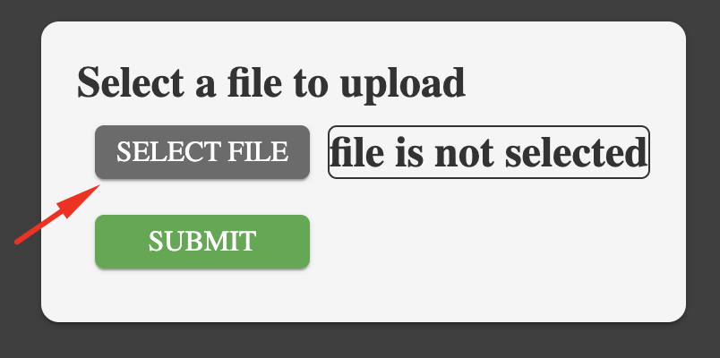

**STEP 3:** Press submit button

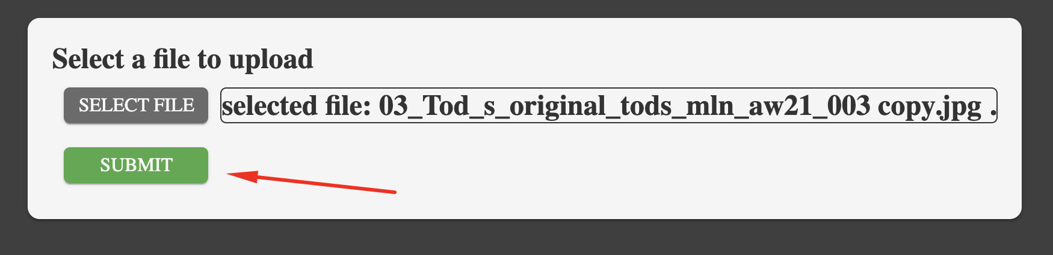

**STEP 4:** Wait for result

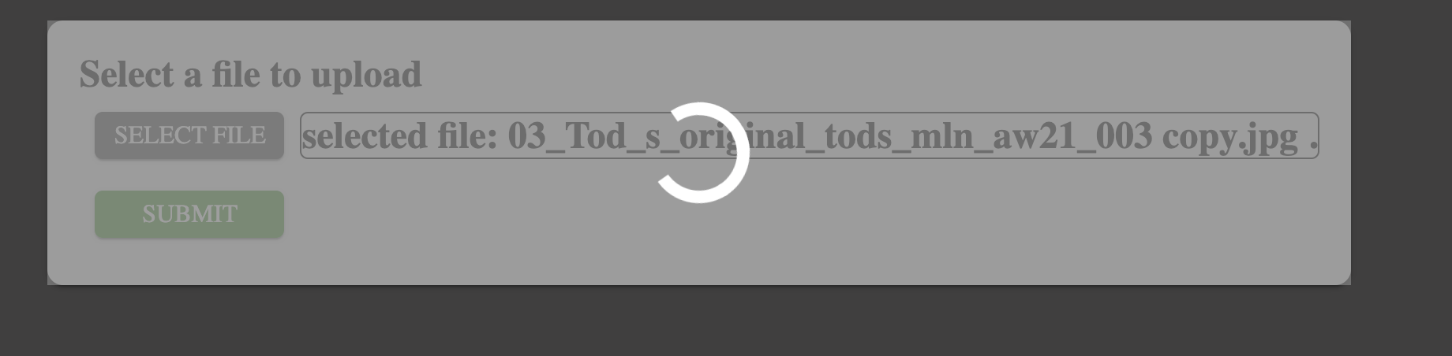

**STEP 5:** Check the result

