|  |
| --- |
| MINISTRY OF EDUCATION AND SCIENCE OF UKRAINE  NATIONAL TECHNICAL UNIVERSITY  “KHARKIV POLYTECHNIC INSTITUTE”  Department of Software Engineering and Intelligent Management Technology  COURSE WORK  in the discipline “________________________________________”  Supervisor:  ____________ of SEMIT Dept. ________________  Performer:  student of the group KN-____ ________________  Kharkiv – 20____ |

National Technical University

“Kharkiv Polytechnic Institute”

Department of “Software Engineering and Management Intelligent Technology”

Student ________________ Group КN-____ Course ____

Task

for a course work

Topic: “________________________________________________________”

Summary of the work:

a) ________________________________________________________

b) ________________________________________________________

c) ________________________________________________________

Task issued ____ ________ 20____

Student (course work author) / ________________ /

Term of defense of the course work ____ ________ 20____

Course work supervisor / ________________ /

**CONTENT**

ABBREVIATIONS 4

INTRODUCTION 5

1 ANALYSIS OF THE SUBJECT DOMAIN 6

1.1 The system of business rules 6

1.2 Modeling of the subject area 7

1.3 Problem statement 8

2 DATABASE DESIGN AND DEVELOPMENT 10

2.1 Development of logical and physical data models 10

2.2 Description of the database structure 11

2.3 Implementation of the database in the MySQL DBMS 11

2.4 Filling the database with initial records 13

2.5 Creating database queries 17

3 DESIGN AND DEVELOPMENT OF THE DATABASE APPLICATION 20

3.1 Database application design 20

3.2 Database application usage example 21

CONCLUSIONS 23

REFERENCES 24

# ABBREVIATIONS

DB – database.

DBMS – database management system.

DDL – Data Definition Language.

ER – Entity-Relationship.

SQL – Structured Query Language.

# INTRODUCTION

Some companies buy goods from different suppliers (both legal entities and individuals). The purchase of goods is carried out in batches and is executed in the form of supply contracts. Each contract for the supply of goods has a unique number and can be concluded with only one supplier. The documents for each contract for each product indicate: name, size of the delivered lot and price (in UAH).

To store and process such information, it is necessary to develop a database (DB), which will take into account the specifics of considered business rules.

The object of work – the process of supplying products that are performed in a commercial enterprise.

The subject of the work is a database that will allow storing and processing information on the supply of products in a commercial enterprise.

The purpose of the work is to increase the productivity of storage and processing of information on the supply of products through the development of an appropriate database.

# 1 ANALYSIS OF THE SUBJECT DOMAIN

## 1.1 The system of business rules

As a result of research and analysis of the subject area, the following system of business rules was formed.

The facts include the following business rules.

1 Each supplier of goods is characterized by the name and address of the location. A code is used to uniquely identify each vendor.

2 Supplied goods belong to different product groups. Each product group is characterized by a code and name. A code is used to uniquely identify each product group.

3 Each product is characterized by a code and name. A code is used to uniquely identify each product. Each product must belong to a specific product group.

4 Each delivery of goods is carried out on the basis of a contract concluded with a specific supplier. The number of each contract is unique. Also for each contract the date of the conclusion of the contract is known.

5 Any quantity of any goods can be delivered under each contract. The same goods under one contract cannot be delivered more than once.

Restrictions include the following business rules.

6 The supplier as a business entity may be either a legal entity or an individual.

7 For suppliers - legal entities, the VAT payer's certificate number and individual tax number cannot be repeated.

8Each supply contract is concluded with a specific supplier. Lack of supplier information is not allowed.

9 The date of concluding the contract must be indicated. If no date is specified, the current date must be used.

10 The quantity of delivered products is always indicated. It cannot be zero or negative.

11 The price of the delivered products is always indicated. It cannot be zero or negative.

The activators of operations include the following business rules.

12 When adding data about the supplier - legal entity, you need to check whether the data about him as an individual have already been entered. If so, adding data is prohibited.

13 When adding data about the supplier - an individual, you need to check whether the data about him as a legal entity have already been entered. If so, adding data is prohibited.

The conclusions include the following business rules.

14 If the payment is not received within 30 calendar days from the date of sending the invoice, the invoice is considered overdue.

15 If the supplier is unable to deliver the ordered goods within five days of receipt of the order, the order is considered unfulfilled.

## 1.2 Modeling of the subject area

The model of the subject area in the notation ER (Entity-Relationship, entity-connection) is shown in Figure 1.1.



Figure 1.1 – ER-model of the subject area

## 1.3 Problem statement

To achieve the goal of the work it is necessary to perform the following tasks:

1 Develop a logical model of the database.

2 Develop a physical database model.

3 Describe the structure of the database.

4 Implement the database in the MySQL database management system (DBMS) using DDL (Data Definition Language) commands.

5 Fill the database with initial records and develop queries in SQL (Structured Query Language).

6 Develop the database application.

7 Demonstrate the usage example of the database application.

# 2 DATABASE DESIGN AND DEVELOPMENT

## 2.1 Development of logical and physical data models

The logical data model in the IDEF1X notation is shown in Figure 2.1.

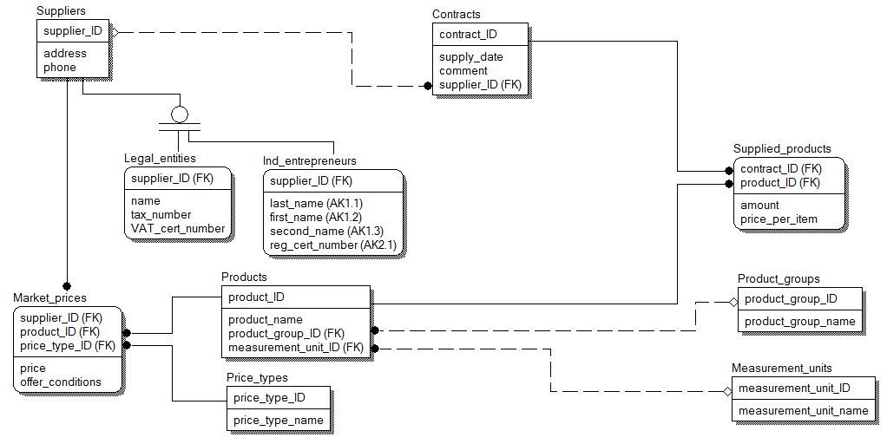

Figure 2.1 – Logical data model

The physical data model in the IDEF1X notation is shown in Figure 2.2.

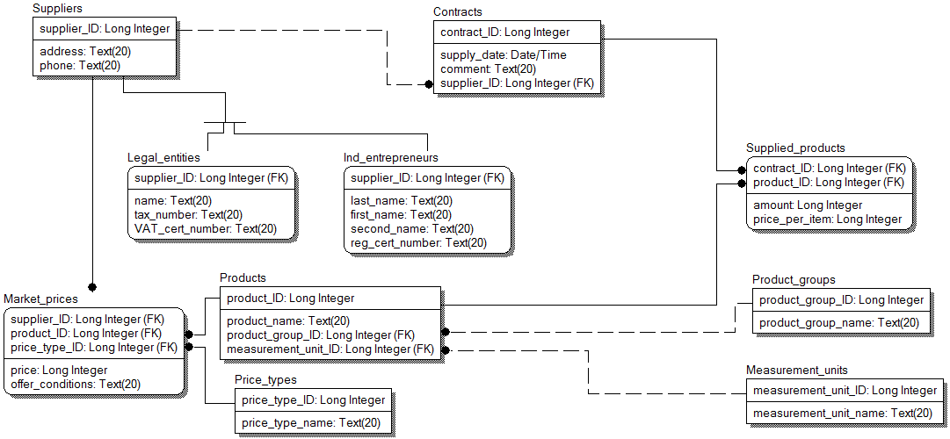

Figure 2.2 – Physical data model

## 2.2 Description of the database structure

The "Contracts" table is intended for storing information on product supply contracts. Each record of the table consists of the following fields, the description of which is given in table 2.1.

Table 2.1 – Description of the structure of the table "Contracts"

| Key | Field name | Data type | Field size | Description |
| --- | --- | --- | --- | --- |
| PC | contract_ID | Numerical | Whole | contract number |
|  | supply_date | Date / time | Short date format | delivery date under the contract |
| FK | supplier_ID | Numerical | Whole | supplier code |
|  | comment | Textual |  | note |

The table "Supplied_products" is intended for storage of the information on production which is delivered on the basis of contracts for delivery of production. Each record of the table consists of the following fields, the description of which is given in table 2.2.

Table 2.2 – Description of the structure of the table "Supplied_products"

| Key | | Field name | Data type | Field size | Description |
| --- | --- | --- | --- | --- | --- |
| PC | FK | contract_ID | Numerical | Whole | contract number |
| FK | product_ID | Numerical | Whole | product code |
|  | | amount | Numerical | Whole | number of units of production |
|  | | price_per_item | Numerical | Single floating point | unit price |

## 2.3 Implementation of the database in the MySQL DBMS

The data scheme for the database, which is implemented by MySQL database, is shown in Figure 2.3.

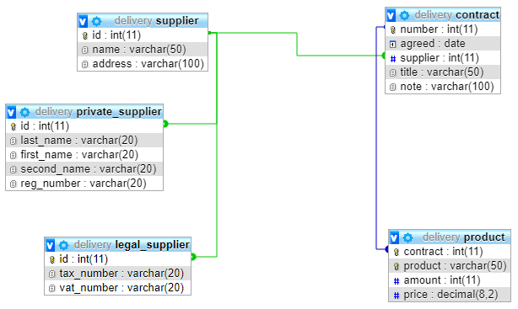

Figure 2.3 – Scheme of the developed database

The following DDL commands were used to create a database in MySQL:

CREATE DATABASE supply;

CREATE TABLE supplier (

supplier_id int NOT NULL,

supplier_address varchar (100) NOT NULL,

supplier_phone varchar (20) NOT NULL,

PRIMARY KEY (supplier_id)

) ENGINE = InnoDB;

CREATE TABLE supplier_person (

supplier_id int NOT NULL,

supplier_last_name varchar (20) NOT NULL,

supplier_first_name varchar (20) NOT NULL,

supplier_middle_name varchar (20) NOT NULL,

PRIMARY KEY (supplier_id),

FOREIGN KEY (supplier_id) REFERENCES supplier (supplier_id)

) ENGINE = InnoDB;

CREATE TABLE supplier_org (

supplier_id int NOT NULL,

supplier_org_name varchar (20) NOT NULL,

PRIMARY KEY (supplier_id),

FOREIGN KEY (supplier_id) REFERENCES supplier (supplier_id)

) ENGINE = InnoDB;

CREATE TABLE contract (

contract_number int NOT NULL AUTO_INCREMENT,

contract_date timestamp NOT NULL,

supplier_id int NOT NULL,

contract_note varchar (100),

PRIMARY KEY (contract_number),

FOREIGN KEY (supplier_id) REFERENCES supplier (supplier_id)

) ENGINE = InnoDB;

CREATE TABLE supplied (

contract_number int NOT NULL,

supplied_product varchar (20) NOT NULL,

supplied_amount decimal (4.0) NOT NULL,

supplied_cost decimal (8,2) NOT NULL,

PRIMARY KEY (contract_number, supplied_product),

FOREIGN KEY (contract_number) REFERENCES contract (contract_number)

) ENGINE = InnoDB;

## 2.4 Filling the database with initial records

The following commands allow you to fill in data about suppliers in the created database (Figure 2.4):

INSERT INTO supplier (supplier_id, supplier_address, supplier_phone) VALUES (1, 'Kharkiv, Nauky av., 55, apt. 108', 'phone: 32-18-44');

INSERT INTO supplier (supplier_id, supplier_address, supplier_phone) VALUES (2, 'Kyiv, Peremohy av., 154, apt. 3', '');

INSERT INTO supplier (supplier_id, supplier_address, supplier_phone) VALUES (3, 'Kharkiv, Pushkinska str., 77', 'phone: 33-33-44, fax: 22-12-33');

INSERT INTO supplier (supplier_id, supplier_address, supplier_phone) VALUES (4, 'Одеса, Деребасивска стр., 75', '');

INSERT INTO supplier (supplier_id, supplier_address, supplier_phone) VALUES (5, 'Poltava, Soborna str., 15, apt. 43', '');

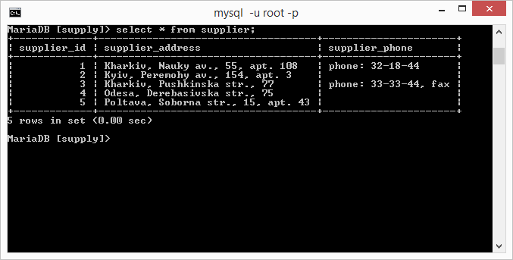

Figure 2.4 – Records of suppliers

The following commands allow you to fill in data on individual suppliers in the created database (Figure 2.5):

INSERT INTO supplier_person (supplier_id, supplier_last_name, supplier_first_name, supplier_middle_name) VALUES (1, 'Petrov', 'Pavlo', 'Petrovych');

INSERT INTO supplier_person (supplier_id, supplier_last_name, supplier_first_name, supplier_middle_name) VALUES (3, 'Ivanov', 'Illia', 'Illych');

INSERT INTO supplier_person (supplier_id, supplier_last_name, supplier_first_name, supplier_middle_name) VALUES (5, 'Sydorov', 'Serhii', 'Stepanovych');

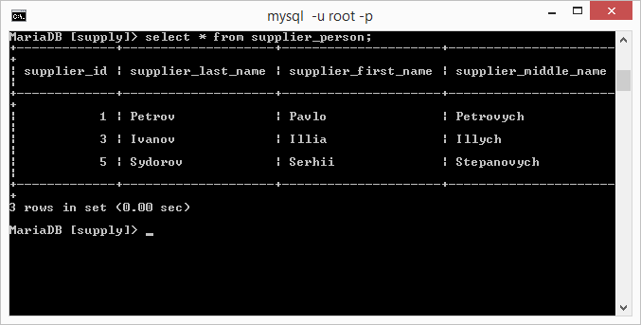

Figure 2.5 – Records of suppliers of individuals

The following commands allow you to fill in data on suppliers-legal entities in the created database (Figure 2.6):

INSERT INTO supplier_org (supplier_id, supplier_org_name) VALUES (2, 'Interfruit Ltd.');

INSERT INTO supplier_org (supplier_id, supplier_org_name) VALUES (4, 'Transservice LLC');

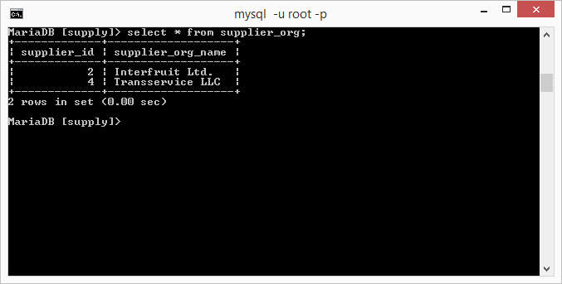

Figure 2.6 – Records of suppliers of legal entities

The following commands allow you to fill in the data on the concluded contracts in the created database (Figure 2.7):

INSERT INTO contract (contract_date, supplier_id, contract_note) VALUES ('2018-09-01', 1, 'Order 34 on 30.08.2018');

INSERT INTO contract (contract_date, supplier_id, contract_note) VALUES ('2018-09-10', 1, 'Invoice 08-78 on 28.08.2018');

INSERT INTO contract (contract_date, supplier_id, contract_note) VALUES ('2018-09-23', 3, 'Order 56 on 28.08.2018');

INSERT INTO contract (contract_date, supplier_id, contract_note) VALUES ('2018-09-24', 2, 'Order 74 on 11.09.2018');

INSERT INTO contract (contract_date, supplier_id, contract_note) VALUES ('2018-10-02', 2, 'Invoice 09-12 on 21.09.2018');

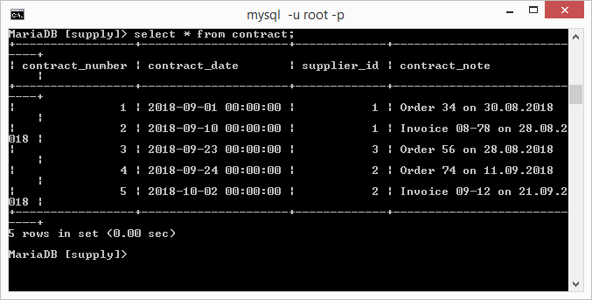

Figure 2.7 – Records of contracts

The following commands allow you to fill in the data on the delivered goods in the created database (Figure 2.8):

INSERT INTO supplied (contract_number, supplied_product, supplied_amount, supplied_cost) VALUES (1, 'TV', 10, 1300);

INSERT INTO supplied (contract_number, supplied_product, supplied_amount, supplied_cost) VALUES (1, 'Audio Player', 25, 700);

INSERT INTO supplied (contract_number, supplied_product, supplied_amount, supplied_cost) VALUES (1, 'Video Player', 12, 750);

INSERT INTO supplied (contract_number, supplied_product, supplied_amount, supplied_cost) VALUES (2, 'Stereo System', 11, 500);

INSERT INTO supplied (contract_number, supplied_product, supplied_amount, supplied_cost) VALUES (2, 'Audio Player', 5, 450);

INSERT INTO supplied (contract_number, supplied_product, supplied_amount, supplied_cost) VALUES (2, 'Video Player', 8, 450);

INSERT INTO supplied (contract_number, supplied_product, supplied_amount, supplied_cost) VALUES (3, 'TV', 52, 900);

INSERT INTO supplied (contract_number, supplied_product, supplied_amount, supplied_cost) VALUES (3, 'Audio Player', 11, 550);

INSERT INTO supplied (contract_number, supplied_product, supplied_amount, supplied_cost) VALUES (3, 'Monitor', 85, 550);

INSERT INTO supplied (contract_number, supplied_product, supplied_amount, supplied_cost) VALUES (4, 'TV', 56, 990);

INSERT INTO supplied (contract_number, supplied_product, supplied_amount, supplied_cost) VALUES (4, 'Audio Player', 22, 320);

INSERT INTO supplied (contract_number, supplied_product, supplied_amount, supplied_cost) VALUES (4, 'Printer', 41, 350);

INSERT INTO supplied (contract_number, supplied_product, supplied_amount, supplied_cost) VALUES (5, 'TV', 14, 860);

INSERT INTO supplied (contract_number, supplied_product, supplied_amount, supplied_cost) VALUES (5, 'Audio Player', 33, 580);

INSERT INTO supplied (contract_number, supplied_product, supplied_amount, supplied_cost) VALUES (5, 'Video Player', 17, 850);

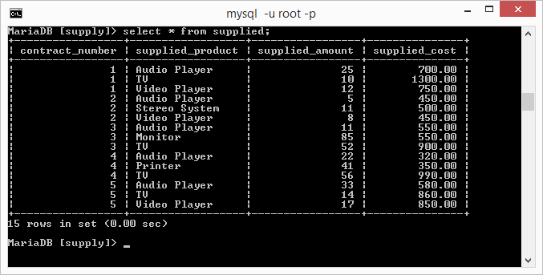

Figure 2.8 – Records of delivered goods

## 2.5 Creating database queries

The following SQL queries have been developed.

1 Create a list of delivered goods. For each product in this list, the following data must be indicated: contract number, product name, number of units, unit price, delivery date, month name and year number (Figure 2.9).

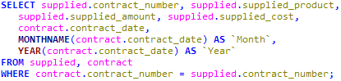

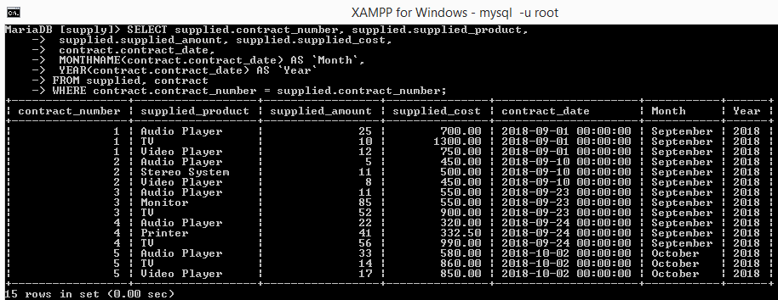

Figure 2.9 – Code and result of query execution 1

2 Create a list of goods that should reflect the frequency of deliveries. Only include goods that have been delivered more than once. The list should be sorted in descending order of delivery frequency (Figure 2.10).

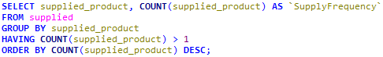

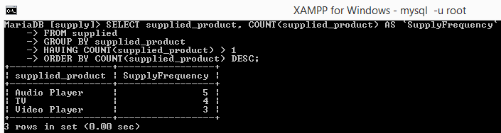

Figure 2.10 – Code and result of query execution 2

3 To form the list of contracts (with indication of number, date of delivery and data on the supplier), the total quantity of the delivered goods and the total amount under each contract. When generating supplier data for individuals to display the name and initials, and for legal entities - the name. The result should include only those contracts on the basis of which the goods were actually delivered (ie the so-called "empty" contracts should not be the result of the request) (Figure 2.11).

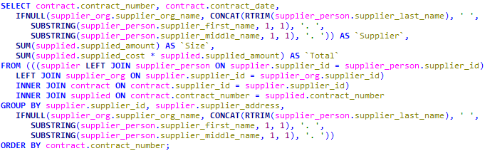

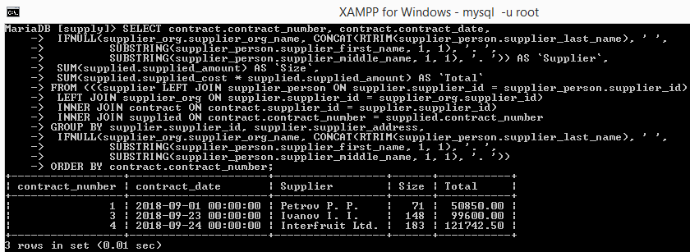

Figure 2.11 – Request code and result 3

4 Create a list of suppliers with the code, address and details of the supplier. When generating supplier data for individuals to display the name and initials, and for legal entities - the name (Figure 2.12).

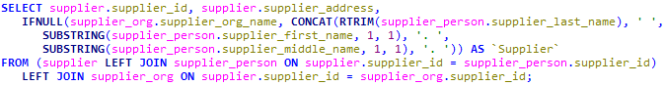

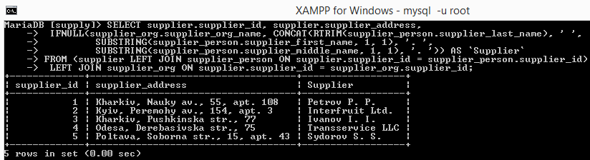

Figure 2.12 – Request code and result 4

5 Display information about the largest consignment of goods in all contracts indicating the supplier, as well as the number and date of the contract (Figure 2.13).

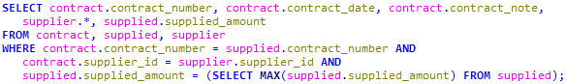

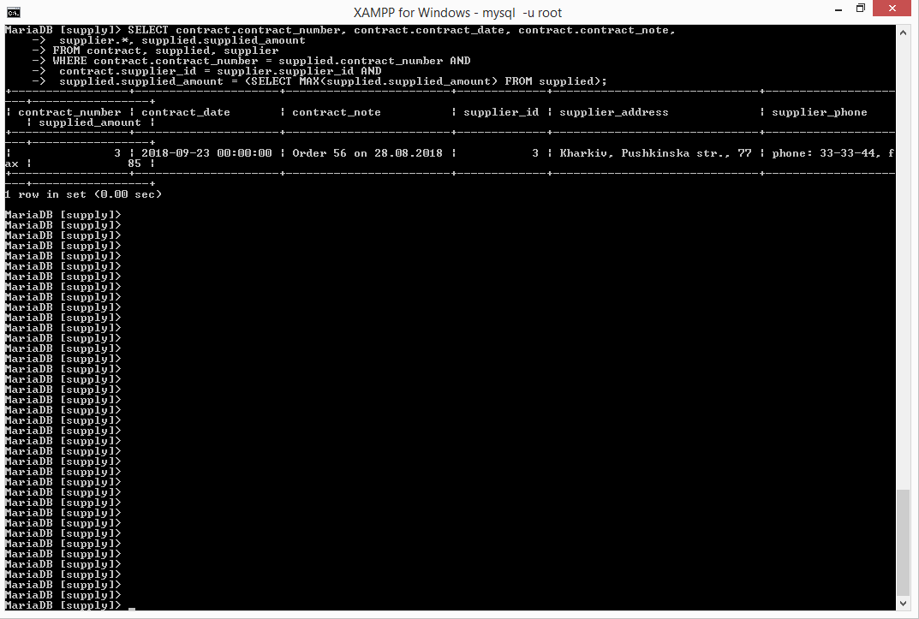

Figure 2.13 – Request code and result 5

# 3 DESIGN AND DEVELOPMENT OF THE DATABASE APPLICATION

## 3.1 Database application design

The use case diagram of the database application is shown in Figure 3.1.

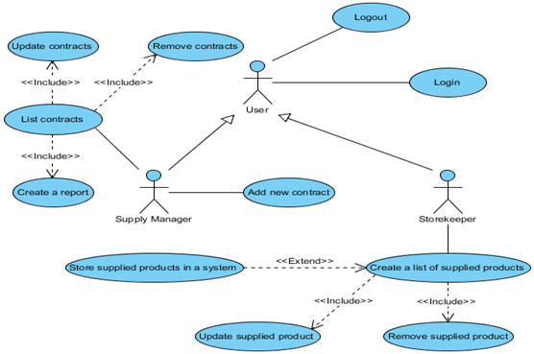

Figure 3.1 – The use case diagram

The deployment diagram of the database application is shown in Figure 3.2.

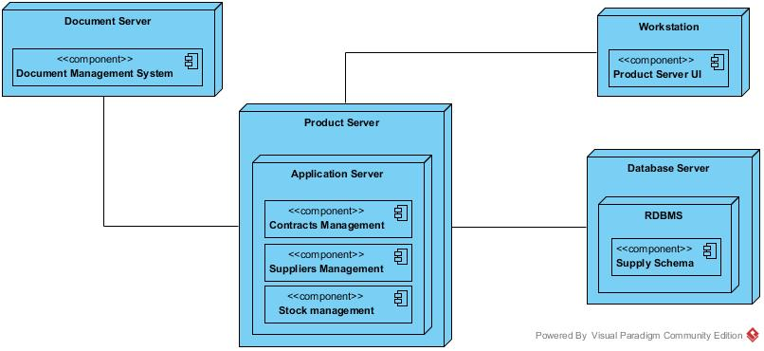

Figure 3.2 – The deployment diagram

## 3.2 Database application usage example

Examples of using the application to work with the database are shown in Figures 3.3 and 3.4.

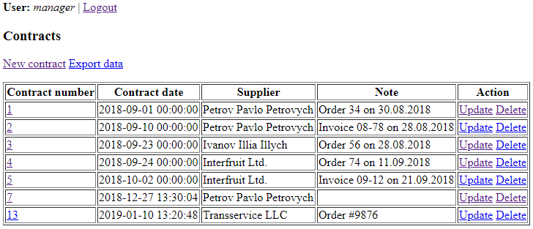

Figure 3.3 – Form for working with supply contracts

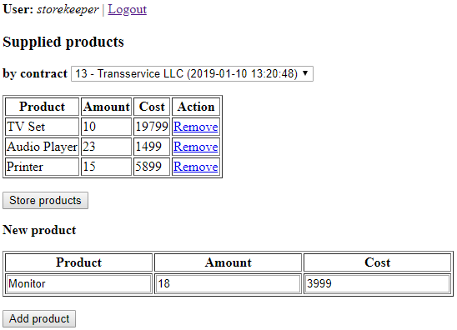

Figure 3.4 – Form for working with delivered goods

# CONCLUSIONS

During the course work, the activities of a company that buys goods from different suppliers (both legal entities and individuals) were considered. The purchase of goods is carried out in batches and is executed in the form of supply contracts. Each contract for the supply of goods has a unique number and can be concluded with only one supplier. The documents for each contract for each product indicate: name, size of the delivered lot and price (in UAH).

To store and process such information, a database was developed that takes into account the specifics of considered business rules. To do this, the following tasks were performed:

1 A logical model of the database has been developed.

2 A physical model of the database is developed.

3 Describes the structure of the database.

4 A database is implemented in the MySQL database management system (DBMS) using DDL (Data Definition Language) commands.

5 The database is filled with initial records, as well as SQL (Structured Query Language) queries are developed.

6 The database application is developed.

7 The database application usage example is demonstrated.

# REFERENCES

1 Halpin T., Morgan T. Information modeling and relational databases. - Morgan Kaufmann, 2010.

2 Date CJ An Introduction to Database Systems. - Pearson Education India, 2006.

3 Tahaghoghi SMM, Williams HE Learning MySQL: Get a Handle on Your Data. - O'Reilly Media, Inc., 2006.

4 Murach J. Murach's MySQL. - Mike Murach & Associates, Incorporated, 2015.

5 DuBois P. MySQL Cookbook: Solutions for Database Developers and Administrators. - “O'Reilly Media, Inc.”, 2014.

6 Nixon R. Learning PHP, MySQL, JavaScript, and CSS: A step-by-step guide to creating dynamic websites. - “O'Reilly Media, Inc.”, 2012.

7 Boronczyk T. et al. Beginning PHP 6, Apache, MySQL 6 Web Development. - Wrox Press Ltd., 2009.

8 Schwartz B., Zaitsev P., Tkachenko V. High performance MySQL: optimization, backups, and replication. - “O'Reilly Media, Inc.”, 2012.

9 Taylor AG SQL for Dummies. - John Wiley & Sons, 2011.

10 Becker J., Kugeler M., Rosemann M. (ed.). Process management: a guide for the design of business processes. - Springer Science & Business Media, 2013.

11 Jukic N., Vrbsky S., Nestorov S. Database systems: Introduction to databases and data warehouses. - Pearson, 2014. - P. 400.