SECUREPROFIT HUB
Technical Documentation
Architecture, Security, Data, Integrations, and Operations
Audience: solution architects, developers, DBAs, security engineers, and operations teams
Version 2.0
26 August 2026
Source baseline: 5f6bb27

Document Control
Field | Value
Product | SecureProfit Hub
Document version | 2.0
Date | 26 August 2026
Source baseline | 5f6bb27
Platforms | React web, Expo mobile, Node.js API, PostgreSQL
Deployment models | Replit Autoscale and on-premise/VM
Status | Updated to current implemented functionality

Purpose and Scope
This document is the current technical reference for SecureProfit Hub. It replaces older architecture descriptions where they conflict with the source baseline shown above. It covers the implemented web, mobile, API, database, integrations, security boundaries, deployment, and operations.
Source of truth: Runtime code, Prisma schema, migrations, OpenAPI contract, and deployment configuration are authoritative. Proposed backlog items are not described as implemented.

Contents
- 1. System Overview
- 2. Monorepo and Components
- 3. Runtime Architecture
- 4. API and Contract Architecture
- 5. Authentication and Authorization
- 6. Database Architecture
- 7. Project Lifecycle and Closing
- 8. Time, Cost, Billing, and Profitability
- 9. Integrations and AI
- 10. Schedulers and Resilience
- 11. File and Document Security
- 12. Mobile Architecture
- 13. Security Architecture
- 14. Testing and Quality
- 15. Deployment and Infrastructure
- 16. Backup, Recovery, and Operations
- 17. Monitoring and Troubleshooting
- 18. Technical Source Map

1. System Overview
SecureProfit Hub is an integrated professional-services automation platform for sales intake, project delivery, resources, timesheets, expenses, financial control, billing, customer satisfaction, performance feedback, analytics, and management reporting.
Layer | Technology | Responsibility
Web | React, TypeScript, Vite, Tailwind, Radix UI, TanStack Query | Role-based SPA, analytics, operational workflows
Mobile | Expo / React Native | Time tracking, timesheets, expenses, projects, approvals, alerts
API | Node.js ESM, Express 5, Zod, Pino | Auth, business rules, integrations, reports, schedulers
Data | PostgreSQL 16, Prisma 5 | Transactional data, audit, settings, scheduler claims
Contracts | OpenAPI, generated React Query hooks and Zod schemas | Client/server contract and validation
Documents | PDFKit, pdf-lib, ExcelJS, local persistent uploads | Receipts, project files, reports, exports
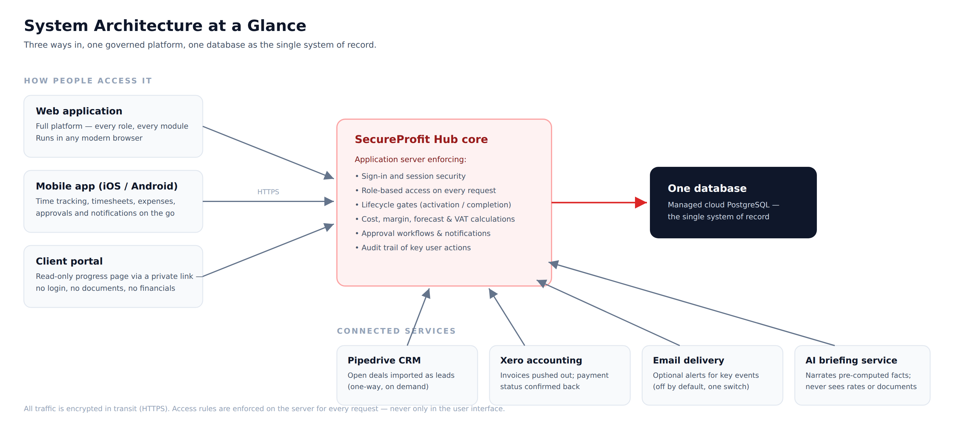
Figure 1 — SecureProfit Hub logical architecture.

Key Design Principles
- Server-side authorization is authoritative; UI visibility is convenience, not security.
- Business calculations and lifecycle gates are centralized in shared/domain helpers.
- Financial and rate data are exposed only to explicitly allowed roles.
- Database writes that enforce lifecycle transitions use conditional or transactional patterns.
- Public token endpoints fail closed and avoid exposing whether a token or project exists.
- Generated clients are used where practical, while custom endpoints remain explicitly scoped.

2. Monorepo and Components
Path | Purpose
artifacts/web | React/Vite web application
artifacts/api-server | Express API and background scheduler host
artifacts/mobile | Expo mobile application and static production server
lib/db | Prisma schema, migrations, generated client
lib/api-spec | OpenAPI source contract
lib/api-client-react | Generated React Query client
lib/api-zod | Generated request/response Zod schemas
lib/shared | Shared domain constants and calculations
scripts | Build, release, documentation, data, and operational utilities

Build and Package Model
The repository is a pnpm workspace. Root typecheck builds shared TypeScript references and then checks artifacts. Production builds compile the API into an ESM bundle, the web application into static assets, and the mobile web target for its artifact server.

3. Runtime Architecture
Runtime | Entry / Delivery | Notes
Web | Static assets from artifacts/web/dist/public | SPA fallback routes to index.html
API | artifacts/api-server/dist/index.mjs | PORT-driven Node process with health endpoint
Mobile | Expo static output served by artifacts/mobile/server/serve.js | Uses absolute API URL outside shared web proxy
Database | PostgreSQL via Prisma | Pooled URL supported; graceful disconnect on shutdown

Request Flow
1. Browser/mobile sends authenticated request.
2. Auth middleware validates JWT from Bearer header or auth cookie.
3. Role and resource scope are enforced by route middleware and domain checks.
4. Zod and semantic validation reject malformed or invalid state transitions.
5. Prisma executes scoped reads or conditional/transactional writes.
6. Audit and notification side effects are recorded when applicable.
7. Response serializers remove fields the caller is not allowed to see. The response is returned to the generated or custom client.

4. API and Contract Architecture
API routes are mounted under /api. Route families cover authentication, users, clients, leads, projects, resources, tasks, RAID, workstreams, timesheets, expenses, documents, billing, revenue recognition, closing checklist, 360 feedback, surveys, dashboards, reports, notifications, AI, Xero, Pipedrive, portal, and access requests.

Validation Layers
Layer | Function
OpenAPI | Transport contract and generated client types
Generated Zod | Structural request validation
Route/domain validation | Non-empty values, ownership, status transitions, semantic business rules
Database constraints | Uniqueness, foreign keys, indexes, atomic transition conditions
Contract discipline: New generated-hook query options must include a stable queryKey. Semantic validation must remain in route/domain code even when a generated Zod schema is present.

5. Authentication and Authorization

Authentication
- Email/password login with bcrypt password hashes and JWT session token.
- JWT is accepted from Authorization: Bearer or the auth_token cookie.
- SESSION_SECRET is mandatory and must be stored outside source control.
- Deleted/deactivated users are rechecked during authenticated requests.
- Google Sign-In validates audience and verified email. Unknown approved-domain users create a pending access request for Site Admin review.

Roles
Role group | Examples | Typical scope
Executive / control | Management, Super Admin | Portfolio, commercial, approvals, CSAT waiver
Delivery management | Project Manager | Owned projects, resources, approvals, closing
Delivery | Consultant, Technical Writer, Admin Project, Principals | Assigned work, tasks, time, RAID, 360
Commercial | Sales, Finance | Pipeline or finance-specific workflows
People / platform | HR, Site Admin | People operations or account/platform administration

Authorization Rules
- requireRole is the primary route-level gate and Super Admin bypasses it.
- Custom visibility and serializers must explicitly account for Super Admin.
- Timesheet scope=all uses default-deny allowlisting and forces other roles to their own user ID.
- Daily-rate visibility is narrower than general financial visibility.
- Project ownership, assignment, and status are evaluated in addition to role.
- Cache keys for scoped responses must encode caller scope.

6. Database Architecture
PostgreSQL is modeled through Prisma with CUID primary keys, explicit relations, indexes, uniqueness constraints, soft-deletion patterns, audit snapshots, and migrations. Major domains are listed below.
Domain | Representative entities
Identity and organization | User, BusinessUnit, Skill, leave and reporting hierarchy
Sales / CRM | Client, Lead, LeadActivity, Pipedrive mapping
Projects / delivery | Project, Workstream, Resource, Task, RAID, ChangeRequest, Baseline
Time and cost | Timesheet, ProjectExpense, rate history
Finance / billing | BillingMilestone, Document, revenue recognition, invoice settings
Quality / performance | SurveyResponse, ProjectFeedback360, PerformanceReview
Templates | Project, task, survey, report, and planning templates
System | Notification, AppSetting, AuditLog, access request, rate limit counter

Migration Strategy
- Prisma Migrate is authoritative; the baseline migration is 0_init.
- Development applies pending migrations through the supported post-merge workflow.
- Production migrations must be deployed before or with the application release.
- db push is guarded and is not the normal production schema-change mechanism.
- Schema-only exports can be distributed without business data for installation planning.

Recent Schema Update
The CSAT closing waiver adds timestamp, grantor, and reason fields to Project and a relation to User. The migration is additive and preserves existing project data.

7. Project Lifecycle and Closing
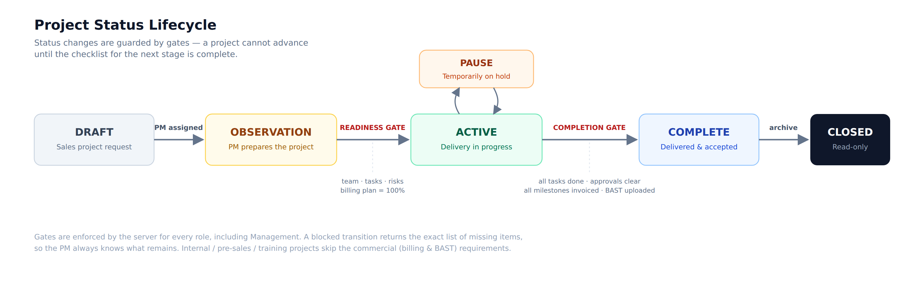
Figure 2 — Project lifecycle overview.
State | Meaning | Key transition controls
DRAFT | Lead-converted project under preparation | Sales edits before handoff
OBSERVATION | Pre-sales or planning stage | Commercial and delivery plan preparation
ACTIVE | Delivery in progress | Required commercial data, PM, resources, tasks, RAID, 100% milestones
PAUSE | Temporarily stopped | Written reason required
COMPLETE | Delivery complete; closing evidence pending | No blocking tasks/time/expenses/RAID; BAST and readiness checks
CLOSED | Finalized project | Checklist, 360, and CLIENT CSAT response or waiver

Closing Readiness
For CLIENT projects, manual closing requires prior COMPLETE status, a populated closing checklist with no pending items, all generated 360 feedback submitted, and at least one CSAT response or an active Management/Super Admin waiver.
CSAT is available while a CLIENT project is COMPLETE or CLOSED. Public access remains blocked before COMPLETE and for archived, deleted, disabled, expired, or non-client projects.

Atomicity
Concurrency rule: The final close update reasserts all applicable readiness predicates. Waiver grant/removal conditionally updates the same Project row, preventing a stale close request from succeeding after a concurrent waiver change.
The BAST + Invoice document path applies the same live CSAT/360 readiness predicate. Its historical checklist exception is intentionally retained.

Project Types
CLIENT projects use commercial, billing, BAST, survey, and closing gates. INTERNAL, PRESALES, and TRAINING projects are non-commercial: billing and BAST gates are skipped, revenue surfaces are hidden, and financial views are cost-only where applicable.

8. Time, Cost, Billing, and Profitability
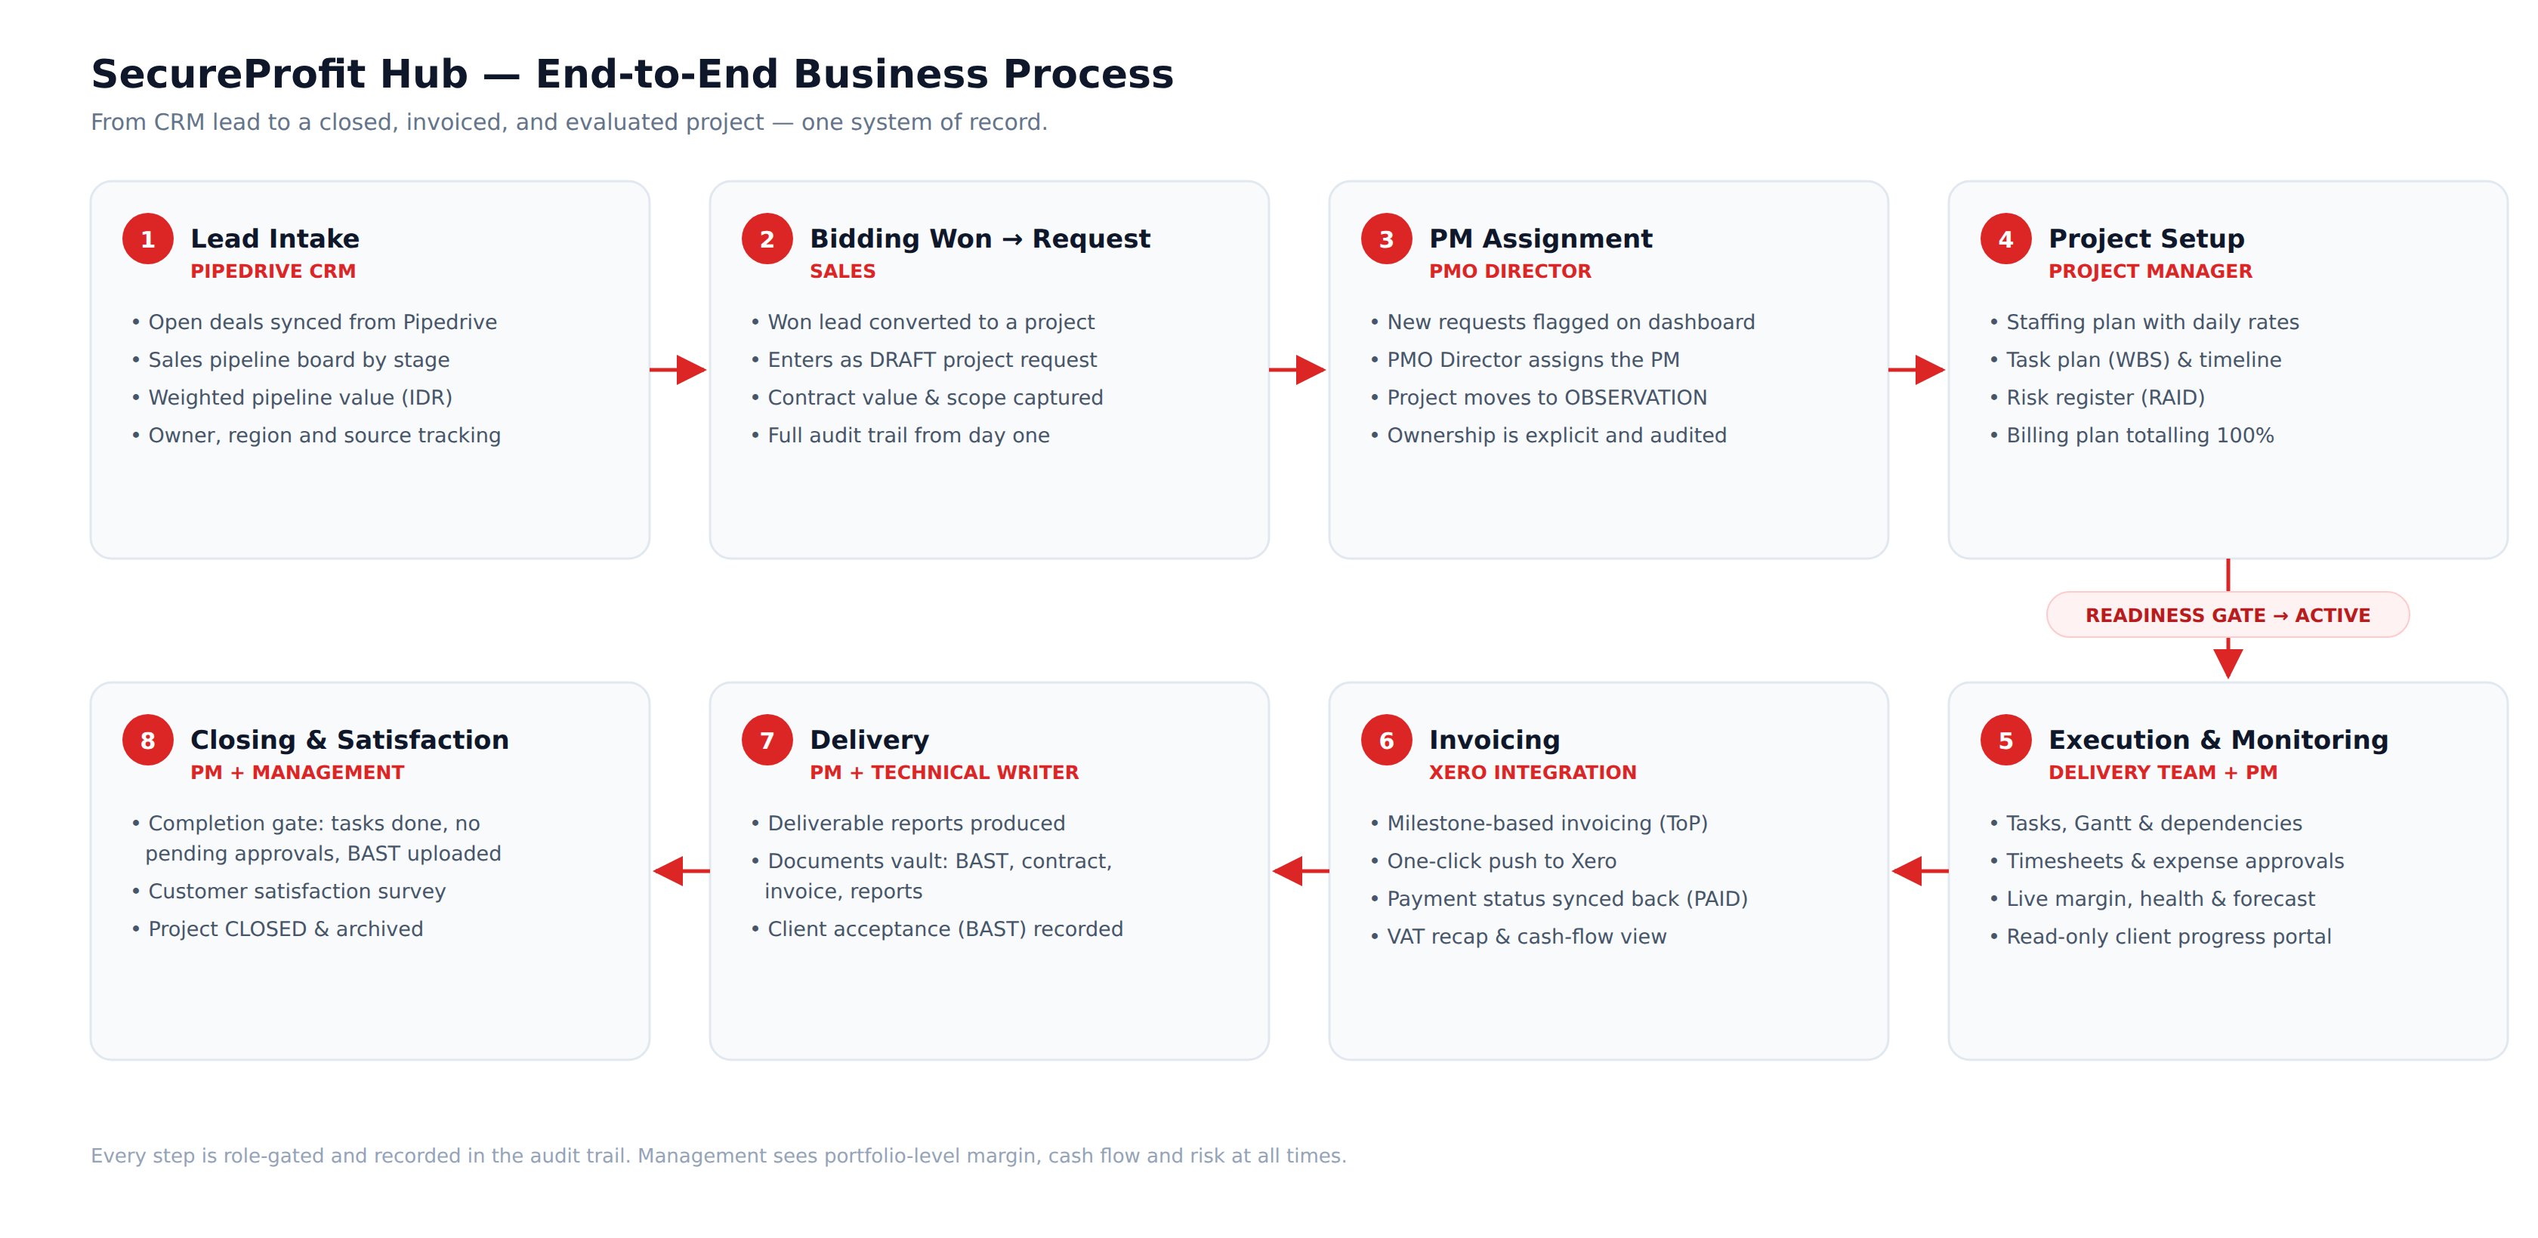
Figure 3 — End-to-end operational and financial flow.

Timesheets
Timesheets move through DRAFT, SUBMITTED, APPROVED, or REJECTED. Only approved hours affect project cost. Delivery roles may require task linkage; PM and Management approvals are scope-controlled. Planned-hour and manday warnings aggregate selected hours to prevent bulk operations from bypassing limits.

Expenses
Expenses move through PENDING, APPROVED, or REJECTED. Management submissions may auto-approve. Only approved expenses affect actual cost. Claims support evidence, receipt PDF, cash advance, and purchase-order settlement data.

Billing and Revenue
Billing milestones must allocate 100% and carry due date, percentage, status, and invoice data. Revenue evidence uses BAST, payment, or report evidence with deterministic priority. Invoice numbers are database-unique and allocated transactionally with retry.

Core Formula
Profitability: Resource cost = approved hours ÷ 8 × effective historical daily rate. Actual cost adds approved expenses. Profit = contract value − actual cost. Margin is profit divided by contract value when contract value is positive.

9. Integrations and AI
Integration | Direction / behavior | Safety and control
Xero | Invoice push and payment-status synchronization | OAuth state, serialized token refresh, advisory locks, AppSetting auto-sync gate
Pipedrive | One-way open-deal import into Leads | Token-based, async sync/status, DB claim, optional secret webhook, 15-minute poll
Resend | Best-effort important notification email | Disabled by default, timeout, allow/block list, no provider body logging
OpenAI integration | Management Copilot, assistant, report drafting, weekly digest | Deterministic facts, role-scoped tools, data minimization, cached/persisted output

AI Data Boundaries
- Financial answers use uncapped shared billing facts rather than display-limited rows.
- Assistant tools are read-only and role-scoped.
- Raw documents, unrestricted rate data, and full timesheet bodies are not sent by default.
- Digest creation is uniqueness-guarded so concurrent workers notify once.
- Provider response bodies are not written to logs.

10. Schedulers and Resilience
Process | Frequency | Coordination
Database keepalive | Default every 4 minutes | SELECT 1; warnings are rate-limited
Notification rules | Attempt every 15 minutes | DB claim allows at most hourly execution
AI weekly digest | Weekly | Shared claim plus unique week key
Pipedrive poll | 15 minutes | AppSetting gate and DB claim
Xero payment poll | 30 minutes | AppSetting gate
SIGTERM/SIGINT triggers graceful HTTP shutdown followed by Prisma disconnect, with a hard timeout. The application does not use a general-purpose queue; operationally heavy paths should be monitored for request duration.

11. File and Document Security
- Uploads use Multer with a 10 MB limit and write to the runtime uploads directory.
- Project files are served through an authenticated, project-authorized endpoint rather than express.static.
- PDF uploads are validated by magic bytes and stored under randomized names.
- Downloads use attachment disposition.
- HTTPS document links can be recorded when the business process uses external storage.
- Production operations must back up uploads separately from PostgreSQL.
Residual operational risk: Baseline upload storage is local disk. Multi-node deployment requires shared or object storage, malware scanning should be considered, and direct public filesystem access must remain disabled.

12. Mobile Architecture
The Expo application shares the API and JWT model with web. Native/mobile requests use an absolute API URL and Bearer token. Browser-only effects in shared fetch code are guarded by checks for window, localStorage, and location.
Area | Implementation
Routing | Expo Router with login, tab routes, and project detail routes
Tabs | Track, Timesheets, Expenses, Projects, Approvals, Alerts; role-gated
Timer | AsyncStorage, keyed per signed-in user to avoid cross-account leakage
Receipts | Bearer-authenticated file download with mobile client header
Production delivery | Expo static build served by a dedicated Node server

13. Security Architecture
Boundary | Controls
Authentication | JWT, bcrypt, Google token verification, deleted-user checks, login rate limits
Authorization | Role middleware, ownership/assignment checks, scoped serializers, default-deny global views
Public links | Opaque tokens, expiry/disable checks, archived/deleted blocking, indistinguishable invalid states
Uploads | Authz, PDF magic bytes, randomized names, attachment response
Audit | Before/after snapshots and action-specific audit records including CSAT waiver changes
Dependencies | Scoped pnpm overrides and locally maintained safe image-size patch where no upstream fix exists
Secrets | Environment/secret store only; no logging of credentials or provider response bodies

Security Maintenance
Recent dependency remediation addressed js-yaml, image-size, and nanoid-related advisories through scoped overrides or a safe local release. Dependency audit, SAST, and threat-model review should remain part of release governance.

14. Testing and Quality
- API Vitest coverage includes lifecycle, survey eligibility, waiver permissions, atomic close conflicts, document access, and authorization.
- Web and mobile packages provide typecheck/test workflows.
- End-to-end browser verification covers critical role and lifecycle flows.
- Production builds are validated for API, web, and mobile artifacts.
- A real pooled-connection reset test remains an explicit verification area and should be run in a controlled environment.

15. Deployment and Infrastructure

Replit Production
The current deployment model uses Replit Autoscale with path-routed artifacts. Web and technical decks are static artifacts; API and mobile server are runnable artifacts. Production schema changes are applied through the supported publish/migration process before code that depends on them serves traffic.

On-Premise Baseline
Server | Recommended production baseline
Application Server | 8 vCPU, 16 GB RAM, 150 GB SSD; Nginx + Node.js 22 LTS
Database Server | 8 vCPU, 32 GB RAM, 500 GB enterprise SSD/NVMe; PostgreSQL 16
Backup Repository | At least 1 TB usable, off-host and encrypted
Network | 1 Gbps minimum; App–DB latency ideally below 2 ms

Environment Configuration Categories
- Core: DATABASE_URL, SESSION_SECRET, NODE_ENV, PORT.
- Public URL and CORS/origin policy.
- Email: provider key, sender, allow/block rollout controls.
- Xero: OAuth client, secret, callback, webhook verification.
- Pipedrive: API token and webhook secret.
- AI: managed base URL and key.
- Site gate and operational scheduler flags where enabled.
Secret handling: This document intentionally does not contain secret values. Store them in an approved secret manager and rotate them using the operational runbook.

16. Backup, Recovery, and Operations
Asset | Backup requirement
PostgreSQL | Daily full backup plus WAL/PITR where RPO requires; restore-tested
Uploads | Filesystem/object-storage backup coordinated with database restore point
Configuration | Versioned non-secret config and separately protected secret references
Certificates | Protected backup or documented reissue procedure
Release artifact | Record application version compatible with each backup
Recommended production targets are RPO 15 minutes with WAL archiving and RTO 2–4 hours, adjusted to business requirements. At least one backup copy must be off-host; immutable storage is preferred. VM snapshots are not a substitute for a tested PostgreSQL backup.

Release Order
1. Back up and confirm rollback point.
2. Apply pending production migration.
3. Build and deploy application artifacts.
4. Wait for health checks.
5. Run authentication, dashboard, project, document, and closing smoke tests.
6. Monitor errors, database connections, and scheduler claims.

17. Monitoring and Troubleshooting
Layer | Required signals
API | Request rate, p95/p99 latency, 4xx/5xx, event-loop lag, restarts, memory
Database | Connections, query latency, locks, deadlocks, vacuum, bloat, WAL, storage latency
Schedulers | Last successful claim/run, duration, failures, duplicate prevention
Integrations | Auth refresh, timeout, webhook verification, sync status
Storage | Disk usage, IOPS/latency, upload failures, backup age
Security | Login failures, privilege changes, audit events, certificate expiry

Common Technical Checks
- Blank preview: confirm workflow, port binding, proxy path, allowed hosts, and browser console.
- Database column missing: confirm migration history before changing code.
- Generated client module empty: force TypeScript project rebuild after code generation.
- Expo module resolution after codegen: clear stale Metro cache and restart mobile workflow.
- Repeated DB disconnect warning: inspect current request errors and pool state; do not let warning floods hide root causes.
- Upload unavailable in HA: confirm every application node uses shared storage and consistent authorization metadata.

18. Technical Source Map
Topic | Authoritative paths
API startup/routes | artifacts/api-server/src/index.ts; src/app.ts; src/routes/index.ts
Auth/RBAC | src/middlewares/auth.ts; src/routes/auth.ts; src/lib/roles.ts
Database | lib/db/prisma/schema.prisma; lib/db/prisma/migrations
API contract | lib/api-spec/openapi.yaml; lib/api-client-react; lib/api-zod
Lifecycle/closing | routes/projects.ts; lib/feedback360.ts; routes/surveys.ts; routes/documents.ts
Financials | lib/serializers.ts; routes/billing-milestones.ts; routes/revenue-recognition.ts
Integrations | routes/xero.ts; lib/xero.ts; routes/pipedrive.ts; lib/pipedrive.ts; lib/email.ts
AI | lib/executive-copilot.ts; lib/ai-assistant.ts; lib/ai-digest.ts
Web | artifacts/web/src/App.tsx; components/layout/Sidebar.tsx; pages
Mobile | artifacts/mobile/app; contexts/auth.tsx; lib/roles.ts; server/serve.js
Deployment | .replit-artifact/artifact.toml files; DEPLOY-LOCAL-EN.md; scripts/release-prod-migrate.sh
— End of Technical Documentation —

