SECUREPROFIT HUB
User Manual
Web and Mobile Applications
Audience: end users, project teams, approvers, finance, HR, and administrators
Version 2.0
26 August 2026
Source baseline: 5f6bb27

Document Control
Field | Value
Product | SecureProfit Hub
Document version | 2.0
Date | 26 August 2026
Source baseline | 5f6bb27
Platforms | Web and mobile
Language | English
Status | Current implemented functionality

How to Use This Manual
Start with your role and the task you need to complete. Menu visibility and available actions depend on role, project ownership, assignment, and project status. If a menu shown in this manual is not visible, your account may not have the required permission.
Important: Screenshots illustrate representative screens. Labels and data may differ from your environment. Server-side permissions always determine what you can view or change.

Contents
- 1. Access and Sessions
- 2. Roles and Navigation
- 3. Dashboard and Alerts
- 4. Sales Pipeline and Leads
- 5. Projects
- 6. Project Delivery Tabs
- 7. Timesheets and Work Hours
- 8. Expenses
- 9. Approvals
- 10. Billing and Finance
- 11. Documents
- 12. Customer Survey, 360 Feedback, and Closing
- 13. Reports and Management Analytics
- 14. People and Administration
- 15. Mobile Application
- 16. Common Messages and Troubleshooting
- 17. Quick Reference

1. Access and Sessions

1.1 Web Sign-In
1. Open SecureProfit Hub. Use the production URL provided by your organization.
2. Enter your credentials. Provide your registered email address and password.
3. Select “Initialize Session”. The system creates your authenticated session and opens the role-appropriate dashboard.
If Google Sign-In is enabled, select the Google option and use an approved company account. A new approved-domain account may create an access request that must be approved by Site Admin.
Login protection: Repeated incorrect passwords can temporarily lock the email/IP combination. Wait for the lock period or contact the administrator; do not keep retrying.

1.2 Sign Out
Open the avatar/account menu and select “Logout”. On mobile, use the sign-out icon in the Track header. Always sign out on shared devices.

2. Roles and Navigation
Role | Typical access
Management / PMO Director | Portfolio, commercial data, approvals, reports, CSAT waiver, closing
Project Manager | Owned projects, resources, tasks, timesheets, expenses, reports, closing
Sales | Sales Pipeline, lead conversion, selected clients/projects and expense visibility
Consultant / Technical Writer / Admin Project | Assigned projects, tasks, time, expenses, selected delivery tabs
Principal roles | Supervised delivery, RAID, performance and selected analytics
Finance | Billing, VAT, revenue recognition, invoice settings and financial workflows
HR | Employees, organization, leave, work hours and people data
Site Admin / Super Admin | Accounts, access requests, platform administration and audit

2.1 Main Navigation Groups
- Main: Dashboard, Smart Alerts, Projects, Time Tracking.
- Operations: My Tasks, My Timesheet, My Expenses, Sales Pipeline, Approval Inbox, Resources, Capacity Planning, Expenses, planning and performance modules.
- People Ops: Employees, Org Chart, Leave Management, Business Units, Skills.
- Administration and analytics: Clients, Users, BI, PM Dashboards, Portfolio Monitor, AI Executive Copilot, VAT, Revenue Recognition, Surveys, Audit Log.
- Bottom actions: Settings and Logout.

3. Dashboard and Alerts
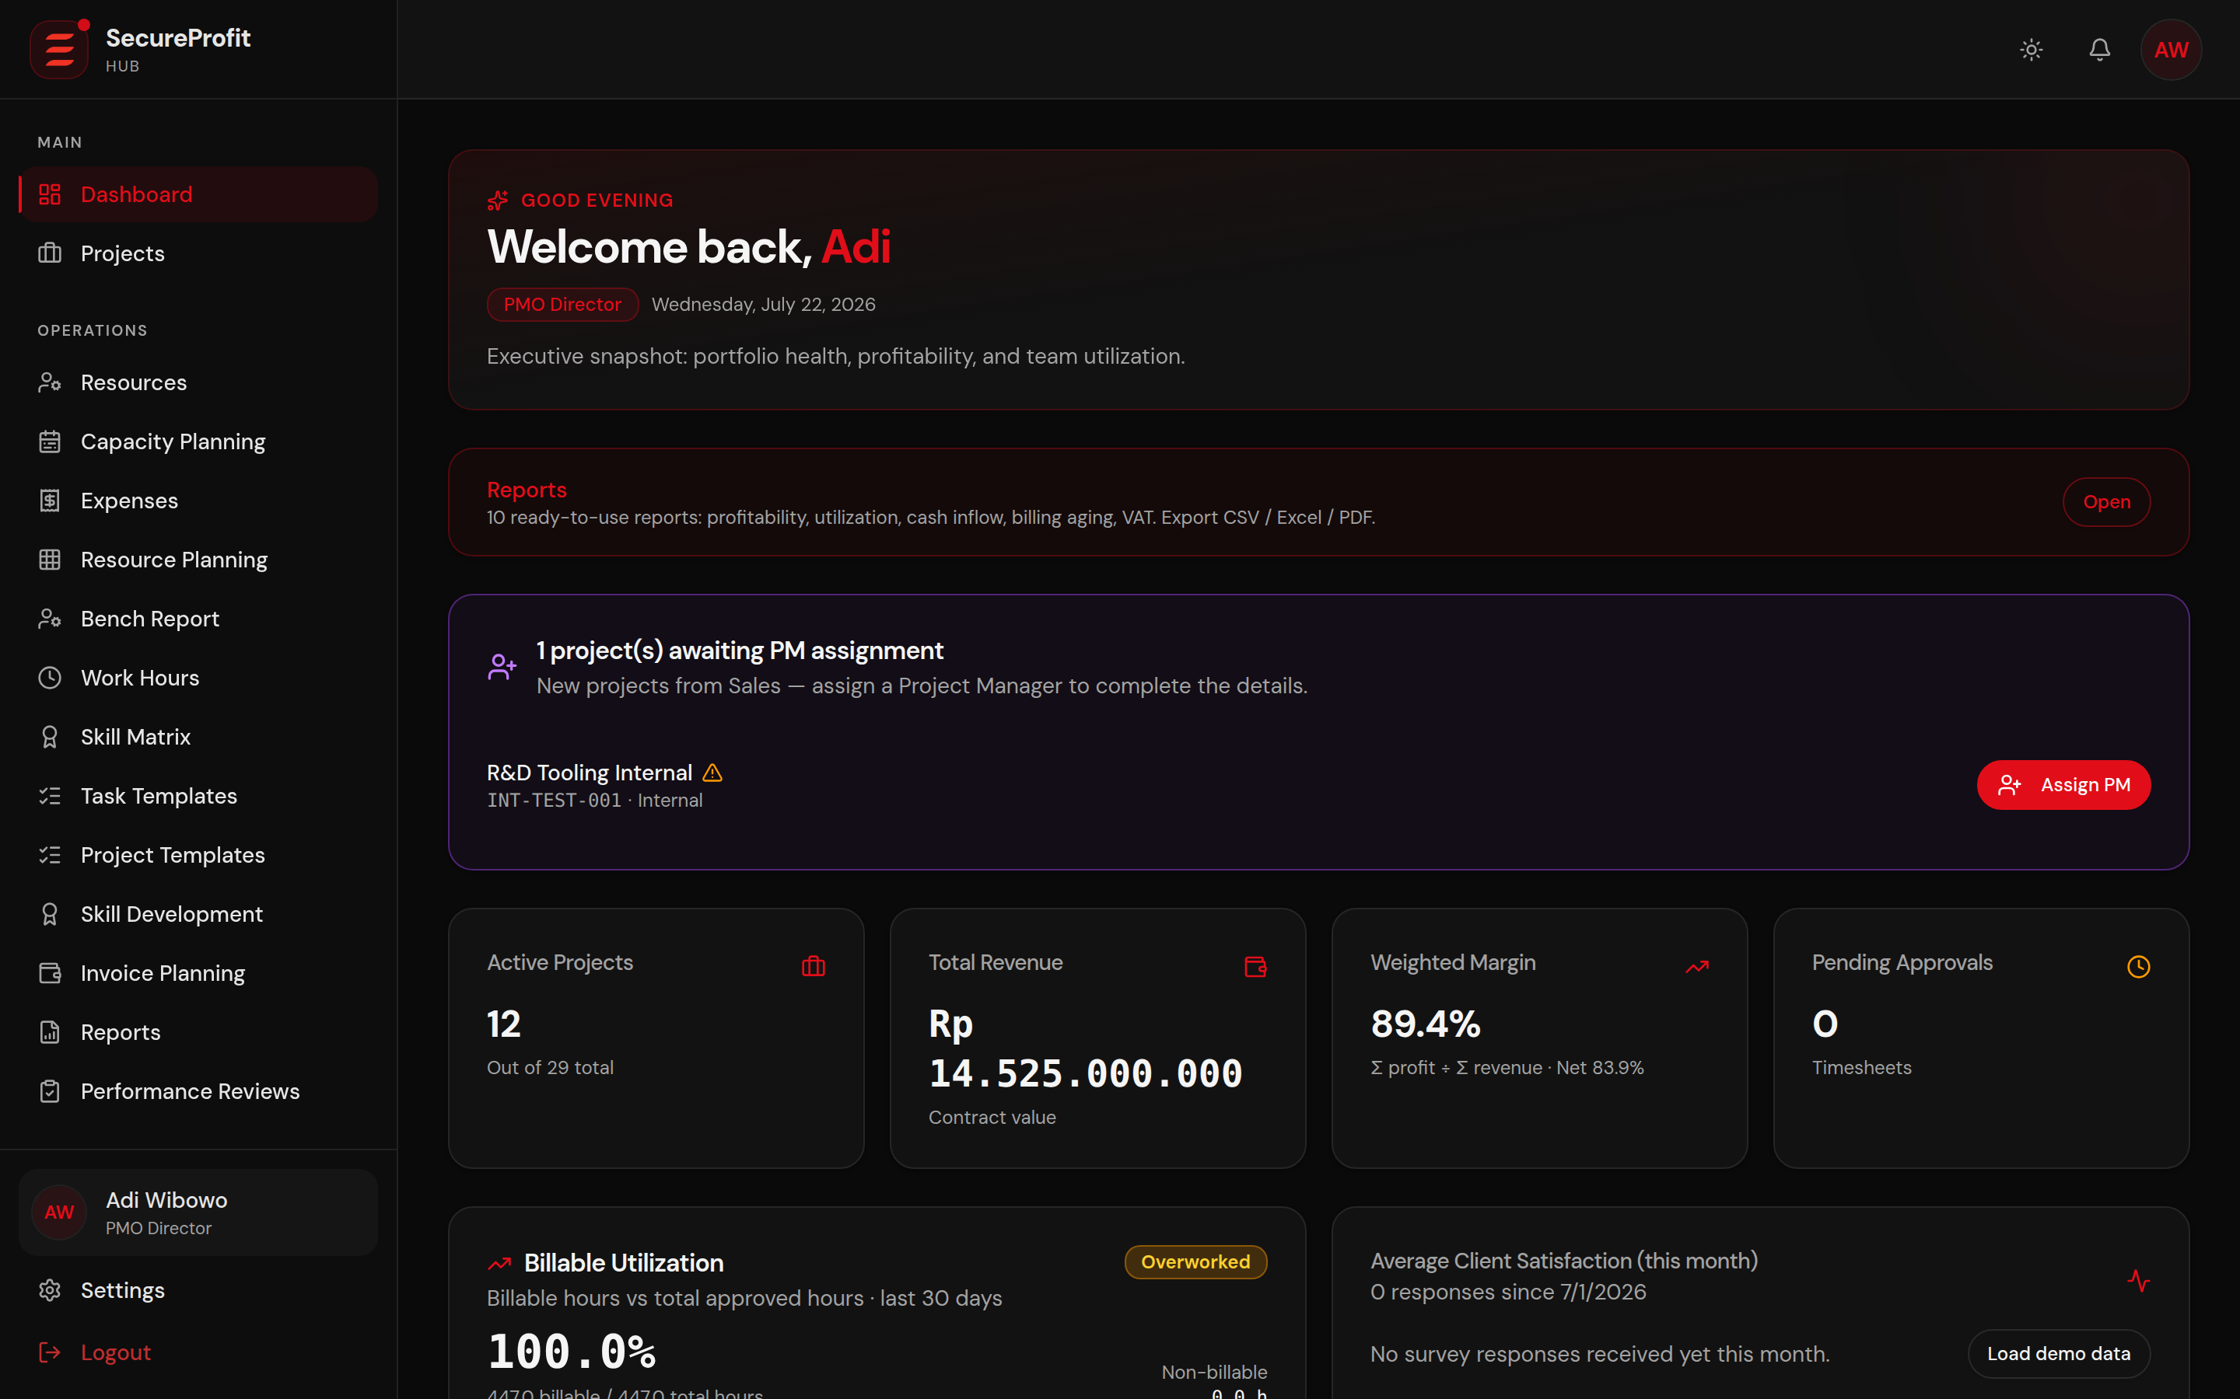
Figure 1 — Management dashboard example.

3.1 Dashboard
Dashboard content is role-scoped. Management can see portfolio KPIs, contract value, cost, profit, margin, project status, utilization, pending approvals, and recent activity. Project Managers see owned-project information. Delivery roles see personal assignments, hours, and activity.

3.2 Smart Alerts
1. Open “Smart Alerts” on web or “Alerts” on mobile.
2. Use severity/status filters when available.
3. Open an alert to follow its project or business context.
4. Select “Mark read” or “Mark all read” after review.
Alerts can cover submitted/approved/rejected timesheets, project status, document uploads, margins, budgets, invoices, and operational checks.

4. Sales Pipeline and Leads
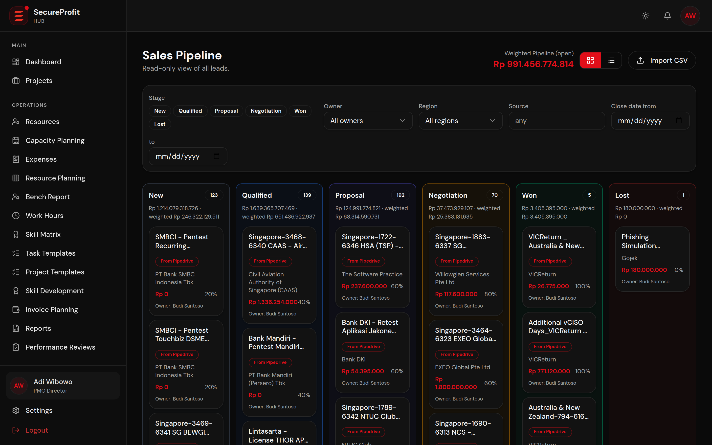
Figure 2 — Sales Pipeline and lead list.

4.1 Create or Update a Lead
1. Open “Sales Pipeline”. This menu is primarily available to Sales.
2. Create or select a lead. Enter company, opportunity, contact, estimated value, stage, and expected dates as required.
3. Save activity. Record follow-up notes and stage changes so the opportunity history remains complete.

4.2 Convert a Lead
1. Review lead data. Confirm client identity, commercial reference, dates, and ownership.
2. Select the conversion action. The system creates the related client/project opportunity according to the current conversion workflow.
3. Complete the project draft. Add delivery plan, PM, resources, tasks, RAID, and billing information before activation.
Current behavior: Do not assume automatic matching to an existing client or a CSV preview unless those options are visible in your environment; those capabilities are not part of the current baseline.

5. Projects
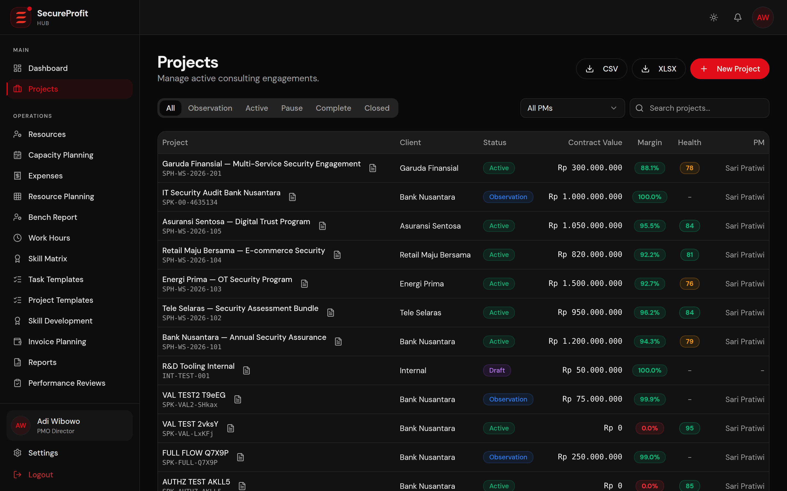
Figure 3 — Projects list with search and status context.

5.1 Find a Project
1. Open “Projects”.
2. Search by project name, Project ID, or SPK/PO where supported.
3. Apply a status filter.
4. Select a project row to open its workspace.
5. Use Export when available to download the filtered list.

5.2 Lifecycle
Status | User meaning
DRAFT | Preparation after lead conversion
OBSERVATION | Pre-sales/planning
ACTIVE | Delivery in progress
PAUSE | Temporarily paused with a written reason
COMPLETE | Delivery finished; survey/feedback/closing evidence remains
CLOSED | Final project closure completed
Archived projects are read-only and excluded from active dashboards and selected reports. Status changes may require a written reason and readiness checks.
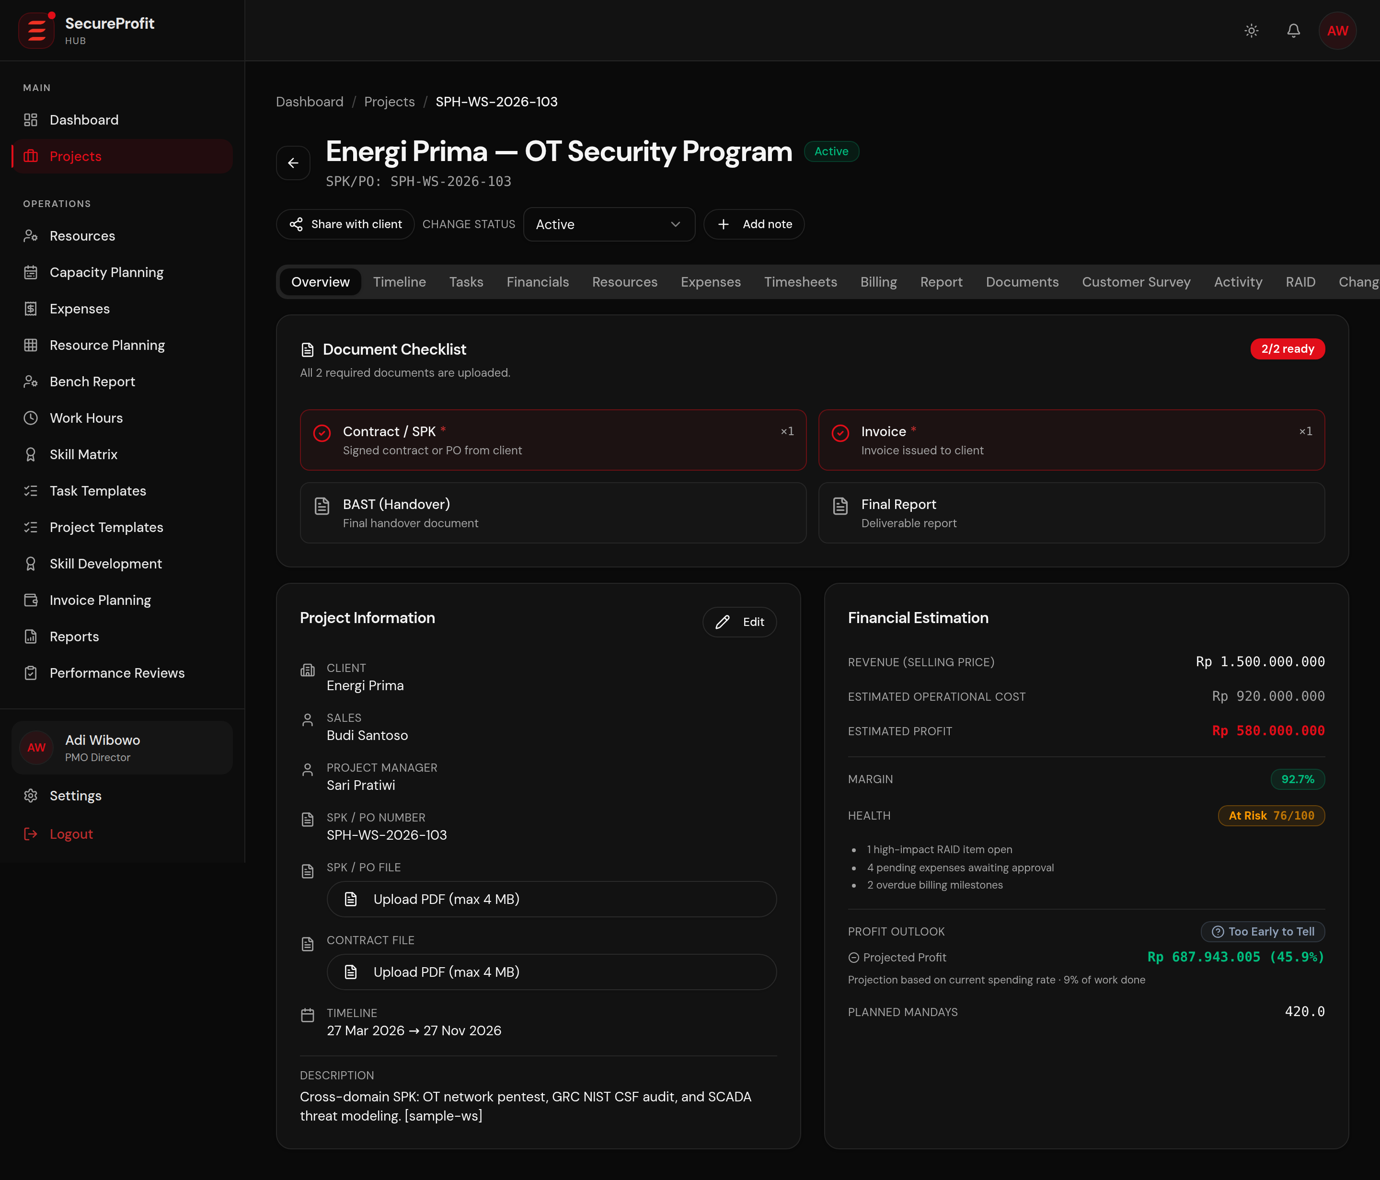
Figure 4 — Project Overview example.

5.3 Project Tabs
Tab | Purpose
Overview | Summary, status, commercial or delivery KPIs according to permission
Timeline | Schedule and Gantt view
Tasks | Assignments, progress, and task board
Financials | Cost, revenue, profit, and margin for authorized roles
Resources | Assigned team, planned mandays, rates for authorized roles
Expenses | Project expense claims
Timesheets | Project time entries and approvals for authorized roles
Billing | Milestones and invoices for commercial projects
Report | Project reporting
Documents | BAST, invoice, contract, and other project files
Customer Survey | CSAT link, responses, and waiver status
Activity | Project activity history
RAID | Risks, assumptions, issues, and dependencies
Change Requests | Controlled scope/baseline changes
Workstreams | Delivery workstream structure
Closing | Checklist, 360 feedback, CSAT readiness, and closing action

6. Project Delivery Tabs
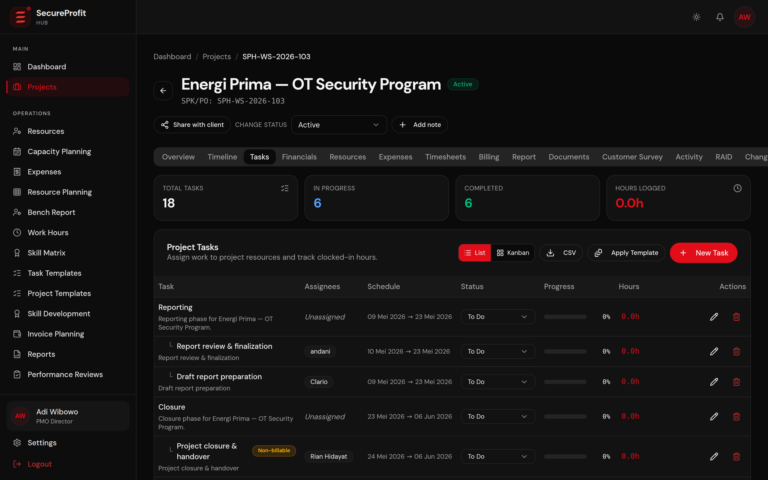
Figure 5 — Project Tasks.

6.1 Tasks
1. Create a task if your role and project status allow it.
2. Assign the appropriate user and workstream.
3. Set planned dates/hours where required.
4. Move the task through its status workflow.
5. Complete all required tasks before moving the project to COMPLETE.

6.2 Resources
1. Open Resources in the project.
2. Add an eligible team member.
3. Set role, planned mandays, allocation, and dates.
4. Management/PM may manage commercial rate fields where permitted.
5. Resolve pending principal/PM acceptance when the assignment workflow requires it.

6.3 RAID
Use RAID to record Risks, Assumptions, Issues, and Dependencies. Keep owner, impact, response/mitigation, due date, and status current. RAID visibility is limited to relevant management and delivery roles.

6.4 Workstreams and Change Requests
Workstreams organize delivery. Change Requests control approved deviations and may create a new current baseline. Use the dedicated tab rather than editing an approved baseline informally.

7. Timesheets and Work Hours
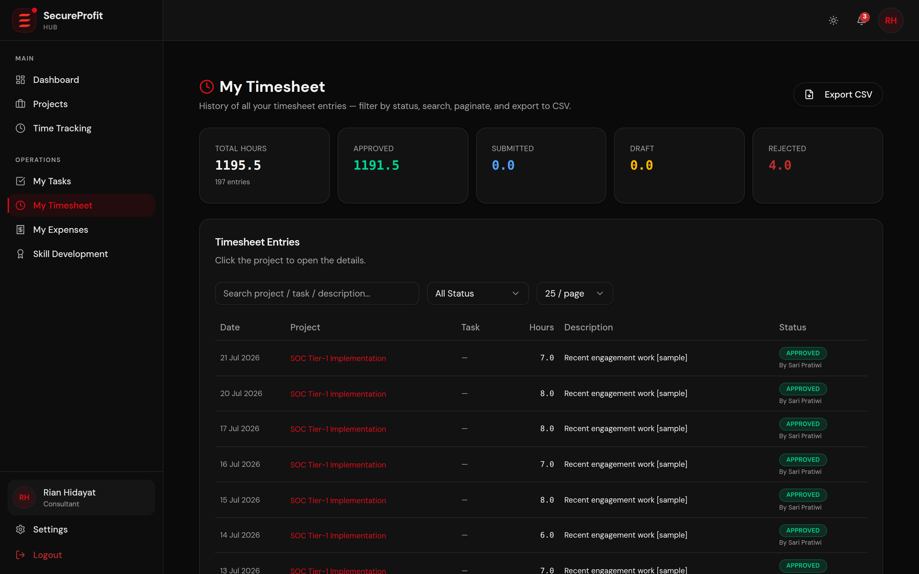
Figure 6 — My Timesheet.

7.1 Create a Web Timesheet
1. Open “My Timesheet” or “Time Tracking”. Select “New Entry”.
2. Choose project, date, and task. Task selection may be mandatory for delivery roles.
3. Enter hours and notes. Hours must be greater than 0 and no more than 24 for one day; notes may be limited to 1,000 characters.
4. Save or Submit. Save keeps DRAFT. Submit sends the entry for approval.

7.2 Statuses
Status | Meaning | What you can do
DRAFT | Not submitted | Edit, delete, or submit
SUBMITTED | Waiting for review | Wait for approver action
APPROVED | Accepted | Included in approved hours and project cost
REJECTED | Returned with reason | Correct and resubmit where allowed
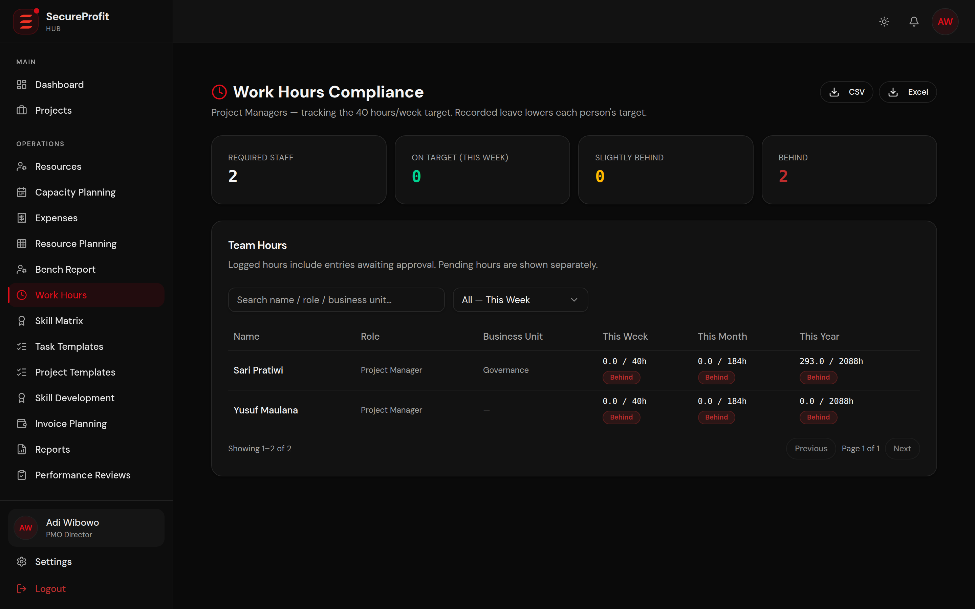
Figure 7 — Work Hours monitoring.

7.3 Work Hours
Required roles are measured against a typical 40-hour week. Approved leave reduces the target by eight hours per distinct business day. Statuses may include On Target, On Track, Slightly Behind, or Behind.

8. Expenses

8.1 Submit an Expense
1. Open “My Expenses” on web or “Expenses” on mobile.
2. Select “Submit Expense”.
3. Choose project and category: Software, Hardware, License, Travel, Cash Advance, Purchase Order, or Other.
4. Enter amount, date, and description.
5. Attach evidence in an accepted PDF/image format within the displayed size limit.
6. Submit the claim and monitor PENDING, APPROVED, or REJECTED status.
Only approved expenses affect project actual cost. Rejected claims display the reason. Receipt documents become available according to claim status and permission.

9. Approvals
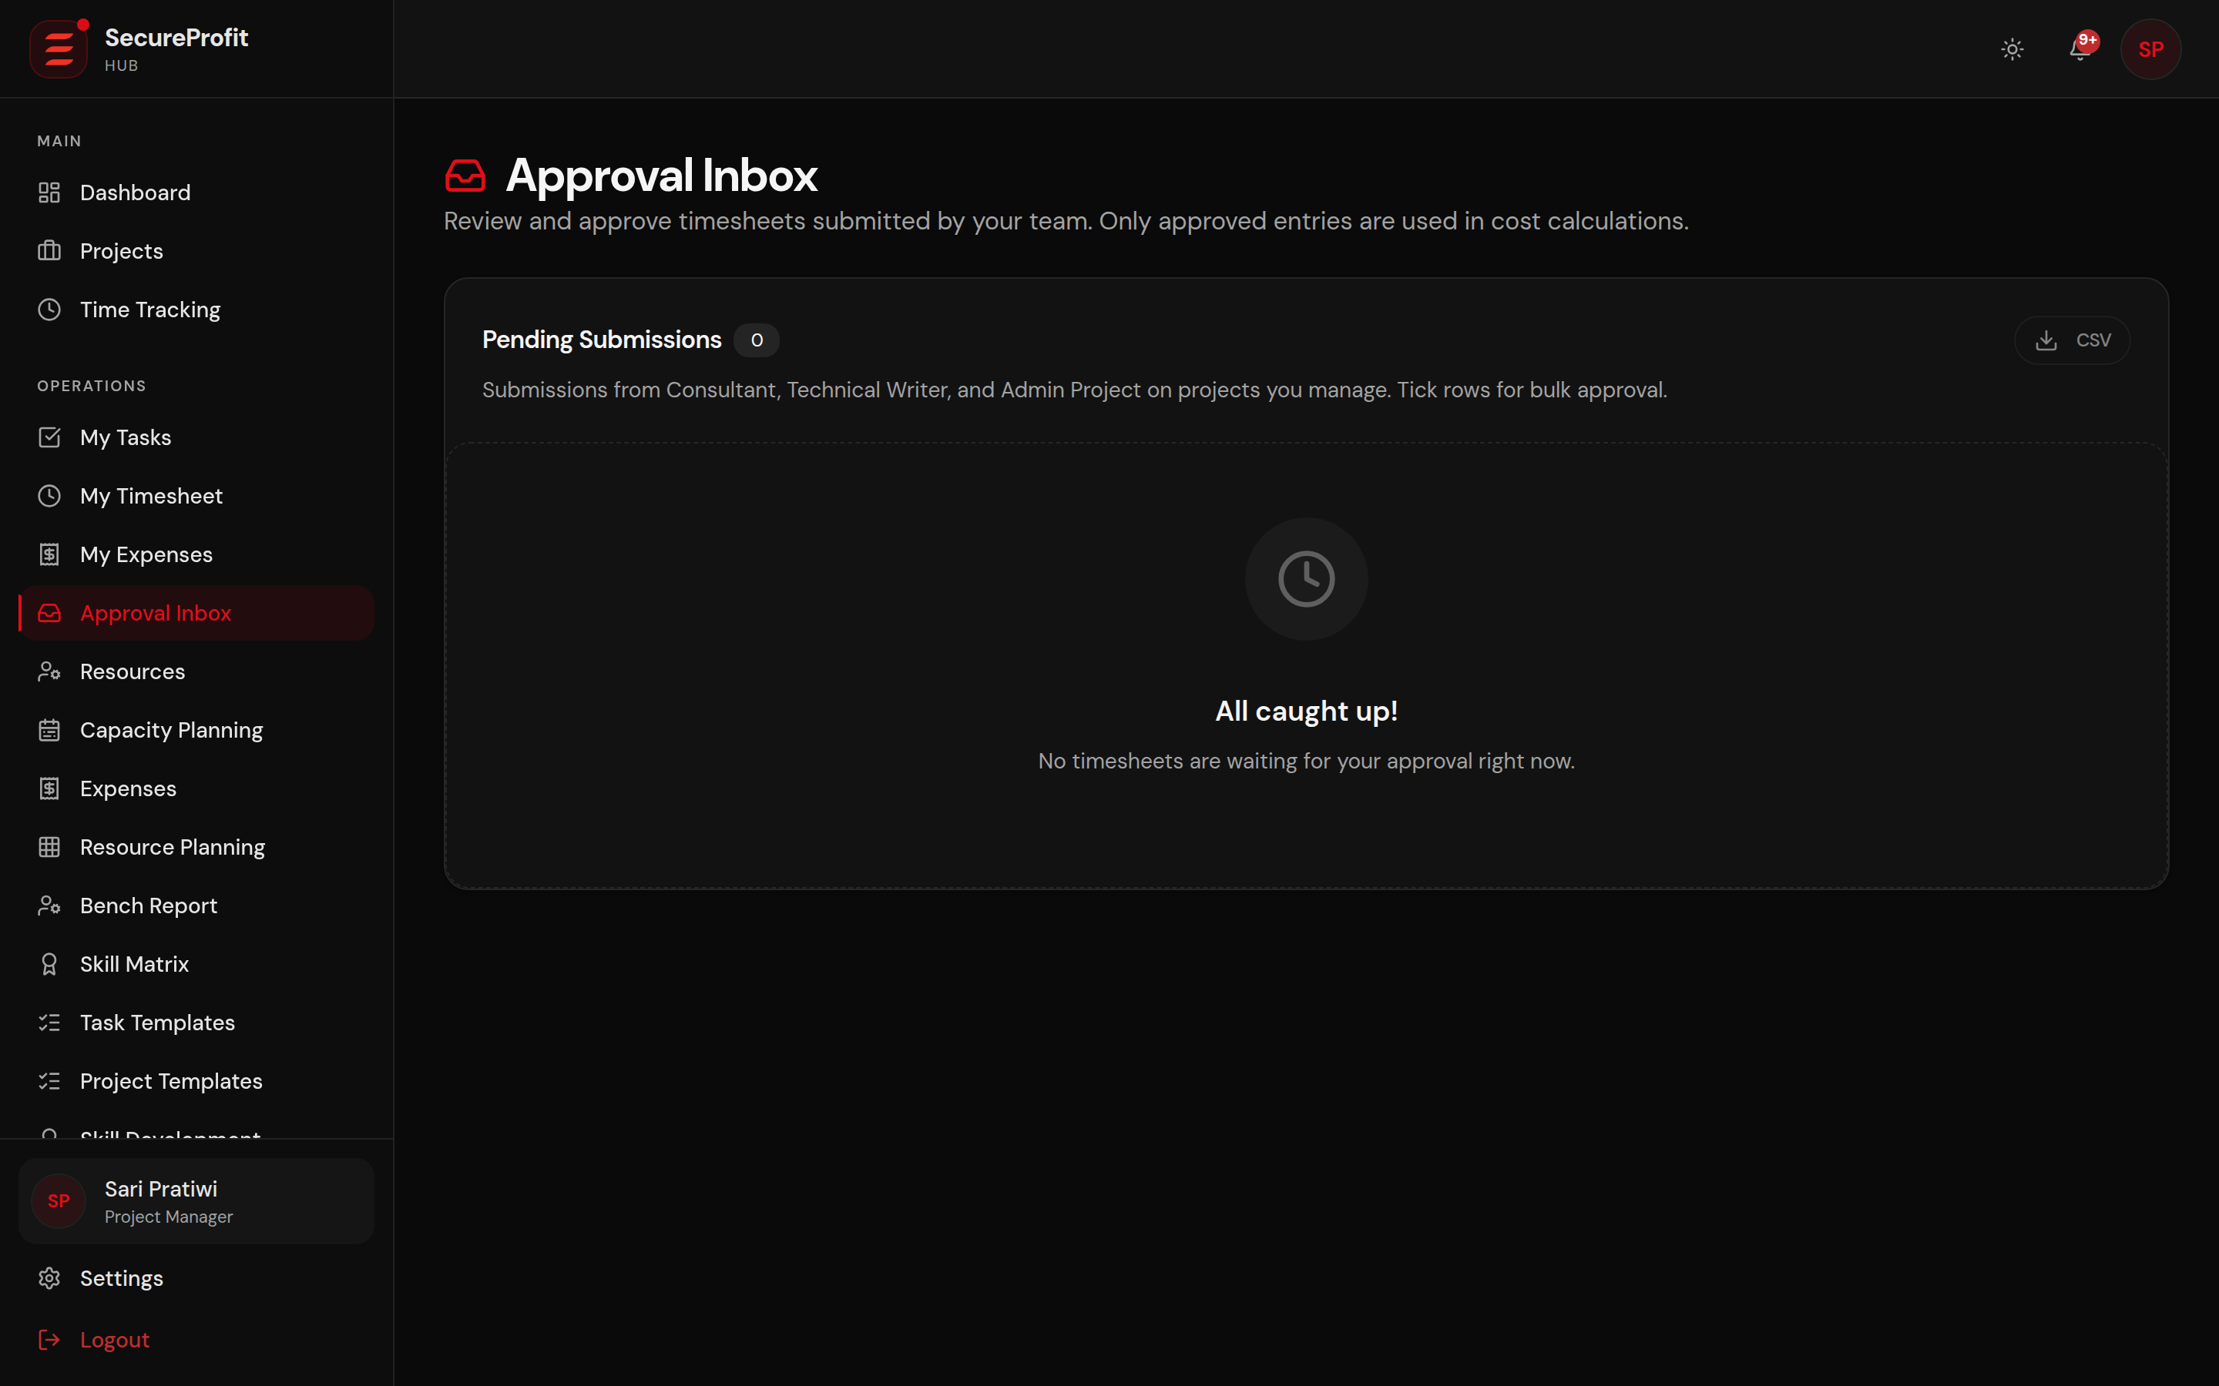
Figure 8 — Approval Inbox.

9.1 Timesheet Approval
1. Open “Approval Inbox” or the project Timesheets tab.
2. Filter to Submitted when needed.
3. Review project, user, date, task, hours, and notes.
4. Select Approve, or select Reject and enter a clear reason.
5. Use bulk approval only after reviewing every selected entry.

9.2 Expense Approval
Authorized PM/Management/Super Admin roles can review evidence and approve or reject. A rejection reason is required. Sales may have visibility without decision rights. Management/Super Admin claims may auto-approve.

10. Billing and Finance
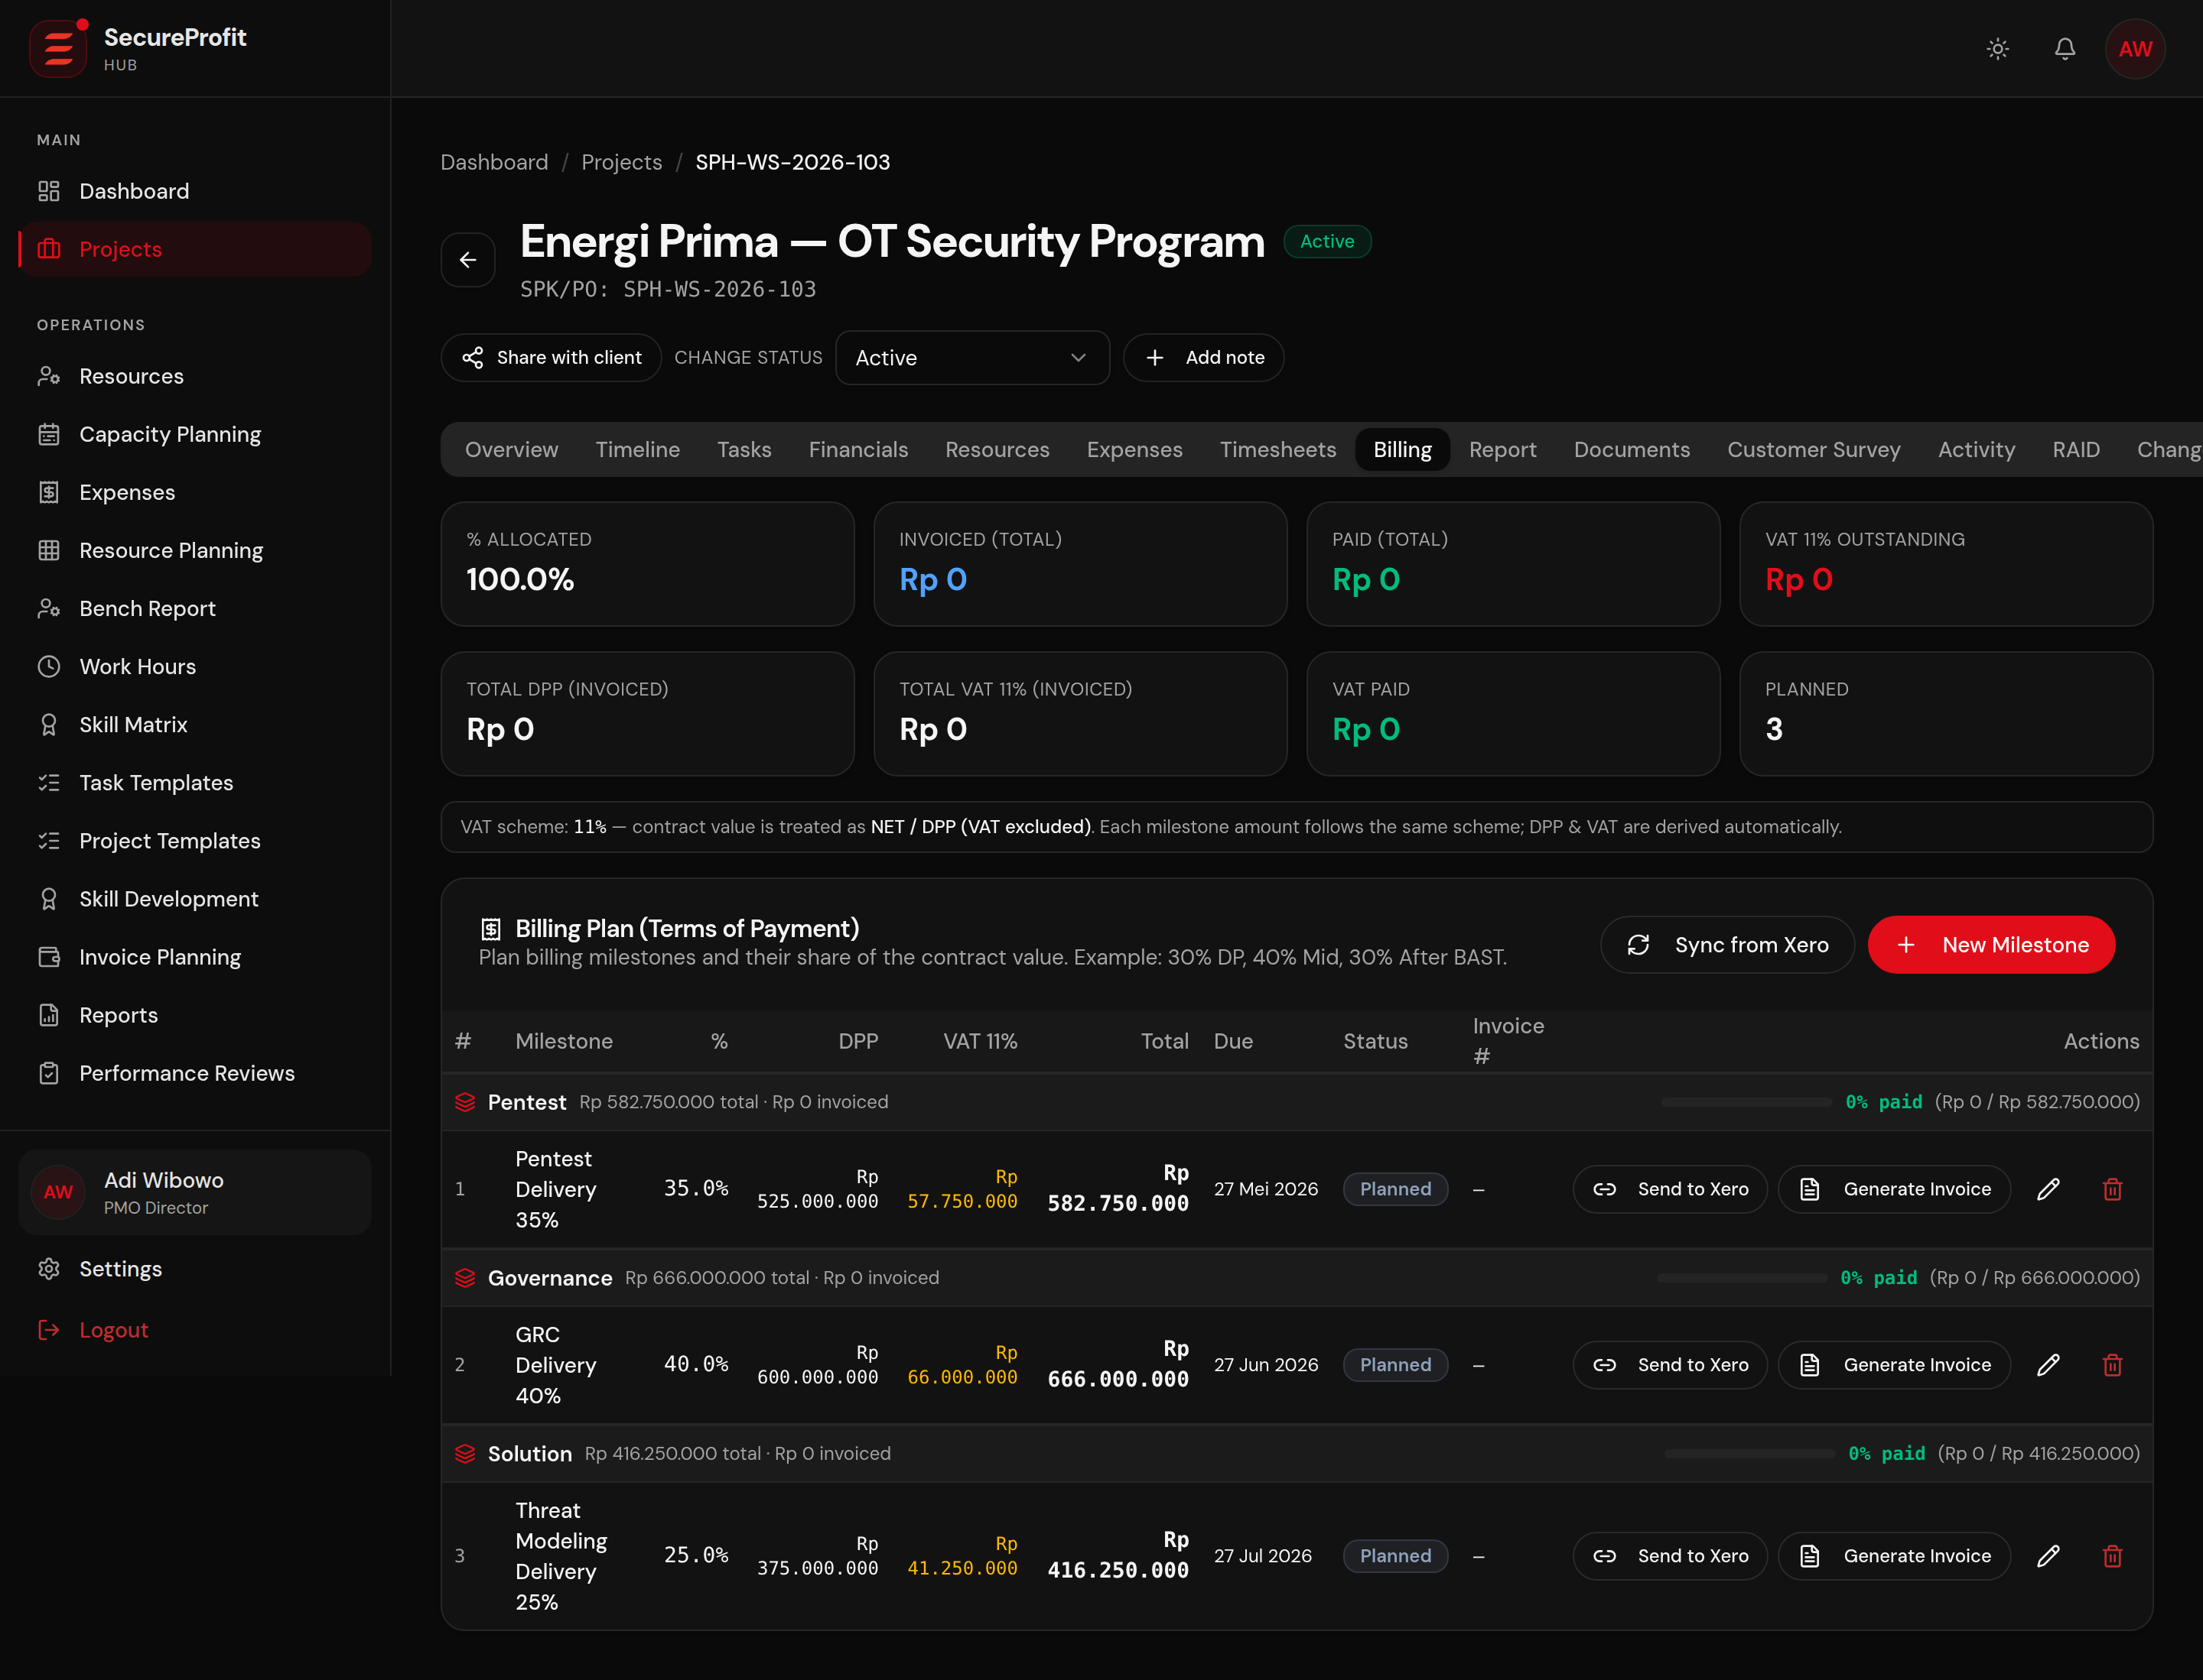
Figure 9 — Project Billing.

10.1 Billing Milestones
1. Open project Billing or Invoice Planning.
2. Create or review milestones, percentage, due date, and status.
3. Ensure milestone allocation totals 100%.
4. Generate or record invoice information according to finance procedures.
5. Use VAT Recap, Revenue Recognition, and Invoice Settings only if your role provides access.
Commercial invoicing is available only for eligible project statuses. Non-commercial project types do not use the same billing and revenue workflow.

11. Documents
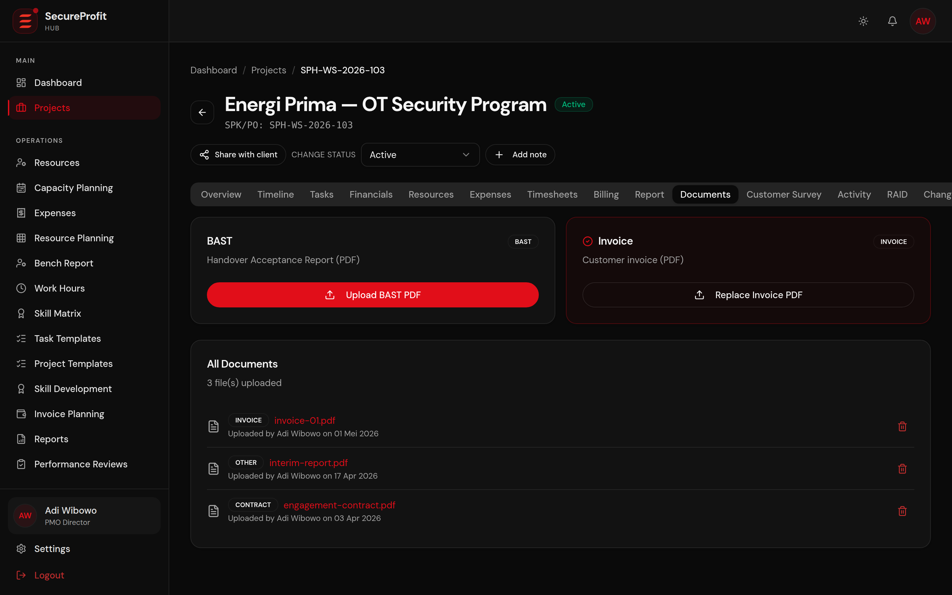
Figure 10 — Project Documents.

11.1 Upload a Project Document
1. Open the Documents tab.
2. Choose BAST, Invoice, Contract, or Other.
3. Select the file and complete required metadata.
4. Upload and confirm the document appears in the list.
5. Use the authorized download action; direct public file paths are not used.
Automatic closing: Uploading BAST and Invoice may trigger a close check, but a COMPLETE CLIENT project remains open until CSAT response or waiver and all required 360 feedback are ready. Manual Closing also requires the closing checklist.

12. Customer Survey, 360 Feedback, and Closing
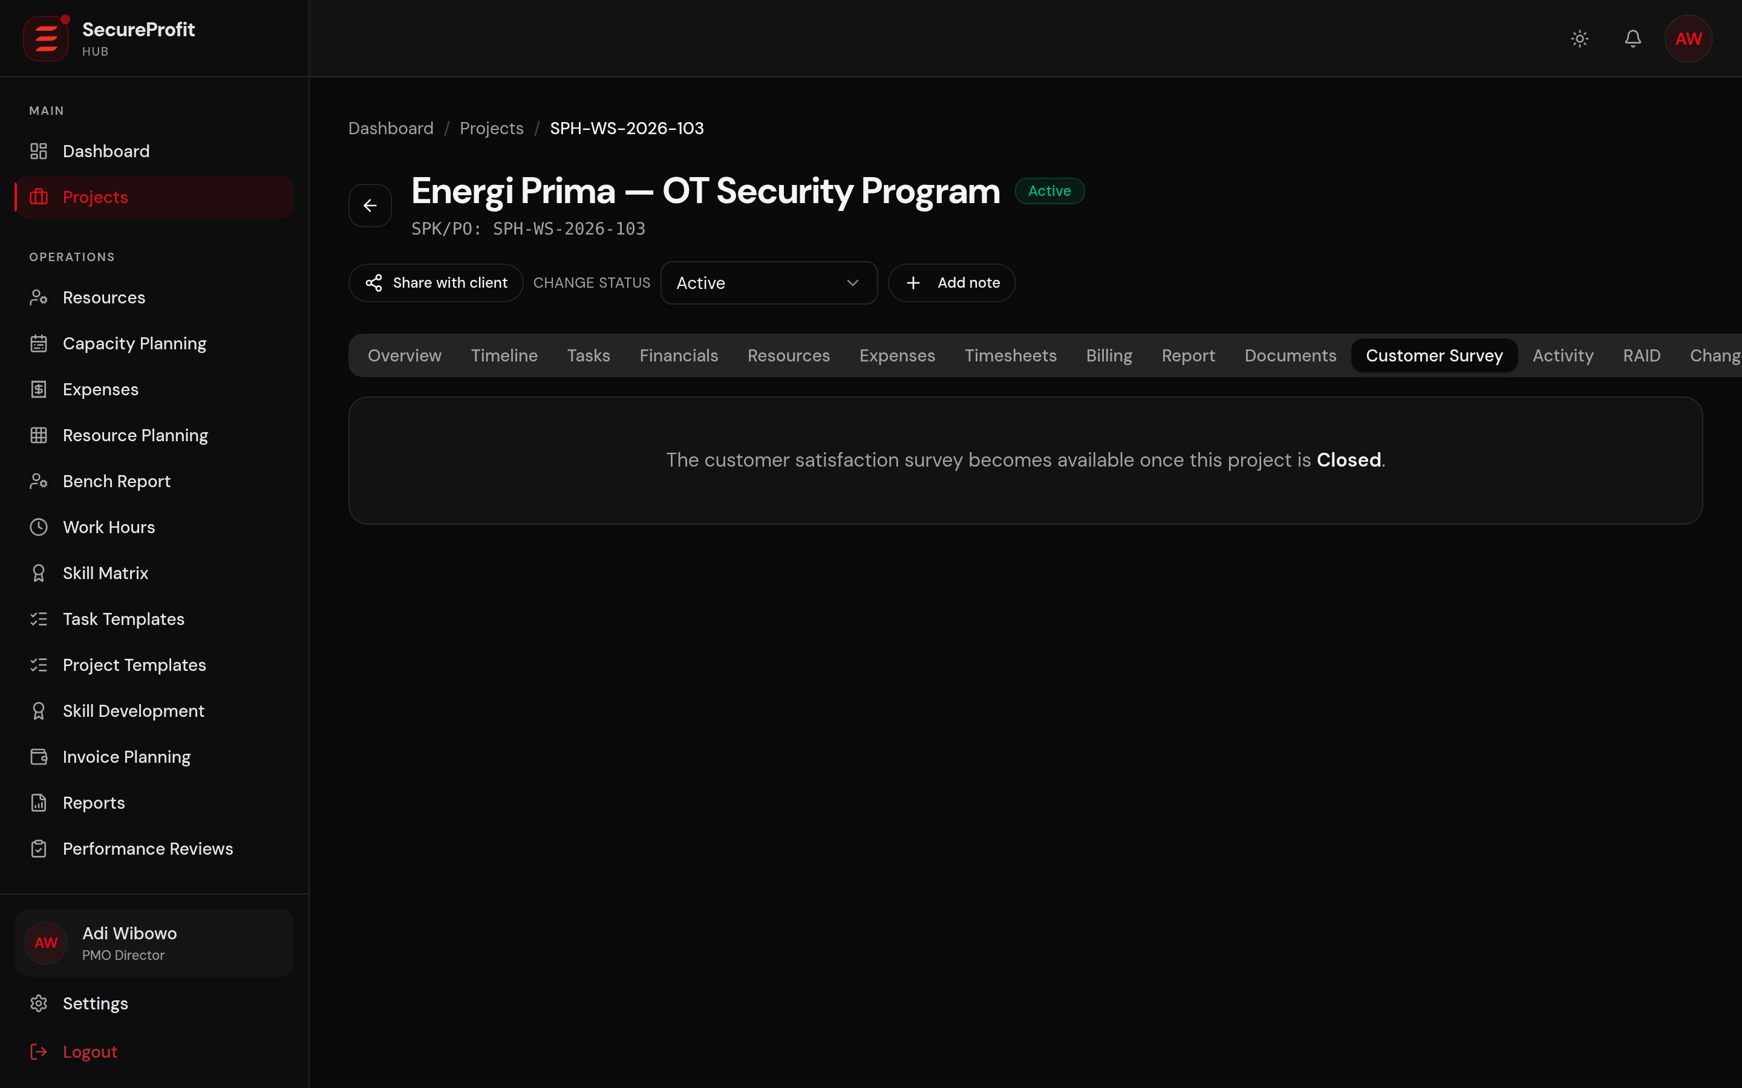
Figure 11 — Customer Survey tab.

12.1 Customer Survey (CSAT)
For a CLIENT project, the CSAT link becomes available at COMPLETE and remains valid at CLOSED unless disabled or expired. Archived/deleted projects and projects before COMPLETE cannot accept a public survey response.

12.2 Management Waiver
1. Open Customer Survey for a live CLIENT project in COMPLETE.
2. Confirm that the client will not provide a response.
3. Management or Super Admin enters a reason between 10 and 500 characters.
4. Grant the waiver. PMs can see waiver details but cannot manage it.
5. Remove the waiver only while the project remains eligible and closure has not occurred.
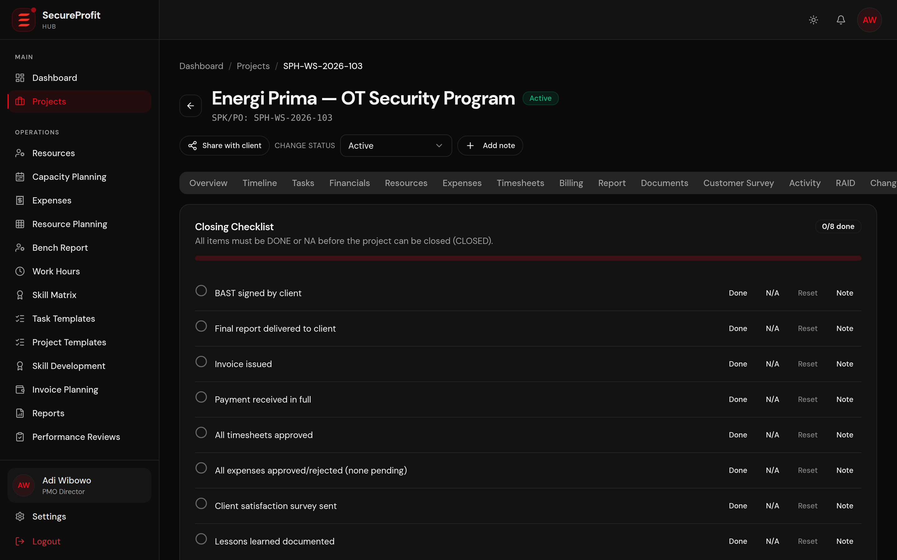
Figure 12 — Closing workspace.

12.3 Close a Project
1. Move delivery to COMPLETE after all completion blockers are resolved.
2. Complete every required closing-checklist item for manual closing.
3. Submit every generated 360 feedback entry.
4. Obtain at least one CSAT response, or use an active Management waiver for a non-responsive client.
5. Review the Close Readiness card.
6. When all applicable checks are ready, select the Close Project action and confirm.
Why the button is disabled: The project is not COMPLETE, checklist items remain pending, CSAT/waiver is missing, or one or more 360 feedback entries have not been submitted.

13. Reports and Management Analytics
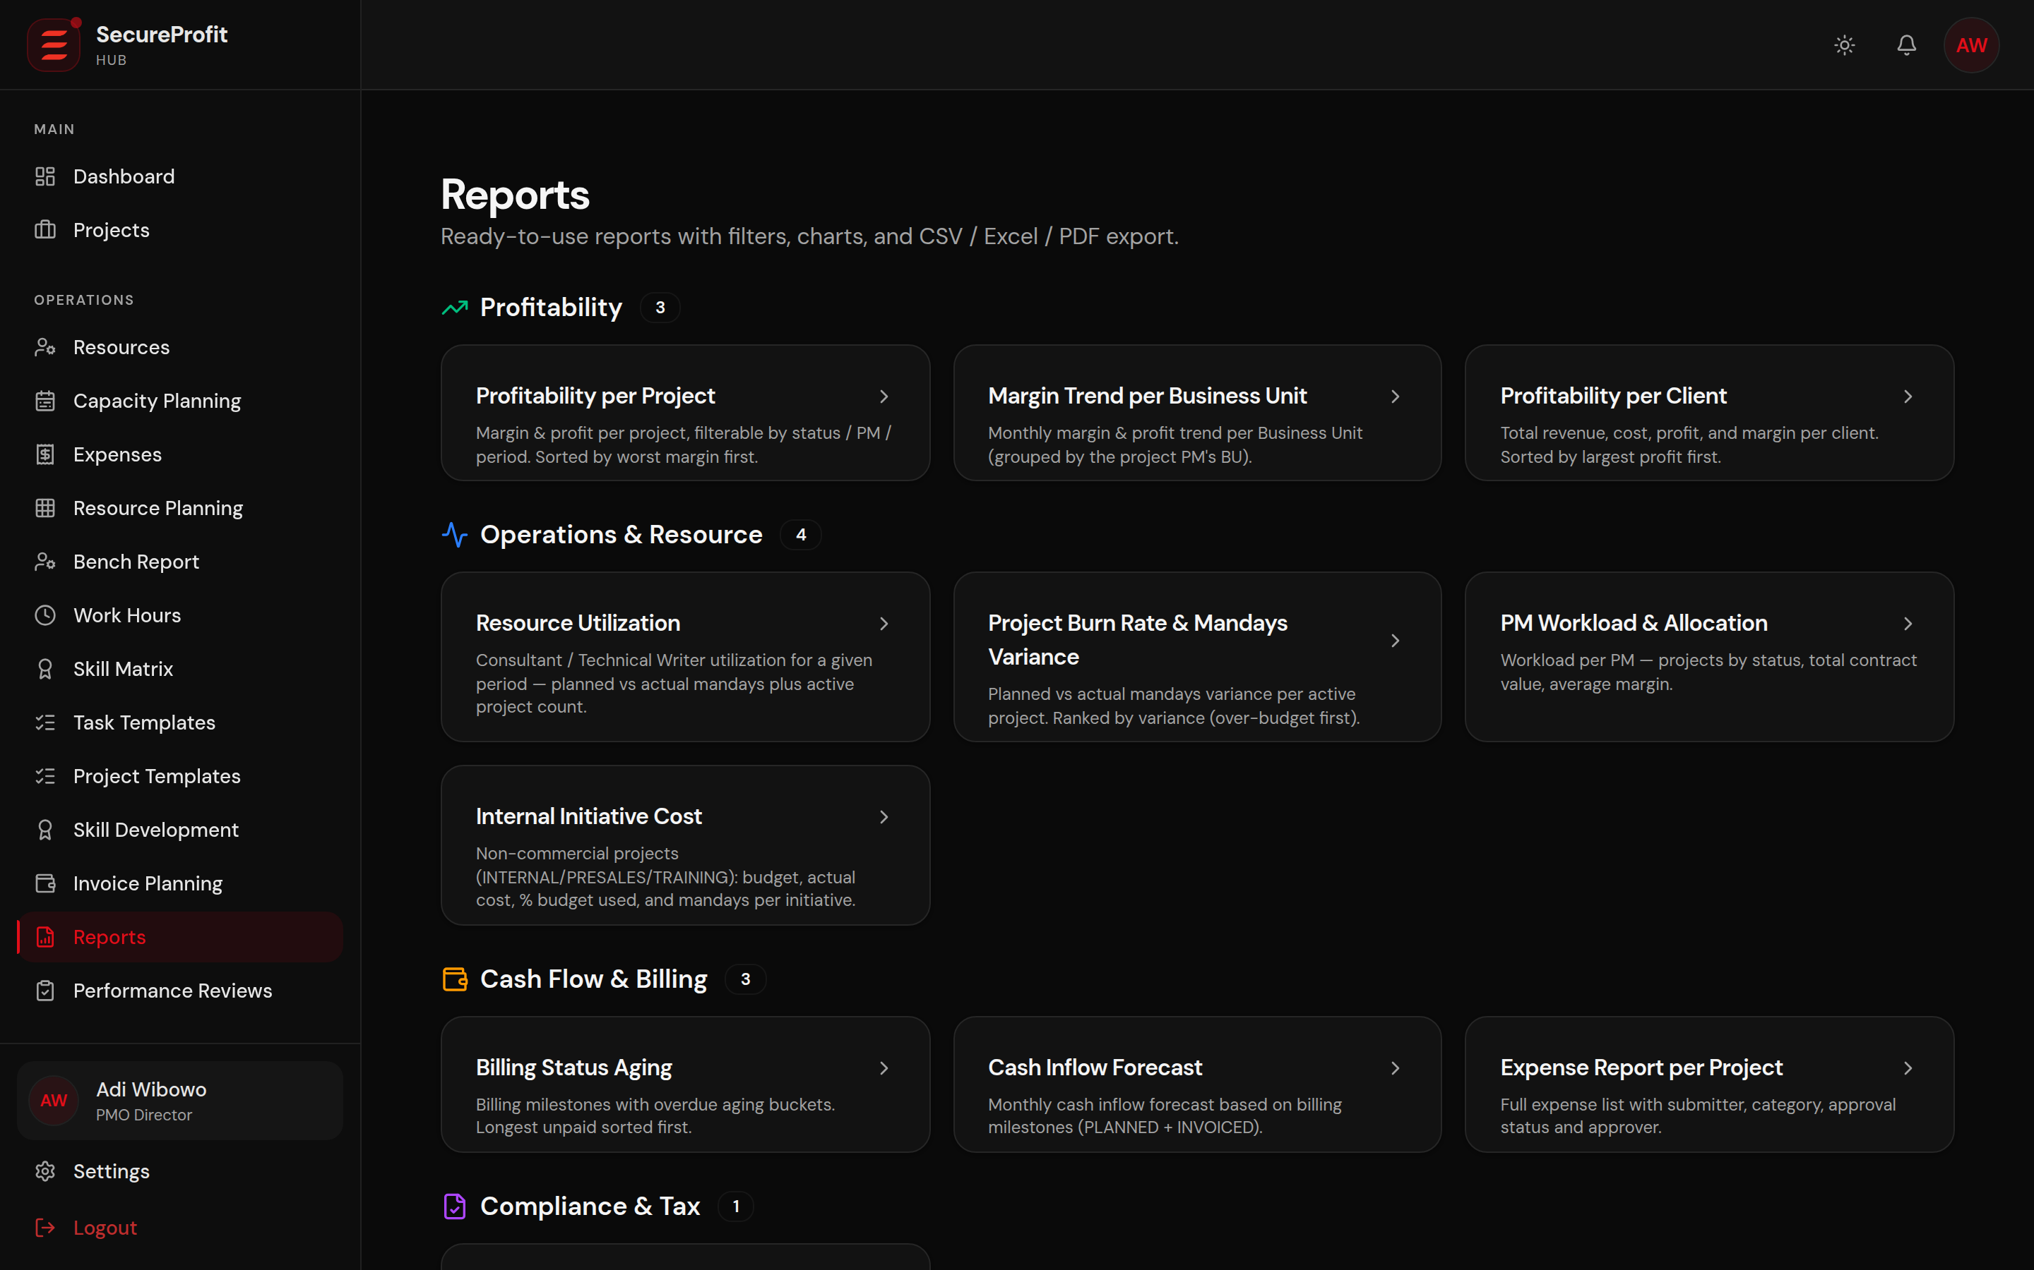
Figure 13 — Reports.
Reports and analytics are role-scoped. Available areas can include Reports, Business Intelligence, PM Dashboards, Portfolio Monitor, Top Performers, Revenue Recognition, VAT Recap, and AI Executive Copilot.

13.1 Run a Report
1. Open Reports.
2. Select the report definition or project report.
3. Set the period and filters.
4. Review the displayed data.
5. Export only when the output and data scope are appropriate for the recipient.

13.2 AI Executive Copilot
Management can request summarized portfolio insights. The system combines deterministic facts with AI narration. Always verify material financial or operational decisions against the source dashboard/report.

14. People and Administration
Area | Primary users | Purpose
Employees / Users | HR, Site Admin, Super Admin | Account and personnel lifecycle
Org Chart / Leave | HR and authorized managers | Reporting lines and leave
Business Units / Skills | HR/admin roles | Organization taxonomy
Clients | Authorized Sales/Finance/admin roles | Client master data
Access Requests | Site Admin | Approve/reject new Google-domain users
Audit Log | Site Admin / Super Admin | Review security and business change history
User deletion is generally soft deletion so historical project, financial, and audit records remain intact.

15. Mobile Application

15.1 Mobile Navigation
Tabs are role-gated and can include Track, Timesheets, Expenses, Projects, Approvals, and Alerts. Track/Timesheets/Expenses are available only to supported logging roles. Approvals is currently shown to Project Manager in the mobile navigation.
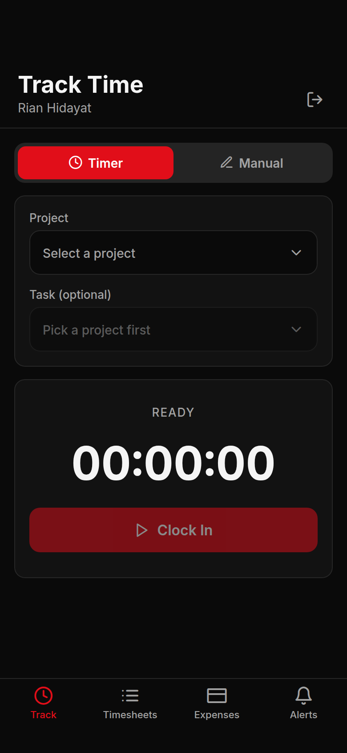
Figure 14 — Mobile Track Time.

15.2 Track Time with Timer
1. Open Track and select Timer.
2. Choose an active project.
3. Choose a task when required by your role.
4. Select “Clock In”.
5. When finished, select “Clock Out & Log”.
6. Confirm “Log & Submit”, or keep the timer running. Use Discard only when the session should not be recorded.
The running timer is stored on the device and keyed to the signed-in user. This prevents a timer from one account appearing in another account on a shared phone.

15.3 Manual Mobile Entry
1. Open Track and select Manual.
2. Choose a date from the available recent-date chips.
3. Select project and required task.
4. Enter hours and optional notes.
5. Select “Log & Submit”.
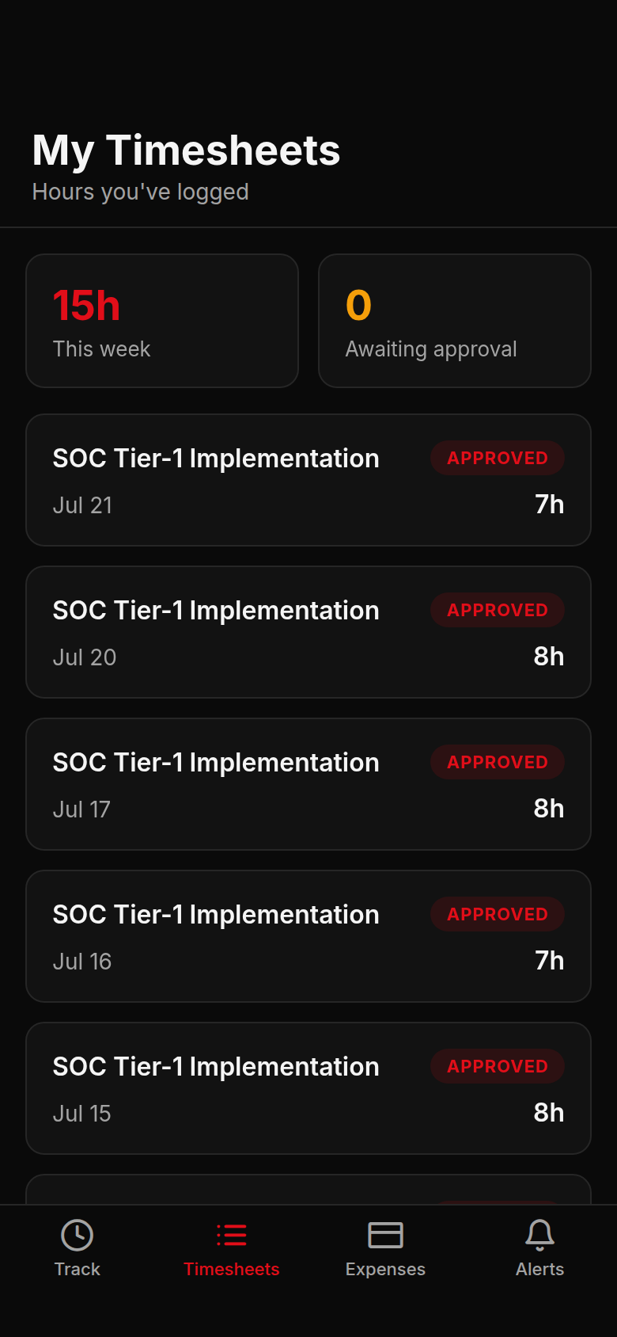
Figure 15 — Mobile Timesheets.

15.4 Mobile Timesheets
My Timesheets shows this-week hours, awaiting-approval count, and rows with date, project, task, hours, and status. A rejected entry shows its rejection reason.
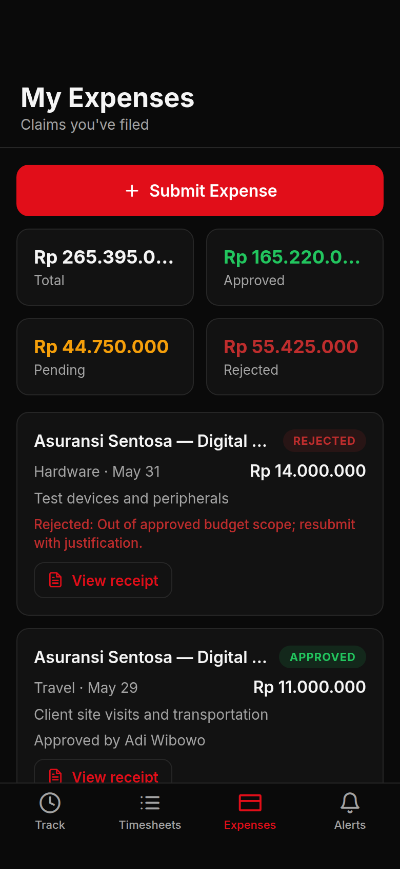
Figure 16 — Mobile Expenses.

15.5 Mobile Expenses
1. Select Submit Expense.
2. Enter project, category, amount, date, description, and evidence.
3. Submit and monitor KPI cards for Total, Approved, Pending, and Rejected.
4. Authorized team reviewers can switch to Team, open evidence/receipt, and Approve or Reject.
5. Enter a reason before confirming rejection.

15.6 Mobile Projects and Alerts
Projects supports search, status chips, pull-to-refresh, and project detail. Alerts shows role-scoped notifications. If a project becomes unavailable or archived during entry, refresh and return to the list before trying again.

16. Common Messages and Troubleshooting
Message / symptom | Meaning and action
Pick a project | Choose a project before starting or submitting time.
Pick a task | Your role requires an assigned task.
Invalid hours | Enter a numeric value greater than 0.
Rejected: [reason] | Correct the entry according to the approver comment and resubmit if allowed.
Project must be in COMPLETE status | Finish completion requirements before closing.
CSAT response or Management waiver required | Collect a survey response or ask Management for a documented waiver.
Pending 360 feedback | The listed reviewers must submit their feedback.
Menu is missing | Your role, assignment, ownership, or project status does not permit the action.
Session expired | Sign in again. Unsaved form data may need to be re-entered.
Upload rejected | Check file type, size, and project permission.

When to Contact Support
- You cannot sign in after the lock period has passed.
- A project or financial value is outside your expected authorized scope.
- An approved record does not appear after refresh.
- A document is listed but cannot be downloaded by an authorized project member.
- A closing check remains stale after CSAT/360/checklist data is refreshed.
- The mobile app repeatedly redirects or cannot reach the production API.

17. Quick Reference

Project Manager Daily Checklist
- Review Smart Alerts and Approval Inbox.
- Check project tasks, RAID, resource allocation, and pending time/expenses.
- Review billing and documents for commercial projects.
- Keep status and status-change reason current.
- At completion, coordinate BAST, CSAT, 360, checklist, and final closing.

Team Member Daily Checklist
- Check assigned tasks and project status.
- Log time against the correct project/task.
- Submit expenses with complete evidence.
- Resolve rejected entries promptly.
- Complete assigned 360 feedback when requested.

Management / Finance Checklist
- Review portfolio health, margin, revenue, and aging.
- Resolve approvals and integration exceptions.
- Use CSAT waiver only for a documented non-response.
- Verify billing and revenue evidence before reporting.
- Review audit and security alerts according to policy.
— End of User Manual —

