TECHNICAL REQUIREMENT

The steps to install Domain Search Tool :
1. Install Java Runtime Environment (JRE) by download from URL :
http://www.oracle.com/technetwork/java/javase/downloads/jre7-downloads-1880261.html
and then select the appropriate version for your OS (Windows, Mac, Linux…)

2. Double-click to activate the program executable file

USER GUIDE

I. Main form:

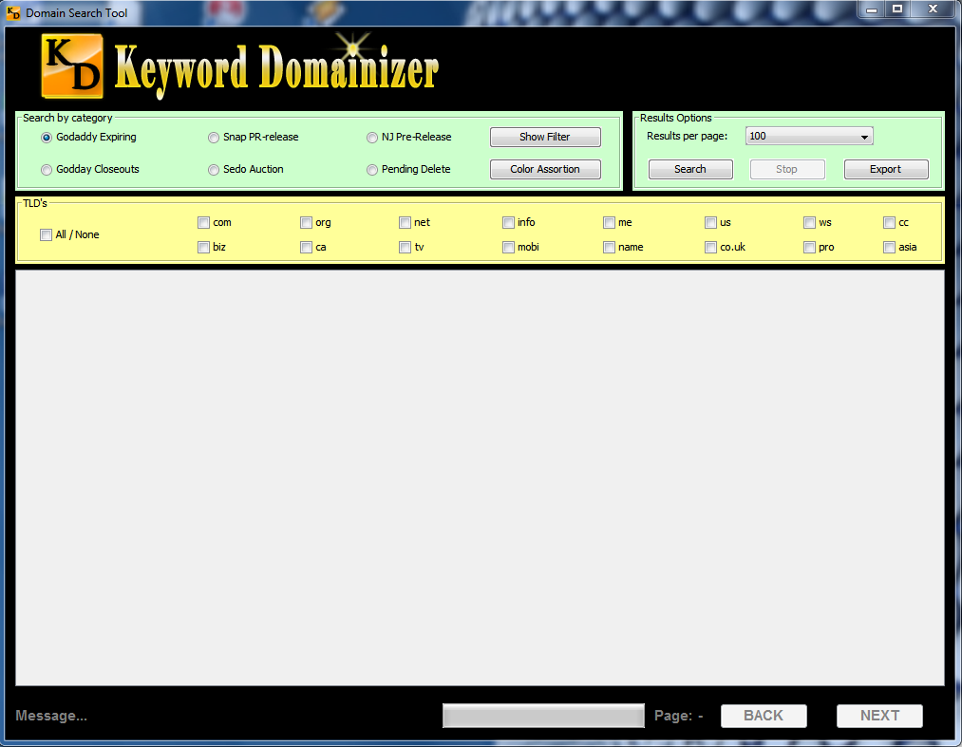

In this main form, you can see areas:
- Search by Category:
+ With 6 single chooses (Godaddy Expiring, Godaddy Closeout, Snap Pr-Release, Sedo Auction, NameJet Pr-Release, Pending Delete)
+ Show Filter button : Open Filter dialog

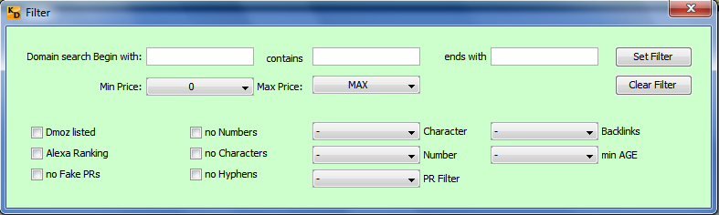

+ Color Assortion : Open Color Assortion dialog

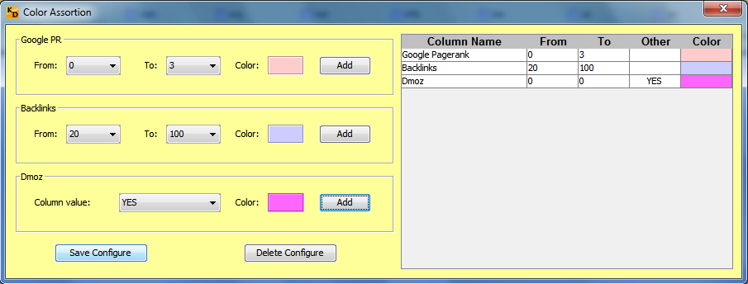

- Result Option: with 3 buttons Refresh, Stop and Export
+ Refresh : click it for active download
+ Stop : click it if you want to stop download
+ Export : this button will help you export download results to excel file or csv file

- If download results larger than 1 page, NEXT button will be enable, you can click NEXT button to go to the next page, click BACK button to return to the previous page
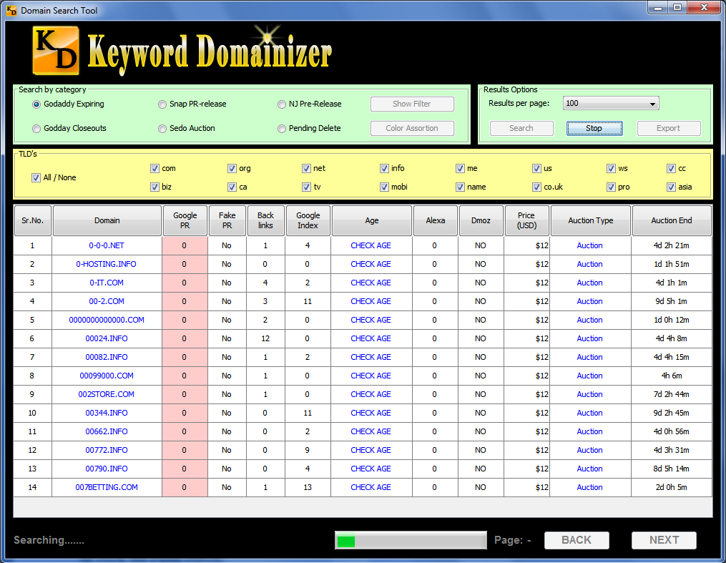

- Columns can be sorted : Domain, Google Pagerank, Fake PR, Backlinks, Google Index, Age, Dmoz, Alexa, Price
- Columns have highlight background color : Google Pagerank, Backlinks, Dmoz

II. Show Filter Dialog:

- Search Begin with OR Contain OR End with
- Search by Min Price to Max price
- If check Dmoz listed : data will be filter with column Dmoz is YES
- If check Alexa Ranking : data will be filter with column Alexa is different 0
- If check No Fake PRs : data will be filter with column Fake PR is No
- If check No number : data will be filter with Domain Name is not exists numbers
- If check No Character : data will be filter with Domain Name is not exists characters
- If check No Hyphen : data will be filter with Domain Name is not exists “-“ char
- You can select numbers in lists (Character, PR, Backlinks, Min Age) to filter data according your wishes
- Click Set Filter button to save configure
- Click Clear Filter button to clear configure on the form, if you want to save this change, you must be click Set Filter button.

III. Color Assortion dialog:

- Click Save Configure button to save config.
- Select one row on the grid, click Delete Configure to delete selected row, but this change has not been saved, if you want to save, you must be click Save Configure button.

IV. Check Age:
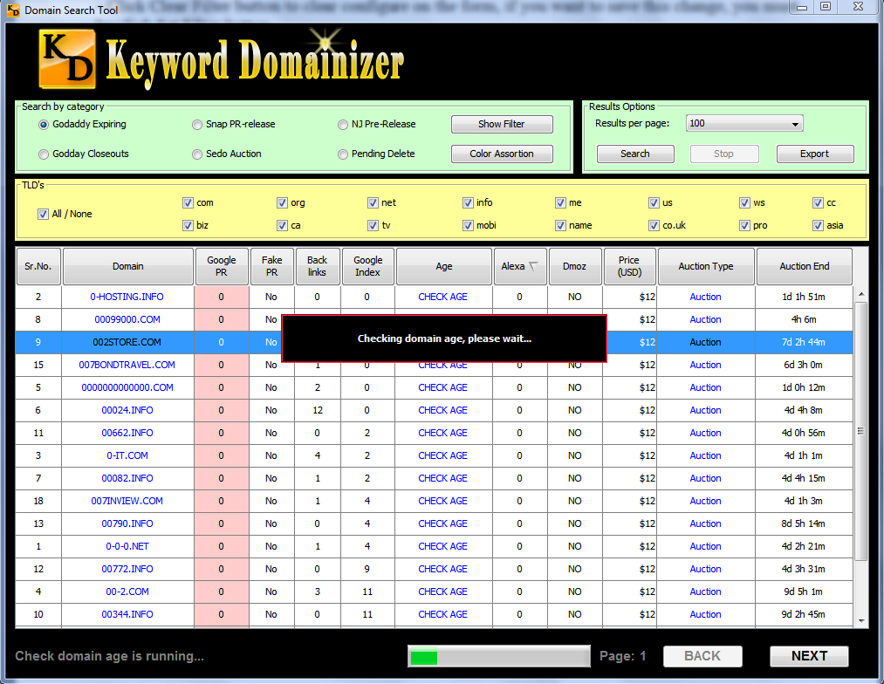

Single click into CHECK AGE link, software will be check domain age and show.

V. Check domain status:

If you right click into Domain name link, the context menu will be show, you choose Check domain status item, software will be check all stats of domain and show into other form.

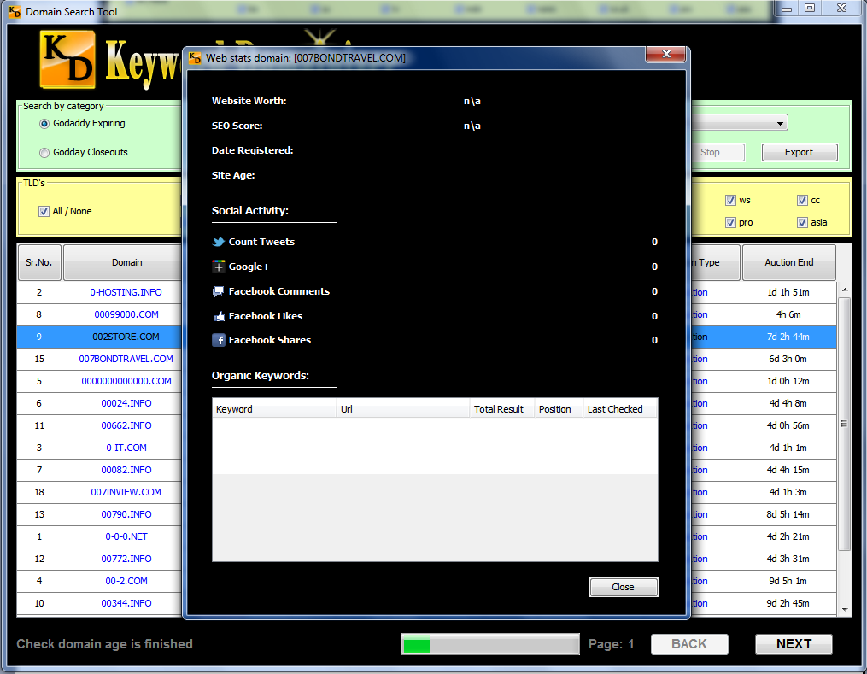

--------------THE END--------------

