Homework — EC3 Column Buckling Check
For your assigned variant, perform the following calculations by hand:
- 1. Calculate the cross-section properties of the given HQ section: Area (A), Moments of inertia (Iy, Iz), Section moduli (Wy, Wz), Radii of gyration (iy, iz), and Centroid position.
- 2. Perform a strength check (EN 1993-1-1 cl. 6.2.4) and a buckling check (EN 1993-1-1 cl. 6.3.1) for both axes. Determine the governing check and overall utilization ratio.

Common Parameters (all variants)
Boundary conditions: Pinned-pinned (μ_y = μ_z = 1.0)
Buckling curve: c (α = 0.49)
Partial safety factors: γ_M0 = γ_M1 = 1.0
Elastic modulus: E = 200,000 MPa

Variant Assignments
Variant | L (m) | N_Ed (kN) | Steel Grade | Section
1 | 8 | 1415 | S235 | 1
2 | 9 | 2440 | S275 | 2
3 | 6 | 6780 | S355 | 3
4 | 6 | 7015 | S420 | 4
5 | 9 | 4400 | S235 | 5
6 | 6 | 4870 | S275 | 6
7 | 8 | 4605 | S355 | 7
8 | 6 | 9630 | S420 | 8
9 | 5 | 5625 | S235 | 9
10 | 3 | 15360 | S275 | 10

Cross-Section Drawings
All dimensions are in millimetres (mm). Coordinate labels show absolute positions of each edge.

Section 1
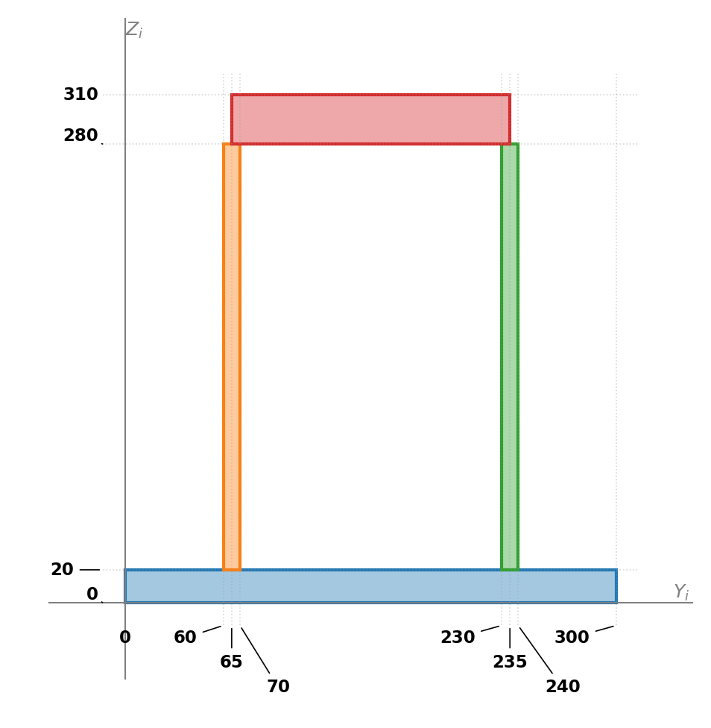

Section 2
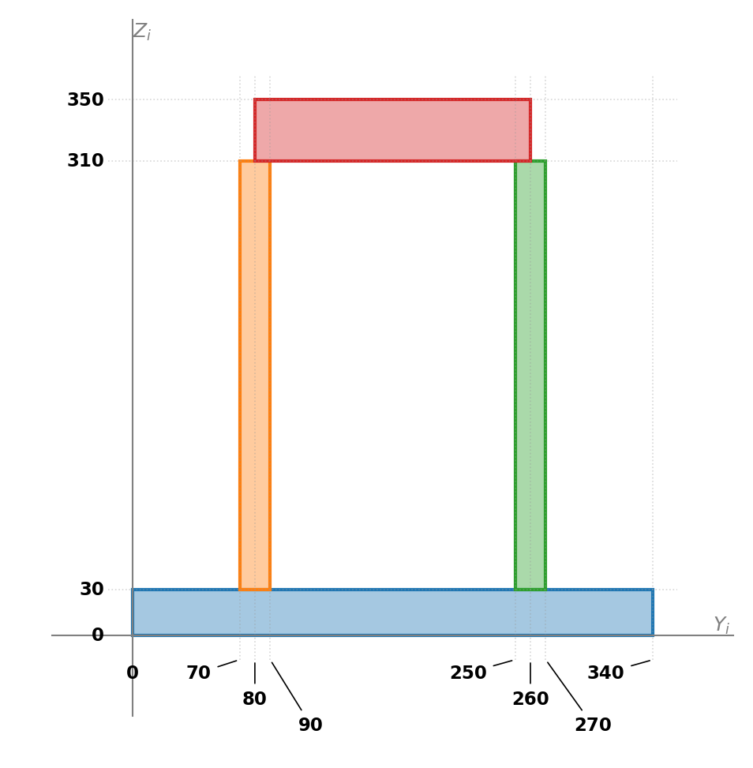

Section 3
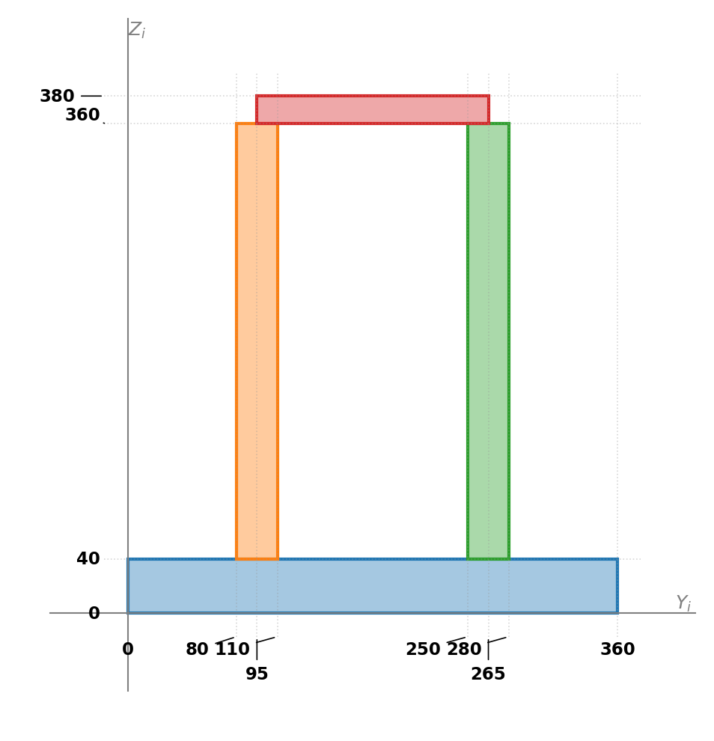

Section 4
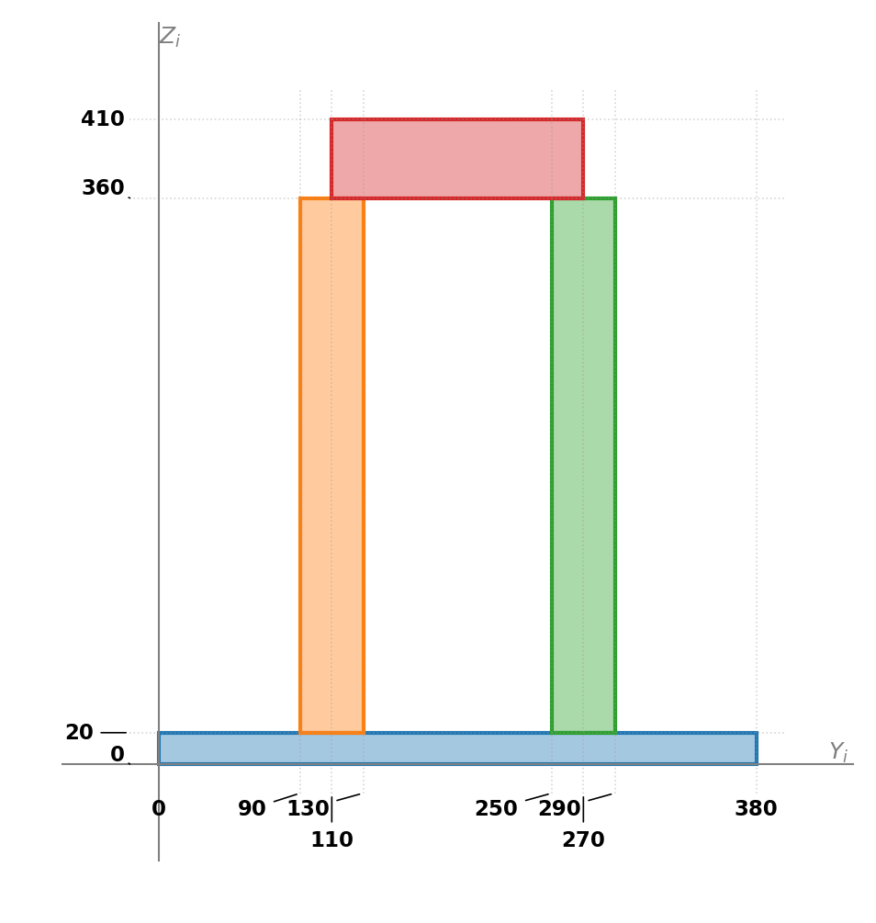

Section 5
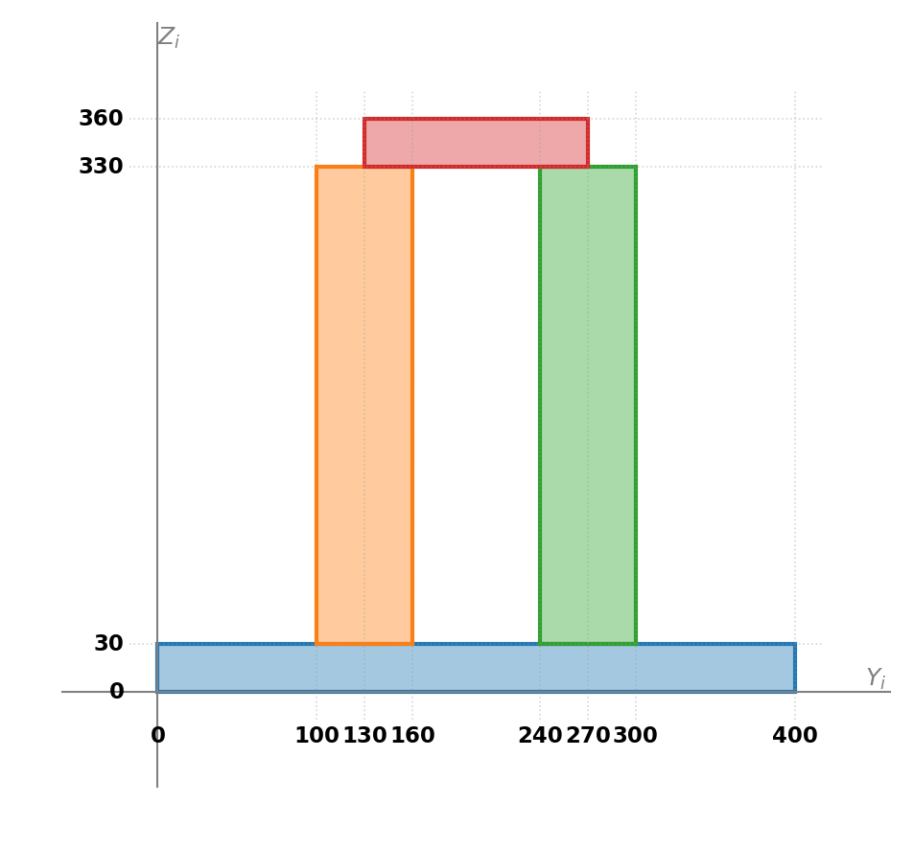

Section 6
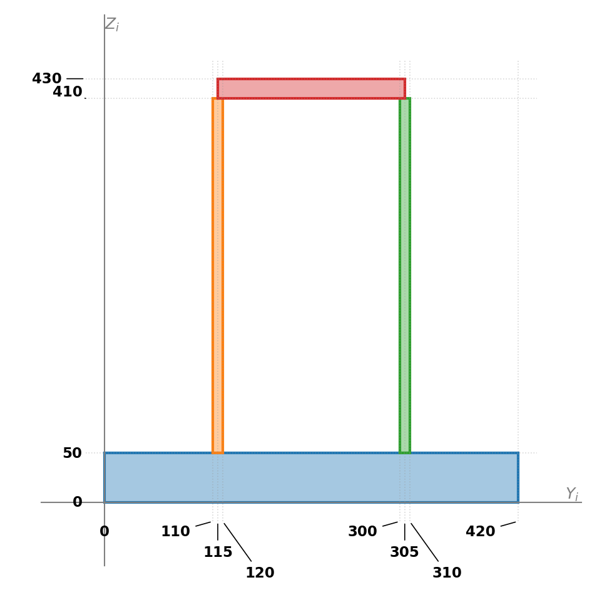

Section 7
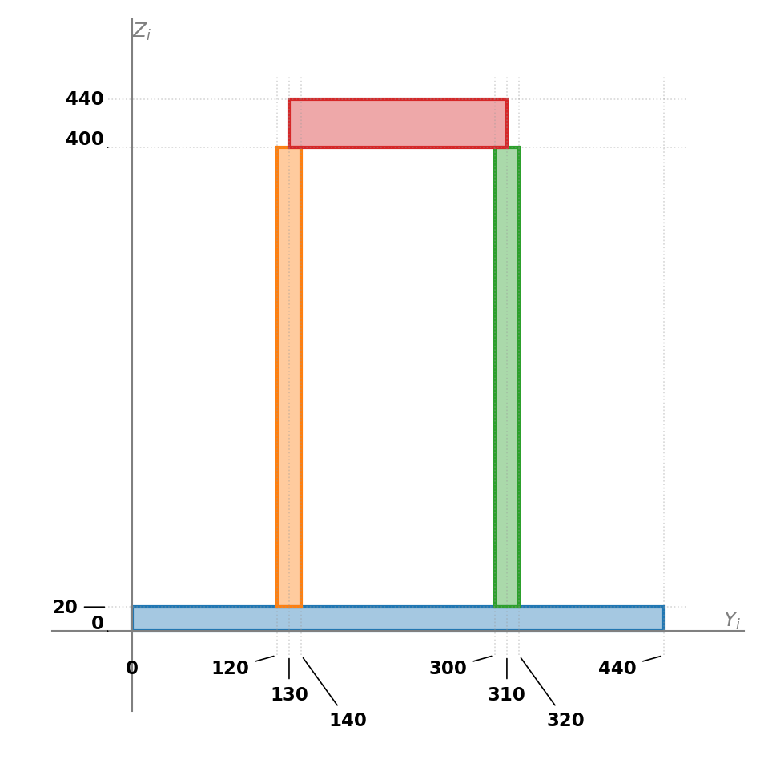

Section 8
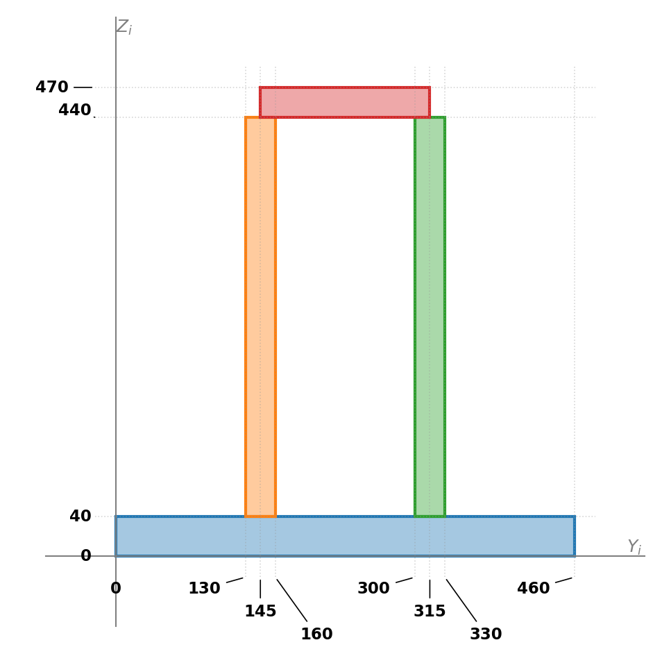

Section 9
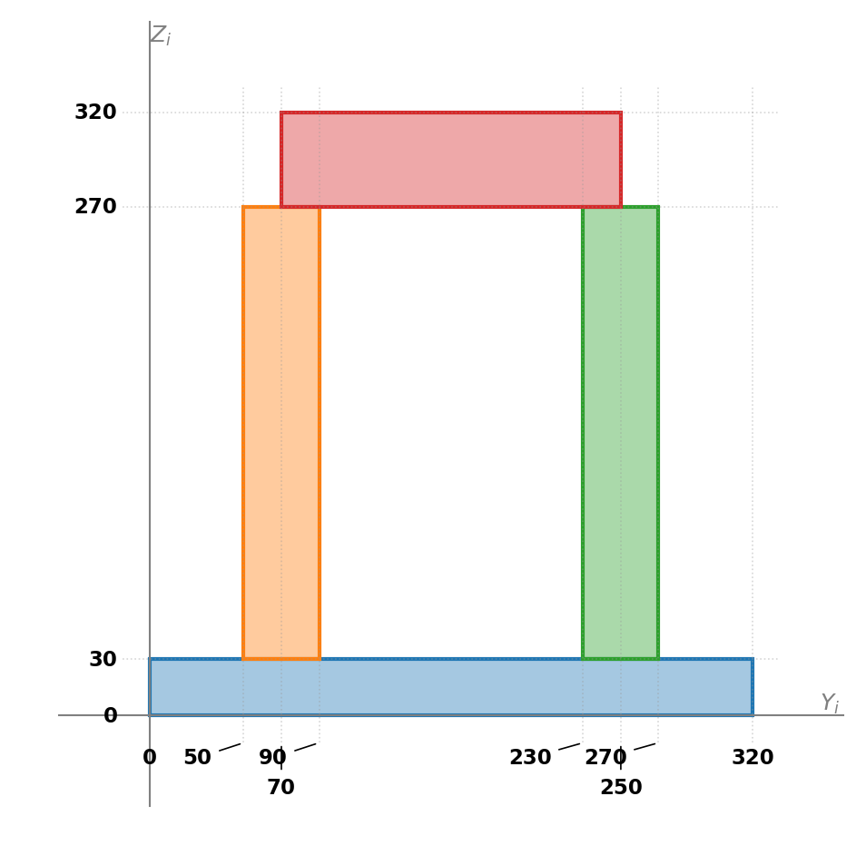

Section 10
