Homework — TEACHER KEY

Section Properties Summary
Sec | A (mm²) | Iy (mm⁴) | Iz (mm⁴) | iy (mm) | iz (mm) | Wy (mm³) | Wz (mm³) | yc (mm) | zc (mm)
1 | 16300 | 254083686 | 94895833 | 124.85 | 76.30 | 1529099 | 632639 | 143.8 | 150.0
2 | 28600 | 497838333 | 208793333 | 131.94 | 85.44 | 2553017 | 1228196 | 155.0 | 170.0
3 | 37000 | 621066414 | 303868333 | 129.56 | 90.62 | 2649234 | 1688157 | 145.6 | 180.0
4 | 42800 | 813525358 | 286226667 | 137.87 | 81.78 | 3774814 | 1506456 | 194.5 | 190.0
5 | 52200 | 680528793 | 354060000 | 114.18 | 82.36 | 3325246 | 1770300 | 155.3 | 200.0
6 | 32000 | 700782635 | 385171667 | 147.98 | 109.71 | 2246323 | 1834151 | 118.0 | 210.0
7 | 31200 | 851708718 | 285040000 | 165.22 | 95.58 | 3579379 | 1295636 | 202.1 | 220.0
8 | 47500 | 1265746444 | 511935833 | 163.24 | 103.82 | 4332718 | 2225808 | 177.9 | 230.0
9 | 37800 | 458937857 | 264300000 | 110.19 | 83.62 | 2703421 | 1651875 | 150.2 | 160.0
10 | 77200 | 1879942867 | 727453333 | 156.05 | 97.07 | 6371009 | 3031056 | 194.9 | 240.0

Cross-Section Drawings (with centroid & axes)

Section 1
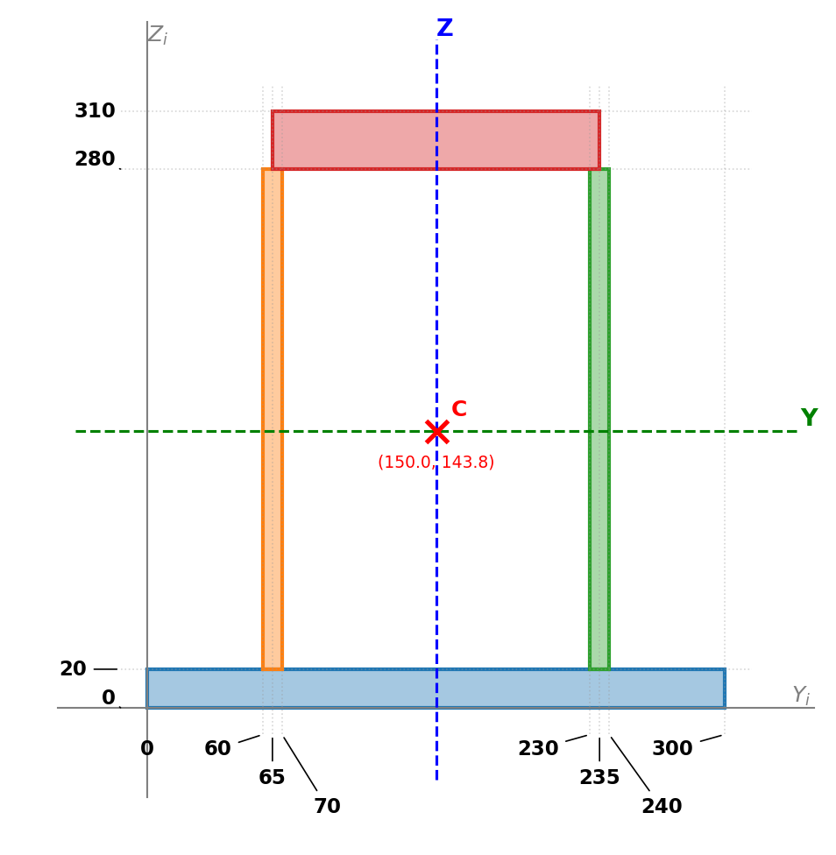

Section 2
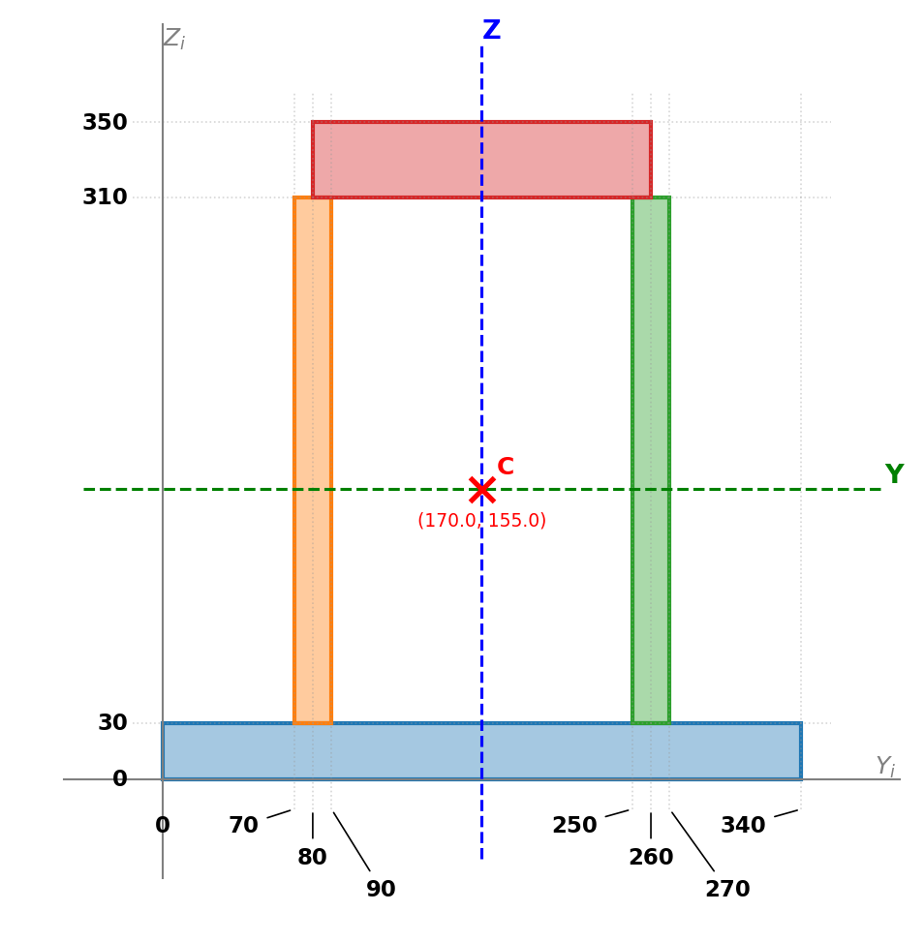

Section 3
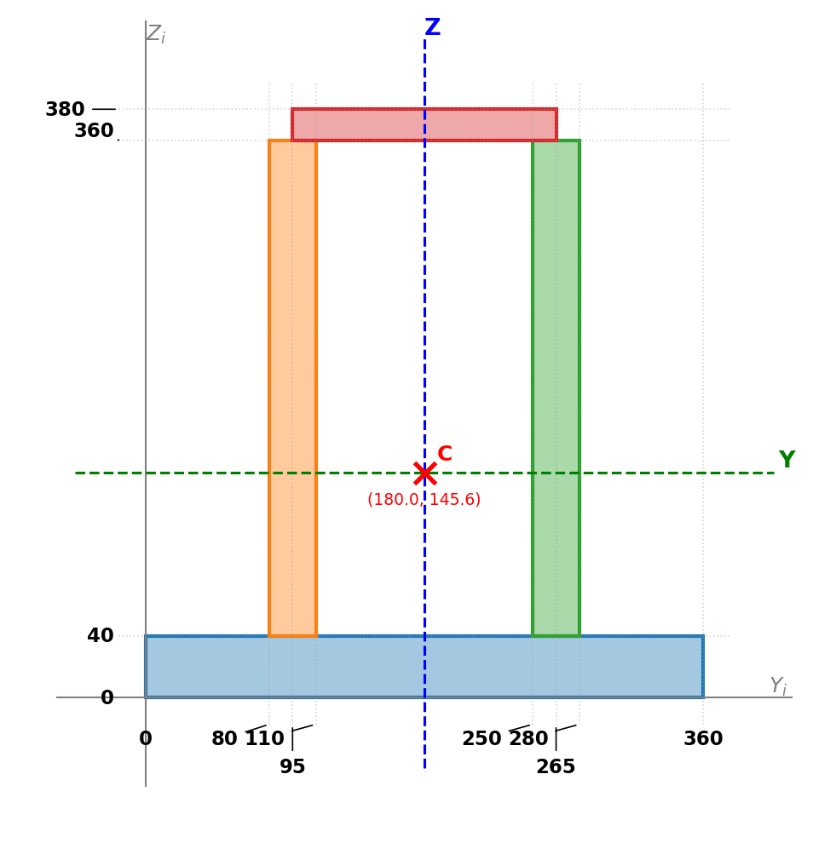

Section 4
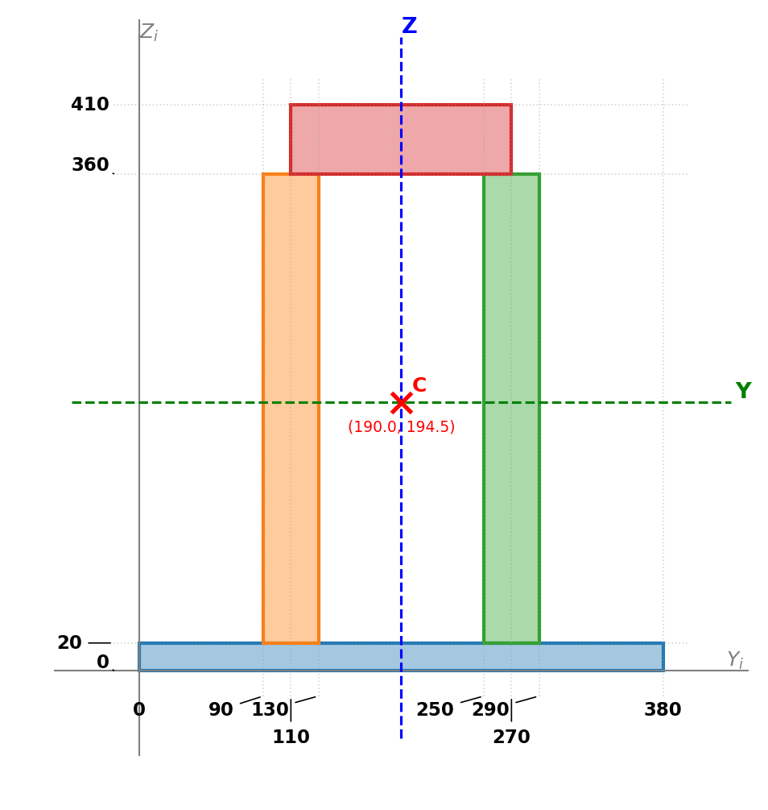

Section 5
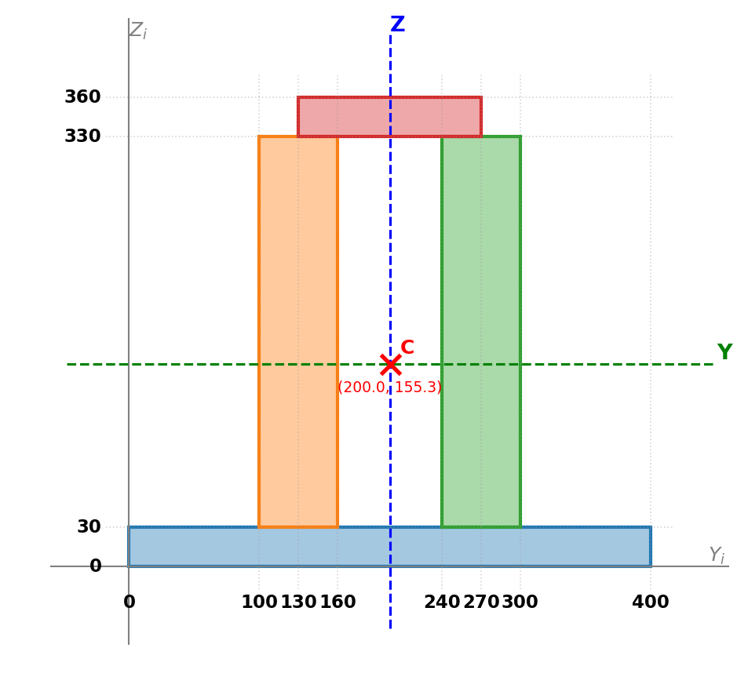

Section 6
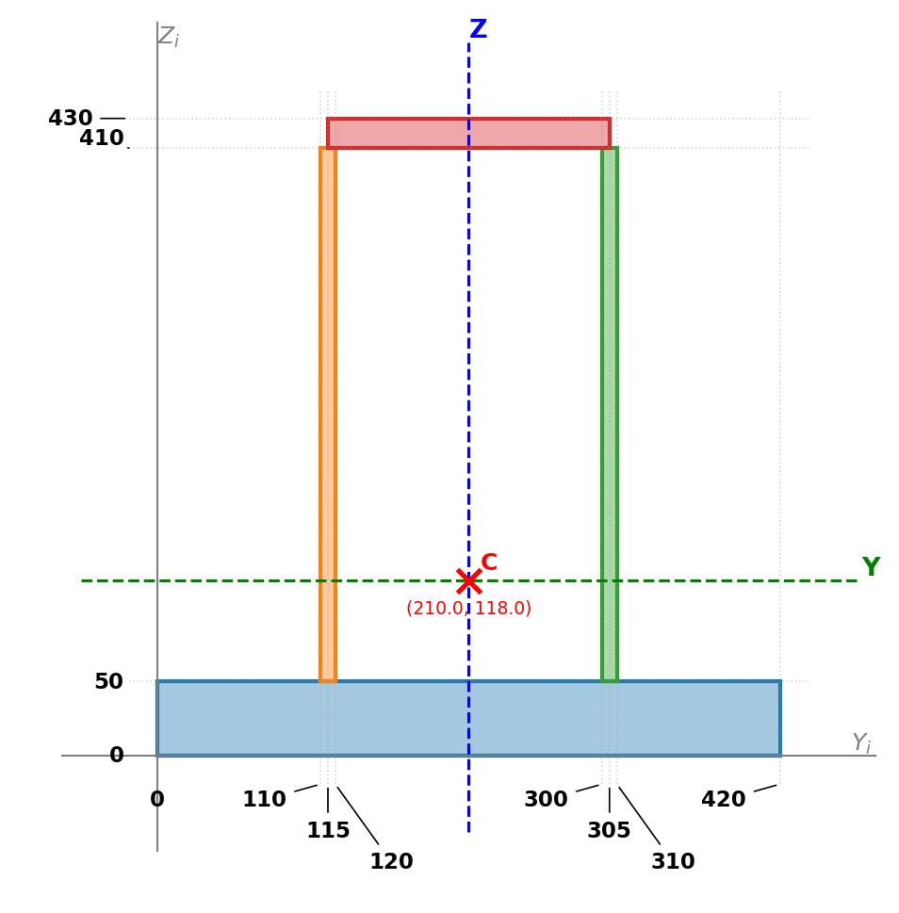

Section 7
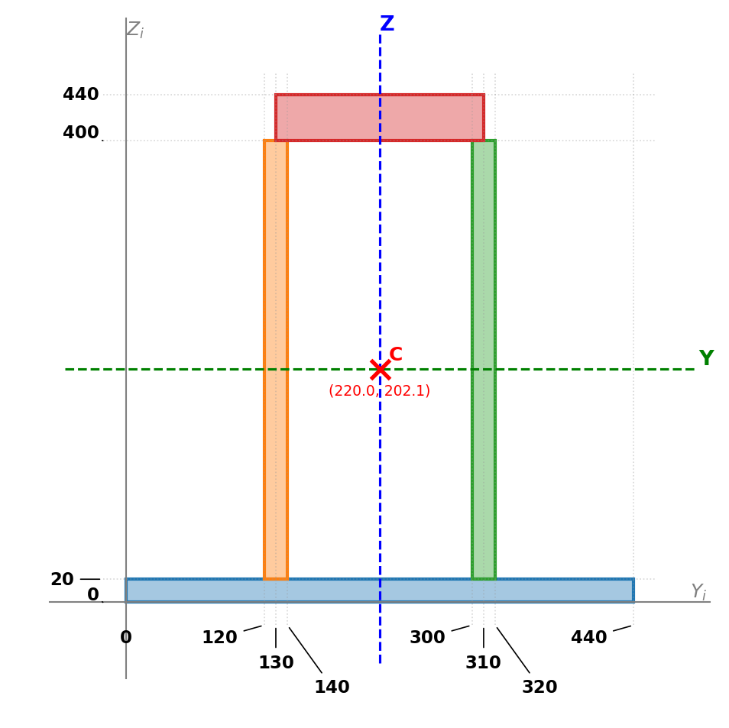

Section 8
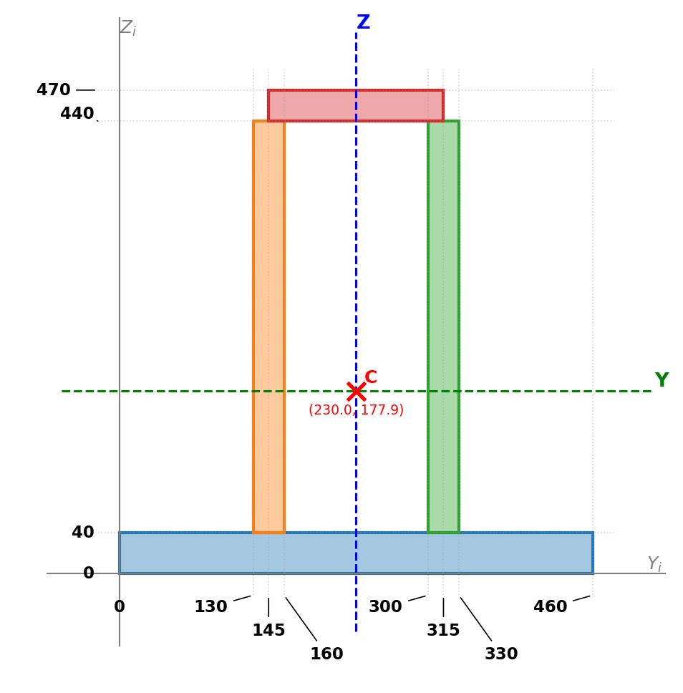

Section 9
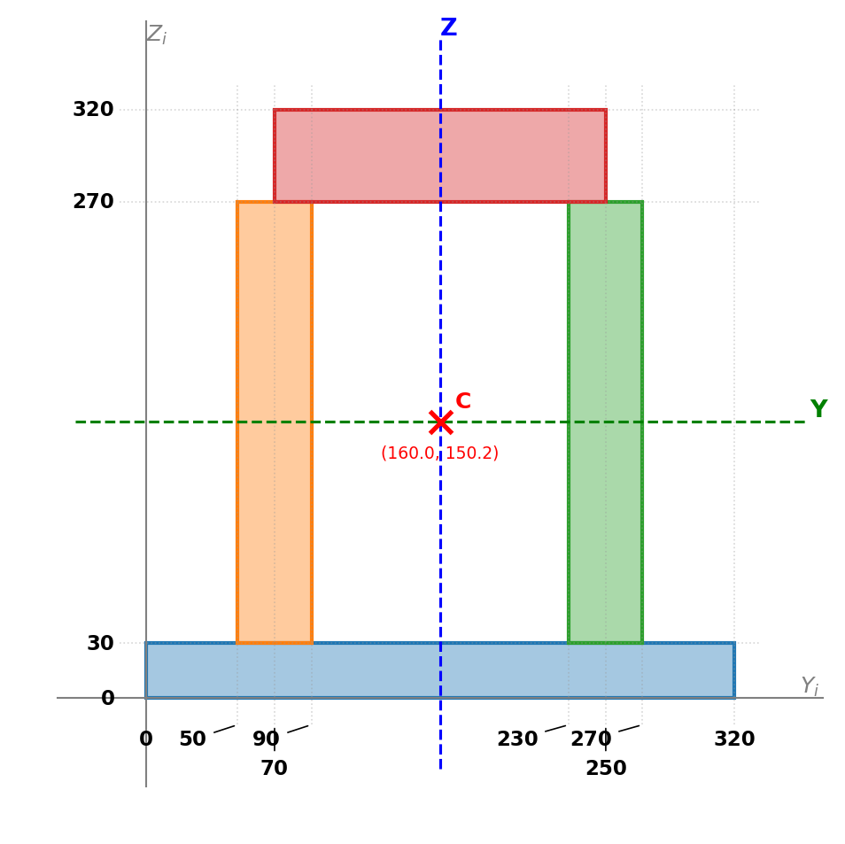

Section 10
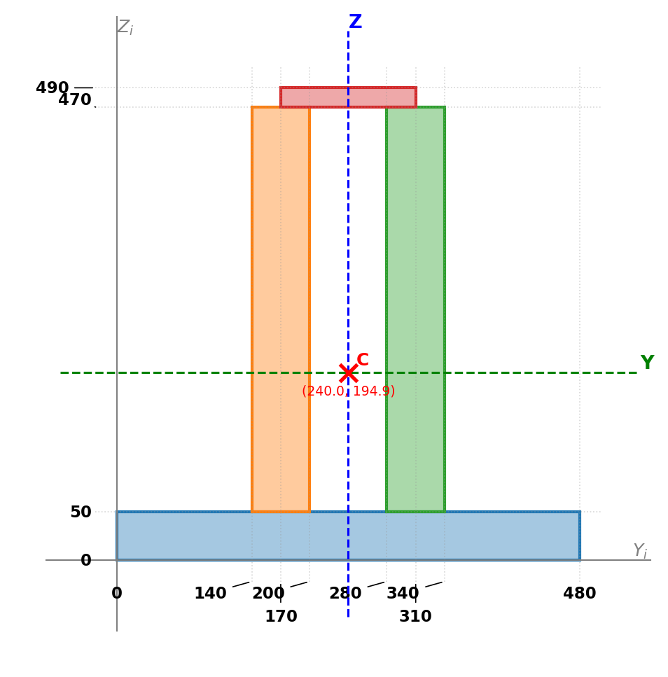

Variant Assignments
Variant | L (m) | N_Ed (kN) | Steel Grade | Section
1 | 8 | 1415 | S235 | 1
2 | 9 | 2440 | S275 | 2
3 | 6 | 6780 | S355 | 3
4 | 6 | 7015 | S420 | 4
5 | 9 | 4400 | S235 | 5
6 | 6 | 4870 | S275 | 6
7 | 8 | 4605 | S355 | 7
8 | 6 | 9630 | S420 | 8
9 | 5 | 5625 | S235 | 9
10 | 3 | 15360 | S275 | 10

Detailed Solutions

Variant 1
Input: Section 1, L = 8 m, N_Ed = 1415 kN (compression), Steel S235 (fy = 235 MPa), Pinned-pinned (μ = 1.0), Curve c (α = 0.49)
Section properties: A = 16300 mm², Iy = 254083686 mm⁴, Iz = 94895833 mm⁴, iy = 124.85 mm, iz = 76.30 mm

Strength Check
N_Rd = A × fy / γ_M0 = 16300 × 235 / 1.0 = 3830.5 kN
Utilization (strength) = 1415 / 3830.5 = 0.369 (36.9%) — OK

Buckling Check — Y-axis
- Step 1: L_cr = μ × L = 1.0 × 8 = 8.0 m = 8000 mm
- Step 2: I_y = 254083686 mm⁴, i_y = √(I/A) = √(254083686/16300) = 124.85 mm
- Step 3: N_Rk = A × fy = 16300 × 235 / 1000 = 3830.5 kN
- Step 4: N_cr = π² × E × I / L_cr² = π² × 200000 × 254083686 / 8000² / 1000 = 7836.6 kN
- Step 5: λ = √(N_Rk / N_cr) = √(3830.5 / 7836.6) = 0.6991
- Step 6: Buckling curve: c
- Step 7: α = 0.49
- Step 8: Φ = 0.5 × [1 + α(λ - 0.2) + λ²] = 0.5 × [1 + 0.49 × (0.6991 - 0.2) + 0.6991²] = 0.8667
- Step 9: χ = 1 / (Φ + √(Φ² - λ²)) = 1 / (0.8667 + √(0.8667² - 0.6991²)) = 0.7252
- Step 10: N_b,Rd = χ × A × fy / γ_M1 = 0.7252 × 16300 × 235 / 1.0 / 1000 = 2778.0 kN
- Step 11: Utilization = 1415 / 2778.0 = 0.509 (50.9%) — OK

Buckling Check — Z-axis
- Step 1: L_cr = μ × L = 1.0 × 8 = 8.0 m = 8000 mm
- Step 2: I_z = 94895833 mm⁴, i_z = √(I/A) = √(94895833/16300) = 76.30 mm
- Step 3: N_Rk = A × fy = 16300 × 235 / 1000 = 3830.5 kN
- Step 4: N_cr = π² × E × I / L_cr² = π² × 200000 × 94895833 / 8000² / 1000 = 2926.8 kN
- Step 5: λ = √(N_Rk / N_cr) = √(3830.5 / 2926.8) = 1.1440
- Step 6: Buckling curve: c
- Step 7: α = 0.49
- Step 8: Φ = 0.5 × [1 + α(λ - 0.2) + λ²] = 0.5 × [1 + 0.49 × (1.1440 - 0.2) + 1.1440²] = 1.3857
- Step 9: χ = 1 / (Φ + √(Φ² - λ²)) = 1 / (1.3857 + √(1.3857² - 1.1440²)) = 0.4614
- Step 10: N_b,Rd = χ × A × fy / γ_M1 = 0.4614 × 16300 × 235 / 1.0 / 1000 = 1767.2 kN
- Step 11: Utilization = 1415 / 1767.2 = 0.801 (80.1%) — OK

Conclusion
Governing check: Buckling Z, Utilization = 0.801 (80.1%) — PASS

Variant 2
Input: Section 2, L = 9 m, N_Ed = 2440 kN (compression), Steel S275 (fy = 275 MPa), Pinned-pinned (μ = 1.0), Curve c (α = 0.49)
Section properties: A = 28600 mm², Iy = 497838333 mm⁴, Iz = 208793333 mm⁴, iy = 131.94 mm, iz = 85.44 mm

Strength Check
N_Rd = A × fy / γ_M0 = 28600 × 275 / 1.0 = 7865.0 kN
Utilization (strength) = 2440 / 7865.0 = 0.310 (31.0%) — OK

Buckling Check — Y-axis
- Step 1: L_cr = μ × L = 1.0 × 9 = 9.0 m = 9000 mm
- Step 2: I_y = 497838333 mm⁴, i_y = √(I/A) = √(497838333/28600) = 131.94 mm
- Step 3: N_Rk = A × fy = 28600 × 275 / 1000 = 7865.0 kN
- Step 4: N_cr = π² × E × I / L_cr² = π² × 200000 × 497838333 / 9000² / 1000 = 12132.0 kN
- Step 5: λ = √(N_Rk / N_cr) = √(7865.0 / 12132.0) = 0.8052
- Step 6: Buckling curve: c
- Step 7: α = 0.49
- Step 8: Φ = 0.5 × [1 + α(λ - 0.2) + λ²] = 0.5 × [1 + 0.49 × (0.8052 - 0.2) + 0.8052²] = 0.9724
- Step 9: χ = 1 / (Φ + √(Φ² - λ²)) = 1 / (0.9724 + √(0.9724² - 0.8052²)) = 0.6589
- Step 10: N_b,Rd = χ × A × fy / γ_M1 = 0.6589 × 28600 × 275 / 1.0 / 1000 = 5182.4 kN
- Step 11: Utilization = 2440 / 5182.4 = 0.471 (47.1%) — OK

Buckling Check — Z-axis
- Step 1: L_cr = μ × L = 1.0 × 9 = 9.0 m = 9000 mm
- Step 2: I_z = 208793333 mm⁴, i_z = √(I/A) = √(208793333/28600) = 85.44 mm
- Step 3: N_Rk = A × fy = 28600 × 275 / 1000 = 7865.0 kN
- Step 4: N_cr = π² × E × I / L_cr² = π² × 200000 × 208793333 / 9000² / 1000 = 5088.2 kN
- Step 5: λ = √(N_Rk / N_cr) = √(7865.0 / 5088.2) = 1.2433
- Step 6: Buckling curve: c
- Step 7: α = 0.49
- Step 8: Φ = 0.5 × [1 + α(λ - 0.2) + λ²] = 0.5 × [1 + 0.49 × (1.2433 - 0.2) + 1.2433²] = 1.5285
- Step 9: χ = 1 / (Φ + √(Φ² - λ²)) = 1 / (1.5285 + √(1.5285² - 1.2433²)) = 0.4136
- Step 10: N_b,Rd = χ × A × fy / γ_M1 = 0.4136 × 28600 × 275 / 1.0 / 1000 = 3253.3 kN
- Step 11: Utilization = 2440 / 3253.3 = 0.750 (75.0%) — OK

Conclusion
Governing check: Buckling Z, Utilization = 0.750 (75.0%) — PASS

Variant 3
Input: Section 3, L = 6 m, N_Ed = 6780 kN (compression), Steel S355 (fy = 355 MPa), Pinned-pinned (μ = 1.0), Curve c (α = 0.49)
Section properties: A = 37000 mm², Iy = 621066414 mm⁴, Iz = 303868333 mm⁴, iy = 129.56 mm, iz = 90.62 mm

Strength Check
N_Rd = A × fy / γ_M0 = 37000 × 355 / 1.0 = 13135.0 kN
Utilization (strength) = 6780 / 13135.0 = 0.516 (51.6%) — OK

Buckling Check — Y-axis
- Step 1: L_cr = μ × L = 1.0 × 6 = 6.0 m = 6000 mm
- Step 2: I_y = 621066414 mm⁴, i_y = √(I/A) = √(621066414/37000) = 129.56 mm
- Step 3: N_Rk = A × fy = 37000 × 355 / 1000 = 13135.0 kN
- Step 4: N_cr = π² × E × I / L_cr² = π² × 200000 × 621066414 / 6000² / 1000 = 34053.8 kN
- Step 5: λ = √(N_Rk / N_cr) = √(13135.0 / 34053.8) = 0.6211
- Step 6: Buckling curve: c
- Step 7: α = 0.49
- Step 8: Φ = 0.5 × [1 + α(λ - 0.2) + λ²] = 0.5 × [1 + 0.49 × (0.6211 - 0.2) + 0.6211²] = 0.7960
- Step 9: χ = 1 / (Φ + √(Φ² - λ²)) = 1 / (0.7960 + √(0.7960² - 0.6211²)) = 0.7728
- Step 10: N_b,Rd = χ × A × fy / γ_M1 = 0.7728 × 37000 × 355 / 1.0 / 1000 = 10151.2 kN
- Step 11: Utilization = 6780 / 10151.2 = 0.668 (66.8%) — OK

Buckling Check — Z-axis
- Step 1: L_cr = μ × L = 1.0 × 6 = 6.0 m = 6000 mm
- Step 2: I_z = 303868333 mm⁴, i_z = √(I/A) = √(303868333/37000) = 90.62 mm
- Step 3: N_Rk = A × fy = 37000 × 355 / 1000 = 13135.0 kN
- Step 4: N_cr = π² × E × I / L_cr² = π² × 200000 × 303868333 / 6000² / 1000 = 16661.4 kN
- Step 5: λ = √(N_Rk / N_cr) = √(13135.0 / 16661.4) = 0.8879
- Step 6: Buckling curve: c
- Step 7: α = 0.49
- Step 8: Φ = 0.5 × [1 + α(λ - 0.2) + λ²] = 0.5 × [1 + 0.49 × (0.8879 - 0.2) + 0.8879²] = 1.0627
- Step 9: χ = 1 / (Φ + √(Φ² - λ²)) = 1 / (1.0627 + √(1.0627² - 0.8879²)) = 0.6073
- Step 10: N_b,Rd = χ × A × fy / γ_M1 = 0.6073 × 37000 × 355 / 1.0 / 1000 = 7976.8 kN
- Step 11: Utilization = 6780 / 7976.8 = 0.850 (85.0%) — OK

Conclusion
Governing check: Buckling Z, Utilization = 0.850 (85.0%) — PASS

Variant 4
Input: Section 4, L = 6 m, N_Ed = 7015 kN (compression), Steel S420 (fy = 420 MPa), Pinned-pinned (μ = 1.0), Curve c (α = 0.49)
Section properties: A = 42800 mm², Iy = 813525358 mm⁴, Iz = 286226667 mm⁴, iy = 137.87 mm, iz = 81.78 mm

Strength Check
N_Rd = A × fy / γ_M0 = 42800 × 420 / 1.0 = 17976.0 kN
Utilization (strength) = 7015 / 17976.0 = 0.390 (39.0%) — OK

Buckling Check — Y-axis
- Step 1: L_cr = μ × L = 1.0 × 6 = 6.0 m = 6000 mm
- Step 2: I_y = 813525358 mm⁴, i_y = √(I/A) = √(813525358/42800) = 137.87 mm
- Step 3: N_Rk = A × fy = 42800 × 420 / 1000 = 17976.0 kN
- Step 4: N_cr = π² × E × I / L_cr² = π² × 200000 × 813525358 / 6000² / 1000 = 44606.5 kN
- Step 5: λ = √(N_Rk / N_cr) = √(17976.0 / 44606.5) = 0.6348
- Step 6: Buckling curve: c
- Step 7: α = 0.49
- Step 8: Φ = 0.5 × [1 + α(λ - 0.2) + λ²] = 0.5 × [1 + 0.49 × (0.6348 - 0.2) + 0.6348²] = 0.8080
- Step 9: χ = 1 / (Φ + √(Φ² - λ²)) = 1 / (0.8080 + √(0.8080² - 0.6348²)) = 0.7646
- Step 10: N_b,Rd = χ × A × fy / γ_M1 = 0.7646 × 42800 × 420 / 1.0 / 1000 = 13743.8 kN
- Step 11: Utilization = 7015 / 13743.8 = 0.510 (51.0%) — OK

Buckling Check — Z-axis
- Step 1: L_cr = μ × L = 1.0 × 6 = 6.0 m = 6000 mm
- Step 2: I_z = 286226667 mm⁴, i_z = √(I/A) = √(286226667/42800) = 81.78 mm
- Step 3: N_Rk = A × fy = 42800 × 420 / 1000 = 17976.0 kN
- Step 4: N_cr = π² × E × I / L_cr² = π² × 200000 × 286226667 / 6000² / 1000 = 15694.1 kN
- Step 5: λ = √(N_Rk / N_cr) = √(17976.0 / 15694.1) = 1.0702
- Step 6: Buckling curve: c
- Step 7: α = 0.49
- Step 8: Φ = 0.5 × [1 + α(λ - 0.2) + λ²] = 0.5 × [1 + 0.49 × (1.0702 - 0.2) + 1.0702²] = 1.2859
- Step 9: χ = 1 / (Φ + √(Φ² - λ²)) = 1 / (1.2859 + √(1.2859² - 1.0702²)) = 0.5003
- Step 10: N_b,Rd = χ × A × fy / γ_M1 = 0.5003 × 42800 × 420 / 1.0 / 1000 = 8993.6 kN
- Step 11: Utilization = 7015 / 8993.6 = 0.780 (78.0%) — OK

Conclusion
Governing check: Buckling Z, Utilization = 0.780 (78.0%) — PASS

Variant 5
Input: Section 5, L = 9 m, N_Ed = 4400 kN (compression), Steel S235 (fy = 235 MPa), Pinned-pinned (μ = 1.0), Curve c (α = 0.49)
Section properties: A = 52200 mm², Iy = 680528793 mm⁴, Iz = 354060000 mm⁴, iy = 114.18 mm, iz = 82.36 mm

Strength Check
N_Rd = A × fy / γ_M0 = 52200 × 235 / 1.0 = 12267.0 kN
Utilization (strength) = 4400 / 12267.0 = 0.359 (35.9%) — OK

Buckling Check — Y-axis
- Step 1: L_cr = μ × L = 1.0 × 9 = 9.0 m = 9000 mm
- Step 2: I_y = 680528793 mm⁴, i_y = √(I/A) = √(680528793/52200) = 114.18 mm
- Step 3: N_Rk = A × fy = 52200 × 235 / 1000 = 12267.0 kN
- Step 4: N_cr = π² × E × I / L_cr² = π² × 200000 × 680528793 / 9000² / 1000 = 16584.1 kN
- Step 5: λ = √(N_Rk / N_cr) = √(12267.0 / 16584.1) = 0.8600
- Step 6: Buckling curve: c
- Step 7: α = 0.49
- Step 8: Φ = 0.5 × [1 + α(λ - 0.2) + λ²] = 0.5 × [1 + 0.49 × (0.8600 - 0.2) + 0.8600²] = 1.0316
- Step 9: χ = 1 / (Φ + √(Φ² - λ²)) = 1 / (1.0316 + √(1.0316² - 0.8600²)) = 0.6246
- Step 10: N_b,Rd = χ × A × fy / γ_M1 = 0.6246 × 52200 × 235 / 1.0 / 1000 = 7661.4 kN
- Step 11: Utilization = 4400 / 7661.4 = 0.574 (57.4%) — OK

Buckling Check — Z-axis
- Step 1: L_cr = μ × L = 1.0 × 9 = 9.0 m = 9000 mm
- Step 2: I_z = 354060000 mm⁴, i_z = √(I/A) = √(354060000/52200) = 82.36 mm
- Step 3: N_Rk = A × fy = 52200 × 235 / 1000 = 12267.0 kN
- Step 4: N_cr = π² × E × I / L_cr² = π² × 200000 × 354060000 / 9000² / 1000 = 8628.2 kN
- Step 5: λ = √(N_Rk / N_cr) = √(12267.0 / 8628.2) = 1.1924
- Step 6: Buckling curve: c
- Step 7: α = 0.49
- Step 8: Φ = 0.5 × [1 + α(λ - 0.2) + λ²] = 0.5 × [1 + 0.49 × (1.1924 - 0.2) + 1.1924²] = 1.4540
- Step 9: χ = 1 / (Φ + √(Φ² - λ²)) = 1 / (1.4540 + √(1.4540² - 1.1924²)) = 0.4374
- Step 10: N_b,Rd = χ × A × fy / γ_M1 = 0.4374 × 52200 × 235 / 1.0 / 1000 = 5366.0 kN
- Step 11: Utilization = 4400 / 5366.0 = 0.820 (82.0%) — OK

Conclusion
Governing check: Buckling Z, Utilization = 0.820 (82.0%) — PASS

Variant 6
Input: Section 6, L = 6 m, N_Ed = 4870 kN (compression), Steel S275 (fy = 275 MPa), Pinned-pinned (μ = 1.0), Curve c (α = 0.49)
Section properties: A = 32000 mm², Iy = 700782635 mm⁴, Iz = 385171667 mm⁴, iy = 147.98 mm, iz = 109.71 mm

Strength Check
N_Rd = A × fy / γ_M0 = 32000 × 275 / 1.0 = 8800.0 kN
Utilization (strength) = 4870 / 8800.0 = 0.553 (55.3%) — OK

Buckling Check — Y-axis
- Step 1: L_cr = μ × L = 1.0 × 6 = 6.0 m = 6000 mm
- Step 2: I_y = 700782635 mm⁴, i_y = √(I/A) = √(700782635/32000) = 147.98 mm
- Step 3: N_Rk = A × fy = 32000 × 275 / 1000 = 8800.0 kN
- Step 4: N_cr = π² × E × I / L_cr² = π² × 200000 × 700782635 / 6000² / 1000 = 38424.7 kN
- Step 5: λ = √(N_Rk / N_cr) = √(8800.0 / 38424.7) = 0.4786
- Step 6: Buckling curve: c
- Step 7: α = 0.49
- Step 8: Φ = 0.5 × [1 + α(λ - 0.2) + λ²] = 0.5 × [1 + 0.49 × (0.4786 - 0.2) + 0.4786²] = 0.6828
- Step 9: χ = 1 / (Φ + √(Φ² - λ²)) = 1 / (0.6828 + √(0.6828² - 0.4786²)) = 0.8549
- Step 10: N_b,Rd = χ × A × fy / γ_M1 = 0.8549 × 32000 × 275 / 1.0 / 1000 = 7523.1 kN
- Step 11: Utilization = 4870 / 7523.1 = 0.647 (64.7%) — OK

Buckling Check — Z-axis
- Step 1: L_cr = μ × L = 1.0 × 6 = 6.0 m = 6000 mm
- Step 2: I_z = 385171667 mm⁴, i_z = √(I/A) = √(385171667/32000) = 109.71 mm
- Step 3: N_Rk = A × fy = 32000 × 275 / 1000 = 8800.0 kN
- Step 4: N_cr = π² × E × I / L_cr² = π² × 200000 × 385171667 / 6000² / 1000 = 21119.4 kN
- Step 5: λ = √(N_Rk / N_cr) = √(8800.0 / 21119.4) = 0.6455
- Step 6: Buckling curve: c
- Step 7: α = 0.49
- Step 8: Φ = 0.5 × [1 + α(λ - 0.2) + λ²] = 0.5 × [1 + 0.49 × (0.6455 - 0.2) + 0.6455²] = 0.8175
- Step 9: χ = 1 / (Φ + √(Φ² - λ²)) = 1 / (0.8175 + √(0.8175² - 0.6455²)) = 0.7581
- Step 10: N_b,Rd = χ × A × fy / γ_M1 = 0.7581 × 32000 × 275 / 1.0 / 1000 = 6671.2 kN
- Step 11: Utilization = 4870 / 6671.2 = 0.730 (73.0%) — OK

Conclusion
Governing check: Buckling Z, Utilization = 0.730 (73.0%) — PASS

Variant 7
Input: Section 7, L = 8 m, N_Ed = 4605 kN (compression), Steel S355 (fy = 355 MPa), Pinned-pinned (μ = 1.0), Curve c (α = 0.49)
Section properties: A = 31200 mm², Iy = 851708718 mm⁴, Iz = 285040000 mm⁴, iy = 165.22 mm, iz = 95.58 mm

Strength Check
N_Rd = A × fy / γ_M0 = 31200 × 355 / 1.0 = 11076.0 kN
Utilization (strength) = 4605 / 11076.0 = 0.416 (41.6%) — OK

Buckling Check — Y-axis
- Step 1: L_cr = μ × L = 1.0 × 8 = 8.0 m = 8000 mm
- Step 2: I_y = 851708718 mm⁴, i_y = √(I/A) = √(851708718/31200) = 165.22 mm
- Step 3: N_Rk = A × fy = 31200 × 355 / 1000 = 11076.0 kN
- Step 4: N_cr = π² × E × I / L_cr² = π² × 200000 × 851708718 / 8000² / 1000 = 26268.8 kN
- Step 5: λ = √(N_Rk / N_cr) = √(11076.0 / 26268.8) = 0.6493
- Step 6: Buckling curve: c
- Step 7: α = 0.49
- Step 8: Φ = 0.5 × [1 + α(λ - 0.2) + λ²] = 0.5 × [1 + 0.49 × (0.6493 - 0.2) + 0.6493²] = 0.8209
- Step 9: χ = 1 / (Φ + √(Φ² - λ²)) = 1 / (0.8209 + √(0.8209² - 0.6493²)) = 0.7558
- Step 10: N_b,Rd = χ × A × fy / γ_M1 = 0.7558 × 31200 × 355 / 1.0 / 1000 = 8370.9 kN
- Step 11: Utilization = 4605 / 8370.9 = 0.550 (55.0%) — OK

Buckling Check — Z-axis
- Step 1: L_cr = μ × L = 1.0 × 8 = 8.0 m = 8000 mm
- Step 2: I_z = 285040000 mm⁴, i_z = √(I/A) = √(285040000/31200) = 95.58 mm
- Step 3: N_Rk = A × fy = 31200 × 355 / 1000 = 11076.0 kN
- Step 4: N_cr = π² × E × I / L_cr² = π² × 200000 × 285040000 / 8000² / 1000 = 8791.4 kN
- Step 5: λ = √(N_Rk / N_cr) = √(11076.0 / 8791.4) = 1.1224
- Step 6: Buckling curve: c
- Step 7: α = 0.49
- Step 8: Φ = 0.5 × [1 + α(λ - 0.2) + λ²] = 0.5 × [1 + 0.49 × (1.1224 - 0.2) + 1.1224²] = 1.3559
- Step 9: χ = 1 / (Φ + √(Φ² - λ²)) = 1 / (1.3559 + √(1.3559² - 1.1224²)) = 0.4724
- Step 10: N_b,Rd = χ × A × fy / γ_M1 = 0.4724 × 31200 × 355 / 1.0 / 1000 = 5232.8 kN
- Step 11: Utilization = 4605 / 5232.8 = 0.880 (88.0%) — OK

Conclusion
Governing check: Buckling Z, Utilization = 0.880 (88.0%) — PASS

Variant 8
Input: Section 8, L = 6 m, N_Ed = 9630 kN (compression), Steel S420 (fy = 420 MPa), Pinned-pinned (μ = 1.0), Curve c (α = 0.49)
Section properties: A = 47500 mm², Iy = 1265746444 mm⁴, Iz = 511935833 mm⁴, iy = 163.24 mm, iz = 103.82 mm

Strength Check
N_Rd = A × fy / γ_M0 = 47500 × 420 / 1.0 = 19950.0 kN
Utilization (strength) = 9630 / 19950.0 = 0.483 (48.3%) — OK

Buckling Check — Y-axis
- Step 1: L_cr = μ × L = 1.0 × 6 = 6.0 m = 6000 mm
- Step 2: I_y = 1265746444 mm⁴, i_y = √(I/A) = √(1265746444/47500) = 163.24 mm
- Step 3: N_Rk = A × fy = 47500 × 420 / 1000 = 19950.0 kN
- Step 4: N_cr = π² × E × I / L_cr² = π² × 200000 × 1265746444 / 6000² / 1000 = 69402.3 kN
- Step 5: λ = √(N_Rk / N_cr) = √(19950.0 / 69402.3) = 0.5361
- Step 6: Buckling curve: c
- Step 7: α = 0.49
- Step 8: Φ = 0.5 × [1 + α(λ - 0.2) + λ²] = 0.5 × [1 + 0.49 × (0.5361 - 0.2) + 0.5361²] = 0.7261
- Step 9: χ = 1 / (Φ + √(Φ² - λ²)) = 1 / (0.7261 + √(0.7261² - 0.5361²)) = 0.8226
- Step 10: N_b,Rd = χ × A × fy / γ_M1 = 0.8226 × 47500 × 420 / 1.0 / 1000 = 16410.0 kN
- Step 11: Utilization = 9630 / 16410.0 = 0.587 (58.7%) — OK

Buckling Check — Z-axis
- Step 1: L_cr = μ × L = 1.0 × 6 = 6.0 m = 6000 mm
- Step 2: I_z = 511935833 mm⁴, i_z = √(I/A) = √(511935833/47500) = 103.82 mm
- Step 3: N_Rk = A × fy = 47500 × 420 / 1000 = 19950.0 kN
- Step 4: N_cr = π² × E × I / L_cr² = π² × 200000 × 511935833 / 6000² / 1000 = 28070.0 kN
- Step 5: λ = √(N_Rk / N_cr) = √(19950.0 / 28070.0) = 0.8430
- Step 6: Buckling curve: c
- Step 7: α = 0.49
- Step 8: Φ = 0.5 × [1 + α(λ - 0.2) + λ²] = 0.5 × [1 + 0.49 × (0.8430 - 0.2) + 0.8430²] = 1.0129
- Step 9: χ = 1 / (Φ + √(Φ² - λ²)) = 1 / (1.0129 + √(1.0129² - 0.8430²)) = 0.6352
- Step 10: N_b,Rd = χ × A × fy / γ_M1 = 0.6352 × 47500 × 420 / 1.0 / 1000 = 12671.6 kN
- Step 11: Utilization = 9630 / 12671.6 = 0.760 (76.0%) — OK

Conclusion
Governing check: Buckling Z, Utilization = 0.760 (76.0%) — PASS

Variant 9
Input: Section 9, L = 5 m, N_Ed = 5625 kN (compression), Steel S235 (fy = 235 MPa), Pinned-pinned (μ = 1.0), Curve c (α = 0.49)
Section properties: A = 37800 mm², Iy = 458937857 mm⁴, Iz = 264300000 mm⁴, iy = 110.19 mm, iz = 83.62 mm

Strength Check
N_Rd = A × fy / γ_M0 = 37800 × 235 / 1.0 = 8883.0 kN
Utilization (strength) = 5625 / 8883.0 = 0.633 (63.3%) — OK

Buckling Check — Y-axis
- Step 1: L_cr = μ × L = 1.0 × 5 = 5.0 m = 5000 mm
- Step 2: I_y = 458937857 mm⁴, i_y = √(I/A) = √(458937857/37800) = 110.19 mm
- Step 3: N_Rk = A × fy = 37800 × 235 / 1000 = 8883.0 kN
- Step 4: N_cr = π² × E × I / L_cr² = π² × 200000 × 458937857 / 5000² / 1000 = 36236.3 kN
- Step 5: λ = √(N_Rk / N_cr) = √(8883.0 / 36236.3) = 0.4951
- Step 6: Buckling curve: c
- Step 7: α = 0.49
- Step 8: Φ = 0.5 × [1 + α(λ - 0.2) + λ²] = 0.5 × [1 + 0.49 × (0.4951 - 0.2) + 0.4951²] = 0.6949
- Step 9: χ = 1 / (Φ + √(Φ² - λ²)) = 1 / (0.6949 + √(0.6949² - 0.4951²)) = 0.8457
- Step 10: N_b,Rd = χ × A × fy / γ_M1 = 0.8457 × 37800 × 235 / 1.0 / 1000 = 7512.5 kN
- Step 11: Utilization = 5625 / 7512.5 = 0.749 (74.9%) — OK

Buckling Check — Z-axis
- Step 1: L_cr = μ × L = 1.0 × 5 = 5.0 m = 5000 mm
- Step 2: I_z = 264300000 mm⁴, i_z = √(I/A) = √(264300000/37800) = 83.62 mm
- Step 3: N_Rk = A × fy = 37800 × 235 / 1000 = 8883.0 kN
- Step 4: N_cr = π² × E × I / L_cr² = π² × 200000 × 264300000 / 5000² / 1000 = 20868.3 kN
- Step 5: λ = √(N_Rk / N_cr) = √(8883.0 / 20868.3) = 0.6524
- Step 6: Buckling curve: c
- Step 7: α = 0.49
- Step 8: Φ = 0.5 × [1 + α(λ - 0.2) + λ²] = 0.5 × [1 + 0.49 × (0.6524 - 0.2) + 0.6524²] = 0.8237
- Step 9: χ = 1 / (Φ + √(Φ² - λ²)) = 1 / (0.8237 + √(0.8237² - 0.6524²)) = 0.7539
- Step 10: N_b,Rd = χ × A × fy / γ_M1 = 0.7539 × 37800 × 235 / 1.0 / 1000 = 6696.8 kN
- Step 11: Utilization = 5625 / 6696.8 = 0.840 (84.0%) — OK

Conclusion
Governing check: Buckling Z, Utilization = 0.840 (84.0%) — PASS

Variant 10
Input: Section 10, L = 3 m, N_Ed = 15360 kN (compression), Steel S275 (fy = 275 MPa), Pinned-pinned (μ = 1.0), Curve c (α = 0.49)
Section properties: A = 77200 mm², Iy = 1879942867 mm⁴, Iz = 727453333 mm⁴, iy = 156.05 mm, iz = 97.07 mm

Strength Check
N_Rd = A × fy / γ_M0 = 77200 × 275 / 1.0 = 21230.0 kN
Utilization (strength) = 15360 / 21230.0 = 0.724 (72.4%) — OK

Buckling Check — Y-axis
- Step 1: L_cr = μ × L = 1.0 × 3 = 3.0 m = 3000 mm
- Step 2: I_y = 1879942867 mm⁴, i_y = √(I/A) = √(1879942867/77200) = 156.05 mm
- Step 3: N_Rk = A × fy = 77200 × 275 / 1000 = 21230.0 kN
- Step 4: N_cr = π² × E × I / L_cr² = π² × 200000 × 1879942867 / 3000² / 1000 = 412317.6 kN
- Step 5: λ = √(N_Rk / N_cr) = √(21230.0 / 412317.6) = 0.2269
- Step 6: Buckling curve: c
- Step 7: α = 0.49
- Step 8: Φ = 0.5 × [1 + α(λ - 0.2) + λ²] = 0.5 × [1 + 0.49 × (0.2269 - 0.2) + 0.2269²] = 0.5323
- Step 9: χ = 1 / (Φ + √(Φ² - λ²)) = 1 / (0.5323 + √(0.5323² - 0.2269²)) = 0.9863
- Step 10: N_b,Rd = χ × A × fy / γ_M1 = 0.9863 × 77200 × 275 / 1.0 / 1000 = 20939.1 kN
- Step 11: Utilization = 15360 / 20939.1 = 0.734 (73.4%) — OK

Buckling Check — Z-axis
- Step 1: L_cr = μ × L = 1.0 × 3 = 3.0 m = 3000 mm
- Step 2: I_z = 727453333 mm⁴, i_z = √(I/A) = √(727453333/77200) = 97.07 mm
- Step 3: N_Rk = A × fy = 77200 × 275 / 1000 = 21230.0 kN
- Step 4: N_cr = π² × E × I / L_cr² = π² × 200000 × 727453333 / 3000² / 1000 = 159548.4 kN
- Step 5: λ = √(N_Rk / N_cr) = √(21230.0 / 159548.4) = 0.3648
- Step 6: Buckling curve: c
- Step 7: α = 0.49
- Step 8: Φ = 0.5 × [1 + α(λ - 0.2) + λ²] = 0.5 × [1 + 0.49 × (0.3648 - 0.2) + 0.3648²] = 0.6069
- Step 9: χ = 1 / (Φ + √(Φ² - λ²)) = 1 / (0.6069 + √(0.6069² - 0.3648²)) = 0.9158
- Step 10: N_b,Rd = χ × A × fy / γ_M1 = 0.9158 × 77200 × 275 / 1.0 / 1000 = 19442.4 kN
- Step 11: Utilization = 15360 / 19442.4 = 0.790 (79.0%) — OK

Conclusion
Governing check: Buckling Z, Utilization = 0.790 (79.0%) — PASS

