SDR-TRX v1.0 HW issues

1. Power hold circuit is non working.
The issue appears due to MCU GPIO protection circuit which cause permanent current via diodes D2 and D3. Protection MCU GPIO protection zener voltage is about 6V as result PWR-HLD signal initially is about 6V. It causes failed state in power circuit. See the next figure for reworked circuit (in case of reworking power hold signal has high level not low).
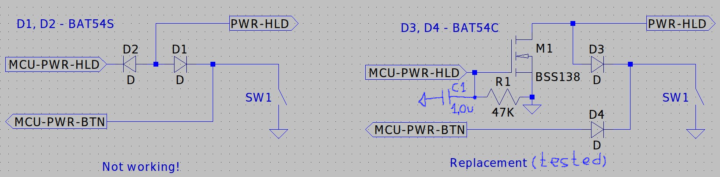
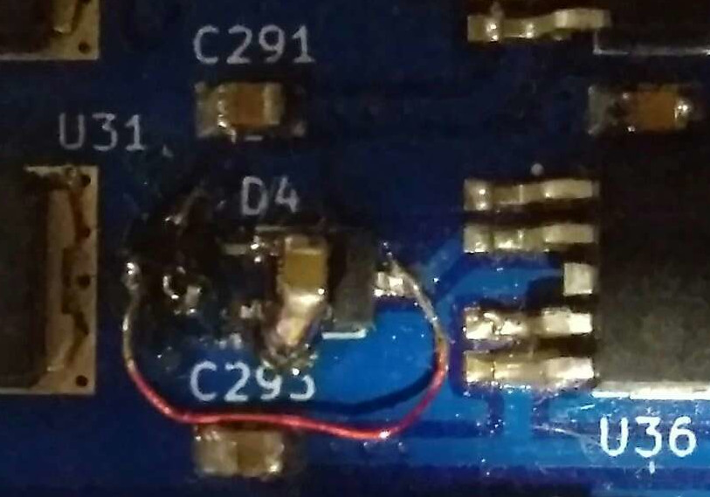
Now power hold circuit is checked see “Replacement” part. Added capacitor C1 1.0uF, this capacitor together with resistor R1 provides power supply switch off ~50mS delay after MCU-PWR-HLD pin deinited. That's one small delay for man, one giant delay for MCU. This delay is important to keep MCU power during resets (showing critical errors or manual resets). The left figure shows rework on PCB. Power hold FW is implemented with commit: 376d971a4ef96f74d7811042c13fd6ab297a75b4
Author: Andrii Bilynskyi <andriy.bilynskyy@gmail.com>
Date: Sat Nov 7 20:15:15 2020 +0200
Add power on/off functionality. Make possible shutdown during notification showing (long press power button). Add battery voltage shutdown and overheat protection.

2. Low speaker volume.
This makes speaker useless because headphones are louder than speaker. The easiest way to fix it is increasing speaker amplifier gain. The gain of speaker amplifier is set using resistors R89 / R91. To increase gain R89 should be equal 15K instead of 8.2K.

3. Wide spectrum at the TCXO output X1.
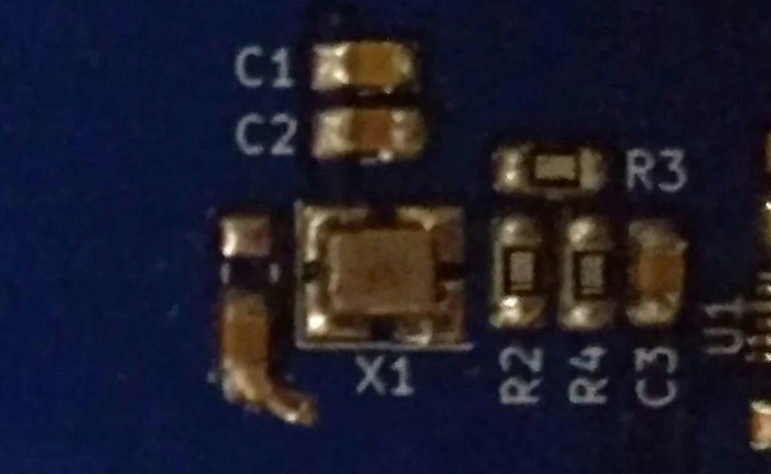
At the output ASTX-H11 unclean spectrum can be observed (like a bunch of sidebands). To fix it remove resistor R1 and add 0805 10nF ceramic capacitor between ASTX-H11 Tri-State pin and ground. See left figure for detailes.

4. Wide spectrum at PO74G74A outputs.
This issue appears for frequencies more than 10MHz. To fix it just remove resistor R5. Still there is small remaining issue at frequencies close to 30MHz seems caused by routing (should be deeply investigated).

5. Suggestion: Route PWR-HLD signal to SWD connector J8.
Useful during SW development when there is no needed to switch board off. Just permanent short this signal with ground on this connector using programming connector. Otherwise current design require tricky to flash the board.

6. Suggestion: Long startup of LSE oscillator.
Issue is caused by long wires near 32.768K crystal. This routing is caused due to using huge footprint of main oscillator 24MHz which also should be close to MCU. So in next routing 24MHz oscillator should have smaller footprint in order to reduce wires of both oscillators.

7. Suggestion: Replace 24CL64 flash memory with analog FRAM FM24CL64.
Huge improvement of write speed.

8. Suggestion: Move ground testpoint TP1 away from from electrolytic capacitor.
Capacitor can be damaged by probe connection.

9. Suggestion: Use more accurate LDO for analog power supply.
Analog supply is also analog reference voltage in that case using LF33CPT is not the best choice. More accurate output voltage is should be used in next design.

10. Suggestion: Use 18650 batteries connection 2s2p.
Currently 3s connection is used so battery voltage is in range 8.4 – 12.6 it’s useful for RF power amplifier and audio amplifier but most of the circuit use 3.3 or 5 volts. In that case lot of heat is produced by its LDOs so battery charge is wasted. Using switching LDO is bad idea for sensitive RF receivers. In that case the solution is to use 2s2p battery connection in that case voltage is in range 5.6 – 8.4V. For sure it’s not minor rework but seems promising. This redesing also require changes in audio amplifier and RF amplifier, for relays there is no problem to use 6V version. For audio amplifier another opamp should be used – more close to rail to rail output. With RF amplifiers seems exists the solution see: https://www.qsl.net/in3otd/ham_radio/Hermes-Lite/AFT05MS003N_PP_PA.html. Anyway this should be taken into account in future design.

11. Suggestion: Add resistors in series with AD5243 rheostats.
The PD85004 gate working voltage range is 3.2 – 3.8 V so range 0 – 5 V is not needed. Limiting range increases gate voltage accuracy.

