Київський національний університет імені Тараса Шевченка

Фізичний факультет

Кафедра ядерної фізики

**Звіт з переддипломної практики за темою:**

**«Тестування Детектора 3х1х1 в Експерименті WA105 в ЦЕРН»**

**Test of Detector 3x1x1 in the experiment WA105 at CERN**

**Переддипломна практика**

студента 1 курсу магістратури

Снуссі Чергуі Асмае

**Науковий керівник:**

кандидат фіз.-мат наук, доцент КЯФ

д.ф.-м.н Аушев Володимир Єгорович

Київ, 2017

Content

Introduction. Neutrino , experiment DUNE,

Liquid Argon Detector WA105-3x1x1

Analysis tool

Experiment - Test of Detector 3x1x1 in the experiment WA105 at CERN

Conclusion

Neutrinos can travel through dense matter such as the Earth without interacting with a single atom, leaving no trace of their passage. To observe even just a few of the extremely rare interactions of neutrinos with matter, physicists build detectors with massive amounts of target material and operate them for many years. The detectors record the tracks of the particles that emerge from the rare collisions of neutrinos with atoms of the target material.

The Deep Underground Neutrino Experiment (DUNE) is a leading-edge, international experiment for neutrino science and proton decay studies. Discoveries over the past half-century have put neutrinos, the most abundant matter particles in the universe, in the spotlight for further research into several fundamental questions about the nature of matter and the evolution of the universe — questions that DUNE will seek to answer.

DUNE will consist of two neutrino detectors placed in the world’s most intense neutrino beam. One detector will record particle interactions near the source of the beam, at the Fermi National Accelerator Laboratory in Batavia, Illinois. A second, much larger, detector will be installed more than a kilometer underground at the Sanford Underground Research Laboratory in Lead, South Dakota — 1,300 kilometers downstream of the source. These detectors will enable scientists to search for new subatomic phenomena and potentially transform our understanding of neutrinos and their role in the universe.

DUNE prototype detectors are under construction at the European research center [CERN](http://home.cern/).

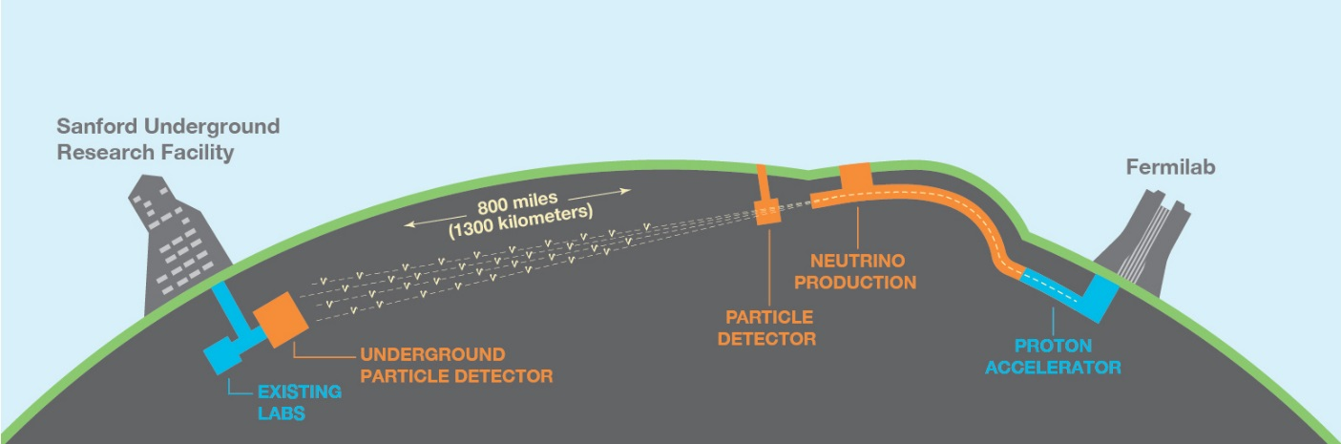

The [Long-Baseline Neutrino Facility](http://lbnf.fnal.gov/) will provide the neutrino beamline and the infrastructure that will support the DUNE detectors. Groundbreaking for the LBNF excavation and construction at Sanford Lab occurred on July 21, 2017.

Physical goal of the DUNE experiment is study of origin of Matter, unification of forces, black hole formation and other subject.

There are currently several test beam experiments which are either running or in the construction/design phase. One of them is detector WA105 at CERN.

The goal of my practice work is to analyse the WA105 data, obtained during test of prototype 3m x 1m x 1m.

**Liquid Argon Detector WA105-3x1x1**

The WA105 Experiment - ProtoDUNE Double-Phase

While liquid argon TPC(Time Projection Chamber), technology is fairly advanced, there is currently still a lot of research being done to optimise detector design and reduce costs, as well as R&D to see if new methods of readout are possible. In addition, test beam experiments are necessary in order to obtain precise data how a priori known particles interact in the liquid argon. This will allow better particle identification in neutrino liquid argon experiments and significant background reduction. Our university is involved in the [WA105](http://wa105.web.cern.ch/wa105/) experiment, which is currently being constructed at CERN. WA105 is also known as the ProtoDUNE Double-Phase and will both test new technology and provide test beam data to use in existing and future neutrino liquid argon experiments.

WA105 will be a 5 ton 6mx6mx6m double-phase liquid argon TPC which will use a non-evacuated membrane tank and a recirculation system to achieve the required LAr purity. A schematic of the experiment is shown below. The demonstration of the use of the double-phase design in a medium LAr-TPC such as WA105 would allow the double-phase concept to be scaled for use in future very-large multi-kton liquid Argon detectors. In my practice work, we tested prototype 3mx1mx1m

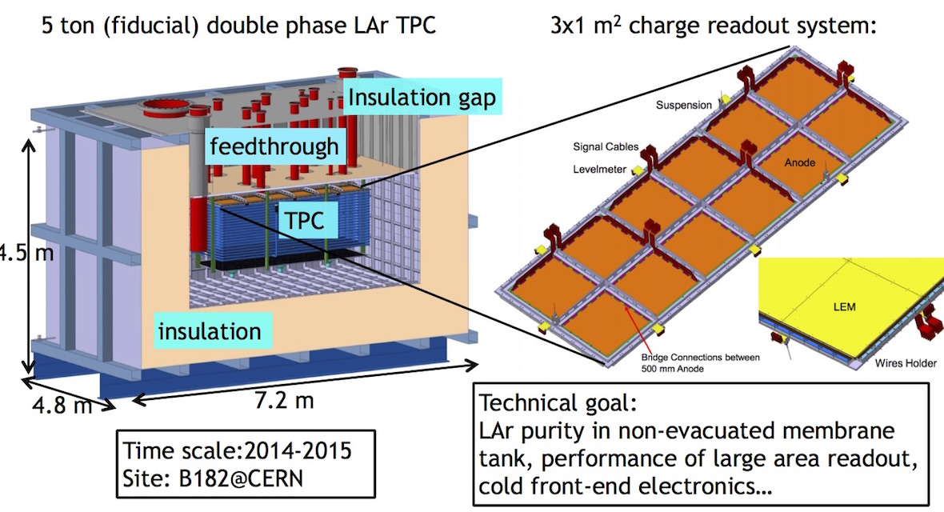

RooT