Extraction & Classification of Drug-Drug Interactions
  - Mining Unstructured Data – Assignment 3
  - Andreja Andrejic & Danila Kokin

Introduction
This is the written report for the assignment of extracting and classifying drug-drug interactions. The first part of the report explains the process of feature extraction and the second one is the tuning and choosing of the best model.

Baseline
The baseline model has the following set of features: form, lemma, PoS tag and a flag if the token is an entity. This is done for the first non-stopword token between the given entity pair. It also has the path from the first entity to the lowest common subsumer (lcs), the path from lcs to the second token, the combination of those two paths and a flag indicating the presence of an entity in between E1 and E2. These features were used on a Naive Bayes model.

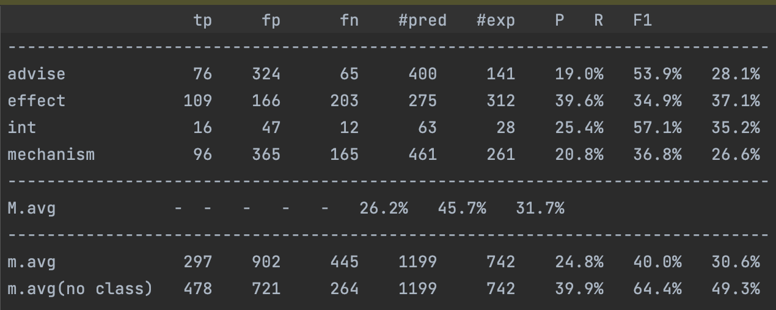
Figure 1: Statistics table of the Naive Bayes baseline model capturing precision, recall, f1-score for advise, effect, int, mechanism groups and their mean.

As can be seen in the table the mean of the F1 score over the 4 classes is 31.7%. Using feature extraction, we tried to improve this score.

Feature extraction
This task was done incrementally on the Naive Bayes model. Different features and feature combinations were tried, while improving the average F1 score, which gradually converged around 46%. The following table shows this score across different feature combinations on the Naive Bayes model.

Feature Set | Precision | Recall | F1
baseline | 26.2% | 45.7% | 31.7%
baseline, 2 internal tokens | 28.3% | 52.3% | 36.0%
baseline, 3 internal tokens | 30.1% | 50.1% | 36.7%
baseline, 5 internal tokens | 26.0% | 37.3% | 30.0%
baseline, 3 internal tokens, distance | 30.6% | 50.2% | 37.2%
baseline, 3 internal tokens, distance, prev | 35.3% | 54.6% | 42.0%
baseline, 3 internal tokens, path length | 30.0% | 49.7% | 36.5%
baseline, 3 internal tokens, path length, previous | 33.7% | 54.4% | 40.8%
baseline, 3 internal tokens, distance, prev, next | 36.9% | 57.8% | 44.1%
baseline, 3 internal tokens, n stopwords, prev, next | 35.5% | 56.5% | 42.8%
baseline, 3 internal tokens, distance, prev, next, sentence length | 37.9% | 54.6% | 43.4%
baseline, 3 internal tokens, distance, prev, next, lcs | 37.8% | 60.0% | 45.8%
baseline, 3 internal tokens, distance, prev, next, lcs, type | 38.2% | 60.0% | 45.9%
baseline, 1 internal token, distance, prev, next, lcs, type | 32.5% | 58.4% | 41.4%
baseline, 3 internal tokens, distance, prev, next, lcs, type, hazardous | 37.9% | 60.1% | 45.8%
baseline, 3 internal tokens, distance, prev, next, lcs, type, verbs | 39.0% | 60.8% | 46.8%
baseline, 3 internal tokens, distance, prev, next, lcs, type, verbs, hazardous | 38.4% | 60.6% | 46.3%
Table 1: Feature selection with corresponding results obtained on precision, recall and f-1 score matrics.

The baseline set of features contains form, PoS tag, lemma and if the token is an entity for the first token between the entity pair. First thing that was done was expanding this to a given number of non-stopword tokens in between the pair. If the pair had less than the given number of tokens in between, the extra features were given blank values. Different number of tokens tried was 2, 3 and 5, with 3 giving us the best results.
Next feature is the number of tokens between the entity pair (distance), which again improved the results. A similar feature (path length) was tried, giving the minimal number of nodes between the entity pair (going through the lowest common subsumer). However, the token distance feature showed better results.
After that, we further expanded the processed token list to the last not-stopword token before E1 and the first not-stopword token after E2 (blank features if there were no such tokens). The same features as before were used, namely: form, PoS tag, lemma and if the token is an entity. We tried two more length/distance features: the number of nodes in the whole sentence and the number of stopwords between the entity pair, but both were proven impractical. Once again: form, PoS tag, lemma and if the token is an entity analysis was expanded also to the LCS of the entity pair.
Different features regarding the entities E1 and E2 themselves were tried: type of entity (drug, brand, group etc.), if the entities were found in the list of hazardous substances.
At this point, the F1 score was stuck right below 46%, so one more feature was tried: classification of the verb connecting E1 and E2. For this purpose an additional preprocessing step was necessary: to create a dictionary with lemmas of verbs that connected the entity pairs and the corresponding interaction class. If a verb was found in more than one interaction class, it was removed from all of them as well as from future consideration. The connecting verbs were LCS nodes of the entity pair, checked for PoS tag to make sure they were indeed verbs. During the feature extraction part, the lemma of the LCS was searched in the dictionary and awarded the corresponding class or blank if not found. In spite of the cumbersome work needed to adjust the boilerplate code and add the corresponding functions, this feature only increased the F1 score by 1%, thus giving our final score of 46.8% on the Naive Bayes model.

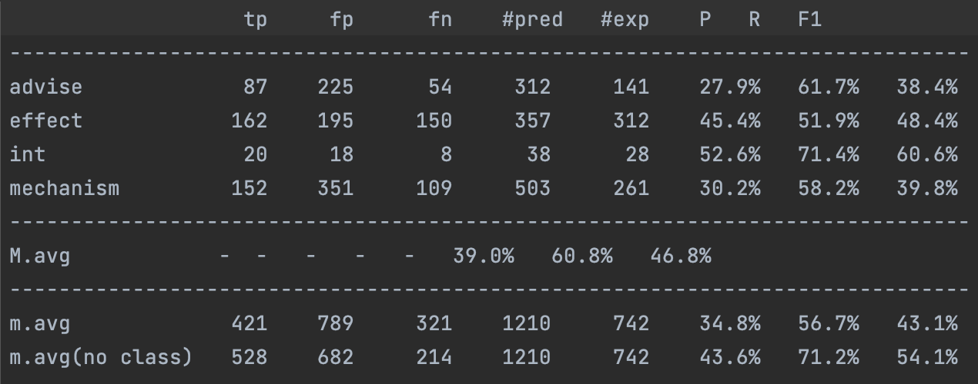
Figure 2: Statistics of naive bayes model with the most optimal feature set

Model tuning
The chosen feature set was used on Naive Bayes, XGBoost and SVC models. The following table shows the comparison.

 | Precision | Recall | F1-score
Naive Bayes | 39.0% | 60.8% | 46.8%
XGBoost | 79.2% | 30.9% | 43.6%
SVC | 62.9% | 45.9% | 53.0%
Table 2: Results obtained with the selected feature set on naive bayes, xgboost and svc models on devel data.

As we can see, SVC had the best results, while XGBoost was the worst. It is probably that XGBoost overfitted the training data, which resulted in a mediocre performance. The given result was obtained using SVC with L2 regularization with regularization coefficient of 1.0. Different coefficient comparison can be seen in the following table.

L2 coefficient | Precision | Recall | F1
0.01 | 85.6% | 19.2% | 27.6%
0.1 | 71.3% | 43.8% | 54.1%
0.5 | 62.6% | 45.7% | 52.7%
1.0 | 62.9% | 45.9% | 53.0%
5.0 | 66.0% | 45.9% | 54.0%
10.0 | 66.0% | 45.9% | 54.0%
100.0 | 66.0% | 45.9% | 54.0%
Table 3: Performance of the SVC model according to different values of the L2 coefficient on devel data.

The optimal regularization coefficient is 0.1, meaning the model should be less penalized for complexity than the baseline. This brings our final F1 score to 54.1%.

Results
After testing and tuning our model using training and validation data, the final model is applied to the test data. This way we will get the most accurate statistics, as shown in the following table.
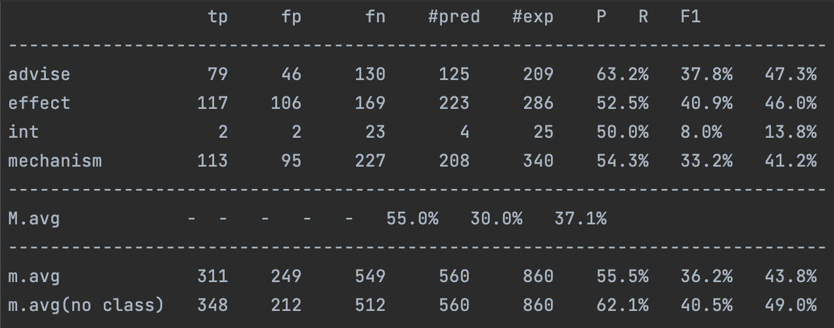
Figure 3: Performance of the SVC model on test data.

As can be seen, the macro F1 score is 37.1%, which is 16% lower than on the validation sample. This is probably a result of overfitting. Macro precision and recall are very different, with precision being at 55.0% and recall at 30.0%. This was the case in the validation test as well and might be improved with a more advanced model properly tuned. Looking at the scores on individual classes, it can be seen that for 3 classes, we have the F1 score over 40% and the class int has only 8.0% F1 score. The most likely reason for that is its underrepresentation in the dataset. Finally, the micro averages show 43.8% F1 for classification.

Code

Connecting-Verb Classification
def verb_extraction(datadir):
verbs = {}
used = set()
for f in listdir(datadir):
# parse XML file, obtaining a DOM tree
tree = parse(datadir + "/" + f)

# process each sentence in the file
sentences = tree.getElementsByTagName("sentence")
for s in sentences:
# analyze sentence
stext = s.attributes["text"].value
analysis = deptree(stext)

# parse entities
entities = {}
ents = s.getElementsByTagName("entity")
for e in ents:
id = e.attributes["id"].value
offs = e.attributes["charOffset"].value.split("-")
entities[id] = {'start': int(offs[0]), 'end': int(offs[-1])}

# for each pair in the sentence, decide whether it is DDI and its type
pairs = s.getElementsByTagName("pair")
for p in pairs:
# ground truth
ddi = p.attributes["ddi"].value
if (ddi == "true"):
dditype = p.attributes["type"].value
else:
dditype = "null"
# continue

# target entities
e1 = p.attributes["e1"].value
e2 = p.attributes["e2"].value
tkE1 = analysis.get_fragment_head(entities[e1]['start'], entities[e1]['end'])
tkE2 = analysis.get_fragment_head(entities[e2]['start'], entities[e2]['end'])

# put lcs lemma in the dict
lcs = analysis.get_LCS(tkE1, tkE2)
if lcs is not None and analysis.get_tag(lcs)[0] == 'V' and tkE1 != tkE2:
lemma = analysis.get_lemma(lcs)
if dditype not in verbs: verbs[dditype] = set()
if lemma not in used:
found = False
for k in verbs.keys():
if dditype == k: continue
if lemma in verbs[k]:
found = True
used.add(lemma)
verbs[k].remove(lemma)
if not found:
verbs[dditype].add(lemma)

return verbs

Feature Extraction
def extract_features(tree, entities, e1, e2):
feats = set()

# get head token for each gold entity
tkE1 = tree.get_fragment_head(entities[e1]['start'], entities[e1]['end'])
tkE2 = tree.get_fragment_head(entities[e2]['start'], entities[e2]['end'])

# check if it's equal, since that's an error of bad offset parsing (e.g. 51-59;70-84 -> start: 51, end: 84)
if tkE1 is not None and tkE2 is not None and tkE1 != tkE2:
# make sure tkE1 is the first token
if tkE1 > tkE2:
t = tkE1
tkE1 = tkE2
tkE2 = t

# features for tokens in between E1 and E2
tk = tkE1
realTokens = []
nstopw = 0
while tk <= tkE2:
try:
while True:
tk += 1
if tk > tkE2:
break
if not tree.is_stopword(tk):
realTokens.append(tk)
break
else:
nstopw += 1
except Exception as e:
raise e

for i in range(3):
if len(realTokens) <= i:
word = ""
lemma = ""
tag = ""
eib = False
else:
word = tree.get_word(realTokens[i])
lemma = tree.get_lemma(realTokens[i]).lower()
tag = tree.get_tag(realTokens[i])
if tree.is_entity(realTokens[i], entities):
eib = True
else:
eib = False

feats.add("lib" + str(i) + "=" + lemma)
feats.add("wib" + str(i) + "=" + word)
feats.add("lpib" + str(i) + "=" + lemma + "_" + tag)
feats.add("eib" + str(i) + "=" + str(eib))

# feature for token before E1
tk = tkE1 - 1
while tk >= 0 and tree.is_stopword(tk):
tk -= 1
if tk < 0:
word = ""
lemma = ""
tag = ""
eib = False
else:
word = tree.get_word(tk)
lemma = tree.get_lemma(tk).lower()
tag = tree.get_tag(tk)
if tree.is_entity(tk, entities):
eib = True
else:
eib = False

feats.add("libprev=" + lemma)
feats.add("wibprev=" + word)
feats.add("lpibprev=" + lemma + "_" + tag)
feats.add("eibprev=" + str(eib))

# feature for token after E2
tk = tkE2 + 1
treeLen = tree.get_n_nodes()
while tk < treeLen and tree.is_stopword(tk):
tk += 1
if tk == treeLen:
word = ""
lemma = ""
tag = ""
eib = False
else:
word = tree.get_word(tk)
lemma = tree.get_lemma(tk).lower()
tag = tree.get_tag(tk)
if tree.is_entity(tk, entities):
eib = True
else:
eib = False

feats.add("libnext=" + lemma)
feats.add("wibnext=" + word)
feats.add("lpibnext=" + lemma + "_" + tag)
feats.add("eibnext=" + str(eib))

# feature indicating the presence of an entity in between E1 and E2
eib = False
for tk in range(tkE1 + 1, tkE2):
if tree.is_entity(tk, entities):
eib = True
feats.add('eib=' + str(eib))

# features about paths in the tree
lcs = tree.get_LCS(tkE1, tkE2)
word = tree.get_word(lcs)
lemma = tree.get_lemma(lcs).lower()
lcs_lemma = lemma
tag = tree.get_tag(lcs)
if tree.is_entity(lcs, entities):
eib = True
else:
eib = False
feats.add("liblcs=" + lemma)
feats.add("wiblcs=" + word)
feats.add("lpiblcs=" + lemma + "_" + tag)
feats.add("eiblcs=" + str(eib))

path1 = tree.get_up_path(tkE1, lcs)
lp1 = len(path1)
path1 = "<".join([tree.get_lemma(x) + "_" + tree.get_rel(x) for x in path1])
feats.add("path1=" + path1)

path2 = tree.get_down_path(lcs, tkE2)
lp2 = len(path2)
path2 = ">".join([tree.get_lemma(x) + "_" + tree.get_rel(x) for x in path2])
feats.add("path2=" + path2)

path = path1 + "<" + tree.get_lemma(lcs) + "_" + tree.get_rel(lcs) + ">" + path2
feats.add("path=" + path)

feats.add("dist=" + str(tkE2 - tkE1))
# feats.add("pathlen=" + str(lp1 + lp2))
# feats.add("sentlen=" + str(treeLen))
# feats.add("nstopw=" + str(nstopw))

# entitiy pair information
feats.add("typ1=" + entities[e1]["type"])
feats.add("typ2=" + entities[e2]["type"])

# connecting verb class
clss = ""
for k in verbs.keys():
if lcs_lemma in verbs[k]:
clss = k
break
feats.add("verbclss=" + clss)

return feats

