Process-Oriented Data Science project
Group 8

Ignasi Cervero Corbella
Iker Jansà Estavillo
Andreja Andrejić
Pol Arévalo Soler
Ákos Schneider

Road traffic management

Contents
- Project motivation and understanding the data
- Understand the process
2.1. Definition of complete cases
2.2. Rules for process conformance
2.3. Variant analysis
2.4. Data cleaning - derived case attributes
2.5. Resource analysis
- Insights
3.1. Bottlenecks (to try to get them low)
3.2. Credit Collection Comparative Analysis (taking into account the case attrs)
3.3. Long vs short cases (taking into account the case attrs)
- Recommendations to the City Council
- Conclusion and further work
  - Recommendations to the city councils on how to improve this process
    - simulations to check how different solutions play out
  - Rules that make sense
  - Go to the simulation if you want to

1. Project motivation and understanding the data

To better understand the entire dataset, we start by interpreting each variable and then examine the descriptive statistics of numerical variables.

- amount: The amount of fine imposed in Euros on the offender
- org:resource: The resource of the event
- dismissal: Takes values of capitalized letters, numbers and a hash mark. Unable to interpret by itself, we will look into how they relate to cases
- concept:name: The name of the activity
- vehicleClass: Class of the vehicle (A, C, M, R, NaN) driven by the offender
- totalPaymentAmount: The total amount paid by the offender in the case up until this event
- lifecycle:transition: Always takes the value complete
- time:timestamp: timestamp of the event (2001-01-01 to 2013-06-18)
- article: Article in the law that the offender infringed
- points: The amount of points deduced from the offender’s behavioural score
- case:concept:name: The name (or identifier) of the case
- expense: Administration fee for the handling of the case
- notificationType: Takes P or C values (Personal or Carta)
- lastSent: Takes P, N, or C values
- paymentAmount: The amount paid in Euros by the offender in the event
- matricola: Registration number (always 0 and given 555 times out of 230k)

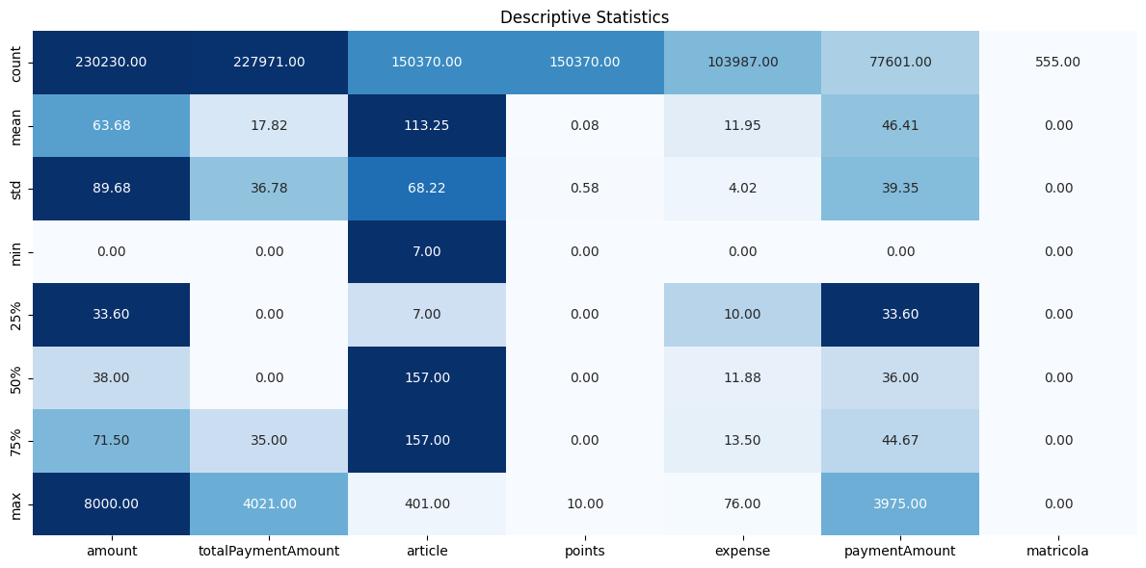
Figure 1: Descriptive statistics of the dataset

We see from here that the expense of a case ranges from 0 to 76 euros, this is correlated with the amount of the fine: the larger the fine the larger the expense. We also see from the amount column, that the maximum fine amount was 8000 euros, whereas the mean is around 64 euros, indicating an expected, strong power-law distribution.

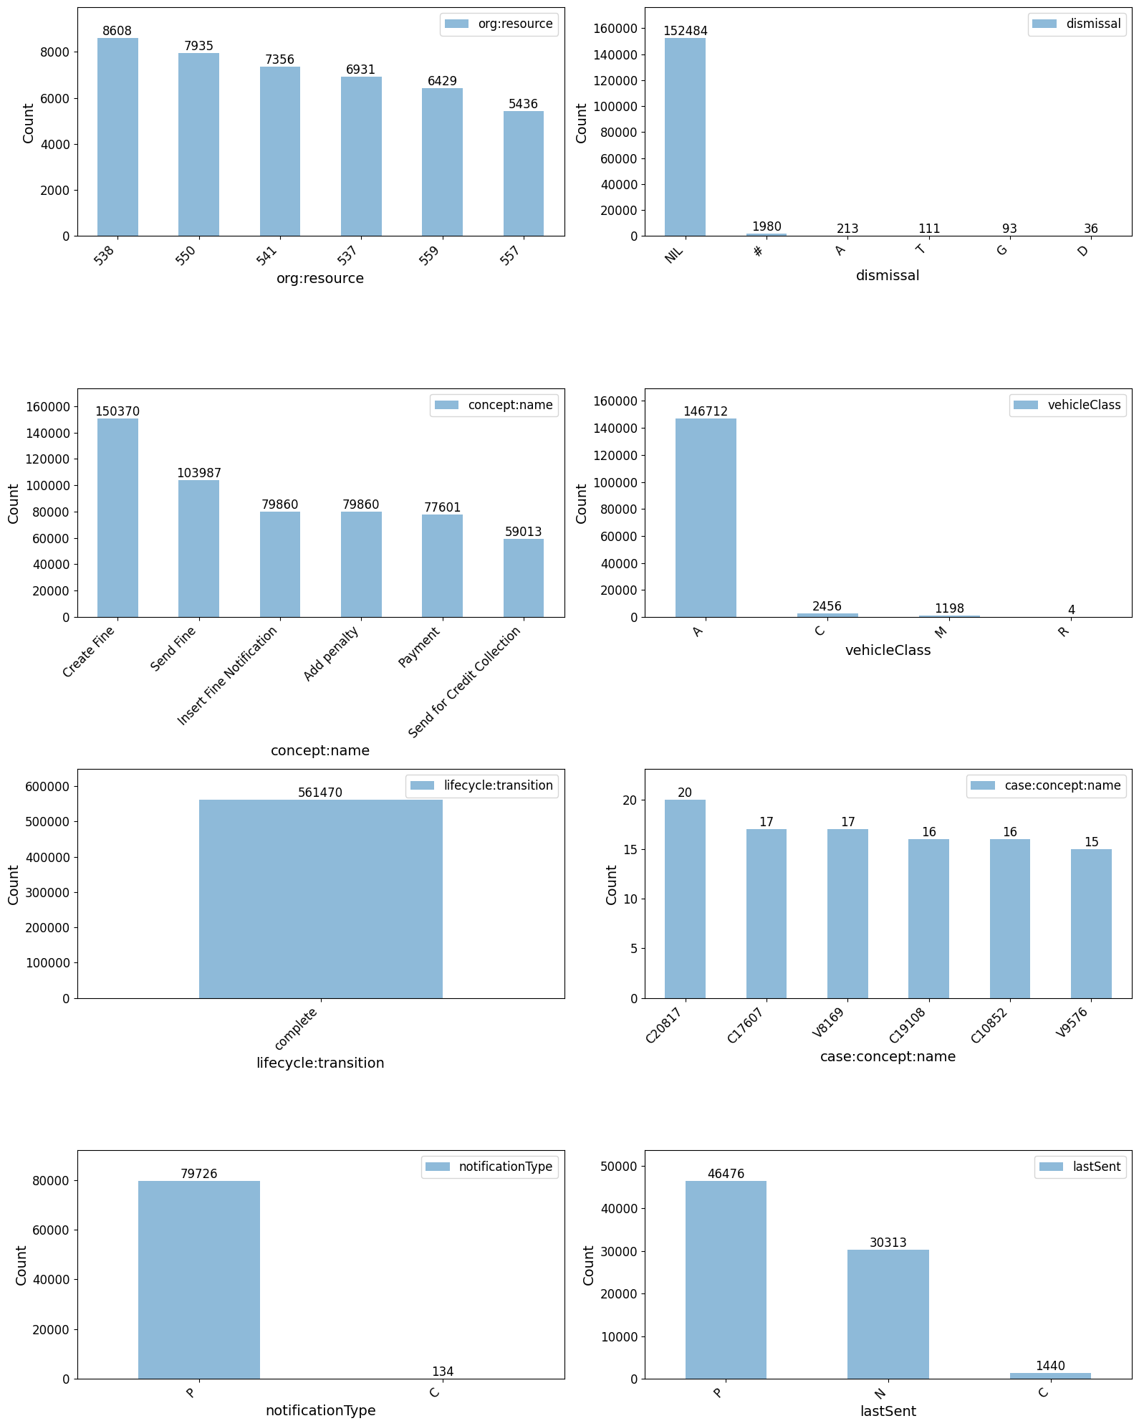

2. Understanding the process
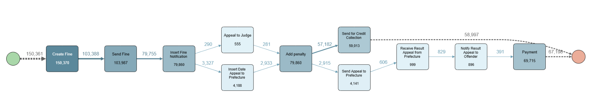
The process map with arcs displayed at 10% shows a sequential process with no reworks. However, when looking at reworks, we see that 100% of reworks are within the Payment activity.
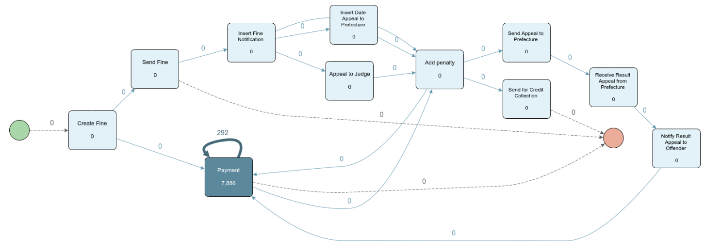
Activity descriptions:
- Create Fine: Initiates a case by registering a fine based on a traffic offence.
- Send Fine: The fine notification is sent to the offender.
- Insert Fine Notification: The system logs that the fine notification has been issued.
- Payment: The offender pays the fine.
- Appeal to Judge: The offender disputes the fine, and the case is escalated to a judge.
- Insert Date Appeal to Prefecture: The system logs the appeal submission date to the local prefecture.
- Add Penalty: A penalty is applied for late payment or unresolved disputes.
- Send for Credit Collection: Cases of unpaid fines are referred to credit collection agencies.
- Send Appeal to Prefecture: Appeals are forwarded to the prefecture for review.
- Receive Result Appeal from Prefecture: The system logs the result of the appeal decision from the prefecture.
- Notify Result Appeal to Offender: The appeal decision is communicated to the offender.

2.1. Definition of complete cases
After carefully examining the process map we decided to define complete cases as
- any case that either ends with the activity Payment or Send for credit collection.
This is derived from the interpretations of the activities. Essentially, a case can end in the offender paying or not paying. In the former case, the city council receives the full payment of the fine and the case is closed. In the latter case, the offender fails to pay and the case is escalated to credit collection agencies. Any case ending with any other activity can not be considered a complete case.

2.2. Rules for process conformance
- An offender has to receive a notification and at least one penalty before being sent to credit collection agencies.
This was validated in Apromore, looking at cases that end with being sent to credit collection. From figure 2, we can see that 100% of the cases contain Add Penalty, Insert Fine Notification, and Send Fine. The first related to there being at least one penalty, while the second and the third relate to there being a notification.
We validated this with case attributes as well: all of the cases that ended with being sent to credit collection have a notificationType of P or C, and not NaN.
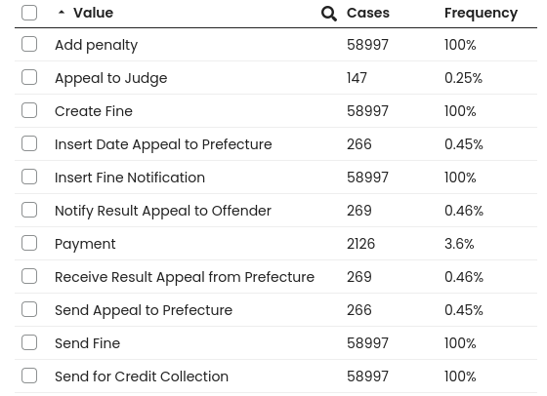
Figure 2: Ratio of activities in cases that ended with Send for credit collection

- In all of the cases that ended with being sent for credit collection, the offender has failed to pay to full amount of the fine
This was validated via python, where we filtered for such cases and found the following three not conforming:
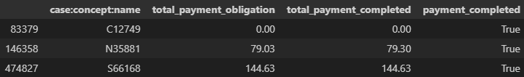
Notably, case C12749 has 0 payment obligation yet it still ended up in the system indicating that it’s an erroneous row. The other two seem to be related with delayed payment.

2.3. Variant Analysis
- Variant 1 is almost half of all cases. It represents the most undesirable outcome, where the offender is notified and penalized, but does nothing and the case is ultimately sent for credit collection.
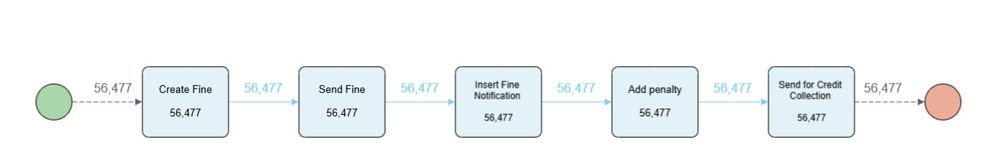
- Variant 2 is the most desirable case, when the offender completes the payment after the fine is issued (5 day median). With Variant 1, they take up 80% of all cases.
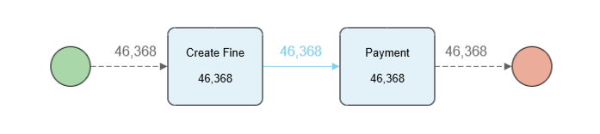
- Variant 3 is much less common (7.5%) and represents the situation where the offender completed a payment after being notified, but only when he was first penalized.
- Variant 4 is even less (3%) common and is the same as the previous case, but with 2 payments instead of one.
- Variants 5-8 are combinations of the above cases. They do not include any additional activities.

2.4. Data cleaning - derived case attributes
The Road Traffic Fine Management Process dataset originally contained event-level information, but to enable proper case-level analysis in Apromore, we needed to derive and propagate several case attributes across all events within each case. We used the pm4py and pandas libraries from python to load and manipulate the initial .xes dataset. The following features were extracted and replicated across all events of the same case:

Financial Attributes
- Total Fine Amount: The final fine amount including penalties
- Total Expenses: Sum of administrative costs
- Total Payment Obligation: Combined amount of fine and expenses
- Total Amount Paid: Maximum amount actually paid by the offender
- Payment Completed: Boolean indicating if the payment obligation was fully met

Process Characteristics
- Number of Penalties: Count of additional fines
- Number of Payment Installments: Count of payment transactions
- Initial Fine Amount: The original fine before any penalties
- Total Penalty Amount: Additional fines accumulated (difference between final and initial fine)
- Article: The number of the article that was violated
- notificationType: When a penalty is added, it indicates the type of notification that is sent
- lastSent: Status update of notificationType

By propagating these derived attributes to every event within a case, we ensured that Apromore would correctly interpret them as case-level attributes rather than event-level attributes. This transformation was necessary because Apromore determines case attributes based on whether the attribute values remain constant across all events within a case. The modified dataset was exported to CSV format, making it suitable for further analysis in process mining tools while maintaining the integrity of the case-level information.

2.5. Resource analysis
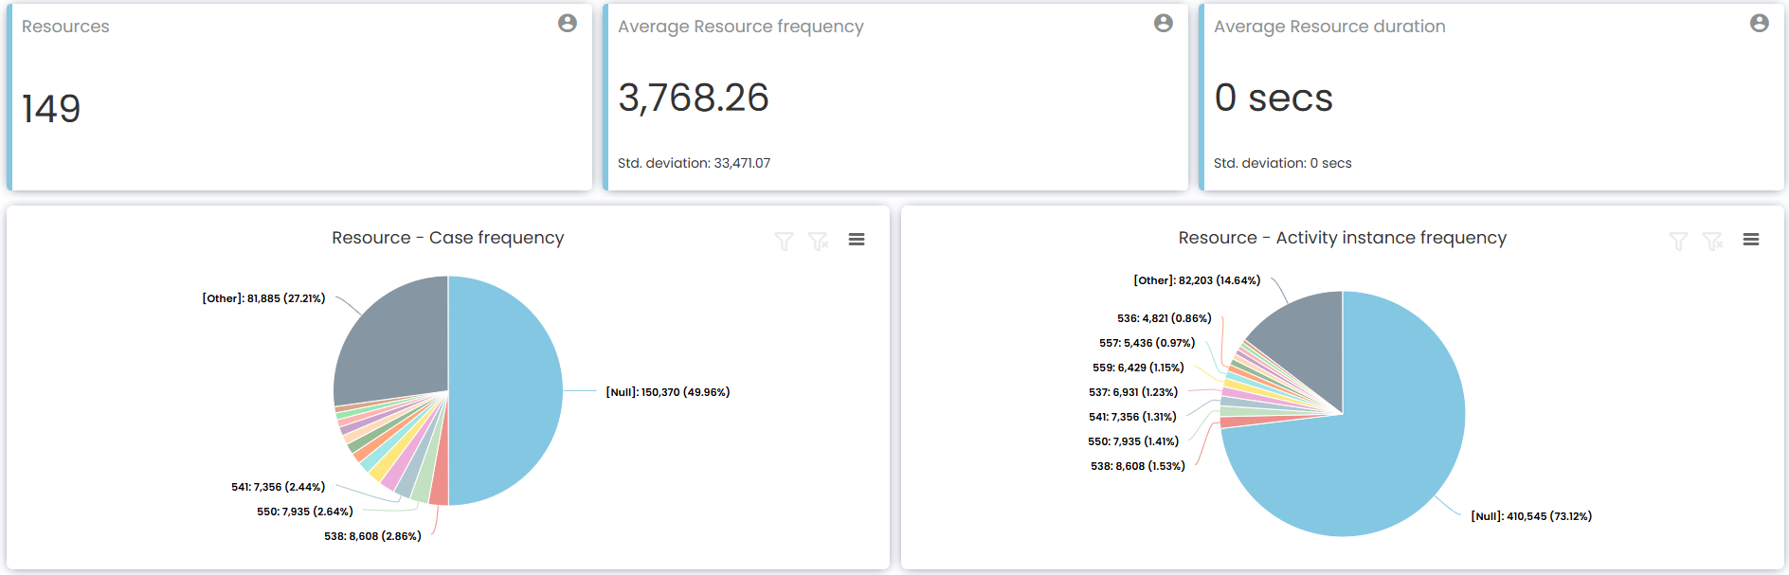
We see 149 unique resources with seemingly non-interpretable names (some being numbers, the most common being Null).They might mean worker IDs, we can not tell with certainty. When looking at the resource perspective of the process map, it also does not convey more information. Since this view is not feasible to interpret, we focus on other areas of the process discussed in later sections.
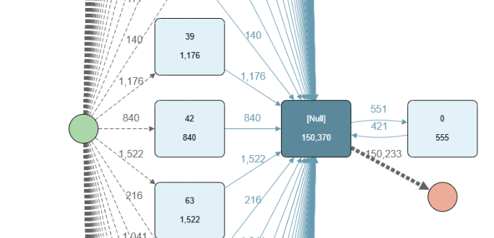

3. Insights
Our study focused on lowering the average case length and reducing the number of resources needed to handle cases efficiently, ultimately improving operational performance and optimizing resource allocation within the organization. To do so we focused on bottlenecks and explored strategies to avoid the credit collection phase, which is both time-consuming and resource-intensive.

Bottlenecks
summary:
- Penalty not working, 77% end up going to credit collection

Add penalty for taking to long (100% of credit collection have penalty)
77% end up in credit collection -> penalty doesn’t work
Solution -> raise prices of the penalization as we have seen it makes people pay

Last sent is sent in Insert Fine Notification which happens before add penalty.

In this process map, all activities take instant time, therefore, we must rely on the transition time between activities in order to identify bottlenecks. An interesting thing to do before looking for bottlenecks is actually finding where the process is optimized, which is the path that we know is possible and the business would desire. The Create Fine to Payment variant is the desired “fast path”,this path involves only two activities, minimal resources, and an average transition time of 1.5 weeks (with a median of 5 days), making it the most efficient sequence.

Add Penalty to Send for Credit Collection is the most common long arc, which takes an average of 1.44 years. While there are even longer arcs in the process, they occur far less frequently. Instead of accelerating this transition, efforts should focus on reducing its occurrence, as it signals undesirable outcomes. The administration wants the offender to end up paying before being sent to credit collection. However, the Add Penalty process appears ineffective in achieving this goal, as 77% of the people penalized end up being sent for Credit Collection anyway. This indicates a breakdown in the intended pathway and highlights the need for a reevaluation of the penalty system to ensure it drives payment rather than escalating to credit collection.

Another significant transition, Add Penalty to Payment, averages 5.29 months, with approximately 50% of these cases resolving within an acceptable timeframe of 2 months. However, the remaining 50%, approximately 9,000 cases, take longer. As mentioned in the previous point, these numbers further support the argument against the effectiveness of the penalization system.

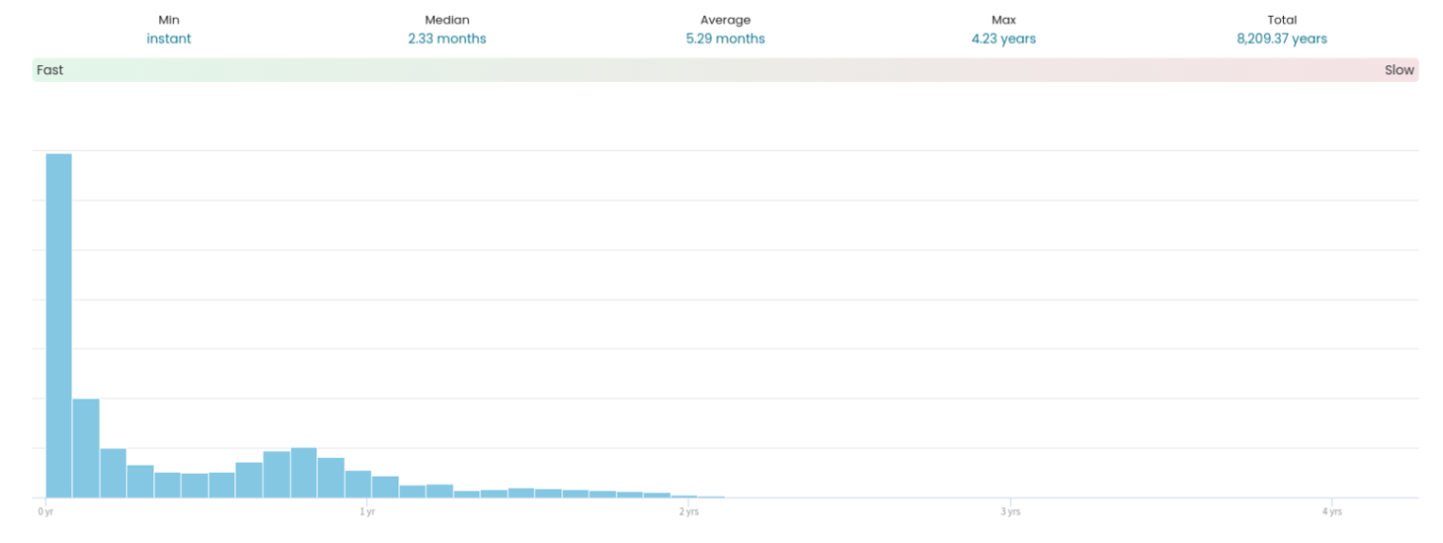
Figure X: Distribution of time elapsed before paying after receiving a penalty

Another area of interest is the transition from Create Fine to Send Fine, which averages 2.8 months and occurs in 63% of finished cases. With modern technology, automating the notification process could significantly reduce this timeframe, thereby accelerating the entire workflow. Similarly, the transition from Send Fine to Insert Fine Notification takes an average of 2.5 weeks. Automation in this step could potentially make this transition instantaneous, eliminating unnecessary delays and enhancing overall process efficiency. These observations provide actionable insights into reducing bottlenecks and optimizing the management of road traffic fines.

Credit Collection Comparative Analysis (Iker)

In Figure X we can see that the credit collection cases consistently account for a significant portion of the active cases, often peaking above 15,000 simultaneous cases. This reveals a clear bottleneck in resource allocation and operational efficiency, highlighting the importance of reducing credit collection cases.

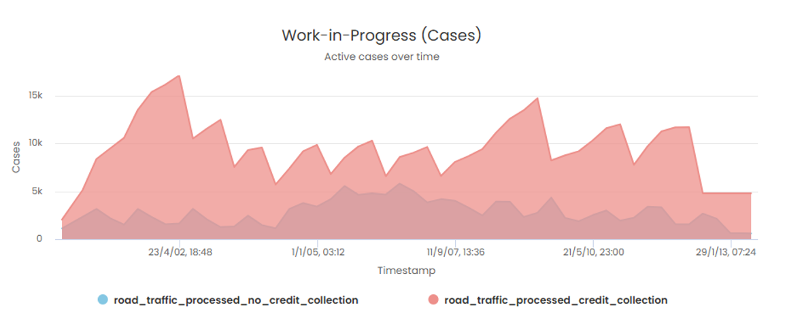
Figure X: Comparison of active cases over time between credit collection and no credit collection processes.

To obtain a comparative analysis between cases with and without credit collection, we first filtered finished cases based on whether credit collection occurred and downloaded the corresponding raw data. We then processed the data to create a more compact dataset, as many case attributes were only mentioned in a single activity within each case. This processing was done through Python to provide greater flexibility in visualization, enabling clearer and more customized results.

Figure X shows the average total payment obligation categorized by credit collection. It can be seen that cases that didn’t end up in credit collection have a higher average than those that did.

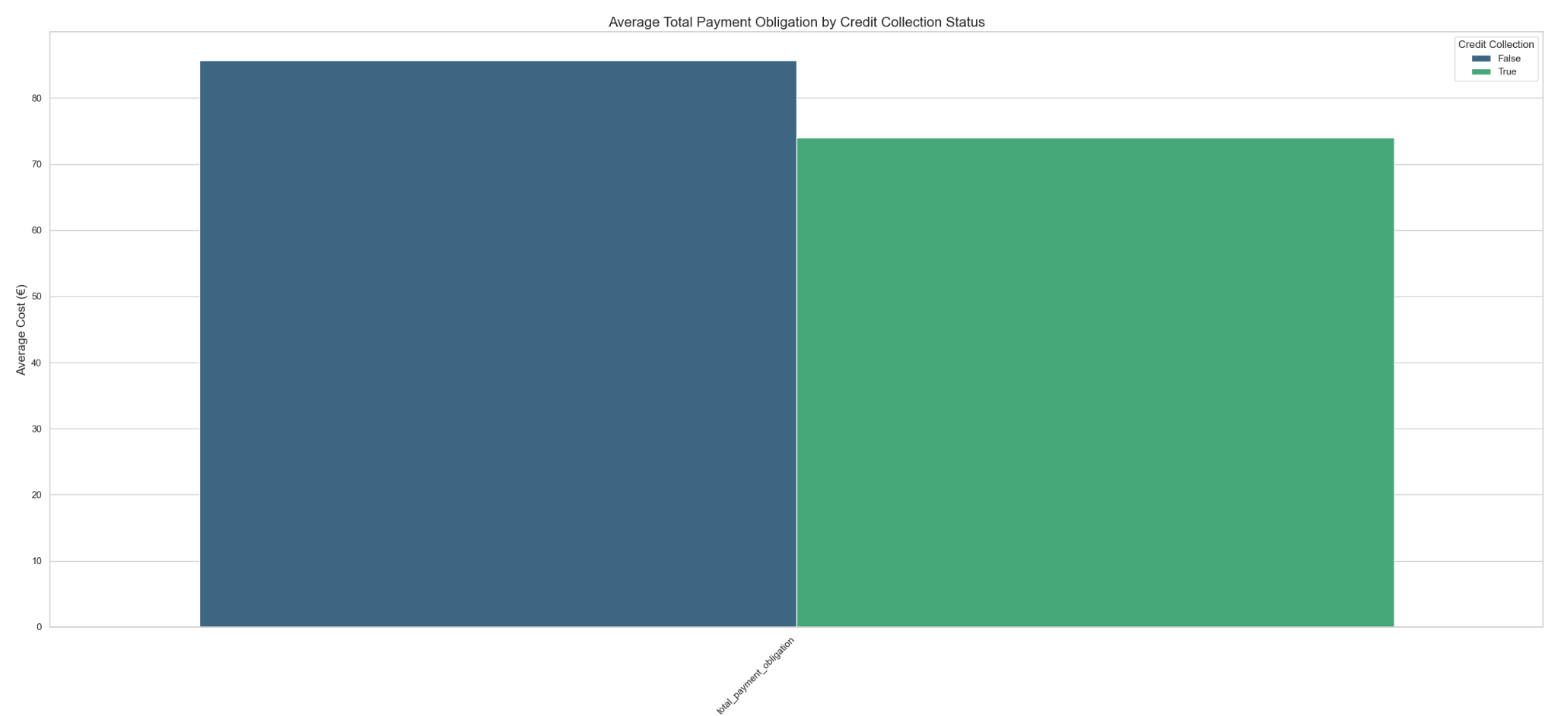
Figure X: Average Total Payment Obligation categorized by Credit Collection

A potential explanation for this trend could be that individuals are more likely to pay earlier when the total amount is higher, as the discount for early payment is greater in absolute terms. Additionally, a higher fine may generate greater economic stress, making individuals settle their obligations sooner to get it under control sooner. This combination of financial and psychological factors likely contributes to the observed reduction in average payment obligations under credit collection conditions.

The following plots illustrate the percentage distribution of cases across different categories based on credit collection status. This approach ensures that the absolute number of cases does not distort the visual interpretation, allowing for a clear comparison of the percentual differences of each category relative to the target variable.
Figure X presents the distribution by violated article, highlighting that individuals who breach Articles 7 and 157 are more likely to settle their payments. As explained in Section X of the Appendix, Article 157 addresses the rules concerning vehicle stopping and parking, while Article 7 prohibits the use of lanes specifically reserved for public transport by private vehicles. On the other hand, individuals who violate Articles 142 and 158 have a tendency to end up in credit collection. These articles address speeding regulations and loading and unloading goods, respectively.

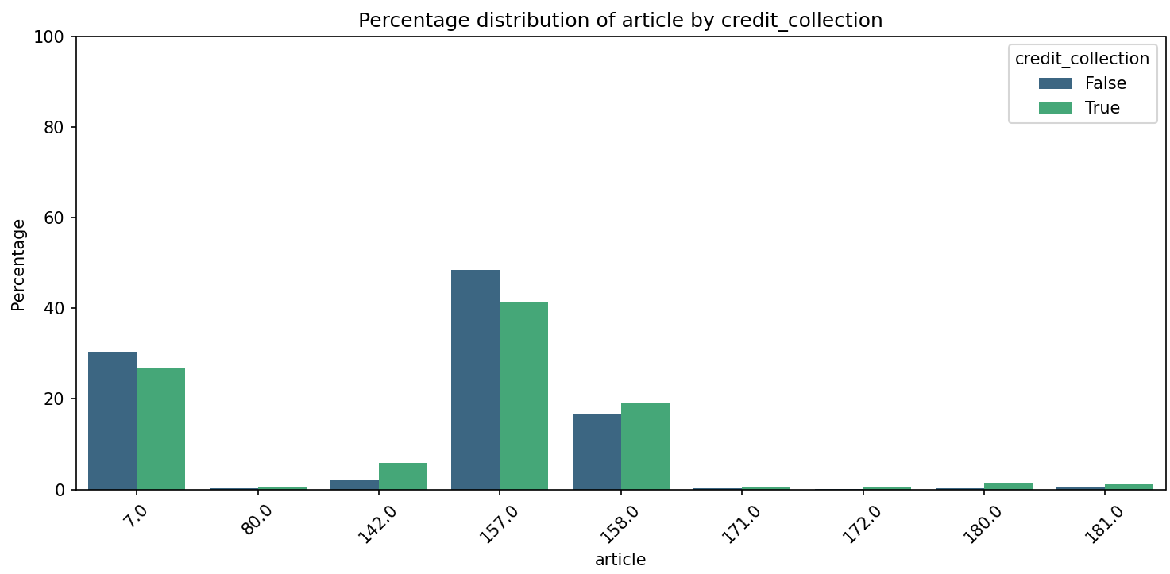
Figure X: Percentual distribution of articles categorized by Credit Collection

Figure X supports that the overall quality of the dataset is good as there are 0 cases that have ended up in credit collection but have not received a notification (NA notificationType). Additionally, a low percentage of cases that haven’t ended up in credit collection receive a notification because almost 70% of the credit collection False follow case variant 2 which, as seen in Figure X, creates the fine and then pays it and therefore doesn’t go through “Insert Fine Notification”. Furthermore, there are practically no cases that have a notification type C in either category of the target variable.

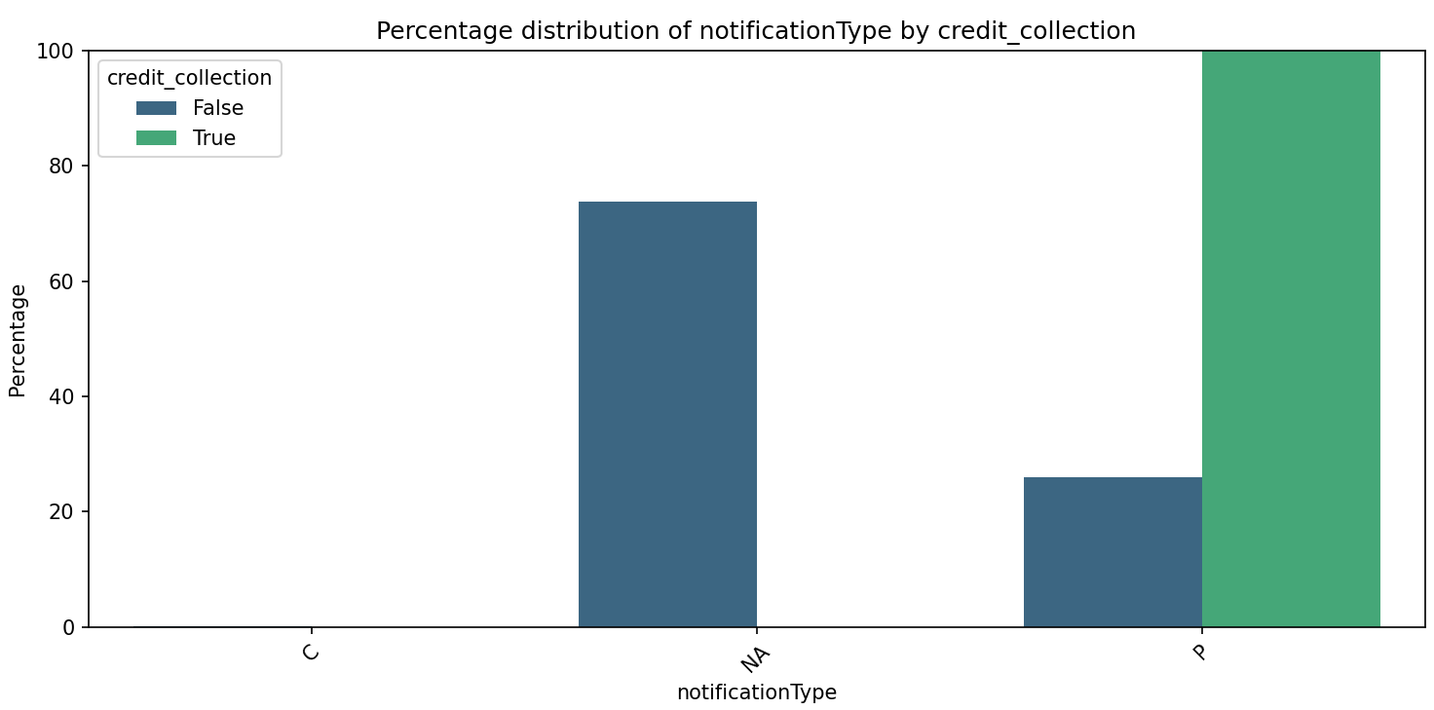
Figure X: Percentual distribution of notificationType categorized by Credit Collection

Finally, the information extracted from the lastSent feature is very insightful as it demonstrates that certain types of notifications have a more positive effect than others. This feature is linked to the Insert Fine Notification activity, similar to notificationType, sharing the same categories with the addition of a category labeled N. We believe it is a status update of the initial notification type and the category N indicates that the notification has failed or not reached the person. This would also justify that the number of cases that receive a card notification increases from 123 in NotificationType to 1348 in lastSent as they haven’t been able to access the fined person in person and then decide to send a card.

Out of all the cases that have a lastSent of type C 29.6% (399/1348) have ended up paying, only 15.6% (4630/29764) of the type N and 27.6% (12131/43928) of the type P.
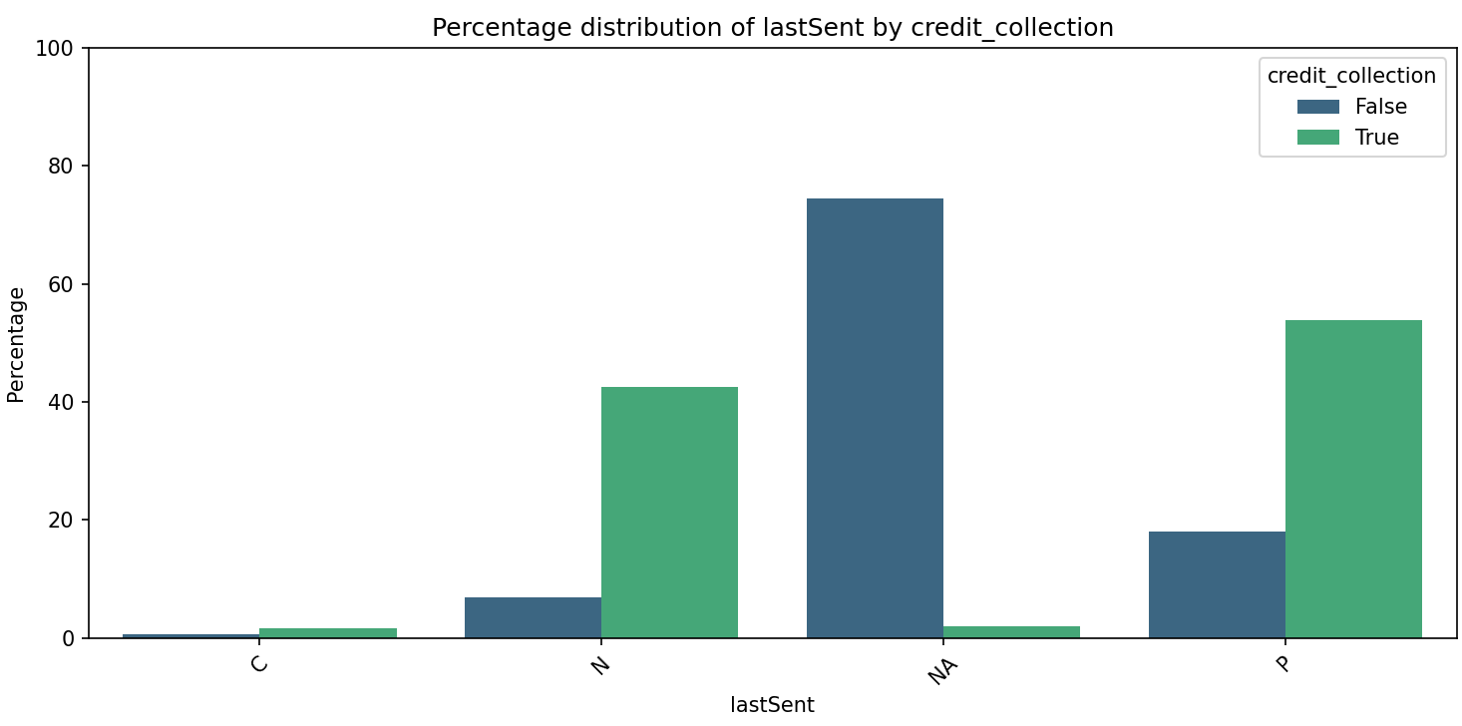
Figure X: Percentual distribution of lastSent categorized by Credit Collection

If all the notifications that didn’t reach the person (lastSent = N) would have simply received a card, assuming the sample size of 1348 cases is valid this would have increased the number of people that paid by 4180 which is a reduction of more than 7% of the total number of people sent to credit collection.

Long vs. short cases (Andreja)
Even though we discovered the main bottlenecks of the process, we wanted to find out what the major contributing factors of a short case duration are. We set a threshold of 100 days and tried to predict whether a case was above or below (short or long). After cleaning the data, we used a Random Forest Classifier for prediction. Using RF, we got the importance of each variable for predicting the case duration. We did this using Python and its ML and visualization libraries.

Among the top factors, we got the presence of the following activities: Send Fine, Add penalty, Insert Fine Notification, Send for Credit Collection. Each of these activities extend the duration of cases. This is common sense because cases that end (pay the fine) before these events are triggered have a shorter duration. Payment activity also appears on this list, but with a positive connotation, as cases that end in payment are definitely shorter than the ones that end with Credit Collection.

Furthermore, in Figure X we compare the median duration in days across the three levels of notificationType. We see that C has a shorter duration than P, but we need to take into account that C is severely underrepresented. Also, cases without this variable are the ones where the offender has not received a penalty and therefore not notified meaning that the payment was finished before the notification was sent. Therefore it is straightforward why these cases are the shortest.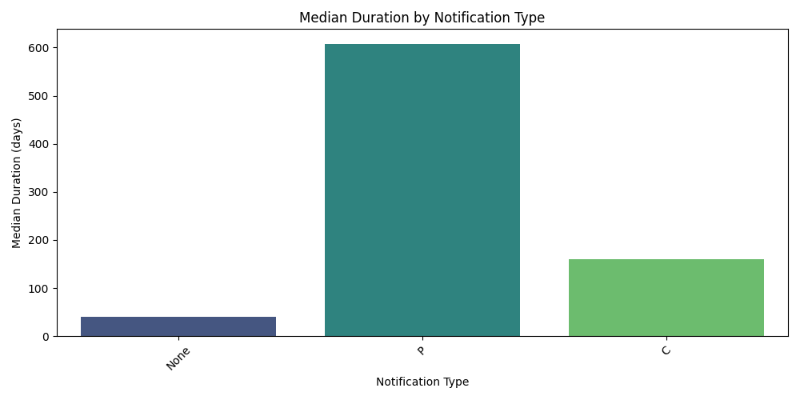
Figure X: Median duration in days across the levels of notificationType

The last influential categorical variable is ‘last sent’. We can see how it affects the duration in Figure X. We believe that this variable represents the method of the last notification. Figure X shows again that cases where the offender had not been notified take the shortest amount of time. As for values P, N and C, their median is mostly the same, however we can see the difference in the outliers. C has the least outliers, followed by P and finally N has the highest variability with large tails of outliers in both directions.
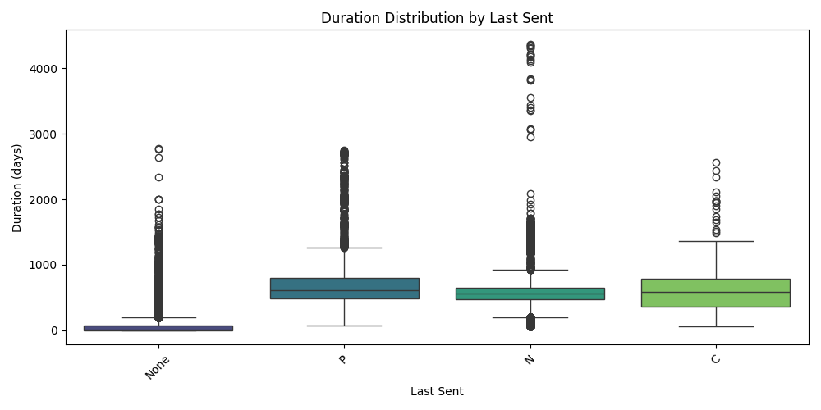
Figure X

The final influential variable is the total payment obligation. Figure X shows its correlation with the duration of the cases. In cases where the fine exceeds 1000 euros, there are just a few cases where duration exceeds 1000 days. This is most likely because people consider greater fines a more serious issue and want to handle them sooner. Also it cannot be due to the discounts that the Italian government gives when fines are paid quickly, as still more than half of the cases take longer than a year to finish.
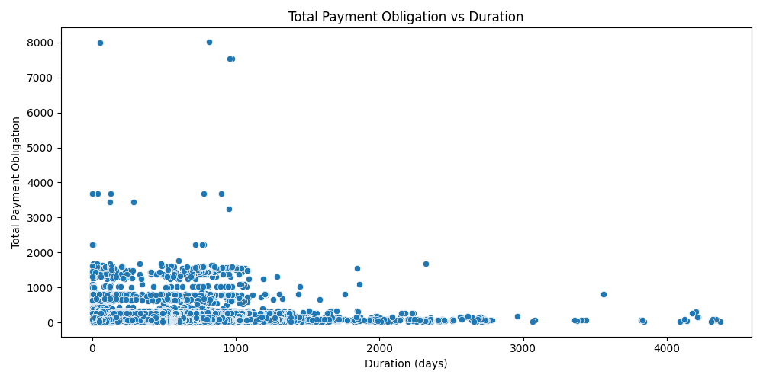
Figure X: Scatter Plot of Total Payment Obligation vs Duration

The insights regarding the case duration correlate with the comparative analysis for credit collection. This means that adjustments for reducing cases going for credit collection will also shorten the duration of cases that end in payment.

4. Recommendations to the City Council
The data indicates that higher fines correlate with fewer cases escalating to credit collection and cases being shorter. Increasing the baseline fine across all violations may therefore serve as a preventive measure, reducing the administrative burden.
While the current practice of adding a penalty for offenders who fail to pay on time is intended to avoid ending up in credit collection, the data suggests this measure is not effective. In fact, 77% of penalized offenders still end up in credit collection. Instead of maintaining the current penalty structure, we recommend substantially raising the subsequent fine amounts. As mentioned before, it has been seen that higher prices incentivize people to pay, so by doing so, non-compliant offenders may be more incentivized to pay promptly before incurring a significantly higher cost.
Additionally, violations related to Articles 142 and 158 have demonstrated a higher likelihood of ending up in credit collection. To address this, the Council should consider imposing an even greater fine increase for these specific infractions. By doing so, the adjusted penalty framework will more accurately reflect their heightened risk, potentially reducing the number of delinquent accounts tied to these particular violations.

To accelerate the process, we recommend investing in automating the transition from “Create Fine” to “Send Fine,” currently averaging 2.8 months. Similarly, automating the “Send Fine” to “Insert Fine Notification” step, which takes 2.5 weeks, could make it instantaneous accelerating the entire process
Finally, data shows that making sure that the notification of the added penalty is at least sent by card would reduce subsequent credit collection cases by more than 7%. Moreover, given the demonstrated impact of sending notifications, we also recommend implementing an electronic notification immediately upon issuing a fine. This method ensures that offenders are aware of their responsibilities and the benefits of paying fines early, such as avoiding additional penalties and saving costs. This would reduce by a significant amount the instances where the City must engage in the costly credit collection process.

Overall, these measures are expected to reduce the number of cases escalated to credit collection, improve recovery rates, and promote operational efficiency. By modernizing notifications and restructuring fines, the system becomes not only more effective but also fairer and more transparent, fostering greater public trust and compliance.

Appendix A: Analysis Extension

Feature Importance Analysis for RandomForest Classifier

During the feature importance analysis of the RandomForest Classifier, it was observed that notificationType and lastSent accounted for approximately 70% of the total impurity reduction, initially suggesting these features were critical for the model’s performance. However, further investigation revealed that they were leaked variables, containing information from the future since they are only non-null for users who have already received a penalty for late payments. This temporal leakage gave the model access to future events, resulting in an unrealistically high performance during training. After removing these features, close to 90% of the impurity remained unexplained by the remaining variables, indicating a significant lack of predictive information in the dataset.

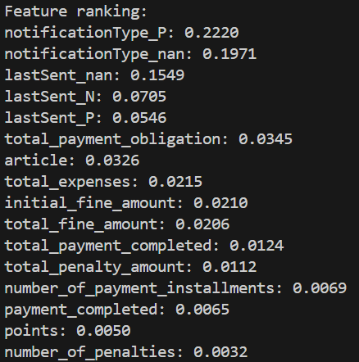
Figure X: Feature ranking for predicting Credit Collection

Relevant Legal References from the Italian Highway Code
Article 157 of the Italian Highway Code addresses the rules concerning vehicle stopping, parking, and standing. It outlines the appropriate procedures for temporarily halting a vehicle and specifies conditions under which parking is considered improper or unlawful. For further details, refer to the official documentation here.
According to Article 158, goods must be loaded and unloaded in a manner that ensures road safety and operational efficiency. Specifically, the loading process must not obstruct the driver’s visibility, impede the movement of other vehicles, or create hazardous protrusions from the vehicle. Additional guidance can be found here.
Article 7 prohibits the use of lanes specifically reserved for public transport by private vehicles. This regulation ensures the smooth operation of buses and taxis, contributing to an efficient public transportation system. For more information, see the official guidelines here.
Article 142 sets forth the legal speed limits on Italian roads and the penalties for exceeding them. Compliance with these limits is essential to maintain road safety and reduce the risk of accidents. For detailed information about speeding penalties, consult the relevant section here.

