Schweitzer Scheduler System

System Requirements Specification

Version 2.1

July 18, 2019

# Table of contents

Table of contents 2

Purpose 3

Product Scope 3

Personnel involved 3

Glossary 4

References 4

Overview 4

General Description 4

Product Perspective 4

Product Functionality 5

User Features 5

Restrictions 5

Assumptions and Dependencies 5

Specific Requirements 6

Functional Requirements 6

Non-Functional Requirements 7

Common Requirements of Interfaces 8

User interface 8

Hardware Interfaces 8

Software Interfaces 9

Functional Requirements 9

## Purpose

* The purpose of this document is to define functional, non-functional specifications for the development of a computer application that will manage the multiple procedures involved in requesting maintenance and repairs services from the Schweitzer Company. This will be used by the company technicians and customers.

## Product Scope

* The main purpose of the Revision’s System is to speed up the process of accepting a work request and delivering a technician to realize an installation or maintenance. To have a better management of the clients, generating a list of frequent clients giving to each one a unique ID.

## Personnel involved

|  |  |
| --- | --- |
| **Name** | Edison Lascano |
| **Role** | QA |
| **Area** | Software |
| **Responsibility** | Support to offer quality software |
| **Information of contact** | edison_lascano@yahoo.com |

|  |  |
| --- | --- |
| **Name** | David Lopez |
| **Role** | Developer |
| **Area** | Software |
| **Responsibility** | Analysis of information, design and programming |
| **Information of contact** | Alejofon98@hotmail.com |

|  |  |
| --- | --- |
| **Name** | Jhony Naranjo |
| **Role** | Developer |
| **Area** | Software |
| **Responsibility** | Analysis of information, design and programming |
| **Information of contact** | jhonyagus@hotmail.com |

|  |  |
| --- | --- |
| **Name** | Renan Garcia |
| **Role** | Developer |
| **Area** | Software |
| **Responsibility** | Analysis of information, design and programming |
| **Information of contact** | jhonyagus@hotmail.com |

## Glossary

|  |  |
| --- | --- |
| ***Name*** | ***Description*** |
| **QA** | Quality Assurance |
| **FR** | Functional requirement |
| **SRS** | Software Requirements Specification |
| **NFR** | Non-functional requirement |

## References

|  |  |
| --- | --- |
| **Document** | **Reference** |
| Standard IEEE 830 - 1998 | IEEE |

## Overview

This document consists of three sections. The first section realizes an introduction and give a general vision of resource specification of the system.

The second section of the document realizes a general description about the system, with the purpose to know the principal functions to do, associated data, factors, restrictions, dependencies that affect the development, without going into details.

Finally, the third section of the document is where define in detail the requirements that system will satisfy.

# General Description

## Product Perspective

The system will be a product designed to work in a PC with Windows OS, as a desktop

App which provides a fast and efficient performance.

## Product Functionality

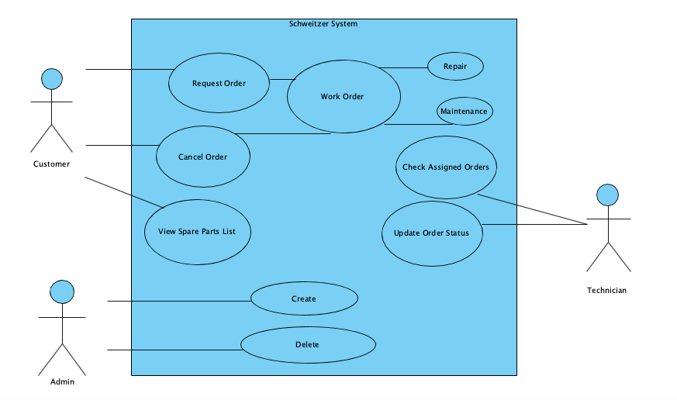

## User Features

|  |  |
| --- | --- |
| **Type of users** | Administrator |
| **Formation** | Degree in Business Administration |
| **Activities** | Contract the technicians and fire them. |

|  |  |
| --- | --- |
| **Type of users** | Technician |
| **Formation** | Degree in Electronic Engineering |
| **Activities** | Do maintenances, installations and give support to clients |

|  |  |
| --- | --- |
| **Type of users** | Customer |
| **Formation** | NA |
| **Activities** | Request different kind of services |

## Restrictions

* Interface to work in PC with Windows OS and Mac OS
* Languages and technologies in use: Java.
* The system must be able to notify the services incoming to the technicians
* The system will have a design and implementation simple and independent of the platform or program language.

## Assumptions and Dependencies

* Suppose to be the case, all the following requirements described are stable.
* The devices where the program will be executed must have the minimum requirements before indicated to guarantee a correct execution.

# Specific Requirements

## Functional Requirements

|  |  |
| --- | --- |
| **Requirement identification:** | FR01 |
| **Requirement Name:** | Type of user selection |
| **Characteristics:** | The user must to select the kind of user. |
| **Requirement description:** | The system should display two types of users, technician and client |
| **NON functional requirement:** | * NFR01 |
| **Requirement priority:**  High | |

|  |  |
| --- | --- |
| **Requirement identification:** | FR02 |
| **Requirement Name:** | Verify work orders |
| **Characteristics:** | To the technician show all orders of service |
| **Requirement description:** | Technician user must enter his ID and password to access the system |
| **NON functional requirement:** | * NFR04 |
| **Requirement priority:**  High | |

|  |  |
| --- | --- |
| **Requirement identification:** | FR03 |
| **Requirement Name:** | Show work orders |
| **Characteristics:** | To the technician show all orders of service |
| **Requirement description:** | The technician can check the orders assigned to him/her, it could be a maintenance or repair. |
| **NON functional requirement:** | * NFR04 * NFR02 |
| **Requirement priority:**  High | |

|  |  |
| --- | --- |
| **Requirement identification:** | FR04 |
| **Requirement Name:** | Check Order Status |
| **Characteristics:** | Shows and configure the status of the orders. |
| **Requirement description:** | Technicians can update the status of an order |
| **NON functional requirement:** | * NFR04 |
| **Requirement priority:**  High | |

|  |  |
| --- | --- |
| **Requirement identification:** | FR05 |
| **Requirement Name:** | Request Maintenance |
| **Characteristics:** | Create a maintenance or repair order. |
| **Requirement description:** | The client uses the system to request a maintenance or repair order, this order will be assigned to a technician |
| **NON functional requirement:** | * NFR02 * NFR04 |
| **Requirement priority:**  High | |

|  |  |
| --- | --- |
| **Requirement identification:** | FR06 |
| **Requirement Name:** | Cancel Order |
| **Characteristics:** | Cancel an assigned Order |
| **Requirement description:** | The client have the chance to cancel an order |
| **NON functional requirement:** | * NFR02 |
| **Requirement priority:**  High | |

|  |  |
| --- | --- |
| **Requirement identification:** | FR07 |
| **Requirement Name:** | Spare Parts List Review |
| **Characteristics:** | Shows an overview of the spare list. |
| **Requirement description:** | The client can see a small spare parts list review available to realize the maintenances and repairs. |
| **NON functional requirement:** | * NFR02 |
| **Requirement priority:**  High | |

|  |  |
| --- | --- |
| **Requirement identification:** | FR08 |
| **Requirement Name:** | Create Technician |
| **Characteristics:** | The administrator of the system could have the option to create an technician |
| **Requirement description:** | The administrator can create the technician if is necessary without change the code. |
| **NON functional requirement:** | * NFR04 * NFR02 * NFR05 |
| **Requirement priority:**  High | |

|  |  |
| --- | --- |
| **Requirement identification:** | FR09 |
| **Requirement Name:** | Delete Technician |
| **Characteristics:** | The administrator of the system could have the option to delete an technician |
| **Requirement description:** | The administrator can delete the technician if is necessary without change the code. |
| **NON functional requirement:** | * NFR04 * NFR02 * NFR05 |
| **Requirement priority:**  High | |

|  |  |
| --- | --- |
| **Requirement identification:** | FR10 |
| **Requirement Name:** | Login Technician |
| **Characteristics:** | Lets the technician to log in with a password and ID |
| **Requirement description:** | The technician access to his functions must lo log in with an ID and password |
| **NON functional requirement:** | * NFR02 * NFR06 |
| **Requirement priority:**  High | |

|  |  |
| --- | --- |
| **Requirement identification:** | FR11 |
| **Requirement Name:** | Login Admin |
| **Characteristics:** | Lets the admin of the system to log in with a password and ID |
| **Requirement description:** | The admin access to his functions must lo log in with an ID and password. |
| **NON functional requirement:** | * NFR02 * NFR06 |
| **Requirement priority:**  High | |

## Non-Functional Requirements

|  |  |
| --- | --- |
| **Requirement identification:** | NFR01 |
| **Requirement Name:** | Interface of the system |
| **Characteristics:** | The system presents a simple user interface so that it is easy to use for system users. |
| **Requirement description:** | The system must have an intuitive and simple user interface. |
| **Requirement priority:**  High |  |

|  |  |
| --- | --- |
| **Requirement identification:** | NFR02 |
| **Requirement Name:** | Performance |
| **Characteristics:** | It must be a desktop application; it is not connected to the internet |
| **Requirement description:** | The system didn’t need an internet connection is fully functional without it. |
| **Requirement priority:**  High |  |

|  |  |
| --- | --- |
| **Requirement identification:** | NFR03 |
| **Requirement Name:** | Portability |
| **Characteristics:** | The application must to run in windows |
| **Requirement description:** | The app only run in windows computers |
| **Requirement priority:**  High |  |

|  |  |
| --- | --- |
| **Requirement identification:** | NFR04 |
| **Requirement Name:** | Storage |
| **Characteristics:** | All of the data will be saved. |
| **Requirement description:** | The data will be saved in files with .json standard and in No SQL data base |
| **Requirement priority:**  High |  |

|  |  |
| --- | --- |
| **Requirement identification:** | NFR05 |
| **Requirement Name:** | User level |
| **Characteristics:** | Guarantee to the user access to the information as level as have the current user. |
| **Requirement description:** | Facilities and controls for allow the access to the information of personal throught the files, with the intention to update the files. |
| **Requirement priority:**  High |  |

|  |  |
| --- | --- |
| **Requirement identification:** | NFR06 |
| **Requirement Name:** | Security of the information |
| **Characteristics:** | The system guarantees to the users the security of the information |
| **Requirement description:** | Guarantee the security of the system with respect to the information and data handled such as documents, files and passwords. |
| **Requirement priority:**  High |  |

# Common Requirements of Interfaces

## User interface

The interface with the user will consist of a set of windows with buttons, lists and text fields. This must be built specifically for the proposed system and will be viewed from any PC.

## Hardware Interfaces

It will be necessary to have computer equipment in perfect condition with the following characteristics:

• Processor of 1.66GHz or higher.

• Minimum memory of 256Mb.

• Mouse.

• Keyboard.

## Software Interfaces

• Operating System: Windows XP or higher

## Functional Requirements

Functional Requirement 1

* Type of user selection: The user must to select the kind of user.

The system allows two type of users, a technician or client, if are the technician must enter the ID

Functional Requirement 2

* Technician must identify themselves: Technicians are given an ID and password.

To access the system, the technician must provide his credentials.

Technicians have the chance to change their passwords.

Functional Requirement 3

* Assigned Orders: Display assigned order.

Once the technician enters the system, he should be able to check the orders and dates assigned to him

Functional Requirement 4

* Request Maintenance: Update Order Status.

Technicians can update an order and modify three attributes: description, completion date and order completed.

Functional Requirement 5

* Request Maintenance: Create a maintenance or repair order.

The system creates a maintenance or repair order, this order will be assigned to the technician.

Functional Requirement 6

* Cancel Order: Clients have the chance to cancel orders, they must provide the id of the order they want to cancel.

Functional Requirement 7

* Spare Parts List Review: Shows an overview of the spare list.

Have an inventory that shows the quantity of the spare parts available to realize the maintenances and repairs.

Functional Requirement 8

* Create Technician: allows create a technician.

Once administrator enter to the system could have the chance to create a new technician.

Functional Requirement 9

* Delete Technician: allows delete a technician.

Once administrator enter to the system could have the chance to delete a technician.

## Non functional Requirements

Performance

* Guarantee the design in windows involved on all of the process of the system.

Security

* Guarantee the reliability, security and performance of the computer system to different users. In this sense, the information stored, or records made can be consulted and updated permanently and simultaneously, without affecting the response time.

Fixability

* The system must have an intuitive and simple user interface.

Availability

* System availability must be continuous with a service level for users of 7 days for 24 hours

Portability

* The system will be implemented on Windows.