Academic DNA Fingerprinting Lab Report
Analysis of clean csv dna py and dna csv
Source files: clean.csv, dna.py, and dna.csv

Purpose and main findings
This report documents the Academic DNA pipeline and analyzes its current output for 3,293 student records. The generated file contains seven mutually exclusive academic profile labels across 7 departments. The largest profile is Group 5: The Comeback with 970 students (29.5 percent). CSE is the largest department in the dataset with 1,398 students (42.5 percent).
Across all students, mean CGPA is 2.884 and median CGPA is 2.919. The mean recorded course point is 3.088. The profile mean CGPA ranges from 1.180 in Group 4: Struggling Students to 3.728 in Group 1: High Achievers.

Data lineage and preparation
The pipeline begins with clean.csv, where each row represents a student and repeated S-numbered fields represent ordered course result slots. dna.py reads the dataset as text, derives student-level performance features, clusters students, assigns interpretable profile labels, and writes dna.csv. The current dna.csv contains fixed-width alignment spaces. The analysis removes surrounding whitespace from headers and fields before interpreting IDs, grades, or numeric values. This formatting normalization does not change the underlying values.
Check | Observed result
Input student rows | 3,293
Output student rows | 3,293
Input fields | 393
Output fields | 394
Ordered course slots | 78
Recorded course points | 82,244
Mean recorded courses per student | 25.0
Duplicate output IDs | 0
IDs in clean only | 0
IDs in dna only | 0

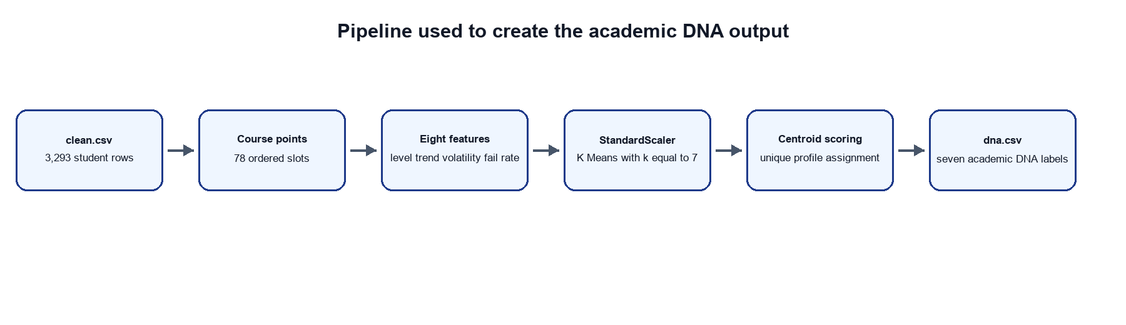
Figure 1. Implemented pipeline from clean.csv to the labeled dna.csv output.

Method used in dna py
The program uses unsupervised K Means clustering. It does not begin with hand-labeled examples. Instead, it represents each student with eight numeric features built from the available course points in S-number order, standardizes those features, and fits seven clusters. K Means is configured with k equal to 7, n init equal to 20, and random state equal to 42. The fixed random state makes the stated implementation reproducible when the same source file and library behavior are used.
For each course slot, dna.py uses S-point if it can be read as a finite number. If not, it maps the letter grade to a point value from A plus equal to 4.00 through F equal to 0.00. The first segment is the first quarter of recorded results, the middle segment runs from one third to two thirds of the result sequence, and the last segment is the final quarter.
Feature | How dna py calculates it
Mean grade | Mean of available course points.
First grade | Mean point in the first quarter of recorded results.
Middle grade | Mean point in the middle third of recorded results.
Last grade | Mean point in the final quarter of recorded results.
Grade volatility | Population standard deviation of course points.
Change volatility | Population standard deviation of consecutive point changes.
Early peak | Highest point in the first quarter minus the highest later point.
Fail rate | Share of course points below 2.00. A D at 2.00 is not included by this exact rule.

After K Means assigns numerical cluster IDs, dna.py computes a score for each centroid against every requested profile. It tests every one-to-one assignment of the seven clusters to the seven group names and keeps the assignment with the largest total score. This preserves a unique label for each cluster. The labels describe statistical patterns in this dataset and should not be treated as clinical, causal, or permanent judgments about a student.

CGPA and course result statistics
Measure | Value
Students with numeric CGPA | 3,293
Mean CGPA | 2.884
Median CGPA | 2.919
CGPA standard deviation | 0.686
CGPA minimum | 0.118
CGPA first quartile | 2.477
CGPA third quartile | 3.400
CGPA maximum | 4.000
Mean recorded course point | 3.088
Median recorded course point | 3.250

Academic DNA profile distribution
The two charts below use the actual profile counts in dna.csv. The bar chart retains counts, and the pie chart shows the same counts as proportions of the full student population.
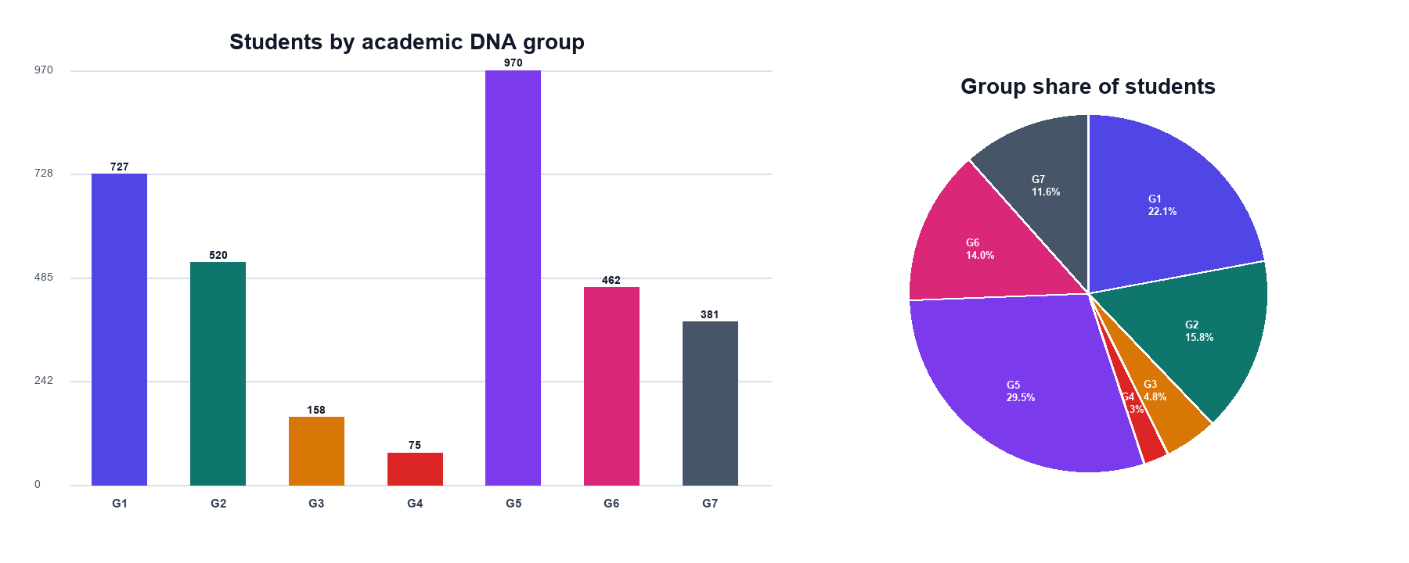
Figure 2. Student count and share for each academic DNA group.
Profile | Students | Share | Mean CGPA | Mean course point
Group 1: High Achievers | 727 | 22.1% | 3.728 | 3.729
Group 2: Late Bloomers | 520 | 15.8% | 2.761 | 2.775
Group 3: Declining Performers | 158 | 4.8% | 1.467 | 1.583
Group 4: Struggling Students | 75 | 2.3% | 1.180 | 1.334
Group 5: The Comeback | 970 | 29.5% | 3.111 | 3.149
Group 6: Peaked too soon | 462 | 14.0% | 2.398 | 2.409
Group 7: Heart monitor | 381 | 11.6% | 2.381 | 2.502

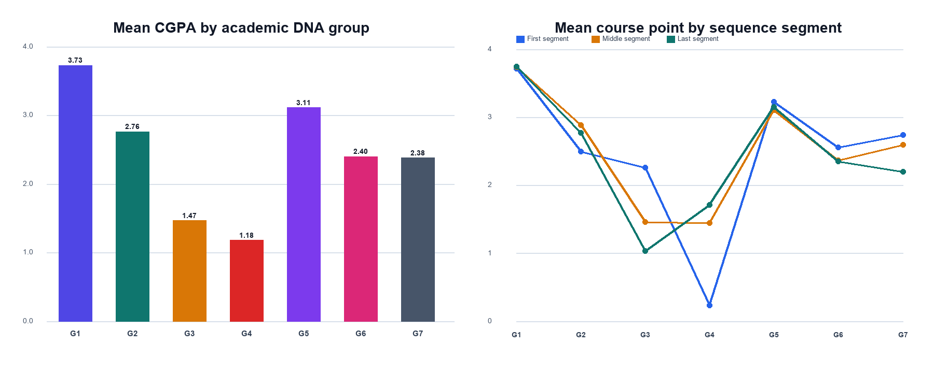
Figure 3. Actual mean CGPA and sequence-segment course points by profile.

Profile definitions and observed results
The descriptions below combine the intended interpretation of each group with its observed statistics in the current output. The final column records the centroid scoring logic implemented in dna.py.
Profile | Meaning | Observed statistics | Centroid scoring rule
Group 1: High Achievers | High and comparatively stable course performance. | n=727; 22.1%; mean CGPA=3.728; first/middle/last=3.712/3.740/3.745; fail rate=0.0%. | mean - grade volatility - change volatility - absolute first to last difference
Group 2: Late Bloomers | A later course-average level that exceeds the early level. | n=520; 15.8%; mean CGPA=2.761; first/middle/last=2.492/2.887/2.768; fail rate=0.2%. | 2 times last minus first
Group 3: Declining Performers | An early course-average level that exceeds the later level. | n=158; 4.8%; mean CGPA=1.467; first/middle/last=2.258/1.462/1.034; fail rate=35.2%. | 2 times first minus last
Group 4: Struggling Students | Low overall, early, and later course performance, with greater weight for points below 2.00. | n=75; 2.3%; mean CGPA=1.180; first/middle/last=0.231/1.442/1.708; fail rate=47.9%. | negative mean - 0.75 first - 0.75 last + fail rate
Group 5: The Comeback | Both ends of the sequence are stronger than the middle segment. | n=970; 29.5%; mean CGPA=3.111; first/middle/last=3.226/3.105/3.148; fail rate=0.3%. | minimum of first and last minus middle
Group 6: Peaked too soon | An early peak that is not maintained later in the sequence. | n=462; 14.0%; mean CGPA=2.398; first/middle/last=2.557/2.365/2.348; fail rate=0.1%. | early peak + first minus last
Group 7: Heart monitor | Large within-sequence and step-to-step variation in course points. | n=381; 11.6%; mean CGPA=2.381; first/middle/last=2.737/2.593/2.202; fail rate=10.9%. | grade volatility + change volatility

Department distribution
Department is derived from the alphabetic prefix at the beginning of each cleaned student ID. The current file contains ARCH, BBA, CE, CSE, EEE, ELL, and JMC. The following charts use actual department counts.
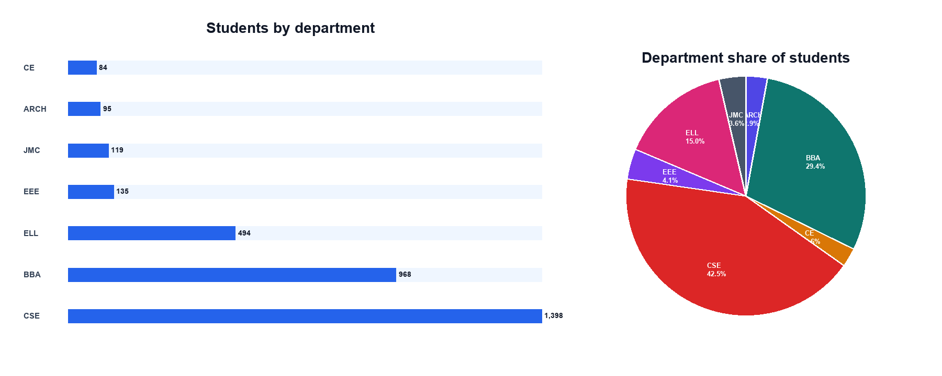
Figure 4. Student count and share for each department.
Department | Students | Share | Mean CGPA | Median CGPA | CGPA standard deviation | Mean course point
ARCH | 95 | 2.9% | 3.288 | 3.381 | 0.478 | 3.278
BBA | 968 | 29.4% | 2.898 | 2.900 | 0.656 | 2.909
CE | 84 | 2.6% | 2.938 | 3.015 | 0.757 | 3.024
CSE | 1,398 | 42.5% | 2.924 | 2.989 | 0.711 | 2.990
EEE | 135 | 4.1% | 2.989 | 3.062 | 0.746 | 3.136
ELL | 494 | 15.0% | 2.685 | 2.688 | 0.596 | 2.679
JMC | 119 | 3.6% | 2.659 | 2.601 | 0.735 | 2.659

Department and profile heatmap
Each heatmap cell is the actual number of students in one department and one Academic DNA profile. Read across a row to see where a profile appears, and down a column to see the profile mixture within a department. The values are counts rather than standardized percentages.
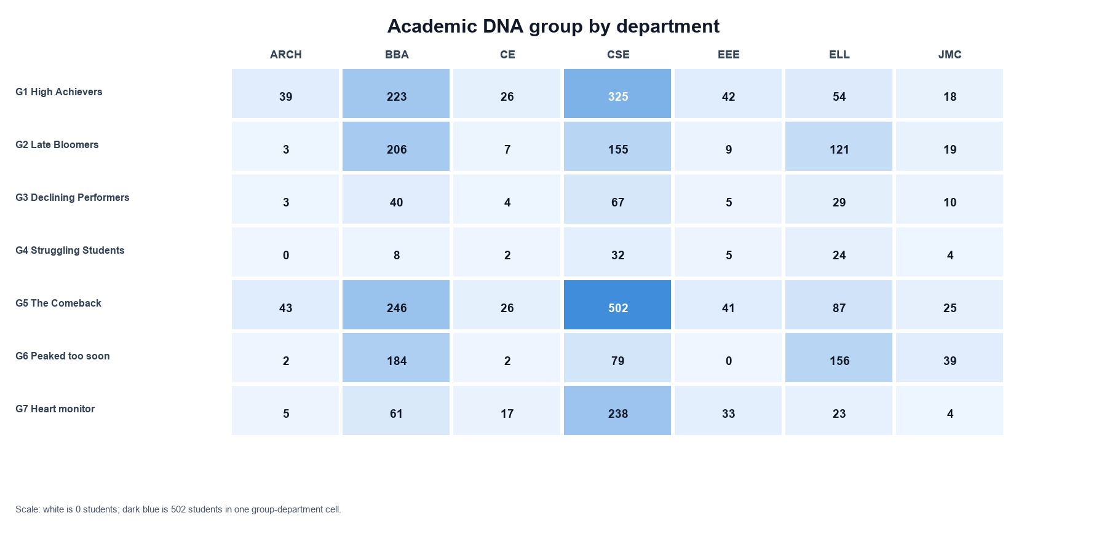
Figure 5. Actual student counts for every group and department combination.

Interpretation and limitations
- The report describes the dataset and the implemented code. It does not validate whether the seven labels are educationally optimal or predict later student outcomes.
- The ordered S fields are analyzed as a sequence of recorded course attempts. The implementation does not convert course codes or student enrollment codes into an explicit semester timeline.
- K Means groups students by the eight selected features. A different feature set, number of clusters, handling of repeated courses, or random seed can produce different group membership.
- The current DNA output is whitespace-normalized before analysis because fixed-width alignment padding appears in its headers and cells. No grade, CGPA, ID, course code, or group label is otherwise edited.
The current output provides a compact view of heterogeneous academic trajectories. It is most appropriate as a descriptive screening tool for aggregate academic support planning. Any student-level action should be reviewed with the detailed academic record and institutional context.

