**Content**

1. Project Overview 2

1.1 Product Description 2

1.2 Introduction to the main functions 2

1.2.1 Restricting the use of other software for a specific period of time 2

1.2.2 Playing sleep aid audio 3

1.2.3 Lockout time and duration statistics 3

1.3 Project innovations 3

1.3.1 Minimalist interface design 3

1.3.2 Professional Sleep Aid Audio Library 4

2. Market Analysis 4

2.1 Analysis of domestic macro environment 4

2.1.1 Political and Legal Environment 4

2.1.2 Economic Environment 4

2.1.3 Social-cultural environment 7

2.1.4 Technical Environment 8

2.2 Industry chain analysis 8

2.3 Market pain points 9

2.4 Market Capacity Estimates 10

2.5 Target Users 10

2.6 Competitive Analysis 11

2.6.1 Threats from Existing Competitors 11

2.6.2 Enterprise SWOT analysis 13

3. marketing analysis 13

3.1 Overall marketing strategy 13

3.1.1 Market positioning 14

3.1.2 Marketing objectives 14

3.1.3 Market development stage and marketing strategy 15

3.2 4PS marketing Strategy 15

3.2.1 Product Strategy 15

3.2.2 Price strategy 17

3.2.3 Marketing channels 17

3.2.4 Publicity Strategy 18

4. Business model 21

4.1 Business model 21

4.2 Development Planning 22

4.2.1 Overall development plan 22

4.2.2 Specific development plan 22

5. Financials 24

5.1 Product investment forecast 24

5.2 Revenue and user volume projections 25

# Project Overview

## Product Description

SleepOnTime is a software that provides sleep time monitoring for working people, students and other groups who need to sleep regularly. The product is close to the user's daily life and has a broad market prospect. The product is designed to meet the individual needs of different user groups. By providing an interactive way of APP, it can restrict the use of specific software during specific hours, display health tips, count and analyse sleep time and other functions, thus helping users to control the time they use their mobile phones at night, improve their sleep quality, understand their sleep situation and develop a regular routine. The product will be developed using Kotlin as the development syntax and Android Studio as the development tool.

## Introduction to the main functions

### Restricting the use of other software for a specific period of time

The user can set a sleep start time and a sleep end time according to their needs, during which SleepOnTime will put the user's phone into a locked state and restrict the use of other software. In exceptional circumstances, the user can use the limited unlocking opportunity to unlock the phone in advanced. Each month the user has three opportunities to unlock the phone. If all three opportunities have been used and there is still a need to unlock the phone, the user will have to watch an advert to get the extra opportunity. This is a simple and effective restriction that significantly reduces the amount of time users spend browsing apps such as Xiaohongshu, Tiktok and e-novels before going to bed, leading users to develop healthy habits.

### Playing sleep aid audio

Users can select sleep aids from the library and set the duration of playback to help them fall asleep according to their needs. Sleeping audio will cover a variety of different styles to meet the needs of different user groups, such as pure music, white noise, audio books, etc.

### Lockout time and duration statistics

The software will record the daily start time and duration of the lockout state, analyse and visualise the data on a monthly basis. Users can check their sleep time and adjust their sleep schedule by viewing the records. At the same time, the software will remind users who use the early unlock function several times and encourage them to stick to their sleep plan.

## Project innovations

### Minimalist interface design

In recent years, most software on the market has pursued a variety of software functions and a full interface design. However, with the intensification of the internal volume, work pressure and academic pressure constantly squeeze the entertainment time of young people today, people gradually tend to use mobile phone software that is easy to use, simple to operate and has a minimalist interface. APPs such as Quark Browser, Curtain and One Word, which mainly focus on "minimalist" design, are rapidly becoming popular. Compared to self-discipline apps such as TomatoTODO and FattyCat, SleepOnTime's interface is designed in a "minimalist" style. The minimalist interface not only improves responsiveness to a certain extent, but also enhances the visual aesthetics by using solid colours to clearly reflect the main functions of the software, helping users to quickly familiarise themselves with the interface and operation of the software. At the same time, the simple operation steps help users to save time on unnecessary entertainment such as decorating personal pages, changing avatars, socialising and so on.

### Professional Sleep Aid Audio Library

The software provides a wide range of professional sleep aids to meet the needs of different user groups, such as pure music, white noise and audio books. In addition, the software encourages the uploading of original sleep-aid audio by sleep-aid audio biographers, which enriches the library of sleep-aid audio and provides a platform for professional sleep-aid audio creators to showcase and attract more users. Compared to YouTube, bilibili and other platforms where videos are mixed under the "sleep aid" tag, SleepOnTime can ensure the quality of sleep aid audio in the app from a professional perspective, effectively helping users to improve their sleep quality.

# Market Analysis

## Analysis of domestic macro environment

### Political and Legal Environment

The 14th Five-Year Plan strongly supports the continued innovation and development of the Internet big data industry in which the Company operates. The State Council's "14th Five-Year Plan" for the development of the digital economy proposes to encourage market forces to tap into the value of commercial data, promote the productization and service-orientation of data value, vigorously develop professional and personalized data services, promote the deep integration of data, technology, and scenarios, and meet the needs of data in various fields. SleepOnTime is committed to providing users with personalized sleep supervision services, meeting users' sleep duration supervision needs, and actively responding to the national 14th Five-Year Plan.

### Economic Environment

#### GDP growth sustained

The steady progress of the domestic economic development is conducive to the development of the start-up company. In the face of multiple tests such as the complex and severe international environment and the spread of the domestic epidemic, the national economy has continued to recover and develop, reform, opening up and innovation have been deepened, new steps have been taken to build a new development pattern, and new results have been achieved in high-quality development, achieving a good start of the "14th Five-Year Plan". According to data from the National Bureau of Statistics, China's GDP in 2021 increased by 8.1% over the previous year, and the economic growth rate ranked first among the world's major economies; The total economic volume reached 114.4 trillion yuan, exceeding 110 trillion yuan, and the average annual exchange rate reached 17.7 trillion US dollars, ranking second in the world, accounting for more than 18% of the global economy 。 At the moment when opportunities and challenges coexist, SleepOnTime insists on developing its core competitiveness, strives to seize the opportunity of market economic recovery, strives to become bigger and stronger, and becomes a leader in the field of sleep duration supervision within 3-5 years.

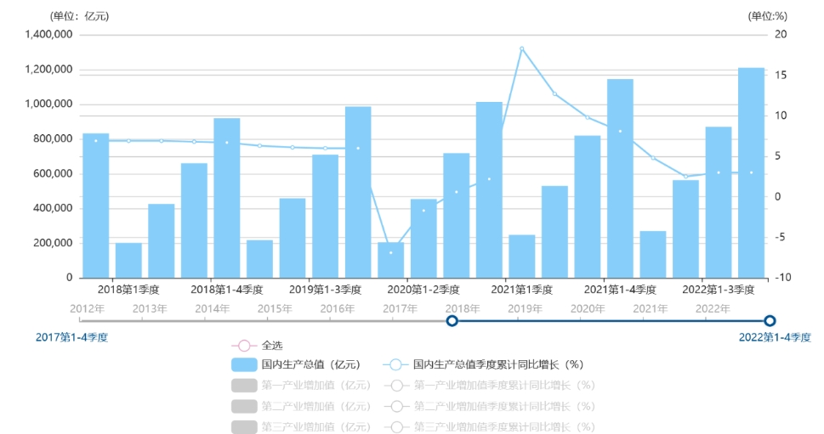

Figure 2-1 GDP statistics for the third quarter of 2018-2022

**(1) Internet business revenue continued to grow**

Under the economic situation of continuous growth of Internet business, the company can take advantage of the momentum and develop rapidly. According to data from the Ministry of Industry and Information Technology, **Internet business revenue maintained a rapid growth trend in 2021,** and China's Internet and related service enterprises above designated size completed business income of 1.55 trillion yuan, a year-on-year increase of 21.2%, and the growth rate was 8.7% faster than the previous year percentage points, the two-year average growth rate is 16.8%. Among them, the revenue of platform services has grown rapidly, and the operation of platforms such as life services has been active. In 2021, the platform service revenue will be 576.7 billion yuan, a year-on-year increase of 32.8%; It accounted for 37.2% of Internet business revenue, an increase of 3.8 percentage points year-on-year. The business revenue of life service platform enterprises reversed the decline of the previous year and achieved rapid growth. The growth of the life service platform business indicates the increase in consumers' demand for life platforms in the future, and SleepOnTime can provide consumers with personalized life services to meet users' needs for life services.

**(2) The software industry is operating well**

The software business continues to grow and still has great potential for development. According to data from the Ministry of Industry and Information Technology, China's software and information technology service industry operated well in 2021, with software business revenue maintaining rapid growth and profitability steadily increasing. In 2021, there will be more than 40,000 enterprises above designated size in the software and information technology service industry in China, and the cumulative software business revenue will be 9,499.4 billion yuan, a year-on-year increase of 17.7%, and a two-year compound growth rate of 15.5%. Profitability has steadily improved. In 2021, the total profit of the software industry will be 1,187.5 billion yuan, a year-on-year increase of 7.6%; The profit margin of the main business increased by 0.1 percentage points to 9.2%. The project group belongs to the software industry, under the situation of sustainable development of the software industry, it is expected that the project can start smoothly, create operating profits, and create a high-quality software brand reputation.

**(3) The self-regulatory software economy market is growing**

The self-regulatory software market is currently growing, as a class of applications designed to help users manage time, increase efficiency, maintain concentration, and more. According to a report by market research firm Reports and Data, the global self-regulatory software market size reached $2.95 billion in 2020 and is expected to grow to $9.94 billion by 2028, with a compound annual growth rate of $9.94 billion 14.2%。 Meanwhile, Sensor Tower's data shows that downloads of self-regulatory software increased by 27% in the first quarter of 2021 compared to the same period last year. Overall, the economic market for self-regulatory software has great potential due to the increased demand for efficiency and management time, as well as the digital transformation and the spread of smartphones.

**(4) The sleep monitoring software industry has developed steadily**

Sleep monitoring software has received more and more attention and use in recent years. According to market research firm Markets and Markets, the global sleep monitoring market is expected to grow from $3.33 billion in 2020 $8.12 billion in 2025, with a CAGR of 19.7%. It can be seen that the development trend of the sleep monitoring software industry is relatively stable and showing a trend of increasing year by year. As people's health awareness and attention to sleep quality increases, the demand for sleep monitoring software will increase.

### Social-cultural environment

**(1)** **People's attention to sleep quality and sleep time continues to increase**

According to sleep experts and researchers, about half of adults have some degree of sleep problems. At the same time, people are becoming more and more aware of the relationship between poor sleep habits and sleep quality and various health problems, such as psychological problems, obesity, diabetes, cardiovascular diseases, cancer, etc. To raise public awareness of adequate sleep, sleep specialists and doctors actively conduct educational campaigns. For example, many sleep centers, hospitals, and health organizations offer sleep education courses and sleep coaching services that provide services such as sleep assessment and treatment of sleep disorders. In addition, scientific research and advice on sleep and health have been widely reported in various forms of media and social networks. In recent years, although many people still have sleep problems, more and more people have begun to recognize the importance of getting enough sleep and taking positive steps to improve sleep quality.

**(2) Mobile phones are a major factor affecting residents' sleep**

Using mobile phones in bed before going to bed has become a major factor affecting people's sleep quality. Melatonin is a hormone that regulates sleep, and the blue light emitted by the mobile phone screen easily inhibits the secretion of melatonin in the human body, resulting in the body not receiving sleep signals, difficulty falling asleep or poor sleep quality. Research by Sarah Jane Fox, Ben Carter, and Nicola Lindson shows that the more often you use a smartphone in bed, the shorter the quality and duration of sleep, and the more common it is to have difficulty falling asleep and waking up early.

**(3) Contemporary residents have a strong demand for sleep supervision**

According to the survey report of the "2018 American Sleep Survey: Electronic Device Use in Bed" released by the National Sleep Foundation in 2018, there are more than 80 Percent said they thought cell phone use negatively affected sleep, and more than 40 percent said they had tried limiting phone use to improve sleep. As a result, many people have taken steps to reduce the disturbance of sleep from phone use, including forcing the phone to turn off before going to bed. However, many people with weak self-control will can't help but turn on their mobile phones again, resulting in a decline in sleep quality, and it is imminent to assist sleep supervision through mobile phone software.

### Technical Environment

**(1) Intelligence becomes the future trend**

According to Statista, the global mobile app market is expected to generate annual revenue of $46.2 billion as of March 2022. This shows that consumers have become accustomed to solving problems in life through applications and improving the quality and efficiency of life, and intelligence has become a future trend.

**(2)** **Advances in sleep monitoring technology**

Advances in sleep monitoring technology have provided technical support for the development of sleep monitoring software. With the continuous development and popularization of sleep monitoring devices such as wearable devices, smart mattresses, and smart pillows, sleep monitoring software can obtain users' sleep data more accurately and provide more personalized sleep supervision services. In addition, the application of artificial intelligence technology can also make sleep monitoring software more intelligent and personalized.

## Industry chain analysis

The upstream part of the APP industry is a variety of APP development talents, mainly including product managers, UI designers, background program developers, software testers and other types, providing excellent technical support for the design and development of APP. The midstream part is an APP development company or team, that is, recruiting excellent upstream talent resources to form a development team, and conducting a series of production processes such as product research, interaction design, UI design, database development, algorithm design, and final testing to ensure the feasibility of product promotion. The downstream part of the industry chain is the vast number of user groups that use APP services.

**In** the APP industry chain, the company **is in the middle of the industry chain and belongs to** **the APP** **development company.** SleepOnTime APP is a sleep supervision APP application developed by the company, which is open to downstream user groups by landing in the third-party application market and major app store channels for users to download and enjoy SleepOnTime's excellent service.

## Market pain points

**(1) Sleep duration is generally insufficient**

People are accustomed to using electronic devices before bedtime, especially using devices such as smartphones and tablets in bed. Blue light from these devices may inhibit melatonin secretion, affecting sleep duration and quality. At the same time, due to the irregular use of electronic devices before going to bed, people have irregular life schedules, irregular life schedules will affect the body's biological clock, resulting in insufficient sleep and decreased quality.

**(2) The need for sleep supervision is not being met**

At present, sleep monitoring software on the market cannot meet the user's mandatory supervised sleep needs. At present, most of the mainstream sleep supervision software lock function, most of the user needs to have a certain degree of self-control, otherwise the user can interrupt the lock process by himself, the user's sleep supervision effect is insufficient, and the software with the forced lock function is not a dedicated sleep software, does not have the function of sleep duration recording.

**(3) There are deficiencies in existing sleep software**

At present, the sleep software on the market is defective and cannot solve the user's demands. First, software dedicated to sleep supervision is still in the minority, mostly as a module of a piece of software. When users use software to supervise sleep before going to bed, they are easily attracted by the various functions of the software, so they start browsing and using other functions of the software, and fall asleep later, so that the effect of software sleep supervision cannot be achieved. Secondly, most sleep software in the software market requires users to have a certain degree of self-control, and the effect of sleep supervision cannot be produced for users with poor self-control, and the user's sleep duration cannot be guaranteed. Most of the existing software is unstable during use, and it is easy to be cleared by the background during use, affecting the user experience. In addition, some specific applications of some software require payment. Various deficiencies reduce user satisfaction with sleep monitoring products.

## Market Capacity Estimates

In 2019, the global self-regulatory application market reached $162 million and is expected to grow to $374 million by 2024. The huge number of people using self-regulatory applications around the world and increasing year by year provides a feasibility guarantee for the promotion of this product. Sleep supervision and detection software is one of the most important components of self-regulatory software, with a large market size and development space. As people's pursuit of sleep duration and sleep quality grows, the market size of sleep monitoring software will become larger and larger. According to a report from App Annie, sleep health apps have become one of the fastest-growing app categories in the world in the first quarter of 2021. Among them, the number of downloads of sleep tracking apps worldwide increased by more than 30%. In addition, sleep tracking and analytics company Sleep Cycle reports that its app has been downloaded more than 6 million times worldwide. Therefore, it is reasonable to estimate the company's market capacity that the market size of SleepOnTime will reach 100,000 US dollars in the future.

## Target Users

With the popularization of health knowledge, people gradually realize the importance of adequate sleep. And due to the development and popularization of electronic devices, there are people of all ages and social groups who affect the quality and duration of sleep due to electronic devices such as mobile phones.

Categorizing SleepOnTime's target groups according to age groups and lifestyle habits helps the Company to better grasp the needs of different target users. The specific analysis is shown in the table below.

Table 2-1 SleepOnTime target group user portrait

## Competitive Analysis

### Threats from Existing Competitors

#### Competitor Analysis

The sleep supervision industry is booming, and there are many related competitive software, and the mainstream software crisis in the industry is represented by competitors. Table 2-2 SleepTown, Digital Wellbeing competitor analysis table

#### Comparative analysis

As the main competitors, sleep supervision apps such as SleepTown and DigitalWellbeing have certain homogeneity problems with SleepOnTime's platform design and main business in terms of sleep duration recording and forced locking, and the competition is fierce.

### Enterprise SWOT analysis

#### SWOT analysis

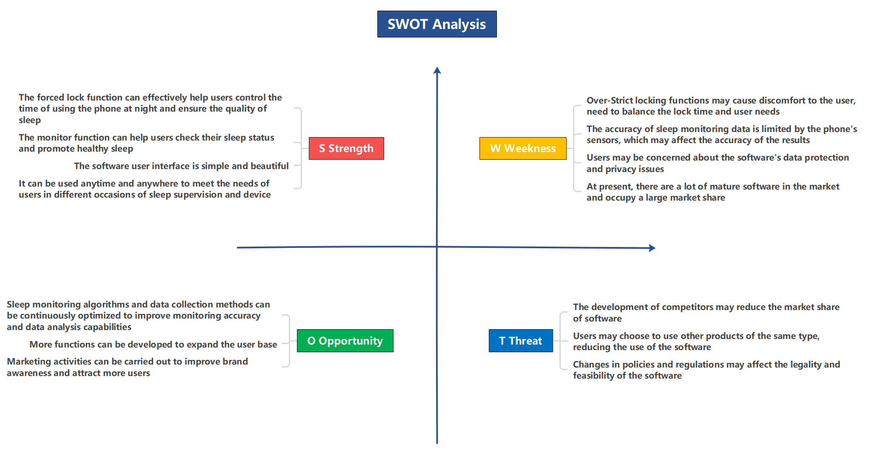

Figure 2-2 GDP SWOT analysis

# marketing analysis

## Overall marketing strategy

The marketing strategy of this project is to attract consumers to use this product through a combination of online web platform, new-media channels and various offline promotions, together with independent technology and customer-oriented quality service.

### Market positioning

Through unique page-design which is different from domestic counterparts, this product improves the sleep quality of users with direct and efficient locking function and supplementary means for sleeping. It is committed to providing customized sleep plans for all kinds of people, cultivating healthy living habits with regularity and improving physical fitness.

### Marketing objectives

Based on the team members’ in-depth investigation and market demand analysis on the market of self-regulation software and sleep monitoring software, the project forecast of the number of user groups for the product, taking into account the project’s productivity and development strategy objectives, is shown in the following table.

|  |  |  |  |  |  |
| --- | --- | --- | --- | --- | --- |
| The year | First year | Second year | Third year | Fourth year | Fifth year |
| Number of platform users | 35814 | 43349 | 62021 | 86228 | 105408 |
| Number of active users | 11326 | 21340 | 44808 | 60491 | 86163 |
| Number of creators in residence | 716 | 1694 | 3585 | 6439 | 8693 |

Table 3-1 Forecast for number of SleepOnTime product users

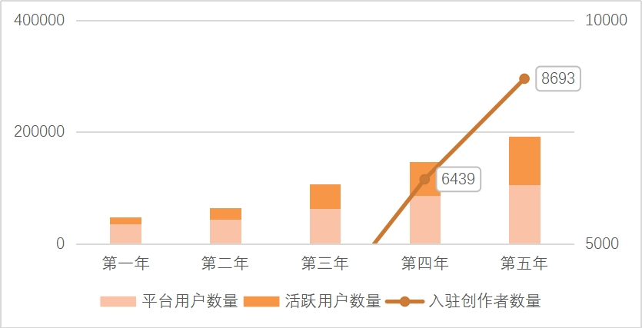

Figure 3-1 SleepOnTime product user type distribution

### Market development stage and marketing strategy

According to the development strategy of the project, the target market should be developed gradually in three stages: market cultivation, market development and market expansion, so as to expand the sales volume and influence of the project.

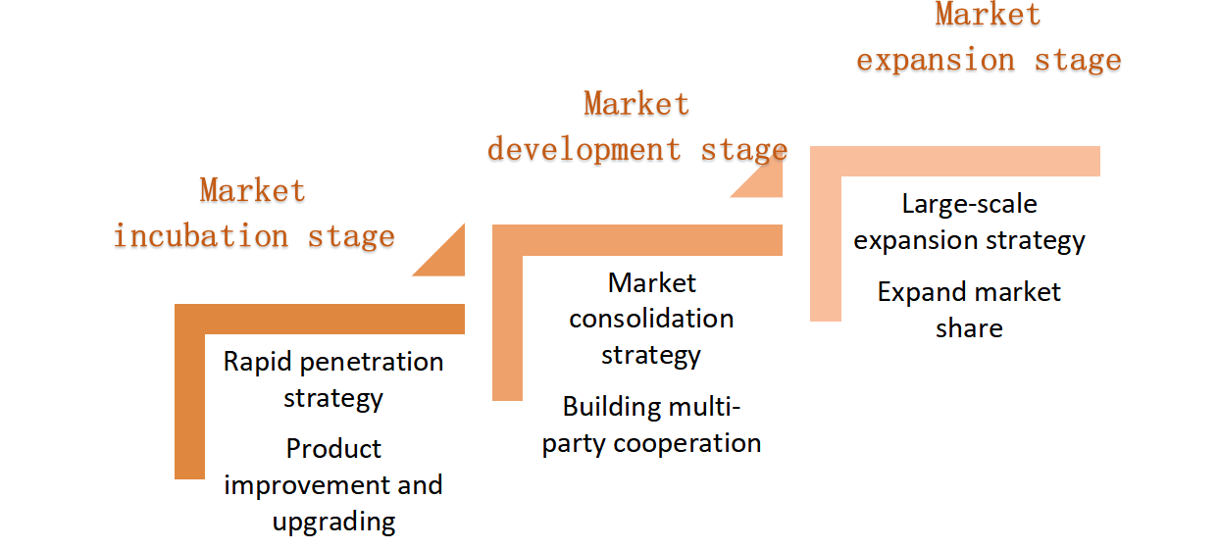

Figure 3-2 SleepOnTime development stage and marketing strategy

## 4PS marketing Strategy

### Product Strategy

#### Product Positioning

**(1) User positioning**

Mainly for college students and workplace workers.

College students can freely use electronic devices and have poor self-control. It is difficult to resist the temptation of mobile phone software, which leads to lack of sleep, affecting their learning efficiency and physical health. Working people have heavy work, and often receive work information during sleep, which affects the sleep time and quality.

**(2) Functional positioning**

* **Early stage (basic function + update function)**

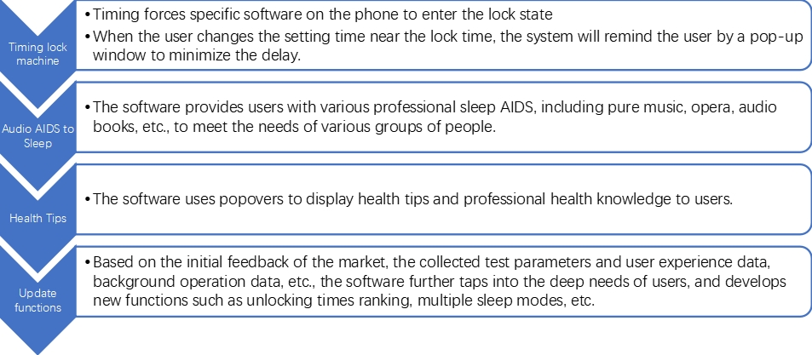

Figure 3-3 SleepOnTime feature categories

* **Medium term (building multi-party cooperation)**

**Cooperation with e-commerce platforms:** The platform will professionally select a number of sleeping products, such as night lights, steam eye masks, humidifiers, etc., and recommend them to users in the "Health Tips" pop-up window. Product recommendations are divided into two parts, one is based on user preferences, the other is to recommend the quality content on the e-commerce platform.

**Deepen cooperation with advertisers**: Users will have three opportunities per month to unlock their phone in advanced, and if they have additional needs, they will need to watch ads to get them. In the medium term, the platform can recommend more suitable ads based on user preference data, so as to accurately target consumers for advertising partners and increase revenue.

* **In the later stage (expand the market and business)**

**All-round customized sleep plan:** It forms customized sleep plan based on user data preferences, including integrated services such as software white list, sleep aid song list and intelligent recommendation of sleep aid products, so as to enhance user stickiness, consolidate and expand product market share.

#### Brand strategy

**(1) Concept identification system**

Brand mission: Create a healthy life with intelligence

Brand spirit: self-discipline, health

Brand core values: Customer first, dare to innovate, keep passion

**(2) Brand communication strategy**

Brand awareness and reputation are both important factors to improve customer goodwill and trust, and brand awareness is an important intangible asset of an enterprise. Therefore, while vigorously promoting the products, we should focus on the spiritual aspect of humanistic care, integrating the brand concept identity, as well as the brand visual identity elements into all aspects of product and brand communication, and shaping a positive brand image. Establish brand and consumer cognition, memory and emotional connection, so as to improve consumer goodwill and trust, improve user stickiness.

### Price strategy

The SleepOnTime platform maintains that the basic features are free to users, encourages more people to use the product to improve sleep quality, and realizes revenue through partnerships with advertisers and e-commerce platforms. Achieve the desired market share while achieving substantial and long-term profits.

### Marketing channels

In order to achieve efficient and high-quality product promotion, we focus on the multi-channel promotion strategy, through the simultaneous promotion of "online + offline", online advertising, layout of multimedia matrix to achieve differentiated operation mainly, offline promotion activities as a supplement, to maximize the target consumers and potential consumers to understand the concept and function of the product, improve visibility. The main channels are as follows:

|  |  |
| --- | --- |
| Online promotion channel | **Search engine: SEM, search engine optimization**  **We media platforms: Baijia, bilibili, Weibo, etc**  **Advertorial promotion**  **Information stream promotion**  **Video promotion** |
| Offline promotion channels | Offline roadshows and salon activities |

Table 3-2 SleepOnTime Channel Strategy at a glance

### Publicity Strategy

SleepOnTime platform combines the multi-channel strategy of product promotion with an **"online + offline"** publicity and promotion model:

|  |  |
| --- | --- |
| Categories | Form |
| Online publicity | advertising |
| New media marketing |
| Video marketing |
| Holiday deals to promote merchandise |
| Offline promotion | Advertising marketing |
| Campus outreach |

Table 3-3 SleepOnTime Promotional Strategy at a glance

**(1) Online publicity**

* **Advertising marketing**

CPC advertising through search engine platform, as well as SEO natural optimization to optimize SleepOnTime platform related promotional videos optimized to the home page to achieve precision marketing.

Through software such as Xiaohongshu, bilibil, Weibo and other software to carry out volume drainage; Apps related to the platform or similar in nature but not competitive with each other guide each other through mutual advertising, information sharing, activity cooperation and other ways.

* **New media operation**

The Wechat official account can be operated, in which tweets and videos such as health tips and sleep helping experience can be posted on a daily basis. For example, on World Sleep Day, you can launch activities such as the "Sleep Data Challenge". Capture buzzwords that are widely discussed to attract the target audience to view the tweets, e.g. "workforce", "996", etc.

By bidding for microblog topics, the platform users discuss and forward the topics, which can be fed back to the SleepOnTime app. Upon review, the platform can provide users with coupons for sleep-related products.

In collaboration with Xiaohongshu, YouTube sleep aid bloggers and health column bloggers, KOL increases the app exposure through short videos or articles that show how the app is used and the grass planting app. "The nTH Day of learning Makeup on Douyin," which is a hot topic of Douyin and XiaoHongshu, created UGC through experiential videos of "The first day of using SleepOnTime" and "The second day of using SleepOnTime" ,

In e-commerce platforms (Taobao, Jingdong, Vipshop, etc.), especially in the area of sleep aid products, online promotional videos and posters of the platform for display.

* **Video marketing**

Shoot product explanation videos and enterprise promotion videos and place them on the PC side of the platform. Platform users and partners can have a deeper understanding of the basic functions and services of the platform by watching the videos with pictures and texts.

Shoot short videos about user experience sharing, on-the-street interviews, etc., operate short video accounts of exclusive platforms, and publish them regularly on short video platforms such as Douyin and Kuaishou, so as to realize brand marketing by taking advantage of traffic dividends.

* **Holiday promotions**

Use the time nodes of some special festivals (Singles' Day and World Sleep Day) to cooperate with e-commerce platforms to carry out special promotional activities, such as giving consumption coupons, experiencing sleep aid products for free, and one-to-one analysis of sleep conditions by experts.

**(2) Offline publicity**

* **Advertising marketing**

Advertising posters of products of the platform will be put in subway stations in major cities to show the features and personalized services of the platform. By focusing on the user group and covering the potential audience, the platform can effectively output to consumers and form long-term memory.

|  |  |  |
| --- | --- | --- |
| Types of media | Station level | Media quote (ten thousand yuan /4 weeks/block) |
| 1/2/3/4/3 North 5/6/7/8/9/13/14/APM Line No. : 4 Cover light box advertising offer | | |
| 4 light boxes (station Hall/Channel) | S | 3.5 |
| A++ | 3.2 |
| A+ | 2.3 |
| A | 1.8 |

Table 3-4 List of advertisement prices of 4 light boxes in Guangzhou Metro (Data source: Omnimedia)

* **Store promotion**

Promote and publicize the platform in offline stores of cooperative sleep aid products and daily necessities. When entering the store, the store attendants introduce the basic functions of the platform to the customers, ask the customers about their feelings and give feedback to the platform.

In addition, salon activities related to professional knowledge popularization can be carried out in shopping festivals and related festivals to encourage brand customers to share their usual difficulty in sleeping, and invite professionals and doctors to the site to answer questions and difficulties for everyone.

* **Campus promotion**

Strengthen cooperation and publicity among universities, cooperate with university associations and other student organizations, and carry out targeted publicity by means of university resources, community, stall and publicity. For example, we can investigate the sleeping conditions of college students and the reasons leading to low sleep quality, and call on college students to adhere to the self-discipline of life and rest.

# Business model

## Business model

SleepOnTime offers a lock-in service for all age groups in order to achieve rest on time, and an advertising space service for advertisers. The project operates through multiple channels in order to provide services and generate profitable income. In addition, the project actively cooperates with external parties, mainly in production, promotion and resource support, in order to build a solid foundation for sustainable operation.

SleepOnTime targets customers of all ages, but the main user groups are university students and working professionals. SleepOnTime helps college students avoid using their electronic devices before bedtime by locking them out of bed due to their lack of self-control and late nights. People in the workplace tend to receive work messages at break times due to their heavy workload, resulting in lack of sleep. Again SleepOnTime will help them avoid receiving messages by locking their phones.

The project is free in the early stages. By providing free light music and white noise, the software will create a good atmosphere for users to sleep, improving user stickiness and increasing platform traffic. In the medium term, we will work with musician or storytellers to provide a platform for them to promote their work. In the later stages, after a certain number of users have been accumulated, we will charge companies for advertising on the platform to achieve more profit on top of the medium-term profit model. By cooperating with advertisers and brands whose main customers are university students and working professionals, the project will use the platform data as a support to accurately match consumer groups for enterprises, and effectively increase the exposure rate for enterprises through intelligent ad recommendation, link jumping and brand pavilion construction, etc., so as to collect a certain amount of advertising fees from enterprises.

## Development Planning

### Overall development plan

To become the leader in the field of sleep management applications within 1-3 years, through continuous innovation and R&D to develop new functional areas based on user feedback, so as to meet the more diversified needs of users.

### Specific development plan

The project will adopt a unique positioning strategy to provide sleep management services for all age groups. The development strategy is divided into three phases: initial, medium and mature. Considering the specificity of the Internet industry, the division of the strategic period is shorter than that of the traditional industry, usually taking the quarter as the strategic cycle unit. The project strives to create a good sleep atmosphere for users with intelligence and seeks to become a leader in sleep management applications within 1-3 years.

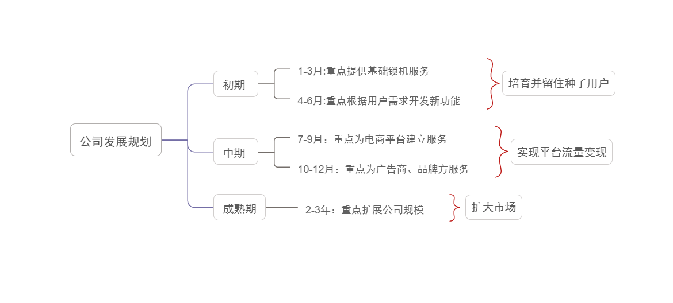

Figure 4-1 The development strategy

#### Initial Phase (1st - 6th Month)

Cultivate and retain regular users by focusing on promoting user experience and providing free light music and white noise services, seizing the market and building the brand.

During the first three months, the mobile application software will be launched, providing users with locking services to improve the quality of their sleep, improving and updating the functions of the various components of the app, and collecting and feeding back users' opinions on the use of the software in a timely manner. Based on the basic locking service, set up function upgrade service, optimize the product and service, provide higher quality sleep management function.

From 4th to 6th month, based on the feedback from the early stage of the market, the test parameters and user experience data collected, and the background operation data, we quickly improved the operation of the program. Based on the number of users accumulated in the initial operation, we will further explore the deeper needs of users and develop new functions such as unlocking times ranking and multiple sleep modes to meet the needs of users.

#### **Mid-term phase (7th to 12th Month)**

Realise the realisation of platform traffic, on the basis of ensuring individual user experience, match advertisers and brands with accurate consumer groups, continuously optimise products and services, develop new cooperation channels and strengthen brand penetration.

From 7th to 9th month, we will focus on cooperation with e-commerce platforms, establishing links with e-commerce platforms, recommending good products for users to help them sleep, and accurately matching consumers with e-commerce platform merchants through the analysis of back-end data collection. At the same time, we will continue to improve the functions, enhance the performance of the software, increase marketing efforts and improve the bargaining power of the project when working with e-commerce platforms.

From 10th to 12th month, the project will deepen cooperation with advertisers and brands to deliver intelligent customised advertisements to users and improve the efficiency of traffic realisation. Utilise technical advantages, summarise the project's experience in software development and operation, and in operating the market, continuously optimise products and services, develop new cooperation channels, and continue to build brand reputation

#### Maturity stage (Year 2-3)

The operation of the project comes to maturity and the scale of the project is further expanded through financing. Broaden the scope of software services, expand service targets, build a full range of intelligent sleep aid services and promote brand awareness.

**(1) Maturity of project operation**

Sign strategic cooperation agreements with well-known domestic e-commerce platforms, and the software brand has high visibility in the domestic market. ▪

**(2) Expansion of software service functions**

Increase investment in R&D, increase body health management functions, expand business to for the health management market and build an all-round body health management structure when already occupying the sleep management market to a greater extent. ▪

**(3) A sizeable user base**

In its third year of development, SleepOnTime has reached a total of 600,000 registered users.

# Financials

## Product investment forecast

The initial investment for this project is budgeted at approximately $68,596. Based on the need for equipment for APP platform development, computer purchases are divided into computers for technical staff at a unit price of $12/unit and computers for other staff at a unit price of $6,299/unit.

|  |  |  |  |
| --- | --- | --- | --- |
| **Item** | **Details Item** | | **Money** |
| Fixed Assets | Computer | | 22,998 |
| 12,598 |
| Subtotal |  | | 35,596 |
| Establishment Charges | Industrial and Commercial Registration | | 1,000 |
| Subtotal |  | | 1,000 |
| Floating Capital | Low Priced and Easily Worn Articles | | 3,000 |
| Publicity Fees | KOL popularize | 3,000 |
| Advertising on Other Platforms | 2,000 |
| Media Account Publicity | 2,000 |
| Technology Development Costs | | 20,000 |
| Others | | 2,000 |
| Subtotal |  | | 32,000 |
| Total |  | | 68,596 |

Table 5-1 Product investment forecast

## Revenue and user volume projections

The project team's primary revenue for the first five years is third party placement revenue. The project team plans to start advertising in the fourth quarter of the first year, so only the fourth quarter of the first year will have advertising revenue. Through market research and taking into account the type of platform, user experience and other relevant factors, the project team will launch full-screen ads and horizontal ads in the platform. The costs will be negotiated with third parties.

The project team expects the number of users to increase year on year from the time the software is officially launched. Three years after the release of the software, SleepOnTime is expected to have a total of 600,000 registered users.