****2.CineCritique App Overview****

This project aims to develop a high-quality movie review platform called CineCritique, leveraging AI-driven sentiment analysis and recommendation algorithms to deliver personalized movie suggestions and review aggregation. The app will utilize machine learning to analyze user reviews, ratings, and preferences, allowing it to generate tailored recommendations and provide users with access to both critic reviews and public opinions. By combining these technologies, CineCritique enhances the movie-watching experience, empowering users to make informed decisions about what to watch next based on their tastes and mood. This approach not only improves user satisfaction but also streamlines the process of discovering new films. Additionally, the platform ensures robust data encryption and privacy protection, fostering user trust. A user-friendly interface will simplify review submission, browsing recommendations, and accessing curated lists of top films. CineCritique is committed to advancing intelligent entertainment curation, supporting a diverse range of moviegoers and critics alike.

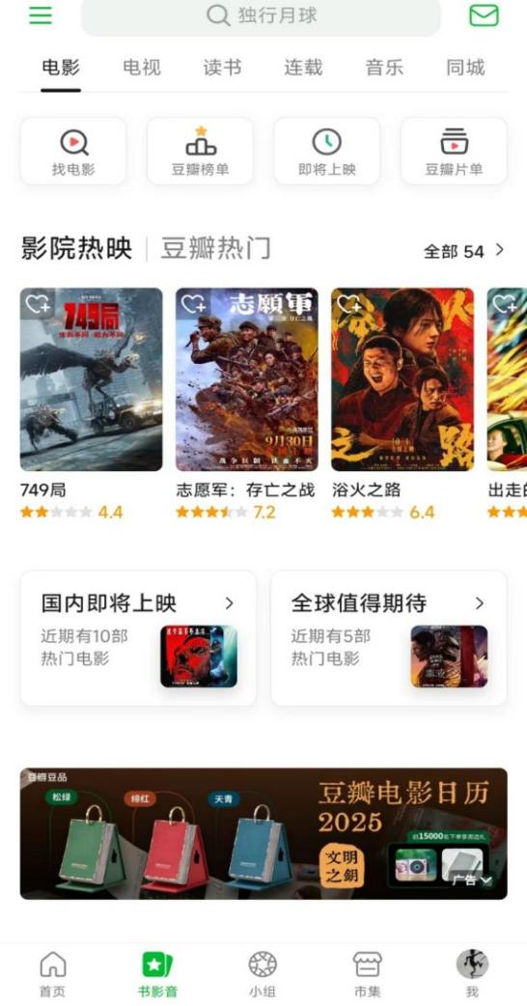

Figure 1: Home Page

**3. Target User Persona**

The CineCritique project aims to cater to both individual users and movie enthusiasts by addressing the need for a comprehensive, user-friendly movie review platform that aggregates both expert and public opinions. It also seeks to foster a community of movie lovers by offering features such as discussion forums, trending lists, and personalized recommendations.

### 3.1 Individual Users

**Current Situation:** Many moviegoers find themselves overwhelmed by the sheer number of films available across multiple streaming platforms and theaters, making it difficult to choose what to watch. Users often rely on fragmented information, consulting multiple sources for reviews, or simply taking a chance on films without much prior insight.

**User Needs:** Users require a platform that simplifies decision-making by combine movie reviews and ratings in one place. Additionally, they need personalized recommendations based on their viewing history and preferences. The app should also provide access to trending films, detailed critiques, and a social space for discussing movies with like-minded individuals.

**Behavioral Characteristics:** Users regularly interact with movie-streaming platforms and entertainment apps, making them comfortable navigating digital spaces for their media consumption. They expect convenience, ease of use, and personalized content.

**Demographic Information:** The target user base spans various age groups, with a particular focus on users aged 18-45, who are more tech-savvy and frequent users of streaming services. These users come from diverse backgrounds, with younger users typically interested in new releases and blockbusters, while older users may lean towards classic films or niche genres. Economic diversity also affects their sensitivity to app subscription models and willingness to pay for premium content.

**Psychological Characteristics:** Users exhibit a proactive approach to entertainment, actively seeking out recommendations to optimize their movie-watching experiences. Trust in AI-generated suggestions varies, with some users embracing the technology and others preferring to explore content organically.

### 3.2 Movie Critics & Reviewers

**Current Situation:** Professional movie critics and casual reviewers alike face challenges in reaching a wide audience and showcasing their critiques in an increasingly competitive digital landscape. Traditional platforms often prioritize mainstream opinions, making it harder for smaller voices to be heard.

**User Needs:** Critics and reviewers require a platform where their reviews can reach a broader audience while maintaining credibility. The app should offer advanced tools for review writing, categorization, and influence metrics to track user engagement. Moreover, the platform must provide recognition to users who consistently offer high-quality insights, thus encouraging more participation and higher standards of review writing.

**Behavioral Characteristics:** Critics and reviewers are often highly involved in movie analysis, frequently watching films across various genres and platforms. They seek spaces that allow for thoughtful discourse, community engagement, and opportunities to influence other moviegoers' opinions.

**Demographic Information:** Reviewers are likely to be older, typically ranging from 25 to 60, with a solid background in film studies or deep interest in cinema. Many have developed their own following on social media or blog platforms, but they require better integration into app ecosystems that allow for direct interaction with their audience.

**Psychological Characteristics:** Reviewers are motivated by the desire to influence public perception of films and contribute to discussions around cinematic artistry. They value platforms that showcase their expertise while maintaining a fair balance between casual and professional opinions.

**4. Market Analysis**

The movie review and recommendation market is essential for guiding consumer decisions in a saturated entertainment landscape. Although there are existing platforms like Rotten Tomatoes and IMDb, they often fail to provide highly personalized experiences and robust community engagement. CineCritique aims to fill this gap by offering tailored recommendations based on individual preferences and providing a space for more in-depth critical discussion.

### 4.1 Industry Background

The movie industry continues to grow with the expansion of streaming services, which increases the demand for platforms that assist users in navigating vast film libraries. Traditional review systems have not evolved in tandem with this growth, leaving a significant portion of users underserved.

### 4.2 Current State of AI Technologies

Although AI-driven recommendation systems are in place on some platforms, they often lack the nuance required to cater to diverse and evolving user tastes. CineCritique aims to address these issues by using sentiment analysis and advanced algorithms to provide more precise and varied recommendations based on both individual preferences and wider community trends.

### 4.3 Policy Support

As digital entertainment consumption rises, governments and industry leaders emphasize data privacy and security, creating a favorable environment for apps that ensure compliance with stringent privacy regulations. CineCritique is committed to maintaining the highest standards of data protection, ensuring that user reviews and personal information are handled securely.

### 4.4 Market Trends

The shift towards personalized entertainment is evident as consumers increasingly demand content tailored to their preferences. AI and machine learning technologies play a key role in shaping these trends by providing more accurate recommendations. Moreover, the rise of online communities centered around shared interests, such as film discussion groups, highlights the need for platforms that facilitate social interaction and personalized content discovery.

### 4.5 Future Projections

With advancements in AI technology and an increase in demand for personalized experiences, the movie review market is set to grow significantly in the coming years. CineCritique is well-positioned to become a leader in this space, offering unique features that appeal to both casual moviegoers and film critics alike. The app is expected to gain a strong user base by integrating AI-driven insights with community engagement, providing users with a more comprehensive and satisfying movie review experience.

**5. Identify a Unique Selling Proposition**

### 5.1 Competitive Landscape

The movie review and recommendation app market is highly competitive, with several established platforms offering various features. Some notable examples include:

* **IMDb**: A widely used platform for movies, TV shows, and celebrity content. It aggregates reviews from both critics and users, offering ratings and comprehensive movie information.
* **Rotten Tomatoes**: Known for its Tomatometer score, this platform aggregates professional critic reviews alongside audience reviews, giving users an idea of how well a movie is received.
* **L****etterboxd**: A social network for movie lovers where users can rate, review, and track the films they watch. It fosters a strong community vibe, allowing users to follow each other’s movie-watching habits.
* **Flixster**: A user-friendly app that focuses on helping users discover upcoming movies and check reviews and ratings.



Figure 3: IMDB

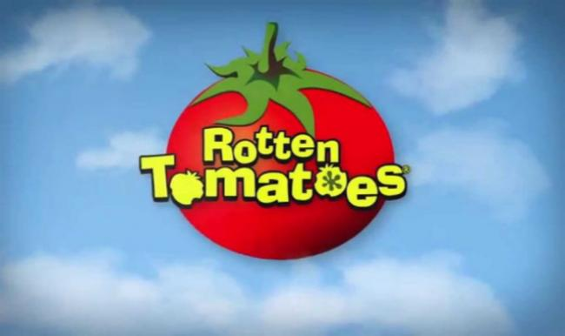

Figure 4: Rotten Tomatoes

While these platforms are well-established and offer robust features, CineCritique stands out through its unique selling proposition.

### 5.2 Unique Selling Proposition

The concept of **Unique Selling Proposition (USP)**, introduced by Rosser Reeves, is key to differentiating a product in a competitive market. The USP emphasizes the unique benefit a product offers to its audience, clearly communicating what makes it stand out. For CineCritique, the USP focuses on three main components

1. **Benefit Promise**  
   CineCritique delivers personalized movie recommendations based on AI-driven sentiment analysis and user preferences. The platform aggregates both expert and user reviews, offering a holistic perspective on films. Users save time by receiving curated movie suggestions tailored to their tastes, ensuring an enhanced viewing experience and fewer frustrating searches for the perfect movie.
2. **Uniqueness**  
   What sets CineCritique apart is its **AI-powered sentiment analysis**. The platform not only provides traditional reviews and ratings but also analyzes review content to capture emotional responses, offering users a unique perspective on how films make audiences feel. Additionally, CineCritique fosters community interaction by enabling users to engage in discussions, follow movie influencers, and participate in film-based challenges, unlike competitors which tend to focus more on static review aggregation.
3. **Strong Focus**  
   CineCritique’s core focus is on **enhancing user engagement through personalized experiences**. It emphasizes creating a dynamic community where users can interact with content, share recommendations, and discover films based on emotional resonance. Furthermore, the platform is designed to be intuitive and accessible, ensuring a seamless experience for all types of users, from casual moviegoers to avid cinephiles. CineCritique also prioritizes data privacy, ensuring that user preferences and viewing habits are protected, addressing growing concerns over privacy in the digital age.

**6. Use the Right Marketing Channels**

To effectively market the app and reach the target users, we will adopt a marketing strategy that leverages both digital and offline channels, ensuring maximum visibility and user engagement. The marketing channels will be chosen based on the SMART framework to ensure efficiency and goal-oriented campaigns.

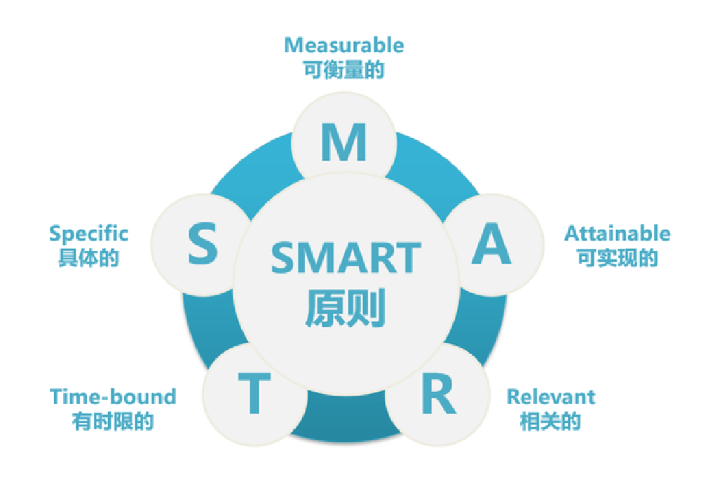

Figure 2:SMART framework

* **Specific:**

1. Promote the app via social media platforms such as WeChat, TikTok, and Xiaohongshu, as these platforms have a high penetration rate among the target demographic.
2. Collaborate with industry influencers, particularly movie critics and popular review bloggers, to reach a wider audience and build credibility.
3. Utilize email marketing and in-app notifications to keep current users engaged and informed of new features.

* **Measurable**:

1. Achieve 5000-downloads within the first three months of the launch.
2. Target a 50% user retention rate and 1,500 monthly active users (MAU).
3. Aim for 1,000 interactions per social media post within the first six months.

* **Achievable**:

1. The strategy will focus on cost-effective social media marketing and partnerships with bloggers and influencers in the entertainment industry.
2. Localized events and film-based challenges will also help build a community around the app.

* **Relevant:**

These marketing strategies are aligned with the app's core functionality of personalized movie recommendations and the creation of a movie-loving community.

* **Time-bound:**

Initial launch and marketing will focus on the first six months post-launch, with goals for downloads, user retention, and social media engagement within this period.

**7. Financial Key Metrics for Our Mobile App Business Plan**

To measure financial success and operational efficiency, we will focus on key financial metrics including costs, revenue projections, and potential return on investment (ROI).

* **Product/Service**:

The app will initially offer a freemium model, with the basic version available for free and premium features (such as more detailed movie analytics and early access to critic reviews) behind a subscription model.

* **Pricing:**

The freemium model will allow users to access basic functionalities for free, while premium content (e.g., exclusive content from film critics, advanced recommendations) will be priced at $3.99/month.

* **Forecast:**

· **User Base**: A realistic goal might be 10,000 users in the first year, with a 5% conversion rate to premium subscribers, resulting in around 500 premium users.

· **Revenue**: With 500 premium users paying $3.99/month, the annual revenue would be approximately $23,940, assuming steady subscription rates throughout the year.

· **Marketing Costs**: The marketing budget could be set at $10,000, focusing on cost-effective methods such as social media promotion, partnerships with student influencers, or hosting small competitions within university communities. This would align better with a student-developed app and its resources

**8. Channel to Validate an App**

**8.1 User Testing:**

Beta testing will involve 500 users across different demographics, testing the app’s core features including personalized recommendations and critic engagement.

Usability metrics: Task completion time under 3 minutes, user satisfaction rating above 80%.

**8.2 Market Research:**

Conduct surveys and focus groups with target users to gather feedback on the user interface, recommendation accuracy, and overall experience.

- A/B testing will be used to fine-tune the app’s onboarding process.

**8.3 Feedback Iteration:**

A dedicated feedback mechanism within the app will encourage users to provide input, with a commitment to addressing key feedback within two weeks.

Regular updates based on feedback will be scheduled quarterly.

**9. Risk Analysis**

* **Technical Risks**:

Algorithm accuracy may fall short of expectations, leading to unsatisfactory recommendations. Continuous R&D investment will mitigate this risk.

* **Market Competition:**

The movie recommendation space is competitive, with platforms like IMDb and Rotten Tomatoes already established. However, CineCritique’s unique AI-driven sentiment analysis offers a distinct value proposition.

* **User Retention Risks:**

While initial downloads may be high, keeping users engaged and active is a challenge. A strong focus on community-building through film discussions, challenges, and user-generated content will address this risk.