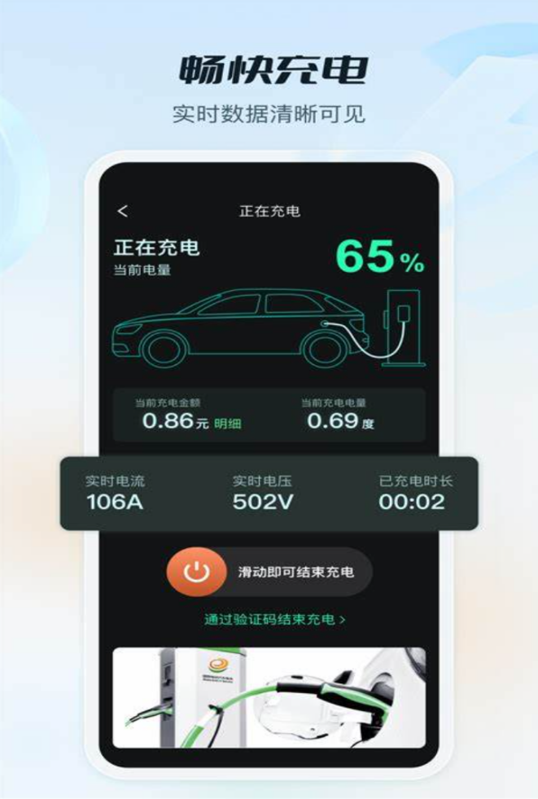

**Echarging App**

**Business Plan**

**Group Number: 1**

**Group Member：**

**Minzhen Lai**

**Ziyang Lu**

**Ziheng Huang**

**Yin Yuan**

**Introduction**:

Echarging App provides EV drivers with a simple, real-time solution to locate and monitor charging stations. With easy access to station availability and status updates, users can manage their charging needs quickly and confidently.

**Address:** SCNU

**Date of submission:** Oct 8th

****Context****

Echarging App Business Plan ..................................................................................................................1

1. Abstract ................................................................................................................................................2

2. Echarging APP overview......................................................................................................................3

3. Target a User Persona...........................................................................................................................4

3.1 Individual Users..........................................................................................................................4

3.2 Movie Critics & Reviewers........................................................................................................5

4. Market Analysis....................................................................................................................................6

4.1. Industry Background .................................................................................................................6

4.2. Current State of AI Technologies..............................................................................................6

4.3. Policy Support.......................................................................................................................... .6

4.4. Market Trends...........................................................................................................................6

4.5. Future Projections......................................................................................................................6

5. Identify a Unique Selling Proposition...................................................................................................7

5.1 Competitive Landscape...............................................................................................................7

5.2 Unique Selling Proposition.........................................................................................................7

6. Use the Right Marketing Channels........................................................................................................8

7. Financial Key Metrics for Our Mobile App Business Plan. .................................................................9

8. Channel to Validate an App ..................................................................................................................9

8.1 User Testing ................................................................................................................................9

8.2 Market Research ......................................................................................................................10

8.3 Feedback Iteration ...................................................................................................................10

9. Risk Analysis.......................................................................................................................................10

****1.Abstract****

**Project Overview**  
Echarging App is a streamlined mobile platform designed to simplify the electric vehicle (EV) charging experience. By providing real-time access to charging station availability and status updates, Echarging App empowers EV drivers with the information needed to make efficient charging decisions and reduce time spent searching for available stations.

**Service Description**

**Echarging App offers users a convenient, user-friendly interface to locate nearby charging stations, view station availability, and monitor usage status. With constantly updated information on station conditions, drivers can plan charging stops with ease, ensuring a reliable and efficient charging experience.**

**Market Niche**  
CineCritique addresses the growing demand for personalized content curation in the saturated movie market. As streaming platforms continue to expand, CineCritique provides a solution for users overwhelmed by endless choices, simplifying the decision-making process through smart recommendations.

**Technological Advancement**  
As the number of EVs on the road grows, so does the demand for accessible, reliable charging options. Echarging App caters to this need by providing a straightforward solution for drivers who want real-time information on charging stations without the complexity of additional features. It helps users avoid the frustration of unavailable stations and makes EV ownership more convenient.

**Operational Strategy**  
CineCritique will initially target individual moviegoers and critics, focusing on building a strong community of film enthusiasts. Starting with users at South China Normal University and expanding to wider audiences, the app will refine its features based on user feedback to ensure a smooth and engaging experience.

**Financial Projection**  
Echarging App will adopt a freemium model, offering essential functions such as station location and availability checks for free. Premium features like ad-free browsing and access to expanded station information will be available via low-cost subscriptions. Initial funding will come from personal and academic resources, with projected revenue growth through premium subscriptions as the user base expands.

**Conclusion**  
Echarging App aims to redefine the EV charging experience by providing reliable, real-time information on charging availability. Designed for simplicity and convenience, it helps EV drivers feel confident and connected, making the EV lifestyle easier and more efficient.

****2.Echarging App Overview****  
Echarging App is a streamlined mobile solution developed to simplify the EV charging experience, offering real-time access to charging station availability and status updates. The platform is designed to empower EV drivers with accurate, up-to-date information on nearby charging points, helping them make well-informed decisions about where and when to charge their vehicles. Echarging App provides users with a clear and intuitive interface to locate stations, check real-time availability, and monitor charging station usage.

This straightforward approach ensures that EV drivers save time and avoid the frustration of unavailable charging stations, enhancing the overall convenience of EV ownership. With its focus on reliability and ease of use, Echarging App also emphasizes secure data handling to protect user privacy. The platform’s intuitive design supports seamless browsing, quick decision-making, and efficient charging management, making it an essential tool for today’s EV drivers.

Echarging App aims to support a growing EV community by offering a trusted and efficient way to access charging information, contributing to a positive, convenient, and stress-free EV charging experience.

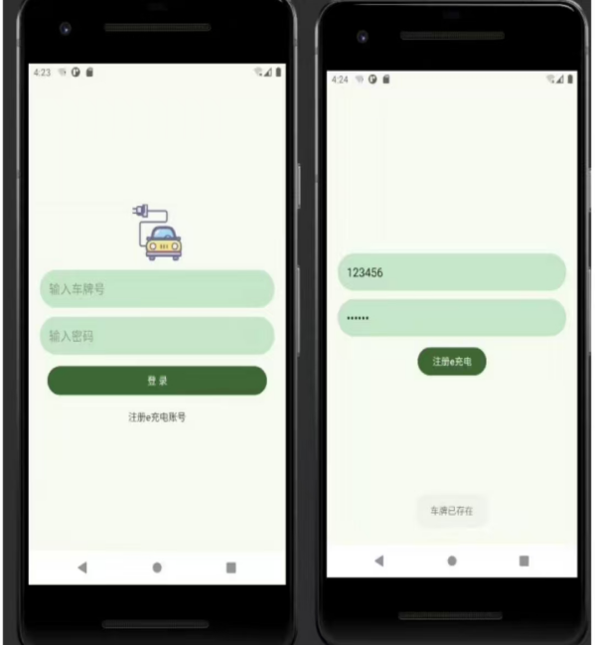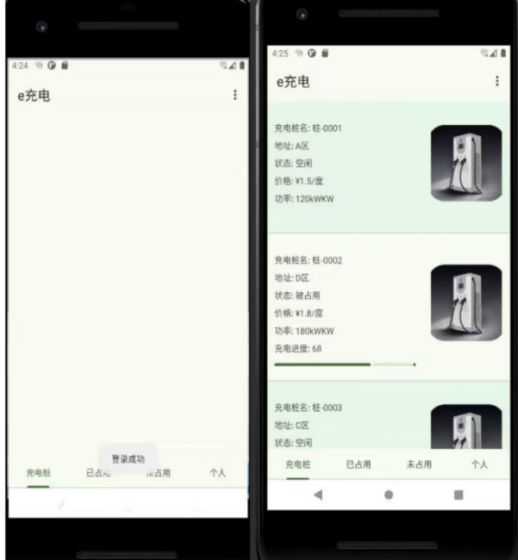

**Figure 1: Home Page**

1. **Target User Persona**

**3.1 Individual Users**

**Current Situation**: With the rise in electric vehicle ownership, drivers often face challenges in finding available charging stations, especially in busy urban areas. Many users rely on fragmented information from multiple apps or websites, leading to inconvenience and inefficiency when planning charging stops.

**User Needs**: Users need a simple, comprehensive platform that consolidates charging station locations and availability in one place. They want access to accurate, real-time updates on station occupancy and status, allowing them to optimize charging stops without the hassle of consulting multiple sources.

**Behavioral Characteristics**: EV drivers are accustomed to using apps and online tools in their daily lives, making them comfortable with digital navigation for charging management. They value convenience, real-time updates, and ease of use in planning their journeys.

**Demographic Information**: The target audience includes a wide range of EV drivers, particularly urban and suburban users who frequently commute. This group spans various age demographics but focuses on individuals aged 25-50, who are familiar with digital apps and seek efficient charging solutions.

**Psychological Characteristics**: Users are proactive in managing their driving and charging experiences, seeking solutions that make EV ownership easier and more convenient. They prefer straightforward, reliable tools that reduce the uncertainty around charging station availability.

**3.2 Charging Network Operators**

**Current Situation**: Operators of EV charging networks face the challenge of reaching a broad user base and maximizing station utilization. Traditional information systems often fail to provide real-time updates to drivers, leading to congestion at popular stations and underutilization of others.

**User Needs**: Charging network operators require a platform that allows them to showcase their stations to a wider audience while providing live updates on station availability. Echarging App can assist operators by increasing station visibility and ensuring smoother usage patterns.

**Behavioral Characteristics**: Network operators are highly engaged in optimizing station performance and seek platforms that help manage user flow. They value tools that connect them with drivers, enabling more effective station utilization and customer satisfaction.

**Demographic Information**: Operators include both private companies and public entities in urban and suburban areas. They focus on maximizing station accessibility, appealing to an environmentally conscious user base of various ages and backgrounds.

**Psychological Characteristics**: Operators are driven by the need to increase customer engagement, enhance their network’s reputation, and support the growth of EV infrastructure. They prioritize platforms that promote efficient station usage and provide user-friendly information to drivers.

1. **Market Analysis**

The EV charging market is essential for supporting the growing adoption of electric vehicles. While existing platforms like PlugShare and ChargePoint provide location data, they often lack streamlined interfaces and reliable real-time updates. Echarging App aims to bridge this gap by offering a straightforward, user-friendly solution tailored to the needs of modern EV drivers.

**4.1 Industry Background**  
With rapid growth in EV adoption, there is an increasing demand for reliable charging solutions that offer quick, convenient access to charging points. However, the availability and visibility of charging stations remain challenges, particularly in high-demand urban areas, highlighting the need for platforms like Echarging App that centralize and update station information.

**4.2 Charging Network Infrastructure**  
The expansion of EV charging infrastructure is a priority for both government and private sectors, creating opportunities for apps that streamline access to these stations. By focusing on real-time updates and ease of use, Echarging App aligns with these efforts, helping EV drivers connect with charging infrastructure in a more seamless way.

**4.3 Policy Support**  
With increased emphasis on environmental sustainability, governments worldwide are encouraging EV adoption and developing EV-friendly policies. Echarging App’s design ensures compliance with privacy standards, fostering a secure environment for users. The app aligns with policy trends by promoting sustainable transportation through enhanced charging accessibility.

**4.4 Market Trends**  
As EV ownership grows, so does the demand for apps that support convenient charging management. The shift towards real-time information and user-friendly design underscores the value of tools like Echarging App. Consumers increasingly prioritize platforms that provide reliable updates and straightforward navigation, positioning Echarging App as a practical solution in the market.

**4.5 Future Projections**  
With further expansion of EV infrastructure and increased demand for seamless charging access, the market for EV-related apps is projected to grow significantly. Echarging App is poised to capture a substantial user base by offering a no-nonsense approach to charging management, addressing both convenience and reliability, making it a valuable resource for EV drivers in the coming years.

**5. Identify a Unique Selling Proposition**

**5.1 Competitive Landscape**  
The EV charging app market includes several established platforms, each offering different features to cater to EV drivers’ needs. Some notable examples include:

* **PlugShare**: A widely used platform that allows EV drivers to locate charging stations, read reviews, and view charging costs. It covers a vast range of stations but lacks real-time availability updates.
* **ChargePoint**: Known for its extensive network of charging stations, it provides station locations, availability status, and payment options directly through the app.
* **EVgo**: Offers a network of fast-charging stations with real-time availability and allows users to initiate charging sessions from their devices.
* **Electrify America**: A user-friendly app that helps locate charging stations, make payments, and track charging sessions but is limited to its own network of chargers.

While these platforms are well-established and offer useful features, Echarging App sets itself apart with its unique selling proposition.

**5.2 Unique Selling Proposition**  
The concept of Unique Selling Proposition (USP) helps differentiate Echarging App in a competitive market by highlighting its distinct benefits to EV drivers. The USP of Echarging App focuses on three main components:

**Benefit Promise**  
Echarging App provides EV drivers with real-time access to charging station availability, giving them reliable data to avoid the frustration of arriving at occupied or non-functional stations. This feature saves time and ensures a smoother journey by making charging stops predictable and efficient, resulting in an improved charging experience overall.

**Uniqueness**  
What distinguishes Echarging App from competitors is its exclusive focus on simplicity and convenience. Rather than offering numerous unrelated features, Echarging App prioritizes straightforward access to real-time information and an intuitive design. Unlike competitors that may clutter the user interface with complex options, Echarging App streamlines station availability, status updates, and navigation in one clean, user-friendly platform, ensuring a stress-free experience for all drivers.

**Strong Focus**  
Echarging App’s core focus is on enhancing user convenience through a seamless, no-fuss design. It is developed to meet the fundamental needs of EV drivers—finding available charging stations quickly and confidently. This singular focus results in a clean and straightforward interface that provides immediate value, especially for users in busy urban settings. Echarging App also emphasizes data privacy, ensuring user location and usage data are protected, which is increasingly important in today’s digital landscape.

**6. Use the Right Marketing Channels**

To effectively reach our target users, Echarging App will adopt a multi-channel marketing strategy that leverages both online and offline platforms. Using the SMART framework, our approach will ensure focused, measurable, and goal-oriented campaigns.

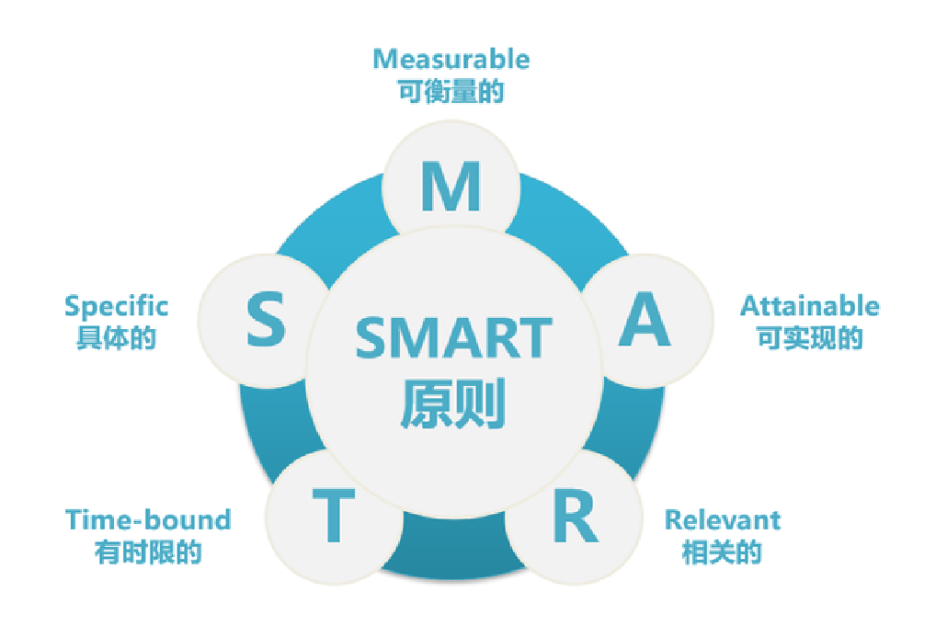

**Figure 2:SMART framework**

· · **Specific**:

1. Promote the app on social media platforms such as WeChat, TikTok, and Xiaohongshu, as these channels are highly popular among our target demographic of tech-savvy EV drivers.
2. Partner with EV-related influencers and popular bloggers in the green tech and sustainability sectors to build credibility and expand reach.
3. Use email marketing and in-app notifications to keep users engaged and updated on new features, charging network expansions, and relevant promotions.

· · **Measurable**:

1. · Achieve 5,000 downloads within the first three months of the launch.
2. Target a 40% user retention rate and reach 1,500 monthly active users (MAU).
3. Aim for 200 interactions per social media post within the first six months.

· · **Achievable**:

1. Focus on cost-effective digital marketing through partnerships with influencers and content creators in the EV space.
2. Host local events in areas with high EV adoption and build a sense of community around the app.

· · **Relevant**: These marketing strategies directly align with Echarging App’s mission to provide EV drivers with accessible, real-time charging information and foster an engaged user community.

· · **Time-bound**: The initial marketing efforts will focus on the first six months post-launch, with goals for downloads, user engagement, and social media reach within this timeframe.

**7. Financial Key Metrics for Our Mobile App Business Plan**

· **Product/Service**: Echarging App will adopt a freemium model. Basic functions such as finding charging stations and checking availability will be free, while premium features like ad-free browsing and expanded station data will be available via a subscription.

· **Pricing**: Premium content will be available for a monthly fee of $2.99, allowing users access to additional station information and customizable alerts.

· **Forecast**:

* In the first year, we project a user base of 10,000, with 5% converting to premium subscribers.
* Year 1 revenue estimate: $2,500 from subscriptions.

**8. Channel to Validate an App**

**8.1 User Testing**:  
Beta testing will involve 300 users from various demographics, focusing on the app’s core features, such as station location and availability updates.

* Usability metrics: Aim for task completion within 2 minutes and user satisfaction above 85%.

**8.2 Market Research**:  
Conduct surveys and focus groups to gather feedback on user interface clarity, real-time updates accuracy, and overall ease of use.

* A/B testing will optimize the onboarding process and assess layout preferences.

**8.3 Feedback Iteration**:  
An in-app feedback option will encourage user input, with a two-week response commitment. Quarterly updates will address user feedback to enhance the experience.

**9. Risk Analysis**

· **Technical Risks**:Potential inaccuracies in real-time data or app downtime could impact user experience. Regular maintenance and partnerships with charging networks will help mitigate this risk.

· **Market Competition**:The EV charging app space is competitive, with established platforms like ChargePoint and PlugShare. However, Echarging App’s focus on simplicity and real-time accuracy offers a clear advantage.

· **User Retention Risks**:Retaining users post-download can be challenging. Echarging App will counter this by prioritizing a user-friendly interface, real-time updates, and engaging community events to build long-term loyalty among users.