1. 产品实现方案
2. UI界面设计
   1. 当前设计用户流程

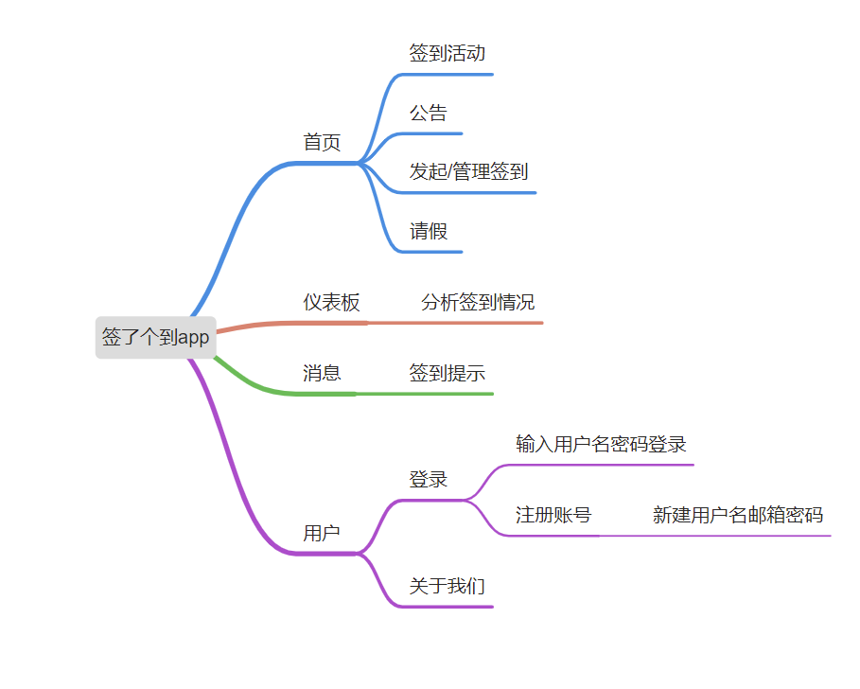

1. 首页： 主要的签到模块，有公告，签到，发起和管理签到，请假等功能
2. 仪表板：分析签到情况

3. 消息： 用于提示使用者签到

4．用户：用来登录与注册

* 1. 关键界面的UI元素和布局， 全局的布局排版

activity_main.xml

<?xml version="1.0" encoding="utf-8"?>  
<androidx.constraintlayout.widget.ConstraintLayout xmlns:android="http://schemas.android.com/apk/res/android"  
 xmlns:app="http://schemas.android.com/apk/res-auto"  
 android:id="@+id/container"  
 android:layout_width="match_parent"  
 android:layout_height="match_parent">  
  
 <androidx.appcompat.widget.Toolbar  
 android:id="@+id/main_toolbar"  
 android:layout_width="match_parent"  
 android:layout_height="?attr/actionBarSize"  
 android:background="@color/my_light_primary"  
 app:layout_constraintEnd_toEndOf="parent"  
 app:layout_constraintStart_toStartOf="parent"  
 app:layout_constraintTop_toTopOf="parent"  
 app:navigationIcon="@drawable/ic_launcher_foreground"  
 app:title="签了个到"  
 app:titleTextColor="@color/white"  
 app:menu="@menu/top_main_menu"/>  
  
 <com.google.android.material.bottomnavigation.BottomNavigationView  
 android:id="@+id/nav_view"  
 android:layout_width="0dp"  
 android:layout_height="wrap_content"  
 android:layout_marginStart="0dp"  
 android:layout_marginEnd="0dp"  
 android:background="?android:attr/windowBackground"  
 app:layout_constraintBottom_toBottomOf="parent"  
 app:layout_constraintLeft_toLeftOf="parent"  
 app:layout_constraintRight_toRightOf="parent"  
 app:menu="@menu/bottom_nav_menu" />  
  
 <fragment  
 android:id="@+id/nav_host_fragment_activity_main"  
 android:name="androidx.navigation.fragment.NavHostFragment"  
 android:layout_width="match_parent"  
 android:layout_height="match_parent"  
 android:layout_marginTop="?attr/actionBarSize"  
 android:layout_marginBottom="80dp"  
 app:defaultNavHost="true"  
 app:layout_constraintBottom_toTopOf="@id/nav_view"  
 app:layout_constraintLeft_toLeftOf="parent"  
 app:layout_constraintRight_toRightOf="parent"  
 app:layout_constraintTop_toTopOf="parent"  
 app:navGraph="@navigation/mobile_navigation" />  
  
</androidx.constraintlayout.widget.ConstraintLayout>

1. 首页

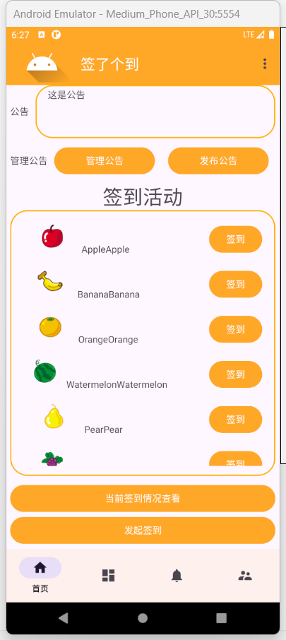

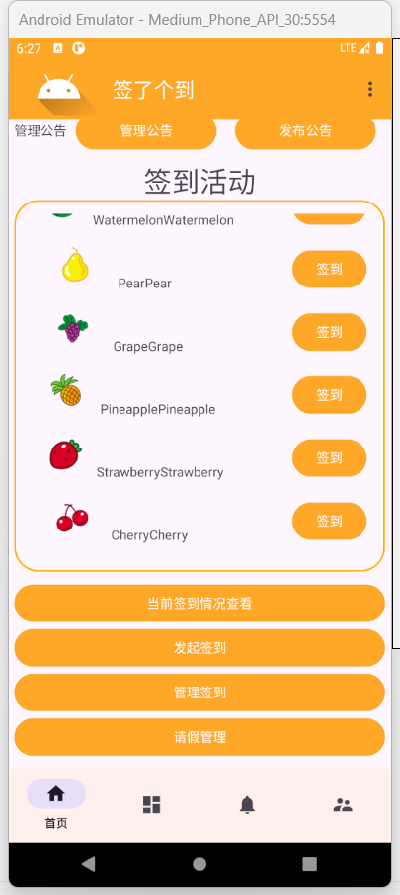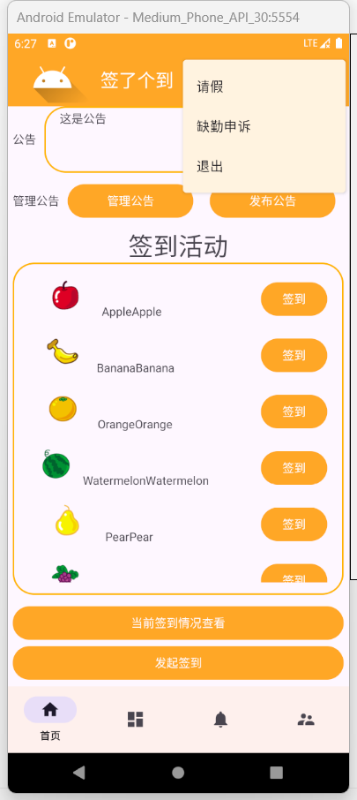

首页的功能主要是签到与管理签到，其中签到管理者的功能与使用者的功能日后会区分成两个版本，其中中间部分的各种签到可滚动，详情请见视频演示

fragment_home.xml

<?xml version="1.0" encoding="utf-8"?>  
<androidx.constraintlayout.widget.ConstraintLayout xmlns:android="http://schemas.android.com/apk/res/android"  
 xmlns:app="http://schemas.android.com/apk/res-auto"  
 xmlns:tools="http://schemas.android.com/tools"  
 android:layout_width="match_parent"  
 android:layout_height="match_parent"  
 tools:context=".ui.home.HomeFragment">  
  
 <ScrollView  
 android:layout_width="match_parent"  
 android:layout_height="wrap_content"  
 android:layout_marginStart="1dp"  
 android:layout_marginTop="0dp"  
 android:layout_marginEnd="1dp"  
 android:layout_marginBottom="1dp"  
 app:layout_constraintBottom_toBottomOf="parent"  
 app:layout_constraintEnd_toEndOf="parent"  
 app:layout_constraintStart_toStartOf="parent"  
 app:layout_constraintTop_toTopOf="parent">  
  
 <LinearLayout  
 android:layout_width="match_parent"  
 android:layout_height="wrap_content"  
 android:orientation="vertical"  
 android:layout_marginHorizontal="5dp">  
 <LinearLayout  
 android:layout_width="match_parent"  
 android:layout_height="wrap_content"  
 android:orientation="horizontal"  
 android:layout_marginBottom="10dp">  
 <TextView  
 android:layout_width="wrap_content"  
 android:layout_height="wrap_content"  
 android:text="公告"  
 android:layout_gravity="center_vertical"/>  
 <TextView  
 android:layout_width="match_parent"  
 android:layout_height="80dp"  
 android:layout_marginLeft="10dp"  
 android:padding="5dp"  
 android:text=" 这是公告"  
 android:background="@drawable/background_round_corner"/>  
 </LinearLayout>  
 <LinearLayout  
 android:layout_width="match_parent"  
 android:layout_height="wrap_content"  
 android:orientation="horizontal"  
 android:layout_marginBottom="10dp">  
 <TextView  
 android:layout_width="wrap_content"  
 android:layout_height="wrap_content"  
 android:text="管理公告"  
 android:layout_gravity="center_vertical"/>  
 <Button  
 android:layout_width="wrap_content"  
 android:layout_height="wrap_content"  
 android:layout_weight="0.5"  
 android:layout_marginHorizontal="10dp"  
 android:text="管理公告" />  
 <Button  
 android:layout_width="wrap_content"  
 android:layout_height="wrap_content"  
 android:layout_weight="0.5"  
 android:layout_marginHorizontal="10dp"  
 android:text="发布公告"/>  
 </LinearLayout>  
 <LinearLayout  
 android:layout_width="match_parent"  
 android:layout_height="wrap_content"  
 android:orientation="vertical"  
 android:layout_marginBottom="10dp">  
 <TextView  
 android:layout_width="match_parent"  
 android:layout_height="wrap_content"  
 android:text="签到活动"  
 android:textSize="30dp"  
 android:textAlignment="center"/>  
 <androidx.recyclerview.widget.RecyclerView  
 android:id="@+id/checkin_list_view"  
 android:layout_width="match_parent"  
 android:layout_height="400dp"  
 android:padding="15dp"  
 android:background="@drawable/background_round_corner"/>  
 </LinearLayout>  
 <LinearLayout  
 android:layout_width="match_parent"  
 android:layout_height="wrap_content"  
 android:orientation="vertical"  
 android:layout_marginBottom="10dp">  
 <Button  
 android:layout_width="match_parent"  
 android:layout_height="wrap_content"  
 android:text="当前签到情况查看"/>  
 <Button  
 android:layout_width="match_parent"  
 android:layout_height="wrap_content"  
 android:text="发起签到"/>  
 <Button  
 android:layout_width="match_parent"  
 android:layout_height="wrap_content"  
 android:text="管理签到"/>  
 <Button  
 android:layout_width="match_parent"  
 android:layout_height="wrap_content"  
 android:text="请假管理"/>  
 </LinearLayout>  
  
  
  
  
 </LinearLayout>  
 </ScrollView>  
</androidx.constraintlayout.widget.ConstraintLayout>

1. 仪表板

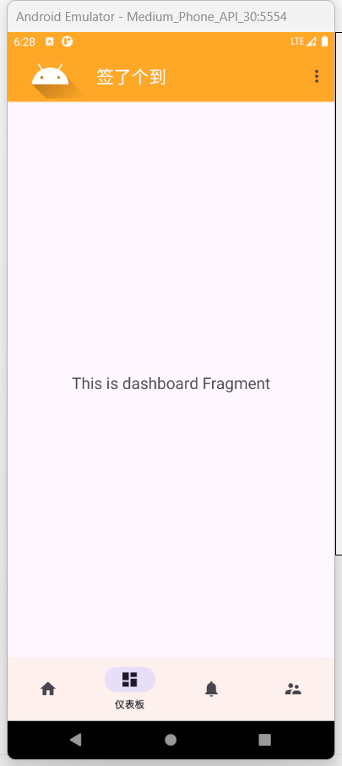

仪表板的功能主要是分析学生签到情况，如某某学生的缺勤率为20%，类似于这样的数据分析

1. 消息

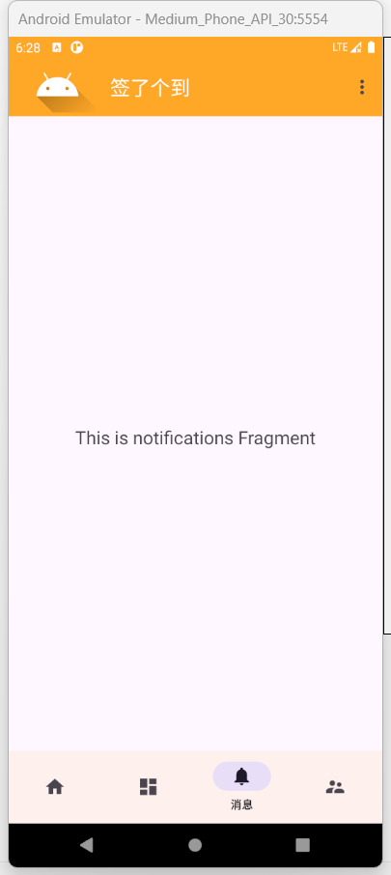

消息这一块主要用于提示使用者签到，也会告知使用者一些签到情况以及请假审批结果等，日后可能会增设课程表这种的提示功能

1. 用户

主要功能是用户登录登出等操作，日后会增添设置功能

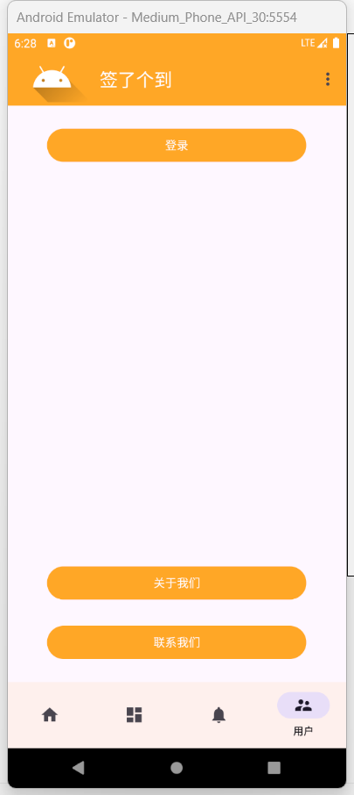

fragment_account.xml

<?xml version="1.0" encoding="utf-8"?>  
<androidx.constraintlayout.widget.ConstraintLayout xmlns:android="http://schemas.android.com/apk/res/android"  
 xmlns:app="http://schemas.android.com/apk/res-auto"  
 xmlns:tools="http://schemas.android.com/tools"  
 android:layout_width="match_parent"  
 android:layout_height="match_parent"  
 tools:context=".ui.account.AccountFragment">  
  
  
 <Button  
 android:id="@+id/button_fragment_login"  
 android:layout_width="match_parent"  
 android:layout_height="wrap_content"  
 android:layout_marginTop="24dp"  
 android:layout_marginHorizontal="48dp"  
 android:text="登录"  
 app:layout_constraintEnd_toEndOf="parent"  
 app:layout_constraintStart_toStartOf="parent"  
 app:layout_constraintTop_toTopOf="parent" />  
  
 <Button  
 android:id="@+id/button_fragment_about"  
 android:layout_width="match_parent"  
 android:layout_height="wrap_content"  
 android:layout_marginBottom="24dp"  
 android:layout_marginHorizontal="48dp"  
 android:text="关于我们"  
 app:layout_constraintBottom_toTopOf="@+id/button_fragment_contact"  
 app:layout_constraintEnd_toEndOf="parent"  
 app:layout_constraintHorizontal_bias="0.0"  
 app:layout_constraintStart_toStartOf="@id/button_fragment_login" />  
  
 <Button  
 android:id="@+id/button_fragment_contact"  
 android:layout_width="match_parent"  
 android:layout_height="wrap_content"  
 android:layout_marginBottom="24dp"  
 android:layout_marginHorizontal="48dp"  
 android:text="联系我们"  
 app:layout_constraintBottom_toBottomOf="parent"  
 app:layout_constraintEnd_toEndOf="parent"  
 app:layout_constraintHorizontal_bias="0.0"  
 app:layout_constraintStart_toStartOf="@id/button_fragment_about" />  
</androidx.constraintlayout.widget.ConstraintLayout>

登录时用户使用用户名+密码的方式登录

布局文件：

activity_login.xml

<?xml version="1.0" encoding="utf-8"?>  
<androidx.appcompat.widget.LinearLayoutCompat xmlns:android="http://schemas.android.com/apk/res/android"  
 xmlns:app="http://schemas.android.com/apk/res-auto"  
 xmlns:tools="http://schemas.android.com/tools"  
 android:layout_width="match_parent"  
 android:orientation="vertical"  
 android:layout_height="match_parent"  
 tools:context=".LoginActivity">  
  
 <androidx.appcompat.widget.Toolbar  
 android:id="@+id/toolbar"  
 android:layout_width="match_parent"  
 android:layout_height="wrap_content"  
 android:background="@color/my_light_primary"  
 app:title="登录"  
 app:titleTextColor="@color/white"  
 app:navigationIcon="@drawable/baseline_arrow_back_24"/>  
  
 <TextView  
 android:layout_width="match_parent"  
 android:layout_height="100dp"  
 android:background="@color/my_light_primary"  
 android:textColor="@color/white"  
 android:gravity="center"  
 android:textSize="30dp"  
 android:text="@string/app_name"/>  
  
 <TextView  
 android:layout_width="match_parent"  
 android:layout_height="wrap_content"  
 android:gravity="center"  
 android:textSize="30sp"  
 android:layout_margin="20dp"  
 android:textColor="#333"  
 android:textStyle="bold"  
 android:text="登录"/>  
  
 <androidx.appcompat.widget.LinearLayoutCompat  
 android:layout_width="match_parent"  
 android:layout_height="wrap_content"  
 android:layout_margin="26dp"  
 android:orientation="vertical">  
  
 <androidx.appcompat.widget.LinearLayoutCompat  
 android:layout_width="match_parent"  
 android:layout_height="50dp"  
 android:paddingLeft="10dp"  
 android:paddingRight="10dp"  
 android:background="@drawable/background_round_corner">  
  
 <ImageView  
 android:layout_width="wrap_content"  
 android:layout_height="wrap_content"  
 android:layout_gravity="center_vertical"  
 android:src="@drawable/baseline_account_box_24"/>  
  
 <EditText  
 android:layout_width="match_parent"  
 android:layout_height="match_parent"  
 android:layout_marginLeft="10dp"  
 android:background="@null"  
 android:hint="请输入用户名"  
 android:textSize="14dp" />  
  
 </androidx.appcompat.widget.LinearLayoutCompat>  
  
 <androidx.appcompat.widget.LinearLayoutCompat  
 android:layout_width="match_parent"  
 android:layout_height="50dp"  
 android:layout_marginTop="10dp"  
 android:paddingLeft="10dp"  
 android:paddingRight="10dp"  
 android:background="@drawable/background_round_corner">  
  
 <ImageView  
 android:layout_width="wrap_content"  
 android:layout_height="wrap_content"  
 android:layout_gravity="center_vertical"  
 android:src="@drawable/baseline_lock_24"/>  
  
 <EditText  
 android:layout_width="match_parent"  
 android:layout_height="match_parent"  
 android:layout_marginLeft="10dp"  
 android:background="@null"  
 android:hint="请输入密码"  
 android:inputType="textPassword"  
 android:textSize="14dp" />  
  
 </androidx.appcompat.widget.LinearLayoutCompat>  
   
 <TextView  
 android:layout_width="wrap_content"  
 android:layout_height="wrap_content"  
 android:id="@+id/register"  
 android:layout_marginTop="10dp"  
 android:layout_gravity="right"  
 android:textColor="@color/my_light_primary"  
 android:text="注册账号"/>  
  
 <Button  
 android:layout_width="match_parent"  
 android:layout_height="50dp"  
 android:layout_marginTop="20dp"  
 android:text="登录"/>  
  
 </androidx.appcompat.widget.LinearLayoutCompat>  
   
</androidx.appcompat.widget.LinearLayoutCompat>

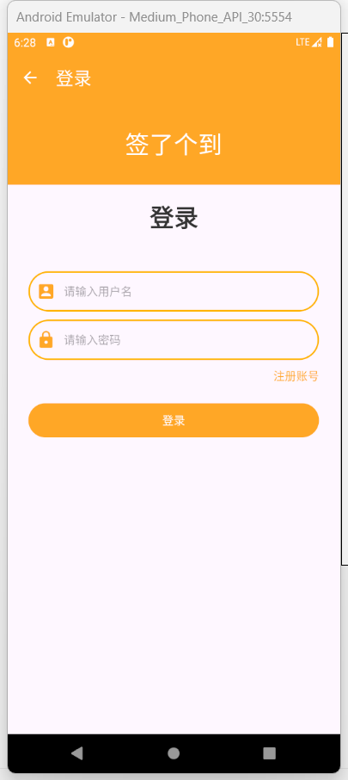

注册界面用户需要设置自己的用户名与密码，还有绑定的邮箱，用户数据会记录在数据库里

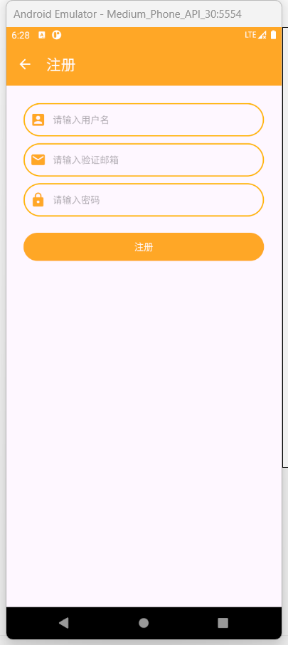

activity_register.xml

<?xml version="1.0" encoding="utf-8"?>  
<androidx.appcompat.widget.LinearLayoutCompat xmlns:android="http://schemas.android.com/apk/res/android"  
 xmlns:app="http://schemas.android.com/apk/res-auto"  
 xmlns:tools="http://schemas.android.com/tools"  
 android:layout_width="match_parent"  
 android:orientation="vertical"  
 android:layout_height="match_parent"  
 tools:context=".RegisterActivity">  
  
 <androidx.appcompat.widget.Toolbar  
 android:id="@+id/toolbar"  
 android:layout_width="match_parent"  
 android:layout_height="wrap_content"  
 android:background="@color/my_light_primary"  
 app:title="注册"  
 app:titleTextColor="@color/white"  
 app:navigationIcon="@drawable/baseline_arrow_back_24"/>  
  
  
 <androidx.appcompat.widget.LinearLayoutCompat  
 android:layout_width="match_parent"  
 android:layout_height="wrap_content"  
 android:layout_margin="26dp"  
 android:orientation="vertical">  
  
 <androidx.appcompat.widget.LinearLayoutCompat  
 android:layout_width="match_parent"  
 android:layout_height="50dp"  
 android:paddingLeft="10dp"  
 android:paddingRight="10dp"  
 android:background="@drawable/background_round_corner">  
  
 <ImageView  
 android:layout_width="wrap_content"  
 android:layout_height="wrap_content"  
 android:layout_gravity="center_vertical"  
 android:src="@drawable/baseline_account_box_24"/>  
  
 <EditText  
 android:layout_width="match_parent"  
 android:layout_height="match_parent"  
 android:layout_marginLeft="10dp"  
 android:background="@null"  
 android:hint="请输入用户名"  
 android:textSize="14dp" />  
  
 </androidx.appcompat.widget.LinearLayoutCompat>  
  
 <androidx.appcompat.widget.LinearLayoutCompat  
 android:layout_width="match_parent"  
 android:layout_height="50dp"  
 android:layout_marginTop="10dp"  
 android:paddingLeft="10dp"  
 android:paddingRight="10dp"  
 android:background="@drawable/background_round_corner">  
  
 <ImageView  
 android:layout_width="wrap_content"  
 android:layout_height="wrap_content"  
 android:layout_gravity="center_vertical"  
 android:src="@drawable/baseline_email_24"/>  
  
 <EditText  
 android:layout_width="match_parent"  
 android:layout_height="match_parent"  
 android:layout_marginLeft="10dp"  
 android:background="@null"  
 android:hint="请输入验证邮箱"  
 android:textSize="14dp" />  
  
 </androidx.appcompat.widget.LinearLayoutCompat>  
  
 <androidx.appcompat.widget.LinearLayoutCompat  
 android:layout_width="match_parent"  
 android:layout_height="50dp"  
 android:layout_marginTop="10dp"  
 android:paddingLeft="10dp"  
 android:paddingRight="10dp"  
 android:background="@drawable/background_round_corner">  
  
 <ImageView  
 android:layout_width="wrap_content"  
 android:layout_height="wrap_content"  
 android:layout_gravity="center_vertical"  
 android:src="@drawable/baseline_lock_24"/>  
  
 <EditText  
 android:layout_width="match_parent"  
 android:layout_height="match_parent"  
 android:layout_marginLeft="10dp"  
 android:background="@null"  
 android:hint="请输入密码"  
 android:inputType="textPassword"  
 android:textSize="14dp" />  
  
 </androidx.appcompat.widget.LinearLayoutCompat>  
  
 <Button  
 android:layout_width="match_parent"  
 android:layout_height="50dp"  
 android:layout_marginTop="20dp"  
 android:text="注册"/>  
  
 </androidx.appcompat.widget.LinearLayoutCompat>  
  
</androidx.appcompat.widget.LinearLayoutCompat>

value

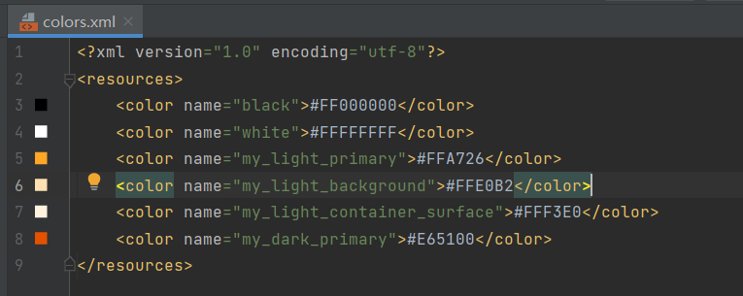

* 1. 交互流程设计

