
《Smart Mobile Application Development》
Software Design Document
学 院： | 阿伯丁数据科学与人工智能学院
班 级： | (2025-2026-1)-38HA4960-01阿伯丁
组 别： | 第 13 组
项目名称： | Waynote（行记）
学号/姓名： | 20233803075 冯先益  20233803093 孟皓皓

Table of Contents

1. Introduction 3
1.1 Target Audience 3
1.2 Core Features 3

2. Requirements Specification 3
2.1 User Needs 3
2.2 Functional Requirements 4
2.3 Non-functional Requirements 4

3. Overall Design 4
3.1 Architecture 4
3.2 State Management 4
3.3 Feature Modules 4

4. User Interface Design 5
4.1 Visual Language 5
4.2 Key Screens 5
4.3 Accessibility 10

5. Key Technologies & Challenges 10
5.1 Technologies 10
5.2 Challenges 10

6. Testing and User Experience Analysis 10
6.1 Third-Party Cloud Testing Results 10
6.1.1 Device Specifications 10
6.1.2 Compatibility Conclusion 11
6.1.3 Coverage Scope 11
6.2 Performance Metrics 11
6.2.1 Outliers / Abnormal Devices 12
6.2.2 Complementary Data 12
6.3 User Feedback and Experience 12
6.3.1 Overall Feedback 12
6.3.2 Device-Specific Issues 13
6.3.3 Suggestions for Improvement 13

7. Conclusion 13
7.1 Achievements 13
7.2 Challenges Encountered During Development 14
7.3 Suggestions for Future Improvements 14

1. Introduction
Waynote is a comprehensive Jetpack Compose-based Android application designed to streamline the entire travel experience from discovery to booking. It integrates several key features, including travel discovery, trip planning, mock flight booking, community engagement, real-time chat, and the ability to save favorite destinations and posts, all in one application.

1.1 Target Audience
Waynote is tailored to modern Android users (API 24+), optimized for devices running API 26+ with the use of java.time for advanced date handling. The app employs a sleek, light blue Material 3 theme to ensure a visually appealing user interface. The app is designed with offline capabilities to retain important data locally, ensuring uninterrupted user experience even in the absence of a network connection.

1.2 Core Features
- Travel Discovery: Offers a rich catalog of destinations, with comprehensive information, images, and user reviews, all presented in a localized format (available in English and Chinese).
- Trip Planning: Users can plan their trips with template-driven or custom itineraries, save drafts, and revisit them for later edits.
- Flight Booking: The app demonstrates a mock flight booking system, allowing users to search for flights, sort results, and complete a mock checkout process.
- Community Engagement: A dedicated space for users to browse community posts, interact with others, share experiences, and follow topics of interest.
- Real-Time Chat: A messaging system that enables users to chat with contacts and store their conversation history.
- Favorites: Users can save destinations, posts, and other content to their personal collection for easy access later.

2. Requirements Specification

2.1 User Needs
- Browse through various destinations with English and Chinese.
- Create, modify, and save trip plans with templates and drafts.
- Engage in mock flight booking, maintaining user-selected flights in an order list.
- Browse community posts, follow favorite content, and interact via real-time chat.
- Manage personal profile, including avatar customization, language settings, and saved content.
- Simple authentication system with the option to skip or lock the user out after 3 unsuccessful attempts.

2.2 Functional Requirements
- Authentication: Login and registration flow with a 3-attempt lockout and optional skip.
- Navigation: Bottom navigation that includes Home, Messages, and Profile with state restoration.
- Destination Catalog: Includes favorite toggles for destinations and posts, a community feed (recommended, following, activities), and search functionality.
- Flight Booking: Mock flight search, result sorting, expanded information, passenger selection, and checkout success.
- Trip Planner: Trip creation with date validation, auto-fill templates, manual stops, and the ability to save trips.
- Profile Management: Users can customize their profile with avatar picking, language toggle, and view shortcuts to their orders and favorites.

2.3 Non-functional Requirements
- Performance: Optimized for fast load times and minimal data consumption.
- Offline Functionality: The app works offline to retain key data such as saved trips, orders, and favorites.
- Accessibility: Ensure accessibility for all users, including contrast ratios for readability, dynamic text support, and talkback labels for blind or visually impaired users.

3. Overall Design

3.1 Architecture
The app uses a single-activity architecture with NavHost for navigation. Routes are managed by a set of destination constants and a bottom-tab enum that provides easy access to key areas. Navigation is argumentized, allowing deep linking for specific destinations or chat sessions.

3.2 State Management
- DataStore is used for storing preferences like authentication status, avatar images, trip plans, favorites, orders, and chat history.
- Compose's rememberSaveable is utilized for UI state, ensuring a smooth experience during orientation changes.
- Complex objects like orders and chat data are encoded/decoded using JSON and CSV helpers to persist data offline.

3.3 Feature Modules
- Authentication: Handles login, registration, and state restoration on re-entry.
- Home: Displays featured destinations, promotional content, and popular picks.
- Community: Offers a tabbed community feed with media-rich posts and interactive elements such as bookmarking and posting.
- Messages/Chat: Supports real-time messaging with thread lists, unread badges, avatars, and persisted chat history.
- Trip Planning: Offers templates for quick trip creation and manual entry, along with a saved trip view.
- Flight Booking: Simulates a booking flow with a multi-step process for searching, selecting, and confirming flight choices.
- Favorites: Allows users to save their favorite destinations and posts.
- Profile: Enables users to manage their profile, including their avatar, language preference, and order/favorites management.

4. User Interface Design

4.1 Visual Language
- Color Palette: The app uses a light blue palette with Aqua accent colors, ensuring a calm, modern, and visually appealing design.
- Typography: Consistent use of Material 3 typography for clarity and readability. Headlines, body text, and captions are styled using the standard Material design principles.
- UI Components: The interface is built using rounded cards, shadows, and gradients on hero sections to create a more dynamic and modern feel. Material 3 components like top app bars, bottom navigation, sheets, and forms are used to maintain consistency.

4.2 Key Screens
Login/Register and Skip Login:
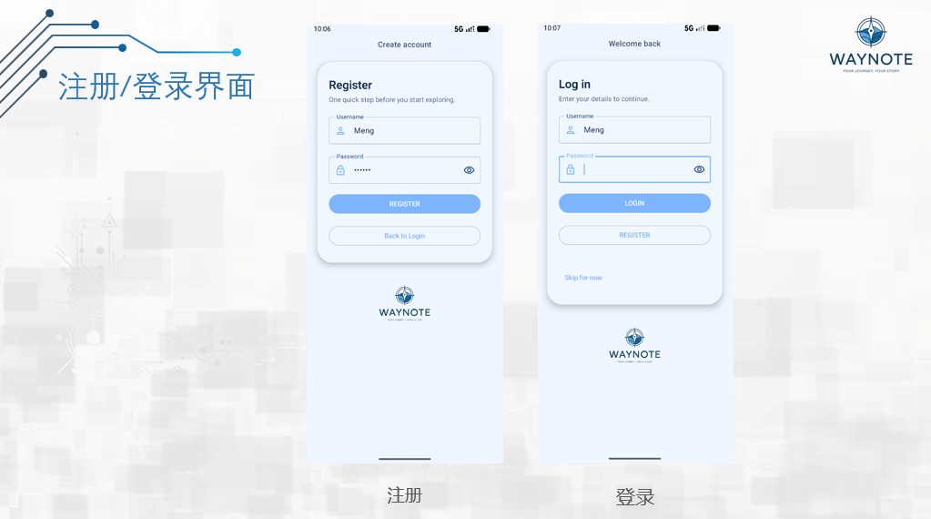
Homepage (banners, message reminders, section shortcuts, popular destinations):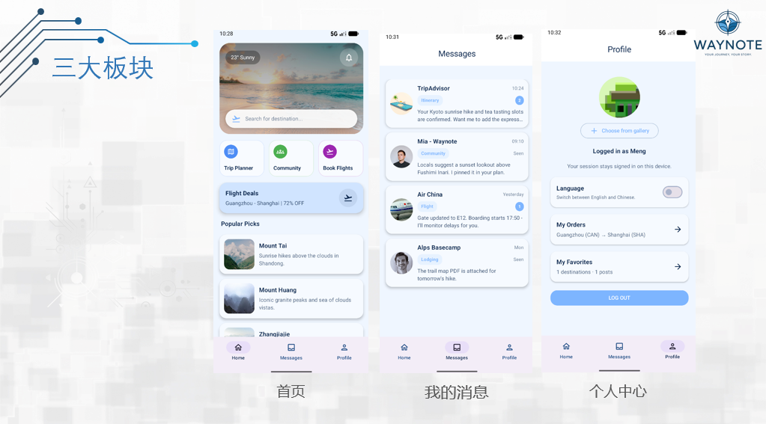
Destination details and bookmarks:
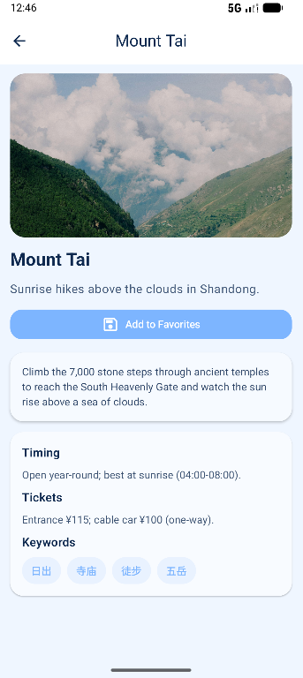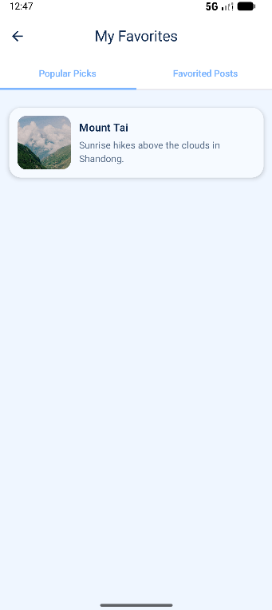
Community multi tab (recommended/followed/active), post/video display and collection:
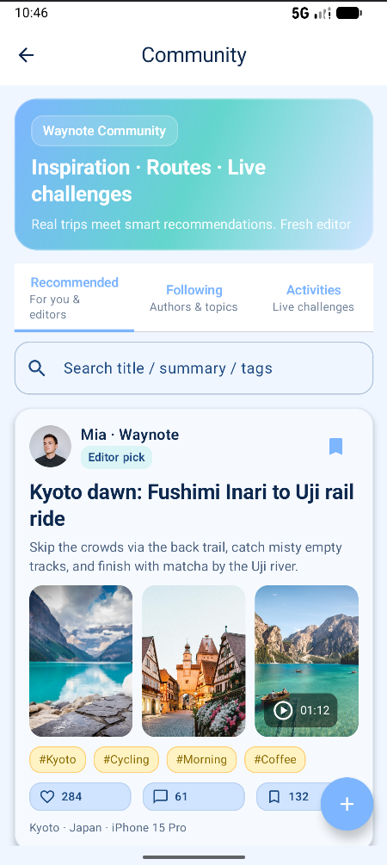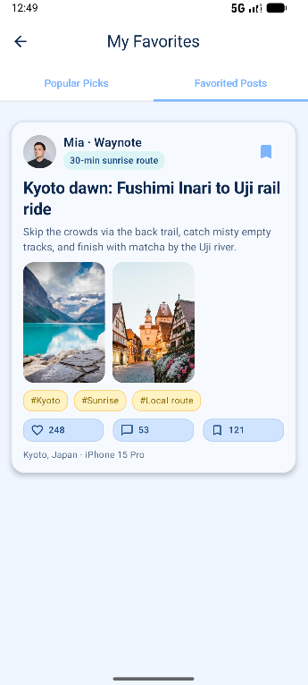
Message list and chat history:
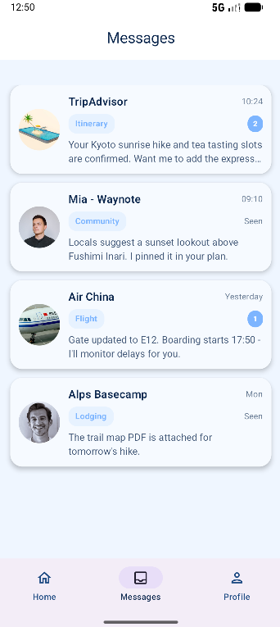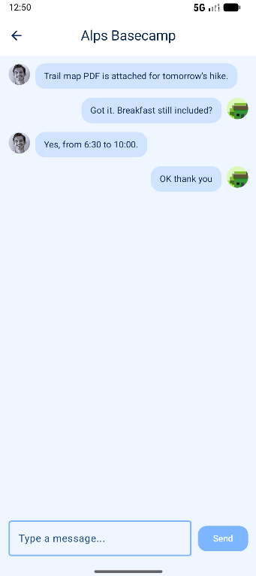
Flight ticket search - results - settlement - successful ticket issuance process and order list:
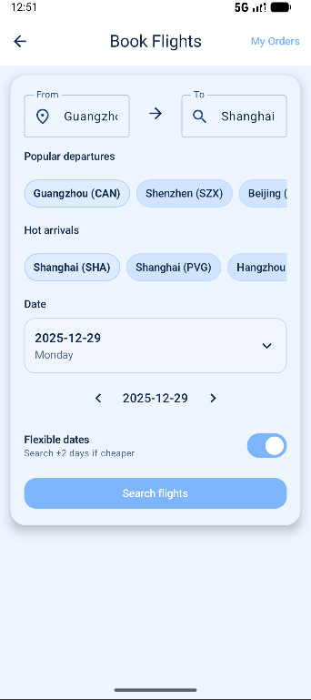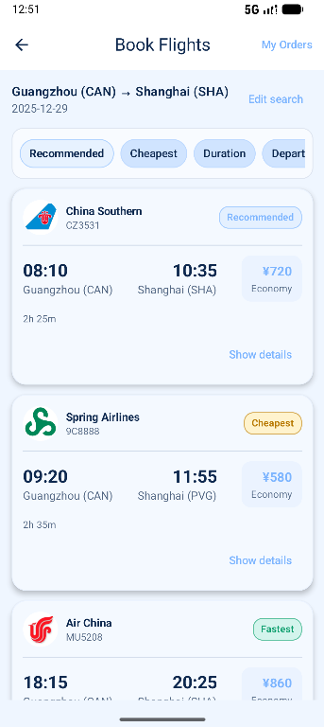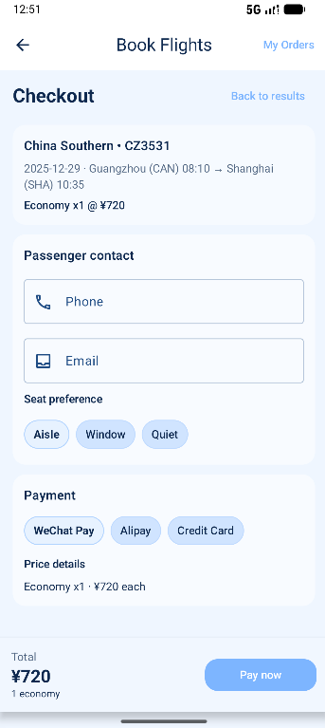
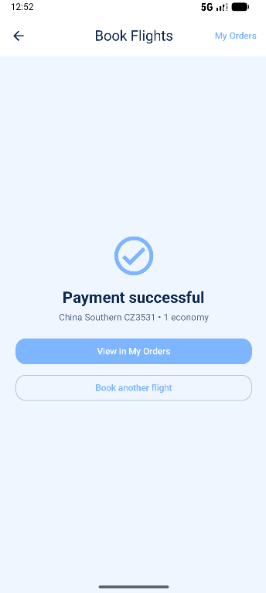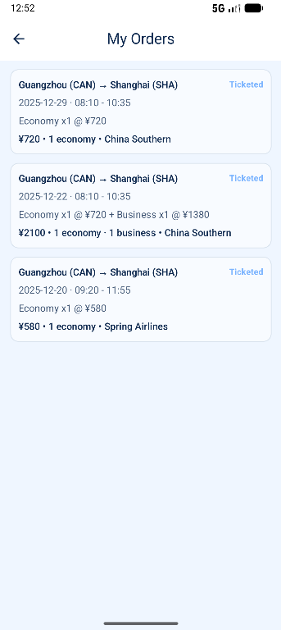
Schedule (automatic) planning editing and template saving:
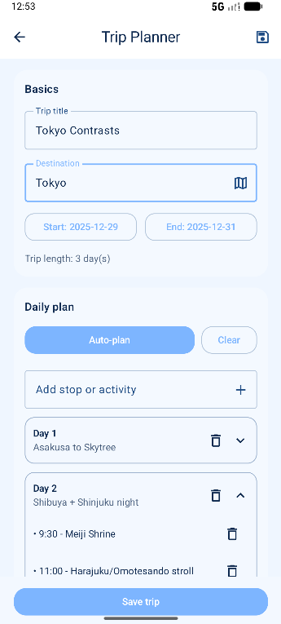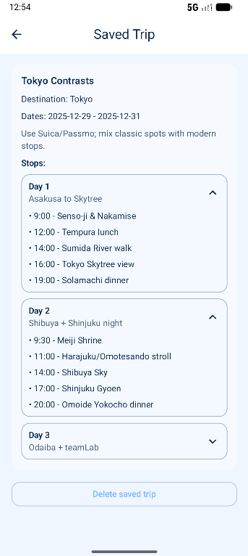
Personal Center (avatar, language switching, entrance collection, logout):
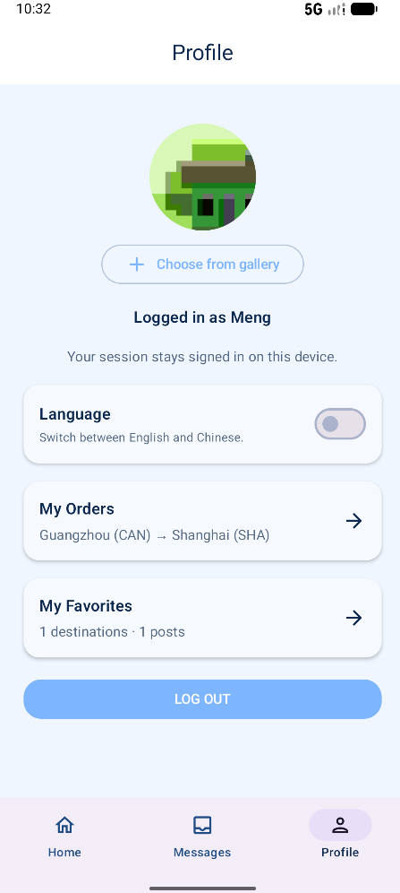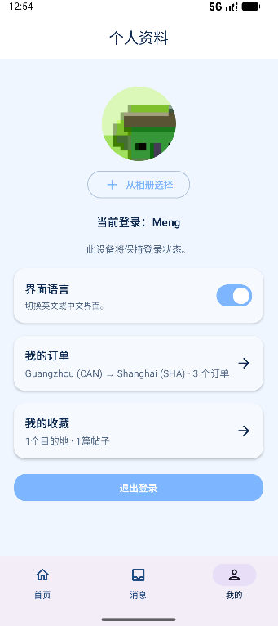

4.3 Accessibility
- Contrast and Colors: High contrast between text and background to ensure readability, especially in bright or low-light environments.
- Dynamic Text Support: The app supports dynamic type sizes, making it accessible to users with visual impairments.
- Touch Targets: Larger touch targets ensure the app is easy to use on a variety of devices, especially for users with motor impairments.

5. Key Technologies & Challenges

5.1 Technologies
- Jetpack Compose + Material 3 for building modern and responsive UIs.
- Navigation-Compose for routing, handling dynamic and static screens.
- DataStore Preferences for efficient offline data storage.
- java.time for date handling, ensuring robust support for date validations and calculations.
- Coil for remote image loading and displaying visuals from URLs.

5.2 Challenges
- Ensuring a seamless UX during lockout states and providing clear messaging to the user.
- Date validation in trip planning, especially for users with older Android versions (pre-API 26).
- Handling state restoration across app screens, ensuring user data persists when switching between tabs.
- Realistic mock booking without backend support, maintaining flow realism without an actual flight API.

6. Testing and User Experience Analysis

6.1 Third-Party Cloud Testing Results
WeTest was used as the third-party cloud testing platform for this round. A total of 20 devices were covered in the test, including 1 device that was not tested. The devices came from various brands, such as Huawei, OPPO, vivo, and Samsung. All the tested devices passed successfully with a 100% success rate. The devices featured different hardware configurations and Android versions, ranging from Android 9 to Android 13.

6.1.1 Device Specifications
The tested devices included Huawei (e.g., Huawei Mate 30, Huawei P10, Huawei Y100), OPPO (e.g., OPPO Reno4 Pro, OPPO Reno2 Z), vivo (e.g., vivo Y100, vivo V1831A), and Samsung (e.g., Galaxy Note 20 Ultra, Galaxy S20+ 5G) models. The system versions included Android 9, 10, 11, and 12, with some devices using custom ROMs. The hardware configurations also varied, with different CPUs (e.g., Qualcomm Snapdragon, MediaTek Helio, Kirin 990) and memory configurations (ranging from 4GB to 12GB).

6.1.2 Compatibility Conclusion
- Overall Pass Rate: All 19 devices tested successfully passed the tests, with a success rate of 100%. No issues were found in the report.
- Problematic/Failed Device List: Any issues such as crashes, black screens, freezes, ANRs, permission/compatibility errors, etc., typically fall under the "compatibility failure device distribution/problem list."
- Untested Device: This report includes one device marked as "untested" (Huawei Mate 30, system version 4.0.0). It is assumed that the issue was caused by device scheduling/scripts/environment.
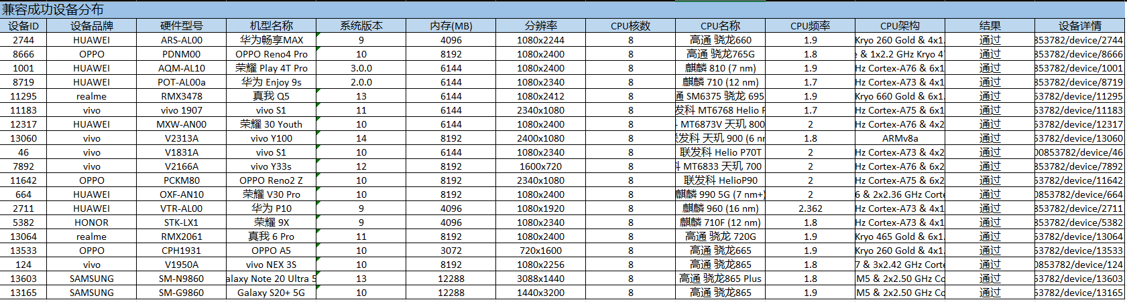

6.1.3 Coverage Scope
- Brand Distribution: The tested devices were primarily from Huawei (6), vivo (5), OPPO (3), realme (2), SAMSUNG (2), and HONOR (1).
- System Version Distribution: The test covered major Android versions (e.g., 9, 10, 11, 12, 13, 14), and versions like 2.0.0, 3.0.0, and 4.0.0 were also found, typically seen in specific ROMs/ecosystems.
- Hardware Range: The devices tested ranged from 3GB to 12GB of memory, and screen resolutions from 720p to 1080p.

6.2 Performance Metrics

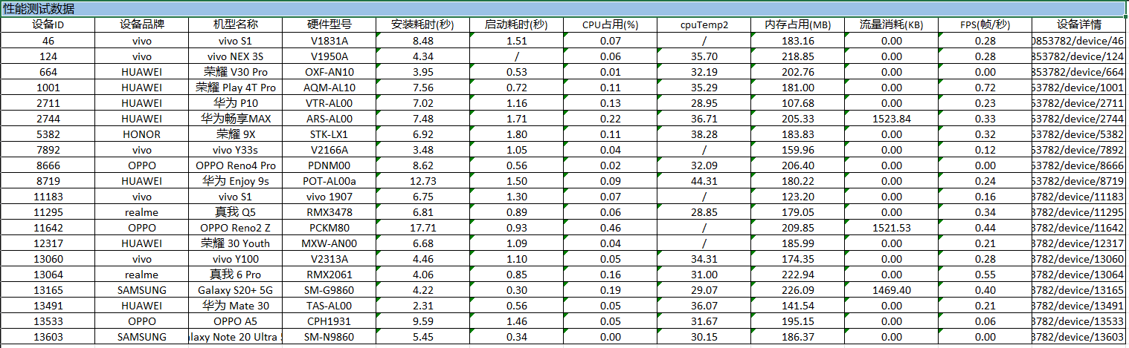

Metric | Average | Range
Installation Time | 6.93 seconds | 2.31 - 17.71 seconds
Launch Time | 1.02 seconds | 0.30 - 1.80 seconds
CPU Usage | 0.10% | 0.00 - 0.46%
Memory Usage | 183.69 MB | Peak: 226.09 MB
Network Consumption | 1523.84 KB | Reasonable for cloud testing
Frame Rate (FPS) | 0.28 FPS | 0.00 - 0.72 FPS

6.2.1 Outliers / Abnormal Devices
- Slowest Installation: OPPO Reno2 Z (approximately 17.71 seconds) stood out as an outlier.
- Slowest Launch: HONOR 9X (approximately 1.80 seconds) had a slower launch time.
- Highest Memory Usage: Samsung Galaxy S20+ 5G (approximately 226.09 MB) had the highest memory usage.

6.2.2 Complementary Data
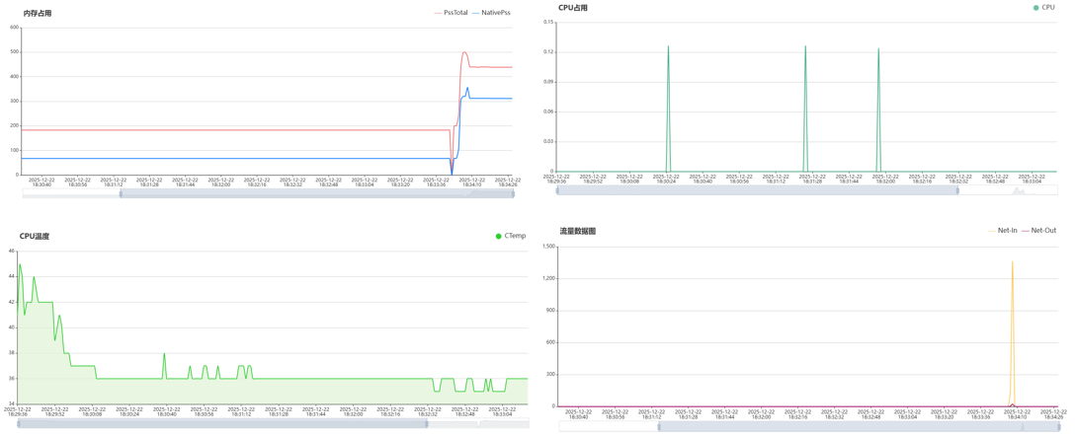

6.3 User Feedback and Experience

6.3.1 Overall Feedback
The user interface (UI) of the app was generally considered intuitive, with most users navigating smoothly. However, some users provided suggestions for improvement. The most common suggestion was to optimize the application's response time, as some users experienced slight delays, particularly on lower-spec devices.
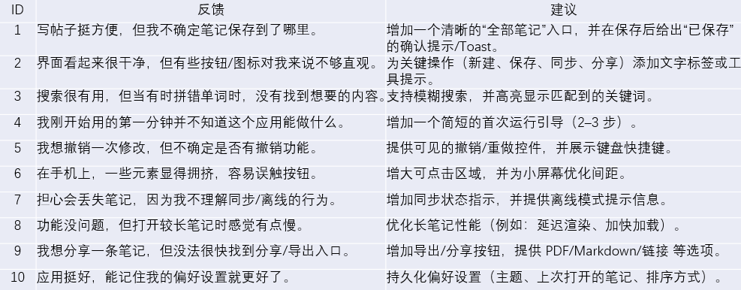

6.3.2 Device-Specific Issues
Some devices experienced slow app responsiveness, especially those with lower specs or older Android versions. For instance, Huawei Mate 30 (Android 10) and OPPO Reno2 Z (Android 9) had longer launch times. A few users reported intermittent freezing or delays when switching between different sections of the app, especially on devices with lower processing power.

6.3.3 Suggestions for Improvement
- Users suggested further optimization of the app to improve performance on lower-spec devices.
- There was a request for clearer visual indicators, such as loading bars or progress indicators, to improve user perception of the app's responsiveness.
- Users also expressed the need for better cloud service integration, ensuring smoother data synchronization and improving offline functionality.

7. Conclusion
Waynote provides a cohesive, localized travel experience with a well-designed UI and persistent state management. By integrating features like travel discovery, trip planning, mock flight booking, community engagement, and real-time chat, Waynote successfully creates an end-to-end travel workflow that meets the needs of modern Android users. The app ensures a seamless user experience, even when offline, by leveraging efficient data storage and local persistence.

7.1 Achievements
- End-to-End Workflow: The app delivers a complete travel experience, from discovering destinations and planning trips to booking flights and saving favorite content.
- Bilingual UI: With localization in both English and Chinese, the app reaches a broader audience, catering to diverse language preferences.
- State Management: Persistent state handling is implemented through DataStore, ensuring users' data such as trip plans, favorites, and chat history are retained even when offline.
- Seamless User Experience: Through the use of Jetpack Compose and Material 3, Waynote offers a smooth, responsive interface with modern design elements and a consistent theming system.

7.2 Challenges Encountered During Development
- Backend Simulation: One of the main challenges was simulating a real-world flight booking flow without integrating a backend. This was overcome by creating a mock system, though future versions would benefit from real data integration for a fully functional booking experience.
- Device Compatibility: Ensuring compatibility across a range of devices and Android versions (API 9 to API 13) was crucial. The app passed testing with a 100% success rate on 19 devices, though performance on lower-spec devices was slower.
- State Restoration: Another challenge was ensuring smooth state restoration, especially when switching between different app screens. This was addressed using Compose's rememberSaveable, although further improvements in state handling could be made with the MVVM architecture.

7.3 Suggestions for Future Improvements
- Real Data Integration: Integrating actual APIs for flights, destinations, and user data will enhance the app's functionality, providing users with up-to-date information. This will also require implementing offline caching and robust error handling to ensure a seamless user experience.
- MVVM Architecture: Moving to an MVVM architecture with ViewModel and repository separation will make the app more maintainable and scalable. This will simplify state management, allow better testing, and separate concerns more effectively across different parts of the app.
- Encrypted Storage and Enhanced Security: Implementing encrypted storage for sensitive user data, such as authentication credentials and personal information, will improve security. Additionally, strengthening authentication flows, such as adding multi-factor authentication, will enhance user trust and data protection.
- Improved Trip Planner: Future versions should introduce a calendar export feature, enabling users to export their trips to their preferred calendar app. Additionally, incorporating notifications to remind users of upcoming trips and a richer template gallery for trip planning would enhance usability.
- Accessibility Enhancements: To ensure the app is accessible to a wider audience, a thorough accessibility review should be conducted. Improvements could include TalkBack labels for screen readers, larger touch targets for easier navigation, and support for dynamic text to cater to users with visual impairments.
In summary, Waynote has successfully delivered a localized, intuitive, and feature-rich travel app that enhances the way users plan and manage their trips. Moving forward, by integrating real-world data sources, optimizing performance for lower-spec devices, and implementing a more secure and scalable architecture, Waynote will continue to evolve into a powerful tool for travelers.

