

**Business plan**

**SkinAdvisor**

**-- An AI-driven full-cycle intelligent skin care and skin health management platform**

**School Name: South China Normal University**

**Project Members: Zhang Yating, Chen Jiaqi, Xie Xiaolu, Tang Yue**

**Supervisor: Cao Yang**

**1.0 Project Overview**

**1.1 Project Overview**

SkinAdvisor is a multi-age skin care platform integrating AI-powered image analysis, lifestyle data insights, smart recommendations, and dermatological services. By capturing real-time facial photos, the system automatically identifies skin concerns like dullness, flakiness, or sensitivity, while analyzing users daily habits (diet, sleep patterns) to deliver personalized skincare advice, product recommendations, and over-the-counter solutions. For professional consultations or prescription medications, users can schedule virtual appointments with dermatologists for instant expert consultations.

Beyond providing customized skincare solutions for different skin types, SkinAdvisor delivers cutting-edge research updates and a dedicated skincare discussion forum, delivering scientifically-backed content free from advertisements. To help users maintain consistent skincare routines, the platform features personalized reminders that send daily skincare to-do lists at dawn. As a one-stop skincare ecosystem, SkinAdvisor guides users from "identifying skin concerns" to "scientific improvement", helping them achieve radiant skin through its comprehensive skincare solutions.

**1.2 Market Pain Points**

1. Professional testing equipment is expensive and difficult to be widely used: skin testing equipment (such as professional skin testing equipment) is mostly introduced by beauty salons, and the equipment cost is high and the popularity is low. Ordinary users can not easily and cheaply obtain professional skin testing, and lack of scientific tools to understand their own skin type, and can only rely on perceptual, empirical and subjective judgment.
2. Fragmented information and decision-making difficulties: In the Internet, a large number of skin care product recommendations contain hidden advertisements, and it is difficult to find real reviews; the massive amount of information obtained by self-searching is easy to make users confused, and it is difficult to determine the correct and effective skin care methods according to their daily habits and physical conditions.
3. Scarcity of medical resources: Appointments with dermatologists at regular hospitals are hard to get, with long waiting times and high time costs. In-person visits are inconvenient for students and working professionals, especially those with mild to moderate skin issues who prefer not to visit hospitals for minor problems. Moreover, doctors time is limited, making real-time or asynchronous consultations impractical.
4. Data tracking is lacking: Most skincare apps fail to consistently monitor skin condition changes, provide professional advice, or quantify improvement outcomes.
5. There is no platform that can realize the full set of skin care services: skin type detection, skin care forum, online consultation and other functions are scattered in different software, mini programs and public accounts. Users need to switch between different platforms to achieve all the steps of skin care, which will lead to the decline of users enthusiasm.

**1.3 Solutions**

"SkinAdvisor" addresses the aforementioned issues through three core technologies: AI, big data, and telemedicine.

1. The trained skin disease recognition model is used to automatically identify the skin status, and the knowledge base based on cutting-edge scientific research achievements and authoritative doctors insights is used to accurately analyze the causes of the problem.
2. Integrate lifestyle data such as daily diet, exercise and sleep to generate personalized plans.
3. Connect directly to online doctors with one click for instant consultation and medication advice.
4. Track and visualize skin changes to create a dynamic health profile and continuously optimize the latest skin care regimen.
5. Manage large databases and store forum content for easy access.

**1.4 Core Competitive Advantages**

1. AI Deep Skin Analysis: A deep learning model trained on massive skin image data, achieving over 90% accuracy.
2. Data-driven recommendation engine: dynamically generates customized solutions based on users lifestyle habits, environmental factors, and skin conditions.
3. Medical collaboration resources: Partner with dermatology specialists at tertiary hospitals to deliver authoritative remote medical consultations.
4. Comprehensive skincare service: from testing, analysis and improvement to consultation and tracking, users do not need to jump to multiple platforms, and can get one-stop service in the SkinAdvisor.

**1.5 Market Potential and Target**

With the increasing attention of people to skin health, the market size of skin care products continues to expand, and the popularity of Internet medical care also provides a broad space for online skin consultation. The target market of the project has great growth potential.

Three-year project goals:

1. Registered users ≥ 50,000
2. ≥ 10,000 daily active users
3. Established cooperation with ≥50 grade A hospitals

**2.0 Products and Services**

**2.1 Product Positioning and Vision**

Positioning: An intelligent skin management platform for urban people who pursue scientific skin care, people with problem skin and people with limited time for mild symptoms. At the same time, it provides advice and real product reviews for people who want to find skin care products.

Vision: To become "the mobile dermatologist in everyones pocket", making skin health management as simple as swiping your phone, and making skin care a regular habit.

**2.2 Core Function Matrix**

**2.2.1 AI Instant Skin Test & Smart Analysis**

Users can upload photos or take a face in real time.

AI models automatically identify skin problems such as dullness, peeling, erythema, acne, and sensitivity.

Generate a "skin health report" based on the test results and provide a preliminary analysis of possible causes.

**2.2.2 Personalized Skincare Plan Generation**

The system collects multidimensional data such as diet, sleep, environment, and weather.

Generate "internal improvement suggestions" (such as sleep and diet adjustments) and "external care plans" (skin care products and ointment recommendations) through algorithms.

Recommendations are based on real skin case database matching.

**2.2.3 "Express Consultation" Online Medical Services**

Cooperate with tertiary hospitals and access the Internet hospital platform.

Users can select hospitals and doctors recommended by the platform to match dermatologists within minutes.

Doctors can provide professional prescriptions or suggestions based on AI detection results and user data, and realize asynchronous communication with users.

**2.2.4 Dynamic Skin Status Tracking and Visualization System automatically records historical inspection data.**

Generate a skin improvement trend chart that supports viewing across different time dimensions and quantifies the correlation between behavior and effect.

Provide a "skin care check-in" feature to encourage users to take care of their skin on a daily basis.

**2.2.5 Skin Care Knowledge and User Communication Community**

The homepage displays local weather and skincare alerts (including UV index and related information, along with physical/chemical sun protection recommendations).

The Knowledge Center regularly shares the latest research findings and skincare trends. The community section showcases trending topics for users to share experiences, and the platform regularly checks for ads and removes them.

**2.3 Unusual Terms of Sale**

The whole process from "problem discovery" to "problem solving" is intelligent, so that users can get efficient and highly data-driven services.

Personalized recommendations are based on real user data rather than advertising, so that users are happy and confident in using them.

Online medical services make "dermatology consultation" as convenient as chatting, and support asynchronous consultation between doctors and users within a certain time limit, without worrying about any special situation such as emergency.

**2.4 Technical Barriers: Large-scale models trained on massive medical data**

It has a massive database of skin images, cases and improvement plans.

AI models are continuously refined through iterative training using datasets annotated by dermatologists and medical imaging technicians.

The recommendation algorithm combines deep learning and knowledge graph to achieve high precision matching.

**2.5 Brand Future**

Building on its core expertise in skin care, the brand will expand into personalized beauty tech integration, creating a seamless skin care + makeup ecosystem.

1. **Precision Beauty Matching System**

Leveraging AI technology to conduct in-depth analysis of skin tone (cool/hot/neutral), skin type (dry/oily/hybrid), and seasonal variations, the system delivers ultra-precise foundation color recommendations. By comprehensively considering dynamic factors like lighting and skin hydration, it ensures makeup products perfectly match your natural skin type. The newly launched "Skin Tone Color Card Test" generates personalized color palettes, precisely matching lipstick, blush, eyeshadow, and other makeup shades to prevent issues like "cluttered makeup" or "tone mismatch".

1. **Smart beauty tools**

Beauty brands and tech manufacturers collaborate to enable seamless integration with smart beauty mirrors and portable makeup tools. These devices synchronize real-time skin data and provide dynamic feedback: for instance, highlighting areas requiring precise foundation blending based on skin texture, or recommending lightweight formulas during humid weather to prevent pore clogging. Through deep synergy between hardware and software, makeup procedures become more attuned to the skins real-time condition.

1. **Cross-brand color code matching database**

To tackle the color code confusion in the beauty industry, weve developed a universal color-matching database. When users select their preferred foundation shade, the system cross-brand recommends compatible shades while verifying ingredient compatibility with skin types. This not only eliminates the hassle ofre-testing colors when switching brands but also prevents skin irritation caused by unsuitable ingredients.

1. **Skin-Makeup interaction tracking**

Going beyond single recommendation dimensions, the system continuously monitors long-term effects of makeup products on skin: tracking key indicators like post-application irritation, oiliness, dryness, and powdering. By integrating historical data, it generates personalized beauty adaptation reports. For example, it recommends oil-control primers for T-zone oiliness and hydrating concealers for dry lines, enabling adaptive iteration of beauty solutions.

1. **AR virtual try-on experience**

Powered by augmented reality, the system allows users to virtually try recommended makeup on their real-time facial images based on the latest skin condition data. This feature enables risk-free color and formula trials, while AI provides customized application techniques tailored to skin types. For example, it suggests: For dry areas, gently pat the foundation outward from the center to prevent powder buildup.

Through these enhancements, the brand evolves from a skin health manager to a holistic beauty companion, bridging the gap between scientific skincare and personalized beauty. This transformation brings the skin-first beauty philosophy to a wider audience.

# **3.0 Market Analysis**

## **3.1 Industry Overview & Market Size**

3.1.1 Macroeconomic Background and Market Trends

1. Macro market size

China’s cosmetics and skincare market has officially entered the "trillion-yuan scale". Driven by the rise of domestic brands, better technology and higher consumer demands, its market structure is quickly becoming more professional and digital.

Macroeconomic Market Size:Trillion-yuan scale: According to the research of China Fragrance and Cosmetics Association’s Industry Research Center, China’s total cosmetics market sales reached 1.073822 trillion yuan in 2024. This is a 2.8% increase from the previous year. It shows that China’s cosmetics industry is growing steadily.

Skincare market size: As a key category, the skincare market is expected to hit 318.6 billion yuan by 2025 (sources: iiMedia Research, Kaiyuan Securities Research Institute). It has great long-term growth potential.

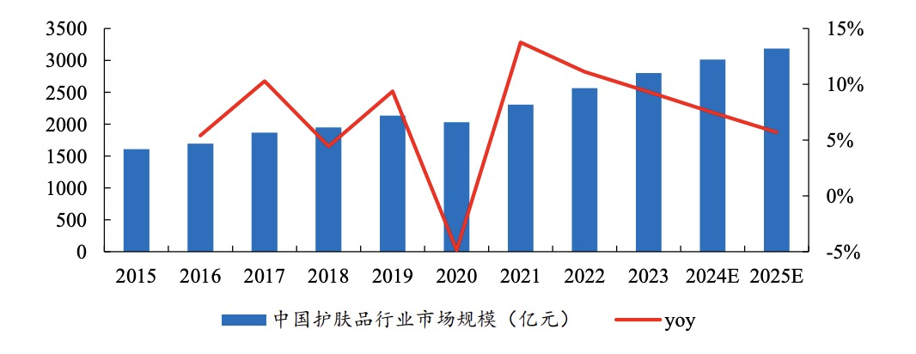

2、Channel Trends

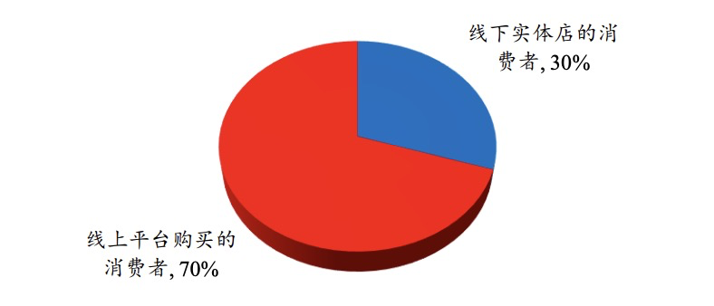(Consumers who buy from offline stores, 30%Consumers who buy from online platforms, 70%)

Online shopping is mainstream: As the chart shows (sources: CNR.cn, Kaiyuan Securities Research Institute), 70% of consumers prefer to buy cosmetics online. Only 30% buy from offline stores.

Strategic meaning: This data clearly focuses the market on online channels. "SkinAdvisor" is a mobile app. Its business model fits this mainstream, high-growth online shopping trend. It is the strategic basis for getting customers and guiding sales.

1. Consumption Trends: Function-driven, Scientific Customization and Technological Upgrading

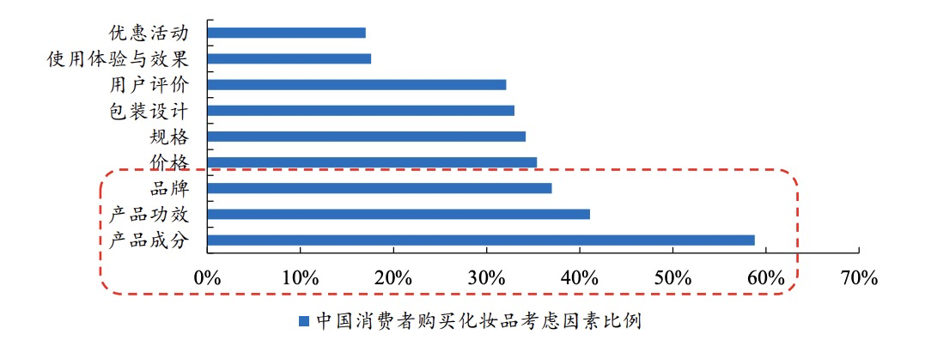

Efficacy-focused skincare is mainstream: Companies are improving their technology. They want to meet consumers’ personalized and varied needs for product effects and ingredients. Consumers are more into "ingredient-based" scientific skincare. The idea of efficacy-focused skincare is deeply rooted. This directly drives the fast growth of the efficacy-focused skincare market.

AI and online medical care help: Although online shopping is common, consumers need an authoritative, accurate data center for efficacy-focused skincare. "SkinAdvisor" solves this problem. It uses AI diagnosis to meet consumers’ strong needs for effective and scientific skincare. It also uses the 418 million online medical users. It turns online traffic into professional health management services.

3.1.2 Target Market Positioning and Size

This project’s target market focuses on the overlap of "AI-driven intelligent skin health management" and "online dermatology services". It aims to seize the overlap of two high-growth areas in the trillion-yuan cosmetics market: mainstream online channels and efficacy-focused skincare.

Market size potential: In 2024, the total cosmetics sales reached 1.073822 trillion yuan. The skincare market will reach 318.6 billion yuan in 2025. 70% of consumers prefer online shopping. With this strong channel foundation, the platform has huge business potential.

Value positioning: "SkinAdvisor" uses data-driven solutions. It takes the lead in scientific skincare management and remote dermatology services. It builds technical barriers and a complete service loop.

**3.2 User Persona**

This project’s target users are young people. They use digital products a lot. They have strong needs for beauty and skincare. They also want scientific, accurate and personalized services. Based on their shopping habits and problems, we divide them into the following groups:

3.2.1 Core User Group

Exquisite White-collar Worker Lily (25-35 years old) / Advanced Skincare User:

Profile: She is an office worker or college student. She is passionate about skincare. She is willing to try new tech. She relies heavily on social media.

Problems: Staying up late and stress make her skin unstable. She has tried many "internet-famous" skincare products but they don’t work. She needs a scientific, effective solution for skin problems. She wants to know changes in her skin data.

Needs: She wants a systematic skincare plan. The plan should fit her skin type and lifestyle. She wants to use AI monitoring and professional advice. She also wants to track results dynamically.

3.2.2 New User Group: Skincare Beginners

Profile: Student Xiao Xi (16-25 years old) / Skincare Novice:

Background: She just started to be interested in skincare. Or she has skin problems (like acne) during adolescence or college. But she has a limited budget. She feels confused by a lot of information. She is easily influenced by KOCs/KOLs to buy products.

Problems: She doesn’t know her skin type. She is afraid of "damaging her skin". She lacks systematic skincare knowledge. She wants to try professional skincare but can’t afford expensive medical aesthetics or private hospitals.

Needs: She needs a "guide" that is easy to use, objective and professional. It should use AI to quickly identify her skin type. It should provide basic skincare knowledge and correct steps. It should also recommend affordable and effective products.

3.2.3 New User Group: Users in Specific Scenarios (Gift-Givers/Male Users)

Profile: Workplace Professional Hao (25-35 years old) / Thoughtful Gift-Giver:

Background: He needs to give gifts to his girlfriend, relatives or important friends. Skincare products are a common choice but they are risky to pick.

Problems: He doesn’t know about skincare products. He doesn’t know the recipient’s skin type or real needs. He is afraid of giving "bad gifts" or inappropriate products. He wants the gifts to be "accurate and useful" and show he cares with high tech.

Needs: He wants to use "SkinAdvisor’s" AI analysis and data. He wants to get accurate product recommendations based on the recipient’s real-time skin condition. He wants to turn gift-buying into "care based on scientific data". He wants to avoid risks from blind choices.

3.2.4 Potential/User Group with Problematic Skin

Potential user group (over 35 years old): They start to care about deeper issues like anti-aging and skin repair. They have higher requirements for professionalism and authority.

User group with problematic skin: They have long-term skin problems like acne, sensitivity and dark spots. They have spent a lot on trying solutions. They need scientific and effective solutions badly. They have a strong need for "quick consultations".

**3.3 Competitive Landscape Analysis**

3.3.1 Major Competitors

|  |  |  |  |  |
| --- | --- | --- | --- | --- |
| Type of Competitor | Representative App/Product | Competitive Positioning/Core Service | Core Advantage | Potential Threats and Limitations |
| Online Medical Consultation | Haodf Online, Mini Programs of Major Hospitals | They offer online text/image/video consultations, including dermatology services. | They have many doctors. They have medical licenses and follow rules well. | They lack objective skin condition data. Consultations are slow. Diagnosis depends on users’ descriptions. |
| Beauty/Skincare Community E-commerce | Xiaohongshu, Tmall Beauty Section | They share skincare knowledge, promote products, sell products and guide purchases. | They have a large user base. Their community is active. Shopping is easy. They focus on driving sales. | Information quality varies. No professional doctors are involved. Recommendations are subjective. They can’t form a complete medical service loop. |
| Independent AI Skin Testing Tools | You Look Great Today | They offer basic skin tests via photos and provide reports. | They are easy and fast to use. They focus on basic testing functions. | Tests are not very accurate or in-depth. They don’t track long-term data. No real experts are involved in diagnosis. |

3.3.2 Differentiated Advantages of SkinAdvisor

"SkinAdvisor’s" core strength is building a data-driven, complete service loop. This loop connects "AI accurate diagnosis" and "real expert services". The app’s advantages lie in "professionalism" and "connection efficiency":

|  |  |  |
| --- | --- | --- |
| Dimension | Problems of Traditional Competitors | Core Advantages of SkinAdvisor |
| Service Loop | They only offer one-time consultations or product recommendations. | It forms a full-process loop: "AI testing - data tracking - real-person consultation - community sharing - product guidance". |
| Diagnosis Accuracy | They depend on users’ descriptions or basic photo tests that are not accurate. | It uses an AI model trained with a lot of medical data. It can identify and analyze skin conditions in real time, from multiple angles and with high accuracy. |
| Doctor Service | Online doctors don’t have objective skin data about patients. | AI reports come first to help doctors. Doctors can check AI’s historical analysis data during consultations. This makes diagnosis faster and more accurate. |
| Data Value | They only use data for one-time diagnosis or simple user profiles. | It tracks data dynamically and shows it clearly. It records every skincare change of users. It helps users see if skincare products and lifestyle changes work. This makes users more loyal. |
| Business Model | They focus on transaction commissions (e-commerce) or guiding traffic (consultations). | It makes money in multiple ways: data services (subscriptions), professional consultation fees, B2B services (for medical aesthetics/brands). Its income structure is healthier and more promising. |

## **3.4 SWOT Comprehensive Analysis**

3.4.1 Strengths

(1) Core Technical Barriers Driven by AI (S1)

SkinAdvisor’s biggest advantage is its unique AI diagnosis technology and professional depth.

High-accuracy diagnosis: The platform uses an AI model. This model is trained with a lot of medical data, including diagnosis reports and professional knowledge from dermatologists. It can analyze users’ skin in real time, from multiple angles and with high accuracy.

Application potential: This core technology can automatically create personalized skincare plans. It can also "use AI reports to help doctors". It can be an auxiliary diagnosis tool. It can connect with professional medical services smoothly in the future. This technical barrier makes it different from traditional beauty apps. It is the basis for efficient and objective diagnosis.

1. Data-Driven High-Loyalty Service Loop (S2)

This project offers continuous health management and community value supported by data. The platform forms a complete service loop: "AI testing - diagnosis - plan - consultation - tracking - community". It integrates professional services into daily management.

Community value: Users can share experiences, discuss products and talk about skincare in the community. This increases how often users use the platform and makes them more loyal.

Self-improvement: Every time users use the platform, it collects data. This makes the model and services "more accurate with more use". It creates a positive cycle. It provides continuous value to users.

1. Core Market Support and Channel Advantages (S3)

This project’s business model fits current mainstream shopping habits and the trend of higher consumer demands.

Online channels are mainstream: 70% of consumers prefer to buy cosmetics online (sources: CNR.cn, Kaiyuan Securities Research Institute). This project’s mobile app model fits this online trend. It is the strategic basis for guiding e-commerce traffic and getting customers efficiently.

Demand basis: The skincare market is huge (it will reach 318.6 billion yuan by 2025). Consumers care more about product effects and ingredients than ever. They need professional, data-driven solutions like SkinAdvisor badly.

3.4.2 Weaknesses

(1) High R&D and Compliance Costs (W1)

R&D and operation costs: Although we rely less on professional doctors, training, optimizing and updating the AI model needs a lot of computing resources, technical talents and money. Besides, the AI medical auxiliary diagnosis field is developing fast. Maintaining software and data platforms also costs a lot.

(2) Challenges in Data Privacy and Trust-Building (W2, W3)

Data privacy and security risks: The platform’s core services involve sensitive personal information. This includes users’ facial photos and skin health data. So, it has strict requirements for data security, storage and privacy protection. Any security problem can damage the platform’s reputation badly.

Trust-building and education costs: Users need time to trust AI diagnosis results. This is especially true for health management. In the early promotion stage, we need to spend more on market education. We need to convince users that AI diagnosis is objective and effective.

(3) External Dependence and Risks in Market Expansion (W4)

Risks of external cooperation and qualification: Although we rely less on doctors, in the long run, we still need to cooperate with authoritative medical institutions. This is if we want to "help doctors" or offer more in-depth consultation services. This makes it hard for the platform to expand fast and integrate resources. Also, if we offer medical diagnosis auxiliary functions in the future, we need to pay attention to internet medical qualifications and policy risks.

3.4.3 Opportunities

(1) Huge Market Size and Channel Advantages (O1)

Market demand and online channel advantages: The "appearance economy" is popular. The skincare market is huge (it will reach 318.6 billion yuan by 2025). More importantly, 70% of consumers prefer to buy cosmetics online (sources: CNR.cn, Kaiyuan Securities Research Institute). This gives us a natural, efficient way to get customers and guide product sales. We can turn online traffic directly into professional services and sales income.

(2) Growing Demand for Accurate Solutions Driven by Consumption Upgrading (O2)

Personalization and efficacy are here to stay: Consumers know more about skincare products. They focus on "ingredients" and "effects". They are tired of one-size-fits-all marketing. The market needs accurate, customized data solutions more than ever. This gives the "AI-driven personalized recommendation" model huge market space and pricing power.

(3) Favorable Policy and Technical Environment (O3)

Remote health management is popular: China has 418 million online medical users (2024 estimate). This shows users are more willing to use online health services. Although we focus on skin health management, the macro environment helps promote remote digital services.

(4) Diverse Business Model Extensions (O4)

Diverse business models: This project’s AI diagnosis and data collection have great potential for business expansion. It can turn from a single service to making money in multiple fields:

B2B services: It can provide accurate user data analysis and product effect verification. It can serve medical aesthetics institutions, cosmetics brands and OEM factories.

High-value subscriptions: It can offer premium membership services and personalized report subscriptions. This increases users’ long-term value.

Accurate e-commerce: It can guide high-conversion e-commerce traffic. It uses AI diagnosis results to recommend products.

3.4.4 Threats

(1) Cross-Industry Competition from Existing Giants (T1)

Fiercer competition and giants entering the market: Existing market giants may enter this field at any time. They have large user bases, capital advantages and mature e-commerce/medical systems.

Beauty e-commerce giants (like Xiaohongshu): They may add AI skin testing functions. They can use their loyal communities and traffic advantages to get users quickly.

Comprehensive medical apps (like Ping An Good Doctor): They may improve their online dermatology services. They may add data-based auxiliary tools. This threatens our professional position.

(2) Technology Imitation and Capital Catch-Up (T2)

Technology imitation and capital catch-up: AI skin testing and skin health management technologies are not exclusive. We have a first-mover advantage. But once tech giants or large medical aesthetics/skincare groups see the value of this field, they may invest heavily or buy technologies. They can copy or even surpass our technology quickly. This challenges our technical barriers.

(3) Compliance and Policy Supervision Risks (T3)

Policy uncertainty and compliance risks: National policies for AI medical diagnosis, remote health management and cosmetics effect claims are still being improved. The platform needs to spend more resources to meet strict compliance requirements. Any sudden policy change can affect the business model and operation costs.

# **0Marketing & Go-to-Market Strategy**

## **Marketing Objectives and Phased Growth Plan**

Core marketing objective: In the first year, we want to quickly establish "SkinAdvisor’s" professional image in "AI-driven scientific skincare". We will get customers efficiently through online content and brand cooperation. We will also test the B2C and B2B2C money-making models initially.

|  |  |  |  |
| --- | --- | --- | --- |
| Phase | Time Span | Core Objective | Key Performance Indicators (KPI) |
| Phase 1 | Cold Start and Model Testing (0-3 months) | Test the path: "free AI skin test → paid conversion". Cooperate with leading brands/e-commerce platforms initially. Collect content IP assets. | App downloads: 50,000. B2C paid conversion rate: 1.5% - 2.0% (for paid consultations or subscriptions). Xiaohongshu/Douyin followers: 10,000. 1-2 strategic cooperations with brands/e-commerce platforms. |
| Phase 2 | User Growth and Channel Scaling (4-12 months) | Expand user scale. Reach skincare beginners and users in specific scenarios. Deepen B2B cooperation to get stable customers. | Total registered users: 100,000. E-commerce traffic guidance GMV: 100,000 yuan/month (based on high accuracy). Active community/group members: 5,000. B2B cooperative institutions/brands: 15. |
| Phase 3 | Market Maturity and Profit Expansion (After 12 months) | Optimize the data loop continuously. Achieve large-scale profits. Expand B2B data services. | Total registered users: Over 500,000. Monthly revenue (MRR): Over 500,000 yuan/month Content IP exposure: 5 million/month. |

## **Market Cold Start Strategy: Online Content-Driven and Cooperative Conversion**

This project will use two parallel strategies for efficient cold start. They are "online content for customer acquisition" and "professional cooperation for traffic guidance".

* + 1. Online Content for Customer Acquisition and Free Trials (Core B2C Customer Acquisition)

Core channels:

Xiaohongshu (main focus): Target users who care about appearance. Focus on promoting products and sharing reviews.

Douyin: Get high traffic exposure. Focus on fast-paced, interesting skincare science and AI function demos.

Bilibili: Target users who like learning. Focus on in-depth, professional ingredient analysis and AI principle explanations.

Cold start method: Set up and run official accounts. Launch the "free AI accurate skin test" activity. Users download the app through Xiaohongshu’s science content or product promotions. They can try AI skin testing for free to experience its professionalism.

Conversion path: The AI skin test report points out users’ skin problems. Then, it guides users to buy "real-doctor consultations" or "high-value subscription services (like 30-day tracking membership)". This completes B2C conversion.

* + 1. Strategic Cooperation: Deep Cooperation with Skincare/Cosmetics Brands (Key Cooperation)

Model: In the cold start phase, select influential emerging or mature brands. These brands focus on product effects and ingredients. Cooperate deeply with them.

Cooperation content:

AI effect certification (B2B): Provide "SkinAdvisor AI effect verification" reports for cooperative brands. Use these reports in product marketing for scientific support. Build professional authority together.

Joint marketing (B2C): Launch joint "AI skin test + accurate recommendation" activities. Do this on platforms like Xiaohongshu and Douyin. Brands provide prizes (products/coupons). The app provides professional services. Share the customers acquired.

4.2.3 Platform Channel Cooperation: Connect E-Commerce Traffic Guidance Paths (Traffic Monetization)

Model: Use the high accuracy of AI skin test reports. Cooperate with mainstream e-commerce platforms (like Taobao/Tmall Beauty) or vertical beauty e-commerce platforms.

Cooperation content:

Accurate recommendations: After users complete AI skin tests and get personalized plans, the platform recommends products that match the plans. Users can click to jump to the cooperative e-commerce platform’s links directly.

Data collection: Test the high conversion rate brought by AI skin testing through initial cooperation. Lay a data foundation for getting higher traffic guidance commissions on e-commerce platforms in the future.

4.2.4 Professional Channels: Cooperation with Beauty Salons/Skin Management Centers (Authoritative Certification)

Model: Provide professional versions of the app or SaaS interfaces. Empower offline institutions with AI skin testing and data tracking.

Value: Get high-quality seed users quickly. Strengthen the app’s authority and user trust through offline institutions’ professional services.

## **4.3 Content Marketing: Building Professional IP and Community**

4.3.1 Content Marketing: Building Professional IP

Content positioning: Focus on two themes. They are "AI scientific skincare" and "doctor consultation case analysis". Create content that is professional, easy to read and useful.

Channels: Set up official accounts on Xiaohongshu, Douyin and Bilibili. Keep posting high-quality short videos and articles about skincare science.

4.3.2 Word-of-Mouth Marketing: KOL/KOC Matrix

Strategy: Cooperate with dermatologists, professional skincare experts (KOLs) and users who have solved skin problems (KOCs).

Content cooperation: Invite them to test the accuracy of AI skin testing and the professionalism of online consultations. Build word-of-mouth through real comparisons and cases.

4.3.3 Community Operation: Enhancing User Loyalty and Spontaneous Growth

Incentive mechanism: Launch the "30-day skin improvement challenge". Encourage users to check in daily, record skin changes and share AI reports and skincare experiences.

Atmosphere building: Create a professional, friendly and sharing community atmosphere. Turn users from tool users into community members. Core discussion contents include:

Result sharing: Users share before-and-after photos of skin improvement after using the app. They also share satisfying skincare results or makeup effects.

Experience exchange: Based on AI diagnosis results or doctors’ advice, users share product use experiences. They also talk about how to mix different ingredients and adjust lifestyles.

Growth mechanism: Set up rewards (like consultation coupons, customized gifts). Encourage users to share their "skin change" cards on social media. This creates spontaneous growth based on scientific results.

**5.0 Business Model**

The business model of SkinAdvisor on diversified revenue streams, achieving sustainable profitability through integrated B2C and B2B channels. The platform constructs a complete ecosystem by connecting AI-powered skin analysis, online medical consultations, and e-commerce guidance services around user data and service loops, generating income through both user payments and corporate partnerships. This multi-dimensional monetization structure ensures healthier revenue sources with greater flexibility, avoiding reliance on single channels while maximizing commercial value through high-value user experiences. Additionally, to maintain user trust, the platform does not depend on traditional advertising revenue but instead monetizes through professional services and data value.

**5.1 Income Sources**

The revenue sources of the platform mainly include the following aspects:

**5.1.1 Online consultation service fee**

When users require professional dermatological advice, they can initiate text-based or video consultations through the app, with services provided by collaborating licensed dermatologists. These consultations are billed per session, with users completing payments online. The platform and doctors share revenue through a profit-sharing model. Compared to in-person hospital consultations, this online service offers lower costs and instant efficiency: users receive timely medical consultations, doctors earn additional income, while the platform fulfills strong demand for immediate healthcare services, generating stable cash flow.

**5.1.2 Premium Membership**

For core users with long-term skincare needs, SkinAdvisor offers premium membership services with monthly or annual payment options. Subscribers gain exclusive benefits including unlimited AI skin analysis, advanced health reports, personalized skincare plan adjustments, and monthly access to discounted or free expert consultations. Payments are made through in-app purchases. The tiered pricing model caters to diverse user needs: delivering high-value services to premium members (boosting loyalty) while generating steady, predictable revenue for the platform.

**5.1.3 E-commerce referral commission**

Based on AI diagnostic results and medical recommendations, the platform intelligently suggests skincare products tailored to users skin types, providing one-click purchase links to partner e-commerce platforms. After users complete transactions through the SkinAdvisor shopping guide, the platform earns sales commissions from these merchants or brands. The seamless in-app shopping process allows users to enjoy convenient purchases without additional fees. This traffic monetization model directly converts professional skincare advice into product sales, aligning with mainstream online skincare consumption trends. By creating value for users, the platform simultaneously generates transaction revenue shares.

**5.1.4 Brand Integrated Marketing**

Through deep collaboration with skincare brands, medical aesthetics institutions, and other corporate clients, SkinAdvisor delivers diversified marketing and data services to generate B2B revenue. The platform leverages AI-powered skin analysis and extensive dermatology databases to provide professional services including efficacy verification reports and skin type data analysis, charging fees per project or contract to offer scientific support for brand product development and marketing. Additionally, the platform co-creates marketing campaigns with brands (such as AI skin assessment challenges and product trial recommendations), with brands either paying cooperation fees or providing equivalent resource exchanges. This deeply integrated business model enables the platform to monetize its data and technological value without compromising user experience, thereby expanding revenue streams while strengthening its professional credibility.

**5.2 Pricing Strategy**

The SkinAdvisor adopts a tiered pricing model of "free + premium" to match its service portfolio of "AI skin analysis + online consultation + e-commerce guidance". Core foundational features (such as basic AI skin detection) will be offered at no cost or at a minimal price, lowering the barrier to entry for new users, rapidly acquiring a large user base, accumulating data, and improving retention. Subsequently, paid service tiers will be introduced for users with varying needs:

Basic (Free): Get limited AI skin analysis and basic skin report. Users can get preliminary skin analysis and product recommendations for free. Build trust in the platform by experiencing core features firsthand.

Premium (Subscription): Pay a monthly or annual fee for unlimited AI skin analysis, personalized skincare plans, continuous skin status tracking reports, and free or discounted monthly expert consultations. This premium version combines AI monitoring, doctor services, and shopping discounts to deliver a one-stop skincare management experience for dedicated users.

The platform employs a phased pricing strategy that combines free trials with promotional campaigns to guide users toward core features. After demonstrating tangible value, it converts users into paying subscribers or encourages them to purchase consultation services. The pricing model strikes a balance between user-friendly affordability and corporate profitability: paid services offer more competitive pricing compared to offline skincare consultations or hospital-based medical consultations. Through multi-tiered package designs, the platform maximizes lifetime user value and ARPU (Average Revenue Per User). This tiered pricing approach effectively balances user acquisition with profitability enhancement, with continuous optimization based on market feedback.

**6.0 Core Team**

We implement a "small but specialized" cross-disciplinary configuration, establishing an end-to-end collaboration framework encompassing the product lifecycle: AI skin analysis → personalized solutions → rapid consultation → data tracking → community/content. By deeply integrating technology with medical applications, we ensure efficient and high-quality implementation from prototype development to commercialization. This closed-loop system is fully aligned with the projects product architecture, functional matrix, and differentiated positioning.

**6.1 Team Members and Responsibilities**

Zhang Yating-Product Manager / Project Manager (CEO)

Key responsibilities: Develop product roadmaps, prioritize requirements, and manage release cycles; lead user research and experience standards; coordinate privacy and compliance reviews; collaborate with hospitals and brands to design "Instant Consultation" and subscription/traffic diversion strategies.

Chen Jiaqi-Chief Technology Officer (CTO) for Algorithms and Data

Key responsibilities: AI-powered skin analysis and recommendation engine development, encompassing data governance and annotation strategies, training evaluation and inference optimization, along with A/B testing and MLOps. This includes building knowledge bases and model iteration mechanisms to support personalized solutions and enable visual tracking of performance outcomes.

Xie Xiaolu-Front-end and Growth Lead (App/UX)

Key responsibilities: Design and implement mobile architecture and interactions, including photo/album detection workflows, skin report visualization, check-in features and the "30-Day Improvement Challenge", as well as community and knowledge center content presentation; develop growth funnel strategies and retention mechanisms.

Tang Yue-Back-end and Platform Integration Lead (BE/Platform)

Main responsibilities: Manage accounts and subscriptions, data services and audits, messaging and asynchronous consultation channels, and hospital/电商平台API integration; establish data security and access control policies to ensure stability and compliance.

**6.2 Team Core Competitiveness**

**6.2.1 Capability for "Productization Implementation" in the Integration of Medicine, Engineering, and Industry**

The team covers key links such as AI image recognition, recommendation algorithm, mobile experience, back-end platform and medical docking, and can make "AI skin test-personalization-rapid consultation-tracking-community" into a complete operational product closed loop, rather than a single point function, significantly improving user value and conversion efficiency.

**6.2.2 Verifiable technical barriers and data flywheel**

The system employs a deep learning model powered by massive skin imaging/case data and knowledge base, achieving ≥90% accuracy in target recognition. Through continuous data feedback and A/B testing, it delivers increasing precision with use, supporting personalized treatment plans and visualizing therapeutic outcomes.

**6.2.3 Differentiated Positioning of "AI+ Doctor Services"**

AI-powered reports lead the way in empowering medical consultations, boosting doctors efficiency while reducing trial-and-error costs for users. This creates a professional closed loop from detection to treatment, setting it apart from competitors offering only consultation, e-commerce, or basic skin testing.

**6.2.4 Clear channels and business paths**

Capitalizing on the online-first, efficacy-focused skincare trend and users growing acceptance of remote health management, our business model naturally aligns with online customer acquisition and traffic diversion. Monetization channels include subscription services, consultation fees, and e-commerce traffic redirection/B2B empowerment, resulting in a more balanced revenue structure.

**6.2.5 Compliance and Safety Inherent**

Privacy protection, data minimization, and access audit are incorporated into the product design phase. Through cooperation with authoritative hospitals/platforms, compliant online consultation and prescription processes are realized to reduce policy and compliance uncertainty risks.

**7.0 Risk Analysis and Response Strategies**

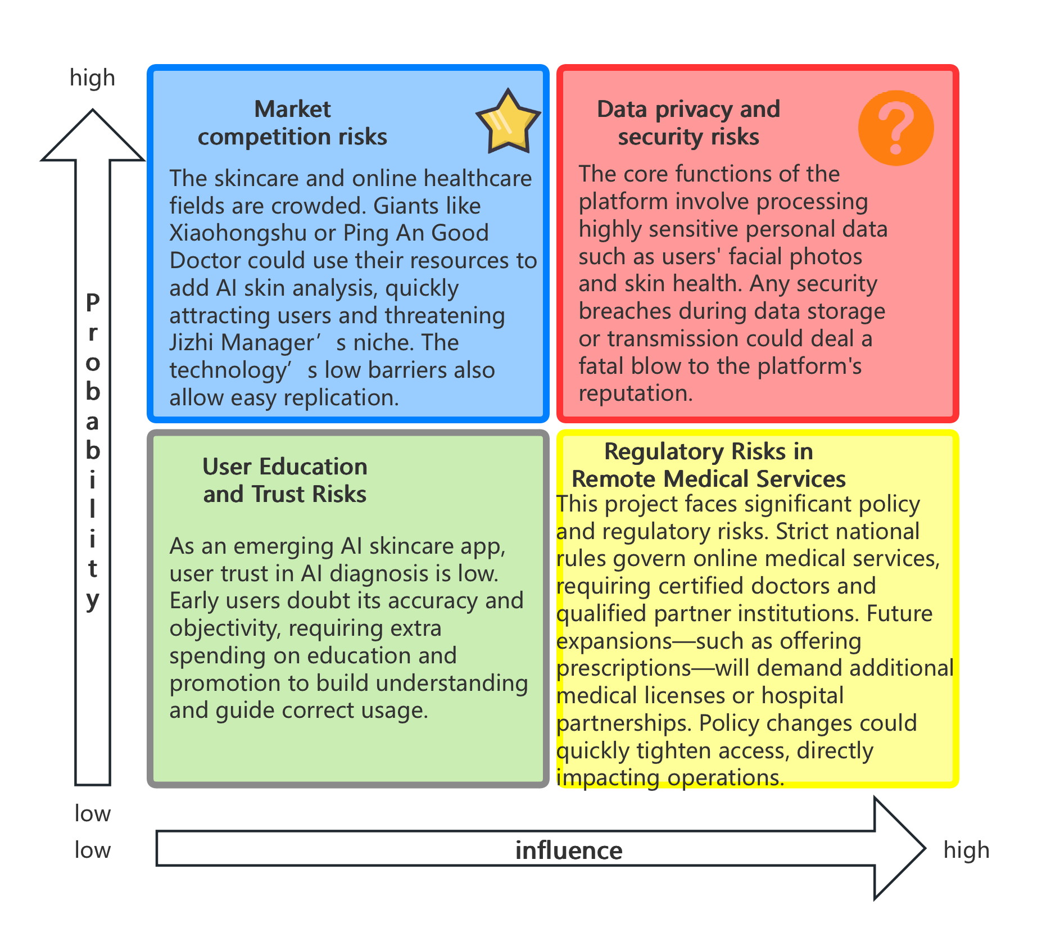

**7.1 Technical Risks**

**AI model training difficulty:**

The project relies on deep learning models for skin diagnosis, but training high-precision AI models requires massive professional data and powerful computing power. The training and continuous optimization of the model require huge computing resources, professional technical personnel and funds. This brings the risk of long research and development cycle and high cost.

**coping strategy ：**

Increase R&D investment and seek technical cooperation, such as sharing data and algorithm experience with universities and research institutions, and adopting transfer learning and other technologies to reduce dependence on massive data. At the same time, introduce experienced AI engineer teams to improve model training efficiency and control R&D progress and cost.

**Data privacy and security risks:**

The platforms core features involve processing highly sensitive personal data such as users facial photos and skin health. Any security breach during data storage or transmission could deal a fatal blow to the platforms reputation.

**coping strategy ：**

Strictly enforce data security measures, including medical-grade encryption for storage, transmission protocols, and access controls. Platforms must comply with privacy regulations and obtain certifications such as ISO/IEC 27001 Information Security Management. Implement robust user data access controls, collect only necessary data with anonymization, and conduct regular security scans and emergency drills to prevent data breaches.

**System iteration and maintenance costs:**

AI skin analysis algorithms and their software systems require continuous updates to stay ahead of the industry. However, frequent system upgrades and model optimizations incur substantial maintenance costs. The technical team must also rapidly adapt to emerging skin concerns and feature expansions, demanding agile development capabilities.

**coping strategy ：**

The modular architecture design enhances system scalability while reducing marginal costs per iteration. Automated DevOps tools monitor system performance to promptly identify and resolve issues, minimizing manual maintenance. By establishing clear technical roadmaps and iteration plans, the focus is on prioritizing core function optimization to avoid redundant development, thereby controlling long-term operational costs.

**7.2 Market Risk**

**User education and trust risk:**

As an emerging AI-powered skin health management app, user acceptance of AI diagnostic results requires time to develop. Many users may initially lack understanding and trust in AI skin analysis, questioning its objectivity and effectiveness. This means early market promotion requires additional investment in educating users and guiding them to use the product correctly.

**coping strategy ：**

Enhance user education through new media outreach and expert endorsements to boost public awareness of AI-powered skincare. For instance, share dermatologists evaluations of AI diagnostic accuracy and showcase successful cases to establish credibility. Offer free trial opportunities for new users to experience AI skin analysis firsthand, thereby lowering the cognitive barrier. Simultaneously, clearly explain AI diagnostic criteria within the app to enhance transparency and gradually build user trust in the platform.

**Market competition risk:**

The skincare and digital healthcare sectors face intense competition. Established players may leverage their existing advantages to enter this arena, posing threats to "SkinAdvisor". For instance, beauty communities or e-commerce giants like Xiaohongshu could integrate similar AI skin analysis features, capitalizing on their highly engaged communities and massive user bases to rapidly capture market share. Alternatively, comprehensive digital healthcare platforms such as Ping An Good Doctor might enhance dermatological online services to capture our specialized niche market. Moreover, AI skin analysis technology itself lacks insurmountable barriers, allowing other companies to swiftly replicate its capabilities through substantial investments or acquisitions.

**coping strategy ：**

Implement differentiated competitive strategies to build technological and service barriers. First, continuously enhance the platforms AI algorithm capabilities and dermatological medical expertise to maintain first-mover technological advantages. Through data accumulation, establish a virtuous cycle of "increasing accuracy with usage" to create technical barriers. Second, focus on providing specialized service ecosystems lacking in competitors, such as deeply integrating AI diagnostics with dermatology expert consultations to deliver exclusive value. Meanwhile, closely monitor market trends and adjust strategies promptly: seek partnerships rather than confrontations when industry giants enter early stages, for example, by establishing traffic diversion collaborations with e-commerce platforms to leverage their traffic advantages, or by specializing in niche markets and customized features to avoid direct competition with comprehensive giants.

**Platform engagement risk:**

After acquiring users, how to improve user retention and usage frequency is an important challenge for marketing operations. If the product lacks stickiness, users may abandon the product after a short experience, resulting in the inability to recover the cost of customer acquisition.

**coping strategy ：**

Enhance user engagement through enriched community and interactive features. For instance, implement user incentive programs like the "30-Day Skin Improvement Challenge" that encourages daily progress tracking and experience sharing, thereby boosting platform usage frequency and user retention. Simultaneously, establish online communities where users can exchange skincare insights, fostering a sense of community belonging alongside professional services. Continuously deliver valuable content (e.g., skincare tutorials, product reviews) to attract regular logins, while leveraging personalized reminders (such as daily skincare plan notifications) to maintain long-term user activity.

**7.3 Policy and Compliance Risks**

**Telemedicine regulatory risks:**

This project involves online dermatology consultations and health management services, which fall under the category of telemedicine. The Chinese government has strict regulatory requirements for internet-based medical practices, including qualifications for medical practitioners and partnerships with accredited healthcare institutions. If the platform aims to provide more in-depth consultation and prescription services in the future, it may need to obtain relevant medical certifications or collaborate with authoritative medical institutions. Policy changes could also increase the accessibility of telemedicine services.

**coping strategy ：**

Ensure service models comply with current telemedicine regulatory policies, and collaborate with medical institutions when necessary to obtain legal certifications. Establish a compliance team to closely monitor policy updates in the telemedicine sector. When new regulatory requirements emerge, promptly adjust service scopes or apply for necessary licenses. For example, restrict AI skin analysis functions to health consultation services, with additional services provided by licensed physicians online to meet regulatory boundaries. Proactively communicate with regulators to understand policy directions, ensuring operational compliance while proactively adapting to policy changes.

**Data compliance risk:**

The platform must store and process large volumes of sensitive user data, including medical and health records, in strict compliance with national data security and privacy regulations. Any violations during data collection or usage—such as unauthorized data access or non-compliant cross-border transfers—could result in legal penalties and a loss of public trust.

**coping strategy ：**

The products data flow is rigorously designed in strict compliance with the Personal Information Protection Law and related regulations. We implement the principle of minimal data collection, obtaining user authorization before gathering necessary information, while clearly disclosing usage purposes and retention periods. A data compliance review system is established, with legal advisors and security experts conducting periodic assessments to ensure platform data processing meets current regulatory standards. For sensitive health data, we maintain domestic storage without cross-border transmission, implementing data masking and access control measures at server and database levels when necessary to prevent data misuse risks. By obtaining authoritative data security compliance certifications, we demonstrate the platforms reliability in privacy protection to users.

**AI Healthcare Technology Compliance Risks:**

The regulatory framework for AI applications in healthcare continues to evolve. Chinas regulatory policies regarding AI-assisted diagnostics, medical device software, and cosmetic efficacy claims are likely to undergo ongoing refinement and adjustments. For instance, AI diagnostic algorithms may be incorporated into medical device regulations, while stricter legal liabilities could be imposed on online skin health recommendations. Such abrupt policy shifts may significantly impact business models and operational costs.

**coping strategy ：**

Maintain sensitivity to policy environments and sustain resource allocation to ensure regulatory compliance. Key measures include: actively participating in industry association discussions and standard-setting processes to stay updated on regulatory trends; designing products with built-in flexibility to enable rapid adjustments when regulatory requirements change (e.g., requiring additional manual verification steps). Internally, establish AI algorithm ethics and compliance review mechanisms to ensure algorithmic decisions are evidence-based and results are interpretable, thereby meeting potential regulatory review requirements. Simultaneously, maintain communication with regulatory authorities to seek guidance while advancing AI innovation applications within legal and compliance frameworks, achieving both regulatory compliance and seizing technological development opportunities.

|  |  |  |
| --- | --- | --- |
| Risk category | Key Risks | Response strategy |
| Technical risk | AI model training is difficult and costly | Boost R&D investment and technical collaboration, recruit top-tier AI experts to optimize model efficiency, and utilize pre-trained models to reduce resource demands. |
| Technical risk | Data privacy security vulnerabilities cause reputational damage | Implement strict data encryption and access control, pass compliance certification, and conduct regular security audits to ensure user privacy is fully protected. |
| Technical risk | High system maintenance and upgrade costs | The modular architecture and automated operations reduce maintenance workload, focus on core function optimization and iteration, and improve the input-output ratio |
| Market risk | User awareness is insufficient and trust is slow to build | Strengthen market education and popular science publicity, provide free trial to reduce the threshold, and gradually cultivate user trust with the endorsement of experts and successful cases |
| market risk | Industry competition intensifies, with the entry of giants posing a threat | Strengthen technological barriers and differentiated advantages in professional services, continuously innovate to maintain first-mover advantages; while flexibly seeking cooperation with giants to leverage their traffic advantages |
| market risk | The technical solution is easy to copy | Build AI model training advantages through data accumulation to improve algorithm accuracy; apply for patents and intellectual property protection to consolidate leading position |
| market risk | Insufficient platform engagement and low user retention | Enhance community interaction features (such as check-in challenges), provide personalized content and reminders, and increase user engagement and activity |
| Compliance risk | Telemedicine policy changes have limited business | Obtain medical qualifications or hospital resources in advance, closely track policy trends, and adjust business models in time to comply with new regulations |
| Compliance risk | Data and privacy compliance risks | Strictly comply with the Personal Information Protection Law and other regulations, improve data governance and compliance review mechanisms, and ensure that data collection and use are legal and compliant |
| Compliance risk | Changes in AI medical regulatory requirements | Establish an internal compliance team to monitor regulations and maintain product flexibility; actively participate in industry standard development to ensure technical evolution keeps pace with regulatory changes |