CONFIDENTIAL
The Invisible Chores Translator
A cognitive-labor logging and negotiation tool for couples
Business Plan
Prepared October 26, 2026
Contact Information
Course: Intelligent Application Development (Fall 2026)
Team members: ________ / ________ / ________ / ________
Table of Contents
1. Executive Summary
2. Product Overview
3. Demand Background & Market Analysis
4. Product Value Proposition
5. Target-User Evidence & Real Cases
6. Product Implementation & Feature Design
7. Marketing Plan
8. Business Viability & Development Resources
9. Evaluation Plan
10. Risk & Mitigation
11. Team Execution
Appendix A: Public Sources & Citations
Appendix B: Experience-Record Fields
Appendix C: Primary Research Instruments
1. Executive Summary
Product. The Invisible Chores Translator is a cognitive-labor logging and negotiation prototype designed for two adult partners. It addresses a real, long-overlooked pain point: a large share of household work — anticipating needs, identifying options, making decisions, and monitoring outcomes — is carried silently by one partner, is hard for the other to see or verify, and becomes a hidden source of conflict.
Innovation. The product centers on three innovations. First, it treats “cognitive labor” rather than physical chores as the unit of record, turning Daminger’s (2019) four categories of cognitive labor into usable log labels. Second, a two-account, independent-estimate, side-by-side mechanism presents differences without declaring a winner, so the tool does not itself create antagonism. Third, AI-assisted task breakdown converts voice or text input into sub-tasks and candidate types that users confirm and correct — a direct fit with the course theme of intelligent application development.
Market. The seventh national population census reports 494.16 million households in China. The National Bureau of Statistics’ third time-use survey shows that participants in household labor spend 1 hour 59 minutes per day on average, with a marked gender gap in unpaid work (3 hours 29 minutes for women versus 1 hour 52 minutes for men). Existing products (FairPlay, Tody, Cozi) do not offer a Chinese, two-person, negotiable record of cognitive labor — a clear market gap.
Scope. This phase is scoped to a course project and prototype. App development may draw on necessary development funds; promotion stays at zero cash spend, and users do not pay. The analysis focuses on demand, alternatives, resources, and feedback records; a revenue model is presented only as a next-phase outlook. All public facts and cases are cited; feature, recruitment, and development plans are proposed implementations.
2. Product Overview
2.1 Product Definition
The Invisible Chores Translator is a household chore-logging and negotiation prototype for families. “Translation” here means breaking everyday descriptions into verifiable sub-tasks and candidate types: AI drafts the record, the user edits and confirms it, and text input, templates, and manual labeling serve as fallback paths.
Each family space holds exactly two adult partners, linked through an invitation between their separate accounts. Chores involving childcare can be logged, but no membership is offered to minor children or a third adult. Both partners can review records and confirm arrangements on their own devices, with access controlled by member identity on the backend.
2.2 Problem Basis and Conceptual Boundary
Daminger (2019) divides cognitive household labor into four steps: anticipating needs, identifying options, deciding, and monitoring outcomes. [1] This project concerns how these management activities appear in a record. Cognitive labor and physical chores can occur simultaneously, so the former should not be described as “no action,” nor equated with emotional labor.
Building on Daminger’s four steps, the project operationalizes them into five loggable labels — execute, plan, prepare, coordinate, and close. The mapping is: Daminger’s “anticipating needs” and “identifying options” map to “prepare” (checking or assembling conditions for later action); “deciding” maps to “plan” (setting a goal, time, or approach); “monitoring outcomes” maps to “close” (putting things away, checking results, or noting follow-ups); and “coordinate” and “execute” are added to cover two-person collaboration. The five labels are this project’s interaction design, not an established academic taxonomy. Reminders are not a separate sixth label but fall under prepare or coordinate by their actual action; closing can also involve physical movement.
2.3 Core Innovations
Compared with existing chore tools and generic large-platform solutions, the project has three differentiating innovations.
Innovation 1 — cognitive labor, not task completion, as the unit of record. Existing chore apps (Tody, Cozi) focus on whether a task is due or done, which records only the execution side of physical chores; the anticipation, research, and decisions before execution, and the follow-up and monitoring after it, are systematically dropped. Grounded in Daminger’s theory, this project makes that invisible work visible and verifiable. This is the fundamental difference from a to-do list: the former records what was done, the latter only what remains.
Innovation 2 — two-account binding, independent estimates, side-by-side, no verdict. Most tools are either single-person ledgers or shared lists collapsed into a single score (e.g. FairPlay’s point system, which invites “who works harder” comparisons). This project has both partners independently log time, frequency, and perceived effort for the same item, then displays the results side by side without a total and without judging who contributes more. The tool presents the difference objectively and leaves the discussion to the partners, rather than amplifying conflict.
Innovation 3 — AI-assisted breakdown, tied to the “intelligent application” theme. After a user describes a task by voice or text, a large language model extracts structured sub-tasks and candidate types, which the user then confirms and corrects; on failure the system falls back to the original text and templates. This “AI draft plus human confirmation” interaction shows an intelligent prototype while preventing the model from fabricating facts.
2.4 Logging and Negotiation Flow
A user enters a description by voice or text; the system generates a draft of sub-tasks and types. The author reviews, edits, and shares it, and the partner confirms the task description. Both partners then enter their own effort estimates and discuss the coming week. Jointly confirmed records enter the board; the two estimates may differ, and are shown side by side without declaring who is right.

BUSINESS FLOW / PROPOSED SERVICE
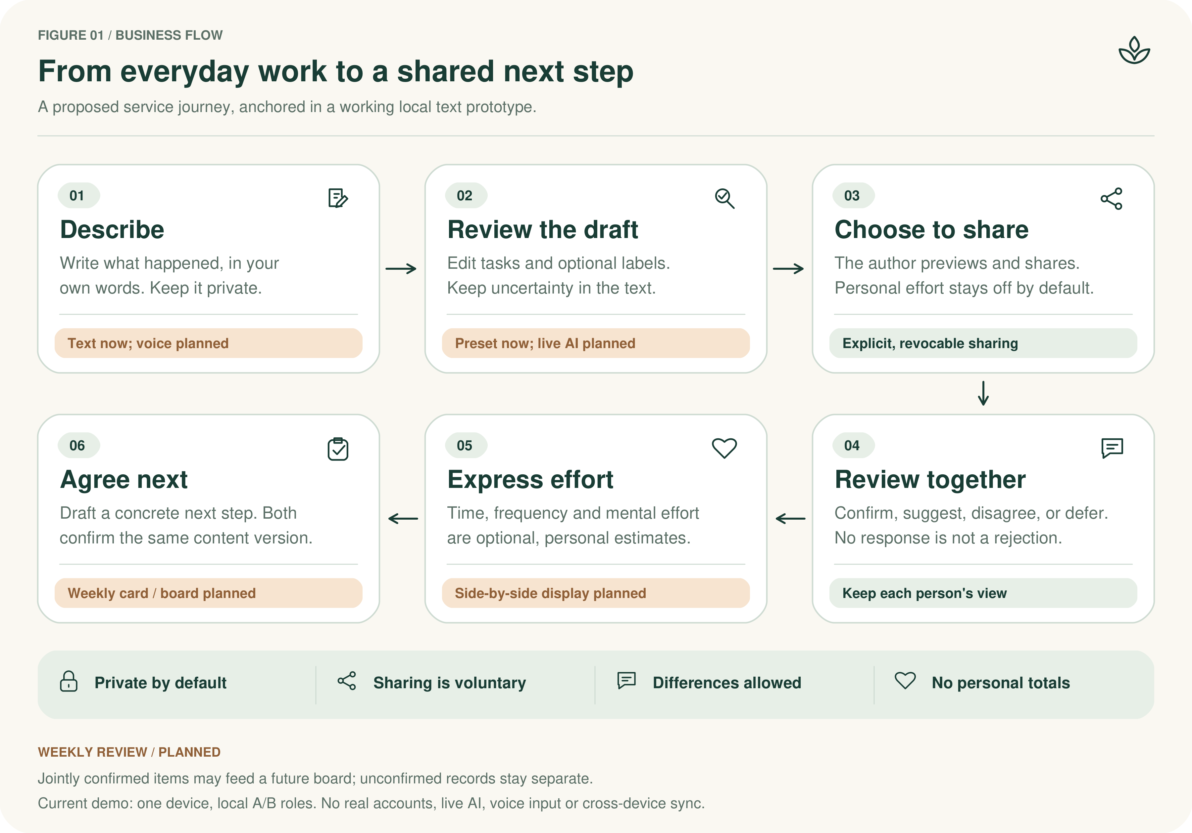
Figure 1. Proposed logging and negotiation workflow. Text entry and preset suggestions are available in the current local demo; voice input, live AI, side-by-side estimates, and weekly cards/boards are planned. Agreement requires both local roles to confirm the same version.

2.5 Product Labels and Operational Definitions
Label | Operational definition | What is recorded
Execute | Directly completing a household task | Task name, performer, completion status
Plan | Deciding a goal, time, or approach | Items to decide and their arrangement
Prepare | Checking or assembling conditions for later action | What to check and what to prepare
Coordinate | Exchanging information and aligning plans with the partner | Items to discuss and agreements
Close | Putting away, checking results, or noting follow-ups | Completion standard and follow-up actions
2.6 Minimum Viable Product Scope
P0. The P0 scope covers: two-account and invitation-code binding, voice and text entry, AI task breakdown with manual correction, joint confirmation, two-device sync, a weekly board, basic effort negotiation, a basic weekly negotiation card, and editing, exporting, and deleting data. Basic effort negotiation means each partner separately enters time, perceived effort, and frequency, then discusses differences — no personal total is computed.
P1. The P1 scope covers a month view, extended negotiation templates, and input shortcuts, to be built after P0 and counted into development hours and service costs. Multi-person households, communities, leaderboards, money settlement, and complex commercial operations are outside this phase.
2.7 Product Principles
Both partners participate voluntarily and may pause or withdraw a record at any time. Task descriptions, personal estimates, and joint agreements are stored separately. The system does not judge who works harder, does not diagnose relationship problems from records, and does not promise that using it will reduce arguments.
3. Demand Background & Market Analysis
3.1 Market Size and Demand Basis (Traceable Data)
The demand basis rests on two verifiable official sources, which together show that household labor is widespread and that cognitive labor is worth recording.
Data 1 — time scale of household labor. The National Bureau of Statistics’ third national time-use survey (Bulletin No. 2) reports a 64.9% participation rate in household labor in 2024; residents average 1 hour 17 minutes of household work per day, and participants average 1 hour 59 minutes. [2] More than six in ten residents do household work every day, and those who participate spend close to two hours on it.
Data 2 — gender gap in household labor. The same survey (Bulletin No. 3) shows a clear gender gap in unpaid work (including household labor and family care): participants average 3 hours 29 minutes per day for women versus 1 hour 52 minutes for men, with participation rates of 83.9% versus 67.5%. [13] This gap is the macro-level reflection of the core pain point — unevenly distributed cognitive labor.
Data 3 — size of the target population. The seventh national population census reports 494.16 million households, 1.293 billion people in households, and 2.62 people per household on average. [14] Two-adult couples form the core of a large share of these households and are this product’s potential target base.
These figures describe overall participation and time in household labor and cannot be converted directly into a paying-user count. Their value is instead that household labor is universal, and its invisible cognitive component has long gone unrepresented by existing tools — which is precisely this product’s entry point.
3.2 Target User Personas
The product defines users by usage conditions rather than demographics: two adult partners who manage household tasks together, are willing to log specific items, and are willing to discuss the division of labor on an informed basis. Three typical personas follow.
Persona 1 — new parents (high load, high conflict). Both partners work, or one stays home, with young children. Cognitive labor is dense (booking checkups, buying childcare supplies, coordinating pickups) and friction easily arises over “who remembers, who reminds, who follows up.” Their need is to make implicit anticipation and follow-up visible, easing the sense of “I am the only one thinking about all this.”
Persona 2 — dual-earner couples without children (blurred division). Both partners are busy; household work is spread thin but boundaries are unclear, leading to “I thought you were handling it” or “the same person always ends up closing up.” Their need is to log each partner’s input and agreements clearly, avoiding duplication and hidden imbalance.
Persona 3 — couples with an uneven division (negotiation need). One partner has long carried more cognitive labor while the other is not fully aware, and both are willing to renegotiate the division through an objective record. Their need is a neutral logging tool to replace emotionally charged arguments with a factual basis for negotiation.
The common thread across all three: the source of conflict is not the result “who does more” but the invisibility of the cognitive-labor process. This is where the product’s value lies.
3.3 Primary Research Design (Survey and Interviews)
Secondary data alone cannot show how local couples actually divide and talk about household work. To ground the personas and the market-gap claim, the team will run a small primary study in two forms, both reported as they are completed rather than projected in advance.
Survey. A short questionnaire, distributed through voluntary acquaintance forwarding, asks whether each partner notices the anticipation, research, and follow-up behind household tasks; who usually carries these; and whether the couple has discussed them. Questions are closed-ended with a free-text field, so the results can be tabulated by count without collecting identifying information.
Interviews. Semi-structured interviews with eligible adult couples follow a fixed protocol: first ask what recently happened and how it was handled, then observe how the pair uses the prototype, and finally ask whether they would use it again. Each interview records the date, recruitment path, and an anonymous ID; both partners consent separately, and quoting requires separate permission.
The survey tests the breadth of the pain point (how common the invisible work is), and the interviews test the depth (whether the logging-and-negotiation flow fits real practice). Neither is used to estimate market size; both are reported with the actual number of respondents and participants, not as scaled-up projections.
The survey instrument and interview protocol are reproduced in Appendix C. Results will be added to this section once collected; until then, no figures are stated.
3.4 Competitive Analysis Matrix
The table below compares publicly described features from each product’s official site and App Store page. [5][6][7][8] These pages are used only to confirm feature positioning, not as evidence of reduced conflict or improved relationships.
Dimension | Invisible Chores Translator (this project) | FairPlay: Chores for Couples | Tody | Cozi
Unit of record | Cognitive labor (anticipate / decide / monitor, etc.) | Chore cards + mental-load points | Cleaning tasks and due dates | Calendar, lists, menus
Two-person collaboration | Two accounts, independent estimates, side-by-side | Shared on a single iPhone | Sharing and assignment | Family sharing
Personal score total | No total; only side-by-side differences | Point system | None | None
Chinese support | Native Chinese entries | Primarily English | Primarily English | Primarily English
Negotiation mechanism | Weekly negotiation card (records agreements) | Weekly review | None | None
Intelligence | AI voice/text draft breakdown | None | None | None
Data ownership | Export, delete, unbind | Unclear | Unclear | Unclear
Conclusion. FairPlay is the most direct comparison, but its point system is the opposite of this project’s “no total, compare only” philosophy. Tody and Cozi cover scheduling, reminders, and family calendars — execution and coordination — but neither treats cognitive labor as an object of record. This project differentiates on four dimensions: making cognitive labor visible, two-person non-adversarial negotiation, native Chinese, and AI assistance.
3.5 Market Gap
Combining the analysis above, the market entry conclusion is: the Chinese market lacks a household logging tool centered on making cognitive labor visible and on two-person negotiation, natively in Chinese, with AI-assisted breakdown. Existing products either focus on execution (Tody, Cozi) or use a total-score mechanism prone to comparison (FairPlay), and all live in an English-language ecosystem. This project fills the vacant niche of cognitive-labor logging and negotiation for couples in a Chinese context.
As a course project, the product demonstrates capability through clear label definitions, a revisable logging process, and a runnable prototype — not through patents, a proprietary taxonomy, data barriers, or existing brand strength.
3.6 Testable Questions for This Phase
This phase examines three questions: whether users can turn their description of household work into entries; whether the partner can understand and verify them; and whether the two can form a follow-up agreement they are willing to keep. App downloads, topic views, and search trends are not used to argue for demand.
4. Product Value Proposition
4.1 Core Value
The core value is to let two partners explain, in a single record, the planning, preparation, and communication behind a task, and to discuss the future division of labor on that basis. Value is judged by actual experience feedback, not derived from a feature list.
4.2 Difference from an Ordinary To-Do Record
Beyond task completion, the record keeps the main labor type, both partners’ effort estimates, and the negotiated agreement. These functions can also be reproduced by other tools or a manual spreadsheet; the student version’s design focus is arranging these steps into a single, easy-to-follow flow.
4.3 Deliverables for This Phase
Deliverables include: a runnable Android two-person prototype, label and operation descriptions, and experience records filled in from what actually happened. Class demos use the team’s own operations; information involving external participants is anonymized after authorization.
4.4 Users and What They Gain
What the user needs to do | Support provided this phase
Explain their own contribution clearly | Voice or text drafts, candidate types, editable fields
Understand what the partner describes | Joint review of task descriptions, keeping separate estimates
Clarify what comes next | Basic weekly negotiation card, recording owner and completion standard
Control their own data | Draft permissions, share confirmation, export, withdraw, delete — no paywall
5. Target-User Evidence & Real Cases
5.1 Public Case 1: The Blueberry Shopping Episode
In a public Q&A on The Bump, Eve Rodsky recalls that, after having two children, a text from her husband about forgetting to buy blueberries became overwhelming, and she began to reflect on why she had by default taken on the management of household and childcare. [3] This material is the participant’s personal account, not research evidence.
Its design implication: the record must keep more than the purchase result; it must let participants state who noticed the need and who arranged the follow-up. This is the team’s application analysis based on the case, not the participant’s evaluation of this product.
5.2 Public Case 2: Division of Labor in Birthday Planning
In a signed article, Daminger describes a couple who both worked full-time in consulting: the wife gathered options and listed preparations for a child’s birthday party, and only then discussed options with her husband, yet described the whole process as jointly planned. [4] The case shows that taking part in the final discussion and carrying the earlier search and preparation can be two different kinds of contribution.
This record comes from a researcher’s public account of an interview and is cited separately from this project’s experience data. Accordingly, the design separates early preparation, decision, and coordination so both partners verify specific actions, rather than tallying only who took part in the final decision.
5.3 User Basis from Published Research
The 2019 paper behind the birthday case used 70 in-depth interviews with members of 35 couples. [1] The author notes the sample comprised college-educated, married parents with young children and discusses its limits. [4] This supports the project’s focus on family management processes, but does not represent Chinese families, nor prove the student team has grasped local user preferences.
5.4 From Cases to Design
Sourced observation | Proposed design
Reflection on default management responsibility in the blueberry case [3] | Allow logging need-discovery and arrangement, not substituting purchase completion for total contribution
Early preparation and joint decision are separate steps in the birthday case [4] | Break into sub-tasks and verify planning, preparation, and coordination separately
The literature distinguishes stages of cognitive activity [1] | Provide label explanations and manual correction; no single labor total summarizing personal contribution
5.5 How Local Experience Adds Evidence
The plan is to invite, through voluntary introductions by acquaintances, eligible adult couples to recount their real experiences: first ask what happened and how they handled it, then observe their use of the prototype — without having interviewees play figures from the public cases. Interview records keep dates, recruitment paths, and anonymous IDs; the team reports only as much as actually happens.
6. Product Implementation & Feature Design
6.1 Feature Architecture and Priorities
Module | Student-version scope | Priority
Two-person space & sync | Separate accounts, invitation binding, family permissions, two-device sync | P0
Voice & AI logging | Voice transcription, text input, AI breakdown; manual correction and template fallback | P0
Joint confirmation | Confirm per current version; re-verify after description changes | P0
Weekly board | Aggregate only jointly confirmed records, showing type and status | P0
Basic effort negotiation | Both partners enter estimates, then view side by side | P0
Basic weekly negotiation card | Template review, proposal, save after both confirm | P0
Data control | Draft permissions, export, edit, withdraw, unbind, delete | P0
Experience improvements | Month view, extended templates, shortcuts; counted into development cost | P1
P0 forms this phase’s core flow: first close the logging-to-negotiation loop, then integrate voice, AI, and two-device sync, then finalize through testing. Funding does not equal technical capability; demos must still distinguish planned work from completed items. Multi-person permissions and a payment system are outside this phase.

SYSTEM ARCHITECTURE / IMPLEMENTATION STATUS
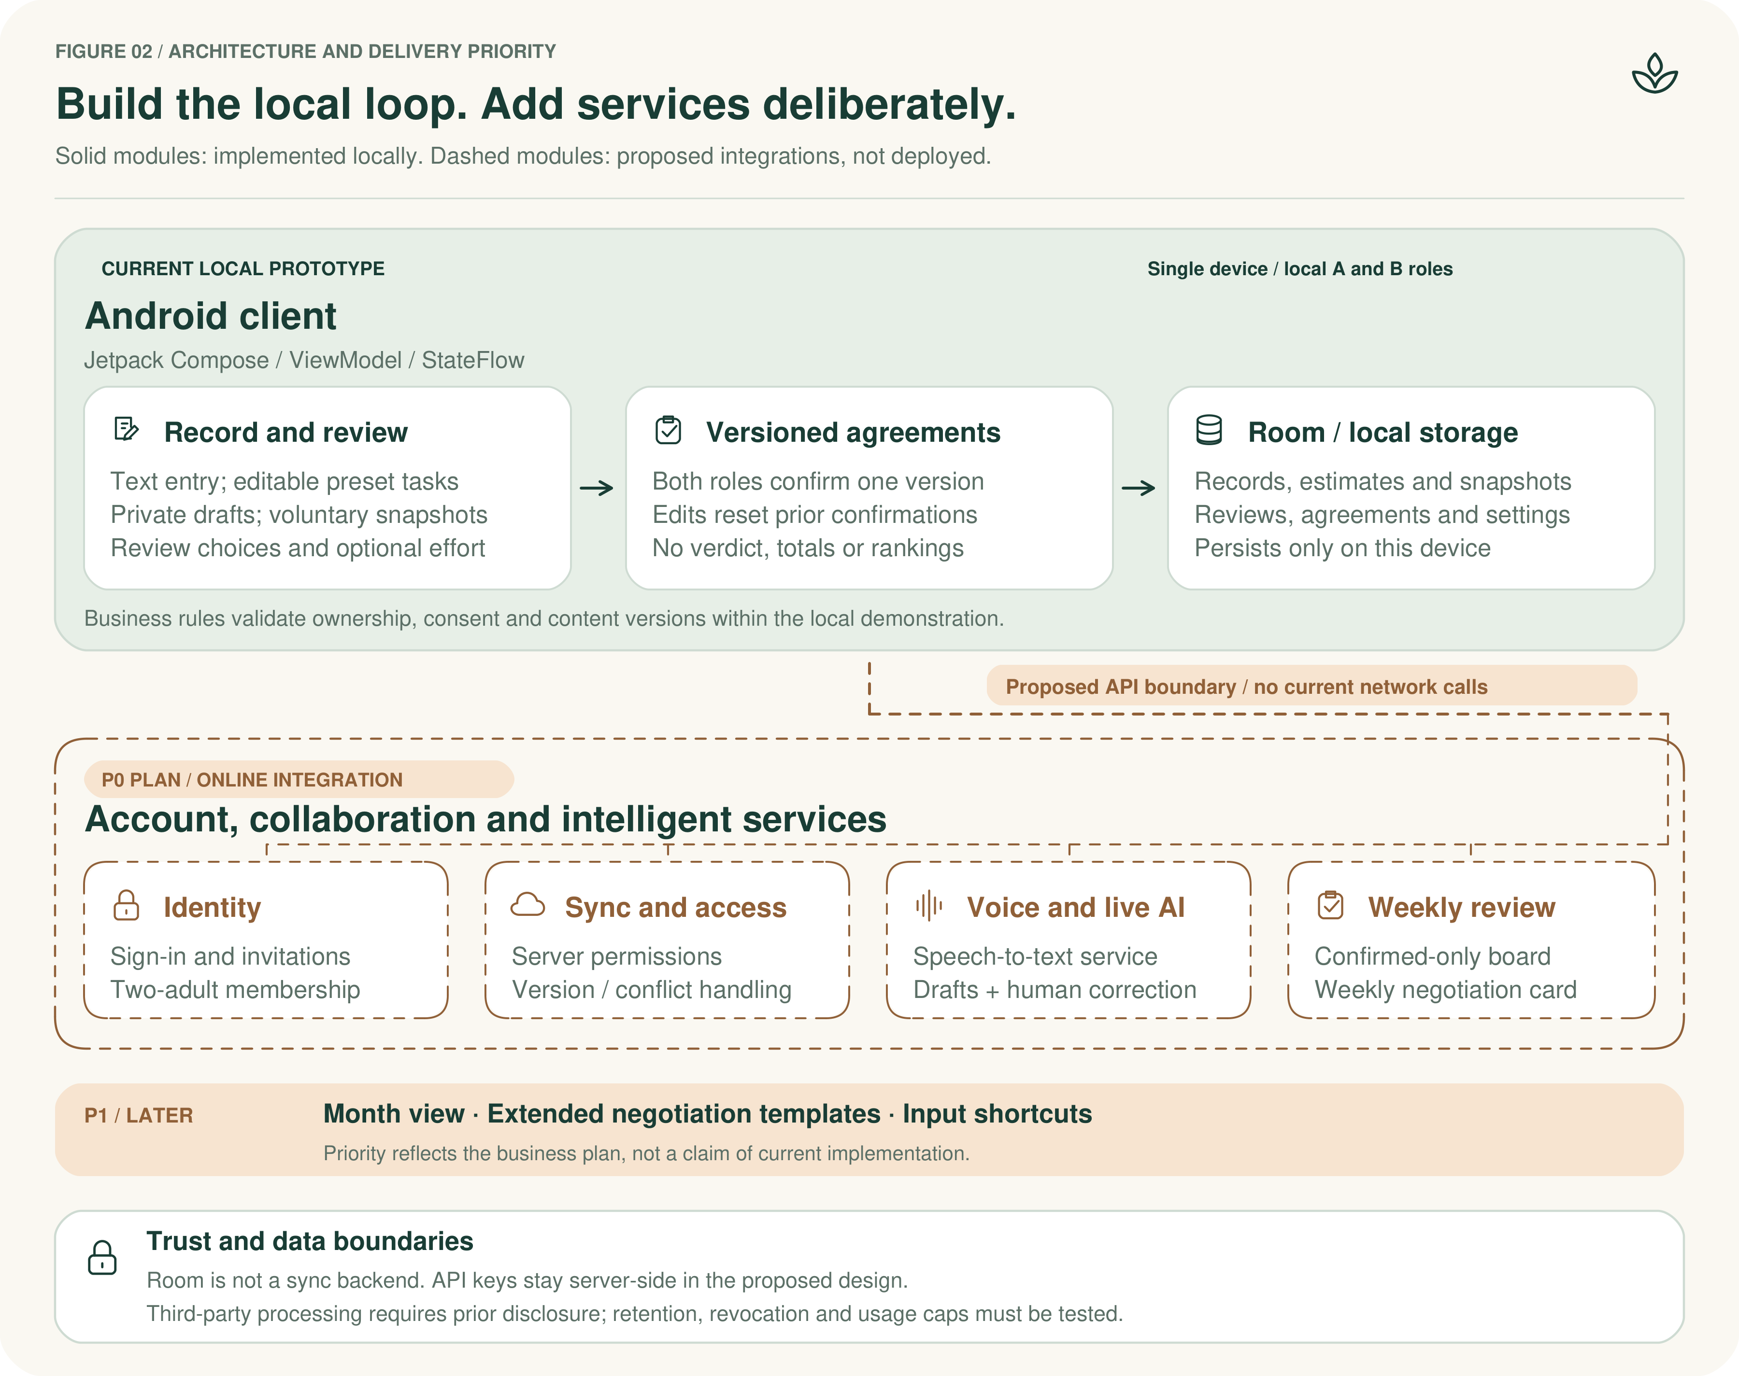
Figure 2. Local implementation and planned architecture. Solid elements represent the current single-device Android client; dashed elements are planned account, permission, synchronization, voice/AI, and weekly-review services. P0/P1 denote the plan's delivery priorities, not completion status.

6.2 Two-Account Binding and Joint Confirmation Flow
Each partner logs into their own account and joins the same family space through an invitation. Personal drafts are visible only to their author by default, and are checked by the partner after being shared; the two enter separate estimates for the same item, shown side by side after both submit. Unsubmitted estimates must be blocked from reading on the server, not merely hidden in the interface.
Joint confirmation is saved per current version of a record; once the description changes it must be re-confirmed, and a record without both partners’ approval does not enter the confirmed total. On sync failure the system shows a pending or conflict state and does not treat a local submission as the partner’s agreement. Account authentication confirms operator identity only; it cannot prove a chore actually happened.

PROTOTYPE AT A GLANCE

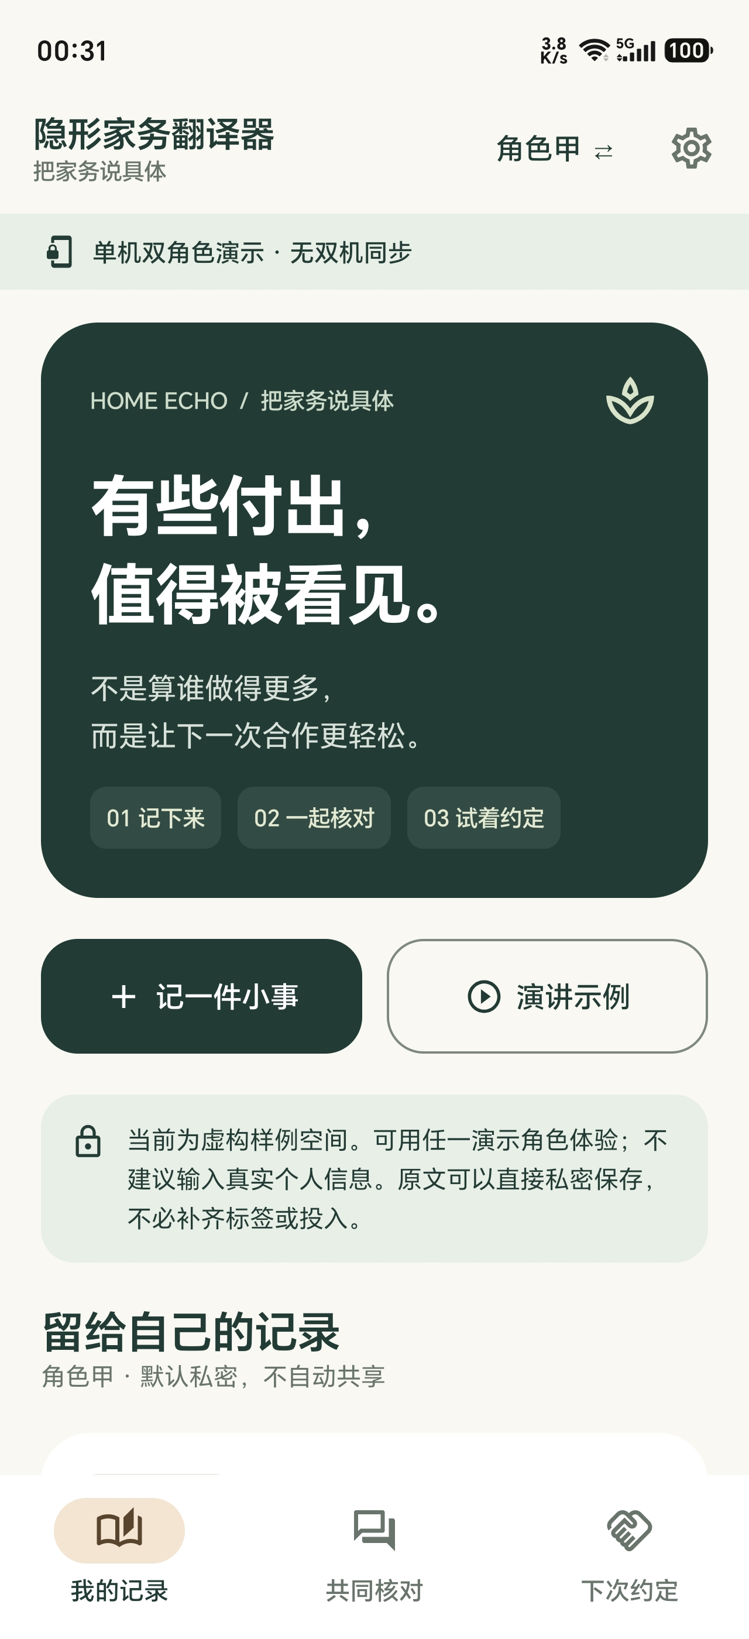  01 HOME  Private by default | 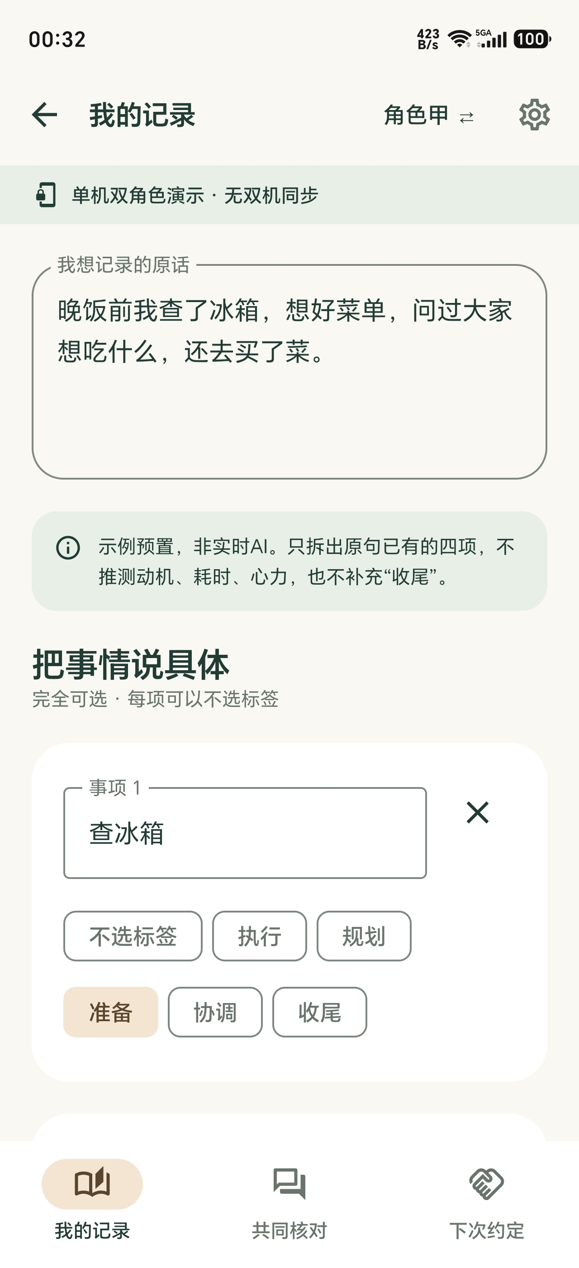  02 RECORD  Text + preset tasks |   03 REVIEW  Unanswered shared v1 | 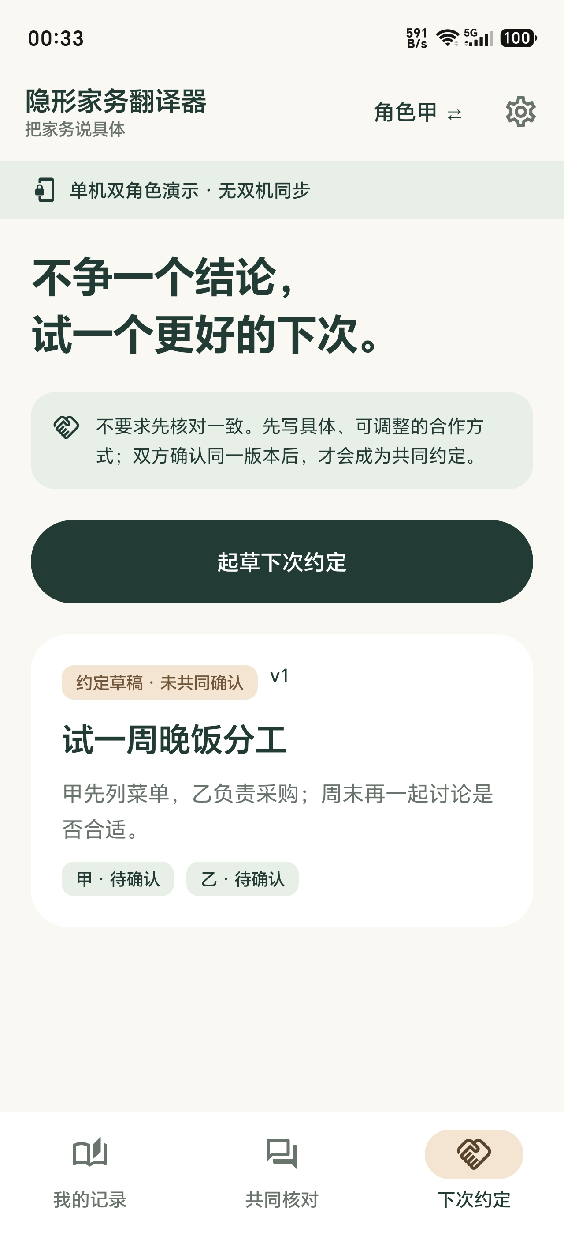  04 AGREE NEXT  Unconfirmed draft
One-device prototype only. No real account binding, live AI, side-by-side estimate screen or confirmed weekly card is shown.
Figure 3. Current prototype screens in the supplied order, left to right: (1) home; (2) text entry with preset suggestions; (3) shared review with no received item and an unanswered author-sent v1; (4) a next-step agreement draft confirmed by neither role. Single-device demonstration, not synchronized two-device views.

6.3 Labeling and Counting Rules
Each sub-task has exactly one primary type. A whole chore and its sub-tasks are not double-counted, and label counts are not converted into a personal-effort ranking. AI labeling is only a candidate; when content is ambiguous the original text is kept for the user to choose, rather than forcing a judgment by keywords.
The time field records actual work time and may be left blank; items spanning several days are not converted into continuous hours by calendar span. The two partners’ estimates for the same task are stored separately and are not summed into an actual labor amount.
6.4 Technical Approach and Use of Development Funds
The client uses Android Studio and Android UI components, with Room for local persistence; two-device collaboration additionally requires account authentication, family-member permissions, and a sync interface. Android documentation distinguishes on-device storage from cross-device sync, so a local database cannot replace the backend. [9][10] To keep the student team’s workload manageable, the project reuses mature authentication and cloud data services rather than building a complex account platform from scratch.
Voice recognition can first use Android’s SpeechRecognizer for on-device validation, comparing paid recognition services later if needed; official documentation notes the implementation may send audio to a remote service, so offline or zero-service-cost support cannot be claimed outright. [12] Transcribed text is extracted into structured drafts by a large model, then field-checked and confirmed by a human; the model does not fabricate time or effort, and falls back to the original text and templates on failure.
Development funds cover the model calls, voice services, backend or cloud resources, and testing and debugging required to complete the listed P0. Existing devices are reused first; new tools or devices are listed only as actual development needs. Vendors, models, billing terms, and usage caps are fixed before purchase or activation; free tiers are counted only as available discounts, not as a guarantee of long-term operation.
6.5 Basic Effort Negotiation and the Weekly Negotiation Card
Each partner separately enters single-session time, frequency, and perceived effort. Perceived effort uses an ordered scale chosen by the user; the field is for personal expression only — it is not a psychometric scale, computes no weighted total, and does not interpret scale differences as objective burden differences.
The negotiation card is built around confirmed items and records whether the coming week adjusts the owner, the completion standard, or the schedule, saved after both confirm. Keeping the division unchanged is itself a valid outcome; changing the owner is not treated as the measure of success.
6.6 Privacy and Record Management
Privacy covers three layers: personal drafts, shared records, and third-party processing. Only data necessary for the function is collected; the family space does not store ID numbers, addresses, or real occupations. Before voice recognition or AI calls, users are told the data’s purpose, the receiving service, and retention; raw audio is not kept long-term by default. Model API keys are held on the backend and never written into a distributable client.
Local automatic backup follows Android’s official guidance, with clear processes for cloud sync, backup retention, and deletion. [11] After unbinding, access to the shared space stops; rules for both partners’ own data and shared records are explained before the trial. Family records have no public link and do not enter promotional screen recordings; demos use the team’s own records, and public cases continue to be cited by source.
6.7 Stating Technical Completion Accurately
Class demos describe capabilities by the interface and flow actually completed: implemented features are shown live, and unimplemented ones are not passed off as automatic processing through video effects or staff proxy. The prototype does not claim certification for performance, privacy, or algorithm accuracy.
7. Marketing Plan (Cold Start Under a Zero-Cash Constraint)
7.1 Marketing Goals and Constraints
The marketing goal is to make eligible people aware of the prototype and to gain voluntary trial opportunities. Marketing cash spend is capped at zero — no paid traffic, placements, printed materials, gifts, memberships, or promotion services. App development funds are accounted separately and are not diverted to promotion. Project introductions use electronic materials made by the team and do not ask the school, instructors, or platforms to endorse the project.
7.2 Cold Start Strategy
As a two-sided market (the two partners who log), cold start has two core difficulties: the concept of cognitive labor needs to be taught to users, and there is no real record to show as seed content. To address both, the project uses the following strategies.
Strategy 1 — seed content to start supply. Two team members (or one eligible pair within the team) first complete an initial record through real household collaboration, forming displayable seed content. This is both an internal validation and a concrete example for later participants.
Strategy 2 — invite and review pair by pair. Through voluntary introductions by acquaintances, serve one eligible couple at a time: complete support for that pair before deciding whether to recruit the next. Under a zero-cash constraint, this deep single-point approach trades effort for high-quality real feedback rather than trading money for scale.
Strategy 3 — use the concept of cognitive labor as a hook. Outreach centers on Daminger’s concept of cognitive labor and real cases (with citations), sparking the recognition that “I have been carrying this invisible work all along,” rather than directly selling the product.
7.3 Acquisition Channels and Concrete Actions
Feasible channel | What the team does | Zero-cost execution
Team personal accounts | Post a project introduction with a real screen recording, stating the student prototype and trial scope | Use only existing accounts; buy no exposure
Voluntary forwarding by acquaintances | Ask willing classmates or friends to forward the original introduction; participants contact on their own | No red packets, no referral rewards, no soliciting others’ family information
Existing course exchanges or demos | Demo the prototype in existing showcase opportunities and provide an electronic explanation | No paid events; no assumption of extra booths or venues
One post in an existing community | Send a trial invitation only where group rules permit and administrators agree | Skip if not permitted; no spamming or hard selling
7.4 Staged Promotion Roadmap
Stage | Timing | Core actions | Milestone
Stage 1 — internal validation | Before the prototype is complete | Complete the first real record within the team; verify the log-to-negotiate loop | Displayable seed content
Stage 2 — deep single-point trial | After the prototype is fully demonstrable | Invite the first eligible couples pair by pair; complete the full log-and-negotiate flow | Traceable real experience feedback
Stage 3 — word of mouth | After the first round of fixes | Compile authorized feedback into an improvement note; trigger second-round forwarding | A word-of-mouth loop and an improvement record
Public releases keep pace with actual progress: before the prototype is complete, only sourced topic introductions and the student-project note are published; once it is fully demonstrable, screen recordings and trial invitations follow.
7.5 Retention and Word-of-Mouth Mechanism
Under the zero-cash constraint, retention relies not on material incentives but on product value and transparent improvement: each time an operational problem is solved, a publishable improvement note is created, showing participants their issues are heard. The jointly confirmed negotiation card is also inherently “continuous” — it records the partners’ agreement and draws them back to review it the following week, creating a natural return visit.
7.6 Assessing Reachability of Target Users
Classmates paying attention to the project does not mean adult couples are willing to use it. The team reaches people with shared household-management experience through voluntary forwarding, then confirms that both partners agree to participate before scheduling a trial. Group size, likes, or classmate count must not be written as the family-user base.
If only ineligible classmates can be reached, they are asked to assess interface readability, and the results are recorded separately as interface feedback — not relabeled as target-family validation, nor used to stretch the product into a multi-person dormitory scenario to fill the sample.
7.7 Publishable Content
Content centers on real material and the team’s development process: explain Daminger’s concept of cognitive labor with citations; introduce which problems existing products cover; screen-record how a voice or text draft moves through confirmation into the negotiation card; and state which operational problem the latest round of changes solved.
Fabricated quarrel scripts, participant stories, or research conclusions are not used to attract forwarding. Real families’ text, images, and comments all require separate public authorization; agreeing to participate in a trial is not the same as agreeing to publicity.
7.8 Feedback and Outreach Records
A local table records the channel, date, actual contacts, eligible couple count, couples who accepted a trial, and completion and dropout status, along with members’ actual minutes spent. Re-contacting the same couple across channels counts as one couple.
With a small sample, report the concrete process and headcount, without promising download, booking, or conversion targets. If a proportion is shown, both numerator, denominator, and the statistical period must be stated, and no overall-demand inference may be drawn from it.
7.9 Student Execution Boundary
Outreach is done by the members themselves, without buying influencer services, and without making institutional partnerships a precondition for completing the course task. When course pressure rises, recruitment pauses and already-contacted people are notified, prioritizing completion of agreed support and data cleanup.
8. Business Viability & Development Resources
8.1 Business Goal for This Phase
This phase tests whether the use scenario, the alternatives, and prototype operation match. There is no selling, paid membership, or pre-sale. The outcome is an evidence-backed demand analysis and real experience records.
8.2 Revenue Model Outlook (Next Phase)
This phase centers on validating demand and the prototype; the revenue model is presented as a next-phase outlook. Based on the product’s value proposition, possible future paths include (all outlooks, not this-phase items): a subscription for couples (offering fuller negotiation templates, history review, and analysis); B2B licensing for the counseling and family-relations field; and partnerships with household-service providers. Each path requires further validation after demand verification and scaled usage feedback.
8.3 Pricing and Funding (This Phase)
Participants do not pay, and the team takes no deposit. App production may use development funds, limited to feature implementation, service operation, and testing; commercial promotion stays at zero cash. This document sets no subscription price, no sales target, and no financing arrangement.
8.4 Separate Accounting for Development and Marketing
Item | This-phase arrangement | Cost treatment
Development & debugging | Reuse existing devices first; list necessary tools or test devices by need | Development funds, actual accounting
Account & cloud sync | Authentication and family-permission control; record compute, storage, and traffic | Development funds, by service quote and usage
Voice & AI | Account for recognition volume, model input/output, retries; negotiation card uses templates | Development funds, with usage caps
Promotion & recruitment | Self-made electronic notes and recordings, voluntary forwarding, no paid traffic | Marketing cash capped at zero
Voluntary trial | No gifts, red packets, or transport subsidies; trial tech calls go to development cost | Recruitment incentive zero; tech cost itemized
The total development budget is set by what the team can actually afford and the quotes of chosen services; this document pre-fills no unquoted amounts. Development costs include one-time purchases as well as ongoing calls, storage, compute, or traffic; the marketing cash budget is zero. Existing devices, network, and member time also consume resources, but unpaid hours are not converted into cash spend.
8.5 Handling Business Questions
This phase’s research value concentrates on three points: whether users need entry organization, whether they accept joint confirmation, and whether they are willing to use it again. Willingness to pay is not an acceptance metric this phase, and a survey choice is not substituted for actual payment behavior.
8.6 Resource and Output Records During the Project
No three-year revenue, gross margin, CAC, LTV, or profit forecast is produced. During the project, record completed modules, member hours, development cash spend, trial couple count, and problem fixes as they actually occur, without filling the results table with planned recruitment numbers. Voice fees are accounted by actually billed audio usage, model fees by input, output, and retry usage, and cloud resources by actually ordered items and usage. Keep quote dates, bills, and purposes, and set call caps and balance alerts.
8.7 Conditions for a Feasibility Conclusion
Only by completing the P0 flow within affordable development funds and course time, and by obtaining traceable operation feedback, can the student-version path be called executable. If target users cannot be reached, the conclusion is limited to “the prototype is demonstrable,” without confirming household demand or commercial return. Whether marketing proceeds is always checked against the zero-cash requirement.
9. Evaluation Plan
9.1 Evaluation Subjects
Evaluation subjects fall into three groups: internal team debugging, interface feedback from ordinary classmates, and the target-user experience of adult couples. The first two help surface operational problems but cannot replace a real family’s joint use. Public cases provide design basis only and do not count as project samples.
9.2 What to Observe and How to Record It
Observation | How to record | Conclusion it can support
Voice & text logging | User enters their own items; record transcription, AI correction, completion time, and failures | Whether entry and breakdown are convenient; no model-accuracy claim from a small sample
Label understanding | Ask both partners to explain their chosen labels; keep disputed entries and how they were handled | How label explanations should be adjusted
Joint confirmation & sync | Check record versions, confirmation state, retries, and permissions on two devices | Whether flow and access control match the design on tested devices
Negotiation card | Observe whether a follow-up can be written and jointly confirmed; refusal or no change allowed | Whether a negotiation operation can be completed
Willingness to reuse | Ask each partner separately after the trial; record refusals or drop-out reasons | Case-level feedback; no retention or payment-rate estimate from it
Evaluation is presented by actual headcount and records, without setting accuracy, conflict-reduction, latency, or conversion thresholds that lack research basis. A small-scale trial has no randomized control and cannot, from before-and-after feedback, prove conflict has decreased.
9.3 Recruitment and Informed Consent
Both adults separately confirm willingness to participate and are told how accounts and devices are used, the visibility of personal and shared data, how voice and model services process data, and how feedback is used and how to withdraw. Research interviews are not recorded by default; the app’s voice input follows the user’s active operation and the stated processing rules. Quoting someone publicly requires separate permission; if either party asks to pause, the joint trial stops.
9.4 How to Report Results
The report states the recruitment path, actual dates, actual participation and completion counts, drop-out reasons, and specific design-related problems. It does not fill in survey results not yet conducted, nor delete entries from sign-up records because someone dropped out. If recruitment fails, that is recorded as-is, and the literature and prototype work continue.
10. Risk & Mitigation
Risk | Mitigation this phase
Scope and budget runaway | Complete the P0 loop first, integrate item by item; account by quote and actual usage; set service caps
Unable to reach target users | Contact household by household through voluntary forwarding; on failure limit conclusions, never use classmates as stand-ins for family users
Labels and records cause disputes | Allow editing, refusing confirmation, and withdrawal; generate no personal total
Cloud and third-party data handling | Restrict family access; explain model and voice processing; test unbinding and deletion; keep keys out of the client
Misuse of sources or cases | Keep authors, dates, and links; separate external public cases from this project’s feedback
Course progress vs maintenance conflict | Schedule tasks by available time; pause new recruitment; complete promised data handling
11. Team Execution
11.1 Division of Labor
Actual members take on, or share, source verification, interaction and Android development, backend and AI integration, testing, trial outreach, and record keeping. This document presets no member count, professional ability, or fixed weekly hours; each iteration is scheduled by actually available time. Technical costs and marketing cash are recorded separately — the former by actual reimbursement, the latter kept at zero.
11.2 Staged Progress
Stage | Core work | Material retained on completion
Source & scope definition | Read cited sources; unify the two-person scope, development-fund use, and zero-cash marketing requirement | Citation register, P0 list, actual quote records
Core feature development | Implement account binding, text entries, joint confirmation, independent estimates, and the negotiation card | Prototype and internal issue list
Voice, AI & sync integration | Integrate voice, AI drafts, and two-device sync; check permissions, correction, failure fallback | On-device test records, screen recordings, cost records
Voluntary trial | Invite and support couple by couple; collect feedback by actual process | Anonymous records and consent records
Course presentation | Compile completed items, outstanding items, and research boundaries | Final report, prototype, and real-feedback notes
11.3 Wrap-Up and Data Handling
Before the course ends, participants are told when prototype support ends, and local and cloud records are exported, cleared, and have sharing permissions revoked as agreed; billable services no longer needed are disabled to avoid further cost. Demo material keeps only team operations and authorized public content; the project does not promise continued commercial operation.
Appendix A: Public Sources & Citations
Sources were verified on October 25, 2026. Public interviews are the participants’ own accounts, researcher articles are the authors’ own introductions to their work, and product pages are the developers’ feature descriptions; each source is used within its evidentiary scope. The URLs below allow re-checking the in-text citations.
[1] Daminger, A. 2019. The Cognitive Dimension of Household Labor. American Sociological Review, 84(4), 609–633. DOI 10.1177/0003122419859007. The abstract states 35 couples and 70 interviews. https://journals.sagepub.com/doi/abs/10.1177/0003122419859007
[2] National Bureau of Statistics, October 31, 2024. Third National Time-Use Survey Bulletin No. 2, household labor activities and Appendix Table 2. https://www.stats.gov.cn/xxgk/sjfb/zxfb2020/202410/t20241031_1957216.html
[3] Aggarwal, N. (updated November 5, 2020). Eve Rodsky on Fair Play and How Moms Can Reclaim Their Time and Space. The Bump. The participant’s account of the blueberry episode in a public Q&A. https://www.thebump.com/a/eve-rodsky-fair-play-life
[4] Daminger, A. September 19, 2019. How Couples Share Cognitive Labor and Why it Matters. Behavioral Scientist. A signed researcher article with the birthday case and sample note. https://behavioralscientist.org/how-couples-share-cognitive-labor-and-why-it-matters/
[5] FairPlay developer site. “How it works” and FAQ on points, weekly review, and single-iPhone use. https://fairplaycouple.app/
[6] App Store (Canada). FairPlay: Chores for Couples, developer Yassine Benhamouda. Product description and developer identity. https://apps.apple.com/ca/app/fairplay-chores-for-couples/id6761787753
[7] Tody official site. Cleaning frequency, sharing, and task assignment. https://todyapp.com/
[8] Cozi official site. Shared calendar, shopping lists, to-dos, and meal planning. https://www.cozi.com/
[9] Android Developers. Android Studio download and tooling, as the basis for the development path. https://developer.android.com/studio
[10] Android Developers. Save data in a local database using Room, on local persistence versus cross-device sync. https://developer.android.com/training/data-storage/room
[11] Android Developers. Back up user data with Auto Backup, on auto backup, opting out, and cross-version migration. https://developer.android.com/identity/data/autobackup
[12] Android Developers. SpeechRecognizer API reference, on the recognition service, remote processing, and device capability. https://developer.android.com/reference/android/speech/SpeechRecognizer
[13] National Bureau of Statistics, October 31, 2024. Third National Time-Use Survey Bulletin No. 3, unpaid-work participants’ time and participation by sex. https://www.stats.gov.cn/zt_18555/zthd/lhfw/2025/2025_qgsjlydc/202501/t20250127_1958534.html
[14] National Bureau of Statistics and the Office of the Leading Group for the Seventh National Population Census, May 11, 2021. Seventh National Population Census Bulletin (No. 2), population by household type. http://www.stats.gov.cn/sj/pcsj/rkpc/7rp/zk/html/fu03b.pdf
Appendix B: Experience-Record Fields
Each record keeps the actual date, anonymous household ID, recruitment path, both partners’ consent, the prototype version, completed steps, points where help was asked, label disputes, changed items, willingness to continue, and drop-out reason. Member hours are recorded separately; the record table is filled only after a real trial has occurred.
Names, ID numbers, detailed addresses, and household income are not requested; acquaintance introductions do not broaden the scope of collected information. Completion and drop-out counts are traced from actual sign-up records, and public citation requires separate authorization.
Appendix C: Primary Research Instruments
This appendix reproduces the survey instrument and the interview protocol referenced in Section 3.3. Both are templates to be finalized before data collection; no results are stated until the data are collected and counted.
C.1 Survey Questionnaire (Draft)
Distributed through voluntary acquaintance forwarding, with no collection of names or contact details. Each item is single-choice unless noted; a free-text field is provided at the end.
1. Before a household task is actually done, are there steps like remembering it, researching options, or arranging it that are not obvious to the other partner? (Yes / No / Not sure)
2. In your household, who usually carries these hidden steps — you, your partner, or both roughly equally?
3. Have you and your partner ever talked about who carries these hidden steps? (Often / Occasionally / Never)
4. Do you think a record that makes these hidden steps visible would help that conversation? (Likely / Unlikely / Not sure)
5. (Free text) Any other household tasks whose planning or follow-up you feel is easy to overlook?
C.2 Interview Protocol (Draft)
Semi-structured; both partners consent separately before the interview. The interview is not recorded by default.
Opening. Explain the purpose, the data-visible scope, and the right to pause or withdraw.
1. Think of a recent household task. What had to happen before it was done, and who did those steps?
2. Was any of that preparation or follow-up hard for the other partner to see? Why?
3. Try logging that task in the prototype. Was the description easy to break into entries?
4. Review the partner’s entries together. Were the two views of the task the same?
5. Fill in the effort estimates side by side. Did the difference surprise either of you?
6. Would you use this again next week? Why or why not?
Each interview is logged with the date, recruitment path, an anonymous household ID, and both partners’ consent status. Quoting any response publicly requires separate permission.

