 |  | RCSJTA TT BB CR_001 R1  Android API
Meeting Information
Meeting Name and Number
Meeting Date
Meeting Location |  | Conference Call
Document Information
Document Author(s)
Document Creation Date
 |  | Approval | X
This document is for: (mark X as appropriate) |  | Discussion
 |  | Information only
Security Classification – Non Confidential / Confidential GSMA Material (Delete as appropriate and delete the rows below that do not apply) |  |  | Can be distributed to: (mark X as appropriate or specify group
Non Confidential |  | Public
Confidential |  | Project Team or Group | X
Confidential |  | GSMA HQ Staff | X
Confidential |  | GSMA Full Members | X
Confidential |  | GSMA Associate Members | X
Confidential |  | GSMA Rapporteur Members | X
Document Summary
CR created to Samsung’s proposed document format (GSMA PRD format) to update Introduction and Architecture sections based on the feedback received during London F2F meeting.

Document History
Date | Version | Author / Comments and for updates description of changes
14 March 2014 | R1 | Jean-Marc AUFFRET (jeanmarc.auffret@orange.com)

© GSMA 2010. The GSM Association (“Association”) makes no representation, warranty or undertaking (express or implied) with respect to and does not accept any responsibility for, and disclaims liability for the accuracy or completeness or timeliness of the information contained in this document. The information contained in this document may be subject to change without prior notice. This document has been classified according to the GSMA Document Confidentiality Policy. GSMA meetings are conducted in full compliance with the GSMA Antitrust Policy.

RCC TF Change Request Form
Title: | Android API
Type of Change Request: Mark the appropriate box by “X” | New Feature |  | Major  Change Errata
  X
Targeted Document | joyn Terminal API Specification
Impact on Other Official Documents: | None

======================= Summary of Changes =============================

14 March 2014 – OrangeLabs : overall review after implementation :
- Missing classes GeolocMessage and Geoloc.
- New RCS 5.2 syntax for feature tag extensions.
- New automata flag in capabilities.
- Missing geoloc methods in the chat service.
- Missing methods in the group chat service.
- Missing configuration settings for the geoloc service.
- New method to return the service version.
- BLOB type for chat messages.
- Remove the altitude in geoloc info.

======================= End of Summary =================================

======================= 1st Change ==================================

Android API

See also a detailed Javadoc of the Android API from the RCJTA web site (https://code.google.com/p/rcsjta/).

Components Interaction
Each of the Terminal APIs for Android defines their interaction individually and how they can be used by an Android Application.

New service application
When an Android application wants to define a new service, it needs to add its feature tag as meta-data value in its Android Application Manifest. The RCS Service Tag also needs to be accompanied by the feature tag. Refer to Error: Reference source not foundfor exact definitions of possible feature tags.

Constraints
Following constraints apply:
- Only a single joyn Client can be active on a device. This constraint limits the possibilities for deployment of additional joyn Clients with the Terminal API, as they cannot replace the package of a previously installed client on the device. This constraint could be avoided if the Terminal APIs could be retrieved dynamically instead of static package reference.
- When multiple applications are present, that support the same type of service notifications, multiple notification may be placed in the Notification Tray, if each application handles the broadcasted intent.
- Trusted application can only run if any IMS Client is running. This means trusted applications can only be dynamically registered/de-registered. They are not allowed to be part of initial registration application set. Any exceptions need to be carefully considered.

Security
Most of the joyn APIs provide access to sensitive functionality, either because they enable access to privacy-sensitive information or because they can cause charges to be incurred for network and service usage. In addition, certain APIs expose the internal functionality of the stack, and abuse of those APIs could compromise the integrity of the stack or the joyn services.

4.2.1.1 Service API Access Control
The Service API comprises a number of specific services (IM, File Transfer, etc.) and access to each of these is mediated by one or more permissions. The Service APIs are designed so that they may be used by Third Party Applications. In each case, the API exposes privacy-sensitive information or may trigger service charges, and the user must grant permission for any application to use that API. The permissions are defined for each service API in the sections that follow.

4.2.1.2 Privileged Client API Access Control
The Privileged Client APIs are sensitive and their abuse could compromise the integrity of the stack or the joyn services, Access is therefore restricted so that they may only be used by authorised applications such as the Core Applications that are part of the joyn Client. Any component requiring access to the Privileged Client API must undergo review and approval in the same manner as the other elements of the joyn Client. Procedures for obtaining access to these APIs are beyond the scope of this document.

4.2.1.3 IMS API Access Control
Since the IMS API provides low-level access to the IMS stack, there is significant scope for abuse including generation of excessive network traffic, interception of requests intended for other applications, and other abuses resulting in denial of service.
Access to the IMS API is limited only to trusted components provided by MNO and/or OEMs. Procedures for obtaining access to these APIs are beyond the scope of this document.

UX API
This API offers:
- Intents which permit to link joyn applications with other third party applications installed on the device.
- Methods to discover existing joyn services on the device and their activation states.

Package
Package name com.gsma.services.rcs

Methods and Callbacks
Class joynUtils:
- Method: returns the list of joyn clients installed on the device (except myself). An application is identified as a joyn client by including an intent filter with the ACTION_CLIENT_SETTINGS action in the Manifest.xml of the application.
<intent-filter>
<category android:name="android.intent.category.LAUNCHER"/>
<category android:name="android.intent.category.DEFAULT"/>
<action android:name="com.gsma.services.rcs.client.action.VIEW_SETTINGS"/>
</intent-filter>

static List<ResolveInfo> getJoynClients(Context context)

- Method: detects if a particular joyn client is activated. The result is returned asynchronously via a broadcast receiver. The joyn client is identified by the object ResolveInfo recovered via the method getJoynClients. Each joyn client should implement a Broadcast receiver with the following Intent filter in order to return its current status:
<intent-filter>
<action android:name="<client package name>.client.action.GET_STATUS"/>
</intent-filter>
The action should start with the specific client package name and should terminate with ACTION_CLIENT_GET_STATUS.
static void isJoynClientActivated(Context context, ResolveInfo appInfo, BroadcastReceiver receiverResult)

- Method: Load the settings activity of a particular joyn client. The joyn client activity is identified by the object ResolveInfo recovered via the method getJoynClients.
static void loadJoynClientSettings(Context context, ResolveInfo appInfo)

Intents
Class Intents.Chat:
This class offers Intents to link applications to joyn applications for chat services.
- Intent: load the chat application to view a chat conversation. This Intent takes into parameter a Uniform Resource Identifier (URI) on the chat conversation (i.e. content://chats/chat_ID). If no parameter found the main entry of the chat application is displayed.
static final String ACTION_VIEW_CHAT = "com.gsma.services.rcs. action.VIEW_CHAT"

- Intent: load the chat application to start a new conversation with a given contact. This Intent takes into parameter a contact URI (i.e. content://contacts/people/contact_ID). If no parameter the main entry of the chat application is displayed.
static final String ACTION_INITIATE_CHAT = "com.gsma.services.rcs.action.INITIATE_CHAT"

- Intent: load the group chat application. This Intent takes into parameter an URI on the group chat conversation (i.e. content://chats/chat_ID). If no parameter is found the main entry of the group chat application is displayed.
static final String ACTION_VIEW_CHAT_GROUP = "com.gsma.services.rcs.action.VIEW_GROUP_CHAT"

- Intent: load the group chat application to start a new conversation with a group of contacts. This Intent takes into parameter a list of contact URIs. If no parameter, the main entry of the group chat application is displayed.
static final String ACTION_INITIATE_CHAT_GROUP = "com.gsma.services.rcs.action.INITIATE_CHAT_GROUP"
Class Intents.Client:
This class offers intents to link client applications.
- Intent: load the settings activity to enable or disable the client.
static final String ACTION_VIEW_SETTINGS = “com.gsma.services.rcs.client.action.VIEW_SETTINGS”;

- Intent: get the client status.
static final String ACTION_CLIENT_GET_STATUS = “.client.action.GET_STATUS”;
Class Intents.FileTransfer:
This class offers Intents to link applications to joyn applications for file transfer services.
- Intent: load the file transfer application to view a file transfer. This Intent takes into parameter a URI on the file transfer (i.e. content://filetransfers/ft_ID). If no parameter is found, the main entry of the file transfer application is displayed.
static final String ACTION_VIEW_FT = "com.gsma.services.rcs.action.VIEW_FT"

- Intent: load the file transfer application to start a new file transfer to a given contact. This Intent takes into parameter a contact URI (i.e. content://contacts/people/contact_ID). If no parameter, the main entry of the file transfer application is displayed.
static final String ACTION_INITIATE_FT = "com.gsma.services.rcs.action.INITIATE_FT"

Class Intents.IPCall:
This class offers Intents to link applications to joyn applications for IP Call services.
- Intent: load the IP call application to view a call. This Intent takes parameter into a URI on the call with the following syntax: content://ipcalls/ID, where ID identifies the call entry in the IP call history (see IPCallLog.ID column). If no parameter is found, the main entry of the IP call application is displayed.
static final String ACTION_VIEW_IPCALL = "com.gsma.services.rcs.action.VIEW_IPCALL"

- Intent: load the IP call application to start a new call with a given contact. This Intent takes parameter into a URI on the call with the following syntax: content://contacts/people/ID, where ID identifies the contact in the native address book. If no parameter, the main entry of the IP call application is displayed.
static final String ACTION_INITIATE_IPCALL = "com.gsma.services.rcs.action.INITIATE_IPCALL"

NOTE: for Intents using a contact URI as a parameter, if the contact has several phone numbers which are joyn compliant, then the application receiving the Intent should request to the user to select which phone number should be used by the service.
NOTE: sharing during a call (image & video) are part of the native dialler application and may be only visible when a call is established, in this case there is no public Intent to initiate a sharing.

Services API

Overview
This section contains all the Service APIs. Each of the presented APIs may have a Core Application using it, but a separate 3rd Party Application can also use it. Each API exposes all its functionality on a high level and does put constraints on the invoking application as to the preconditions and order of method calls. All Service APIs are stateless, meaning that any part of the API can be used without first satisfying any preconditions.

Access Control
Each of the services requires one or more permissions to be held by the calling application; the permissions associated by each service are defined in the sections that follow.
The permissions are organised on a service-by-service basis and at a sufficiently fine-grained level – e.g. the ability to read contact details from the address book - that the user can make a meaningful choice when confronted with a request at the install prompt. The user is not asked to give blanket approval to a very broad permission such as the ability to read any user data.

Common architecture
The joyn terminal API contains the following service API:
- Capability service API,
- Chat API,
- File Transfer API,
- Video Share service API,
- Image Share service API.
Each service API is based on a Client/Server model using the Android Interface Definition Language (AIDL) Android interface to communicate between the application using the service and the RCS service or stack implementing the service. So many applications can connect in parallel to the core RCS service.

Package
Package name com.gsma.services.rcs

Methods and Callbacks
Class JoynService:
Each service API should extend the abstract class joynService.
- Constructor: instantiates a service API. This method takes in parameter a service event listener which permits to monitor the connection to the RCS service. The parameter context is an Android context which permits to initiate the binding with the corresponding service.
joynService(Context ctx, JoynServiceListener listener)

- Method: connects to the API. This method permits to bind to the service.
void connect()

- Method: disconnects from the API. This method permits to unbind from the service.
void disconnect()

- Method: returns “true” if connected to the service, else returns “false”.
boolean isServiceConnected()

- Method: returns “true” if service registered to the RCS service platform, else returns “false”.
boolean isServiceRegistered()

- Method: adds a listener on service registration event.
void addServiceRegistrationListener(JoynServiceRegistrationListener listener)

- Method: removes a listener on service registration event.
void removeServiceRegistrationListener(JoynServiceRegistrationListener listener)

- Method: returns the version of the service (see constants from class JoynService.Build.VERSION_CODES).
int getServiceVersion()

Class JoynServiceListener:
- Method: callback called when service is connected. This method is called when the service is well connected to the RCS service (binding procedure successful): this means the methods of the API may be used.
void onServiceConnected()

- Method: callback called when service has been disconnected. This method is called when the service is disconnected from the RCS service (e.g. service deactivated). The reason code may have the following values: CONNECTION_LOST, SERVICE_DISABLED, INTERNAL_ERROR.
void onServiceDisconnected(int reason)

Class JoynServiceRegistrationListener:
- Method: callback called when a service is registered to the RCS platform. This method is called when the terminal is registered to the RCS/IMS service platform.
void onServiceRegistered()

- Method: callback called when a service is unregistered from RCS platform. This method is called when the terminal is not registered to the RCS service platform.
void onServiceUnregistered()

Class JoynServiceConfiguration:
This class represents the particular configuration of joyn Service.
- Method: returns True if the joyn service is activated, else returns False. The service may be activated or deactivated by the end user via the joyn settings application.
static boolean isServiceActivated(Context ctx)

- Method: returns the display name associated to the joyn user account. The display name may be updated by the end user via the joyn settings application.
static String getUserDisplayName(Context ctx)

Exceptions
Class JoynServiceException:
This class is used to propagate generic service API exception.
Class JoynServiceNotAvailableException:
This class is thrown when a method of the service API is called and the service API is not bound to the RCS service (e.g. joyn service not yet started or API not yet connected).
Class JoynServiceNotRegisteredException:
This class is thrown when a method of the service API using the RCS service platform is called and the terminal is not registered to the RCS service platform (e.g. not yet registered).
Class JoynContactFormatException:
This class is thrown when when the contact format is not supported or not well formatted.

Permissions
Access to the Services API requires the com.gsma.services.rcs.READ_RCS_STATE permission. This is a new permission, analogous to READ_PHONE_STATE, covering general access to the RCS stack state.
This permission is additionally required to access any of the specific services, since use of those services implicitly reveals information about the current network and stack state

Capability API
This API allows for querying the capabilities of a user or users and checking for changes in their capabilities:
- Read the supported capabilities locally by the user on its device.
- Retrieve all capabilities of a user.
- Checking a specific capability of a user.
- Refresh capabilities for all contacts.
- Registering for changes to a user/users ‘s capabilities
- Unregistering for changes to a user/users ‘s capabilities
- Define scheme for registering new service capabilities based on manifest defined feature tags.
This API may be accessible by any application (third party, MNO, OEM). The RCS extensions are controlled internally by the RCS service.
Note: there is the same API between File transfer and File Transfer over HTTP. So from an API perspective there is the same capability for both mode (MSRP and HTTP) and it is transparent for the user.

Capability Discovery API calling flow
The Capability Discovery (CD) service provides the API through which the user can get the capabilities of other contacts and also "announce" its own capabilities.
The figures in this section contains basic call flows of the CD service API.
Error: Reference source not found is an example that shows the retrieval of the capabilities of a list of remote contacts.
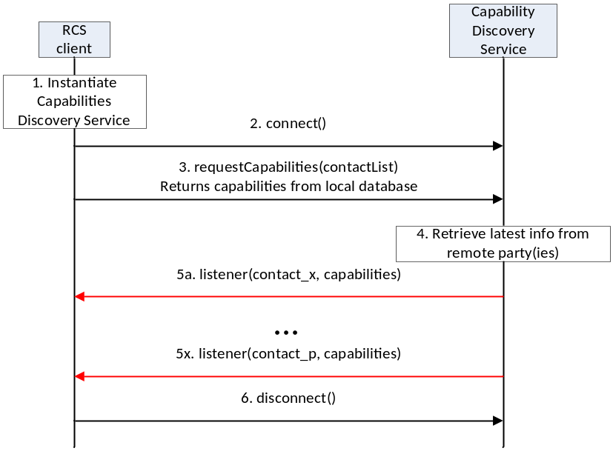
- : Get the capabilities of a list of remote contacts
- The RCS client instantiates a service instance of the Capability Discovery Service. At this time, it also specifies the list of listener functions.
- The RCS client establishes a connection with the Capability Discovery Service. The Capability Discovery Service associates the listener with this RCS client.
- The RCS client constructs a list of contacts for which it wants to get the latest capabilities. It invokes the API to get the capabilities of these contacts by providing the contact list as parameter. The Capability Discovery Service returns the requested information from the local database.
- Additionally, the Capability Discovery Service initiates procedures with the remote parties to retrieve the latest capabilities.
- When the updated capability information is available for a contact, the listener function(s) are invoked to inform all the RCS clients that have installed a listener. This step is repeated for each contact for which updated capability information becomes available.
- Finally, the RCS client, having retrieved the contact information, disconnects from the capability discovery service. At this time, the Capability Service discards all listeners associated with this client.

Package
Package name com.gsma.services.rcs.capability

Methods and Callbacks
Class CapabilityService:
This class offers the main entry point to the Capability service which permits to read capabilities of remote contacts, to initiate capability discovery and to receive capabilities updates. Several applications may connect/disconnect to the API.

A set of capabilities is associated to each MSISDN of a contact.
- Method: connects to the API.
void connect()

- Method: disconnects from the API.
void disconnect()

- Method: returns the capabilities supported by the local end user. The supported capabilities are fixed by the MNO and read during the provisioning.
Capabilities getMyCapabilities()

- Method: returns the capabilities of a given contact from the local database. This method doesn’t request any network update to the remote contact. The parameter contact supports the following formats: MSISDN in national or international format, SIP address, SIP-URI or Tel-URI.
Capabilities getContactCapabilities(String contact);

- Method: requests capabilities to a remote contact. This method initiates in the background a new capability request to the remote contact by sending a SIP OPTIONS. The result of the capability request is sent asynchronously via callback method of the capabilities listener. A capability refresh is only sent if the timestamp associated to the capability has expired (the expiration value is fixed via MNO provisioning). The parameter contact supports the following formats: MSISDN in national or international format, SIP address, SIP-URI or Tel-URI. If the format of the contact is not supported an exception is thrown. The result of the capability refresh request is provided to all the clients that have registered the listener for this event.
void requestContactCapabilities(String contact)

- Method: requests capabilities for a group of remote contacts. This method initiates in the background new capability requests to the remote contact by sending a SIP OPTIONS. The result of the capability request is sent asynchronously via callback method of the capabilities listener. A capability refresh is only sent if the timestamp associated to the capability has expired (the expiration value is fixed via MNO provisioning). The parameter contact supports the following formats: MSISDN in national or international format, SIP address, SIP-URI or Tel-URI. If the format of the contact is not supported an exception is thrown. The result of the capability refresh request is provided to all the clients that have registered the listener for this event.
void requestContactCapabilities(Set<String> contacts)

- Method: requests capabilities for all contacts existing in the local address book. This method initiates in the background new capability requests for each contact of the address book by sending SIP OPTIONS. The result of a capability request is sent asynchronously via callback method of the capabilities listener. A capability refresh is only sent if the timestamp associated to the capability has expired (the expiration value is fixed via MNO provisioning). The result of the capability refresh request is provided to all the clients that have registered the listener for this event.
void requestAllContactsCapabilities()

- Method: registers a listener for receiving capabilities on any contact.
void addCapabilitiesListener(ICapabilitiesListener listener)

- Method: unregisters a capabilities listener.
void removeCapabilitiesListener(ICapabilitiesListener listener)

- Method: registers a capabilities listener for receiving capabilities on a list of contacts.
void addCapabilitiesListener(Set<String> contacts, ICapabilitiesListener listener)

- Method: unregisters a capabilities listener on a list of contacts.
void removeCapabilitiesListener(Set<String> contacts, ICapabilitiesListener listener)

Class ICapabilitiesListener:
This class offers callback methods for the listener of capabilities.
- Method: callback called when new capabilities are received for a given contact.
The first argument contact contains the canonical representation of the identity of the contact whose capabilities are indicated by the second argument capabilities.
void onCapabilitiesReceived(String contact, Capabilities capabilities)

Class Capabilities:
This class encapsulates the different capabilities which may be supported by the local user or a remote contact.
- Method: returns true if the file transfer is supported, else returns false
boolean isFileTransferSupported()

- Method: returns true if IM/Chat is supported, else returns false
boolean isImSessionSupported()

- Method: returns true if image sharing is supported, else returns false
boolean isImageSharingSupported()

- Method: returns true if video sharing is supported, else returns false
boolean isVideoSharingSupported()

- Method: returns true if the specified feature tag is supported, else returns false. The parameter tag represents the feature tag to be tested.
boolean isExtensionSupported(String tag)

- Method: returns the list of supported RCS extensions
Set<String> getSupportedExtensions()

- Method: returns true if it’s an automata, else returns false
boolean isAutomata()

Content Providers
A content provider is used to store locally the capabilities of each remote contact. In this case the capabilities may be read even if there is no connection to the RCS platform. There is one entry per remote MSISDN Number.
The content provider has the following columns:
Data | Data type | Comment
CONTACT_NUMBER | TEXT | Contains the MSISDN of the contact associated to the capabilities
CAPABILITY_IMAGE_SHARING | Integer | Image sharing capability. Values: 1 (true), 0 (false)
CAPABILITY_VIDEO_SHARING | Integer | Video sharing capability. Values: 1 (true), 0 (false)
CAPABILITY_IM_SESSION | Integer | IM/Chat capability. Values: 1 (true), 0 (false)
CAPABILITY_FILE_TRANSFER | Integer | File transfer capability. Values: 1 (true), 0 (false)
CAPABILITY_GEOLOC_PUSH | Integer | Geolocation push capability. Values: 1 (true), 0 (false)
CAPABILITY_IP_VOICE_CALL | Integer | IP voice call capability. Values: 1 (true), 0 (false)
CAPABILITY_IP_VIDEO_CALL | Integer | IP video call capability. Values: 1 (true), 0 (false)
CAPABILITY_EXTENSIONS | TEXT | Supported RCS extensions. List of features tags semicolon separated (e.g. <TAG1>;<TAG2>;…;TAGn)
AUTOMATA | Integer | Is an automata. Values: 1 (true), 0 (false).

RCS extensions
A MNO/OEM application can create a new RCS/IMS service by defining a new RCS capability (or RCS extension). This new service is identified by an IARI feature tag which is the unique key to identify the service in the RCS API and to trigger the service internally in the device and to route the service on the network side.
Note: How the IARI feature tags are used in the RCS API is for further study
To create a new capability, the MNO/OEM application should declare the new supported feature tag in its Android Manifest file. Then, when the MNO/OEM application is deployed on the device, the RCS service will detect automatically the new installed application and will take into account the new feature tag in the next capability refreshes, via SIP OPTIONS.
When the MNO/OEM application is removed the RCS service will remove the associated capability from the next capability refreshes via SIP OPTIONS.
The role of the RCS service is to manage the extensions and to take into account the new feature tag or not. This may be done by analysing the certificate of the application supporting the feature tag or by checking the provisioning.
There are two type of extensions:
- Extensions for service provider specific service.
- Extensions for third-party specific service.

For a third-party specific service, the extension should start with the prefix « +g.3gpp.iari-ref=”urn%3Aurn-7%3A3gpp-application.ims.iari.rcs.ext.xxx”, where “xxx“ is a unique service identifier encoded in base64 as per [RFC4648] associated to the application implementing the RCS extension.
See the following API syntax to be added in the Android Manifest file:
<intent-filter>
<action android:name="com.gsma.services.rcs.capability.EXTENSION"/>
<data android:mimeType="+g.3gpp.iari-ref/urn%3Aurn-7%3A3gpp-application.ims.iari.rcs.ext.A5TgS99bJloIUIh1209SJ82B21m87S1B87SBqfS871BS8787SBXBA3P45wjp63tk"/>
</intent-filter>

For a service provider specific service, the extension should start with the prefix « +g.3gpp.iari-ref=”urn%3Aurn-7%3A3gpp-application.ims.iari.rcs.mnc<mnc>.mcc<mcc>.xxxx », where « mnc » is the Mobile Network Code, where « mcc » is the Mobile Country Code and « xxx » a unique service identifier (string) associated to the application implementing the RCS extension.
See the following API syntax to be added in the Android Manifest file:
<intent-filter>
<action android:name="org.gsma.joyn.capability.EXTENSION"/>
<data android:mimeType="+g.3gpp.iari-ref/urn%3Aurn-7%3A3gpp-application.ims.iari.rcs.mnc01.mcc208.xxx"/>
</intent-filter>

      - Permissions
Access to the Capabilities API is requires the following permissions:
- com.gsma.services.rcs.RCS_READ_CAPABILITIES:
this is a new permission that governs access to capability information.
- android.permission.READ_CONTACTS:
this permission is required by any client using the capabilities service, since use of the API implicitly reveals information about past and current contacts for the device.

IM/Chat API
This API exposed all functionality for the Instant Messaging/Chat Service. It allows:
- Sending messages to a contact.
- Starting group chats with an ad-hoc list of participants and an optional subject.
- Joining existing group chats.
- Re-joining existing group chats.
- Restarting a previous group chat.
- Extends a 1-1 chat to a group chat.
- Sending messages in a group chat.
- Leaving a group chat.
- Adding participants to a group chat.
- Retrieving information about a group chat (status, participants and their status)
- Receiving notifications about incoming messages, “is-composing” events, group chat invitations and group chat events.
- Accept/reject an incoming chat invitation.
- Displaying chat history (messages and group chats).
- Erasing chat history by a user, by group chat, or by single messages.
- Marking messages as displayed.
- Receiving message delivery reports.
- Read configuration elements affecting IM.
NOTE: a chat (single/group) is identified by a unique conversation Identifier (ID) which corresponds to the “Contribution-ID” header in the signalling flow. This permits to have a permanent chat or group chat like user experience.

IM/Chat API calling flow
The figures in this section contain basic call flows of the IM/Chat service API.

Session establishment
Error: Reference source not found is an example that shows the flow for a RCS client establishing a IM/Chat session with a remote contact.
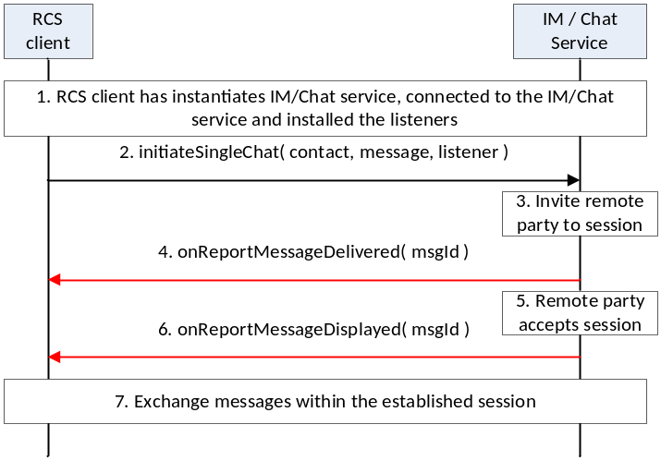
- : Establish a one-to-one chat session with remote party
- The RCS client instantiates a service instance of the IM/Chat Service, establishes a connection with the IM/Chat Service and associates the listener with this RCS client.
- By selecting a user, opening the IM window and typing a message, the user initiates a IM/Chat session request to the remote party
- RCS service sends the session request to the remote party
- The session request is delivered to the remote party and a confirmation of delivery of the message is received by the RCS service. This delivery confirmation is provided to the RCS client.
- By opening the chat window and viewing the incoming message, the remote party accepts the chat session and sends a confirmation of the message display
- The RCS service provides the message displayed notification to the RCS client
- Using procedures described in Error: Reference source not found, the two users exchange IM / Chat messages

Incoming session request
Error: Reference source not found is an example that shows the flow for an RCS client receiving an IM/Chat session request from a remote contact.

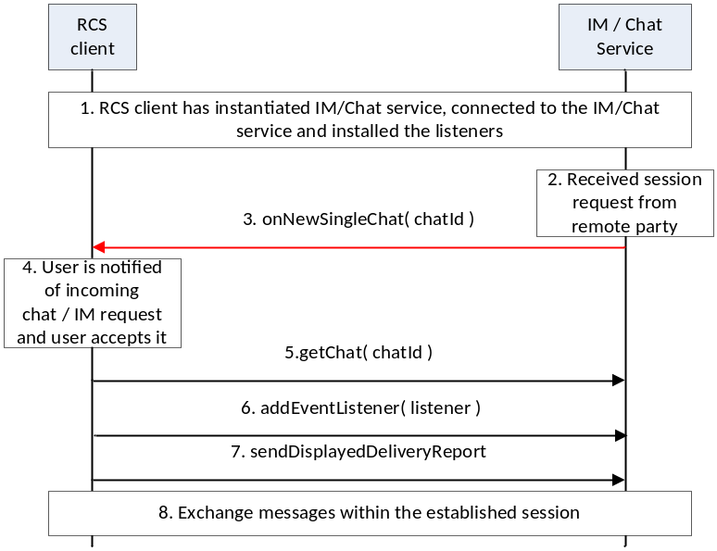
- : Establish a one-to-one chat session with remote party
- The RCS client instantiates a service instance of the IM/Chat Service, establishes a connection with the IM/Chat Service and associates the listener with this RCS client.
- IM/Chat Service receives a request for a session from a remote party
- IM/Chat Service notifies the RCS client through the invocation of the appropriate listener function
- The RCS client notifies the user by displaying the message received in the incoming session invitation to the user. The user accepts the session request
- The RCS client retrieves the chat object associated with this session
- The RCS client installs the listener function for this chat session
- The RCS client requests the IM/Chat service to send to the remote party, an indication of display of the message to the user
- Using procedures described in Error: Reference source not found, the two users exchange IM / Chat messages

Message exchange after chat session establishment
Error: Reference source not found is an example that shows the flow for a RCS client receiving a IM/Chat session request from a remote contact.
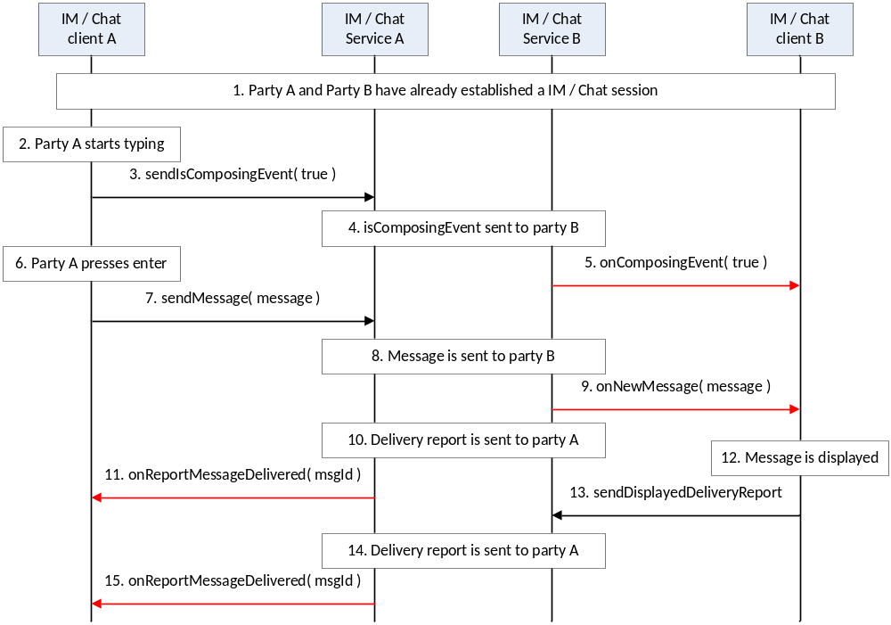
- : Establish a one-to-one chat session with remote party
- A party and B party have already established a IM/Chat session
- Party A starts to type a new chat / IM message
- Client A provides an indication of composing event to the IM/Chat service
- IM/Chat service of party A provides indication of composing toward party B.
- IM/Chat service of party B provides the indication to the IM client of party B
- Party A completes typing the message and presses enter
- Client A provides the message to the IM/Chat service A
- IM/Chat service A sends the message to IM/Chat service B
- IM/Chat service B provides an indication to the client B
- IM/Chat service B provides delivery indication to IM/Chat service A
- IM/Chat service A provides the delivery indication to IM client A
- IM Client B displays the message to user
- IM client B provides the displayed indication to the IM/Chat service B
- IM/Chat service B provides the displayed indication to IM/Chat service A
- IM/Chat service A provides the indication to the client A

Package
Package name com.gsma.services.rcs.chat

Methods and Callbacks
Class ChatService:
This class offers the main entry point to initiate chat conversations with contacts: 1-1 and group chat conversation. Several applications may connect/disconnect to the API.
- Method: connects to the API.
void connect()

- Method: disconnects from the API.
void disconnect()

- Method: opens a single chat with a given contact and returns a Chat instance. The parameter contact supports the following formats: MSISDN in national or international format, SIP address, SIP-URI or Tel-URI.
Chat openSingleChat(String contact, ChatListener listener)

- Method: initiates a group chat with a group of contacts and returns a GroupChat instance. The subject is optional and may be null.
GroupChat initiateGroupChat(Set<String> contacts, String subject, GroupChatListener listener)

- Method: rejoins an existing group chat from its unique chat ID.
GroupChat rejoinGroupChat(String chatId)

- Method: restarts a previous group chat from its unique chat ID.
GroupChat restartGroupChat(String chatId)

- Method: adds a listener on new chat invitation event.
void addNewChatListener(NewChatListener listener)

- Method: removes a listener on new chat invitation event.
void removeNewChatListener(NewChatListener listener)

- Method: returns the list of single chats in progress.
Set<Chat> getChats()

- Method: returns a chat in progress from its unique ID.
Chat getChat(String chatId)

- Method: returns a single chat from its invitation Intent.
Chat getChatFor(Intent intent)

- Method: returns the list of group chats in progress.
Set<GroupChat> getGroupChats()

- Method: returns a group chat in progress from its unique ID.
GroupChat getGroupChat(String chatId)

- Method: returns a group chat from its invitation Intent.
GroupChat getGroupChatFor(Intentintent)

- Method: returns the configuration for chat service.
ChatServiceConfiguration getConfiguration()

Class NewChatListener:
This class offers callback methods on a new chat invitation event.
- Method: callback called when a new chat invitation has been received
void onNewSingleChat(String chatId, ChatMessage message)

- Method: callback called when a new group chat invitation has been received
void onNewGroupChat(String chatId)

Class ChatMessage:
This class contains chat message information for single and group chats.
- Method: returns the contact who sends the message.
String getContact()

- Method: returns the message ID.
String getId()

- Method: returns the message content.
String getMessage()

- Method: returns the receipt date.
Date getReceiptDate()

- Method: is displayed delivery report requested.
boolean isDisplayedReportRequested()

Class GeolocMessage:
This class contains geoloc message information for single and group chat.
Method: returns the contact who sends the message.
String getContact()
Method: returns the message ID.
String getId()
Method: returns the geoloc info.
Geoloc getGeoloc()
Method: returns the receipt date.
Date getReceiptDate()
Method: is displayed delivery report requested.
boolean isDisplayedReportRequested()

Class Geoloc:
This class contains geoloc information.
Method: returns the label associated to the geoloc.
String getLabel()
Method: returns the latitude.
double getLatitude()
Method: returns the longitude.
double getLongitude()
Method: returns the accuracy of the geoloc info (in meter).
float getAccuracy()
Method: returns the expiration date of the geoloc info.
long getExpirationDate()

Class Chat:
This class maintains the information related to a single chat and offers methods to manage the chat conversation.

- Method: returns the remote contact.
String getRemoteContact()

- Method: sends a chat message. The method returns a unique message ID.
String sendMessage(String message)

- Method: sends a geoloc message. The method returns a unique message ID.
String sendGeoloc(Geoloc geoloc)

- Method: sends a displayed delivery report for a given message ID.
void sendDisplayedDeliveryReport(String msgId)

- Method: sends an “is-composing” event. The status is set to true when typing a message, else it is set to false.
void sendIsComposingEvent(boolean status)

- Method: adds a listener on chat events.
void addEventListener(ChatListener listener)

- Method: removes a listener on chat events.
void removeEventListener(ChatListener listener)

Class ChatListener:
This class offers callback methods on 1-1 chat events.
- Method: callback called when a new message has been received
void onNewMessage(ChatMessage message)

- Method: callback called when a new geoloc has been received
void onNewGeoloc(GeolocMessage message)

- Method: callback called when a message has been delivered to the remote.
void onReportMessageDelivered(String msgId)

- Method: callback called when a message has been displayed by the remote.
void onReportMessageDisplayed(String msgId)

- Method: callback called when a message has failed to be delivered to the remote.
void onReportMessageFailed(String msgId)

- Method: callback called when a “is-composing” event has been received. If the remote is typing a message the status is set to true, else it is false.
void onComposingEvent(boolean status)

Class GroupChat:
This class maintains the information related to a group chat and offers methods to manage the group chat conversation.
- Method: returns the chat ID.
String getChatId()

- Method: returns the subject of the group chat.
String getSubject()

- Method: returns the remote contact.
String getRemoteContact()

- Method: returns the list of connected participants. A participant is identified by its MSISDN in national or international format, SIP address, SIP-URI or Tel-URI.
Set<String> getParticipants()

- Method: returns the direction of the group chat: INCOMING, OUTGOING.
int getDirection()

- Method: returns the state of the group chat. The state may have the following values: INVITED, INITIATED, STARTED, TERMINATED, ABORTED, FAILED.
int getState()

- Method: accepts chat invitation.
void acceptInvitation()

- Method: rejects chat invitation.
void rejectInvitation()

- Method: sends a message to the group. This method returns a unique message ID.
String sendMessage(String text)

- Method: sends a geoloc message. The method returns a unique message ID.
String sendGeoloc(Geoloc geoloc)

- Method: transfers a file to participants.
FileTransfer sendFile(String filename, String fileicon, FileTransferListener listener)

- Method: sends a “is-composing” event. The status is set to true when typing a message, else it is set to false.
void sendIsComposingEvent(boolean status)

- Method: sends a displayed delivery report for a given message ID.
void sendDisplayedDeliveryReport(String msgId)

- Method: adds participants to a group chat.
void addParticipants(Set<String> participants)

- Method: returns the maximum number of participants for a group chat from the group chat info subscription (this value overrides the provisioning parameter).
int getMaxParticipants()

- Method: quits a group chat conversation. The conversation will continue between other participants if there are enough participants.
void quitConversation()

- Method: adds a listener on chat events.
void addEventListener(GroupChatListener listener)

- Method: removes a listener on chat events.
void removeEventListener(GroupChatListener listener)

Class GroupChatListener:
This class offers callback methods on group chat events.
- Method: callback called when the session is well established and messages may be exchanged with the group of participants.
void onSessionStarted()

- Method: callback called when a new message has been received
void onNewMessage(ChatMessage message)

- Method: callback called when a message has failed to be delivered to the remote.
void onReportMessageFailed(String msgId)

- Method: callback called when a new geoloc has been received
void onNewGeoloc(GeolocMessage message)

- Method: callback called when a message has been delivered to the remote.
void onReportMessageDelivered(String msgId)

- Method: callback called when a message has been displayed by the remote.
void onReportMessageDisplayed(String msgId)

- Method: callback called when a “is-composing” event has been received. If the remote is typing a message the status is set to true, else it is false.
void onComposingEvent(String contact, boolean status)

- Method: callback called when the session has been aborted or terminated.
void onSessionAborted ()

- Method: callback called when the session has failed. The error code may be: CHAT_NOT_FOUND, INVITATION_DECLINED, CHAT_FAILED.
void onSessionError(int error)

- Method: callback called when a new participant has joined the group chat.
void onParticipantJoined(String contact, String contactDisplayname)

- Method: callback called when a participant has voluntary left the group chat.
void onParticipantLeft(String contact)

- Method: callback called when a participant is disconnected from the group chat.
void onParticipantDisconnected(String contact)

Class ChatServiceConfiguration:
This class represents the particular configuration of a IM Service.
- Method: returns the “imCapAlwaysOn” configuration. True if Store and Forward capability is supported, False if no Store & Forward capability.
boolean isChatSf()

- Method: returns the “imWarnSF” configuration. True if a user should be informed when sending a message to an offline user. False if a user should not be informed when sending a message to an offline user. This should be used with imCapAlwaysOn.
boolean isChatWarnSf()

- Method: returns the time after an inactive chat session could be closed.
int getChatTimeout()

- Method: returns the maximum participants in a group chat session.
int getGroupChatMaxParticipantsNumber()

- Method: returns the maximum single chat message’s length can have
int getSingleChatMessageMaxLength()

- Method: returns the maximum single group chat message’s length can have
int getGroupChatMessageMaxLength()

- Method: returns the maximum number of simultaneous single chats.
int getMaxSingleChats()

- Method: returns the maximum number of simultaneous group chats.
int getMaxGroupChats()

- Method: returns the SMS fall-back configuration. True if SMS fall-back procedure is activated, else returns False.
boolean isSmsFallback()

- Method: returns True if auto accept mode is activated for chat, else returns False.
boolean isChatAutoAcceptMode()

- Method: returns True if auto accept mode is activated for a group chat, else returns False.
boolean isGroupChatAutoAcceptMode()

- Method: activates or deactivates the displayed delivery report on a received chat messages.
void setDisplayedDeliveryReport(boolean state)

- Method: returns the is-compoisng timeout value.
int getIsComposingTimeout ()

- Method: returns the maximum length of a geoloc label.
int getGeolocLabelMaxLength()

- Method: returns the expiration time of a geoloc info.
int getGeolocExpirationTime()

Intents
Intent broadcasted when a new chat conversation has been received. This Intent contains the following extras:
  - “contact”: MSISDN of the contact sending the invitation.
  - “contactDisplayname”: display name of the contact sending the invitation (extracted from the SIP address).
  - “message”: received chat message (parceable object). This may be a ChatMessage or a GeolocMessage.
com.gsma.services.rcs.chat.action.NEW_CHAT

Intent broadcasted when a new group chat invitation has been received. This Intent contains the following extras:
  - “contact”: MSISDN of the contact sending the invitation.
  - “contactDisplayname”: display name of the contact sending the invitation (extracted from the SIP address).
  - “chatId”: unique ID of the group chat conversation.
  - “subject”: subject of the group chat (optional).
com.gsma.services.rcs.chat.action.NEW_GROUP_CHAT

Content Providers
A content provider is used to store the chat history persistently. There is one entry per chat message.
The content provider has the following tables and columns:
- GROUPCHAT

No. | Data | Data Type | Description
1. | CHAT_ID | String | Id for chat room
2. | STATE | Integer | State of chat room. See note below for the list of states.
3. | SUBJECT | String | Subject of the group chat room
4 | DIRECTION | Integer | Status direction of group chat. See note below for the list of status.
5 | TIMESTAMP | Long | Date of the invitation

- Message
No. | Data | Data Type | Description
1. | MESSAGE_ID | Long | Id of the message
2. | CHAT_ID | String | Id of chat room
3. | CONTACT_NUMBER | String | Contact number of sender
4. | BODY | BLOB | Body of the message
5. | TIMESTAMP | Long | Time when message inserted
6. | TIMESTAMP_SENT | Long | Time when message sent. If 0 means not sent.
7. | TIMESTAMP_DELIVERED | Long | Time when message delivered. If 0 means not delivered.
8. | TIMESTAMP_ DISPLAYED | Long | Time when message displayed. If 0 means not displayed.
9. | MIME_TYPE | String | Multipurpose Internet Mail Extensions (MIME) type of message
10. | MESSAGE_STATUS | Integer | See note below for the list of status.  INVITED = 0Y
11. | DIRECTION | Integer | Status direction of message. See note below for the list of status.
12. | MESSAGE_TYPE | Integer | Type of message. See note below for the list of types.= 0, SY
Note: State values for chat session management in GROUPCHAT->STATE:
- INVITED : incoming chat.
- INITIATED : outgoing chat.
- STARTED : invitation has been accepted and chat is started.
- ABORTED: chat has been aborted.
- TERMINATED: chat has been terminated.
- CLOSED_BY_USER: ended session closed by user.
- FAILED: chat session has failed.
- INACTIVE: chat is not yet active.
Status values for a message in MESSAGE->MESSAGE_STATUS:
- In case of a chat message (MESSAGE->MESSAGE_TYPE = CONTENT):
  - UNREAD: the message is delivered.
  - UNREAD_REPORT: the message is delivered and a displayed delivery report is requested.
  - READ: message is read (i.e. DISPLAYED).
  - SENDING: message is in progress of sending.
  - SENT: message is sent.
  - FAILED: message is failed to be sent.
  - TO_SEND: message is queued to be sent by stack.
  - BLOCKED: message is a spam message.
- In case of a system message (MESSAGE->MESSAGE_TYPE = SYSTEM):
  - INVITED: invitation pending.
  - ACCEPTED: invitation has been accepted (i.e.; JOINED).
  - DECLINED: the invitation has been declined on remote participant.
  - TIMEOUT: the invitation has been timeout.
  - JOINED: participant has joined the group.
  - GONE: participant has left the group (i.e. DEPARTED).
  - DISCONNECTED (i.e. BOOTED).
  - BUSY.
  - FAILED.
  - PENDING.
Type values of a message direction in MESSAGE->DIRECTION and group chat direction in GROUPCHAT->DIRECTION:
- INCOMING: a message from remote user (incoming message)
- OUTGOING: a message sent for a remote user / conference
Type values for a message in MESSAGE->MESSAGE_TYPE:
- CONTENT: the message represents a chat message (plain text or geoloc).
- SYSTEM: the message is considered a system (events) message.

Permissions
Access to the Chat API requires the following permissions:
- com.gsma.services.rcs.RCS_USE_CHAT: this is a new permission that governs access to the chat API, and is required both to receive and to send over an RCS chat session.
- com.gsma.services.rcs.RCS_READ_CHAT: this is a new permission that is required by a client in order to read the chat history from the content provider.

File Transfer API
This API exposes all functionality related to transferring files via the File Transfer Service. It allows:
- Send a file transfer request
- Send a file transfer request with thumbnail (file icon)
- Receive notifications about incoming file transfer and file transfer events.
- Receive notifications upon file delivery
- Retrieve the list of all file transfers and their statuses for a specific contact
- Clean all file transfer history or single file transfers (including the transferred files if possible)
- Monitor a file transfers progress.
- Cancel a file transfer in progress.
- Accept/reject an incoming file transfer request.
- Read configuration elements affecting a file transfer
- Resume a file transfer

File Transfer API calling flow
The figures in this section contain basic call flows of the File Transfer service API.

Session establishment
Error: Reference source not found is an example that shows the flow for a File Transfer (FT) client establishing a FT session with a remote contact.
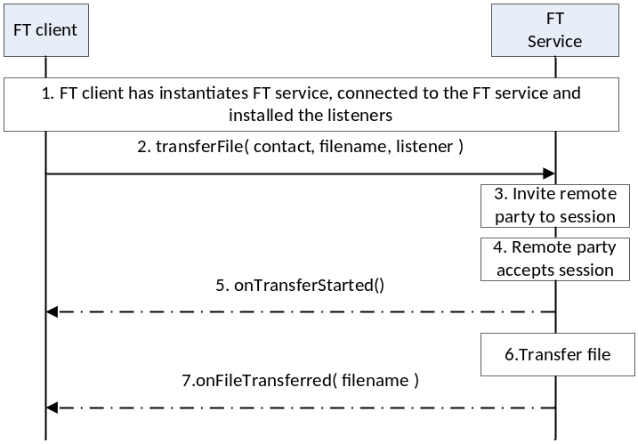
- : Successful sending of a file to remote party
- The FT client instantiates a service instance of the File Transfer Service, establishes a connection with the FT Service and associates the listener with this RCS client.
- By selecting a user and the file to be transferred, the user initiates a FT session request to the remote party
- The FT Service sends the session request to remote party
- The session request is delivered to the remote party and an indication is received that the remote user has accepted the file transfer request.
- The FT client is notified that the file transfer has started.
- The FT Service transfers the file to the remote party.
- The FT client is notified that the file transfer is completed.

Incoming session request
Error: Reference source not found is an example that shows the flow for a FT client receiving a File Transfer request from a remote contact.

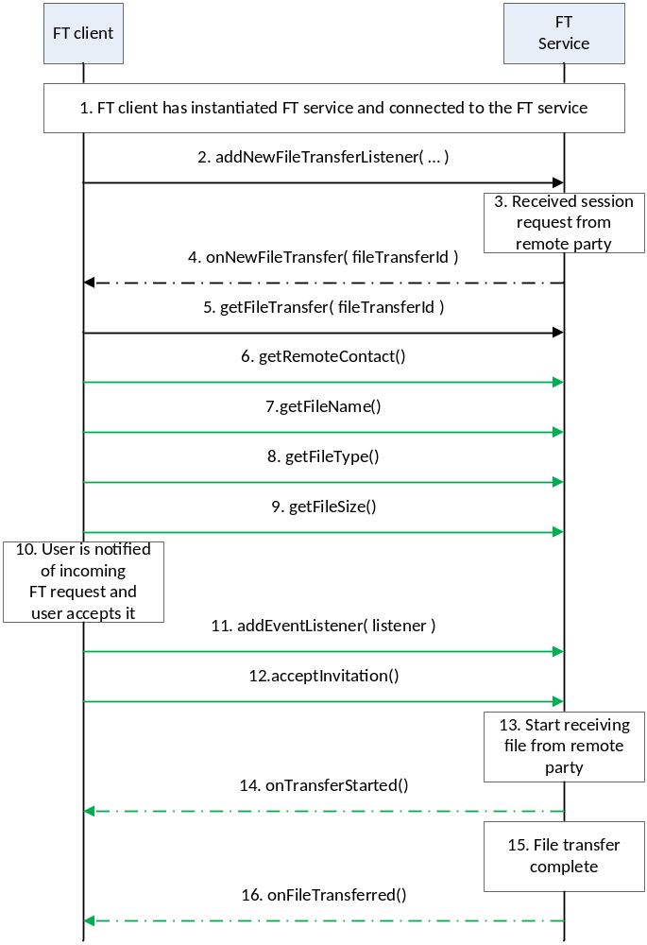
- : Successful reception of a file from remote party
- The FT client instantiates a service instance of the FT Service and establishes a connection with the FT Service.
- The FT client associates the listener with this FT client.
- The FT Service receives a request for a session from a remote party
- The FT Service notifies the FT client through the invocation of the appropriate listener function
- The FT client retrieves the file transfer session object from the FT service
- The FT client retrieves the identity of the remote party that is sending the file.
- The FT client retrieves the name of the file that is being sent by the remote party.
- The FT client retrieves the type of file that is being sent by the remote party
- The FT client retrieves the size of the file that is being sent by the remote party.
- The FT client notifies the user by displaying the details of the file that is being sent to the user. The user accepts the request,
- The FT client installs the listener function for this FT session.
- The RCS client notifies the FT Service that the user has accepted to receive the file
- The FT service informs the remote end that it is ready to receive the file
- The FT client is notified that the file transfer has started.
- The FT service interacts with the remote end to receive the file
- The FT client is notified that the file transfer is complete.

Package
Package name com.gsma.services.rcs.ft

Methods and Callbacks
Class FileTransferService:
This class offers the main entry point to transfer files and to receive files. Several applications may connect/disconnect to the API.
- Method: connects to the API.
void connect()

- Method: disconnects from the API.
void disconnect()

- Method: returns the list of file transfers in progress.
Set<FileTransfer> getFileTransfers()

- Method: returns a current file transfer from its unique ID.
FileTransfer getFileTransfer(String transferId)

- Method: returns a current file transfer from its invitation Intent.
FileTransfer getFileTransferFor(Intent intent)

- Method: transfers a file to a contact. The parameter contact supports the following formats: MSISDN in national or international format, SIP address, SIP-URI or Tel-URI. The parameter file contains the complete filename including the path to be transferred.
FileTransfer transferFile(String contact, String filename, FileTransferListener listener)

- Method: transfers a file to a contact with an optional file icon.
FileTransfer transferFile(String contact, String filename, String fileicon, FileTransferListener listener)

- Method: transfers a file to a group of contacts outside of a current group chat. The parameter file contains the complete filename including the path to be transferred. See also the method GroupChat.sendFile() of the Chat API to send a file from an existing group chat conversation.
FileTransfer transferFileToGroup(Set<String> contacts, String filename, FileTransferListener listener)
- Method: transfers a file to a group of contacts with an optional file icon.
FileTransfer transferFileToGroup(Set<String> contacts, String filename, String fileicon, FileTransferListener listener)

- Method: returns the configuration for a File Transfer service.
FileTransferServiceConfiguration getConfiguration()

- Method: adds a new file transfer invitation listener.
void addNewFileTransferListener(NewFileTransferListener listener)

- Method: removes a new file transfer invitation listener.
void removeNewFileTransferListener(NewFileTransferListener listener)

Class FileTransfer:
This class maintains the information related to a file transfer and offers methods to manage the transfer.
- Method: returns the file transfer ID of the file transfer.
String getTransferId()

- Method: returns the remote contact.
String getRemoteContact()

- Method: returns the direction of the transfer: INCOMING, OUTGOING.
int getDirection()

- Method: returns the complete filename of the icon or thumbnail.
String getFileIconName()

- Method: returns the complete filename including the path of the file to be transferred.
String getFileName()

- Method: returns the size of the file to be transferred (in bytes).
String getFileSize()

- Method: returns the MIME type of file to be transferred.
String getFileType()

- Method: returns the state of the file transfer. The state may have the following values: INVITED, INITIATED, STARTED, TRANSFERRED, ABORTED, FAILED, and PAUSED.
int getState()

- Method: accepts the file transfer invitation.
void acceptInvitation()

- Method: rejects the file transfer invitation.
void rejectInvitation()

- Method: aborts the file transfer.
void abortTransfer()

- Method: pauses the file transfer.
void pauseTransfer()

- Method: resumes the file transfer.
void resumeTransfer()
- Method: adds a listener on the file transfer events.
void addNewFileTransferListener(IFileTransferListener listener)

- Method: removes a listener from file transfer.
void removeNewFileTransferListener(IFileTransferListener listener)

Class FileTransferListener:
This class offers callback methods on file transfer events.
- Method: callback called when the file transfer is started.
void onTransferStarted()

- Method: callback called when the file transfer has been aborted.
void onTransferAborted()

- Method: callback called when the file transfer has failed. The error code may be: INVITATION_DECLINED, SAVING_FILE, and TRANSFER_FAILED.
void onTransferError(int error)

- Method: callback called during the file transfer progress.
void onTransferProgress(long currentSize, long totalSize)

- Method: callback called when the file has been transferred. The parameter filename contains the complete filename including the path.
void onFileTransferred(String filename)

Class NewFileTransferListener:
This class offers callback method to receive a new file transfer invitation.
- Method: callback called when a new file transfer invitation has been received.
void onNewFileTransfer(String transferId)

- Method: callback called when the file has been delivered.
void onReportFileDelivered(String transferId)

- Method: callback called when the file has been displayed.
void onReportFileDisplayed(String transferId)

Class FileTransferServiceConfiguration:
This class represents the particular configuration of a FT Service.
- Method: returns the file size warning of a File Transfer configuration. It can return null if this value was not set by the auto-configuration server (no need to warn).
long getWarnSize()

- Method: returns the max file size of a File Transfer configuration. It can return null if this value was not set by the auto-configuration server.
long getMaxSize()

- Method: returns the Auto Accept Mode of a File Transfer configuration.
boolean isAutoAcceptMode()

- Method: returns the max number of simultaneous file transfers.
int getMaxFileTransfers()

- Method: returns True if the file icon (i.e. thumbnail) is supported, else returns False.
boolean isFileIconSupported()

- Method: returns the max size for a file icon (i.e. thumbnail).
long getMaxFileIconSize()

Intents
- Intent broadcasted when a new file transfer invitation has been received. This Intent contains the following extras:
  - “contact”: MSISDN of the contact sending the invitation.
  - “contactDisplayname”: display name of the contact sending the invitation (extracted from the SIP address).
  - “transferId”: unique ID of the file transfer.
  - “fileicon”: filename of the file icon (complete path).
  - “filename”: filename of the file to be transferred.
  - “filesize”: size of the file in bytes.
  - ”filetype”: MIME type of the file.
com.gsma.services.rcs.ft.action.NEW_FILE_TRANSFER

Content Providers
A content provider is used to store the file transfer history persistently. There is one entry per file transfer.
The content provider has the following columns:
Data | Data type | Comment
FT_ID | TEXT | Unique file transfer identifier
CONTACT_NUMBER | TEXT | Contains the MSISDN of the remote contact
FILENAME | TEXT | Filename
MIME_TYPE | TEXT | MIME type of the file
FILEICON | TEXT | Filename
DIRECTION | Integer | Incoming transfer or outgoing transfer
FILESIZE | Long | File size in bytes
TRANSFERRED | Long | Size transferred in bytes
TIMESTAMP | Long | Date of the transfer
TIMESTAMP_SENT | Long | Time when file is sent. If 0 means not sent.
TIMESTAMP_DELIVERED | Long | Time when file is delivered. If 0 means not delivered.
TIMESTAMP_ DISPLAYED | Long | Time when file is displayed.
STATE | Integer | See note below for the list of states
Note : State values for file transfer session management:
- INVITED: incoming session.
- INITIATED: outgoing session.
- STARTED: invitation has been accepted and transfer is started.
- TRANSFERRED: file has been transferred with success.
- ABORTED: session has been aborted.
- FAILED: session has failed.
- PAUSED : transfer has been paused and may be resumed.
- DELIVERED: file has been delivered.
- DISPLAYED: file has been displayed.
- INACTIVE: transfer is not yet active.

Permissions
Access to the File Transfer API is requires the following permissions:
- com.gsma.services.rcs.RCS_FILETRANSFER_RECEIVE: this is a new permission that is required by a client in order to handle the receipt of a file transferred from a remote party.
- com.gsma.services.rcs.RCS_FILETRANSFER_SEND: this is a new permission that is required by a client in order to initiate the transfer of a file transferred to a remote party.
- com.gsma.services.rcs.RCS_FILETRANSFER_READ: this is a new permission that is required by a client in order to read the file transfer history from the content provider.

Image Share API
This API exposes all functionality related to transferring images during a Circuit Switched (CS) call via the Image Share Service. It allows:
- Send an image share request
- Receive notifications about an incoming image share invitation and sharing events.
- Monitors an image share’s progress.
- Cancel an image share in progress.
- Accept/reject an incoming image share request.
- Read configuration elements affecting image share.

Image Share API calling flow
The figures in this section contain basic call flows of the Image Share service API.
        - Session establishment
Error: Reference source not found is an example that shows the flow for an image share client establishing an image share session with a remote contact.
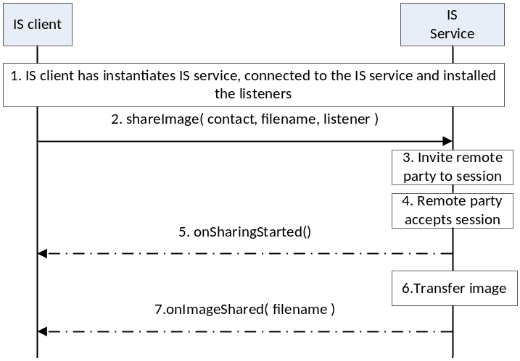
- : Successful sharing an image with remote party
- The Image Share (IS) client instantiates a service instance of the Image Share Service, establishes a connection with the IS Service and associates the listener with this IS client.
- By selecting a user and the image file to be transferred, the user initiates a IS session request to the remote party
- The IS service sends the session request to a remote party
- The session request is delivered to the remote party and an indication is received that the remote user has accepted the image sharing request.
- The IS client is notified that the image sharing has started.
- The IS service transfers the image to the remote party.
- The IS client is notified that the image sharing is completed.
        - Incoming session request
Error: Reference source not found is an example that shows the flow for a IS client receiving an Image Share request from a remote contact.

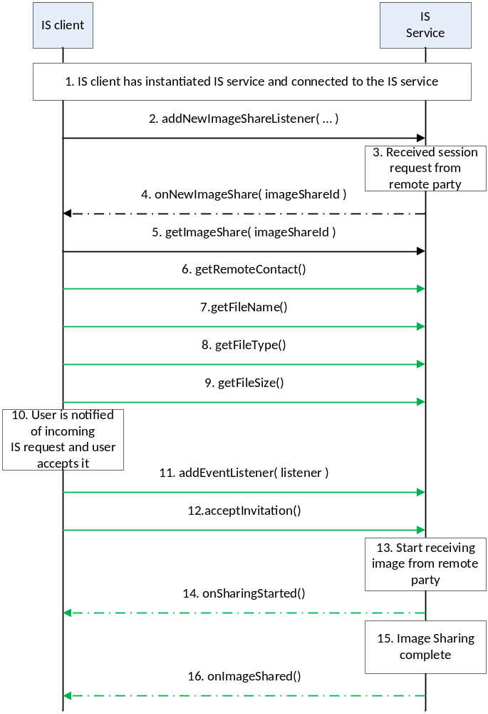
- : Successful sharing of an image from remote party
- The IS client instantiates a service instance of the IS Service and establishes a connection with the IS Service.
- The IS client associates the listener with this IS client.
- The IS Service receives a request for a session from a remote party
- The IS Service notifies the IS client through the invocation of the appropriate listener function
- The IS client retrieves the image share session object from the FT service
- The IS client retrieves the identity of the remote party that is sharing the image.
- The IS client retrieves the name of the image file that is being shared by the remote party.
- The IS client retrieves the type of image file that is being shared by the remote party
- The IS client retrieves the size of the image file that is being shared by the remote party.
- The IS client notifies the user by displaying the details of the image that is being shared to the user. The user accepts the request,
- The IS client installs the listener function for this IS session.
- The IS client notifies the IS service that the user has accepted to receive the image sharing request
- The IS service informs the remote end that it is ready to receive the image to be shared
- The IS client is notified that the image share has started.
- The IS service interacts with the remote end to receive the image being shared
- The IS client is notified that the image sharing is complete.

Package
Package name com.gsma.services.rcs.ish

Methods and Callbacks
Class ImageSharingService:
This class offers the main entry point to share images during a CS call, when the call hangs up the sharing is automatically stopped. Several applications may connect/disconnect to the API.
- Method: connects to the API.
void connect()

- Method: disconnects from the API.
void disconnect()

- Method: returns the list of image sharing in progress.
Set<ImageSharing> getImageSharings()

- Method: returns a current image sharing from its unique ID.
ImageSharing getImageSharing(String sharingId)

- Method: returns a current image sharing from its invitation Intent.
ImageSharing getImageSharingFor(Intent intent)

- Method: shares an image with a contact. The parameter contact supports the following formats: MSISDN in national or international format, SIP address, SIP-URI or Tel-URI. The parameter file contains the complete filename including the path of the image to be shared. An exception if thrown if there is no on-going CS call.
ImageSharing shareImage(String contact, String filename, ImageSharingListener listener)

- Method: returns the configuration for image share service.
ImageSharingServiceConfiguration getConfiguration()

- Method: adds a new image share invitation listener.
void addNewImageSharingListener(NewImageSharingListener listener)

- Method: removes a new image share invitation listener.
void removeNewImageSharingListener(NewImageSharingListener listener)

Class ImageSharing:
This class maintains the information related to an image share and offers methods to manage the sharing.
- Method: returns the sharing ID of the image sharing.
String getSharingId()

- Method: returns the remote contact.
String getRemoteContact()

- Method: returns the complete filename including the path of the file to be shared.
String getFileName()

- Method: returns the size of the file to be shared (in bytes).
String getFileSize()

- Method: returns the MIME type of file to be shared.
String getFileType()

- Method: returns the state of the image share. The state may have the following values: INVITED, INITIATED, STARTED, TRANSFERRED, ABORTED and FAILED.
int getState()

- Method: returns the direction of the sharing: INCOMING, OUTGOING.
int getDirection()

- Method: accepts image share invitation.
void acceptInvitation()

- Method: rejects image share invitation.
void rejectInvitation()

- Method: aborts the sharing.
void abortSharing()

- Method: adds a listener on image sharing events.
void addEventListener(ImageSharingListener listener)

- Method: removes a listener from image sharing.
void removeEventListener(ImageSharingListener listener)

Class ImageSharingListener:
This class offers callback methods on image sharing events.
- Method: callback called when the sharing is started.
void onSharingStarted()

- Method: callback called when the sharing has been aborted.
void onSharingAborted()

- Method: callback called when the sharing has failed. The error code may be: INVITATION_DECLINED, SAVING_FAILED and SHARING_FAILED.
void onSharingError(int error)

- Method: callback called during the sharing progress.
void onSharingProgress(long currentSize, long totalSize)

- Method: callback called when the sharing has been terminated. The parameter filename contains the complete filename including the path.
void onImageShared(String filename)

Class NewImageSharingListener:
This class offers callback method to receive a new image share invitation.
- Method: callback called when a new image share invitation has been received.
void onNewImageSharing(String sharingId)

Class ImageSharingServiceConfiguration:
This class represents the particular configuration of the Image Sharing Service.
- Method: returns the file size warning of Image Sharing configuration. It returns 0 if this value was not set by the auto-configuration server (no need to warn).
long getWarnSize()

- Method: returns the max file size of the Image Sharing configuration. It can return null if this value was not set by the auto-configuration server.
long getMaxSize()

Intents
Intent broadcasted when a new image sharing invitation has been received. This Intent contains the following extras:
  - “contact”: MSISDN of the contact sending the invitation.
  - “contactDisplayname”: display name of the contact sending the invitation (extracted from the SIP address).
  - “sharingId”: unique ID of the image sharing.
  - “filename”: filename of the image to be transferred
  - “filesize”: size of the image file in bytes.
  - ”filetype”: MIME_type of the image.
com.gsma.services.rcs.ish.action.NEW_IMAGE_SHARING

Content Providers
A content provider is used to store the image sharing history persistently. There is one entry per image sharing.
The content provider has the following columns:
Data | Data type | Comment
SHARING_ID | TEXT | Unique sharing identifier
CONTACT_NUMBER | TEXT | Contains the MSISDN of the remote contact
FILENAME | TEXT | Filename
MIME_TYPE | TEXT | MIME type of the file
DIRECTION | Integer | Incoming sharing or outgoing sharing
FILESIZE | Long | File size in bytes
TRANSFERRED | Long | Size transferred in bytes
TIMESTAMP | Long | Date of the sharing
STATE | Integer | See note below for the list of states
Note : State values for file transfer session management :

- INVITED: incoming session.
- INITIATED: outgoing session.
- STARTED: invitation has been accepted and sharing is started.
- TRANSFERRED: session has been terminated and sharing successful.
- ABORTED: session has been aborted.
- FAILED: session has failed.
- INACTIVE: session is not yet active.

Permissions
Access to the Image Share API is requires the following permissions:
- com.gsma.services.rcs.RCS_IMAGESHARE_RECEIVE: this is a new permission that is required by a client in order to handle the receipt of an image shared by a remote party.
- com.gsma.services.rcs.RCS_IMAGESHARE_SEND: this is a new permission that is required by a client in order to initiate the sharing of an image with a remote party.
- com.gsma.services.rcs.RCS_IMAGESHARE_READ: this is a new permission that is required by a client in order to read the image share history from the content provider.

Video Share API
This API exposes all functionality related to sharing a live video stream during a CS call via the Video Share Service. It allows:
- Send a video share request.
- Receive notifications about incoming video share invitation and sharing events.
- Cancel an on-going video share.
- Accept/reject an incoming video share request.
- Read configuration elements affecting video share.

Package
Package name com.gsma.services.rcs.vsh

Methods and Callbacks
Class VideoSharingService:
This class offers the main entry point to share a live video during a CS call, when the call hangs up the sharing is automatically stopped. Several applications may connect/disconnect to the API.
- Method: connects to the API.
void connect()

- Method: disconnects from the API.
void disconnect()

- Method: returns the list of video sharing in progress.
Set<VideoSharing> getVideoSharings()

- Method: returns a current video sharing from its unique ID.
VideoSharing getVideoSharing(String sharingId)

- Method: returns a current video share from its invitation Intent.
VideoSharing getVideoSharingFor(Intent intent)

- Method: shares a live video stream with a contact. The parameter contact supports the following formats: MSISDN in national or international format, SIP address, SIP-URI or Tel-URI. The parameter player contains a media player which streams over RTP the live video from the camera. The media player is an interface which permits to have a player implementation independent from the joyn API. An exception is thrown if there is no on-going CS call.
VideoSharing shareVideo(String contact, VideoPlayer player, VideoSharingListener listener)

- Method: returns the configuration for video share service.
VideoSharingServiceConfiguration getConfiguration()

- Method: adds a new video share invitation listener.
void addNewVideoSharingListener(NewVideoSharingListener listener)

- Method: removes a new video share invitation listener.
void removeNewVideoSharingListener(NewVideoSharingListener listener)

Class VideoSharing:
This class maintains the information related to a video sharing and offers methods to manage the sharing.
- Method: returns the sharing ID of the video sharing.
String getSharingId()

- Method: returns the remote contact.
String getRemoteContact()

- Method: returns the video codec.
VideoCodec getVideoCodec()

- Method: returns the state of the video share. The state may have the following values: INVITED, INITIATED, STARTED, TERMINATED, ABORTED, and FAILED.
int getState()

- Method: returns the direction of the sharing: INCOMING, OUTGOING.
int getDirection()

- Method: accepts video share invitation with a given renderer.
void acceptInvitation(VideoRenderer renderer)

- Method: rejects video share invitation.
void rejectInvitation()

- Method: aborts the sharing.
void abortSharing()

- Method: adds a listener on video sharing events.
void addEventListener(VideoSharingListener listener)

- Method: removes a listener from video sharing.
void removeEventListener(VideoSharingListener listener)

Class VideoSharingListener:
This class offers callback methods on video sharing events.
- Method: callback called when the sharing is started.
void onSharingStarted()

- Method: callback called when the sharing has been aborted.
void onSharingAborted()

- Method: callback called when the sharing has failed. The error code may be: INVITATION_DECLINED and SHARING_FAILED.
void onSharingError(int error)

Class VideoPlayer:
This class offers an interface to manage the video player instance independently of the joyn service. The video player is implemented on the application side.
- Method: opens the player and prepares resources (e.g. encoder, camera).
void open(VideoCodec codec, String remoteHost, int remotePort)

- Method: closes the player and de-allocates resources.
void close()

- Method: starts the player.
void start()

- Method: stops the player.
void stop()

- Method: returns the local RTP port used to stream video.
int getLocalRtpPort()

- Method: returns the list of codecs supported by the player.
VideoCodec[] getSupportedCodecs()

- Method: adds a listener on video player events.
void addEventListener(VideoPlayerListener listener)

- Method: removes a listener from video player.
void removeEventListener(VideoPlayerListener listener)

Class VideoPlayerListener:
This class offers callback methods on video player events.
- Method: callback called when the player is opened.
void onPlayerOpened()

- Method: callback called when the player is started.
void onPlayerStarted()

- Method: callback called when the player is stopped.
void onPlayerStopped()

- Method: callback called when the player is closed.
void onPlayerClosed()

- Method: callback called when the player has failed. The error code may be: INTERNAL_ERROR and NETWORK_FAILURE.
void onPlayerError (int error)

Class VideoRenderer:
This class offers an interface to manage the video renderer instance independently of the joyn service. The video renderer is implemented in the application side.
- Method: opens the renderer and prepares resources (e.g. decoder, display).
void open(VideoCodec codec, String remoteHost, int remotePort)

- Method: closes the renderer and de-allocates resources.
void close()

- Method: starts the renderer.
void start()

- Method: stops the renderer.
void stop()

- Method: returns the local RTP port used to stream video.
int getLocalRtpPort()

- Method: returns the list of codecs supported by the renderer.
VideoCodec[] getSupportedCodecs()

- Method: adds a listener on video renderer events.
void addEventListener(VideoRendererListener listener)

- Method: removes a listener from video renderer.
void removeEventListener(VideoRendererListener listener)

Class VideoRendererListener:
This class offers callback methods on video renderer events.
- Method: callback called when the renderer is opened.
void onRendererOpened()

- Method: callback called when the renderer is started.
void onRendererStarted()

- Method: callback called when the renderer is stopped.
void onRendererStopped()

- Method: callback called when the renderer is closed.
void onRendererClosed()

- Method: callback called when the renderer has failed. The error code may be: INTERNAL_ERROR and NETWORK_FAILURE.
void onRendererError(int error)

Class VideoCodec:
This class maintains the information related to a video codec.
- Method: returns the encoding name (e.g. H264).
String getEncoding()

- Method: returns the codec payload type(e.g. 96).
int getPayloadType()

- Method: returns the codec clock rate (e.g. 90000).
int getClockRate()

- Method: returns the codec frame rate (e.g. 10).
int getFrameRate()

- Method: returns the codec bit rate (e.g. 64000).
int getBitRate()

- Method: returns the video width (e.g. 176).
int getVideoWidth()

- Method: returns the video height (e.g. 144).
int getVideoHeight()

- Method: returns a codec parameter from its key name (e.g. profile-level-id, packetization-mode).
String getParameter(String key)

Class VideoSharingServiceConfiguration:
This class represents the particular configuration of Video Sharing Service.
- Method: returns the maximum authorized duration of the content that can be shared in a VSH session. It can return null if this value was not set by the auto-configuration server.
int getMaxTime()

Intents
Intent broadcasted when a new video sharing invitation has been received. This Intent contains the following extras:
  - “contact”: MSISDN of the contact sending the invitation.
  - “contactDisplayname”: display name of the contact sending the invitation (extracted from the SIP address).
  - “sharingId”: unique ID of the sharing.
  - ”encoding”: video encoding (e.g. H264).
  - “width”: video width (e.g. 176 for QCIF).
  - “height”: video height (e.g. 144 for QCIF).
com.gsma.services.rcs.vsh.action.NEW_VIDEO_SHARING

Content Providers
A content provider is used to store the video sharing history persistently. There is one entry per video sharing.
The content provider has the following columns:
Data | Data type | Comment
SHARING_ID | TEXT | Unique sharing identifier
CONTACT_NUMBER | TEXT | Contains the MSISDN of the remote contact
DIRECTION | Integer | Incoming sharing or outgoing sharing
TIMESTAMP | Long | Date of the sharing
STATE | integer | See note below for the list of states
DURATION | Long | Duration of the sharing in seconds. The value is only set at the end of the sharing.
Note : State values for video sharing session management:
- INVITED: incoming session.
- INITIATED: outgoing session.
- STARTED: invitation has been accepted and sharing is started.
- ABORTED: session has been aborted.
- TERMINATED: session has been terminated.
- FAILED: session has failed.
- INACTIVE: session is not yet active.

Sequence diagrams
The following diagrams explain the interactions between the video player or video renderer instantiated by the application and the joyn API.
Originating side:
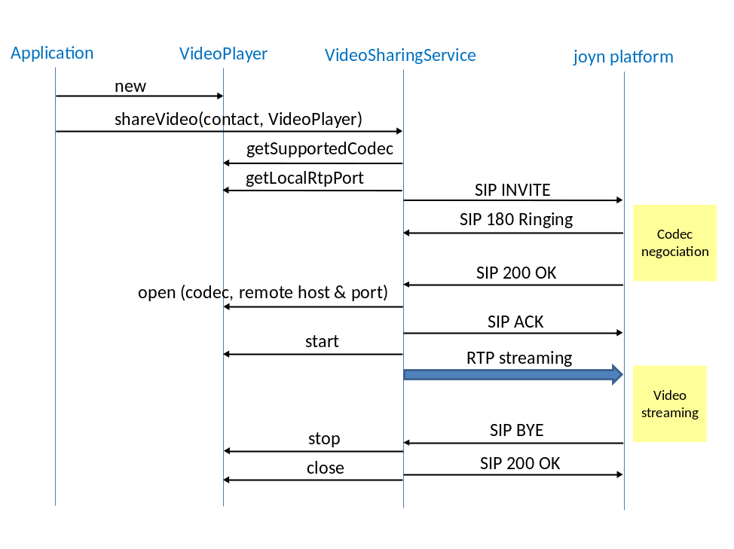
- : Terminating side
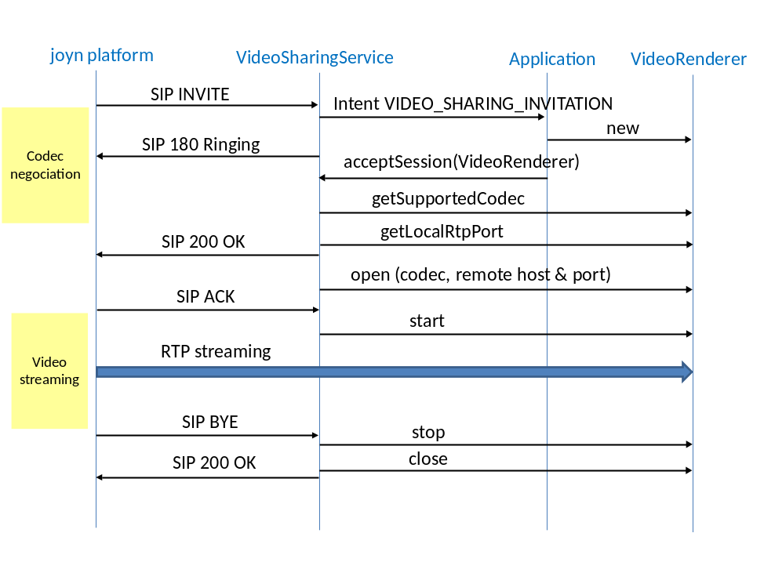
- : Add Caption

Permissions
Access to the Video Share API requires the following permissions:
- com.gsma.services.rcs.RCS_VIDEOSHARE_RECEIVE: this is a new permission that is required by a client in order to handle the receipt of a video shared by a remote party.
- com.gsma.services.rcs.RCS_VIDEOSHARE_SEND: this is a new permission that is required by a client in order to initiate the sharing of a video with a remote party.
- com.gsma.services.rcs.RCS_VIDEOSHARE_READ: this is a new permission that is required by a client in order to read the video share history from the content provider.

Geoloc Share API
This API exposes all functionality related to share a geoloc during a CS call via the Geoloc Share Service. It allows to:
- Send a geoloc share request
- Receive notifications about incoming geoloc share invitation.
- Monitors a geoloc share’s progress.
- Cancel a geoloc share in progress.
- Accept/reject an incoming geoloc share request.
A geoloc contains the following information:
- a label associated to the geoloc info
- latitude
- longitude

- accuracy of the geoloc info (in meter)
- an expiration date of the geoloc info
The shared geoloc is displayed to the end user and also stored in the Chat log in order to be displayed afterwards from the “Show us in a map” service.

Package
Package name com.gsma.services.rcs.gsh

Methods and Callbacks
Class GeolocSharingService:
This class offers the main entry point to share a geoloc during a CS call, when the call hangs up the sharing is automatically stopped. Several applications may connect/disconnect to the API.
- Method: connects to the API.
void connect()

- Method: disconnects from the API.
void disconnect()

- Method: returns the list of geoloc sharing in progress.
Set<GeolocSharing> getGeolocSharings()

- Method: returns a current geoloc sharing from its unique ID.
GeolocSharing getGeolocSharing(String sharingId)

- Method: returns a current geoloc sharing from its invitation Intent.
GeolocSharing getGeolocSharingFor(Intent intent)

- Method: shares a geoloc with a contact. The parameter contact supports the following formats: MSISDN in national or international format, SIP address, SIP-URI or Tel-URI. An exception is thrown if there is no ongoing CS call.
GeolocSharing shareGeoloc(String contact, Geoloc geoloc, GeolocSharingListener listener)

- Method: adds a new geoloc sharing invitation listener.
void addNewGeolocSharingListener(NewGeolocSharingListener listener)

- Method: removes a new geoloc sharing invitation listener.
void removeNewGeolocSharingListener(NewGeolocSharingListener listener)

Class GeolocSharing:
This class maintains the information related to a geoloc sharing and offers methods to manage the sharing.
- Method: returns the sharing ID of the geoloc sharing.
String getSharingId()

- Method: returns the remote contact.
String getRemoteContact()

- Method: returns the geoloc info to be shared.
Geoloc getGeoloc()

- Method: returns the state of the geoloc sharing. The state may have the following values: INVITED, INITIATED, STARTED, TRANSFERRED, ABORTED, and FAILED.
int getState()

- Method: returns the direction of the sharing: INCOMING, OUTGOING.
int getDirection()

- Method: accepts geoloc sharing invitation.
void acceptInvitation()

- Method: rejects geoloc sharing invitation.
void rejectInvitation()

- Method: aborts the sharing.
void abortSharing()

- Method: adds a listener on geoloc sharing events.
void addEventListener(GeolocSharingListener listener)

- Method: removes a listener from geoloc sharing.
void removeEventListener(GeolocSharingListener listener)

Class GeolocSharingListener:
This class offers callback methods on geoloc sharing events.

- Method: callback called when the sharing is started.
void onSharingStarted()

- Method: callback called when the sharing has been aborted.
void onSharingAborted()

- Method: callback called when the sharing has failed. The error code may be: INVITATION_DECLINED, SAVING_FAILED, SHARING_FAILED.
void onSharingError(int error)

- Method: callback called during the sharing progress.
void onSharingProgress(long currentSize, long totalSize)

- Method: callback called when the sharing has been terminated. The parameter geoloc contains the geoloc info.
void onGeolocShared(Geoloc geoloc)

- Class NewGeolocSharingListener:
This class offers callback method to receive new geoloc sharing invitation.
- Method: callback called when a new geoloc sharing invitation has been received.
void onNewGeolocSharing(String sharingId)

Note: the object “Geoloc” is already defined in the Chat API.

Intents
Intent broadcasted when a new geoloc sharing invitation has been received. This Intent contains the following extras:
- “contact”: MSISDN of the contact sending the invitation.
- “contactDisplayname”: display name of the contact sending the invitation (extracted from the SIP address).
- “sharingId”: unique ID of the geoloc sharing.
com.gsma.services.rcs.gsh.action.NEW_GEOLOC_SHARING

Content Providers
The geoloc info shared during a call is stored in the Chat Log. There is no specific call log as with the Image/Video Sharing services.

Permissions
Geoloc Share is a convenience mechanism to allow geolocation information to be delivered in a chat message. From the perspective of a client receiving such events, the permissions are no different from those relating to any other chat message. On the sending side, permissions are defined that govern the ability of a client to access geolocation information, and to send that information via the Geoloc Share mechanism.
Access to the Geoloc API is requires the following permissions:
- android.permission.ACCESS_FINE_LOCATION: this is the standard Android permission that governs whether or not the app is entitled to access fine-grained geolocation information such as might be available from GPS.
- android.permission.ACCESS_COARSE_LOCATION: this is the standard Android permission that governs whether or not the app is entitled to access coarse-grained geolocation information such as might be available from CellID or WiFi sources.
- com.gsma.services.rcs.RCS_LOCATION_SEND: this is a new permission that is required to send Geolocation data over an RCS chat session.
- com.gsma.services.rcs.RCS_USE_CHAT: this is the permission that governs access to the chat API which is a prerequisite to being able to use the Geoloc Share API.
- com.gsma.services.rcs.RCS_READ_CHAT: this is the permission that that is required by a client in order to read data relating to geloocation push events in the chat history from the content provider.

IP Call API
This API exposes all functionality related to manage the IP Call service. It allows to:
- Initiate an IP Call: voice only, voice & video.
- Receive notifications about incoming IP Call invitation.
- Monitors an IP Call (call hold, call events, etc.).
- Ends a current IP Call.
- Accept/reject an incoming IP Call.
- Read configuration elements affecting IP call.
The media engine which process audio and video samples is implemented by the application (via software or via hardware), in this case the API stays independent from the media engine implementation and offers more openness.

Package
Package name com.gsma.services.rcs.ipcall

Methods and Callbacks
Class IPCallService:
This class offers the main entry point to manage IP Calls. Several applications may connect/disconnect to the API.
- Method: connects to the API.
void connect()

- Method: disconnects from the API.
void disconnect()

- Method: returns the list of IP calls in progress.
Set<IPCall> getIPCalls()

- Method: returns a current IP call from its unique ID.
IPCall getIPCall(String callId)

- Method: returns a current IP call from its invitation Intent.
IPCall getIPCallFor(Intent intent)

- Method: initiates an IP Call with a contact. The parameter contact supports the following formats: MSISDN in national or international format, SIP address, SIP-URI or Tel-URI. The parameters player and renderer contain respectively a media player and a media renderer which stream over RTP the live audio and live video. The media player/renderer are interfaces which permit to have an implementation independent from the joyn API.
IPCall initiateCall(String contact, IPCallPlayer player, IPCallRenderer renderer, IPCallListener listener)

- Method: returns the configuration for IP call service.
IPCallServiceConfiguration getConfiguration()

- Method: adds a new IP call invitation listener.
void addNewIPCallListener(NewIPCallListener listener)

- Method: removes a new IP call invitation listener.
void removeNewIPCallListener(NewIPCallListener listener)

Class IPCall:
This class maintains the information related to an IP Call and offers methods to manage the call.
- Method: returns the call ID of the IP call.
String getCallId()

- Method: returns the remote contact.
String getRemoteContact()

- Method: returns the state of the IP call. The state may have the following values: INVITED, INITIATED, STARTED, ABORTED, FAILED.
int getState()

- Method: returns the direction of the sharing: INCOMING, OUTGOING.
int getDirection()

- Method: accepts IP call invitation.
void acceptInvitation(IPCallPlayer player, IPCallRenderer renderer)

- Method: rejects IP call invitation.
void rejectInvitation()

- Method: aborts the call.
void abortCall()

- Method: checks if the call is on hold.
boolean isOnHold()

- Method: puts a call on hold.
void holdCall()

- Method: continues a call that hold on.
void continueCall()

- Method: adds a listener on IP call events.
void addEventListener(IPCallListener listener)

- Method: removes a listener from IP call.
void removeEventListener(IPCallListener listener)

Class IPCallListener:
This class offers callback methods on IP call events.
- Method: callback called when the call is started.
void onCallStarted()

- Method: callback called when the call has been aborted.
void onCallAborted()

- Method: callback called when the call has failed. The error code may be: INVITATION_DECLINED, CALL_FAILED.
void onCallError(int error)

- Method: callback called when the call has been held.
void onCallHeld()

- Method: callback called when the call continues after being on hold.
void onCallContinue()

Class NewIPCallListener:
This class offers callback method to receive new IP call invitation.
- Method: callback called when a new IP call invitation has been received.
void onNewCall(String callId)

Class IPCallPlayer:
This class offers an interface to manage the IP call player instance independently of the joyn service. The IP call player is implemented on the application side.
- Method: opens the player and prepares resources (e.g. encoder, microphone, camera).
void open(AudioCodec audiocodec, VideoCodec videocodec, String remoteHost, int remoteAudioPort, int remoteVideoPort)

- Method: closes the player and de-allocates resources.
void close()

- Method: starts the player.
void start()

- Method: stops the player.
void stop()

- Method: returns the local RTP port used to stream audio.
int getLocalAudioRtpPort()

- Method: returns the local RTP port used to stream video.
int getLocalVideoRtpPort()

- Method: returns the list of audio codecs supported by the player.
AudioCodec[] getSupportedAudioCodecs()

- Method: returns the list of video codecs supported by the player.
VideoCodec[] getSupportedVideoCodecs()

- Method: adds a listener on IP call player events.
void addEventListener(IPCallPlayerListener listener)

- Method: removes a listener from IP call player.
void removeEventListener(IPCallPlayerListener listener)

Class IPCallPlayerListener:
This class offers callback methods on IP call player events.
- Method: callback called when the player is opened.
void onPlayerOpened()

- Method: callback called when the player is started.
void onPlayerStarted()

- Method: callback called when the player is stopped.
void onPlayerStopped()

- Method: callback called when the player is closed.
void onPlayerClosed()

- Method: callback called when the player has failed.
void onPlayerError(int error)

Class IPCallRenderer:
This class offers an interface to manage the IP call renderer instance independently of the joyn service. The IP call renderer is implemented on the application side.
- Method: opens the renderer and prepares resources (e.g. decoder, display).
void open(AudioCodec audiocodec, VideoCodec videocodec, String remoteHost, int remoteAudioPort, int remoteVideoPort)

- Method: closes the renderer and de-allocates resources.
void close()

- Method: starts the renderer.
void start()

- Method: stops the renderer.
void stop()

- Method: returns the local RTP port used to stream audio.
int getLocalAudioRtpPort()

- Method: returns the local RTP port used to stream video.
int getLocalVideoRtpPort()

- Method: returns the list of audio codecs supported by the renderer.
AudioCodec[] getSupportedAudioCodecs()

- Method: returns the list of video codecs supported by the renderer.
VideoCodec[] getSupportedVideoCodecs()

- Method: adds a listener on IP call renderer events.
void addEventListener(IPCallRendererListener listener)

- Method: removes a listener from IP call renderer.
void removeEventListener(IPCallRendererListener listener)

Class IPCallRendererListener:
This class offers callback methods on IP call renderer events.
- Method: callback called when the renderer is opened.
void onRendererOpened()

- Method: callback called when the renderer is started.
void onRendererStarted()

- Method: callback called when the renderer is stopped.
void onRendererStopped()

- Method: callback called when the renderer is closed.
void onRendererClosed()

- Method: callback called when the renderer has failed.
void onRendererError(int error)

Class AudioCodec:
This class maintains the information related to an audiocodec.
- Method: returns the encoding name (e.g. AMR_WB).
String getEncoding()

- Method: returns the codec sample rate (e.g. 15).
int getSampleRate()

- Method: returns the codec payload type (e.g. 96).
int getPayloadType()

- Method: returns a codec parameter from its key name (e.g. packetization-mode).
String getParameter(String key)

Class VideoCodec:
This class maintains the information related to a video codec.
- Method: returns the encoding name (e.g. H264).
String getEncoding()

- Method: returns the codec payload type (e.g. 96).
int getPayloadType()

- Method: returns the codec clock rate (e.g. 90000).
int getClockRate()

- Method: returns the codec frame rate (e.g. 10).
int getFrameRate()

- Method: returns the codec bit rate (e.g. 64000).
int getBitRate()

- Method: returns the video width (e.g. 176).
int getVideoWidth()

- Method: returns the video height (e.g. 144).
int getVideoHeight()

- Method: returns a codec parameter from its key name (e.g. profile-level-id, packetization-mode).
String getParameter(String key)

Class IPCallServiceConfiguration:
This class represents the particular configuration of IP Call Service.
- Method: returns True if the IP voice call service can reach any user or returns False if only joyn users supporting the capability may be called.
boolean isVoiceCallBreakout()

Intents
Intent broadcasted when a new IP call invitation has been received. This Intent contains the following extras:
- “contact”: MSISDN of the contact sending the invitation.
- “contactDisplayname”: display name of the contact sending the invitation (extracted from the SIP address).
- “callId”: unique ID of the IP call.
- “audioEncoding”: audio encoding (eg. AMR).
- “videoEncoding”: video encoding (eg. H264).
- “videoWidth”: video width (e.g. 176 for QCIF).
- “videoHeight”: video height (e.g. 144 for QCIF).
com.gsma.services.rcs.ipcall.action.NEW_CALL

Content Providers
A content provider is used to store the IP call history persistently. There is one entry per call.
The content provider has the following columns:

Data | Data type | Comment
CALL_ID | TEXT | Unique call identifier
CONTACT_NUMBER | TEXT | Contains the MSISDN of the remote contact
DIRECTION | Integer | Incoming sharing or outgoing sharing
TIMESTAMP | Long | Date of the sharing
STATE | integer | See note below for the list of states
DURATION | Long | Duration of the call in seconds. The value is only set at the end of the call.

Note: State values for IP call session management :

- INVITED : incoming session.
- INITIATED : outgoing session.
- STARTED : invitation has been accepted and call is started.
- ABORTED: session has been aborted.
- TERMINATED: session has been terminated.
- FAILED : session has failed.
- INACTIVE: session is not yet active.

Permissions
Access to the IP Call API requires the following permissions:
- com.gsma.services.rcs.RCS_USE_IPCALL this is a new permission that governs access to the IP Call API, and is required to initiate, receive and to manage RCS IP Call sessions.
- com.gsma.services.rcs.RCS_READ_IPCALL: this is a new permission that that is required by a client in order to read the IP Call history from the content provider.

Contacts API
There is already an Android API to manage contacts of the local address book, see Android package android.provider.ContactsContract. This API offers additional methods to:
- Add RCS info in the local address book,
- Extract RCS info from the local address book.

Package
Package name com.gsma.services.rcs.contacts

Methods and Callbacks
Class ContactsService:
This class offers methods to extract RCS info associated to contacts from the local address book.
- Method: connects to the API.
void connect()

- Method: disconnects from the API.
void disconnect()

- Method: returns the list of joyn contacts.
Set<joynContact> getjoynContacts()

- Method: returns the list of contacts online (i.e. registered).
Set<joynContact> getjoynContactsOnline()

- Method: returns the list of contacts supporting a given extension or service ID (i.e. capability).
Set<joynContact> getjoynContactsSupporting(String serviceId)

- Method: get the vCard of a contact. The parameter contact contains the database URI of the contact in the native address book. The method returns the complete filename including the path of the visit card. The filename has the file extension “.vcf” and is generated from the native address book vCard URI (see Android SDK attribute ContactsContract.Contacts.CONTENT_VCARD_URI which returns the referenced contact formatted as a vCard when opened through openAssetFileDescriptor(Uri, String)).
static String getVCard(Context ctx, Uri contact)

Class JoynContact:
This class maintains the information related to a joyn contact.
- Method: returns the canonical contact ID (i.e. MSISDN).
String getContactId()

- Method: returns the capabilities associated to the contact.
com.gsma.services.rcs.capability.Capabilities getCapabilities()

- Method: is contact online (i.e. registered to the service platform).
boolean isRegistered()

Content Providers
In addition to the methods, the RCS information are stored in the local address book thanks to the Contacts Contract interface of the Android Software Development Kit (SDK). This permits to have a native integration of joyn in the address book.
See the following MIME-type to be supported:
MIME type | Comment
vnd.android.cursor.item/com.gsma.services.rcs.number | RCS phone number
vnd.android.cursor.item/com.gsma.services.rcs.registration-state | Registration state (online | offline)
vnd.android.cursor.item/com.gsma.services.rcs.image-share | Image share capability supported
vnd.android.cursor.item/com.gsma.services.rcs.video-share | Video share capability supported
vnd.android.cursor.item/com.gsma.services.rcs.im-session | IM/Chat capability supported
vnd.android.cursor.item/com.gsma.services.rcs.file-transfer | File transfer capability supported
vnd.android.cursor.item/com.gsma.services.rcs.extensions | RCS extensions supported
Implementation notes:
- To store the MIME-type see the following tutorial http://developer.android.com/reference/android/provider/ContactsContract.RawContacts.html.
- A raw contact is created to store the RCS info associated to a contact. A RCS account is created to manage raw contacts.
- When a contact becomes enriched with RCS information, we associate a corresponding raw contact with MIME type vnd.android.cursor.item/vnd.joyn.
- The number associated to the contact is put into the field Data.DATA1.
- The supported MIME type is put into the field Data.MIMETYPE.
- The description associated to the supported MIME type is always put into the field Data.DATA2. This label is displayed at UI level (i.e. menu item of the local native address book).
- If a MIME type is not set for a contact, this means the associated capability is not supported.

Permissions
Access to the Contacts API requires the following permissions:
- android.permission.READ_CONTACTS: this permission is required by any client using the capabilities service, since use of the API implicitly reveals information about past and current contacts for the device.
- Additionally, methods that reveal contact capabilities (getjoynContactsSupporting() and getCapabilities()) require:
- com.gsma.services.rcs.RCS_READ_CAPABILITIES: this is a new permission that governs access to capability information.

API Versioning
This API maintains information about the current version of the RCS terminal API.
A build is identified by:
- GSMA version: hotfixes, Blackbird, .etc.
- Implementer name: entity name who has implemented the API.
- Release number of the API.
- Incremental number to identify the build into a release number.
A software release of the API is identified uniquely by its release number and the incremental number.

Package
Package name com.gsma.services.rcs

Methods and Callbacks
Class Build:
This class offers information related to the build version of the API.

- Constant: API release implementer name.
public final static String API_CODENAME

- Constant: API version number from class Build.VERSION_CODES.
public final static int API_VERSION.

- Constant: Internal number used by the underlying source control to represent this build.
public final static int API_INCREMENTAL

Class Build.VERSION_CODES:
This class contains the list of API versions.
- Constant: The original first version of joyn API or hotfixes version.
public final static int BASE

- Constant: Blackbird version
public final static int BLACKBIRD

- Constant: Crane version
public final static int CRANE

======================= End of changes================================

