 |  | RCSJTA TT BB CR_030  VideoShare API
Meeting Information
Meeting Name and Number
Meeting Date
Meeting Location |  | Conference Call
Document Information
Document Author(s) |  | Heri Parid Pardian, Samsung
Document Creation Date |  | June 10th 2014
 |  | Approval | X
This document is for: (mark X as appropriate) |  | Discussion
 |  | Information only
Security Classification – Non Confidential / Confidential GSMA Material (Delete as appropriate and delete the rows below that do not apply) |  |  | Can be distributed to: (mark X as appropriate or specify group
Non Confidential |  | Public
Confidential |  | Project Team or Group | X
Confidential |  | GSMA HQ Staff | X
Confidential |  | GSMA Full Members | X
Confidential |  | GSMA Associate Members | X
Confidential |  | GSMA Rapporteur Members | X
Document Summary
CR created to Samsung’s proposed document format (GSMA PRD format) to update Introduction and Architecture sections based on the feedback received during London F2F meeting.

Document History
Date | Version | Author / Comments and for updates description of changes
06/10/2014 | R1 | Initial document
07/11/2014 | R2 | Hyejung Kim / Remove all incoming/outgoing* classes
07/21/2014 | R3 | Hyejung Kim / Integrated version – Internalized + externalised video codec
08/05/2014 | R4 | Hyejung Kim / Add Orange and Sony’s feedback
08/11/2014 | R5 | Hyejung Kim / feedback from conference call

© GSMA 2010. The GSM Association (“Association”) makes no representation, warranty or undertaking (express or implied) with respect to and does not accept any responsibility for, and disclaims liability for the accuracy or completeness or timeliness of the information contained in this document. The information contained in this document may be subject to change without prior notice. This document has been classified according to the GSMA Document Confidentiality Policy. GSMA meetings are conducted in full compliance with the GSMA Antitrust Policy.

RCC TF Change Request Form
Title: | Video Share API
Type of Change Request: Mark the appropriate box by “X” | New Feature |  | Major  Change Errata
  X
Targeted Document | Rcs Terminal API Specification
Impact on Other Official Documents: | None

======================= Summary of Changes =============================
06/10/2014 – Samsung: propose simplicity for Video Share API
07/11/2014 - Remove all incoming/outgoing* classes
07/21/2014 - Integrated version – Internalized + externalized video codec
- Previous VideoPlayer is changed to VideoSurface
- From Sony’s feedback, APIs related to several accepted CRs are added or removed.
- For default codec, we introduced the below APIs. Each of them are highlighted at the detailed description of Video Share API.
  - VideoSharingService
    - VideoSharing shareVideo(ContactId contact)
  - VideoSharing
    - void acceptInvitation()
    - boolean setOrientation(enum Orientation)
    - boolean setCamera(enum Camera)
  - VideoSharingListener
    - void onIncomingVideoDescriptorChanged(VideoDescriptor descriptor)
    - void onIncomingCameraChanged(VideoDescriptor descriptor)
  - VideoDescriptor and VideoSurface classes are newly introduced.
07/25/2014 – Add several value and method
- More enum values for orientation are added.
ANGLE_0(0), ANGLE_90(1), ANGLE_180(2), ANGLE_270(3)
- getCamera() in VideoDescriptor is added.
- onIncomingCameraChanged() is removed because the information could be get via onIncomingVideoDescriptorChanged(). Because they have same parameter type such as VideoDescriptor and FW doesn’t need to distinguish b/w them. And if there are modifications in orientation and camera type at the same time, FW needs to send 2 callbacks. It wouldn’t be efficient.
08/05/2014 – Add several changes and orange and sony’s feedback
- VideoSharing shareVideo(ContactId contact, VideoDescriptor descriptor, Surface surface) // parameters are added
- void onVideoSharingStateChanged(ContactId contact, String sharingId, enum State state, VideoDescriptor descriptor) // parameter is added
- VideoDescriptor(Orientation orientation, int width, int height, enum Camera source)
- enum Camera getCamera()
- VideoDescriptor getRemoteVideoDescriptor() is removed.
08/08/2014 – Add GSMA meeting review and remove VideoPlayer/VideoRenderer
- Change the "enum Camera " to "enum CameraSource"
- onVideoSharingStateChanged()’s descriptor parameter is removed.
- attachSurface()’s descriptor parameter is removed.
- Sequence diagram is updated.
- VideoPlayer and VideoRenderer is removed to separate the media control with the core implementation
  - VideoSharing shareVideo(ContactId contact, VideoCodec[] codec, int remotePort)
  - void acceptInvitation(VideoCodec[] codec, int remotePort)
- VideoDescriptor getRemoteVideoDescriptor() is added to consider resume scenario.
- Overloaded default codec's method name for shareVideo() and acceptInvitation() is changed to avoid misunderstanding by user.
  - shareVideoUsingDefaultCodec() and acceptInvitationUsingDefaultCodec()
08/19/2014 – Internal review
- void attachSurface(Surface surface)
- Remove VideoCodec’s width and height and add VideoDesriptor instead of them
- VideoPlayer is added again with removing open(), start(), stop(), close() but adding setRemoteInfo() because it wasn't efficient only with VideoCodec and remotePort
  - shareVideo(contact, VideoPlayer player)
  - acceptInvitation(VideoPlayer player)
- Sequence diagrams are updated

- Default codec concept is also needed to be considered in IP call

08/27/2014 – R07 provide by Kelvin
- Cleaned all agreed comments and accepted all agreed changes by Kelvin Qin, to accommodate SONY to add comments
08/29/2014 – R8 provide by Kelvin
- Incorporated SONY’s comment, and left one comment to next review. The generic question is how to make API simpler to use for the developers.
08/29/2014 – R09 provide by Kelvin
- Reviewed the last open comments in RCSJTA call. This version was agreed by the participants in the call.
======================= End of Summary =================================

======================= 1st Change ==================================

Video Share API
This API exposes all functionality related to sharing a live video stream during a CS call via the Video Share Service. It allows:
- Send a video share request.
- Receive notifications about incoming video share invitation and sharing events.
- Cancel an on-going video share.
- Accept/reject an incoming video share request.
- Read configuration elements affecting video share.
- Can use an external codec or default codec for video share.
  - External codec : Programmer’s externally customized codec.
  - Default codec : Stack’s internal codec.

Package
Package name com.gsma.services.rcs.vsh

Methods and Callbacks
Class VideoSharingService:
This class offers the main entry point to share a live video during a CS call, when the call hangs up the sharing is automatically stopped. Several applications may connect/disconnect to the API.
- Method: connects to the API.
void connect()

- Method: disconnects from the API.
void disconnect()

- Method: returns the list of video sharing in progress.
Set<VideoSharing> getVideoSharings()

- Method: returns a video sharing from its unique ID.
VideoSharing getVideoSharing(String sharingId)

- Method: shares a live video stream with a contact. The parameter player contains a media player which streams over RTP the live video from the camera. The media player is an interface which permits to have a player implementation independent from the RCS API. An exception is thrown if there is no on-going CS call. It’s for the external codec.
VideoSharing shareVideo(ContactId contact, VideoPlayer player)

- Method: shares a live video stream with a contact. It will use the default codec. If the application’s scenario needs to have camera preview before VSH is started, then developer can add the surface here.
VideoSharing shareVideo(ContactId contact, VideoDescriptor descriptor, Surface surface)

- Method: returns the configuration for video share service.
VideoSharingServiceConfiguration getConfiguration()

- Method: adds a video share event listener.
void addEventListener(VideoSharingListener listener)

- Method: removes a video share event listener.
void removeEventListener(VideoSharingListener listener)

- Method: deletes all video sharings.
void deleteVideoSharings()

- Method: deletes video sharings associated with a given contact from history.
void deleteVideoSharings(ContactId contact)

- Method: deletes a videosharing from its sharing ID from history.
void deleteVideoSharing(String sharingId)

Class VideoSharing:
This class maintains the information related to a video sharing and offers methods to manage the sharing.
public class Encoding {

public final static String H264 = “H264”;

}

- Enum: the VideoSharing state.
enum State { UNKNOWN(0), INVITED(1), INITIATED(2), STARTED(3), ABORTED(4), FAILED(5), TERMINATED(6), REJECTED(7), RINGING(8) }

- Enum: the reason code for the video sharing.
enum ReasonCode { UNSPECIFIED(0), ABORTED_BY_USER(1), ABORTED_BY_REMOTE(2), ABORTED_BY_SYSTEM(3), ABORTED_BY_SECONDARY_DEVICE(4), REJECTED_MAX_SHARING_SESSIONS(5), REJECTED_BY_USER(6) REJECTED_BY_REMOTE(7), REJECTED_TIME_OUT(8), FAILED_INITIATION(9), FAILED_SHARING(10) }

- Method: returns the sharing ID of the video sharing.
String getSharingId()

- Method: returns the remote contact.
ContactId getRemoteContact()

- Method: attaches video surface to be proceed by core implementation.
void attachSurface(Surface surface) throws RcsServiceException

- Method: detaches video surface from core implementation.
void detachSurface() throws RcsServiceException
- Method: get the remote video descriptor in case the VideoShare direction is incoming, the local video descriptor in use in case of outgoing direction.
VideoDescriptor getVideoDescriptor()

- Method: returns the state of the video share.
State getState()

- Method: returns the reason code of the video share.
ReasonCode getReasonCode()

- Method: returns the video encoding of the video share.
String getVideoEncoding()
- Method: returns the timestamp of the video share.
long getTimeStamp()

- Method: returns the duration of the video share.
long getDuration()

- Method: returns the direction of the sharing:
com.gsma.services.rcs.Direction getDirection()

- Method: accepts video share invitation with a given renderer. It’s for the external codec.
- void acceptInvitation(VideoPlayer player)

- Method: accepts video share invitation by attaching a surface if user decides to use default codec.
- void acceptInvitation(Surface surface) throws RcsServiceException

- Method: rejects video share invitation.
void rejectInvitation()

- Method: aborts the sharing.
void abortSharing()

- Method: sets the orientation of the video. It will return true if setting the orientation is succeeded otherwise false.
void setOrientation(Orientation orientation)
Enum: The orientation of the video share.
enum Orientation { ANGLE_0(0), ANGLE_90(1), ANGLE_180(2), ANGLE_270(3) }

- Method: sets the source of camera. Only for an outgoing sharing.
void setCameraSource(CameraSource source)

Enum: The camera source of the outgoing video share.
enum CameraSource { BACK(0), FRONT(1) }

Class VideoSharingListener:
This class offers callback methods on video sharing events.
- Method : Callback called when the sharing state/reasonCode is changed.
void onVideoSharingStateChanged(ContactId contact, String sharingId, VideoSharing.State state, VideoSharing.ReasonCode reasonCode)

- Method: callback called when the video descriptor was changed. This is done as a result of a call to VideoShare.setOrientation and VideoShare.setCamera for outgoing VideoShares or when remote VideoDescriptor was change for incoming VideoShares.
void onVideoDescriptorChanged(ContactId contact, String sharingId, VideoDescriptor descriptor)

Class VideoDescriptor:
Class represents an object for video share parameters.
- Constructor: public constructor of a VideoDescriptor.
VideoDescriptor(Orientation orientation, int width, int height, CameraSource source)

Method: returns the orientation of the video stream.
Orientation getOrientation()

- Method: returns the width of video frame.
int getWidth()

- Method: returns the height of video frame.
int getHeight()

- Method: returns the source of camera
CameraSource getCameraSource()

abstract Class VideoPlayer:
This class offers an interface to manage the video player instance independently of the RCS service. The video player is implemented on the application side.

- Method: returns the codec information, remoteHost, remotePort as a result of codec negotiation
void setRemoteInfo(VideoCodec codec, String remoteHost, int remotePort)

- Method: returns the local RTP port used to stream video.
int getLocalRtpPort()

- Method: gets the Video Codec
VideoCodec getCodec()

- Method: returns the list of codecs supported by the player.
VideoCodec[] getSupportedCodecs()

Class VideoCodec:
This class maintains the information related to a video codec.

- Constructor : public constructor of a VideoCodec.
VideoCodec(String encoding, int payload, int clockRate, int frameRate, int bitRate, VideoDescriptor descriptor, String parameters)

- Method: returns the encoding name (e.g. H264).
String getEncoding()

- Method: returns the codec payload type (e.g. 96).
int getPayloadType()

- Method: returns the codec clock rate (e.g. 90000).
int getClockRate()

- Method: returns the codec frame rate (e.g. 10).
int getFrameRate()

- Method: returns the codec bit rate (e.g. 64000).
int getBitRate()

- Method: returns the VideoDescriptor.
VideoDescriptor getVideoDescriptor()

- Method: Returns the list of codec parameters (e.g. profile-level-id, packetization-mode). Parameters are are semicolon separated.
String getParameters()

Class VideoSharingServiceConfiguration:
This class represents the particular configuration of Video Sharing Service.
- Method: returns the maximum authorized duration of the content that can be shared in a VSH session. It can return null if this value was not set by the auto-configuration server.
int getMaxTime()

Intents
Intent broadcasted when a new video sharing invitation has been received. This Intent contains the following extra:
- “sharingId”: unique ID of the sharing.
com.gsma.services.rcs.vsh.action.NEW_VIDEO_SHARING

Content Providers
A content provider is used to store the video sharing history persistently. There is one entry per video sharing.
The content provider has the following columns:
Data | Data type | Comment
SHARING_ID | Text | Unique sharing identifier
CONTACT | Text | ContactId formatted number of the remote contact
DIRECTION | Integer | Incoming sharing or outgoing sharing. See enum Direction
TIMESTAMP | Long | Date of the sharing
STATE | Integer | See enum VideoSharing.State for the list of states
REASON_CODE | Integer | Reason code associated with the video sharing state. See enum VideoSharing.ReasonCode for the list of reason codes
DURATION | Long | Duration of the sharing in seconds. The value is only set at the end of the sharing.
VIDEO_ENCODING | String | Encoding of the shared video
WIDTH | Integer | Width of the shared video
HEIGHT | Integer | Height of the shared video
ORIENTATION | Integer | See enum VideoShare.Orientation for the list of orientations.
CAMERA_SOURCE | Integer | See enum VideoShare.CameraSource for the list of camera sources.

Sequence diagrams
The following diagrams explain the interactions between the video player or video renderer instantiated by the application and the RCS API.

- External codec

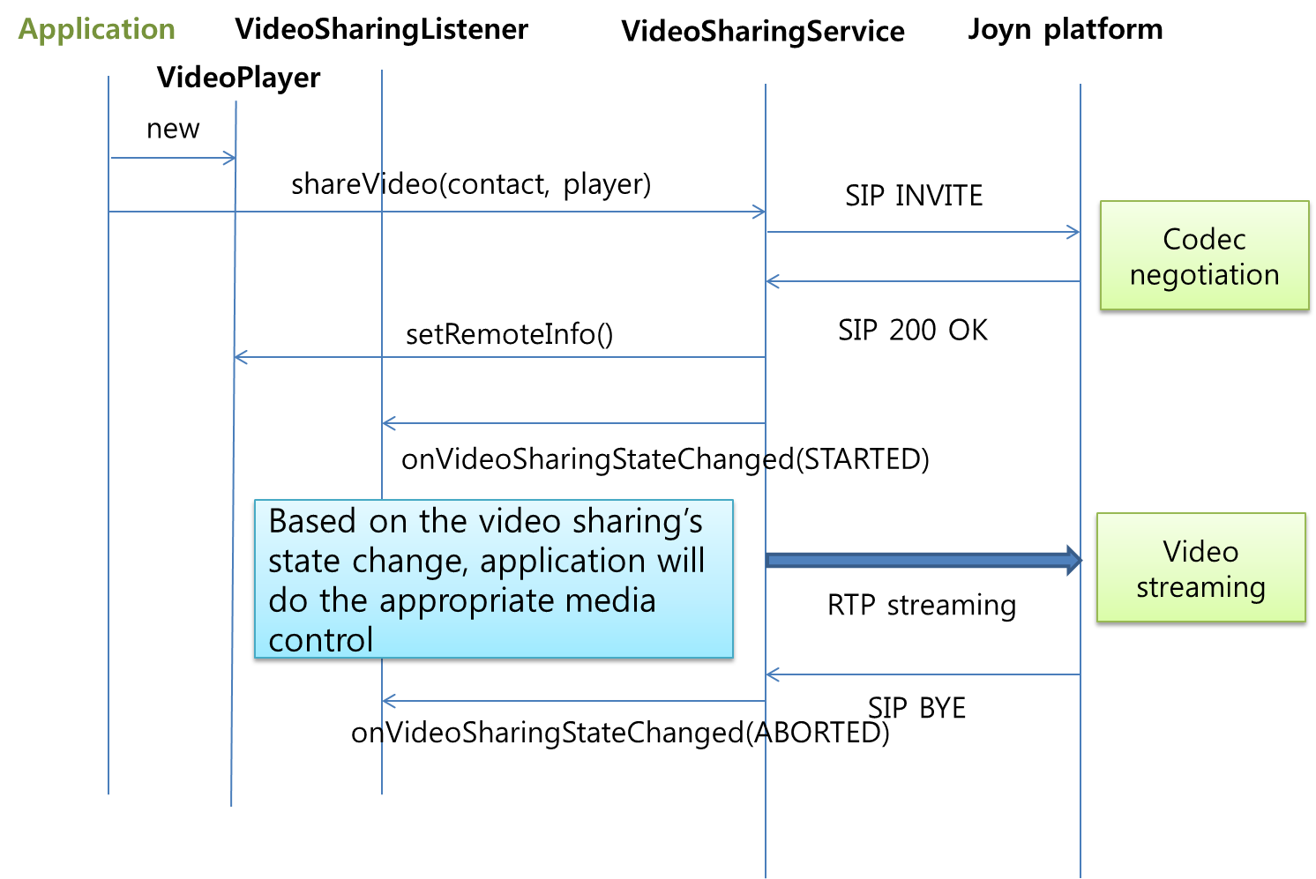
- : Originating side

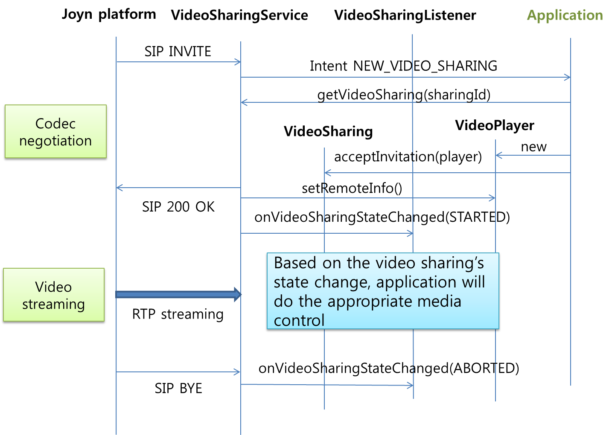
- : Terminating side

Internal codec

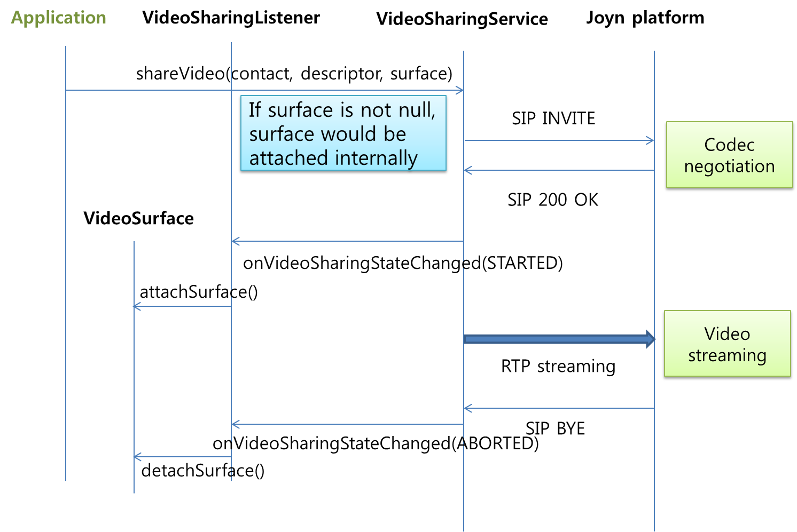
- : Originating side

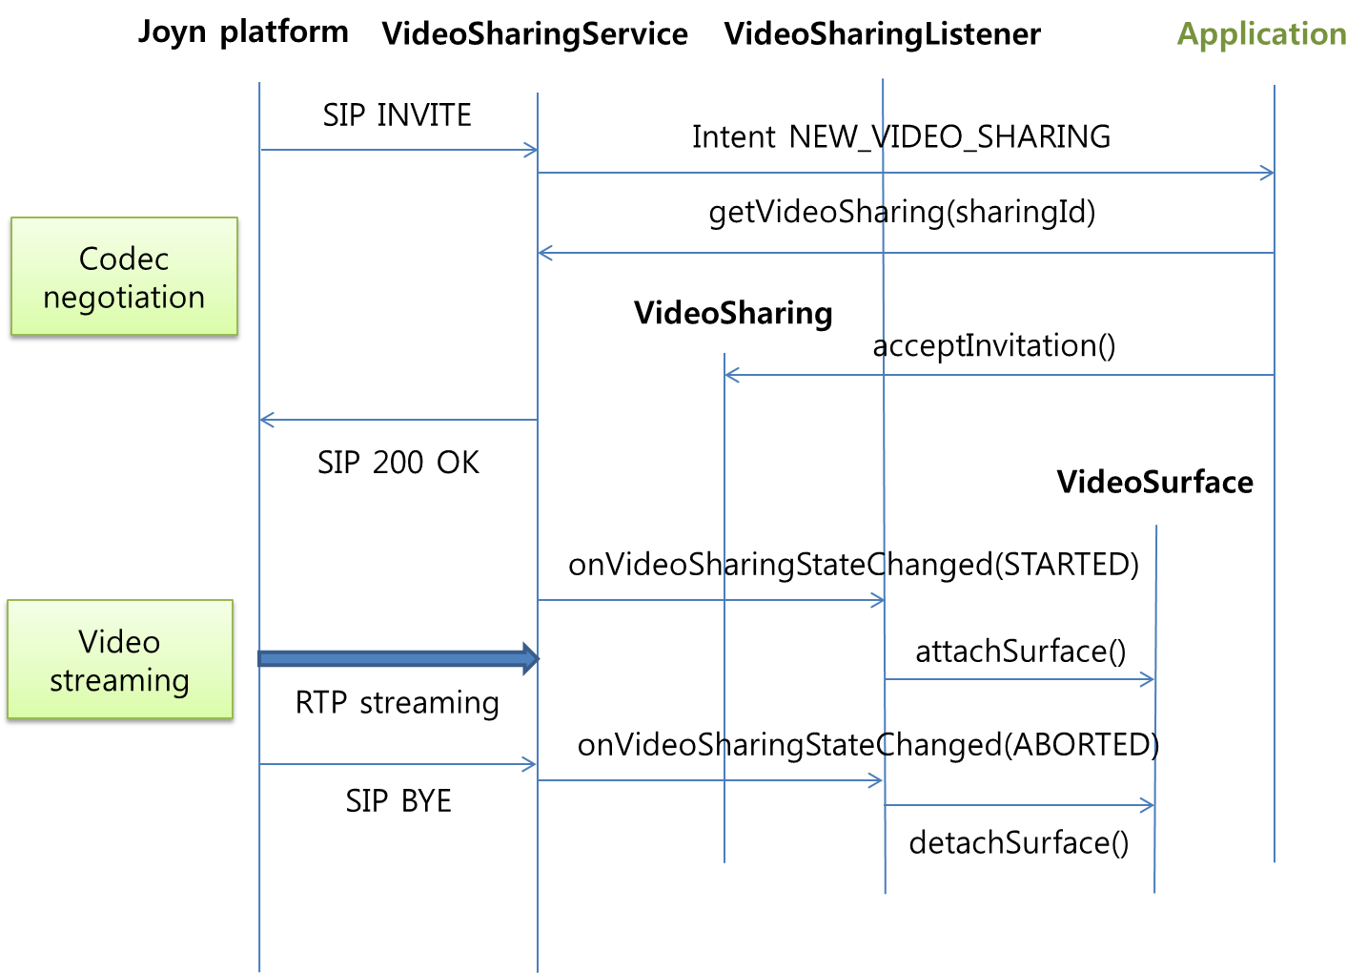
- : Terminating side

Permissions
Access to the Video Share API requires the following permissions:
- com.gsma.services.rcs.RCS_VIDEOSHARE_RECEIVE: this is a new permission that is required by a client in order to handle the receipt of a video shared by a remote party.
- com.gsma.services.rcs.RCS_VIDEOSHARE_SEND: this is a new permission that is required by a client in order to initiate the sharing of a video with a remote party.
- com.gsma.services.rcs.RCS_VIDEOSHARE_READ: this is a new permission that is required by a client in order to read the video share history from the content provider.
======================= End of changes================================

