 |  | RCSJTA TT BB CR_026  Removing New*Listener
Meeting Information
Meeting Name and Number
Meeting Date
Meeting Location |  | Conference Call
Document Information
Document Author(s)
Document Creation Date
 |  | Approval | X
This document is for: (mark X as appropriate) |  | Discussion
 |  | Information only
Security Classification – Non Confidential / Confidential GSMA Material (Delete as appropriate and delete the rows below that do not apply) |  |  | Can be distributed to: (mark X as appropriate or specify group
Non Confidential |  | Public
Confidential |  | Project Team or Group | X
Confidential |  | GSMA HQ Staff | X
Confidential |  | GSMA Full Members | X
Confidential |  | GSMA Associate Members | X
Confidential |  | GSMA Rapporteur Members | X
Document Summary
CR created to Samsung’s proposed document format (GSMA PRD format) to update Introduction and Architecture sections based on the feedback received during London F2F meeting.

Document History
Date | Version | Author / Comments and for updates description of changes
12 June 2014 | R1 | Hyejung Kim(hyejung8.kim@samsung.com)

© GSMA 2010. The GSM Association (“Association”) makes no representation, warranty or undertaking (express or implied) with respect to and does not accept any responsibility for, and disclaims liability for the accuracy or completeness or timeliness of the information contained in this document. The information contained in this document may be subject to change without prior notice. This document has been classified according to the GSMA Document Confidentiality Policy. GSMA meetings are conducted in full compliance with the GSMA Antitrust Policy.

RCC TF Change Request Form
Title: | Removing New*Listener
Type of Change Request: Mark the appropriate box by “X” | New Feature |  | Major  Change Errata
  X
Targeted Document | joyn Terminal API Specification
Impact on Other Official Documents: | None

======================= Summary of Changes =============================
12/06/2014 – Samsung :
The below listeners could be replaced with each of intents.

 | New*Listener | Intents
1 | NewChatListener | com.gsma.services.rcs.chat.action.NEW_CHAT  com.gsma.services.rcs.chat.action.NEW_GROUP_CHAT
2 | NewFileTransferListener | com.gsma.services.rcs.ft.action.NEW_FILE_TRANSFER
3 | NewImageSharingListener | com.gsma.services.rcs.ish.action.NEW_IMAGE_SHARING
4 | NewVideoSharingListener | com.gsma.services.rcs.vsh.action.NEW_VIDEO_SHARING
5 | NewGeolocSharingListener | com.gsma.services.rcs.gsh.action.NEW_GEOLOC_SHARING
6 | NewIPCallListener | com.gsma.services.rcs.ipcall.action.NEW_CALL

It could be much easier to maintain smaller API set with removing some redundant codes.
And Intent could be more general way because it could cover the scenario when app is not active state and it doesn't add New*Listener.
======================= End of Summary =================================

======================= 1st Change ==================================

IM/Chat API

Incoming session request
Error: Reference source not found is an example that shows the flow for an RCS client receiving an IM/Chat session request from a remote contact.

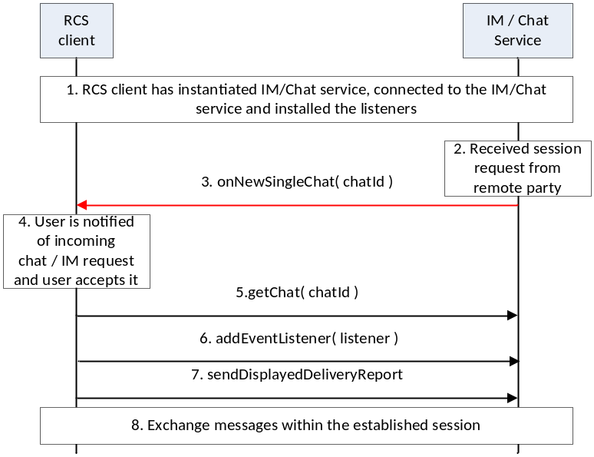
- : Establish a one-to-one chat session with remote party
- The RCS client instantiates a service instance of the IM/Chat Service, establishes a connection with the IM/Chat Service and associates the listener with this RCS client.
- IM/Chat Service receives a request for a session from a remote party
- IM/Chat Service notifies the RCS client through the invocation of the appropriate listener function
- The RCS client notifies the user by displaying the message received in the incoming session invitation to the user. The user accepts the session request
- The RCS client retrieves the chat object associated with this session
- The RCS client installs the listener function for this chat session
- The RCS client requests the IM/Chat service to send to the remote party, an indication of display of the message to the user
- Using procedures described in Error: Reference source not found, the two users exchange IM / Chat messages

Methods and Callbacks
Class ChatService:
This class offers the main entry point to initiate chat conversations with contacts: 1-1 and group chat conversation. Several applications may connect/disconnect to the API.
- Method: connects to the API.
void connect()

- Method: disconnects from the API.
void disconnect()

- Method: opens a single chat with a given contact and returns a Chat instance. The parameter contact supports the following formats: MSISDN in national or international format, SIP address, SIP-URI or Tel-URI.
Chat openSingleChat(String contact, ChatListener listener)

- Method: initiates a group chat with a group of contacts and returns a GroupChat instance. The subject is optional and may be null.
GroupChat initiateGroupChat(Set<String> contacts, String subject, GroupChatListener listener)

- Method: rejoins an existing group chat from its unique chat ID.
GroupChat rejoinGroupChat(String chatId)

- Method: restarts a previous group chat from its unique chat ID.
GroupChat restartGroupChat(String chatId)

- Method: adds a listener on new chat invitation event.
void addNewChatListener(NewChatListener listener)

- Method: removes a listener on new chat invitation event.
void removeNewChatListener(NewChatListener listener)

- Method: returns the list of single chats in progress.
Set<Chat> getChats()

- Method: returns a chat in progress from its unique ID.
Chat getChat(String chatId)

- Method: returns a single chat from its invitation Intent.
Chat getChatFor(Intent intent)

- Method: returns the list of group chats in progress.
Set<GroupChat> getGroupChats()

- Method: returns a group chat in progress from its unique ID.
GroupChat getGroupChat(String chatId)

- Method: returns a group chat from its invitation Intent.
GroupChat getGroupChatFor(Intentintent)

- Method: returns the configuration for chat service.
ChatServiceConfiguration getConfiguration()

Class NewChatListener:
This class offers callback methods on a new chat invitation event.
- Method: callback called when a new chat invitation has been received
void onNewSingleChat(String chatId, ChatMessage message)

- Method: callback called when a new group chat invitation has been received
void onNewGroupChat(String chatId)

File Transfer API

Incoming session request
Error: Reference source not found is an example that shows the flow for a FT client receiving a File Transfer request from a remote contact.

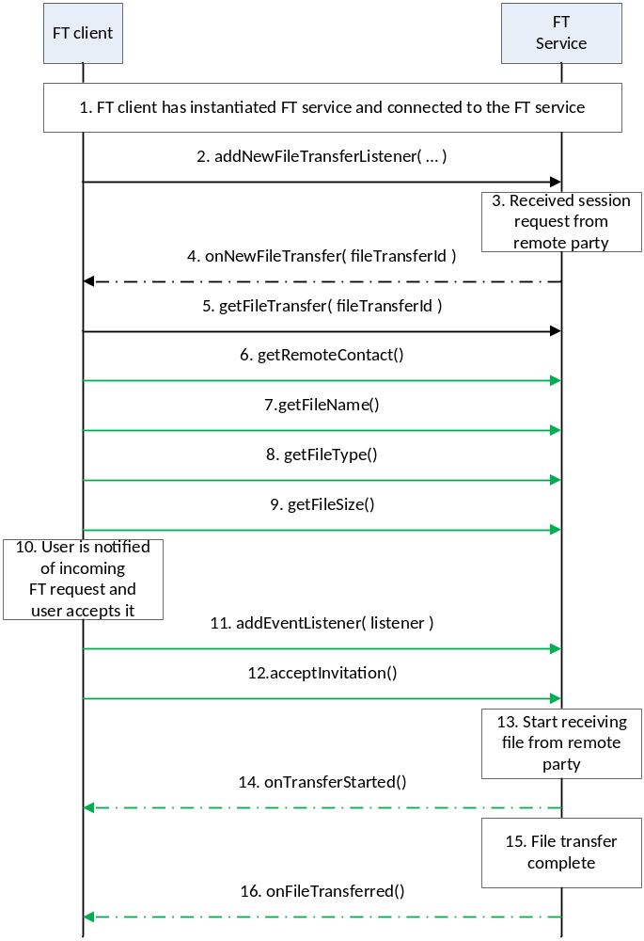
- : Successful reception of a file from remote party
- The FT client instantiates a service instance of the FT Service and establishes a connection with the FT Service.
- The FT client associates the listener with this FT client.
- The FT Service receives a request for a session from a remote party
- The FT Service notifies the FT client through the invocation of the appropriate listener function
- The FT client retrieves the file transfer session object from the FT service
- The FT client retrieves the identity of the remote party that is sending the file.
- The FT client retrieves the name of the file that is being sent by the remote party.
- The FT client retrieves the type of file that is being sent by the remote party
- The FT client retrieves the size of the file that is being sent by the remote party.
- The FT client notifies the user by displaying the details of the file that is being sent to the user. The user accepts the request,
- The FT client installs the listener function for this FT session.
- The RCS client notifies the FT Service that the user has accepted to receive the file
- The FT service informs the remote end that it is ready to receive the file
- The FT client is notified that the file transfer has started.
- The FT service interacts with the remote end to receive the file
- The FT client is notified that the file transfer is complete.

Package
Package name com.gsma.services.rcs.ft

Methods and Callbacks
Class FileTransferService:
This class offers the main entry point to transfer files and to receive files. Several applications may connect/disconnect to the API.
- Method: connects to the API.
void connect()

- Method: disconnects from the API.
void disconnect()

- Method: returns the list of file transfers in progress.
Set<FileTransfer> getFileTransfers()

- Method: returns a current file transfer from its unique ID.
FileTransfer getFileTransfer(String transferId)

- Method: returns a current file transfer from its invitation Intent.
FileTransfer getFileTransferFor(Intent intent)

- Method: transfers a file to a contact. The parameter contact supports the following formats: MSISDN in national or international format, SIP address, SIP-URI or Tel-URI. The parameter file contains the complete filename including the path to be transferred.
FileTransfer transferFile(String contact, String filename, FileTransferListener listener)

- Method: transfers a file to a contact with an optional file icon.
FileTransfer transferFile(String contact, String filename, String fileicon, FileTransferListener listener)

- Method: returns the configuration for a File Transfer service.
FileTransferServiceConfiguration getConfiguration()

- Method: adds a new file transfer invitation listener.
void addNewFileTransferListener(NewFileTransferListener listener)

- Method: removes a new file transfer invitation listener.
void removeNewFileTransferListener(NewFileTransferListener listener)

Class FileTransfer:
This class maintains the information related to a file transfer and offers methods to manage the transfer.
- Method: returns the file transfer ID of the file transfer.
String getTransferId()

- Method: returns the remote contact.
String getRemoteContact()

- Method: returns the direction of the transfer: INCOMING, OUTGOING.
int getDirection()

- Method: returns the complete filename of the icon or thumbnail.
String getFileIconName()

- Method: returns the complete filename including the path of the file to be transferred.
String getFileName()

- Method: returns the size of the file to be transferred (in bytes).
String getFileSize()

- Method: returns the MIME type of file to be transferred.
String getFileType()

- Method: returns the state of the file transfer. The state may have the following values: INVITED, INITIATED, STARTED, TRANSFERRED, ABORTED, FAILED, and PAUSED.
int getState()

- Method: accepts the file transfer invitation.
void acceptInvitation()

- Method: rejects the file transfer invitation.
void rejectInvitation()

- Method: aborts the file transfer.
void abortTransfer()

- Method: pauses the file transfer.
void pauseTransfer()
- Method: resumes the file transfer.
void resumeTransfer()
- Method: adds a listener on the file transfer events.
void addNewFileTransferListener(IFileTransferListener listener)

- Method: removes a listener from file transfer.
void removeNewFileTransferListener(IFileTransferListener listener)

Class FileTransferListener:
This class offers callback methods on file transfer events.
- Method: callback called when the file transfer is started.
void onTransferStarted()

- Method: callback called when the file transfer has been aborted.
void onTransferAborted()

- Method: callback called when the file transfer has failed. The error code may be: INVITATION_DECLINED, SAVING_FILE, and TRANSFER_FAILED.
void onTransferError(int error)

- Method: callback called during the file transfer progress.
void onTransferProgress(long currentSize, long totalSize)

- Method: callback called when the file has been transferred. The parameter filename contains the complete filename including the path.
void onFileTransferred(String filename)

Class NewFileTransferListener:
This class offers callback method to receive a new file transfer invitation.
- Method: callback called when a new file transfer invitation has been received.
void onNewFileTransfer(String transferId)

- Method: callback called when the file has been delivered.
void onReportFileDelivered(String transferId)

- Method: callback called when the file has been displayed.
void onReportFileDisplayed(String transferId)

Intents
- Intent broadcasted when a new file transfer invitation has been received. This Intent contains the following extras:
  - “contact”: MSISDN of the contact sending the invitation.
  - “contactDisplayname”: display name of the contact sending the invitation (extracted from the SIP address).
  - “transferId”: unique ID of the file transfer.
  - “fileicon”: filename of the file icon (complete path).
  - “filename”: filename of the file to be transferred.
  - “filesize”: size of the file in bytes.
  - ”filetype”: MIME type of the file.
  - “chatId”: chat ID associated to the file transfer under a group chat.
com.gsma.services.rcs.ft.action.NEW_FILE_TRANSFER

Image Share API
        - Incoming session request
Error: Reference source not found is an example that shows the flow for a IS client receiving an Image Share request from a remote contact.

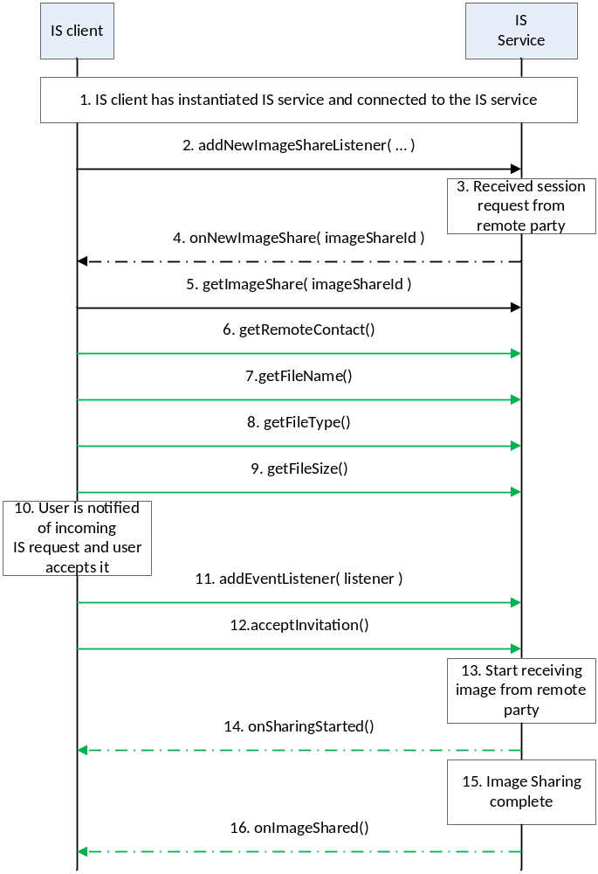
- : Successful sharing of an image from remote party
- The IS client instantiates a service instance of the IS Service and establishes a connection with the IS Service.
- The IS client associates the listener with this IS client.
- The IS Service receives a request for a session from a remote party
- The IS Service notifies the IS client through the invocation of the appropriate listener function
- The IS client retrieves the image share session object from the FT service
- The IS client retrieves the identity of the remote party that is sharing the image.
- The IS client retrieves the name of the image file that is being shared by the remote party.
- The IS client retrieves the type of image file that is being shared by the remote party
- The IS client retrieves the size of the image file that is being shared by the remote party.
- The IS client notifies the user by displaying the details of the image that is being shared to the user. The user accepts the request,
- The IS client installs the listener function for this IS session.
- The IS client notifies the IS service that the user has accepted to receive the image sharing request
- The IS service informs the remote end that it is ready to receive the image to be shared
- The IS client is notified that the image share has started.
- The IS service interacts with the remote end to receive the image being shared
- The IS client is notified that the image sharing is complete.

Package
Package name com.gsma.services.rcs.ish

Methods and Callbacks
Class ImageSharingService:
This class offers the main entry point to share images during a CS call, when the call hangs up the sharing is automatically stopped. Several applications may connect/disconnect to the API.
- Method: connects to the API.
void connect()

- Method: disconnects from the API.
void disconnect()

- Method: returns the list of image sharing in progress.
Set<ImageSharing> getImageSharings()

- Method: returns a current image sharing from its unique ID.
ImageSharing getImageSharing(String sharingId)

- Method: returns a current image sharing from its invitation Intent.
ImageSharing getImageSharingFor(Intent intent)

- Method: shares an image with a contact. The parameter contact supports the following formats: MSISDN in national or international format, SIP address, SIP-URI or Tel-URI. The parameter file contains the complete filename including the path of the image to be shared. An exception if thrown if there is no on-going CS call.
ImageSharing shareImage(String contact, String filename, ImageSharingListener listener)

- Method: returns the configuration for image share service.
ImageSharingServiceConfiguration getConfiguration()

- Method: adds a new image share invitation listener.
void addNewImageSharingListener(NewImageSharingListener listener)

- Method: removes a new image share invitation listener.
void removeNewImageSharingListener(NewImageSharingListener listener)

Class ImageSharingListener:
This class offers callback methods on image sharing events.
- Method: callback called when the sharing is started.
void onSharingStarted()

- Method: callback called when the sharing has been aborted.
void onSharingAborted()

- Method: callback called when the sharing has failed. The error code may be: INVITATION_DECLINED, SAVING_FAILED and SHARING_FAILED.
void onSharingError(int error)

- Method: callback called during the sharing progress.
void onSharingProgress(long currentSize, long totalSize)

- Method: callback called when the sharing has been terminated. The parameter filename contains the complete filename including the path.
void onImageShared(String filename)

Class NewImageSharingListener:
This class offers callback method to receive a new image share invitation.
- Method: callback called when a new image share invitation has been received.
void onNewImageSharing(String sharingId)

Intents
Intent broadcasted when a new image sharing invitation has been received. This Intent contains the following extras:
  - “contact”: MSISDN of the contact sending the invitation.
  - “contactDisplayname”: display name of the contact sending the invitation (extracted from the SIP address).
  - “sharingId”: unique ID of the image sharing.
  - “filename”: filename of the image to be transferred
  - “filesize”: size of the image file in bytes.
  - ”filetype”: MIME_type of the image.
com.gsma.services.rcs.ish.action.NEW_IMAGE_SHARING

Video Share API

Methods and Callbacks
Class VideoSharingService:
This class offers the main entry point to share a live video during a CS call, when the call hangs up the sharing is automatically stopped. Several applications may connect/disconnect to the API.
- Method: connects to the API.
void connect()

- Method: disconnects from the API.
void disconnect()

- Method: returns the list of video sharing in progress.
Set<VideoSharing> getVideoSharings()

- Method: returns a current video sharing from its unique ID.
VideoSharing getVideoSharing(String sharingId)

- Method: returns a current video share from its invitation Intent.
VideoSharing getVideoSharingFor(Intent intent)

- Method: shares a live video stream with a contact. The parameter contact supports the following formats: MSISDN in national or international format, SIP address, SIP-URI or Tel-URI. The parameter player contains a media player which streams over RTP the live video from the camera. The media player is an interface which permits to have a player implementation independent from the joyn API. An exception is thrown if there is no on-going CS call.
VideoSharing shareVideo(String contact, VideoPlayer player, VideoSharingListener listener)

- Method: returns the configuration for video share service.
VideoSharingServiceConfiguration getConfiguration()

- Method: adds a new video share invitation listener.
void addNewVideoSharingListener(NewVideoSharingListener listener)

- Method: removes a new video share invitation listener.
void removeNewVideoSharingListener(NewVideoSharingListener listener)

Intents
Intent broadcasted when a new video sharing invitation has been received. This Intent contains the following extras:
  - “contact”: MSISDN of the contact sending the invitation.
  - “contactDisplayname”: display name of the contact sending the invitation (extracted from the SIP address).
  - “sharingId”: unique ID of the sharing.
  - ”encoding”: video encoding (e.g. H264).
  - “width”: video width (e.g. 176 for QCIF).
  - “height”: video height (e.g. 144 for QCIF).
com.gsma.services.rcs.vsh.action.NEW_VIDEO_SHARING

Geoloc Share API

Methods and Callbacks
Class GeolocSharingService:
This class offers the main entry point to share a geoloc during a CS call, when the call hangs up the sharing is automatically stopped. Several applications may connect/disconnect to the API.
- Method: connects to the API.
void connect()

- Method: disconnects from the API.
void disconnect()

- Method: returns the list of geoloc sharing in progress.
Set<GeolocSharing> getGeolocSharings()

- Method: returns a current geoloc sharing from its unique ID.
GeolocSharing getGeolocSharing(String sharingId)

- Method: returns a current geoloc sharing from its invitation Intent.
GeolocSharing getGeolocSharingFor(Intent intent)

- Method: shares a geoloc with a contact. The parameter contact supports the following formats: MSISDN in national or international format, SIP address, SIP-URI or Tel-URI. An exception is thrown if there is no ongoing CS call.
GeolocSharing shareGeoloc(String contact, Geoloc geoloc, GeolocSharingListener listener)

- Method: adds a new geoloc sharing invitation listener.
void addNewGeolocSharingListener(NewGeolocSharingListener listener)

- Method: removes a new geoloc sharing invitation listener.
void removeNewGeolocSharingListener(NewGeolocSharingListener listener)

Class GeolocSharingListener:
This class offers callback methods on geoloc sharing events.

- Method: callback called when the sharing is started.
void onSharingStarted()

- Method: callback called when the sharing has been aborted.
void onSharingAborted()

- Method: callback called when the sharing has failed. The error code may be: INVITATION_DECLINED, SAVING_FAILED, SHARING_FAILED.
void onSharingError(int error)

- Method: callback called during the sharing progress.
void onSharingProgress(long currentSize, long totalSize)

- Method: callback called when the sharing has been terminated. The parameter geoloc contains the geoloc info.
void onGeolocShared(Geoloc geoloc)

- Class NewGeolocSharingListener:
This class offers callback method to receive new geoloc sharing invitation.
- Method: callback called when a new geoloc sharing invitation has been received.
void onNewGeolocSharing(String sharingId)

Note: the object “Geoloc” is already defined in the Chat API.

Intents
Intent broadcasted when a new geoloc sharing invitation has been received. This Intent contains the following extras:
- “contact”: MSISDN of the contact sending the invitation.
- “contactDisplayname”: display name of the contact sending the invitation (extracted from the SIP address).
- “sharingId”: unique ID of the geoloc sharing.
com.gsma.services.rcs.gsh.action.NEW_GEOLOC_SHARING

IP Call API

Methods and Callbacks
Class IPCallService:
This class offers the main entry point to manage IP Calls. Several applications may connect/disconnect to the API.
- Method: connects to the API.
void connect()

- Method: disconnects from the API.
void disconnect()

- Method: returns the list of IP calls in progress.
Set<IPCall> getIPCalls()

- Method: returns a current IP call from its unique ID.
IPCall getIPCall(String callId)

- Method: returns a current IP call from its invitation Intent.
IPCall getIPCallFor(Intent intent)

- Method: initiates an IP Call with a contact. The parameter contact supports the following formats: MSISDN in national or international format, SIP address, SIP-URI or Tel-URI. The parameters player and renderer contain respectively a media player and a media renderer which stream over RTP the live audio and live video. The media player/renderer are interfaces which permit to have an implementation independent from the joyn API.
IPCall initiateCall(String contact, IPCallPlayer player, IPCallRenderer renderer, IPCallListener listener)

- Method: returns the configuration for IP call service.
IPCallServiceConfiguration getConfiguration()

- Method: adds a new IP call invitation listener.
void addNewIPCallListener(NewIPCallListener listener)

- Method: removes a new IP call invitation listener.
void removeNewIPCallListener(NewIPCallListener listener)

Class NewIPCallListener:
This class offers callback method to receive new IP call invitation.
- Method: callback called when a new IP call invitation has been received.
void onNewCall(String callId)

Intents
Intent broadcasted when a new IP call invitation has been received. This Intent contains the following extras:
- “contact”: MSISDN of the contact sending the invitation.
- “contactDisplayname”: display name of the contact sending the invitation (extracted from the SIP address).
- “callId”: unique ID of the IP call.
- “audioEncoding”: audio encoding (eg. AMR).
- “videoEncoding”: video encoding (eg. H264).
- “videoWidth”: video width (e.g. 176 for QCIF).
- “videoHeight”: video height (e.g. 144 for QCIF).
com.gsma.services.rcs.ipcall.action.NEW_CALL
======================= End of changes================================

