 |  | RCSJTA TT BB CR_0XX  Service API authorisation
Meeting Information
Meeting Name and Number
Meeting Date
Meeting Location |  | Conference Call
Document Information
Document Author(s)
Document Creation Date
 |  | Approval | X
This document is for: (mark X as appropriate) |  | Discussion
 |  | Information only
Security Classification – Non Confidential / Confidential GSMA Material (Delete as appropriate and delete the rows below that do not apply) |  |  | Can be distributed to: (mark X as appropriate or specify group
Non Confidential |  | Public
Confidential |  | Project Team or Group | X
Confidential |  | GSMA HQ Staff | X
Confidential |  | GSMA Full Members | X
Confidential |  | GSMA Associate Members | X
Confidential |  | GSMA Rapporteur Members | X
Document Summary
CR created to Samsung’s proposed document format (GSMA PRD format) to update Introduction and Architecture sections based on the feedback received during London F2F meeting.

Document History
Date | Version | Author / Comments and for updates description of changes
25/7/14 | 0.1 | Paddy Byers / Remove distinction between Service API and Privileged Client API

© GSMA 2010. The GSM Association (“Association”) makes no representation, warranty or undertaking (express or implied) with respect to and does not accept any responsibility for, and disclaims liability for the accuracy or completeness or timeliness of the information contained in this document. The information contained in this document may be subject to change without prior notice. This document has been classified according to the GSMA Document Confidentiality Policy. GSMA meetings are conducted in full compliance with the GSMA Antitrust Policy.

RCC TF Change Request Form
Title: | Service API Authorisation
Type of Change Request: Mark the appropriate box by “X” | New Feature |  | Major  Change Errata
  X
Targeted Document | joyn Terminal API Specification
Impact on Other Official Documents: | None

======================= Summary of Changes =============================

25 July 2014 : Remove distinction between Service API and Privileged Client API.

======================= End of Summary =================================

======================= 1st Change ==================================

API Architecture

Architecture Overview
The joyn Client architecture is composed of several sub-systems, organised into functional layers as shown in the diagram below.
The fundamental enabling component is the IMS Stack which contains the protocol suite (Session Initiation Protocol [SIP], Message Session Relay Protocol [MSRP], Real-Time Protocol [RTP]/Real-Time Control Protocol [RTCP], Hyper-Text Transfer Protocol [HTTP], etc.) and core services (IMS Session Management, Media management, Registration, etc.). The functionality of this component is governed by the IMS specifications.
Above IMS there are the Rich Communication Services (RCS) Enablers, comprising the functionality to enable RCS-based Chat, Video and Image sharing, File Transfer and other RCS services. The functionality of this layer is governed by the GSMA RCS specifications.
Access to these functional layers is mediated by the Client logic, which provides the client API and the functionality to mediate access to that API by multiple clients. Client applications and services access the underlying functionality exclusively through this interface. The client logic

provides access for client applications to the RCS services (Open Mobile Alliance [OMA] SIP Instant Message and Presence Leveraging Extensions [SIMPLE] Instant Messaging [IM], GSMA Video Share, GSMA Image Share, etc.).

- The joyn Core Applications are the (typically embedded) applications that provide the end-user’s access to RCS services. The Core Applications also expose a UX API (not shown in Error: Reference source not found) whereby other applications can programmatically invoke operations that are interactively fulfilled by the Core Applications. Core Applications make use of the Service API.
The architecture is intended to enable RCS Extensions to make direct use also of the Service API, enabling programmatic access to the RCS services. The Service API is scoped so as to make access by Third Party Applications possible subject to those applications having the appropriate permission.
A special distinction is made for independent applications, labelled here as Trusted Extensions that provide services directly on top of the IMS Stack (and which may themselves define their own Service APIs).

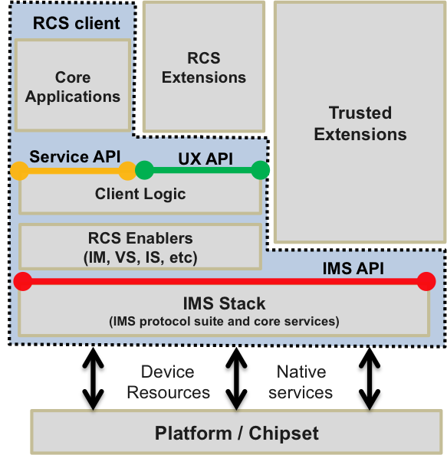

- : General Architecture Overview

API Descriptions
Architecturally, the four API types can be classed as exposing joyn functionality (UX API, Service API and Privileged Client API) and APIs exposing IMS stack functionality (IMS API).

UX APIs
UX APIs enable other installed applications to interface or link the native RCS service.

Service APIs
Service APIs provide a functional interface to the RCS enablers, enabling the Core Applications and Third Party Applications to interoperate with other RCS devices whilst relying on the stack to ensure conformance to the RCS Specification.
Those functionalities are:
- IM/Chat service
- Image Share
- Video Share
- File Transfer
- Client Connector
- Capabilities
NOTE: For Video Share and Image Share functionality to be fully available, a call needs to be ongoing with a RCS contact posessing Video Share and Image Share capabilities.
The APIs in this layer also expose common joyn functionality for capability fetching and retrieving parts of the joyn network configuration required for UI elements.
In case of Android OS, client enables to interface the native RCS service functionality with 3rd party applications on the device.

2.1.1.4 IMS APIs
These APIs allow using a subset of IMS functionality to create new services that work along Standard Services.
The IMS APIs will be defined in the future version.

Applications Types
Applications types can be divided into three broad categories shown in Figure 2.
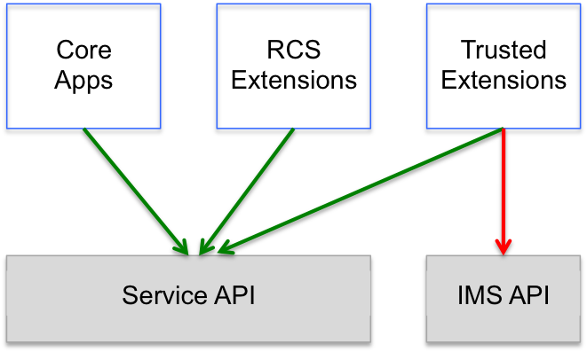
- : Mapping of target component types to APIs based on security
- RCS Extensions - RCS Extensions can use only Service APIs. Some RCS Extensions may provide service-over-service functionality. These applications use additional parameterization defined in the Service APIs, and may have their own feature tags not defined by the joyn Specification.
- Core Applications - Components that are included in the joyn Client. These components must undergo GSMA accreditation as part of the joyn Client. Core Applications may use Service APIs (such as IM) and can have overlapping functionality with RCS Extensions.
- Trusted Extensions - These extensions can use both IMS APIs and Service APIs. They can also define new services that are not part of the joyn Specification and may have their own feature tag.

======================= End of changes================================

======================= 2nd Change ==================================

Security
Most of the joyn APIs provide access to sensitive functionality, either because they enable access to privacy-sensitive information or because they can cause charges to be incurred for network and service usage. In addition, certain APIs expose the internal functionality of the stack, and abuse of those APIs could compromise the integrity of the stack or the joyn services.

4.2.1.1 Service API Access Control
The Service APIs are sensitive and their abuse could compromise the integrity of the stack or the RCS services. Access is therefore restricted so that they may only be used by authorised RCS Extensions, through OEM signing, embedding in system folder, or another solution mutually agreed between MNO and OEM.
Where the Service API exposes privacy-sensitive information or may trigger service charges, the user must grant permission for any application to use that API. The permissions are defined for each service API in the sections that follow.

4.2.1.3 IMS API Access Control
Since the IMS API provides low-level access to the IMS stack, there is significant scope for abuse including generation of excessive network traffic, interception of requests intended for other applications, and other abuses resulting in denial of service.
Access to the IMS API is limited only to trusted components provided by MNO and/or OEMs. Procedures for obtaining access to these APIs are beyond the scope of this document.

======================= End of changes================================

