 |  | RCSJTA TT Crane CR_xxx  Audio Messaging
Meeting Information
Meeting Name and Number
Meeting Date
Meeting Location |  | Conference Call
Document Information
Document Author(s)
Document Creation Date
 |  | Approval | X
This document is for: (mark X as appropriate) |  | Discussion
 |  | Information only
Security Classification – Non Confidential / Confidential GSMA Material (Delete as appropriate and delete the rows below that do not apply) |  |  | Can be distributed to: (mark X as appropriate or specify group
Non Confidential |  | Public
Confidential |  | Project Team or Group | X
Confidential |  | GSMA HQ Staff | X
Confidential |  | GSMA Full Members | X
Confidential |  | GSMA Associate Members | X
Confidential |  | GSMA Rapporteur Members | X
Document Summary
CR to align Terminal API with RCS 5.2 to support audio messaging features

Document History
Date | Version | Author / Comments and for updates description of changes
23/06/14 | 1.0 | Initial proposition

© GSMA 2010. The GSM Association (“Association”) makes no representation, warranty or undertaking (express or implied) with respect to and does not accept any responsibility for, and disclaims liability for the accuracy or completeness or timeliness of the information contained in this document. The information contained in this document may be subject to change without prior notice. This document has been classified according to the GSMA Document Confidentiality Policy. GSMA meetings are conducted in full compliance with the GSMA Antitrust Policy.

RCC TF Change Request Form
Title: | Audio Messaging RCS 5.2
Type of Change Request: Mark the appropriate box by “X” | New Feature | X | Major  Change Errata
Targeted Document | joyn Terminal API Specification
Impact on Other Official Documents: | None

======================= 1st Change ==================================

File Transfer API
This API exposes all functionality related to transferring files via the File Transfer Service. It allows:
- Send a file transfer request
- Send a file transfer request with thumbnail (file icon)
- Receive notifications about incoming file transfer and file transfer events.
- Receive notifications upon file delivery
- Retrieve the list of all file transfers and their statuses for a specific contact
- Clean all file transfer history or single file transfers (including the transferred files if possible)
- Monitor a file transfers progress.
- Cancel a file transfer in progress.
- Accept/reject an incoming file transfer request.
- Read configuration elements affecting a file transfer
- Resume a file transfer

File Transfer API calling flow
The figures in this section contain basic call flows of the File Transfer service API.

Session establishment
Error: Reference source not found is an example that shows the flow for a File Transfer (FT) client establishing a FT session with a remote contact.
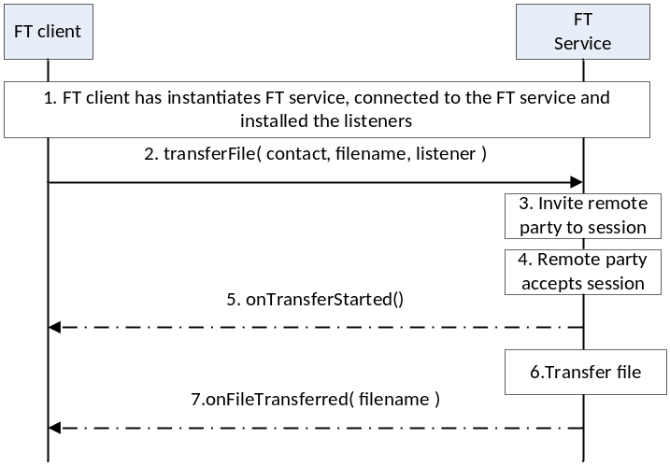
- : Successful sending of a file to remote party
- The FT client instantiates a service instance of the File Transfer Service, establishes a connection with the FT Service and associates the listener with this RCS client.
- By selecting a user and the file to be transferred, the user initiates a FT session request to the remote party
- The FT Service sends the session request to remote party
- The session request is delivered to the remote party and an indication is received that the remote user has accepted the file transfer request.
- The FT client is notified that the file transfer has started.
- The FT Service transfers the file to the remote party.
- The FT client is notified that the file transfer is completed.

Incoming session request
Error: Reference source not found is an example that shows the flow for a FT client receiving a File Transfer request from a remote contact.

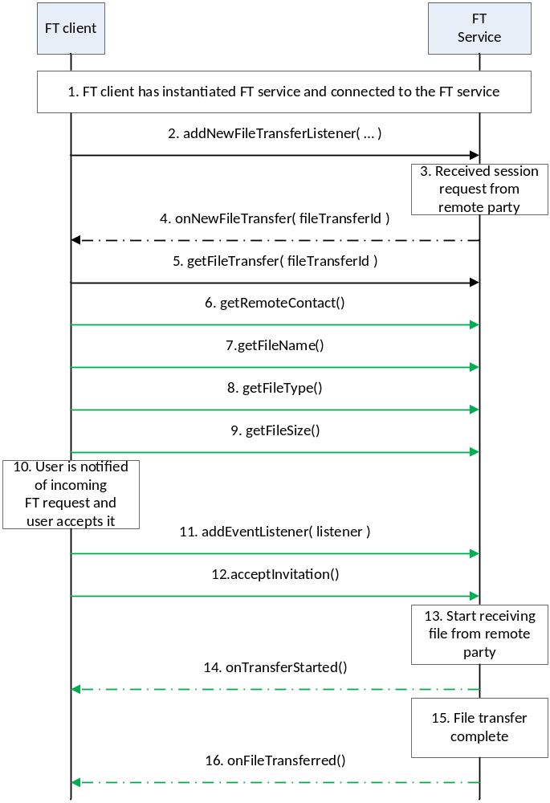
- : Successful reception of a file from remote party
- The FT client instantiates a service instance of the FT Service and establishes a connection with the FT Service.
- The FT client associates the listener with this FT client.
- The FT Service receives a request for a session from a remote party
- The FT Service notifies the FT client through the invocation of the appropriate listener function
- The FT client retrieves the file transfer session object from the FT service
- The FT client retrieves the identity of the remote party that is sending the file.
- The FT client retrieves the name of the file that is being sent by the remote party.
- The FT client retrieves the type of file that is being sent by the remote party
- The FT client retrieves the size of the file that is being sent by the remote party.
- The FT client notifies the user by displaying the details of the file that is being sent to the user. The user accepts the request,
- The FT client installs the listener function for this FT session.
- The RCS client notifies the FT Service that the user has accepted to receive the file
- The FT service informs the remote end that it is ready to receive the file
- The FT client is notified that the file transfer has started.
- The FT service interacts with the remote end to receive the file
- The FT client is notified that the file transfer is complete.

Package
Package name com.gsma.services.rcs.ft

Methods and Callbacks
Class FileTransferService:
This class offers the main entry point to transfer files and to receive files. Several applications may connect/disconnect to the API.
- Method: connects to the API.
void connect()

- Method: disconnects from the API.
void disconnect()

- Method: returns the list of file transfers in progress.
Set<FileTransfer> getFileTransfers()

- Method: returns a current file transfer from its unique ID.
FileTransfer getFileTransfer(String transferId)

- Method: returns a current file transfer from its invitation Intent.
FileTransfer getFileTransferFor(Intent intent)

- Method: transfers a file to a contact. The parameter contact supports the following formats: MSISDN in national or international format, SIP address, SIP-URI or Tel-URI. The parameter file contains the complete filename including the path to be transferred.
FileTransfer transferFile(String contact, String filename, FileTransferListener listener)

- Method: transfers a file to a contact with an optional file icon.
FileTransfer transferFile(String contact, String filename, String fileicon, FileTransferListener listener)

• Method: transfers an audio message to a contact. The parameter contact supports the following formats: MSISDN in national or international format, SIP address, SIP-URI or Tel-URI. The parameter file contains the complete audio message filename including the path to be transferred.
FileTransfer transferAudioMessage (String contact, String filename, FileTransferListener listener)

- Method: returns the configuration for a File Transfer service.
FileTransferServiceConfiguration getConfiguration()

- Method: adds a new file transfer invitation listener.
void addNewFileTransferListener(NewFileTransferListener listener)

- Method: removes a new file transfer invitation listener.
void removeNewFileTransferListener(NewFileTransferListener listener)

Class FileTransfer:
This class maintains the information related to a file transfer and offers methods to manage the transfer.
- Method: returns the file transfer ID of the file transfer.
String getTransferId()

- Method: returns the remote contact.
String getRemoteContact()

- Method: returns the direction of the transfer: INCOMING, OUTGOING.
int getDirection()

- Method: returns the complete filename of the icon or thumbnail.
String getFileIconName()

- Method: returns the complete filename including the path of the file to be transferred.
String getFileName()

- Method: returns the size of the file to be transferred (in bytes).
String getFileSize()

- Method: returns the MIME type of file to be transferred.
String getFileType()

- Method: returns if the file transfer is a transfer of an Audio Message .
Boolean isAudioMessage()

- Method: returns the state of the file transfer. The state may have the following values: INVITED, INITIATED, STARTED, TRANSFERRED, ABORTED, FAILED, and PAUSED.
int getState()

- Method: accepts the file transfer invitation.
void acceptInvitation()

- Method: rejects the file transfer invitation.
void rejectInvitation()

- Method: aborts the file transfer.
void abortTransfer()

- Method: pauses the file transfer.
void pauseTransfer()
- Method: resumes the file transfer.
void resumeTransfer()
- Method: adds a listener on the file transfer events.
void addNewFileTransferListener(IFileTransferListener listener)

- Method: removes a listener from file transfer.
void removeNewFileTransferListener(IFileTransferListener listener)

Class FileTransferListener:
This class offers callback methods on file transfer events.
- Method: callback called when the file transfer is started.
void onTransferStarted()

- Method: callback called when the file transfer has been aborted.
void onTransferAborted()

- Method: callback called when the file transfer has failed. The error code may be: INVITATION_DECLINED, SAVING_FILE, and TRANSFER_FAILED.
void onTransferError(int error)

- Method: callback called during the file transfer progress.
void onTransferProgress(long currentSize, long totalSize)

- Method: callback called when the file has been transferred. The parameter filename contains the complete filename including the path.
void onFileTransferred(String filename)

Class NewFileTransferListener:
This class offers callback method to receive a new file transfer invitation.
- Method: callback called when a new file transfer invitation has been received.
void onNewFileTransfer(String transferId)

- Method: callback called when the file has been delivered.
void onReportFileDelivered(String transferId)

- Method: callback called when the file has been displayed.
void onReportFileDisplayed(String transferId)

Class FileTransferServiceConfiguration:
This class represents the particular configuration of a FT Service.
- Method: returns the file size warning of a File Transfer configuration. It can return null if this value was not set by the auto-configuration server (no need to warn).
long getWarnSize()

- Method: returns the max file size of a File Transfer configuration. It can return null if this value was not set by the auto-configuration server.
long getMaxSize()

- Method: returns the max length of Audio Message. It can return null if this value was not set by the auto-configuration server.
long getMaxAudioMessageLength()

- Method: returns the Auto Accept Mode of a File Transfer configuration.
boolean isAutoAcceptMode()

- Method: returns the max number of simultaneous file transfers (including audio message transfer).
int getMaxFileTransfers()

- Method: returns True if the file icon (i.e. thumbnail) is supported, else returns False.
boolean isFileIconSupported()

- Method: returns the max size for a file icon (i.e. thumbnail).
long getMaxFileIconSize()

Intents
- Intent broadcasted when a new file transfer invitation has been received. This Intent contains the following extras:
  - “contact”: MSISDN of the contact sending the invitation.
  - “contactDisplayname”: display name of the contact sending the invitation (extracted from the SIP address).
  - “transferId”: unique ID of the file transfer.
  - “fileicon”: filename of the file icon (complete path).
  - “filename”: filename of the file to be transferred.
  - “filesize”: size of the file in bytes.
  - ”filetype”: MIME type of the file.
  - “chatId”: chat ID associated to the file transfer under a group chat.
com.gsma.services.rcs.ft.action.NEW_FILE_TRANSFER

Content Providers
A content provider is used to store the file transfer history persistently. There is one entry per file transfer.
The content provider has the following columns:
Data | Data type | Comment
FT_ID | TEXT | Unique file transfer identifier
CONTACT_NUMBER | TEXT | Contains the MSISDN of the remote contact
FILENAME | TEXT | Filename
MIME_TYPE | TEXT | MIME type of the file
FILEICON | TEXT | Filename
AUDIOMESSAGE | Boolean | Audio message flag (true means Audio message)
DIRECTION | Integer | Incoming transfer or outgoing transfer
FILESIZE | Long | File size in bytes
TRANSFERRED | Long | Size transferred in bytes
TIMESTAMP | Long | Date of the transfer
TIMESTAMP_SENT | Long | Time when file is sent. If 0 means not sent.
TIMESTAMP_DELIVERED | Long | Time when file is delivered. If 0 means not delivered.
TIMESTAMP_ DISPLAYED | Long | Time when file is displayed.
STATE | Integer | See note below for the list of states
Note : State values for file transfer session management:
- INVITED: incoming session.
- INITIATED: outgoing session.
- STARTED: invitation has been accepted and transfer is started.
- TRANSFERRED: file has been transferred with success.
- ABORTED: session has been aborted.
- FAILED: session has failed.
- PAUSED : transfer has been paused and may be resumed.
- DELIVERED: file has been delivered.
- DISPLAYED: file has been displayed.
- INACTIVE: transfer is not yet active.

Permissions
Access to the File Transfer API is requires the following permissions:
- com.gsma.services.rcs.RCS_FILETRANSFER_RECEIVE: this is a new permission that is required by a client in order to handle the receipt of a file transferred from a remote party.
- com.gsma.services.rcs.RCS_FILETRANSFER_SEND: this is a new permission that is required by a client in order to initiate the transfer of a file transferred to a remote party.
- com.gsma.services.rcs.RCS_FILETRANSFER_READ: this is a new permission that is required by a client in order to read the file transfer history from the content provider.

======================= End of changes================================

