 |  | RCSJTA TT Crane CR_xxx  Message Revocation
Meeting Information
Meeting Name and Number
Meeting Date
Meeting Location |  | Conference Call
Document Information
Document Author(s)
Document Creation Date
 |  | Approval | X
This document is for: (mark X as appropriate) |  | Discussion
 |  | Information only
Security Classification – Non Confidential / Confidential GSMA Material (Delete as appropriate and delete the rows below that do not apply) |  |  | Can be distributed to: (mark X as appropriate or specify group
Non Confidential |  | Public
Confidential |  | Project Team or Group | X
Confidential |  | GSMA HQ Staff | X
Confidential |  | GSMA Full Members | X
Confidential |  | GSMA Associate Members | X
Confidential |  | GSMA Rapporteur Members | X
Document Summary
CR adding a new API method to support the message revocation procedures described in RCS 5.2 and used in Full integrated messaging.

Document History
Date | Version | Author / Comments and for updates description of changes
24/06/1014 | 1.0 | Initial release

© GSMA 2010. The GSM Association (“Association”) makes no representation, warranty or undertaking (express or implied) with respect to and does not accept any responsibility for, and disclaims liability for the accuracy or completeness or timeliness of the information contained in this document. The information contained in this document may be subject to change without prior notice. This document has been classified according to the GSMA Document Confidentiality Policy. GSMA meetings are conducted in full compliance with the GSMA Antitrust Policy.

RCC TF Change Request Form
Title: | Message revoke
Type of Change Request: Mark the appropriate box by “X” | New Feature | X | Major  Change Errata
Targeted Document | joyn Terminal API Specification
Impact on Other Official Documents: | None

======================= 1st Change ==================================

IM/Chat API
This API exposed all functionality for the Instant Messaging/Chat Service. It allows:
- Sending messages to a contact.
- Starting group chats with an ad-hoc list of participants and an optional subject.
- Joining existing group chats.
- Re-joining existing group chats.
- Restarting a previous group chat.
- Extends a 1-1 chat to a group chat.
- Sending messages in a group chat.
- Leaving a group chat.
- Adding participants to a group chat.
- Retrieving information about a group chat (status, participants and their status)
- Receiving notifications about incoming messages, “is-composing” events, group chat invitations and group chat events.
- Accept/reject an incoming chat invitation.
- Displaying chat history (messages and group chats).
- Erasing chat history by a user, by group chat, or by single messages.
- Marking messages as displayed.
- Receiving message delivery reports.
- Revoking messages sent in a 1-1 chat.
- Read configuration elements affecting IM.
NOTE: a chat (single/group) is identified by a unique conversation Identifier (ID) which corresponds to the “Contribution-ID” header in the signalling flow. This permits to have a permanent chat or group chat like user experience.

IM/Chat API calling flow
The figures in this section contain basic call flows of the IM/Chat service API.

Session establishment
Error: Reference source not found is an example that shows the flow for a RCS client establishing a IM/Chat session with a remote contact.
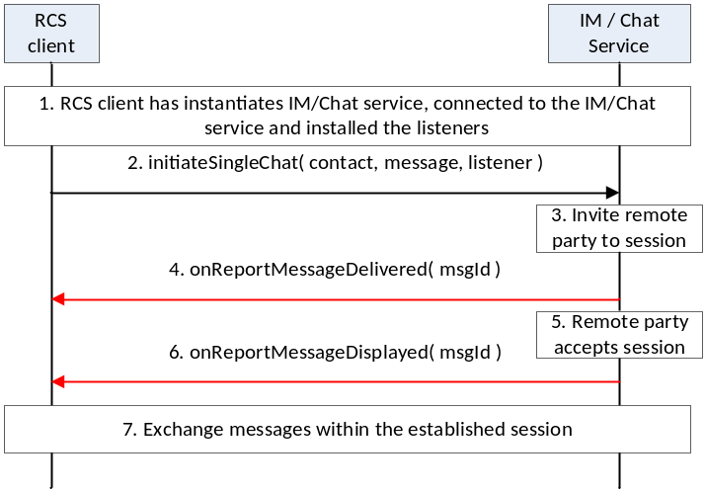
- : Establish a one-to-one chat session with remote party
- The RCS client instantiates a service instance of the IM/Chat Service, establishes a connection with the IM/Chat Service and associates the listener with this RCS client.
- By selecting a user, opening the IM window and typing a message, the user initiates a IM/Chat session request to the remote party
- RCS service sends the session request to the remote party
- The session request is delivered to the remote party and a confirmation of delivery of the message is received by the RCS service. This delivery confirmation is provided to the RCS client.
- By opening the chat window and viewing the incoming message, the remote party accepts the chat session and sends a confirmation of the message display
- The RCS service provides the message displayed notification to the RCS client
- Using procedures described in Error: Reference source not found, the two users exchange IM / Chat messages

Incoming session request
Error: Reference source not found is an example that shows the flow for an RCS client receiving an IM/Chat session request from a remote contact.

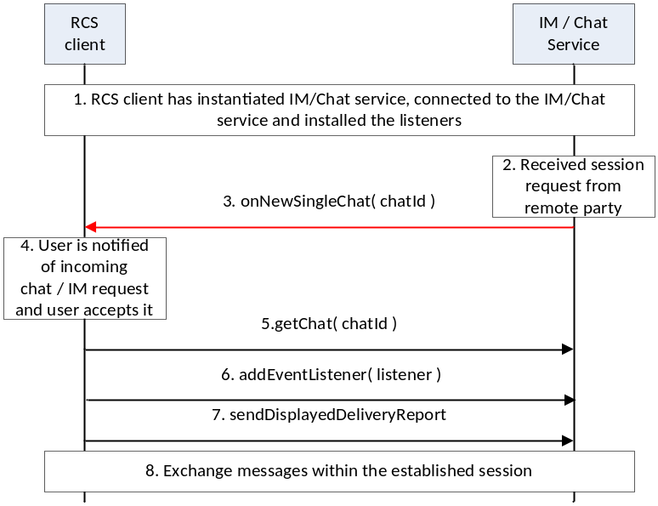
- : Establish a one-to-one chat session with remote party
- The RCS client instantiates a service instance of the IM/Chat Service, establishes a connection with the IM/Chat Service and associates the listener with this RCS client.
- IM/Chat Service receives a request for a session from a remote party
- IM/Chat Service notifies the RCS client through the invocation of the appropriate listener function
- The RCS client notifies the user by displaying the message received in the incoming session invitation to the user. The user accepts the session request
- The RCS client retrieves the chat object associated with this session
- The RCS client installs the listener function for this chat session
- The RCS client requests the IM/Chat service to send to the remote party, an indication of display of the message to the user
- Using procedures described in Error: Reference source not found, the two users exchange IM / Chat messages

Message exchange after chat session establishment
Error: Reference source not found is an example that shows the flow for a RCS client receiving a IM/Chat session request from a remote contact.
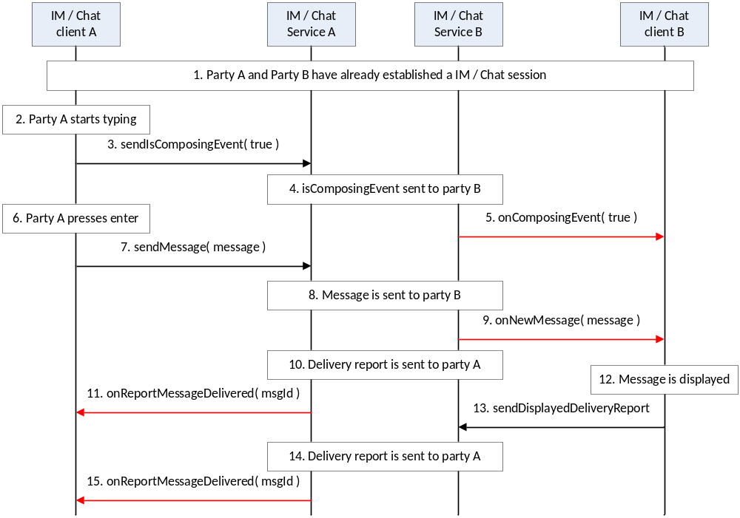
- : Establish a one-to-one chat session with remote party
- A party and B party have already established a IM/Chat session
- Party A starts to type a new chat / IM message
- Client A provides an indication of composing event to the IM/Chat service
- IM/Chat service of party A provides indication of composing toward party B.
- IM/Chat service of party B provides the indication to the IM client of party B
- Party A completes typing the message and presses enter
- Client A provides the message to the IM/Chat service A
- IM/Chat service A sends the message to IM/Chat service B
- IM/Chat service B provides an indication to the client B
- IM/Chat service B provides delivery indication to IM/Chat service A
- IM/Chat service A provides the delivery indication to IM client A
- IM Client B displays the message to user
- IM client B provides the displayed indication to the IM/Chat service B
- IM/Chat service B provides the displayed indication to IM/Chat service A
- IM/Chat service A provides the indication to the client A

Package
Package name com.gsma.services.rcs.chat

Methods and Callbacks
Class ChatService:
This class offers the main entry point to initiate chat conversations with contacts: 1-1 and group chat conversation. Several applications may connect/disconnect to the API.
- Method: connects to the API.
void connect()

- Method: disconnects from the API.
void disconnect()

- Method: opens a single chat with a given contact and returns a Chat instance. The parameter contact supports the following formats: MSISDN in national or international format, SIP address, SIP-URI or Tel-URI.
Chat openSingleChat(String contact, ChatListener listener)

- Method: initiates a group chat with a group of contacts and returns a GroupChat instance. The subject is optional and may be null.
GroupChat initiateGroupChat(Set<String> contacts, String subject, GroupChatListener listener)

- Method: rejoins an existing group chat from its unique chat ID.
GroupChat rejoinGroupChat(String chatId)

- Method: restarts a previous group chat from its unique chat ID.
GroupChat restartGroupChat(String chatId)

- Method: adds a listener on new chat invitation event.
void addNewChatListener(NewChatListener listener)

- Method: removes a listener on new chat invitation event.
void removeNewChatListener(NewChatListener listener)

- Method: returns the list of single chats in progress.
Set<Chat> getChats()

- Method: returns a chat in progress from its unique ID.
Chat getChat(String chatId)

- Method: returns a single chat from its invitation Intent.
Chat getChatFor(Intent intent)

- Method: returns the list of group chats in progress.
Set<GroupChat> getGroupChats()

- Method: returns a group chat in progress from its unique ID.
GroupChat getGroupChat(String chatId)

- Method: returns a group chat from its invitation Intent.
GroupChat getGroupChatFor(Intentintent)

- Method: returns the configuration for chat service.
ChatServiceConfiguration getConfiguration()

Class NewChatListener:
This class offers callback methods on a new chat invitation event.
- Method: callback called when a new chat invitation has been received
void onNewSingleChat(String chatId, ChatMessage message)

- Method: callback called when a new group chat invitation has been received
void onNewGroupChat(String chatId)

Class ChatMessage:
This class contains chat message information for single and group chats.
- Method: returns the contact who sends the message.
String getContact()

- Method: returns the message ID.
String getId()

- Method: returns the message content.
String getMessage()

- Method: returns the receipt date.
Date getReceiptDate()

- Method: is displayed delivery report requested.
boolean isDisplayedReportRequested()

Class GeolocMessage:
This class contains geoloc message information for single and group chat.
Method: returns the contact who sends the message.
String getContact()
Method: returns the message ID.
String getId()
Method: returns the geoloc info.
Geoloc getGeoloc()
Method: returns the receipt date.
Date getReceiptDate()
Method: is displayed delivery report requested.
boolean isDisplayedReportRequested()

Class Geoloc:
This class contains geoloc information.
Method: returns the label associated to the geoloc.
String getLabel()
Method: returns the latitude.
double getLatitude()
Method: returns the longitude.
double getLongitude()
Method: returns the accuracy of the geoloc info (in meter).
float getAccuracy()
Method: returns the expiration date of the geoloc info.
long getExpirationDate()

Class Chat:
This class maintains the information related to a single chat and offers methods to manage the chat conversation.

- Method: returns the remote contact.
String getRemoteContact()

- Method: sends a chat message. The method returns a unique message ID.
String sendMessage(String message)

- Method: revokes a chat message for a given message ID. The method returns true is the message is successfully revoked in the network. Note that a message can only be revoked if the message was not delivered to its recipient yet.
Boolean revokeMessage(String msgId)

- Method: sends a geoloc message. The method returns a unique message ID.
String sendGeoloc(Geoloc geoloc)

- Method: sends a displayed delivery report for a given message ID.
void sendDisplayedDeliveryReport(String msgId)

- Method: sends an “is-composing” event. The status is set to true when typing a message, else it is set to false.
void sendIsComposingEvent(boolean status)

- Method: adds a listener on chat events.
void addEventListener(ChatListener listener)

- Method: removes a listener on chat events.
void removeEventListener(ChatListener listener)

Class ChatListener:
This class offers callback methods on 1-1 chat events.
- Method: callback called when a new message has been received
void onNewMessage(ChatMessage message)

- Method: callback called when a new geoloc has been received
void onNewGeoloc(GeolocMessage message)

- Method: callback called when a message has been delivered to the remote.
void onReportMessageDelivered(String msgId)

- Method: callback called when a message has been displayed by the remote.
void onReportMessageDisplayed(String msgId)

- Method: callback called when a message has failed to be delivered to the remote.
void onReportMessageFailed(String msgId)

- Method: callback called when a “is-composing” event has been received. If the remote is typing a message the status is set to true, else it is false.
void onComposingEvent(boolean status)

Class GroupChat:
This class maintains the information related to a group chat and offers methods to manage the group chat conversation.
- Method: returns the chat ID.
String getChatId()

- Method: returns the subject of the group chat.
String getSubject()

- Method: returns the remote contact.
String getRemoteContact()

- Method: returns the list of connected participants. A participant is identified by its MSISDN in national or international format, SIP address, SIP-URI or Tel-URI.
Set<String> getParticipants()

- Method: returns the direction of the group chat: INCOMING, OUTGOING.
int getDirection()

- Method: returns the state of the group chat. The state may have the following values: INVITED, INITIATED, STARTED, TERMINATED, ABORTED, FAILED.
int getState()

- Method: accepts chat invitation.
void acceptInvitation()

- Method: rejects chat invitation.
void rejectInvitation()

- Method: sends a message to the group. This method returns a unique message ID.
String sendMessage(String text)

- Method: sends a geoloc message. The method returns a unique message ID.
String sendGeoloc(Geoloc geoloc)

- Method: transfers a file to participants.
FileTransfer sendFile(String filename, String fileicon, FileTransferListener listener)

- Method: sends a “is-composing” event. The status is set to true when typing a message, else it is set to false.
void sendIsComposingEvent(boolean status)

- Method: sends a displayed delivery report for a given message ID.
void sendDisplayedDeliveryReport(String msgId)

- Method: adds participants to a group chat.
void addParticipants(Set<String> participants)

- Method: returns the maximum number of participants for a group chat from the group chat info subscription (this value overrides the provisioning parameter).
int getMaxParticipants()

- Method: quits a group chat conversation. The conversation will continue between other participants if there are enough participants.
void quitConversation()

- Method: adds a listener on chat events.
void addEventListener(GroupChatListener listener)

- Method: removes a listener on chat events.
void removeEventListener(GroupChatListener listener)

Class GroupChatListener:
This class offers callback methods on group chat events.
- Method: callback called when the session is well established and messages may be exchanged with the group of participants.
void onSessionStarted()

- Method: callback called when a new message has been received
void onNewMessage(ChatMessage message)

- Method: callback called when a message has failed to be delivered to the remote.
void onReportMessageFailed(String msgId)

- Method: callback called when a new geoloc has been received
void onNewGeoloc(GeolocMessage message)

- Method: callback called when a message has been delivered to the remote.
void onReportMessageDelivered(String msgId)

- Method: callback called when a message has been displayed by the remote.
void onReportMessageDisplayed(String msgId)

- Method: callback called when a “is-composing” event has been received. If the remote is typing a message the status is set to true, else it is false.
void onComposingEvent(String contact, boolean status)

- Method: callback called when the session has been aborted or terminated.
void onSessionAborted ()

- Method: callback called when the session has failed. The error code may be: CHAT_NOT_FOUND, INVITATION_DECLINED, CHAT_FAILED.
void onSessionError(int error)

- Method: callback called when a new participant has joined the group chat.
void onParticipantJoined(String contact, String contactDisplayname)

- Method: callback called when a participant has voluntary left the group chat.
void onParticipantLeft(String contact)

- Method: callback called when a participant is disconnected from the group chat.
void onParticipantDisconnected(String contact)

Class ChatServiceConfiguration:
This class represents the particular configuration of a IM Service.
- Method: returns the “imCapAlwaysOn” configuration. True if Store and Forward capability is supported, False if no Store & Forward capability.
boolean isChatSf()

- Method: returns the “imWarnSF” configuration. True if a user should be informed when sending a message to an offline user. False if a user should not be informed when sending a message to an offline user. This should be used with imCapAlwaysOn.
boolean isChatWarnSf()

- Method: returns the time after an inactive chat session could be closed.
int getChatTimeout()

- Method: returns the maximum participants in a group chat session.
int getGroupChatMaxParticipantsNumber()

- Method: returns the maximum single chat message’s length can have
int getSingleChatMessageMaxLength()

- Method: returns the maximum single group chat message’s length can have
int getGroupChatMessageMaxLength()

- Method: returns the maximum number of simultaneous single chats.
int getMaxSingleChats()

- Method: returns the maximum number of simultaneous group chats.
int getMaxGroupChats()

- Method: returns the SMS fall-back configuration. True if SMS fall-back procedure is activated, else returns False.
boolean isSmsFallback()

- Method: returns True if auto accept mode is activated for chat, else returns False.
boolean isChatAutoAcceptMode()

- Method: returns True if auto accept mode is activated for a group chat, else returns False.
boolean isGroupChatAutoAcceptMode()

- Method: activates or deactivates the displayed delivery report on a received chat messages.
void setDisplayedDeliveryReport(boolean state)

- Method: returns the is-compoisng timeout value.
int getIsComposingTimeout ()

- Method: returns the maximum length of a geoloc label.
int getGeolocLabelMaxLength()

- Method: returns the expiration time of a geoloc info.
int getGeolocExpirationTime()

Intents
Intent broadcasted when a new chat conversation has been received. This Intent contains the following extras:
  - “contact”: MSISDN of the contact sending the invitation.
  - “contactDisplayname”: display name of the contact sending the invitation (extracted from the SIP address).
  - “message”: received chat message (parceable object). This may be a ChatMessage or a GeolocMessage.
com.gsma.services.rcs.chat.action.NEW_CHAT

Intent broadcasted when a new group chat invitation has been received. This Intent contains the following extras:
  - “contact”: MSISDN of the contact sending the invitation.
  - “contactDisplayname”: display name of the contact sending the invitation (extracted from the SIP address).
  - “chatId”: unique ID of the group chat conversation.
  - “subject”: subject of the group chat (optional).
com.gsma.services.rcs.chat.action.NEW_GROUP_CHAT

Content Providers
A content provider is used to store the chat history persistently. There is one entry per chat message.
The content provider has the following tables and columns:
- GROUPCHAT

Data | Data Type | Description
CHAT_ID | String | Id for chat room
STATE | Integer | State of chat room. See note below for the list of states.
SUBJECT | String | Subject of the group chat room
DIRECTION | Integer | Status direction of group chat. See note below for the list of status.
TIMESTAMP | Long | Date of the invitation

- Message
Data | Data Type | Description
MESSAGE_ID | Long | Id of the message
CHAT_ID | String | Id of chat room
CONTACT_NUMBER | String | Contact number of sender
BODY | String | Body of the message
TIMESTAMP | Long | Time when message inserted
TIMESTAMP_SENT | Long | Time when message sent. If 0 means not sent.
TIMESTAMP_DELIVERED | Long | Time when message delivered. If 0 means not delivered.
TIMESTAMP_ DISPLAYED | Long | Time when message displayed. If 0 means not displayed.
MIME_TYPE | String | Multipurpose Internet Mail Extensions (MIME) type of message
MESSAGE_STATUS | Integer | See note below for the list of status.
DIRECTION | Integer | Status direction of message. See note below for the list of status.
MESSAGE_TYPE | Integer | Type of message. See note below for the list of types.
Note: State values for chat session management in GROUPCHAT->STATE:
- INVITED : incoming chat.
- INITIATED : outgoing chat.
- STARTED : invitation has been accepted and chat is started.
- ABORTED: chat has been aborted.
- TERMINATED: chat has been terminated.
- CLOSED_BY_USER: ended session closed by user.
- FAILED: chat session has failed.
- INACTIVE: chat is not yet active.
Status values for a message in MESSAGE->MESSAGE_STATUS:
- In case of a chat message (MESSAGE->MESSAGE_TYPE = CONTENT):
  - UNREAD: the message is delivered.
  - UNREAD_REPORT: the message is delivered and a displayed delivery report is requested.
  - READ: message is read (i.e. DISPLAYED).
  - SENDING: message is in progress of sending.
  - SENT: message is sent.
  - FAILED: message is failed to be sent.
  - TO_SEND: message is queued to be sent by stack.
  - BLOCKED: message is a spam message.
  - REVOKED: message was successfully revoked.
- In case of a system message (MESSAGE->MESSAGE_TYPE = SYSTEM):
  - INVITED: invitation pending.
  - ACCEPTED: invitation has been accepted (i.e.; JOINED).
  - DECLINED: the invitation has been declined on remote participant.
  - TIMEOUT: the invitation has been timeout.
  - JOINED: participant has joined the group.
  - GONE: participant has left the group (i.e. DEPARTED).
  - DISCONNECTED (i.e. BOOTED).
  - BUSY.
  - FAILED.
Type values of a message direction in MESSAGE->DIRECTION and group chat direction in GROUPCHAT->DIRECTION:
- INCOMING: a message from remote user (incoming message)
- OUTGOING: a message sent for a remote user / conference
Type values for a message in MESSAGE->MESSAGE_TYPE:
- CONTENT: the message represents a chat message (plain text or geoloc).
- SYSTEM: the message is considered a system (events) message.

Permissions
Access to the Chat API requires the following permissions:
- com.gsma.services.rcs.RCS_USE_CHAT: this is a new permission that governs access to the chat API, and is required both to receive and to send over an RCS chat session.
- com.gsma.services.rcs.RCS_READ_CHAT: this is a new permission that is required by a client in order to read the chat history from the content provider.

======================= End of changes================================

