 |  | RCSJTA TT CR_010  Capability API Flow
Meeting Information
Meeting Name and Number
Meeting Date |  | May 2, 2013
Meeting Location
Document Information
Document Author(s) |  | Qualcomm Incorporated
Document Creation Date |  | May 2, 2013
 |  | Approval | X
This document is for: (mark X as appropriate) |  | Discussion
 |  | Information only
Security Classification – Non Confidential / Confidential GSMA Material (Delete as appropriate and delete the rows below that do not apply) |  |  | Can be distributed to: (mark X as appropriate or specify group
Non Confidential |  | Public
Confidential |  | Project Team or Group | X
Confidential |  | GSMA HQ Staff | X
Confidential |  | GSMA Full Members | X
Confidential |  | GSMA Associate Members | X
Confidential |  | GSMA Rapporteur Members | X
Document Summary
Description of API concepts

Document History
Date | Version | Author / Comments and for updates description of changes
May 2, 2013 | 1.0 | Split off content from CR 003

© GSMA 2010. The GSM Association (“Association”) makes no representation, warranty or undertaking (express or implied) with respect to and does not accept any responsibility for, and disclaims liability for the accuracy or completeness or timeliness of the information contained in this document. The information contained in this document may be subject to change without prior notice. This document has been classified according to the GSMA Document Confidentiality Policy. GSMA meetings are conducted in full compliance with the GSMA Antitrust Policy.

RCC TF Change Request Form
Title: | RCS API Concepts
Type of Change Request: Mark the appropriate box by “X” | New Feature |  | Major  Change Errata
  X
Targeted Document | joyn Terminal API Specification
Impact on Other Official Documents: | None

--------------------------------------Changes below-----------------------------------

3.3 Capability Discovery API
The Capabilities Discovery (CD) service provides the API through which the user can get the capabilities of other contacts and also "announce" its own capabilities.

The figures in this section contain basic call flows of the CD service API.

Figure 3.3-1 is an example that shows the retrieval of the capabilities of a list of remote contacts.
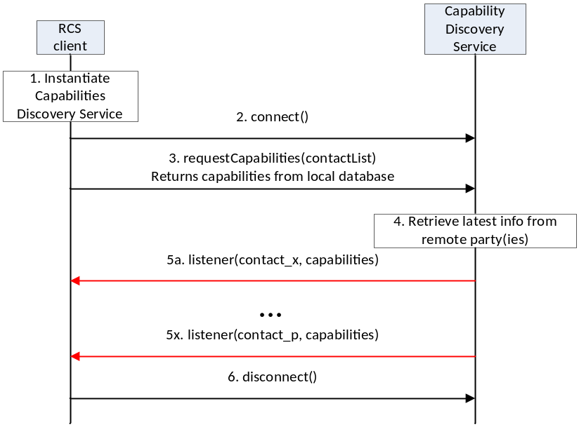

Figure 3.3-1: Get the capabilities of a list of remote contacts
- The RCS client instantiates a service instance of the Capability Discovery Service. At this time, it also specifies the list of listener functions.
- The RCS client establishes a connection with the Capability Discovery Service. The Capability Discovery Service associates the listener with this RCS client.
- The RCS client constructs a list of contacts for which it wants to get the latest capabilities. It invokes the API to get the capabilities of these contacts by providing the contact list as argument. The Capability Discovery Service returns the requested information from the local database.
- Additionally, the Capability Discovery Service initiates procedures with the remote parties to retrieve the latest capabilities.
- When the updated capability information is available for a contact, the listener function(s) are invoked to inform all the RCS clients that have installed a listener. This step is repeated for each contact for which updated capability information becomes available.
- Finally, the RCS client, having retrieved the contact information, disconnects from the capability discovery service. At this time, the Capability Service discards all listeners associated with this client.

