 |  | RCSJTA TT BB CR_002 R3  Multimedia Session API
Meeting Information
Meeting Name and Number
Meeting Date
Meeting Location
Document Information
Document Author(s) |  | JM. Auffret, Orange Labs
Document Creation Date |  | 12 June, 2013
 |  | Approval | X
This document is for: (mark X as appropriate) |  | Discussion
 |  | Information only
Security Classification – Non Confidential / Confidential GSMA Material (Delete as appropriate and delete the rows below that do not apply) |  |  | Can be distributed to: (mark X as appropriate or specify group
Non Confidential |  | Public
Confidential |  | Project Team or Group | X
Confidential |  | GSMA HQ Staff | X
Confidential |  | GSMA Full Members | X
Confidential |  | GSMA Associate Members | X
Confidential |  | GSMA Rapporteur Members | X
Document Summary
CR created to add new MM session API proposed by Orange.

Document History
Date | Version | Author / Comments and for updates description of changes
14 March 2014 | R1 | Jean-Marc AUFFRET (jeanmarc.auffret@orange.com)
12 May 2014 | R2 | Jean-Marc AUFFRET (jeanmarc.auffret@orange.com)
20 May 2014 | R3 | Jean-Marc AUFFRET (jeanmarc.auffret@orange.com)

© GSMA 2010. The GSM Association (“Association”) makes no representation, warranty or undertaking (express or implied) with respect to and does not accept any responsibility for, and disclaims liability for the accuracy or completeness or timeliness of the information contained in this document. The information contained in this document may be subject to change without prior notice. This document has been classified according to the GSMA Document Confidentiality Policy. GSMA meetings are conducted in full compliance with the GSMA Antitrust Policy.

RCC TF Change Request Form
Title: | 3.4.x Multimedia Session API
Type of Change Request: Mark the appropriate box by “X” | New Feature |  | Major  Change Errata
  X
Targeted Document | joyn Terminal API Specification
Impact on Other Official Documents: | None

======================= Summary of Changes ==================================

14/03/2014 - OrangeLabs: Internalize the media layer in the API with MSRP support only. Remove any SDP parameters in the API definition. Rename package to “com.gsma.services.rcs.session”. Add new service ID syntax.
12/05/2014 - OrangeLabs: Update after RCS 5.2 delivery: remove pager mode method, add streaming session.
20/05/2014 - OrangeLabs: GSMA meeting review.

======================= End of Summary ==================================

======================= 1st Change ==================================

Multimedia Session API
This service API exposes all functionality related to initiate a multimedia session between two clients in order to implement a new IMS service based session. The new service is identified by a unique service ID which corresponds to a IARI feature tag and ICSI tag in the signalling flows, the same service ID is used as an extension in the Capability service API.
There are 2 types of services offered by the API:
- Real time messaging session based on the MSRP protocol for media. A session is established between contacts and multimedia messages are exchanged in real time until the session exists. A session exists from its initiation to its termination.
- Real time streaming session based on the RTP protocol for media. A session is established between contacts and multimedia payloads are streamed in real time until the session exists. A session exists from its initiation to its termination.
The session may be accepted or rejected by the remote contact. Any type of message may be exchanged between end points.

The API allows:
- Initiate a multimedia session for messaging or streaming.
- Accept/reject an incoming session invitation.
- Retrieve the list of sessions using a given feature tag.
- Terminate a session.

- For a given service, several sessions may coexist in parallel.
This service API hides:
- the SIP signalling complexity and SDP (Session Description Protocol) answer/offer mechanism to negociate the media exchanged between the two end points.
- The media protocol (MSRP for messaging and RTP for streaming).

Thanks to this API, any application can implement a new RCS/IMS service on top of the RCS background service which maintains a single attachment to the RCS/IMS platform and utilizes common IMS procedures (e.g. authentication) for services implemented on top of it.
Each new RCS/IMS service is associated to a service ID:
- The service ID is used to define a new capability (see Capability API) and to share it with others remote contacts.
- The service ID is used to identify the service in the device (for incoming and outgoing request), but also on the platform side (e.g. to trigger an Application server).
See chapter 1.1.1.4 for detailed callflows corresponding to the service API

.

Package
Package name org.gsma.joyn.extension

Methods and Callbacks
Class MultimediaSessionService:
This class offers the main entry point to initiate and manage new and existing multimedia sessions. Several applications may connect/disconnect to the API.
Method: connects to the API.
void connect()
Method: disconnects from the API.
void disconnect()
Method: returns the list of messaging sessions associated to a given service ID.
Set<MultimediaMessagingSession> getMessagingSessions(String serviceId)
Method: returns a current messaging session from its unique session ID.
MultimediaMessagingSession getMessagingSession(String sessionId)
Method: returns a current messaging session from its invitation Intent.
MultimediaMessagingSession getMessagingSessionFor(Intent intent)
Method: initiate a new multimedia session for real time messaging with a remote contact and for a given service. The messages exchanged in real time during the session may be from any type.
MultimediaSession initiateMessagingSession(String serviceId, String contact, MultimediaSessionListener listener)
Method: returns the list of streaming sessions associated to a given service ID.
Set<MultimediaStreamingSession> getStreamingSessions(String serviceId)
Method: returns a current streaming session from its unique session ID.
MultimediaStreamingSession getStreamingSession(String sessionId)
Method: returns a current streaming session from its invitation Intent.
MultimediaStreamingSession getStreamingSessionFor(Intent intent)
Method: initiate a new multimedia session for real time streaming with a remote contact and for a given service. The payloads exchanged in real time during the session may be from any type.
MultimediaSession initiateStreamingSession(String serviceId, String contact, MultimediaSessionListener listener)

Class MultimediaSession:
This class maintains the information related to a multimedia session and offers methods to manage it. This is an abstract class between a messaging session and a streaming session.
Method: returns the session ID of the multimedia session.
String getSessionId()
Method: returns the remote contact.
String getRemoteContact()
Method: returns the service ID.
String getServiceId()
Method: returns the state of the session. The state may have the following values: INVITED, INITIATED, STARTED, ABORTED, TERMINATED, FAILED.
int getState()
Method: returns the direction of the session: INCOMING, OUTGOING.
int getDirection()
Method: accepts session invitation.
void acceptInvitation()
Method: rejects session invitation.
void rejectInvitation()
Method: aborts the session.
void abortSession()

Class MultimediaMessagingSession:
This class inherits from the class MultimediaSession and is related to a messaging session.
Method: send a multimedia message in real time.
void sendMessage(byte[] content)
Method: adds a listener on session events.
void addEventListener(MultimediaMessagingSessionListener listener)
Method: removes a listener on session events.
void removeEventListener(MultimediaMessagingSessionListener listener)

Class MultimediaMessagingSessionListener:
This class offers callback methods on multimedia session events.
Method: callback called when the session is pending.
void onSessionRinging()
Method: callback called when the session is started.
void onSessionStarted()
Method: callback called when the session has been aborted or terminated.
void onSessionAborted()
Method: callback called when the session has failed. The error code may be: INVITATION_DECLINED, SESSION_FAILED.
void onSessionError(int error)
Method: callback called when a multimedia message is received.
void onNewMessage(byte[] content)

Class MultimediaStreamingSession:
This class inherits from the class MultimediaSession and is related to a streaming session.
Method: send a multimedia message in real time.
void sendPayload(byte[] content)
Method: adds a listener on session events.
void addEventListener(MultimediaStreamingSessionListener listener)
Method: removes a listener on session events.
void removeEventListener(MultimediaStreamingSessionListener listener)

Class MultimediaStreamingSessionListener:
This class offers callback methods on multimedia session events.
Method: callback called when the session is pending.
void onSessionRinging()
Method: callback called when the session is started.
void onSessionStarted()
Method: callback called when the session has been aborted or terminated.
void onSessionAborted()
Method: callback called when the session has failed. The error code may be: INVITATION_DECLINED, SESSION_FAILED.
void onSessionError(int error)
Method: callback called when a multimedia message is received.
void onNewPayload(byte[] content)

Intents
Intent broadcasted when a new messaging session invitation has been received. This Intent contains the following extras:
- “contact”: MSISDN of the contact sending the invitation.
- “contactDisplayname”: display name of the contact sending the invitation (extracted from the SIP address).
- “sessionId”: unique ID of the multimedia session.
- MIME type contains the feature tag associated to the service.
org.gsma.joyn.extension.action.NEW_MESSAGING_SESSION

Intent broadcasted when a new streaming session invitation has been received. This Intent contains the following extras:
- “contact”: MSISDN of the contact sending the invitation.
- “contactDisplayname”: display name of the contact sending the invitation (extracted from the SIP address).
- “sessionId”: unique ID of the multimedia session.
- MIME type contains the feature tag associated to the service.
org.gsma.joyn.extension.action.NEW_STREAMING_SESSION

A service is identified by its service ID which permits to route the incoming request (i.e. SIP INVITE or SIP MESSAGE) to the corresponding Android application on the device. This mechanism is implemented by declaring an Intent filter in the Manifest file of the application. See the following syntax to be used, where “xxx” corresponds to the service ID:

<intent-filter>
<action android:name="org.gsma.joyn.extension.action.NEW_MESSAGING_SESSION"/>
<data android:mimeType="com.gsma.services.rcs/xxx"/>
<category android:name="android.intent.category.LAUNCHER"/>
<category android:name="android.intent.category.DEFAULT"/>
</intent-filter>

<intent-filter>
<action android:name="org.gsma.joyn.extension.NEW_STREAMING_SESSION"/>
<data android:mimeType="com.gsma.services.rcs/xxx"/>
<category android:name="android.intent.category.LAUNCHER"/>
<category android:name="android.intent.category.DEFAULT"/>
</intent-filter>

See the Capability API for the service ID syntax.

So when an incoming SIP request arrives in the RCS background service, the feature tag of the request is read and analyzed in order to broadcast an Intent containing the feature tag in its MIME type. Then the Intent is captured by the corresponding application.

Call flows

See the following call flow for a messaging session:
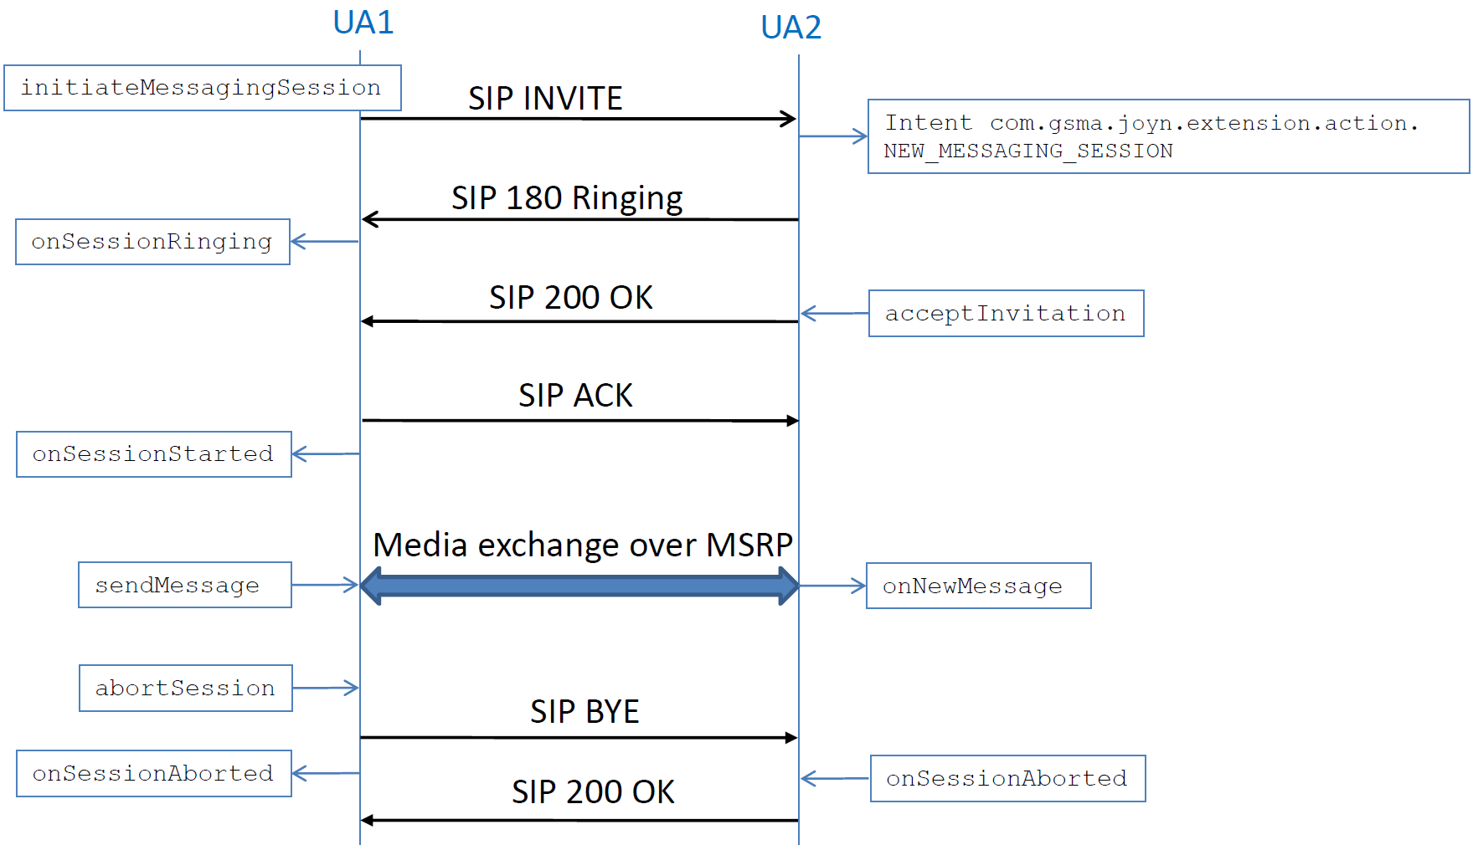

See the following call flow for a streaming session:
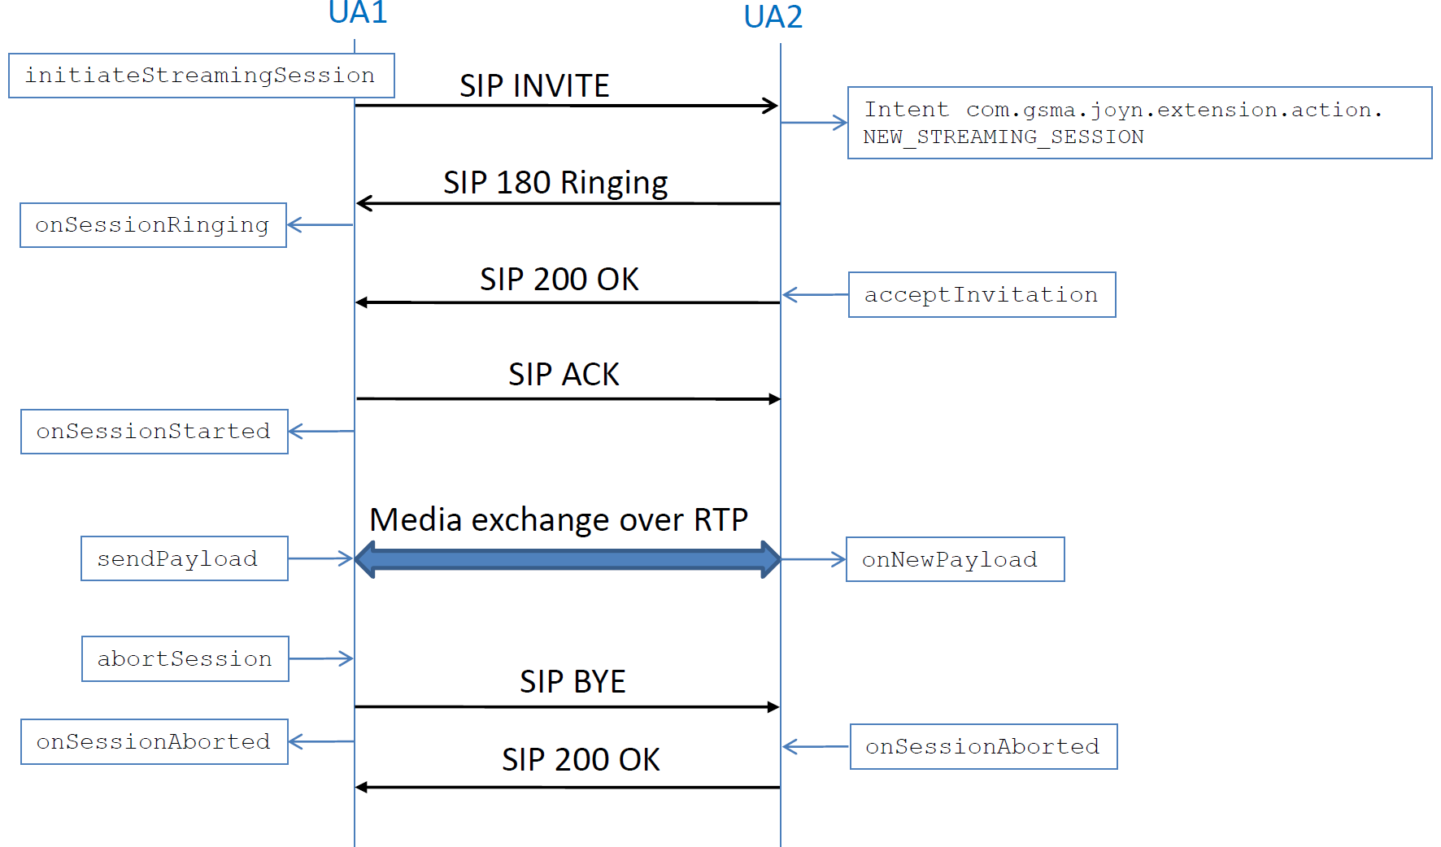

======================= End of changes==================================

