 |  | RCSJTA TT CR_003  Capability API Concepts
Meeting Information
Meeting Name and Number |  | TT #3
Meeting Date |  | April 16, 2013
Meeting Location |  | Conference Call
Document Information
Document Author(s) |  | Qualcomm Incorporated
Document Creation Date |  | April 11, 2013
 |  | Approval | X
This document is for: (mark X as appropriate) |  | Discussion
 |  | Information only
Security Classification – Non Confidential / Confidential GSMA Material (Delete as appropriate and delete the rows below that do not apply) |  |  | Can be distributed to: (mark X as appropriate or specify group
Non Confidential |  | Public
Confidential |  | Project Team or Group | X
Confidential |  | GSMA HQ Staff | X
Confidential |  | GSMA Full Members | X
Confidential |  | GSMA Associate Members | X
Confidential |  | GSMA Rapporteur Members | X
Document Summary
Description of API concepts

Document History
Date | Version | Author / Comments and for updates description of changes
April 11, 2013 | 1.0 | - Remove description of RCS services from this section (3.1)  - Clarify the servers and listeners description – removing implementation specific details (3.1.1)  - Created new sections for describing the concepts of Service and Session (3.1.1 and 3.1.2)  - General improvements in section 3.2.  - In Section 3.3, removed all the flows and replaced them by a single flow that represents an illustrative use. Also provided descriptions for the individual steps in the flow.

© GSMA 2010. The GSM Association (“Association”) makes no representation, warranty or undertaking (express or implied) with respect to and does not accept any responsibility for, and disclaims liability for the accuracy or completeness or timeliness of the information contained in this document. The information contained in this document may be subject to change without prior notice. This document has been classified according to the GSMA Document Confidentiality Policy. GSMA meetings are conducted in full compliance with the GSMA Antitrust Policy.

RCC TF Change Request Form
Title: | RCS API Concepts
Type of Change Request: Mark the appropriate box by “X” | New Feature |  | Major  Change Errata
  X
Targeted Document | joyn Terminal API Specification
Impact on Other Official Documents: | None

--------------------------------------Changes below-----------------------------------
- API concepts

3.1 Servers and Listeners
RCS APIs are provided with a client/server model. At any time, for a service, there may be zero or more clients. At any time, a client may be connected to zero or more services.

Prior to requesting a service, a client connects to that service.

Servers provide RCS services to the clients and notify the registered clients with the events through listeners. Clients request RCS services from the servers by invoking the appropriate API(s). Servers notify clients of RCS events by invoking the appropriate listener (callback functions). For RCS events that a client is required to monitor, the client must supply the listener to the server.

For each service, this document describes all the server APIs. This document also describes the set of events that are available for each service.

Service
Prior to using a service, a RCS client invokes the appropriate API to create the service. For each service that is created, the RCS stack creates a unique handle, which can be subsequently used by the client to communicate with the RCS server. At this time, the client can also register for events by supplying the appropriate listener functions. Also, while creating the service, the client can pass a client handle through which the client can maintain its context (i.e. callback data). A
After the service is created, the service communicates/notifies its clients about the service availability and/or service-specific functionality changes through the listener supplied by the clients. The listener is a combination of a list of functions and a client handle. The client handle is unchanged by the service and can be used as callback data.
At any time, a service may have zero or more sessions associated with it.
When a service is no longer needed, the client can destroy the service by invoking the appropriate API for that service. When a service is destroyed, all the sessions associated with that service are also terminated.

Session
A session is established based on external triggers, e.g. user attempting to establish a call or upon receipt of an event from the RCS server about a request from a remote user. When a session is to be established, the appropriate API is invoked. For each session that is created, the RCS stack creates a unique handle, which can be used by the client to communicate with the RCS server about this session. Each session is associated with a RCS service. Also, while creating the session, the client can also pass a client handle through which the client can maintain its context (i.e. callback data) when the server fires up the events through the listener functions.
After the session is created, the RCS server communicates/notifies its clients about the session state through the listeners supplied by the clients. The listener is a combination of a list of functions and its handle. The client handle is unchanged by the RCS server and can be used as callback data.
At any time, the client can terminate a session by invoking the appropriate API, for example, based on user action or based on events from the RCS server that indicate a change in the session state.

3.2 Service Version/Available/Unavailable
Each service is associated with a specific client. Services are designed to allow each service to have its own service version and its availability/unavailability attribute independently. Each service follows the same template API to provide versioning information and has the same type of listener functions through which the service informs its clients about specific service status.

3.3 Capability Discovery API
The Capabilities Discovery (CD) service provides the API through which the user can get the capabilities of other contacts and also "announce" its own capabilities.

The figures in this section contain basic call flows of the CD service API.

Figure 3.3-1 illustrates the retrieval of the capabilities of a list of remote contacts.
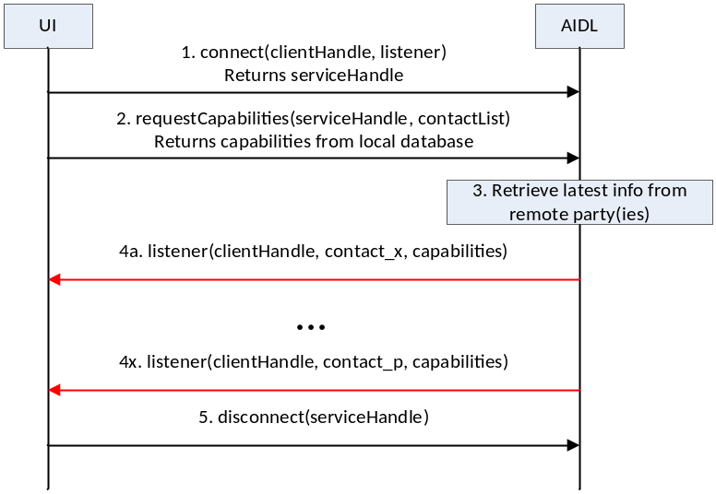
Figure 3.3-1: Get the capabilities of a list of remote contacts
- The UI first establishes a connection with the Capability Discovery service. The UI creats a clientHandle and identifies the list of events that it wishes to be notified of. It provides the clientHandle and the listener as arguments to the API and creates a service instance for the Capability Discovery service. The Capability Discovery service saves the clientHandle and associates the listener to this client. It constructs a serviceHandle and returns it to the UI.
- The UI constructs a list of contacts for which it wants to get the latest capabilities. It invokes the API to get the capabilities of these contacts by providing the contact list and the serviceHandle as arguments. The Capability Discovery service returns the requested information from the local database.
- Additionally, the Capability Discovery service initiates procedures with the remote parties to retrieve the latest capabilities.
- When the updated capability information is available for a contact, the listener function(s) are invoked to inform all the UIs that have installed a listener for this contact. This step is repeated for each contact in the contact list.
- Finally, the UI, having retrieved all the contact information, disconnects from the capability discovery service. At this time, all listeners associated with this client are discarded.

3.4 Instant messaging API
TBD

3.5 Image share API
TBD

3.6 File transfer service API
TBD

3.7 Configuration service API
TBD

