 |  | RCSJTA TT BB CR_032  Minor corrections
Meeting Information
Meeting Name and Number
Meeting Date
Meeting Location |  | Conference Call
Document Information
Document Author(s) |  | Jean-Marc Auffret (ORANGE), Kristoffer Karlsson (SONY)
Document Creation Date |  | June 10th 2014
 |  | Approval | X
This document is for: (mark X as appropriate) |  | Discussion
 |  | Information only
Security Classification – Non Confidential / Confidential GSMA Material (Delete as appropriate and delete the rows below that do not apply) |  |  | Can be distributed to: (mark X as appropriate or specify group
Non Confidential |  | Public
Confidential |  | Project Team or Group | X
Confidential |  | GSMA HQ Staff | X
Confidential |  | GSMA Full Members | X
Confidential |  | GSMA Associate Members | X
Confidential |  | GSMA Rapporteur Members | X
Document Summary
Video Share API proposal for hiding complexity to render video stream

Document History
Date | Version | Author / Comments and for updates description of changes
06/10/2014 | 0.1 | Initial document

© GSMA 2010. The GSM Association (“Association”) makes no representation, warranty or undertaking (express or implied) with respect to and does not accept any responsibility for, and disclaims liability for the accuracy or completeness or timeliness of the information contained in this document. The information contained in this document may be subject to change without prior notice. This document has been classified according to the GSMA Document Confidentiality Policy. GSMA meetings are conducted in full compliance with the GSMA Antitrust Policy.

RCC TF Change Request Form
Title: | Minor corrections found during implementation.
Type of Change Request: Mark the appropriate box by “X” | New Feature |  | Major  Change Errata
  X
Targeted Document | joyn Terminal API Specification
Impact on Other Official Documents: | None

======================= Summary of Changes =============================

======================= End of Summary =================================

======================= 1st Change ==================================

Introduction

Overview
This document defines the architecture and a set of standardized Application Programming Interfaces (API) to develop joyn user experience (UX), use joyn services and develop IP Multimedia Sub-system (IMS)-based services.

Scope
The scope of this document covers the APIs along with security limitations for the functionalities defined in [PRD RCC.60].

Definitions
Term | Description
3rd Party Applications | Applications that are not part of the joyn Client and developed by companies or individuals other than Mobile Network Operators (MNO) and Original Equipment Manufacturers (OEM).
Core Applications | Applications that are part of the joyn Client.
Trusted Applications | Applications using the IMS API, developed by trusted parties (MNOs and OEMs).
IMS Stack | Component responsible for implementing IMS protocol suite and core services.
joyn Client | Complete software package that passed joyn accreditation.
Service API | APIs that expose Standard Services and can be used in multiple instances without any restrictions.
Privileged Client API | API shall expose key functionalities which are necessary for the proper working of the joyn client.
IMS API | APIs that are exposed by the IMS Stack.
Standard Services | Services that are identified by feature tags, as defined by joyn Specification.

Abbreviations
Term | Description
AIDL | Android Interface Definition Language
API | Application Programming Interfaces
CD | Capability Discovery
CS | Circuit Switched
FT | File Transfer
ID | Identifier
IM | Instant Messaging
IMS | IP Multimedia Sub-system
IS | Image Share
MIME | Multipurpose Internet Mail Extensions
MNO | Mobile Network Operator
MSISDN | Mobile Subscriber Integrated Services Digital Network Number
MSRP | Message Session Relay Protocol
OEM | Original Equipment Manufacturer
OMA | Open Mobile Alliance
QCIF | Quarter Common Intermediate Format
RCS | Rich Communication Services
RTCP | Real-Time Control Protocol
RTP | Real-Time Protocol
SDK | Software Development Kit
SIMPLE | SIP (Session Initiation Protocol) Instant Message and Presence Leveraging Extensions
SIP | Session Initiation Protocol
URI | Uniform Resource Identifier
UX | User Experience

References
Ref | Doc Number | Title
[1] | [PRD RCC.60] | joyn Blackbird Product Definition Document http://www.gsma.com/rcs/wp-content/uploads/2013/10/Blackbird-Product-Descrption-Document-v2.0.pdf
[2] | [RFC 2119] | “Key words for use in RFCs to Indicate Requirement Levels”, S. Bradner, March 1997. Available at http://www.ietf.org/rfc/rfc2119.txt

Conventions
“The key words “must”, “must not”, “required”, “shall”, “shall not”, “should”, “should not”, “recommended”, “may”, and “optional” in this document are to be interpreted as described in [RFC 2119].”

API Architecture

Architecture Overview
The joyn Client architecture is composed of several sub-systems, organised into functional layers as shown in the diagram below.
The fundamental enabling component is the IMS Stack which contains the protocol suite (Session Initiation Protocol [SIP], Message Session Relay Protocol [MSRP], Real-Time Protocol [RTP]/Real-Time Control Protocol [RTCP], Hyper-Text Transfer Protocol [HTTP], etc.) and core services (IMS Session Management, Registration, etc.). The functionality of this component is governed by the IMS specifications.
Above IMS there are the Rich Communication Services (RCS) Enablers, comprising the functionality to enable RCS-based Chat, Video and Image sharing, File Transfer and other RCS services. The functionality of this layer is governed by the GSMA RCS specifications.
Access to these functional layers is mediated by RCS Services API. Client applications and services access the underlying functionality exclusively through this interface. The RCS service API logic access for client applications to the RCS services (Open Mobile Alliance [OMA] SIP Instant Message and Presence Leveraging Extensions [SIMPLE] Instant Messaging [IM], GSMA Video Share, GSMA Image Share, etc.).
The joyn Core Applications or OEM UX are the (typically embedded) applications that provide the end-user’s access to RCS services. The Core Applications make use of the RCS Services API and also expose a UX API (a subset of the Service API) whereby any other applications can programmatically invoke operations that are interactively fulfilled by the Core Applications.
The architecture is intended to enable RCS Extension to make direct use also of the RCS Service API, enabling programmatic access to the RCS services. The RCS Service API is scoped so as to make access by Third Party Applications possible subject to those applications having the appropriate permission.

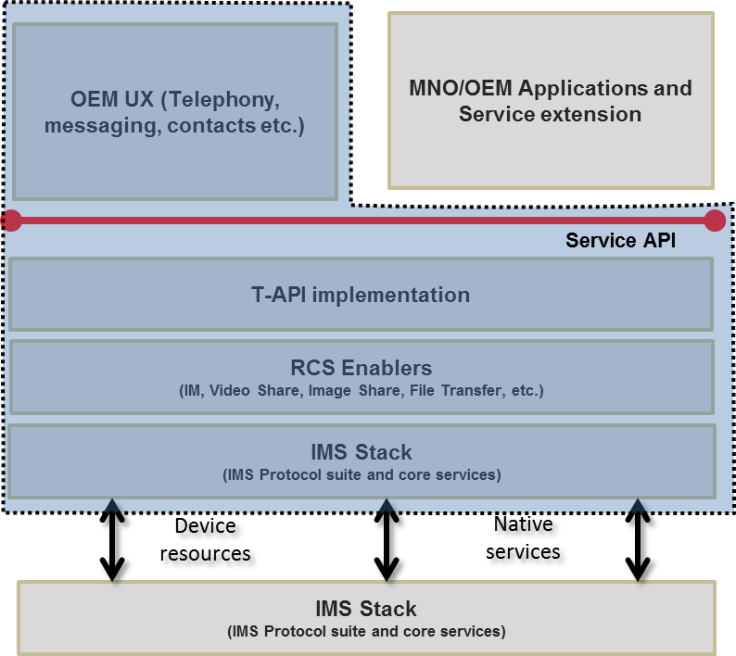
- : General Architecture Overview

API Descriptions

Service APIs
RCS Service APIs provide a functional interface to the RCS enablers, enabling the Core Applications and Third Party Applications to interoperate with other RCS devices whilst relying on the stack to ensure conformance to the RCS Specification.
There are two types of service APIs:
- The UX API which is a high level API enabling other installed applications to link to the native RCS services or applications.
- The core service APIs offering lower level APIs for the following
- Capabilities service API
- Chat service API
- File Transfer service API
- Video Share service API
- Image Share service API
- Geoloc Share service API
- History service API

- MultiMedia Session service API
- File Upload API
- Client Connector
NOTE: For Video Share and Image Share functionality to be fully available, a call needs to be ongoing with a RCS contact posessing Video Share and Image Share capabilities.
Each service API is based on a Client/Server model using the Android Interface Definition Language (AIDL) Android interface to communicate between the application using the service and the RCS service or stack implementing the service. So many applications can connect in parallel to the core RCS service.
The APIs in this layer also expose common joyn functionality for capability fetching and retrieving parts of the joyn network configuration required for UI elements.
In case of Android OS, client enables to interface the native RCS service functionality with 3rd party applications on the device.

Applications Types
Applications types can be divided into three broad categories:
- OEM applications
- MNO applications
- Third party applications
An application may use:
- RCS Extensions to provide service-over-service functionality. These applications use additional parameterization defined in the Service APIs, and may have their own feature tags not defined by the joyn Specification.
- Core Services that are included in the joyn Client. These components must undergo GSMA accreditation as part of the joyn Client. Core Applications may use Service APIs (such as IM) and can have overlapping functionality with RCS Extensions.

API concepts

Servers and Listeners
RCS APIs are provided with a client/server model. At any time, for a service, there may be zero or more clients. At any time, a client may be connected to zero or more services.
Prior to requesting a service, a client connects to that service.
Servers provide RCS services to the clients and notify the registered clients with the events through listeners. Clients request RCS services from the servers by invoking the appropriate API(s). Servers notify clients of RCS events by invoking the appropriate listener (callback functions). For RCS events that a client is required to monitor, the client must supply the listener to the server.
For each service, this document describes all server APIs as well as the set of events that are available for that service.

Service
Prior to using a service, a RCS client invokes the appropriate API to create the service. At this time, the client can also register for events by supplying the appropriate listener functions.
Once the service is created, the service communicates/notifies its clients about the service availability and/or service-specific functionality changes through the listener supplied by the clients.
At any time, a service may have zero or more sessions associated with it.
When a service is no longer needed, the client can destroy the service by invoking the appropriate API for that service. When a service is destroyed, all the service sessions associated with that service are also terminated.

Service Session
A service session is established based on external triggers, e.g. a user attempting to establish a call or upon receipt of an event from the RCS service about a request from a remote user. When a service session is to be established, the appropriate API is invoked. At the time of establishment of a service session, the client registers for events by supplying appropriate listener functions. Each service session is associated with a RCS service.
After the service session is created, the RCS service communicates/notifies its clients about the session state through the listeners supplied by the clients.
At any time, the client can terminate a service session by invoking the appropriate API, for example, based on user action or based on events from the RCS server that indicate a change in the session state.

Service Version/Available/Unavailable
Each service is associated with a specific client. Services are designed to allow each service to have its own service version and its availability/unavailability attribute independently. Each service follows the same template API to provide versioning information and has the same type of listener functions through which the service informs its clients about specific service status.

Android API
See also a detailed Javadoc of the Android API from the RCJTA web site (https://code.google.com/p/rcsjta/).

Components Interaction
Each of the Terminal APIs for Android defines their interaction individually and how they can be used by an Android Application.

New service application
When an Android application wants to define a new service, it needs to add its feature tag as meta-data value in its Android Application Manifest. The RCS Service Tag also needs to be accompanied by the feature tag. Refer to [PRD RCC.60]
for exact definitions of possible feature tags.

Constraints
Following constraints apply:
- Only a single RCS Stack can be active on a device. This constraint limits the possibilities for deployment of additional RCS Stacks with the Terminal API, as they cannot replace the package of a previously installed stack on the device. This constraint could be avoided if the Terminal APIs could be retrieved dynamically instead of static package reference.
- When multiple applications are present, that support the same type of service notifications, multiple notification may be placed in the Notification Tray, if each application handles the broadcasted intent.
- Trusted application can only run if any IMS Stack is running. This means trusted applications can only be dynamically registered/de-registered. They are not allowed to be part of initial registration application set. Any exceptions need to be carefully considered.

Security
Most of the RCS APIs provide access to sensitive functionality, either because they enable access to privacy-sensitive information or because they can cause charges to be incurred for network and service usage. In addition, certain APIs expose the internal functionality of the stack, and abuse of those APIs could compromise the integrity of the stack or the RCS services.

Service API Access Control
The Service APIs are sensitive and their abuse could compromise the integrity of the stack or the RCS services. Access is therefore restricted so that they may only be used by authorised RCS Extensions, through OEM signing, embedding in system folder, or another solution mutually agreed between MNO and OEM.
Where the Service API exposes privacy-sensitive information or may trigger service charges, the user must grant permission for any application to use that API. The permissions are defined for each service API in the sections that follow.

UX API
This API offers:
- Intents which permit to link RCS applications with other third party applications installed on the device.
- Methods to discover existing RCS services on the device and their activation states.

Package
Package name com.gsma.services.rcs

Methods and Callbacks
Class RcsUtils:
- Method: returns the list of RCS services installed on the device (except myself). An application is identified as a RCS service by including an intent filter with the ACTION_VIEW _SETTINGS action in the Manifest.xml of the application(eg. Android service).
<intent-filter>
<category android:name="android.intent.category.LAUNCHER"/>
<category android:name="android.intent.category.DEFAULT"/>
<action android:name="com.gsma.services.rcs.service .action.VIEW_SETTINGS"/>
</intent-filter>

static List<ResolveInfo> getRcsServices (Context context)
- Method: detects if a particular RCS service is activated. The result is returned asynchronously via a broadcast receiver. The RCS service is identified by the object ResolveInfo recovered via the method getRcsServices . Each RCS service should implement a Broadcast receiver with the following Intent filter in order to return its current status:
<intent-filter>
<action android:name="<service package name>.service .action.GET_STATUS"/>
</intent-filter>
- The action should start with the specific service package name and should terminate with ACTION_GET_STATUS.
static void isRcsServiceActivated(Context ctx, ResolveInfo appInfo, BroadcastReceiver receiverResult)

- Method: Load the settings activity of a particular RCS service. The RCS service activity is identified by the object ResolveInfo recovered via the method getRcsServices .
static void loadRcsServiceSettings(Context context, ResolveInfo appInfo)

Intents
Class Intents.Service:
This class offers intents to link applications to the RCS service.
- Intent: load the settings activity to enable or disable the RCS service.
static final String ACTION_VIEW_SETTINGS = “com.gsma.services.rcs.service.action.VIEW_SETTINGS”;

- Intent: get the RCS service status.
static final String ACTION_SERVICE_GET_STATUS = “com.gsma.services.rcs.service.action.GET_STATUS”;

Class Intents.Chat:
This class offers Intents to link applications to RCS applications for chat services.
- Intent: load the chat application to view a chat conversation. This Intent takes into parameter a Uniform Resource Identifier (URI) on the chat conversation (i.e. content://chats/chat_ID). If no parameter found the main entry of the chat application is displayed.
static final String ACTION_VIEW_ONE_TO_ONE_CHAT = "com.gsma.services.rcs.action.VIEW_ONE_TO_ONE_CHAT"

- Intent: load the chat application to start a new conversation with a given contact. This Intent takes into parameter a contact URI (i.e. content://contacts/people/contact_ID). If no parameter the main entry of the chat application is displayed.
static final String ACTION_INITIATE_ONE_TO_ONE_CHAT = "com.gsma.services.rcs.action.INITIATE_ONE_TO_ONE_CHAT"

- Intent: load the group chat application. This Intent takes into parameter an URI on the group chat conversation (i.e. content://chats/chat_ID). If no parameter is found the main entry of the group chat application is displayed.
static final String ACTION_VIEW_GROUP_CHAT = "com.gsma.services.rcs.action.VIEW_GROUP_CHAT"

- Intent: load the group chat application to start a new conversation with a group of contacts. This Intent takes into parameter a list of contact URIs. If no parameter, the main entry of the group chat application is displayed.
static final String ACTION_INITIATE_GROUP_CHAT = "com.gsma.services.rcs.action.INITIATE_GROUP_CHAT"
Class Intents.FileTransfer:
This class offers Intents to link applications to RCS applications for file transfer services.
- Intent: load the file transfer application to view a file transfer. This Intent takes into parameter a URI on the file transfer (i.e. content://filetransfers/ft_ID). If no parameter is found, the main entry of the file transfer application is displayed.
static final String ACTION_VIEW_FT = "com.gsma.services.rcs.action.VIEW_FT"

- Intent: load the file transfer application to start a new file transfer to a given contact. This Intent takes into parameter a contact URI (i.e. content://contacts/people/contact_ID). If no parameter, the main entry of the file transfer application is displayed.
static final String ACTION_INITIATE_ONE_TO_ONE_FT = "com.gsma.services.rcs.action.INITIATE_ONE_TO_ONE_FT"

NOTE: for Intents using a contact URI as a parameter, if the contact has several phone numbers which are RCS compliant, then the application receiving the Intent should request to the user to select which phone number should be used by the service.
NOTE: sharing during a call (image & video) are part of the native dialler application and may be only visible when a call is established, in this case there is no public Intent to initiate a sharing.

Services API

Overview
This section contains all the Service APIs. Each of the presented APIs may have a Core Application using it, but a separate 3rd Party Application can also use it. Each API exposes all its functionality on a high level and does put constraints on the invoking application as to the preconditions and order of method calls. All Service APIs are stateless, meaning that any part of the API can be used without first satisfying any preconditions.

Access Control
Each of the services requires one or more permissions to be held by the calling application; the permissions associated by each service are defined in the sections that follow.
The permissions are organised on a service-by-service basis and at a sufficiently fine-grained level – e.g. the ability to read contact details from the address book - that the user can make a meaningful choice when confronted with a request at the install prompt. The user is not asked to give blanket approval to a very broad permission such as the ability to read any user data.

Common architecture
The RCS terminal API contains the following service API:
- Capability service API
- Chat API
- File Transfer API
- Video Share service API
- Image Share service API
- Geoloc Share service API
- History service API
- Multimedia Session service API
- File Upload API
Each service API is based on a Client/Server model using the Android Interface Definition Language (AIDL) Android interface to communicate between the application using the service and the RCS service or stack implementing the service. So many applications can connect in parallel to the core RCS service.

Package
Package name com.gsma.services.rcs

Methods and Callbacks

Class RcsService:
Each service API should extend the abstract class RcsService.

- Enum: directions of a message, geolocation, filetransfer, imageshare etc..
enum Direction { INCOMING(0), OUTGOING(1), IRRELEVANT(2) }

- Enum: Read status of a chat message or a file transfer
enum ReadStatus { UNREAD(0), READ(1) }

- Constructor: instantiates a service API. This method takes in parameter a service event listener which permits to monitor the connection to the RCS service. The parameter context is an Android context which permits to initiate the binding with the corresponding service.
RcsService(Context ctx, RcsServiceListener listener)

- Method: connects to the API. This method permits to bind to the service.
void connect()

- Method: disconnects from the API. This method permits to unbind from the service.
void disconnect()

- Method: returns “true” if connected to the service, else returns “false”.
boolean isServiceConnected()

- Method: returns true if service registered to the RCS service platform, else returns false.
boolean isServiceRegistered()

- Method: adds a listener on service registration event.
void addEventListener(RcsServiceRegistrationListener listener)

- Method: removes a listener on service registration event.
void removeEventListener(RcsServiceRegistrationListener listener)

- Method: returns the version of the service (see constants from class RcsService.Build.VERSION_CODES).
int getServiceVersion()

Interface RcsServiceListener:

- Method: callback called when service is connected. This method is called when the service is well connected to the RCS service (binding procedure successful): this means the methods of the API may be used.
void onServiceConnected()

- Method: callback called when service has been disconnected. This method is called when the service is disconnected from the RCS service (e.g. service deactivated).
void onServiceDisconnected(ReasonCode reasonCode)

- Enum: the reason code of the service disconnection.
enum ReasonCode { INTERNAL_ERROR(0), SERVICE_DISABLED(1), CONNECTION_LOST(2) }

Class RcsServiceRegistrationListener:

- Method: callback called when a service is registered to the RCS platform. This method is called when the terminal is registered to the RCS/IMS service platform.
void onServiceRegistered()

- Method: callback called when a service is unregistered from RCS platform. This method is called when the terminal is not registered to the RCS service platform.
void onServiceUnregistered()

Class RcsServiceConfiguration:
This class represents the particular configuration of RCS Service.

- Enum: the messaging client mode.
enum MessagingMode { NONE(0), INTEGRATED(1), CONVERGED(2), SEAMLESS(3) }

- Enum: the messaging method.
enum MessagingMethod { AUTOMATIC(0), RCS(1), NON_RCS(2) }

- Method: returns True if the RCS service is activated, else returns False. The service may be activated or deactivated by the end user via the RCS settings application.
static boolean isServiceActivated(Context ctx)

- Method: returns the display name associated to the RCS user account. The display name may be updated by the end user via the RCS settings application.
static String getMyDisplayName(Context ctx)

- Method: set the display name associated to the RCS user account.
static void setMyDisplayName(Context ctx, String name)

- Method: returns the user contact identifior (i.e. username part of the IMPU).
static ContactId getMyContactId(Context ctx)

- Method: returns the user Country Code.
static String getMyCountryCode(Context ctx)

- Method: returns the user Country Area Code.
static String getMyCountryAreaCode(Context ctx)

- Method: returns “true” if RCS configuration is valid
static boolean isConfigValid(Context ctx)

- Method: returns the messaging client mode.
static MessagingMode getMessagingUX(Context ctx)

- Method: returns the default messaging method.
static MessagingMethod getDefaultMessagingMethod(Context ctx)

- Method: set the default messaging method.
static void setDefaultMessagingMethod(Context ctx, MessagingMethod method)

Content Providers
A content provider is used to store the RCS service configuration persistently.
Class RcsServiceConfiguration:
URI to access the provider data:
static final Uri CONTENT_URI = "content://com.gsma.services.rcs.provider.setting/setting"
The “KEY” column below is defined as the unique primary key and can be references with adding a path segment to the CONTENT_URI + “/” + <primary key>
Column name definition constants to be used when accessing this provider:
static final String KEY = “key”
static final String VALUE = “value”

The content provider has the following table and columns:
SETTING
 | No. |  | Data |  | Data Type |  | Description
1 |  | KEY |  | TEXT |  | Key of the Rcs configuration parameter
2 |  | VALUE |  | TEXT |  | Value of the Rcs configuration parameter

Possible values for the KEY fields:
- MY_DISPLAY_NAME,
- MY_CONTACT_ID,
- MY_COUNTRY_CODE,
- MY_COUNTRY_AREA_CODE,
- CONFIGURATION_VALIDITY,
- MESSAGING_MODE,
- DEFAULT_MESSAGING_METHOD

Class GroupDeliveryInfoLog:
URI constant to be able to query the provider data (Note that only read operations are supported since exposing write operations would conflict with the fact that the stack is performing write operations internally to keep the data matching the current situation):
static final Uri CONTENT_URI = "content://com.gsma.services.rcs.provider.groupdeliveryinfo/groupdeliveryinfo"
The “ID” column below is defined as the unique primary key and can be references with adding a path segment to the CONTENT_URI + “/” + <primary key>
Column name definition constants to be used when accessing this provider:
static final String ID = "id"
static final String CONTACT = "contact"
static final String CHAT_ID = "chat_id"
static final String TIMESTAMP_DELIVERED = "timestamp_delivered"
static final String TIMESTAMP_DISPLAYED = "timestamp_displayed"
static final String STATUS = "status"
static final String REASON_CODE = "reason_code"
The content provider has the following columns:
GROUPDELIVERYINFO
Data | Data Type | Description
ID | Long | Unique Id of the chat message or file transfer
CONTACT | String | ContactId formatted number of the remote contact of the group chat message or the group file transfer
CHAT_ID | String | Id of chat room
TIMESTAMP_DELIVERED | Long | Time when message delivered. If 0 means not delivered.
TIMESTAMP_DISPLAYED | Long | Time when message displayed. If 0 means not displayed.
STATUS | Integer | See enum GroupDeliveryInfo.Status for the list of statuses.
REASON_CODE | Integer | See enum GroupDeliveryInfo.ReasonCode for the list of reason codes.

- Enum: states associated with the group chat delivery info provider.
enum Status { UNSUPPORTED(0), NOT_DELIVERED(1), DELIVERED(2), DISPLAYED(3), FAILED(4) }

- Enum: reason code associated with the group chat delivery info provider.
enum ReasonCode { UNSPECIFIED(0), FAILED_DELIVERY(1), FAILED_DISPLAY(2) }

Exceptions
Class RcsServiceException:
This generic class must be thrown when from a service API when the requested operation failed to fully complete its scope of responsibility and none of the more specified exceptions below can be thrown. This exception is not to be defined as an abstract exception neither are any of the more specific exceptions below indented to extend this exception. The client must be able to trust that in case of any failure what so ever and none of the more specific exception below are thrown this exception will be thrown as a kind of default exception to signify that some error occurred that not necessarily need to be more specific than that.
Class RcsServiceNotAvailableException:
This class is thrown when a method of the service API is called and the service API is not bound to the RCS service (e.g. RCS service not yet started or API not yet connected).
Class RcsServiceNotRegisteredException:
This class is thrown when a method of the service API using the RCS service platform is called and the terminal which requires that the RcsCoreService is registered and connected to the IMS server like for instance initiateGroupChat(,,,) is not registered to the RCS service platform (e.g. not yet registered) It is not thrown when a service API method is called that fully could perform its scope of responsibility without having to be connected to the IMS like for instance calling getConfiguration() on a service
Class RcsContactFormatException (RuntimeException):
This class is thrown when the specified contact format String is not supported or not well formatted.
Class RcsMaxAllowedSessionLimitReachedException:
This class is thrown if the message/filetransfer/imageshare/geolocationshare etc (all the types) cannot be sent/transfered/resent or a new groupchat invitation cannot be sent right now since the limit of allowed ongoing sessions has already been reached and the client needs to wait for at least one session to be released back to the stack first.
Class RcsPermissionDeniedException:
This class is thrown when a method of the service API is called that not allowed right now. This can be for multiple reasons like it is not possible to call accept() on a file transfer invitation that has previously already been rejected, the file trying to be sent is not allowed to be read back due to security aspects or any other operation that fails because the operation is not allowed or has been blocked for some other reason.
Class RcsPersistentStorageException:
This class is thrown when a method of the service API is called to persist data or read back persisted data failed. This can be because the underlying persistent storage database (or possibly further on a CPM cloud) reported an error such as no more entries can be added perhaps because disk is full, or just that a SQL operation failed or even a unsuccessful read operation from persistent storage.
Class RcsUnsupportedOperationException (RuntimeException):
This class is thrown when a method of the service API is called that is not supported (ie does not make sense within the scope of the use case) like trying to call pauseTransfer() on a non pausable file transfer that does not support that etc.
Class RcsIllegalArgumentException (RuntimeException):
This class is thrown when a method of the service API is called with one or multiple illegal input parameter. Such as a calling a method and passing null as a parameter in the case that null is not valid for that parameter or a file uri that does not point to any existing file or a file that is bigger than max size limit or a group chat id that must not refer to a non existing group chat unless that is specifically otherwise specified in the method description etc.
NOTE: For more detailed information about exactly which method call in the API can throw which exceptions above see the javadoc

Permissions
Access to the Services API requires the com.gsma.services.rcs.READ_RCS_STATE permission. This is a new permission, analogous to READ_PHONE_STATE, covering general access to the RCS stack state.
This permission is additionally required to access any of the specific services, since use of those services implicitly reveals information about the current network and stack state

Intents

Intent broadcasted when the service is up.

com.gsma.services.rcs.action.SERVICE_UP

Intent broadcasted when the service has been provisioned with success and the service may connect to the service platform.

com.gsma.services.rcs.action.SERVICE_PROVISIONED

Capability API
This API allows for querying the capabilities of a user or users and checking for changes in their capabilities:
- Read the supported capabilities locally by the user on its device.
- Retrieve all capabilities of a user.
- Checking a specific capability of a user.
- Refresh capabilities for all contacts.
- Registering for changes to a user/users ‘s capabilities
- Unregistering for changes to a user/users ‘s capabilities
- Define scheme for registering new service capabilities based on manifest defined feature tags.
This API may be accessible by any application (third party, MNO, OEM). The RCS extensions are controlled internally by the RCS service.
Note: there is the same API between File transfer and File Transfer over HTTP. So from an API perspective there is the same capability for both mode (MSRP and HTTP) and it is transparent for the user.

Capability Discovery API calling flow
The Capability Discovery (CD) service provides the API through which the user can get the capabilities of other contacts and also "announce" its own capabilities.
The figures in this section contains basic call flows of the CD service API.
The following is an example that shows the retrieval of the capabilities of a list of remote contacts.
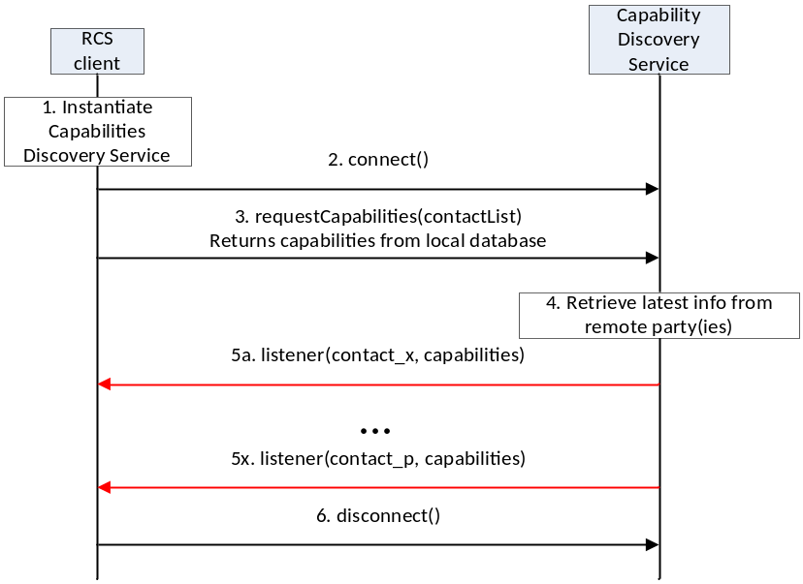
- : Get the capabilities of a list of remote contacts
- The RCS client instantiates a service instance of the Capability Discovery Service. At this time, it also specifies the list of listener functions.
- The RCS client establishes a connection with the Capability Discovery Service. The Capability Discovery Service associates the listener with this RCS client.
- The RCS client constructs a list of contacts for which it wants to get the latest capabilities. It invokes the API to get the capabilities of these contacts by providing the contact list as parameter. The Capability Discovery Service returns the requested information from the local database.
- Additionally, the Capability Discovery Service initiates procedures with the remote parties to retrieve the latest capabilities.
- When the updated capability information is available for a contact, the listener function(s) are invoked to inform all the RCS clients that have installed a listener. This step is repeated for each contact for which updated capability information becomes available.
- Finally, the RCS client, having retrieved the contact information, disconnects from the capability discovery service. At this time, the Capability Service discards all listeners associated with this client.

Package
Package name com.gsma.services.rcs.capability

Methods and Callbacks
Class CapabilityService:
This class offers the main entry point to the Capability service which permits to read capabilities of remote contacts, to initiate capability discovery and to receive capabilities updates. Several applications may connect/disconnect to the API.
A set of capabilities is associated to each MSISDN of a contact.

- Method: connects to the API.
void connect()

- Method: disconnects from the API.
void disconnect()

- Method: returns the capabilities supported by the local end user. The supported capabilities are fixed by the MNO and read during the provisioning.
Capabilities getMyCapabilities()

- Method: returns the capabilities of a given contact from the local database. This method doesn’t request any network update to the remote contact. The parameter contactId supports the following formats: MSISDN in national or international format, SIP address, SIP-URI or Tel-URI. If no matching contact capabilities is found then null is returned.
Capabilities getContactCapabilities(ContactId contact)

- Method: requests capabilities to a remote contact. This method initiates in the background a new capability request to the remote contact by sending a SIP OPTIONS. The result of the capability request is sent asynchronously via callback method of the capabilities listener. A capability refresh is only sent if the timestamp associated to the capability has expired (the expiration value is fixed via MNO provisioning). The parameter contactId supports the following formats: MSISDN in national or international format, SIP address, SIP-URI or Tel-URI. If the format of the contact is not supported an exception is thrown. The result of the capability refresh request is provided to all the clients that have registered the listener for this event.
void requestContactCapabilities(ContactId contact)

- Method: requests capabilities for a group of remote contacts. This method initiates in the background new capability requests to the remote contact by sending a SIP OPTIONS. The result of the capability request is sent asynchronously via callback method of the capabilities listener. A capability refresh is only sent if the timestamp associated to the capability has expired (the expiration value is fixed via MNO provisioning). The parameter contact supports the following formats: MSISDN in national or international format, SIP address, SIP-URI or Tel-URI. If the format of the contact is not supported an exception is thrown. The result of the capability refresh request is provided to all the clients that have registered the listener for this event.
void requestContactCapabilities(Set<ContactId> contacts)

- Method: requests capabilities for all contacts existing in the local address book. This method initiates in the background new capability requests for each contact of the address book by sending SIP OPTIONS. The result of a capability request is sent asynchronously via callback method of the capabilities listener. A capability refresh is only sent if the timestamp associated to the capability has expired (the expiration value is fixed via MNO provisioning). The result of the capability refresh request is provided to all the clients that have registered the listener for this event.
void requestAllContactsCapabilities()

- Method: registers a listener for receiving capabilities on any contact.
void addCapabilitiesListener(ICapabilitiesListener listener)

- Method: unregisters a capabilities listener.
void removeCapabilitiesListener(ICapabilitiesListener listener)

- Method: registers a capabilities listener for receiving capabilities on a list of contacts.
void addCapabilitiesListener(Set<ContactId> contacts, ICapabilitiesListener listener)

- Method: unregisters a capabilities listener on a list of contacts.
void removeCapabilitiesListener(Set<ContactId> contacts, ICapabilitiesListener listener)

Class ICapabilitiesListener:
This class offers callback methods for the listener of capabilities.

- Method: callback called when new capabilities are received for a given contact.
The first argument contact contains the canonical representation of the identity of the contact whose capabilities are indicated by the second argument capabilities
void onCapabilitiesReceived(ContactId contact, Capabilities capabilities)

Class Capabilities:
This class encapsulates the different capabilities which may be supported by the local user or a remote contact.

- Method: returns true if the file transfer is supported, else returns false
boolean isFileTransferSupported()

- Method: returns true if IM/Chat is supported, else returns false
boolean isImSessionSupported()

- Method: returns true if image sharing is supported, else returns false
boolean isImageSharingSupported()

- Method: returns true if video sharing is supported, else returns false
boolean isVideoSharingSupported()

- Method: returns true if geoloc push is supported, else returns false
boolean isGeolocPushSupported()

- Method: returns true if the specified feature tag is supported, else returns false. The parameter tag represents the feature tag to be tested.
boolean isExtensionSupported(String tag)

- Method: returns the list of supported RCS extensions
Set<String> getSupportedExtensions()

- Method: returns true if it’s an automata, else returns false
boolean isAutomata()

- Method: returns the timestamp of the last capability refresh.
long getTimestamp()

- Method: returns true if the capability is valid (no need to refresh it), else returns false.
boolean isValid()

Content Providers
A content provider is used to store locally the capabilities of each remote contact. In this case the capabilities may be read even if there is no connection to the RCS platform. There is one entry per remote MSISDN Number.
Class CapabilitiesLog:
URI constant to be able to query the provider data (Note that only read operations are supported since exposing write operations would conflict with the fact that the stack is performing write operations internally to keep the data matching the current situation):
static final Uri CONTENT_URI = "content://com.gsma.services.rcs.provider.capability/capability"
The “CONTACT” column below is defined as the unique primary key and can be references with adding a path segment to the CONTENT_URI + “/” + <primary key>
Column name definition constants to be used when accessing this provider:
static final String CONTACT = “contact”
static final String CAPABILITY_IMAGE_SHARE = "capability_image_share"
static final String CAPABILITY_VIDEO_SHARE = "capability_video_share"
static final String CAPABILITY_FILE_TRANSFER = "capability_file_transfer"
static final String CAPABILITY_IM_SESSION = "capability_im_session"
static final String CAPABILITY_GEOLOC_PUSH = "capability_geoloc_push"
static final String CAPABILITY_EXTENSIONS = "capability_extensions"
static final String AUTOMATA = “automata”
static final String TIMESTAMP = “timestamp”

The content provider has the following columns:
Data | Data type | Comment
CONTACT | Text | ContactId formatted number of contact associated to the capabilities
CAPABILITY_IMAGE_SHARING | Integer | Image sharing capability. Values: 1 (true), 0 (false)
CAPABILITY_VIDEO_SHARING | Integer | Video sharing capability. Values: 1 (true), 0 (false)
CAPABILITY_IM_SESSION | Integer | IM/Chat capability. Values: 1 (true), 0 (false)
CAPABILITY_FILE_TRANSFER | Integer | File transfer capability. Values: 1 (true), 0 (false)
CAPABILITY_GEOLOC_PUSH | Integer | Geolocation push capability. Values: 1 (true), 0 (false)
CAPABILITY_EXTENSIONS | Text | Supported RCS extensions. List of features tags semicolon separated (e.g. <TAG1>;<TAG2>;…;TAGn)
AUTOMATA | Integer | Is an automata. Values: 1 (true), 0 (false).
TIMESTAMP | Long | Timestamp of the last capability refresh

RCS extensions
A MNO/OEM application can create a new RCS/IMS service by defining a new RCS capability (or RCS extension). This new service is identified by an IARI feature tag which is the unique key to identify the service in the RCS API and to trigger the service internally in the device and to route the service on the network side.
Note: How the IARI feature tags are used in the RCS API is for further study
To create a new capability, the MNO/OEM application should declare the new supported feature tag in its Android Manifest file. Then, when the MNO/OEM application is deployed on the device, the RCS service will detect automatically the new installed application and will take into account the new feature tag in the next capability refreshes, via SIP OPTIONS.
When the MNO/OEM application is removed the RCS service will remove the associated capability from the next capability refreshes via SIP OPTIONS.
The role of the RCS service is to manage the extensions and to take into account the new feature tag or not. This may be done by analysing the certificate of the application supporting the feature tag or by checking the provisioning.
There are two type of extensions:
- Extensions for service provider specific service.
- Extensions for third-party specific service.
For a third-party specific service, the extension should start with the prefix « +g.3gpp.iari-ref=”urn%3Aurn-7%3A3gpp-application.ims.iari.rcs.ext.xxx”, where “xxx“ is a unique service identifier encoded in base64 as per [RFC4648] associated to the application implementing the RCS extension.
See the following API syntax to be added in the Android Manifest file:
<application>
<meta-data
android:name="com.gsma.services.rcs.capability.EXTENSION"
android:value="ext.A5TgS99bJloIUIh1209SJ82B21m87S1B87SBqfS871BS8787SBXBA3P45wjp63tk" />
</application>
For a service provider specific service, the extension should start with the prefix « +g.3gpp.iari-ref=”urn%3Aurn-7%3A3gpp-application.ims.iari.rcs.mnc<mnc>.mcc<mcc>.xxxx », where « mnc » is the Mobile Network Code, where « mcc » is the Mobile Country Code and « xxx » a unique service identifier (string) associated to the application implementing the RCS extension.
See the following API syntax to be added in the Android Manifest file:
<application>
<meta-data
android:name="com.gsma.services.rcs.capability.EXTENSION"
android:value="mnc01.mcc208.xxx"/" />
</application>
Several extensions may be associated per applications, this means the meta-data may contain several tags separated by a semicolon. See the following API syntax:
<application>
<meta-data
android:name="com.gsma.services.rcs.capability.EXTENSION"
android:value="ext.xxx;ext.yyy;ext.zzz"/" />
</application>

      - Permissions
Access to the Capabilities API is requires the following permissions:
- com.gsma.services.rcs.RCS_READ_CAPABILITIES:
this is a new permission that governs access to capability information.
- android.permission.READ_CONTACTS:
this permission is required by any client using the capabilities service, since use of the API implicitly reveals information about past and current contacts for the device.

IM/Chat API
This API exposed all functionality for the Instant Messaging/Chat Service. It allows:
- Sending messages to a contact.
- Starting group chats with an ad-hoc list of participants and an optional subject.
- Joining existing group chats.
- Re-joining existing group chats (this is done implicitly by the implementation when needed).
- Restarting a previous group chat (this is done implicitly by the implementation when needed).
- Extends a 1-1 chat to a group chat.
- Sending messages in a group chat.
- Leaving a group chat.
- Adding participants to a group chat.
- Retrieving information about a group chat (status, participants and their status)
- Receiving notifications about incoming messages, “is-composing” events, group chat invitations and group chat events.
- Accept/reject an incoming chat invitation.
- Displaying chat history (messages and group chats).
- Erasing chat history by a user, by group chat, or by single messages.
- Marking messages as displayed.
- Receiving message delivery reports.
- Read configuration elements affecting IM.
- Message queuing.
NOTE: a group chatis identified by a unique conversation Identifier (ID) which corresponds to the “Contribution-ID” header in the signalling flow. A one to one chat is identified by the ContactId of the remote contact. This permits to have a permanent one to one chat or group chat like user experience.

      - IM/Chat API calling flow
The figures in this section contain basic call flows of the IM/Chat service API.
Session establishment
The following is an example that shows the flow for a RCS client establishing a IM/Chat session with a remote contact.
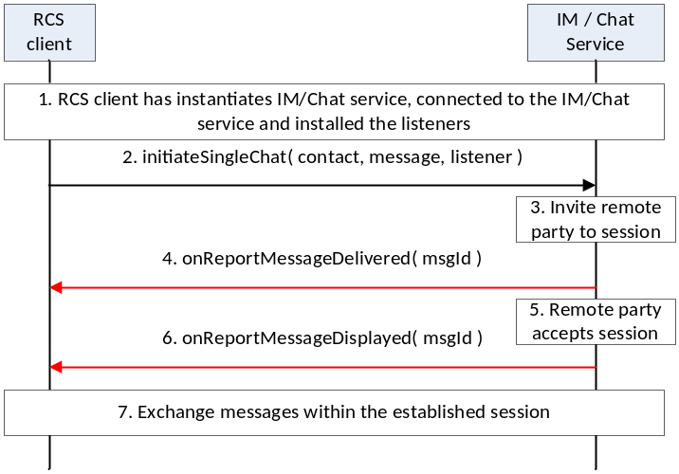
- : Establish a one-to-one chat session with remote party
- The RCS client instantiates a service instance of the IM/Chat Service, establishes a connection with the IM/Chat Service and associates the listener with this RCS client.
- By selecting a user, opening the IM window and typing a message, the user initiates a IM/Chat session request to the remote party
- RCS service sends the session request to the remote party
- The session request is delivered to the remote party and a confirmation of delivery of the message is received by the RCS service. This delivery confirmation is provided to the RCS client.
- By opening the chat window and viewing the incoming message, the remote party accepts the chat session and sends a confirmation of the message display
- The RCS service provides the message displayed notification to the RCS client
- Using procedures described in Error: Reference source not found, the two users exchange IM / Chat messages
Incoming session request
The following is an example that shows the flow for an RCS client receiving an IM/Chat session request from a remote contact.

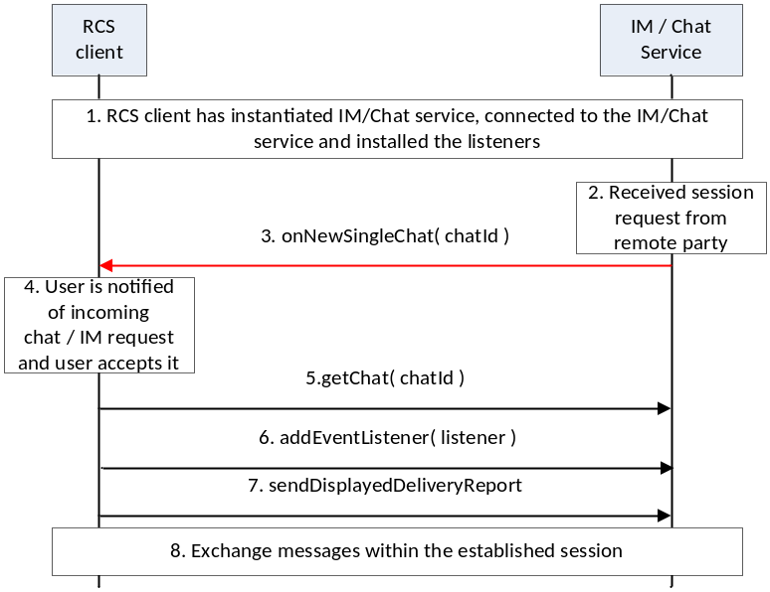
- : Establish a one-to-one chat session with remote party
- The RCS client instantiates a service instance of the IM/Chat Service, establishes a connection with the IM/Chat Service and associates the listener with this RCS client.
- IM/Chat Service receives a request for a session from a remote party
- IM/Chat Service notifies the RCS client through the invocation of the appropriate listener function
- The RCS client notifies the user by displaying the message received in the incoming session invitation to the user. The user accepts the session request
- The RCS client retrieves the chat object associated with this session
- The RCS client installs the listener function for this chat session
- The RCS client requests the IM/Chat service to send to the remote party, an indication of display of the message to the user
- Using procedures described in Error: Reference source not found, the two users exchange IM / Chat messages
Message exchange after chat session establishment
The following is an example that shows the flow for a RCS client receiving a IM/Chat session request from a remote contact.
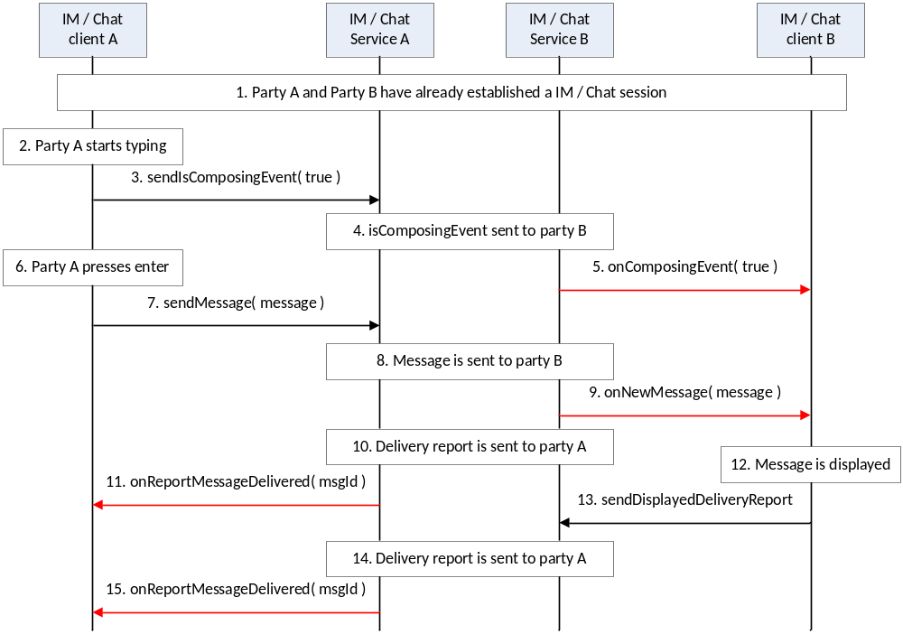
- : Establish a one-to-one chat session with remote party
- A party and B party have already established a IM/Chat session
- Party A starts to type a new chat / IM message
- Client A provides an indication of composing event to the IM/Chat service
- IM/Chat service of party A provides indication of composing toward party B.
- IM/Chat service of party B provides the indication to the IM client of party B
- Party A completes typing the message and presses enter
- Client A provides the message to the IM/Chat service A
- IM/Chat service A sends the message to IM/Chat service B
- IM/Chat service B provides an indication to the client B
- IM/Chat service B provides delivery indication to IM/Chat service A
- IM/Chat service A provides the delivery indication to IM client A
- IM Client B displays the message to user
- IM client B provides the displayed indication to the IM/Chat service B
- IM/Chat service B provides the displayed indication to IM/Chat service A
- IM/Chat service A provides the indication to the client A

Package
Package name com.gsma.services.rcs.chat

Methods and Callbacks
Class ChatService:
This class offers the main entry point to initiate chat conversations with contacts: 1-1 and group chat conversation. Several applications may connect/disconnect to the API.

- Method: connects to the API.
void connect()

- Method: disconnects from the API.
void disconnect()

- Method: returns a one to one chat with the specified contact. If no such ongoing chat exists a reference is returned to a fresh one to one chat so that a call to sendMessage on that will initiate a new invitation to the remote contact.
OneToOneChat getOneToOneChat(ContactId contact)

- Method: returns a group chat from its unique ID. If no ongoing group chat matching the chatId is found the a reference to a historical chat is returned so that a call to sendMessage on that one can try to rejoin that group chat automatically before sending the message.
GroupChat getGroupChat(String chatId)

- Method: returns true if it’s possible initiate a new group chat with the specified contactIds right now, else returns false.
boolean canInitiateGroupChat(Set<ContactId> contacts)

- Method: initiates a group chat with a group of contacts and returns a GroupChat instance. The subject is optional and may be null.
GroupChat initiateGroupChat(Set<ContactId> contacts, String subject)

- Method: mark a received message as read (ie. displayed in the UI)
void markMessageAsRead(String msgId)

- Method: returns the configuration for chat service.
ChatServiceConfiguration getConfiguration()

- Method: deletes all one to one chats from history and abort/reject corresponding sessions if such are ongoing.
void deleteOneToOneChats()

- Method: deletes all group chats from history and abort/reject corresponding sessions if such are ongoing.
void deleteGroupChats()

- Method: deletes a one to one chats conversation with a given contact from history and abort/reject corresponding sessions if such are ongoing.
void deleteOneToOneChat(ContactId contact)

- Method: deletes a group chat conversation from its chat ID from history and abort/reject corresponding sessions if such are ongoing.
void deleteGroupChat(String chatId)

- Method: delete a message from its message ID from history
void deleteMessage(String msgId)

- Method: Adds a listener for one to one chat events
void addEventListener(OneToOneChatListener listener)

- Method: Removes a listener for one to one chat events
void removeEventListener(OneToOneChatListener listener)

- Method: Adds a listener for group chat events
void addEventListener(GroupChatListener listener)

- Method: Removes a listener for group chat events
void removeEventListener(GroupChatListener listener)

- Method: set the parameter that controls whether to respond or not to display reports when requested by the remote. Applicable to one to one chat messages.
void setRespondToDisplayReports(boolean enable)

- Method: returns a set of message IDs of undelivered chat messages corresponding to the contact if there are any.
Set<String> getUndeliveredMessages(ContactId contact)

- Method: marks undelivered chat messages to indicate that messages have been processed.
void markUndeliveredMessagesAsProcessed(Set<String> msgIds)

Class ChatMessage:
This class contains chat message information for single and group chats.

- Method: returns the contactId the remote contact of this message.
ContactId getContact()

- Method: returns the message ID.
String getId()

- Method: returns the message content.
String getContent()

- Method: returns the direction of the chat message.
com.gsma.services.rcs.RcsService.Direction getDirection()

- Method: returns the mime type of the chat message.
String getMimeType()

- Method: returns the local timestamp of when the chat message was sent and/or queued for outgoing messages or the local timestamp of when the chat message was received for incoming messages..
long getTimestamp()

- Method: returns the local timestamp of when the chat message was sent and/or queued for outgoing messages or the remote timestamp of when the chat message was sent for incoming messages.
long getTimestampSent()

Class GeolocMessage:
This class contains geoloc message information for single and group chat.

- Method: returns the contact of the remote contact of this message.
ContactId getContact()

- Method: returns the message ID.
String getId()

- Method: returns the geoloc info.
Geoloc getGeoloc()

- Method: returns the direction of the geoloc message.
com.gsma.services.rcs.RcsService.Direction getDirection()

- Method: returns the mime type of the geoloc message.
String getMimeType()

- Method: returns the local timestamp of when the geoloc message was sent and/or queued for outgoing messages or the local timestamp of when the geoloc message was received for incoming messages.
long getTimestamp()

- Method: returns the local timestamp of when the geoloc message was sent and/or queued for outgoing messages or the remote timestamp of when the geoloc message was sent for incoming messages.
long getTimestampSent()

Class Geoloc:
This class contains geoloc information.

- Method: returns the label associated to the geoloc.
String getLabel()

- Method: returns the latitude.
double getLatitude()

- Method: returns the longitude.
double getLongitude()

- Method: returns the accuracy of the geoloc info (in meter).
float getAccuracy()

- Method: returns the expiration date of the geoloc info.
long getExpiration()

Class OneToOneChat :
This class maintains the information related to a 1-1 chat and offers methods to manage the chat conversation.

- Method: open the chat conversation. Note: if it’s an incoming pending chat session and the parameter IM SESSION START is 0 then the session is accepted now.
void openChat()

- Method: returns the remote contactId.
ContactId getRemoteContact()

- Method: sends a chat message. The method returns a unique message ID. The message is queued if it can’t be sent immediately. Note: if it’s an incoming pending chat session and the parameter IM SESSION START is 2 then the session is accepted before sending the message. The text parameter is considered as mime type “plain/text” and the ChatMessage will be stored in the message provider as such.
ChatMessage sendMessage(String text)

- Method: sends a geoloc message. The method returns a unique message ID. The message is queued if it can’t be sent immediately. Note: if it’s an incoming pending chat session and the parameter IM SESSION START is 2 then the session is accepted before sending the message. The geoloc parameter is considered as mime type “application/geoloc” and the GeolocMessage will be stored in the message provider as such.
GeolocMessage sendMessage(Geoloc geoloc)

- Method: sends an “is-composing” event. The status should be set to true when typing a message, else set to false. Note: if it’s an incoming pending chat session and the parameter IM SESSION START is 1 then the session is accepted before sending the is-composing event.
void sendIsComposingEvent(boolean status)

- Method: resend a message which previously failed.
void resendMessage(String msgId)

Class OneToOneChatListener:
This class offers callback methods on 1-1 chat events.

- Method: Callback called when a message status/reasonCode is changed.
void onMessageStatusChanged(ContactId contactId, String msgId, ChatLog.Message.Content.Status status, ChatLog.Message.Content.ReasonCode reasonCode)

- Method: Callback called when a “is-composing” event has been received. If the remote is typing a message the status is set to true, else it is false.
void onComposingEvent(ContactId contact, boolean status)

- Method: callback called when a delete operation completed that resulted in that one or several one to one chat messages was deleted specified by the msgIds parameter corresponding to a specific contact.
void onMessagesDeleted(ContactId contact, Set<String> msgIds)

Class GroupChat:
This class maintains the information related to a group chat and offers methods to manage the group chat conversation.

- Enum: the Group Chat state.
enum State { INVITED(0), INITIATED(1), STARTED(2), TERMINATED(3), ABORTED(4), FAILED(5), ACCEPTING(6), REJECTED(7) }

- Enum: the reason code for the Group Chat.
enum ReasonCode { UNSPECIFIED(0), ABORTED_BY_USER(1), ABORTED_BY_REMOTE(2), ABORTED_BY_SYSTEM(3), REJECTED_BY_SECONDARY_DEVICE (4), REJECTED_SPAM(5), REJECTED_MAX_CHATS(6) , REJECTED_BY_USER(7) , REJECTED_BY_REMOTE(8), REJECTED_TIME_OUT(9), FAILED_INITIATION(10) }

- Method: returns the chat ID.
String getChatId()

- Method: returns the subject of the group chat.
String getSubject()

- Method: returns the list of participants and associated infos. A participant is identified by its MSISDN in national or international format, SIP address, SIP-URI or Tel-URI.
Set<ParticipantInfo> getParticipants()

- Method: returns the direction of the group chat.
com.gsma.services.rcs.RcsService.Direction getDirection()

- Method: returns the state of the group chat.
State getState()

- Method: open the chat conversation. Note: if it’s an incoming pending chat session and the parameter IM SESSION START is 0 then the session is accepted now.
void openChat()

- Method: returns true is it's possibe to send messages in the group chat right now, else returns false. (for instance it is not possible to send additional messages after a group chat has been left willingly by calling the leave()-method above)
boolean canSendMessage()

- Method: sends a message to the group. This method returns a unique message ID. Note: if it’s an incoming pending chat session and the parameter IM SESSION START is 2 then the session is accepted before sending the message or rejoined if session was in timeout. The text parameter is considered as mime type “plain/text” and the ChatMessage will be stored in the message provider as such.
ChatMessage sendMessage(String text)

- Method: sends a geoloc message. The method returns a unique message ID. Note: if it’s an incoming pending chat session and the parameter IM SESSION START is 2 then the session is accepted before sending the message or rejoined if session was in timeout. The geoloc parameter is considered as mime type “application/geoloc” and the GeolocMessage will be stored in the message provider as such.
GeolocMessage sendMessage(Geoloc geoloc)

- Method: sends a “is-composing” event. The status should be set to true when typing a message, else set to false. Note: if it’s an incoming pending chat session and the parameter IM SESSION START is 1 then the session is accepted before sending the is-composing event.
void sendIsComposingEvent(boolean status)

- Method: returns true if it’s possible to add additional participants to the group chat right now, else returns false.
boolean canAddParticipants()

- Method: returns true if it's possible to add the specified participants to the group chat right now, else returns false.
- boolean canAddParticipants(Set<ContactId> participants)
- Method: adds participants to a group chat.
void addParticipants(Set<ContactId> participants)

- Method: returns the maximum number of participants for a group chat from the group chat info subscription (this value overrides the provisioning parameter).
int getMaxParticipants()

- Method: Leaves a group chat willingly and permanently. The group chat will continue between other participants if there are enough participants.
void leave()

Class GroupChatListener:
This class offers callback methods on group chat events.

- Method: Callback called when a group chat state/reasonCode is changed.
void onStateChanged(String chatId, GroupChat.State state, GroupChat.ReasonCode reasonCode)

- Method: Callback called when a message status/reasonCode is changed.
void onMessageStatusChanged(String chatId, String msgId, ChatLog.Message.Content.Status status, ChatLog.Message.Content.ReasonCode reasonCode)

- Method: callback called when a “is-composing” event has been received. If the remote is typing a message the status is set to true, else it is false.
void onComposingEvent(String chatId, ContactId contact, boolean status)

- Method: Callback called when a group delivery info status/reasonCode was changed for a single recipient to a group message.
void onMessageDeliveryInfoChanged(String chatId, ContactId contact, String msgId, GroupDeliveryInfo.Status status, GroupDeliveryInfo.ResonCode reasonCode)

- Method: callback called when a participant status has been changed in a group chat.
void onParticipantInfoChanged(String chatId, ParticipantInfo info)

- Method: callback called when a delete operation completed that resulted in that one or several group chats was deleted specified by the chatIds parameter.
void onDeleted(Set<String> chatIds)

- Method: callback called when a delete operation completed that resulted in that one or several group chat messages was deleted specified by the msgIds parameter corresponding to a specific group chat.
void onMessagesDeleted(String chatId, Set<String> msgIds)

Class ParticipantInfo:
This class contains information related to Group Chat Participant.

- Enum: the status of the participant.
enum Status { INVITING(0), CONNECTED(1), DISCONNECTED(2), DEPARTED(3), BOOTED(4), FAILED(5), BUSY(6), DECLINED(7), PENDING(8), TIMEOUT(9) }

- Method: returns the contact Id.
ContactId getContact()

- Method: returns the status of the participant.
Status getStatus()

Class ChatServiceConfiguration:
This class represents the particular configuration of a IM Service.

- Method: returns the “imCapAlwaysOn” configuration. True if Store and Forward capability is supported, False if no Store & Forward capability.
boolean isChatSf()

- Method: returns the “imWarnSF” configuration. True if a user should be informed when sending a message to an offline user. False if a user should not be informed when sending a message to an offline user. This should be used with imCapAlwaysOn.
boolean isChatWarnSf()

- Method: returns the time after an inactive chat could be closed.
int getChatTimeout()

- Method: returns the maximum number of participants in a group chat .
int getGroupChatMaxParticipants()

- Method: returns the minimum number of participants in a group chat .
int getGroupChatMinParticipants()

- Method: returns the maximum single chat message’s length can have. The length is the number of bytes of the message encoded in UTF-8.
int getOneToOneChatMessageMaxLength()

- Method: returns the maximum single group chat message’s length can have. The length is the number of bytes of the message encoded in UTF-8.
int getGroupChatMessageMaxLength()
- Method: returns the maximum group chat subject’s length can have. The length is the number of bytes of the message encoded in UTF-8.
int getGroupChatSubjectMaxLength()

- Method: returns the SMS fall-back configuration. True if SMS fall-back procedure is activated, else returns False.
boolean isSmsFallback()

- Method: return True if the client application should send a displayed report when requested by the remote part. Only applicable to one to one chat messages.
boolean isRespondToDisplayReportsEnabled()

- Method: returns the is-composing timeout value.
int getIsComposingTimeout()

- Method: returns the maximum length of a geoloc label.
int getGeolocLabelMaxLength()

- Method: returns the expiration time of a geoloc info.
int getGeolocExpirationTime()

- Method: returns True if group chat is supported, else returns False.
boolean isGroupChatSupported()

Class ChatLog.GroupChat:
- Method: utility method to get list of ParticipantInfo objects from its string representation in the ChatLog provider.
static List<ParticipantInfo> getParticipantInfo(Context ctx, String participantsInfo)

Class ChatLog.Message:
- Method: utility method to get a geoloc object from its string representation in the CONTENT field of the ChatLog provider.
static Geoloc getGeoloc(String geoloc)

Class ChatLog.Message.MimeTypes
static final TEXT_MESSAGE = “text/plain”
static final GEOLOC_MESSAGE = “application/geoloc”
static final GROUPCHAT_EVENT = “rcs/groupchat-event”

Class ChatLog.Message.Content
- Enum : the status of a Content message
enum Status { REJECTED(0), QUEUED(1), SENDING(2), SENT(3), FAILED(4), DELIVERED(5), DISPLAY_REPORT_REQUESTED(6), RECEIVED(7), DISPLAYED(8)

- Enum: the reason code for Content message
enum ReasonCode { UNSPECIFIED(0), FAILED_SEND(1), FAILED_DELIVERY(2), FAILED_DISPLAY(3), REJECTED_SPAM(4) }

Class ChatLog.Message.GroupChatEvent
- Enum : the status of a group chat event message
enum Status { INVITED(0), LEFT(1) }

Intents
Intent broadcasted when a new 1-1 chat message has been received. This Intent contains the following extra:

  - “messageId”: unique message ID of the message.
com.gsma.services.rcs.chat.action.NEW_ONE2ONE_CHAT_MESSAGE
Intent broadcasted when a new group chat invitation has been received. This Intent contains the following extra:

  - “chatId”: unique ID of the group chat conversation.
com.gsma.services.rcs.chat.action.NEW_GROUP_CHAT

Intent broadcasted when there are some undelivered messages detected corresponding to the contact as specified in the intent parameter. This Intent contains the following extras:

  - “contact”: MSISDN of the contact corresponding to the conversation.
com.gsma.services.rcs.chat.action.UNDELIVERED_MESSAGES

Intent broadcasted when a new group chat message has been received. This Intent contains the following extra:

  - “messageId”: unique message id of the message.
com.gsma.services.rcs.chat.action.NEW_GROUP_CHAT_MESSAGE

Content Providers
A content provider is used to store the group chats and the message history persistently. There is one entry per group chat and per chat message.
Class ChatLog.GroupChat:
URI constant to be able to query the provider data (Note that only read operations are supported since exposing write operations would conflict with the fact that the stack is performing write operations internally to keep the data matching the current situation):
static final Uri CONTENT_URI = "content://com.gsma.services.rcs.provider.chat/groupchat"
The “CHAT_ID” column below is defined as the unique primary key and can be references with adding a path segment to the CONTENT_URI + “/” + <primary key>
Column name definition constants to be used when accessing this provider:
static final String CHAT_ID = “chat_id”
static final String STATE = “state”
static final String SUBJECT = “subject”
static final String DIRECTION = “direction”
static final String TIMESTAMP = “timestamp”
static final String REASON_CODE = “reason_code”
static final String PARTICIPANTS = “participants”
The content provider has the following tables and columns:
GROUPCHAT
Data | Data Type | Description
CHAT_ID | String | Id for chat room
STATE | Integer | State of chat room. See enum GroupChat.State for the list of states.
SUBJECT | String | Subject of the group chat room
DIRECTION | Integer | Status direction of group chat. See enum Direction for the list of directions.
TIMESTAMP | Long | timestamp of the invitation
REASON_CODE | Integer | Reason code associated with the group chat state. See enum GroupChat.ResonCode for the list of reason codes
PARTICIPANTS | String | List of participants and associated status stored as a String parseable with the ChatLog.GroupChat.getParticipantInfos() method.
Class ChatLog.Message:
Event log provider member id used when merging the data from this provider with other registered event log provider members data into a common cursor:
static final int HISTORYLOG_MEMBER_ID = 1
URI constant to be able to query the provider data (Note that only read operations are supported since exposing write operations would conflict with the fact that the stack is performing write operations internally to keep the data matching the current situation):
static final Uri CONTENT_URI = "content://com.gsma.services.rcs.provider.chat/chatmessage"
The “MESSAGE_ID” column below is defined as the unique primary key and can be references with adding a path segment to the CONTENT_URI + “/” + <primary key>
Column name definition constants to be used when accessing this provider:
static final String MESSAGE_ID = “msg_id"
static final String CHAT_ID = "chat_id"
static final String CONTACT = "contact"
static final String CONTENT = "content"
static final String TIMESTAMP = "timestamp"
static final String TIMESTAMP_SENT = "timestamp_sent"
static final String TIMESTAMP_DELIVERED = "timestamp_delivered"
static final String TIMESTAMP_DISPLAYED = "timestamp_displayed"
static final String MIME_TYPE = "mime_type"
static final String STATUS = "status"
static final String REASON_CODE = "reason_code"
static final String READ_STATUS = "read_status"
static final String DIRECTION = "direction"
CHATMESSAGE
Data | Data Type | Description
MESSAGE_ID | Long | Id of the message
CHAT_ID | String | Id of chat room
CONTACT | String | ContactId formatted number of remote contact
CONTENT | Text | Content of the message
TIMESTAMP | Long | Time when message inserted
TIMESTAMP_SENT | Long | Time when message sent. If 0 means not sent.
TIMESTAMP_DELIVERED | Long | Time when message delivered. If 0 means not delivered.
TIMESTAMP_ DISPLAYED | Long | Time when message displayed. If 0 means not displayed.
MIME_TYPE | String | Multipurpose Internet Mail Extensions (MIME) type of message
STATUS | Integer | See enum Message.Content.Status for the list of status.
REASON_CODE | Integer | Reason code associated with the message status. See enum Message.Content.ReasonCode for the list of reason codes
READ_STATUS | Integer | This is set on the receiver side when the message has been displayed. See enum ReadStatus for the list of status.
DIRECTION | Integer | Status direction of message. See enum Direction for the list of directions.

Permissions
Access to the Chat API requires the following permissions:
- com.gsma.services.rcs.RCS_USE_CHAT: this is a new permission that governs access to the chat API, and is required both to receive and to send over an RCS chat session.
- com.gsma.services.rcs.RCS_READ_CHAT: this is a new permission that is required by a client in order to read the chat history from the content provider.

File Transfer API
This API exposes all functionality related to transferring files via the File Transfer Service. It allows:
- Send a file transfer request
- Send a file transfer request with thumbnail (file icon)
- Receive notifications about incoming file transfer and file transfer events.
- Receive notifications upon file delivery
- Retrieve the list of all file transfers and their statuses for a specific contact
- Clean all file transfer history or single file transfers (including the transferred files if possible)
- Monitor a file transfers progress.
- Cancel a file transfer in progress.
- Accept/reject an incoming file transfer request.
- Read configuration elements affecting a file transfer
- Resume a file transfer
- File transfer queuing.
- Send several files to a list of contacts.

File Transfer API calling flow
The figures in this section contain basic call flows of the File Transfer service API.
Session establishment
The following is an example that shows the flow for a File Transfer (FT) client establishing a FT session with a remote contact.
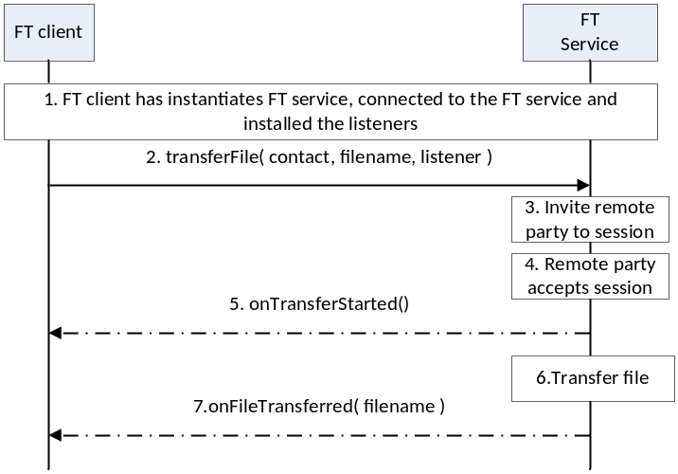
- : Successful sending of a file to remote party
- The FT client instantiates a service instance of the File Transfer Service, establishes a connection with the FT Service and associates the listener with this RCS client.
- By selecting a user and the file to be transferred, the user initiates a FT session request to the remote party
- The FT Service sends the session request to remote party
- The session request is delivered to the remote party and an indication is received that the remote user has accepted the file transfer request.
- The FT client is notified that the file transfer has started.
- The FT Service transfers the file to the remote party.
- The FT client is notified that the file transfer is completed.
Incoming session request
The following is an example that shows the flow for a FT client receiving a File Transfer request from a remote contact.

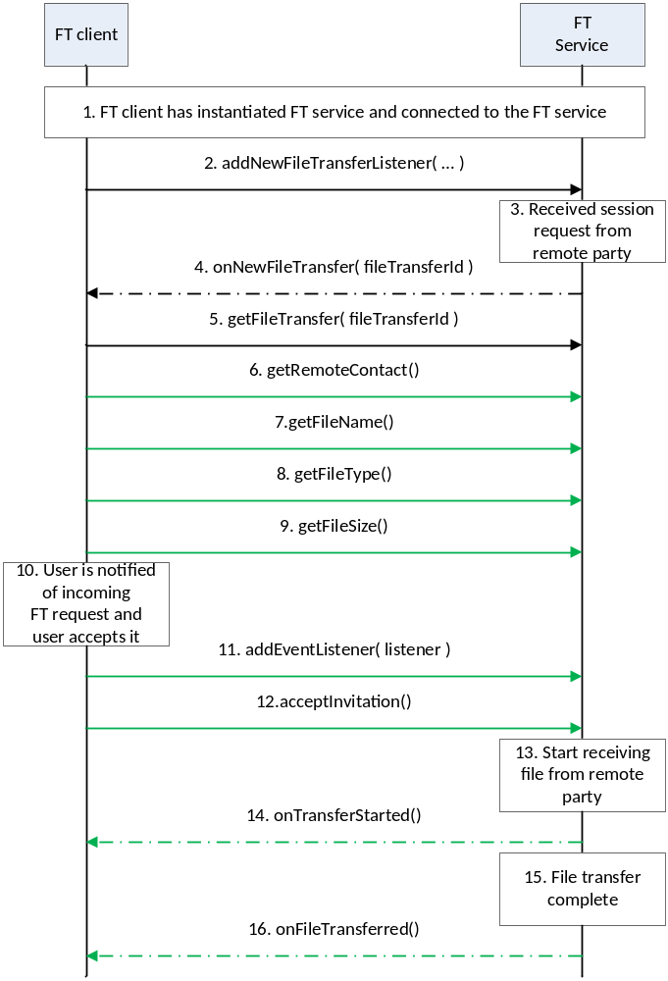
- : Successful reception of a file from remote party
- The FT client instantiates a service instance of the FT Service and establishes a connection with the FT Service.
- The FT client associates the listener with this FT client.
- The FT Service receives a request for a session from a remote party
- The FT Service notifies the FT client through the invocation of the appropriate listener function
- The FT client retrieves the file transfer session object from the FT service
- The FT client retrieves the identity of the remote party that is sending the file.
- The FT client retrieves the name of the file that is being sent by the remote party.
- The FT client retrieves the type of file that is being sent by the remote party
- The FT client retrieves the size of the file that is being sent by the remote party.
- The FT client notifies the user by displaying the details of the file that is being sent to the user. The user accepts the request,
- The FT client installs the listener function for this FT session.
- The RCS client notifies the FT Service that the user has accepted to receive the file
- The FT service informs the remote end that it is ready to receive the file
- The FT client is notified that the file transfer has started.
- The FT service interacts with the remote end to receive the file
- The FT client is notified that the file transfer is complete.

Package
Package name com.gsma.services.rcs.filetransfer

Methods and Callbacks
Class FileTransferService:
This class offers the main entry point to transfer files and to receive files. Several applications may connect/disconnect to the API.

- Method: connects to the API.
void connect()

- Method: disconnects from the API.
void disconnect()

- Method: returns the list of file transfers in progress.
Set<FileTransfer> getFileTransfers()

- Method: returns a file transfer from its unique ID. If no ongoing FileTransfer matching the transferId if found then a reference to a historical FileTransfer is returned so that a call to resendTransfer() and other methods still can be performed.
FileTransfer getFileTransfer(String transferId)

- Method: transfers a file to a contact with an optional file icon.
FileTransfer transferFile(ContactId contact, Uri file, boolean attachFileicon)

- Method: returns true if it’s possible to initiate file transfer to the group chat specified by the chatId parameter, else returns false.
boolean canTransferFileToGroupChat(String chatId)

- Method: transfers a file to a group chat with an optional file icon.
FileTransfer transferFileToGroupChat(String chatId, Uri file, boolean attachFileicon)

- Method: mark a received file transfer as read (i.e. the invitation or the file has been displayed in the UI).
void markFileTransferAsRead(String transferId);

- Method: returns the configuration for a File Transfer service.
FileTransferServiceConfiguration getConfiguration()

- Method: adds a one to one file transfer event listener.
void addEventListener(OneToOneFileTransferListener listener)

- Method: removes a one to one file transfer event listener.
void removeEventListener(OneToOneFileTransferListener listener)

- Method: Adds a group file transfer event listener.
void addEventListener(GroupFileTransferListener listener)

- Method: Removes a group file transfer event listener.
void removeEventListener(GroupFileTransferListener listener)

- Method: deletes all one to one file transfers history and abort/reject corresponding sessions if such are ongoing.
void deleteOneToOneFileTransfers()

- Method: deletes all group file transfers from history and abort/reject corresponding sessions if such are ongoing.
void deleteGroupFileTransfers()

- Method: deletes file transfers corresponding to a given one to one conversation specified by contact from history and abort/reject corresponding sessions if such are ongoing.
void deleteOneToOneFileTransfers(ContactId contact)

- Method: deletes file transfers corresponding to a given group chat specified by chat id from history and abort/reject corresponding sessions if such are ongoing.
void deleteGroupFileTransfers(String chatId)

- Method: deletes a file transfer from its unique ID from history and abort/reject corresponding sessions if such are ongoing.
void deleteFileTransfer(String transferId)

- Method: set the Auto Accept Mode of a File Transfer configuration. The Auto Accept Mode can only be modified by client application if isAutoAcceptChangeable (see FileTransferServiceConfiguration class) is true.
void setAutoAccept(boolean enable)

- Method: set the Auto Accept Mode of a File Transfer configuration while roaming. The AutoAcceptInRoaming can only be modified by client application if isAutoAcceptModeChangeable (see FileTransferServiceConfiguration class) is true and if the Auto Accept Mode in normal conditions is true.
void setAutoAcceptInRoaming(boolean enable)

- Method: set the image resize option for file transfer.
void setImageResizeOption(ImageResizeOption option)

- Method: returns a set of transfer IDs of undelivered file transfers corresponding to the contactId parameter if there are any.
Set<String> getUndeliveredFileTransfers(ContactId contact)

- Method: marks undelivered file transfers to indicate that transfers have been processed.
void markUndeliveredFileTransfersAsProcessed(Set<String> transferIds)

Class FileTransfer:
This class maintains the information related to a file transfer and offers methods to manage the transfer.

- Enum: the file transfer state.
Enum State { INVITED(0), INITIATED(1), STARTED(2), TRANSFERRED(3), ABORTED(4), FAILED(5), PAUSED(6), REJECTED(7), ACCEPTING(8), DELIVERED(9), DISPLAYED(10), QUEUED(11) }

- Enum: the reason code for the file transfer.
Enum ReasonCode { UNSPECIFIED(0), ABORTED_BY_USER(1), ABORTED_BY_REMOTE(2), ABORTED_BY_SYSTEM(3), REJECTED_BY_SECONDARY_DEVICE(4), REJECTED_TIME_OUT(5), REJECTED_SPAM(6), REJECTED_LOW_SPACE(7), REJECTED_MAX_SIZE(8), REJECTED_MAX_FILE_TRANSFERS(9), REJECTED_BY_USER(10), REJECTED_BY_REMOTE(11), PAUSED_BY_SYSTEM(12), PAUSED_BY_USER(13), FAILED_INITIATION(14), FAILED_DATA_TRANSFER(15), FAILED_SAVING(16), FAILED_DELIVERY(17), FAILED_DISPLAY(18), FAILED_NOT_ALLOWED_TO_SEND(19) }

- Method: returns whether the transfer is a group transfer.
boolean isGroupTransfer()

- Method: Returns the chat ID if the file transfer.
String getChatId()

- Method: returns the file transfer ID of the file transfer.
String getTransferId()

- Method: returns the remote contact Id.
ContactId getRemoteContact()

- Method: returns the direction of the transfer.
com.gsma.services.rcs.RcsService.Direction getDirection()

- Method: returns URI of the file icon or thumbnail.
Uri getFileIcon()

- Method: returns the mime type of the file icon.
String getFileIconMimeType()

- Method: returns URI of the file to be transferred.
Uri getFile()

- Method: returns the mime type of the file transfer.
String getMimeType()

- Method: returns the filename of the file to be transferred.
String getFileName()

- Method: returns the size of the file to be transferred (in bytes).
String getFileSize()

- Method: returns the MIME type of file to be transferred.
String getFileType()

- Method: returns the state of the file transfer.
State getState()

- Method: accepts the file transfer invitation.
void acceptInvitation()

- Method: rejects the file transfer invitation.
void rejectInvitation()

- Method: aborts the file transfer.
void abortTransfer()

- Method: returns true if it’s possible to pause this file transfer right now, else returns false. If this Filetransfer corresponds to a file transfer that is no longer present in the persistent storage false will be returned (this is no error).
boolean canPauseTransfer()

- Method: pauses the file transfer.
void pauseTransfer()

- Method: resumes the file transfer.
void resumeTransfer()

- Method: returns whether you can resend the transfer.
boolean canResendTransfer()

- Method: resend a file transfer which was previously failed. This only for 1-1 file transfer, an exception is thrown in case of a file transfer to group.
void resendTransfer()

- Method: returns the local timestamp of when the file transfer was initiated and/or queued for outgoing file transfers or the local timestamp of when the file transfer invitation was received for incoming file transfers.
- long getTimestamp()

- Method: returns the local timestamp of when the file transfer was initiated and/or queued for outgoing file transfers or the remote timestamp of when the file transfer was initiated for incoming file transfers.
long getTimestampSent()

Class OneToOneFileTransferListener:
This class offers callback methods on file transfer events.

- Method: Callback called when the file transfer status/reasonCode is changed.
void onStateChanged(ContactId contact, String transferId, FileTransfer.State state, FileTransfer.ReasonCode reasonCode)

- Method: callback called during the file transfer progress.
void onProgressUpdate(ContactId contact, String transferId, long currentSize, long totalSize)

- Method: callback called when a delete operation completed that resulted in that one or several one to one file transfers was deleted specified by the transferIds parameter corresponding to a specific contact.
void onDeleted(ContactId contact, Set<String> transferIds)

Class GroupFileTransferListener
This class offers callback methods on group file transfer events.

- Method: Callback called when the group file transfer status/reasonCode is changed.
void onStateChanged(String chatId, String transferId, FileTransfer.State state, FileTransfer.ReasonCode reasonCode)

- Method: Callback called during the transfer progress of group file transfer
void onProgressUpdate(String chatId, String transferId, long currentSize, long totalSize)

- Method: Callback called when a group file transfer group delivery info status/reasonCode is changed for a single recipient only.
- void onGroupDeliveryInfoChanged(String chatId, String transferId, ContactId contact, GroupDeliveryInfo.Status status, GroupDeliveryInfo.ReasonCode reasonCode)

- Method: callback called when a delete operation completed that resulted in that one or several group file transfers was deleted specified by the transferIds parameter corresponding to a specific group chat.
void onDeleted(String chatId, Set<String> transferIds)

Class FileTransferServiceConfiguration:
This class represents the particular configuration of a FT Service.

- Enum: the image resize option.
enum ImageResizeOption { ALWAYS_PERFORM(0), ONLY_ABOVE_MAX_SIZE(1), ASK(2) }

- Method: returns the file size warning of a File Transfer configuration. It can return null if this value was not set by the auto-configuration server (no need to warn).
long getWarnSize()

- Method: returns the max file size of a File Transfer configuration. It can return null if this value was not set by the auto-configuration server.
long getMaxSize()

- Method: returns the Auto Accept Mode of a File Transfer configuration.
boolean isAutoAcceptEnabled()

- Method: returns True if client is allowed to change the Auto Accept mode (both in normal or roaming modes) in file transfer
boolean isAutoAcceptModeChangeable()

- Method: returns the Auto Accept Mode of a File Transfer configuration while roaming. This parameter is only applicable if auto accept is active for File Transfer in normal conditions (see above isAutoAcceptEnabled)
boolean isAutoAcceptInRoamingEnabled()

- Method: returns the image resize option
ImageResizeOption getImageResizeOption()

- Method: returns the max number of simultaneous file transfers.
int getMaxFileTransfers()

- Method: returns True if group file transfer is supported, else returns False.
boolean isGroupFileTransferSupported()

Intents
Intent broadcasted when a new file transfer invitation has been received. This Intent contains the following extra:

  - “transferId”: unique ID of the file transfer.
com.gsma.services.rcs.ft.action.NEW_FILE_TRANSFER

Intent broadcasted when a file transfer is resumed automatically by the stack. This Intent contains the following extra:

  - “transferId”: unique ID of the file transfer.
com.gsma.services.rcs.ft.action.RESUME_FILE_TRANSFER

Intent broadcasted when there are some undelivered file transfers detected corresponding to the contact as specified in the intent parameter. This Intent contains the following extras:

  - “contact”: MSISDN of the contact corresponding to the conversation.
com.gsma.services.rcs.ft.action.UNDELIVERED_FILE_TRANSFERS

Content Providers
A content provider is used to store the file transfer history persistently. There is one entry per file transfer.
Class FileTransferLog:
Event log provider member id used when merging the data from this provider with other registered event log provider members data into a common cursor:
static final int HISTORYLOG_MEMBER_ID = 2
URI constant to be able to query the provider data (Note that only read operations are supported since exposing write operations would conflict with the fact that the stack is performing write operations internally to keep the data matching the current situation):
static final Uri CONTENT_URI = "content://com.gsma.services.rcs.provider.filetransfer/filetransfer"
The “FT_ID” column below is defined as the unique primary key and can be references with adding a path segment to the CONTENT_URI + “/” + <primary key>
Column name definition constants to be used when accessing this provider:
static final String FT_ID = "ft_id"
static final String CHAT_ID = "chat_id"
static final String CONTACT = "contact"
static final String FILE = "file"
static final String FILENAME = "filename"
static final String MIME_TYPE = "mime_type"
static final String FILEICON = "fileicon"
static final String FILEICON_MIME_TYPE = "fileicon_mime_type"
static final String DIRECTION = "direction"
static final String FILESIZE = "filesize"
static final String TRANSFERRED = "transferred"
static final String TIMESTAMP = "timestamp"
static final String TIMESTAMP_SENT = "timestamp_sent"
static final String TIMESTAMP_DELIVERED = "timestamp_delivered"
static final String TIMESTAMP_DISPLAYED = "timestamp_displayed"
static final String STATE = "state"
static final String REASON_CODE = "reason_code"
static final String READ_STATUS = "read_status"

The content provider has the following columns:
FILETRANSFER
Data | Data type | Comment
FT_ID | Text | Unique file transfer identifier
CHAT_ID | String | Id of chat
CONTACT | Text | ContactId formatted number of remote contact or null if the filetransfer is an outgoing group file transfer.
FILE | Text | URI of the file
FILENAME | Text | Filename
MIME_TYPE | Text | Multipurpose Internet Mail Extensions (MIME) type of message
FILEICON | Text | URI of the file icon
FILEICON_MIME_TYPE | String | MIME type of the file icon
DIRECTION | Integer | Incoming transfer or outgoing transfer. See enum Direction.
FILESIZE | Long | File size in bytes
TRANSFERRED | Long | Size transferred in bytes
TIMESTAMP | Long | Date of the transfer
TIMESTAMP_SENT | Long | Time when file is sent. If 0 means not sent.
TIMESTAMP_DELIVERED | Long | Time when file is delivered. If 0 means not delivered.
TIMESTAMP_ DISPLAYED | Long | Time when file is displayed.
STATE | Integer | See note below for the list of states
REASON_CODE | Integer | Reason code associated with the file transfer state. See enum FileTransfer.ReasonCode for possible reason codes.
READ_STATUS | Integer | See note below for the list of statuses

Permissions
Access to the File Transfer API is requires the following permissions:
- com.gsma.services.rcs.RCS_FILETRANSFER_RECEIVE: this is a new permission that is required by a client in order to handle the receipt of a file transferred from a remote party.
- com.gsma.services.rcs.RCS_FILETRANSFER_SEND: this is a new permission that is required by a client in order to initiate the transfer of a file transferred to a remote party.
- com.gsma.services.rcs.RCS_FILETRANSFER_READ: this is a new permission that is required by a client in order to read the file transfer history from the content provider.

Image Share API
This API exposes all functionality related to transferring images during a Circuit Switched (CS) call via the Image Share Service. It allows:
- Send an image share request
- Receive notifications about an incoming image share invitation and sharing events.
- Monitors an image share’s progress.
- Cancel an image share in progress.
- Accept/reject an incoming image share request.
- Read configuration elements affecting image share.

Image Share API calling flow
The figures in this section contain basic call flows of the Image Share service API.
Session establishment
The following is an example that shows the flow for an image share client establishing an image share session with a remote contact.
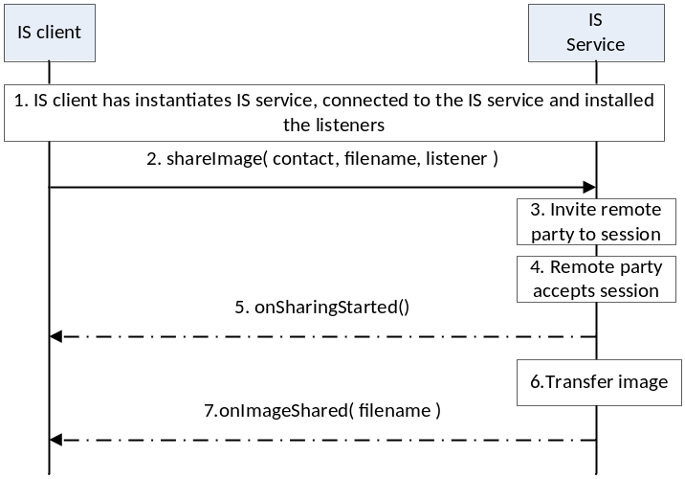
- : Successful sharing an image with remote party
- The Image Share (IS) client instantiates a service instance of the Image Share Service, establishes a connection with the IS Service and associates the listener with this IS client.
- By selecting a user and the image file to be transferred, the user initiates a IS session request to the remote party
- The IS service sends the session request to a remote party
- The session request is delivered to the remote party and an indication is received that the remote user has accepted the image sharing request.
- The IS client is notified that the image sharing has started.
- The IS service transfers the image to the remote party.
- The IS client is notified that the image sharing is completed.
Incoming session request
The following is an example that shows the flow for a IS client receiving an Image Share request from a remote contact.

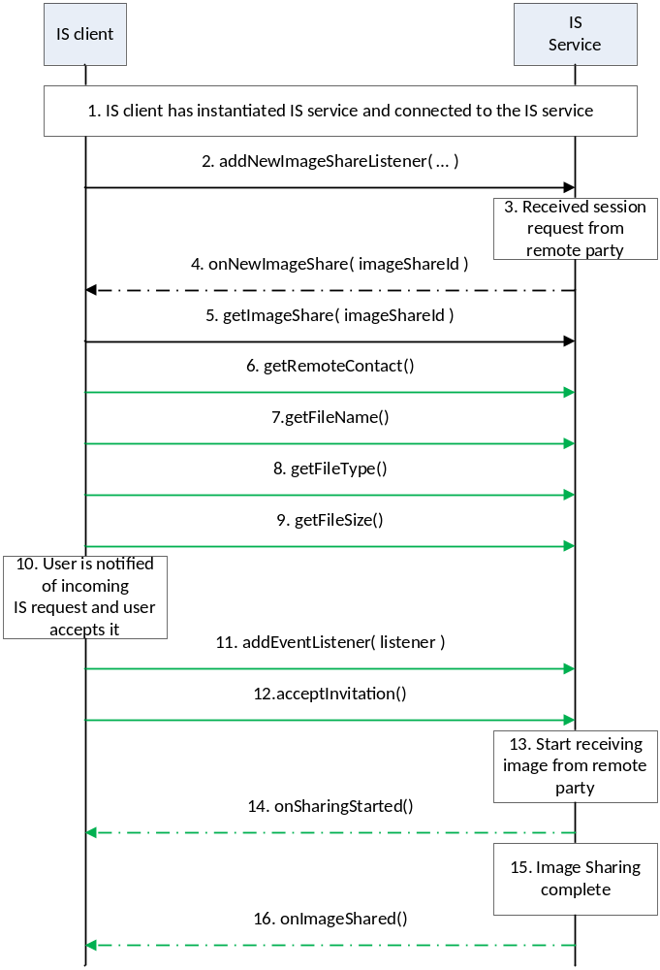
- : Successful sharing of an image from remote party
- The IS client instantiates a service instance of the IS Service and establishes a connection with the IS Service.
- The IS client associates the listener with this IS client.
- The IS Service receives a request for a session from a remote party
- The IS Service notifies the IS client through the invocation of the appropriate listener function
- The IS client retrieves the image share session object from the FT service
- The IS client retrieves the identity of the remote party that is sharing the image.
- The IS client retrieves the name of the image file that is being shared by the remote party.
- The IS client retrieves the type of image file that is being shared by the remote party
- The IS client retrieves the size of the image file that is being shared by the remote party.
- The IS client notifies the user by displaying the details of the image that is being shared to the user. The user accepts the request,
- The IS client installs the listener function for this IS session.
- The IS client notifies the IS service that the user has accepted to receive the image sharing request
- The IS service informs the remote end that it is ready to receive the image to be shared
- The IS client is notified that the image share has started.
- The IS service interacts with the remote end to receive the image being shared
- The IS client is notified that the image sharing is complete.

Package
Package name com.gsma.services.rcs. sharing.image

Methods and Callbacks
Class ImageSharingService:
This class offers the main entry point to share images during a CS call, when the call hangs up the sharing is automatically stopped. Several applications may connect/disconnect to the API.

- Method: connects to the API.
void connect()

- Method: disconnects from the API.
void disconnect()

- Method: returns the list of image sharings in progress.
Set<ImageSharing> getImageSharings()

- Method: returns a current image sharing from its unique ID. If no ongoing ImageSharing matching the sharingId if found then a reference to a historical ImageSharing is returned so that calls to the methods on that still can be performed.
- ImageSharing getImageSharing(String sharingId)

- Method: shares an image with a contact. The parameter file contains the URI of the image to be shared (for a local or a remote image). An exception if thrown if there is no on-going CS call.
ImageSharing shareImage(ContactId contact, Uri file)

- Method: returns the configuration for image share service.
ImageSharingServiceConfiguration getConfiguration()

- Method: adds a new image share invitation listener.
void addEventListener(ImageSharingListener listener)

- Method: removes a new image share invitation listener.
void removeEventListener(ImageSharingListener listener)

- Method: deletes all image sharings from history and abort/reject corresponding sessions if such are ongoing.
void deleteImageSharings()

- Method: deletes image sharings with a given contact from history and abort/reject corresponding sessions if such are ongoing.
void deleteImageSharings(ContactId contact)

- Method: deletes an image sharing from its sharing ID from history and abort/reject corresponding sessions if such are ongoing.
void deleteImageSharing(String sharingId)

Class ImageSharing:
This class maintains the information related to an image share and offers methods to manage the sharing.

- Enum: the ImageSharing state.
enum State { INVITED(0), INITIATED(1), STARTED(2), ABORTED(3), FAILED(4), TRANSFERRED(5), REJECTED(6), RINGING(7), ACCEPTING(8) }

- Enum: the reason code for the image sharing.
enum ReasonCode { UNSPECIFIED(0), ABORTED_BY_USER(1), ABORTED_BY_REMOTE(2), ABORTED_BY_SYSTEM(3), REJECTED_BY_SECONDARY_DEVICE(4), REJECTED_TIME_OUT(5) REJECTED_LOW_SPACE(6), REJECTED_MAX_SIZE(7), REJECTED_MAX_SHARING_SESSIONS(8), REJECTED_BY_USER(9), REJECTED_BY_REMOTE(10), FAILED_INITIATION(11), FAILED_SHARING(12), FAILED_SAVING(13) }

- Method: returns the sharing ID of the image sharing.
String getSharingId()

- Method: returns the remote contact.
ContactId getRemoteContact()

- Method: returns the URI of the file to be shared.
Uri getFile()

- Method: returns the filename of-the file to be shared.
String getFileName()

- Method: returns the size of the file to be shared (in bytes).
String getFileSize()

- Method: returns the MIME type of file to be shared.
String getMimeType()

- Method: returns the local timestamp of when the image sharing was initiated for outgoing image sharing or the local timestamp of when the image sharing invitation was received for incoming image sharings.
long getTimeStamp()

- Method: returns the state of the image share.
State getState()

- Method: returns the direction of the sharing.
com.gsma.services.rcs.RcsService.Direction getDirection()

- Method: accepts image share invitation.
void acceptInvitation()

- Method: rejects image share invitation.
void rejectInvitation()

- Method: aborts the sharing.
void abortSharing()

Class ImageSharingListener:
This class offers callback methods on image sharing events.

- Method: callback called when the image sharing state/reasonCode has been changed
void onStateChanged(ContactId contact, String sharingId, ImageSharing.State state, ImageSharing.ReasonCode reasonCode)

- Method: callback called during the sharing progress.
void onProgressUpdate(ContactId contact, String sharingId, long currentSize, long totalSize)

- Method: callback called when a delete operation completed that resulted in that one or several image sharings was deleted specified by the sharingIds parameter corresponding to a specific contact.
void onDeleted(ContactId contact, Set<String> sharingIds)

Class ImageSharingServiceConfiguration:
This class represents the particular configuration of the Image Sharing Service.

- Method: returns the file size warning of Image Sharing configuration. It returns 0 if this value was not set by the auto-configuration server (no need to warn).
long getWarnSize()

- Method: returns the max file size of the Image Sharing configuration. It can return 0 if this value was not set by the auto-configuration server.
long getMaxSize()

Intents
Intent broadcasted when a new image sharing invitation has been received. This Intent contains the following extra:

- “sharingId”: unique ID of the image sharing.
com.gsma.services.rcs.ish.action.NEW_IMAGE_SHARING

Content Providers
A content provider is used to store the image sharing history persistently. There is one entry per image sharing.

Class ImageSharingLog:
Event log provider member id used when merging the data from this provider with other registered event log provider members data into a common cursor:
static final int EVENTLOG_MEMBER_ID = 3
URI constant to be able to query the provider data (Note that only read operations are supported since exposing write operations would conflict with the fact that the stack is performing write operations internally to keep the data matching the current situation):
static final Uri CONTENT_URI = "content://com.gsma.services.rcs.provider.imageshare/imageshare"
The “SHARING_ID” colunn is defined as the unique primary key and can be references with adding a path segment to the CONTENT_URI + “/” + <primary key>
Column name definition constants to be used when accessing this provider:
static final String SHARING_ID = "sharing_id"
static final String CONTACT = "contact"
static final String FILE = "file"
static final String FILENAME = "filename"
static final String MIME_TYPE = "mime_type"
static final String DIRECTION = "direction"
static final String FILESIZE = "filesize"
static final String TRANSFERRED = "transferred"
static final String TIMESTAMP = "timestamp"
static final String STATE = "state"
static final String REASON_CODE = "reason_code"
The content provider has the following columns:
IMAGESHARE
Data | Data type | Comment
SHARING_ID | Text | Unique sharing identifier
CONTACT | Text | ContactId formatted number of the remote contact
FILE | Text | URI of the file
FILENAME | Text | Filename
MIME_TYPE | Text | Multipurpose Internet Mail Extensions (MIME) type of file
DIRECTION | Integer | Incoming sharing or outgoing sharing. See enum Direction
FILESIZE | Long | File size in bytes
TRANSFERRED | Long | Size transferred in bytes
TIMESTAMP | Long | Date of the sharing
STATE | Integer | See enum ImageSharing.State for the list of states
REASON_CODE | Integer | Reason code associated with the image sharing state. enum ImageSharing.ReasonCode for the list of reason codes

Permissions
Access to the Image Share API is requires the following permissions:
- com.gsma.services.rcs.RCS_IMAGESHARE_RECEIVE: this is a new permission that is required by a client in order to handle the receipt of an image shared by a remote party.
- com.gsma.services.rcs.RCS_IMAGESHARE_SEND: this is a new permission that is required by a client in order to initiate the sharing of an image with a remote party.
- com.gsma.services.rcs.RCS_IMAGESHARE_READ: this is a new permission that is required by a client in order to read the image share history from the content provider.

Video Share API
This API exposes all functionality related to sharing a live video stream during a CS call via the Video Share Service. It allows:
- Send a video share request.
- Receive notifications about incoming video share invitation and sharing events.
- Cancel an on-going video share.
- Accept/reject an incoming video share request.
- Read configuration elements affecting video share.
- Can use an external codec or default codec for video share.
- External codec: Programmer’s externally customized codec.
- Default codec: Stack’s internal codec.
      - Package
Package name com.gsma.services.rcs. sharing.video
      - Methods and Callbacks
Class VideoSharingService:
This class offers the main entry point to share a live video during a CS call, when the call hangs up the sharing is automatically stopped. Several applications may connect/disconnect to the API.
- Method: connects to the API.
void connect()

- Method: disconnects from the API.
void disconnect()

- Method: returns the list of video sharing in progress.
Set<VideoSharing> getVideoSharings()

- Method: returns a video sharing from its unique ID. If no ongoing VideoSharing matching the sharingId if found then a reference to a historical VideoSharing is returned so that calls to the methods on that still can be performed.
VideoSharing getVideoSharing(String sharingId)

- Method: shares a live video stream with a contact. The parameter player contains a media player which streams over RTP the live video from the camera. The media player is an interface which permits to have a player implementation independent from the RCS API. An exception is thrown if there is no on-going CS call. It’s for the external codec.
VideoSharing shareVideo(ContactId contact, VideoPlayer player)

- Method: returns the configuration for video share service.
VideoSharingServiceConfiguration getConfiguration()

- Method: adds a video share event listener.
void addEventListener(VideoSharingListener listener)

- Method: removes a video share event listener.
void removeEventListener(VideoSharingListener listener)

- Method: deletes all video sharings from history and abort/reject corresponding sessions if such are ongoing.
void deleteVideoSharings()

- Method: deletes video sharings associated with a given contact from history and abort/reject corresponding sessions if such are ongoing.
void deleteVideoSharings(ContactId contact)

- Method: deletes a videosharing from its sharing ID from history and abort/reject corresponding sessions if such are ongoing.
void deleteVideoSharing(String sharingId)

Class VideoSharing:
This class maintains the information related to a video sharing and offers methods to manage the sharing.

public class Encoding {
public final static String H264 = “H264”;
}
- Enum: the VideoSharing state.
enum State { INVITED(0), INITIATED(1), STARTED(2), ABORTED(3), FAILED(4), REJECTED(5), RINGING(6), ACCEPTING(7) }

- Enum: the reason code for the video sharing.
enum ReasonCode { UNSPECIFIED(0), ABORTED_BY_USER(1), ABORTED_BY_REMOTE(2), ABORTED_BY_SYSTEM(3), REJECTED_BY_SECONDARY_DEVICE(4), REJECTED_MAX_SHARING_SESSIONS(5), REJECTED_BY_USER(6) REJECTED_BY_REMOTE(7), REJECTED_TIME_OUT(8), FAILED_INITIATION(9), FAILED_SHARING(10) }

- Method: returns the sharing ID of the video sharing.
String getSharingId()

- Method: returns the remote contact.
ContactId getRemoteContact()

- Method: get the remote video descriptor in case the VideoShare direction is incoming, the local video descriptor in use in case of outgoing direction.
VideoDescriptor getVideoDescriptor()

- Method: returns the state of the video share.
State getState()

- Method: returns the reason code of the video sharing.
ReasonCode getReasonCode()
- Method: returns the direction of the sharing:
com.gsma.services.rcs.RcsService.Direction getDirection()

- Method: accepts video share invitation with a given renderer. It’s for the external codec.
void acceptInvitation(VideoPlayer player)

- Method: rejects video share invitation.
void rejectInvitation()

- Method: aborts the sharing.
void abortSharing()

- Method: sets the orientation of the video. It will return true if setting the orientation is succeeded otherwise false.
void setOrientation(Orientation orientation)
Enum: The orientation of the video share.
enum Orientation { ANGLE_0(0), ANGLE_90(1), ANGLE_180(2), ANGLE_270(3) }

- Method: sets the source of camera. Only for an outgoing sharing.
void setCameraSource(CameraSource source)

Enum: The camera source of the outgoing video share.
enum CameraSource { BACK(0), FRONT(1) }

- Method: returns the encoding of the video sharing.
String getVideoEncoding()

- Method: returns the local timestamp of when the video sharing was initiated for outgoing video sharing or the local timestamp of when the video sharing invitation was received for incoming video sharings.
long getTimeStamp()

- Method: returns the duration of the video sharing.
long getDuration()

Class VideoSharingListener:
This class offers callback methods on video sharing events.
- Method : Callback called when the sharing state/reasonCode is changed.
void onStateChanged(ContactId contact, String sharingId, VideoSharing.State state, VideoSharing.ReasonCode reasonCode)

- Method: callback called when the video descriptor was changed. This is done as a result of a call to VideoShare.setOrientation and VideoShare.setCamera for outgoing VideoShares or when remote VideoDescriptor was change for incoming VideoShares.
void onVideoDescriptorChanged(ContactId contact, String sharingId, VideoDescriptor descriptor)

- Method: callback called when a delete operation completed that resulted in that one or several video sharings was deleted specified by the sharingIds parameter corresponding to a specific contact.
void onDeleted(ContactId contact, Set<String> sharingIds)

Class VideoDescriptor:
Class represents an object for video share parameters.
- Constructor: public constructor of a VideoDescriptor.
VideoDescriptor(Orientation orientation, int width, int height, CameraSource source)

- Method: returns the orientation of the video stream.
Orientation getOrientation()

- Method: returns the width of video frame.
int getWidth()

- Method: returns the height of video frame.
int getHeight()

- Method: returns the source of camera
CameraSource getCameraSource()

abstract Class VideoPlayer:
This class offers an interface to manage the video player instance independently of the RCS service. The video player is implemented on the application side.

- Method: returns the codec information, remoteHost, remotePort as a result of codec negotiation
void setRemoteInfo(VideoCodec codec, String remoteHost, int remotePort)

- Method: returns the local RTP port used to stream video.
int getLocalRtpPort()

- Method: gets the Video Codec
VideoCodec getCodec()

- Method: returns the list of codecs supported by the player.
VideoCodec[] getSupportedCodecs()

Class VideoCodec:
This class maintains the information related to a video codec.

- Constructor : public constructor of a VideoCodec.
VideoCodec(String encoding, int payload, int clockRate, int frameRate, int bitRate, VideoDescriptor descriptor, String parameters)

- Method: returns the encoding name (e.g. H264).
String getEncoding()

- Method: returns the codec payload type (e.g. 96).
int getPayloadType()

- Method: returns the codec clock rate (e.g. 90000).
int getClockRate()

- Method: returns the codec frame rate (e.g. 10).
int getFrameRate()

- Method: returns the codec bit rate (e.g. 64000).
int getBitRate()

- Method: returns the VideoDescriptor.
VideoDescriptor getVideoDescriptor()

- Method: Returns the list of codec parameters (e.g. profile-level-id, packetization-mode). Parameters are are semicolon separated.
String getParameters()

Class VideoSharingServiceConfiguration:
This class represents the particular configuration of Video Sharing Service.
- Method: returns the maximum authorized duration of the content that can be shared in a VSH session. It can return null if this value was not set by the auto-configuration server.
int getMaxTime()

Intents
Intent broadcasted when a new video sharing invitation has been received. This Intent contains the following extra:
- “sharingId”: unique ID of the sharing.
com.gsma.services.rcs.vsh.action.NEW_VIDEO_SHARING

Content Providers
A content provider is used to store the video sharing history persistently. There is one entry per video sharing.

Class VideoSharingLog:
Event log provider member id used when merging the data from this provider with other registered event log provider members data into a common cursor:
static final int EVENTLOG_MEMBER_ID = 4
URI constant to be able to query the provider data (Note that only read operations are supported since exposing write operations would conflict with the fact that the stack is performing write operations internally to keep the data matching the current situation):
static final Uri CONTENT_URI = "content://com.gsma.services.rcs.provider.videoshare/videoshare"
The “SHARING_ID” column below is defined as the unique primary key and can be references with adding a path segment to the CONTENT_URI + “/” + <primary key>
Column name definition constants to be used when accessing this provider:
static final String SHARING_ID = "sharing_id"
static final String CONTACT = "contact"
static final String DIRECTION = "direction"
static final String TIMESTAMP = "timestamp"
static final String STATE = "state"
static final String REASON_CODE = "reason_code"
static final String DURATION = "duration"
static final String VIDEO_ENCODING = "video_encoding"
static final String WIDTH = "width"
static final String HEIGHT = "height"
static final String ORIENTATION = "orientation"
static final String CAMERA_SOURCE = "camera_source"
The content provider has the following columns:
VIDEOSHARE
Data | Data type | Comment
SHARING_ID | Text | Unique sharing identifier
CONTACT | Text | ContactId formatted number of the remote contact
DIRECTION | Integer | Incoming sharing or outgoing sharing. See enum Direction
TIMESTAMP | Long | Date of the sharing
STATE | Integer | See enum VideoSharing.State for the list of states
REASON_CODE | Integer | Reason code associated with the video sharing state. See enum VideoSharing.ReasonCode for the list of reason codes
DURATION | Long | Duration of the sharing in seconds. The value is only set at the end of the sharing.
VIDEO_ENCODING | String | Encoding of the shared video
WIDTH | Integer | Width of the shared video
HEIGHT | Integer | Height of the shared video
ORIENTATION | Integer | See enum VideoShare.Orientation for the list of orientations.
CAMERA_SOURCE | Integer | See enum VideoShare.CameraSource for the list of camera sources.

Sequence diagrams
The following diagrams explain the interactions between the video player or video renderer instantiated by the application and the RCS API.
- External codec

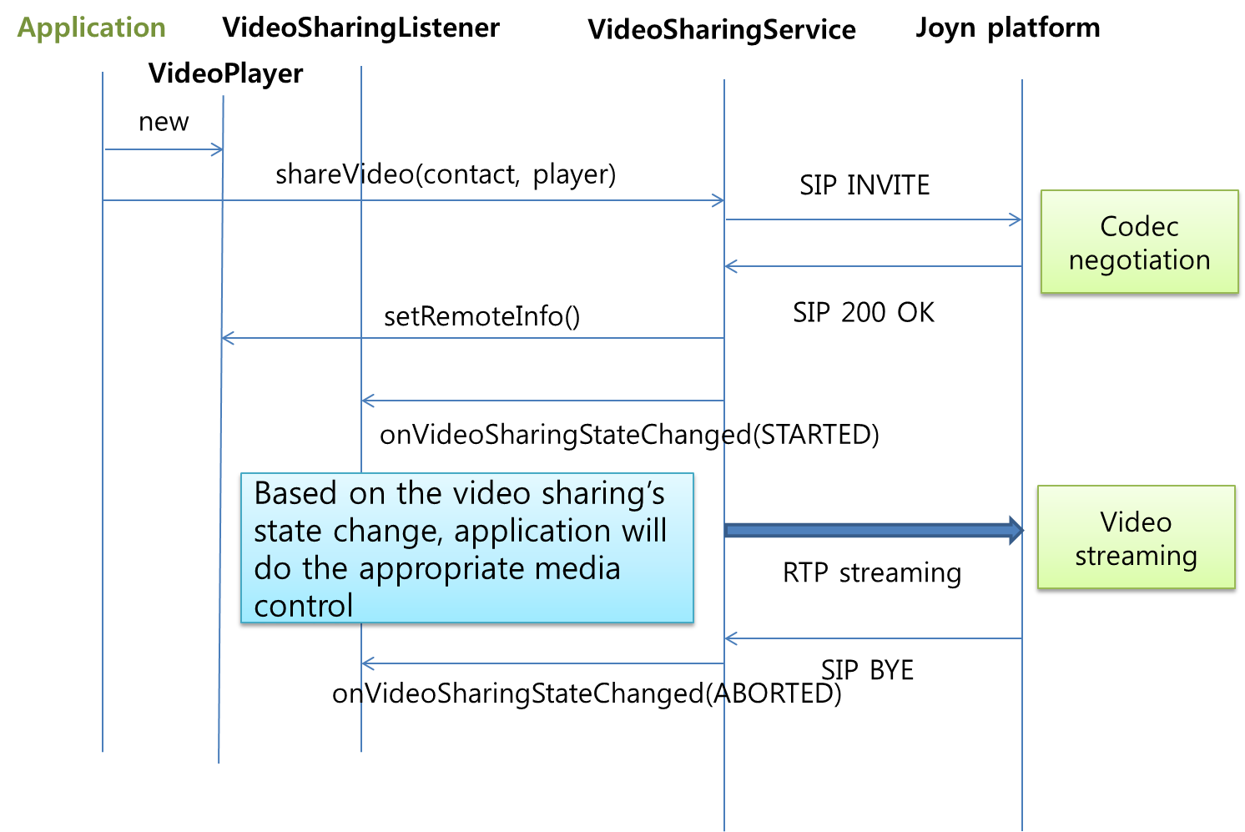
- : Originating side

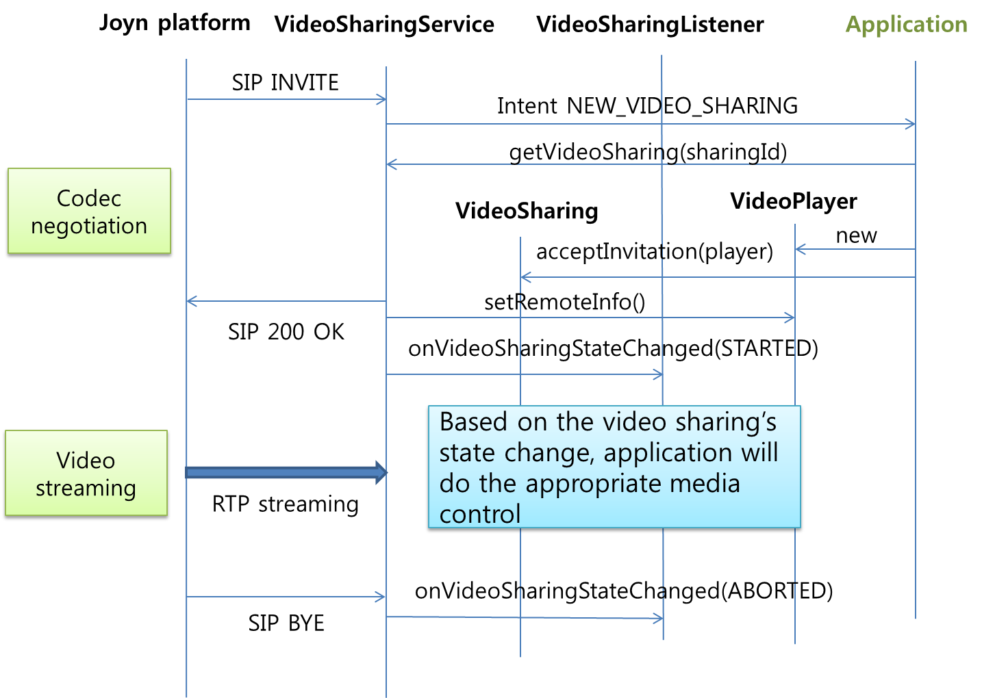
- : Terminating side
- Internal codec
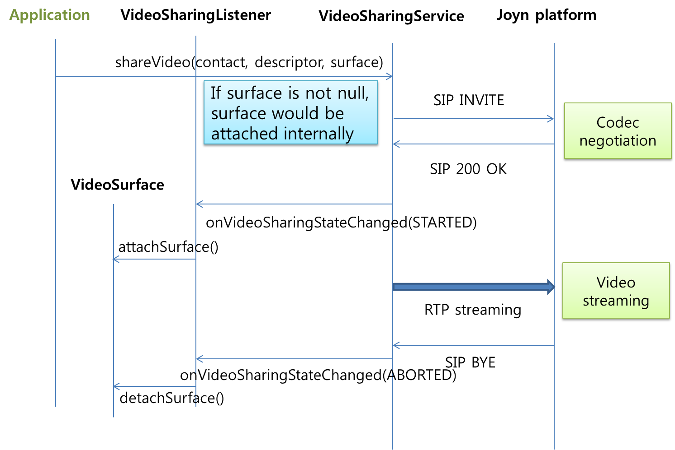
- : Originating side

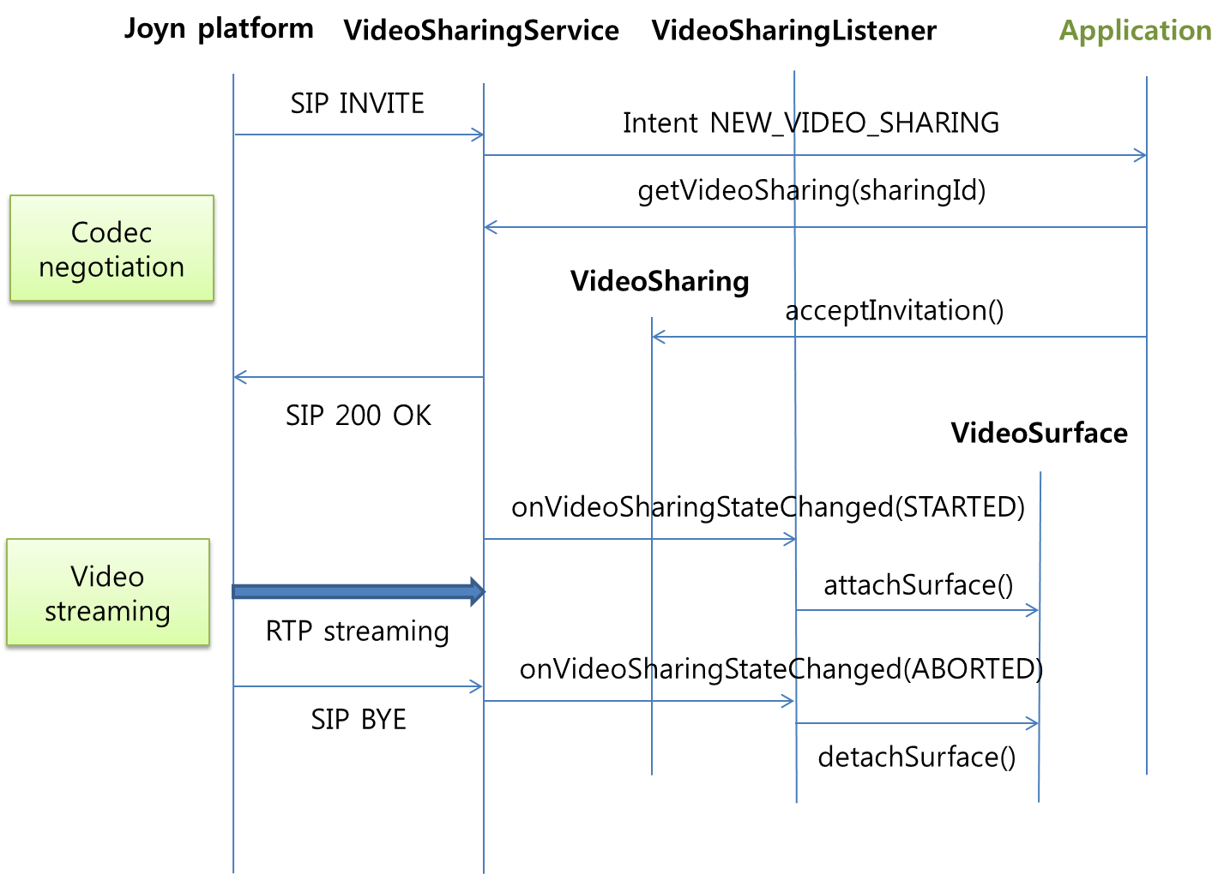
- : Terminating side

      - Permissions
Access to the Video Share API requires the following permissions:
- com.gsma.services.rcs.RCS_VIDEOSHARE_RECEIVE: this is a new permission that is required by a client in order to handle the receipt of a video shared by a remote party.
- com.gsma.services.rcs.RCS_VIDEOSHARE_SEND: this is a new permission that is required by a client in order to initiate the sharing of a video with a remote party.
- com.gsma.services.rcs.RCS_VIDEOSHARE_READ: this is a new permission that is required by a client in order to read the video share history from the content provider.

Geoloc Share API
This API exposes all functionality related to share a geoloc during a CS call via the Geoloc Share Service. It allows to:
- Send a geoloc share request
- Receive notifications about incoming geoloc share invitation.
- Monitors a geoloc share’s progress.
- Cancel a geoloc share in progress.
- Accept/reject an incoming geoloc share request.
A geoloc contains the following information:
- a label associated to the geoloc info
- latitude
- longitude
- accuracy of the geoloc info (in meter)
- an expiration date of the geoloc info
The shared geoloc is displayed to the end user and also stored in sthe Chat log in order to be displayed afterwards from the “Show us in a map” service.

Package
Package name com.gsma.services.rcs. sharing.geoloc

Methods and Callbacks
Class GeolocSharingService:
This class offers the main entry point to share a geoloc during a CS call, when the call hangs up the sharing is automatically stopped. Several applications may connect/disconnect to the API.

- Method: connects to the API.
void connect()

- Method: disconnects from the API.
void disconnect()

- Method: returns the list of geoloc sharing in progress.
Set<GeolocSharing> getGeolocSharings()

- Method: returns a current geoloc sharing from its unique ID. If no ongoing GeolocSharing matching the sharingId if found then a reference to a historical GeiolocSharing is returned so that calls to the methods on that still can be performed.
GeolocSharing getGeolocSharing(String sharingId)

- Method: shares a geoloc with a contact. An exception is thrown if there is no ongoing CS call.
GeolocSharing shareGeoloc(ContactId contact, Geoloc geoloc)

- Method: adds a new geoloc sharing invitation listener.
void addEventListener(GeolocSharingListener listener)

- Method: removes a new geoloc sharing invitation listener.
void removeEventListener(GeolocSharingListener listener)

- Method: deletes all geoloc sharings from history and abort/reject corresponding sessions if such are ongoing.
void deleteGeolocSharings()

- Method: deletes geoloc sharings with a given contact from history and abort/reject corresponding sessions if such are ongoing.
void deleteGeolocSharings(ContactId contact)

- Method: deletes a geoloc sharing from its sharing ID from history and abort/reject corresponding sessions if such are ongoing.
void deleteGeolocSharing(String sharingId)

Class GeolocSharing:
This class maintains the information related to a geoloc sharing and offers methods to manage the sharing.

- Enum: the GeolocationSharing state.
enum State { INVITED(0), INITIATED(1), STARTED(2), ABORTED(3), FAILED(4), TRANSFERRED(5), REJECTED(6), RINGING(7), ACCEPTING(8)}

- Enum: the reason code for the GeolocationSharing
enum ReasonCode { UNSPECIFIED(0), ABORTED_BY_USER(1), ABORTED_BY_REMOTE(2), ABORTED_BY_SYSTEM(3), REJECTED_BY_SECONDARY_DEVICE (4), REJECTED_MAX_SHARING_SESSIONS(5), REJECTED_BY_USER(6), REJECTED_BY_REMOTE(7), REJECTED_TIME_OUT(8), FAILED_INITIATION(9), FAILED_SHARING(10) }

- Method: returns the sharing ID of the geoloc sharing.
String getSharingId()

- Method: returns the remote contact.
ContactId getRemoteContact()

- Method: returns the geoloc info to be shared.
Geoloc getGeoloc()

- Method: returns the local timestamp of when the geoloc sharing was initiated for outgoing geoloc sharing or the local timestamp of when the geoloc sharing invitation was received for incoming geoloc sharings.
long getTimeStamp()

- Method: returns the state of the geoloc sharing.
State getState()

- Method: returns the direction of the sharing:
com.gsma.services.rcs.RcsService.Direction getDirection()

- Method: accepts geoloc sharing invitation.
void acceptInvitation()

- Method: rejects geoloc sharing invitation.
void rejectInvitation()

- Method: aborts the sharing.
void abortSharing()

Class GeolocSharingListener:
This class offers callback methods on geoloc sharing events.

- Method: callback called when the geoloc sharing state is changed.
void onStateChanged(ContactId contact, String sharingId, GeolocationSharing.State state, GeolocSharing.ReasonCode reasonCode)

- Method: callback called during the sharing progress.
void onProgressUpdate(ContactId contact, String sharingId, long currentSize, long totalSize)

- Method: callback called when a delete operation completed that resulted in that one or several geoloc sharings was deleted specified by the sharingIds parameter corresponding to a specific contact.
void onDeleted(ContactId contact, Set<String> sharingIds)

Intents
Intent broadcasted when a new geoloc sharing invitation has been received. This Intent contains the following extras:

- “sharingId”: unique ID of the geoloc sharing.
com.gsma.services.rcs.gsh.action.NEW_GEOLOC_SHARING

Content Providers
A content provider is used to store the geolocation sharing history persistently. There is one entry per geolocation sharing.

Class GeolocSharingLog:
Event log provider member id used when merging the data from this provider with other registered event log provider members data into a common cursor:
static final int EVENTLOG_MEMBER_ID = 5
URI constant to be able to query the provider data (Note that only read operations are supported since exposing write operations would conflict with the fact that the stack is performing write operations internally to keep the data matching the current situation):
static final Uri CONTENT_URI = "content://com.gsma.services.rcs.provider.geolocshare/geolocshare"
The “SHARING_ID” column below is defined as the unique primary key and can be references with adding a path segment to the CONTENT_URI + “/” + <primary key>
Column name definition constants to be used when accessing this provider:
static final String SHARING_ID = "sharing_id"
static final String CONTACT = "contact"
static final String GEOLOC = "geoloc"
static final String MIME_TYPE = "mime_type"
static final String DIRECTION = "direction"
static final String TIMESTAMP = "timestamp"
static final String STATE = "state"
static final String REASON_CODE = "reason_code"
The content provider has the following columns:
GEOLOCSHARE
Data | Data type | Comment
SHARING_ID | Text | Unique sharing identifier
CONTACT | Text | ContactId formatted number of the remote contact
GEOLOC | Text | The geolocation stored as a String parseable with the ChatLog.Message.getGeoloc() method.
MIME_TYPE | Text | Multipurpose Internet Mail Extensions (MIME) type of the geoloc
DIRECTION | Integer | Direction of sharing. See enum Direction.
TIMESTAMP | Long | Date of the sharing
STATE | Integer | See enum GeolocSharing.State for valid states
REASON_CODE | Integer | See enum GeolocSharing.ReasonCode for valid reason codes

Permissions
Geoloc Share is a convenience mechanism to allow geolocation information to be delivered in a chat message. From the perspective of a client receiving such events, the permissions are no different from those relating to any other chat message. On the sending side, permissions are defined that govern the ability of a client to access geolocation information, and to send that information via the Geoloc Share mechanism.
Access to the Geoloc API is requires the following permissions:
- android.permission.ACCESS_FINE_LOCATION: this is the standard Android permission that governs whether or not the app is entitled to access fine-grained geolocation information such as might be available from GPS.
- android.permission.ACCESS_COARSE_LOCATION: this is the standard Android permission that governs whether or not the app is entitled to access coarse-grained geolocation information such as might be available from CellID or WiFi sources.
- com.gsma.services.rcs.RCS_LOCATION_SEND: this is a new permission that is required to send Geolocation data over an RCS chat session.
- com.gsma.services.rcs.RCS_USE_CHAT: this is the permission that governs access to the chat API which is a prerequisite to being able to use the Geoloc Share API.
- com.gsma.services.rcs.RCS_GEOLOCSHARE_READ: this is a new permission that is required by a client in order to read the geolocation share history from the content provider.

Contacts API
There is already an Android API to manage contacts of the local address book, see Android package android.provider.ContactsContract. This API offers additional methods to:
- Add RCS info in the local address book,
- Extract RCS info from the local address book.

Package
Package name com.gsma.services.rcs.contacts

Methods and Callbacks
Class ContactsService:
This class offers methods to extract RCS info associated to contacts from the local address book.

- Method: connects to the API.
void connect()

- Method: disconnects from the API.
void disconnect()

- Method: returns the list of RCS contacts.
Set<RcsContact> getRcsContacts()

- Method: Returns the RCS contact infos from its contact ID (i.e. MSISDN)
RcsContact getRcsContact(ContactId contact)

- Method: returns the list of contacts online (i.e. registered).
Set<RcsContact> getRcsContactsOnline()

- Method: returns the list of contacts supporting a given extension or service ID (i.e. capability).
Set<RcsContact> getRcsContactsSupporting(String serviceId)

- Method: get the vCard of a contact. The parameter contact contains the database URI of the contact in the native address book. The method returns the complete filename including the path of the visit card. The filename has the file extension “.vcf” and is generated from the native address book vCard URI (see Android SDK attribute ContactsContract.Contacts.CONTENT_VCARD_URI which returns the referenced contact formatted as a vCard when opened through openAssetFileDescriptor(Uri, String)).
static String getVCard(Context ctx, Uri contact)

Class ContactUtils:
This class offers utility methods to verify and format contact identifier.

- Method: get an instance of ContactUtils. May be null if country code cannot be read from provider.
static ContactUtils getInstance(Context context)

- Method: returns true if the given contactId have the syntax of valid RCS contactId.If the string is too short (1 digit at least), too long (more than 15 digits) or contains illegal characters (valid characters are digits, space, ‘-‘, leading ‘+’) then it returns false.
boolean isValidContact(String contact)

- Method: formats the given contact to uniquely represent a RCS contact. If the input string is not valid - as can be tested with the method isValidContact() - then RcsContactFormatException is thrown else a valid ContactId is returned.
ContactId formatContactId(String contact)

Class ContactId:
This class represents a formatted and valid contact number. All normal java object methods are supported for this class like toString(), equals(), hashCode()…

NOTE : the contact format is the international representation of the phone number “<CC><NDC><SN>” with:
CC : the country code with a leading ‘+’ character
NDC : the national destination code
SN: the subscriber number
All these codes CC, NDC, SN are digits. If this number needs to be displayed in the UI with some particular UI formatting, it is in the scope of UI code to format that. This class will never hold specific UI formatted numbers since they need to be unique.
Class RcsContact:
This class maintains the information related to a RCS contact.

- Method: returns the canonical contact ID (i.e. MSISDN).
ContactId getContact()

- Method: returns the displayname associated to the contact.
String getDisplayName()

- Method: returns the capabilities associated to the contact.
Capabilities getCapabilities()

- Method: is contact online (i.e. registered to the service platform).
boolean isRegistered()

Content Providers
In addition to the methods, the RCS information are stored in the local address book thanks to the Contacts Contract interface of the Android Software Development Kit (SDK). This permits to have a native integration of RCS in the address book.
See the following MIME-type to be supported:
MIME type | Comment
vnd.android.cursor.item/com.gsma.services.rcs.number | RCS phone number
vnd.android.cursor.item/com.gsma.services.rcs.registration-state | Registration state (online | offline)
vnd.android.cursor.item/com.gsma.services.rcs.image-share | Image share capability supported
vnd.android.cursor.item/com.gsma.services.rcs.video-share | Video share capability supported
vnd.android.cursor.item/com.gsma.services.rcs.im-session | IM/Chat capability supported
vnd.android.cursor.item/com.gsma.services.rcs.file-transfer | File transfer capability supported
vnd.android.cursor.item/com.gsma.services.rcs.extensions | RCS extensions supported
vnd.android.cursor.item/com.gsma.services.rcs.geoloc-push | Geolocation push capability supported
Implementation notes:
- To store the MIME-type see the following tutorial http://developer.android.com/reference/android/provider/ContactsContract.RawContacts.html
- A raw contact is created to store the RCS info associated to a contact. A RCS account is created to manage raw contacts.
- When a contact becomes enriched with RCS information, we associate a corresponding raw contact with MIME type vnd.android.cursor.item/vnd.rcs.
- The number associated to the contact is put into the field Data.DATA1.
- The supported MIME type is put into the field Data.MIMETYPE.
- The description associated to the supported MIME type is always put into the field Data.DATA2. This label is displayed at UI level (i.e. menu item of the local native address book).
- If a MIME type is not set for a contact, this means the associated capability is not supported.

Permissions
Access to the Contacts API requires the following permissions:
- android.permission.READ_CONTACTS: this permission is required by any client using the capabilities service, since use of the API implicitly reveals information about past and current contacts for the device.
- Additionally, methods that reveal contact capabilities (getRcsContactsSupporting() and getCapabilities()) require:
- com.gsma.services.rcs.RCS_READ_CAPABILITIES: this is a new permission that governs access to capability information.

API Versioning
This API maintains information about the current version of the RCS terminal API.
A build is identified by:
- GSMA version: hotfixes, Blackbird, .etc.
- Implementer name: entity name who has implemented the API.
- Release number of the API.
- Incremental number to identify the build into a release number.
A software release of the API is identified uniquely by its release number and the incremental number.

Package
Package name com.gsma.services.rcs

Methods and Callbacks
Class Build:
This class offers information related to the build version of the API.

- Constant: API release implementer name.
public final static String API_CODENAME

- Constant: API version number from class Build.VERSION_CODES.
public final static int API_VERSION.

- Constant: Internal number used by the underlying source control to represent this build.
public final static int API_INCREMENTAL

Class Build.VERSION_CODES:
This class contains the list of API versions.

- Constant: The original first version of RCS API or hotfixes version.
public final static int BASE

- Constant: Blackbird version
public final static int BLACKBIRD

- Constant: Crane version
public final static int CRANE

Content Providers

    - Multimedia Session API
This service API exposes all functionality related to initiate a multimedia session between two clients in order to implement a new IMS service based session. The new service is identified by a unique service ID which corresponds to an IARI feature tag and ICSI tag in the signalling flows, the same service ID is used as an extension in the Capability service API.
There are 2 types of services offered by the API:
- Real time messaging session based on the MSRP protocol for media. A session is established between contacts and multimedia messages or data are exchanged in real time while the session exists. A session exists from its initiation to its termination.
- Real time streaming session based on the RTP protocol for media. A session is established between contacts and multimedia payloads are streamed in real time while the session exists. A session exists from its initiation to its termination.
The session may be accepted or rejected by the remote contact. Any type of message may be exchanged between end points.
The API allows:
- Initiate a multimedia session for messaging or streaming.
- Accept/reject an incoming session invitation.
- Retrieve the list of sessions using a given feature tag.
- Terminate a session.
For a given service, several sessions may coexist in parallel.
This service API hides:
- the SIP signalling complexity and SDP (Session Description Protocol) answer/offer mechanism to negotiate the media exchanged between the two end points.
- The media protocol (MSRP for messaging and RTP for streaming).
Thanks to this API, any application can implement a new RCS/IMS service on top of the RCS background service which maintains a single attachment to the RCS/IMS platform and utilizes common IMS procedures (e.g. authentication) for services implemented on top of it.
Each new RCS/IMS service is associated to a service ID:
- The service ID is used to define a new capability (see Capability API) and to share it with others remote contacts.
- The service ID is used to identify the service in the device (for incoming and outgoing request), but also on the platform side (e.g. to trigger an Application server).
See chapter Error: Reference source not found for detailed callflows corresponding to the service API

Package
Package name com.gsma.rcs.extension

Methods and Callbacks
Class MultimediaSessionService:
This class offers the main entry point to initiate and manage new and existing multimedia sessions. Several applications may connect/disconnect to the API.

- Method: connects to the API.
void connect()

- Method: disconnects from the API.
void disconnect()
- Method: Returns the configuration of the multimedia session service.
MultimediaSessionServiceConfiguration getConfiguration()
- Method: returns the list of messaging sessions associated to a given service ID.
Set<MultimediaMessagingSession> getMessagingSessions(String serviceId)

- Method: returns a current messaging session from its unique session ID.
MultimediaMessagingSession getMessagingSession(String sessionId)

- Method: initiate a new multimedia session for real time messaging with a remote contact and for a given service. The messages exchanged in real time during the session may be from any type.
MultimediaSession initiateMessagingSession(String serviceId, ContactId contact)

- Method: returns the list of streaming sessions associated to a given service ID.
Set<MultimediaStreamingSession> getStreamingSessions(String serviceId)

- Method: returns a current streaming session from its unique session ID.
MultimediaStreamingSession getStreamingSession(String sessionId)

- Method: initiate a new multimedia session for real time streaming with a remote contact and for a given service. The payloads exchanged in real time during the session may be from any type.
MultimediaSession initiateStreamingSession(String serviceId, ContactId contact)

- Method: deletes multimedia sessions from its session ID.
Void addEventListener(MultimediaMessagingSessionListener listener)

- Method: deletes multimedia sessions from its session ID.
void removeEventListener(MultimediaMessagingSessionListener listener)

- Method: deletes multimedia sessions from its session ID.
void addEventListener(MultimediaMessagingSessionListener listener)

- Method: deletes multimedia sessions from its session ID.
void removeEventListener(MultimediaMessagingSessionListener listener)

Class MultimediaSession:
This class maintains the information related to a multimedia session and offers methods to manage it. This is an abstract class between a messaging session and a streaming session.

- Enum: the state of the multimedia session.
enum State { INVITED(0), INITIATED(1), STARTED(2), ABORTED(3), FAILED(4), REJECTED(5), RINGING(6), ACCEPTING(7)}

- Enum: the reason code for the multimedia session.
enum ReasonCode { UNSPECIFIED(0), REJECTED_TIME_OUT(1), REJECTED_BY_USER(2), REJECTED_BY_REMOTE(3), FAILED_SESSION(4), FAILED_MEDIA(5) }

- Method: returns the session ID of the multimedia session.
String getSessionId()

- Method: returns the remote contact.
ContactId getRemoteContact()

- Method: returns the service ID.
String getServiceId()

- Method: returns the state of the session.
State getState()

- Method: returns the direction of the session:
com.gsma.services.rcs.RcsService.Direction getDirection()

- Method: accepts session invitation.
void acceptInvitation()

- Method: rejects session invitation.
void rejectInvitation()

- Method: aborts the session.
void abortSession()

- Method: gets the feature tag
String getFeatureTag()

Class MultimediaMessagingSession:
This class inherits from the class MultimediaSession and is related to a messaging session.

- Method: send a multimedia message or data in real time.
void sendMessage(byte[] content)

Class MultimediaMessagingSessionListener:
This class offers callback methods on multimedia session events.

- Method: Callback called when the multimedia messaging session state/reasonCode is changed
void onStateChanged(ContactId contact, String sessionId, MultimediaMessagingSession.State state, MultimediaMessagingSession.ReasonCode reasonCode)

- Method: callback called when a multimedia message or data is received.
void onMessageReceived(ContactId contact, String sessionId, byte[] content)

Class MultimediaStreamingSession:
This class inherits from the class MultimediaSession and is related to a streaming session.

- Method: send a multimedia payload or data in real time.
void sendPayload(byte[] content)

Class MultimediaStreamingSessionListener:
This class offers callback methods on multimedia session events.

- Method: Callback called when the multimedia messaging session state/reasoncode is changed
void onStateChanged(ContactId contact, String sessionId, MultimediaStreamingSession.State state, MultimediaStreamingSession.ReasonCode reasonCode)

- Method: callback called when a multimedia message or data is received.
void onPayloadReceived(ContactId contact, String sessionId, byte[] content)

Class MultimediaSessionServiceConfiguration:
This class represents the particular configuration of Multimedia Service.

- Method: Return maximum length of a multimedia message
int getMessageMaxLength()

Intents
Intent broadcasted when a new messaging session invitation has been received. This Intent contains the following extra:

- “sessionId”: unique ID of the multimedia session.
com.gsma.rcs.extension.action.NEW_MESSAGING_SESSION

Intent broadcasted when a new streaming session invitation has been received. This Intent contains the following extras:

- “sessionId”: unique ID of the multimedia session.
com.gsma.rcs.extension.action.NEW_STREAMING_SESSION

A service is identified by its service ID which permits to route the incoming request (i.e. SIP INVITE) to the corresponding Android application on the device. This mechanism is implemented by declaring an Intent filter in the Manifest file of the application. See the following syntax to be used, where “xxx” corresponds to the service ID:
<intent-filter>
<action android:name="com.gsma.rcs.extension.action.NEW_MESSAGING_SESSION"/>
<data android:mimeType="com.gsma.services.rcs/xxx"/>
<category android:name="android.intent.category.LAUNCHER"/>
<category android:name="android.intent.category.DEFAULT"/>
</intent-filter>

<intent-filter>
<action android:name="com.gsma.rcs.extension.NEW_STREAMING_SESSION"/>
<data android:mimeType="com.gsma.services.rcs/xxx"/>
<category android:name="android.intent.category.LAUNCHER"/>
<category android:name="android.intent.category.DEFAULT"/>
</intent-filter>

See the Capability API for the service ID syntax.

So when an incoming SIP request arrives in the RCS background service, the feature tag of the request is read and analyzed in order to broadcast an Intent containing the feature tag in its MIME type. Then the Intent is captured by the corresponding application.

Call flows
See the following call flow for a messaging session:
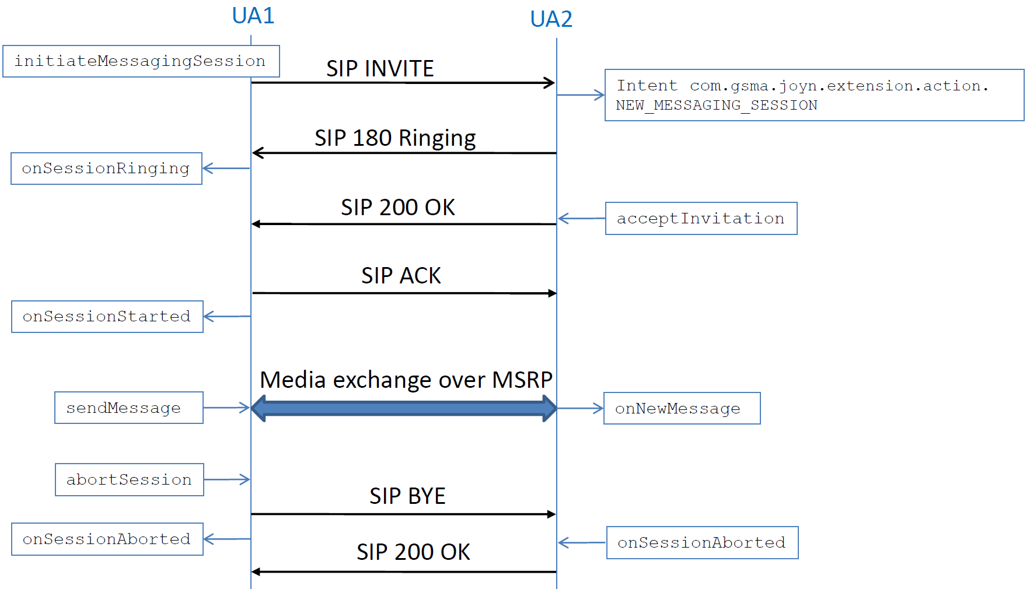
- : Messaging Session
See the following call flow for a streaming session:
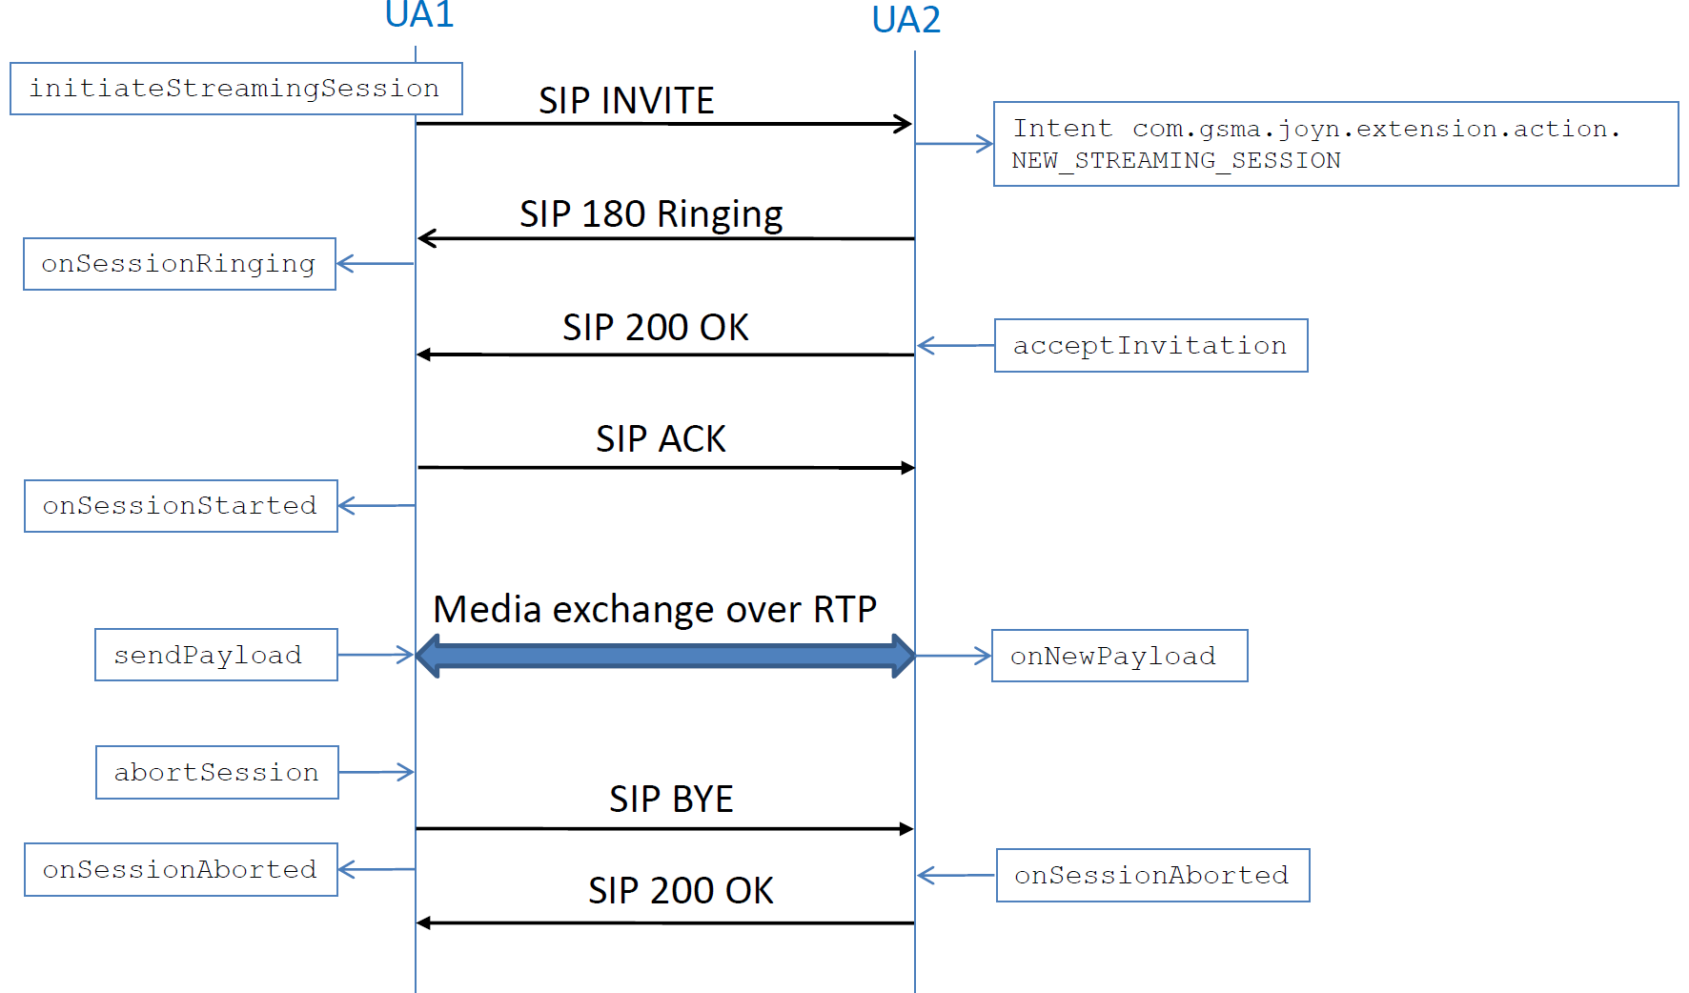
- :Streaming Session

File Upload API
This API exposes all functionality related to upload a file to the RCS Content Server. It allows:
- Upload a file to the Content Server over HTTP.
- Get info on the uploaded file in order to share the file link via any solution (SMS, Chat, Multimedia Session, .etc).
- Monitor the upload progress.
- Abort the upload.

Package
Package name com.gsma.services.rcs.upload

Methods and Callbacks
Class FileUploadService:
This class offers the main entry point to upload files to the Content Server. Several files may be uploaded at a time. Several applications may connect/disconnect to the API.
- Method: connects to the API.
void connect()

- Method: disconnects from the API.
void disconnect()

- Method: returns the list of file uploads in progress.
Set<FileUpload> get FileUploads()

- Method: returns a current file upload from its unique ID.
FileUpload getFileUpload(String uploadId)

- Method: Uploads a file to the RCS content server. The parameter file contains the URI of the file to be uploaded (for a local or a remote file). The parameter fileicon defines if the stack shall try to generate a thumbnail. If the max number of simultaneous uploads is achieved an exception is thrown. If the max size of a file upload is achieved an exception is thrown.
FileUpload uploadFile(Uri file, boolean fileicon)

- Method: returns true if a file can be uploaded right now using the uploadFile method.
boolean canUploadFile()

- Method: adds an event listener on file upload events.
void addEventListener(FileUploadListener listener)
- Method: removes an event listener from file upload.
void removeEventListener(FileUploadListener listener)

- Method: returns the configuration for the File Upload service.
FileUploadServiceConfiguration getConfiguration()

Class FileUploadServiceConfiguration:
This class represents the particular configuration of the File Upload Service (this the same parameter values as for FT Service).
- Method: returns the max file size of a file upload. It can return 0 if there is no limitation.
long getMaxSize()

Class FileUpload:
This class maintains the information related to a file upload and offers methods to monitor the upload.
- Enum: the FileUpload state.
enum State { INACTIVE(0), STARTED(1), ABORTED(2), FAILED(3), TRANSFERRED(4) }

- Method: returns the upload ID of the upload.
String getUploadId()

- Method: returns the URI of the file to be uploaded.
Uri getFile()

- Method: returns the state of the upload.
State getState()

- Method: returns info related to the uploaded file on the content server.
FileUploadInfo getUploadInfo()

- Method: aborts the upload.
void abortUpload()

Class FileUploadInfo:
This class contains information related to the file uploaded on the content server.
- Method: returns URI of the file on the content server.
Uri getFile()

- Method: returns the validity of the file on the content server.
long getValidity()

- Method: returns the size of the file.
long getSize()

- Method: returns the original filename.
String getFilename()

- Method: returns the mime type of the file.
String getMimeType()

- Method: returns URI of the file icon on the content server.
Uri getFileicon()

- Method: returns the validity of the file icon on the content server.
long getFileiconValidity()

- Method: returns the size of the file icon.
long getFileiconSize()

- Method: returns the mime type of the file icon.
String getFileiconMimeType()

Class FileUploadListener:
This class offers callback methods on file upload events.
- Method: callback called when the file upload state has been changed.
void onStateChanged(String uploadId, FileUpload.State state)

- Method: callback called during the upload progress.
void onProgressUpdate(String uploadId, long currentSize, long totalSize)

Permissions
Access to the File Upload API is requires the following permissions:
- com.gsma.services.rcs.RCS_FILEUPLOAD_SEND: this is a new permission that is required by a client in order to upload a file to the content server.

Convergent historylog API

Package
Package name com.gsma.services.rcs.history

Methods and Callbacks
Class HistoryService:
This class offers the possibility to register/unregister additional history log provider members on top of those that terminal api already added by default and which the history log provider supports data from to be presented as a merged cursor. The history log provider members that are added by default by stack and thus needs no registration by any application to be used are currently ChatLog.Message, FileTransferLog, ImageShareLog, VideoShareLog and GeolocShareLog. Several applications may connect/disconnect to the API.
- Method: connects to the API.
void connect()

- Method: disconnects from the API.
void disconnect()

- Method: register an extra event log member so that the event log provider can merge data from that database together with other event log member’s data. The column mapping parameter allows for mapping exactly how the columns in the registered provider should be mapped to the event log provider columns in the resulting cursor.
void registerExtraHistoryLogMember(int providerId, Uri database, String table, Map<String, String> columnMapping)

- Method: unregister an external history log member so that it can no longer be used to join together the data from this member together with the other evenloh members.
void unRegisterExtraHistoryLogMember(int providerId)

Content Providers
The content provider in this package is a virtual content provider in that it does not store any data itself but is allows for a client to make queries dynamically combining entries from several other specified providers per query returning a merged cursor containing all entries that match the selection query in those specified providers. Any normal query should be possible to make against the event log provider including specifying sort order, selection arguments as well as any projection of choice matching the data columns specified below. Operations of insert/update and delete has naturally been blocked in this provider as such operations are handled by other use cases and in each individual other provider that stores the actual data.

Class HistoryLog:
Base URI constant to be able to query the provider data (Note that only read operations are supported). Specific members ids needs to be appended to this base uri as query parameters to specify which members data should be merged (See HistoryLogUriBuilder):
static final Uri CONTENT_URI = "content://com.gsma.services.rcs.provider. history/history"
Alternative URI constant to be able to make a query of the provider data that does not support parameters (like “?”) but is more optimized for speed on larger datasets. (Note that only read operations are supported). Specific members ids needs to be appended to this base uri as query parameters to specify which members data should be merged (See HistoryLogUriBuilder):
static final Uri CONTENT_URI_PARAMLESS = "content://com.gsma.services.rcs.provider. history/history_paramless"

Column name definition constants to be used when accessing this provider:
static final String PROVIDER_ID = "provider_id"
static final String ID = " id"
static final String MIME_TYPE = "mime_type"
static final String DIRECTION = "direction"
static final String CONTACT = "contact”
static final String TIMESTAMP = "timestamp"
static final String TIMESTAMP_SENT = "timestamp_sent"
static final String TIMESTAMP_DELIVERED = "timestamp_delivered"
static final String TIMESTAMP_DISPLAYED = "timestamp_displayed"
static final String MIME_TYPE = "mime_type"
static final String STATUS = "status"
static final String REASON_CODE = "reason_code"
static final String READ_STATUS = "read_status"
static final String CHAT_ID = "chat_id"
static final String DIRECTION = "direction"
static final String CONTENT = "content"
static final String FILEICON = "fileicon"
static final String FILEICON_MIME_TYPE = "fileicon_mime_tyoe"
static final String FILENAME = "filename"
static final String FILESIZE = "filesize"
static final String TRANSFERRED = "transferred"
static final String DURATION = "duration"

The content provider exposes the following virtual table and virtual columns:

HISTORYLOG
Data | Data Type | Description
PROVIDER_ID | Integer | The id of the provider of the entry matching the id defined in the default provider yjay corresponds to the entry.
ID | String | Identifier of the entry (message_id, ft_id, sharing_id or call_id etc depending on the corresponding provider of the entry)
MIME_TYPE | String | Multipurpose Internet Mail Extensions (MIME) type of the entry
DIRECTION | Integer | See enum Direction
CONTACT | String | ContactId formatted number associated with the entry status. See corresponding provider for the list of reason codes
TIMESTAMP | Long | Time when entry was inserted
TIMESTAMP_SENT | Long | Time when this entry was sent. 0 means not sent.
TIMESTAMP_DELIVERED | Long | Time when this entry was delivered. 0 means not delivered.
TIMESTAMP_DISPLAYED | Long | Time when this entry was displayed. 0 means not displayed.
STATUS | Integer | Status (or State) of the entry. See corresponding provider for available statuses and/or states
REASON_CODE | Integer | Reason code associated with the entry status. See corresponding provider for the list of reason codes
READ_STATUS | Integer | Read status (UNREAD or READ) matching the read status of the corresponding provider of the entry.
CHAT_ID | String | Id for chat room
CONTENT | String | Content of the message if this entry corresponds to a content message or the file uri if this entry is a file transfer, image share, geoloc share or video share etc.
FILEICON | String | File Icon Uri if the entry corresponds to a file transfer and it has a file icon attached to it
FILEICON_MIME_TYPE | String | Multipurpose Internet Mail Extensions (MIME) type of the file icon
FILENAME | String | File name if this entry corresponds to a file transfer
FILESIZE | Long | File size in bytes if this entry corresponds to a file transfer
TRANSFERRED | Long | Size transferred in bytes if this entry corresponds to a file transfer
DURATION | Long | Duration of the sharing or call in seconds if this entry corresponds to a sharing or a call. The value is only set at the end of the sharing or call.

Methods and Callbacks

Class HistoryLogUriBuilder:
This class offers methods to build an Uri that can be used to query the history log provider. The uri format is constructed by adding each provider id as standard uri query parameters to either the base CONTENT_URI or the CONTENT_URI_PARAMLESS exposed in the HistoryLog class. Note order of added history log provider members in the uri is of no significance as sort order can be specified on the data in the returned cursor from the history log provider anyway when querying it.
- Constructor: Instantiates a new HistoryLogUriBuilder with a Uri of choice.
HistoryLogUriBuilder(Uri historyLogContentUri)

- Method: adds a registered history log provider member id to the builder instance. A maximum of ten members can be added in total.
HistoryLogUriBuilder appendProvider(int providerId)

- Method: returns an Uri containing the added providers.
Uri build()

- Document Management
  - Document History
Version | Date | Brief Description of Change | Approval Authority | Editor / Company
0.1 | 26 Nov 2013 | Joyn Blackbird release are incorporated | RCS TSG JTA | Kelvin Qin and Tom Van Pelt / GSMA
1.0 | 31 Jan 2014 | Approved by PSMC | PSMC | Kelvin Qin / GSMA
1.5 | xxx | Multimeida API is added and some other API improvement | RCSJTA | Kelvin Qin / GSMA
  - Other Information
Type | Description
Document Owner | RCS TSG JTA
Editor / Company | Kelvin Qin / GSMA

It is our intention to provide a quality product for your use. If you find any errors or omissions, please contact us with your comments. You may notify us at prd@gsma.com

Your comments or suggestions & questions are always welcome.

