 |  | RCSJTA T-API 1.6 Crane Priority Release CR_xxx  Unique method Capability discovery
Meeting Information
Meeting Name and Number
Meeting Date
Meeting Location |  | Conference Call
Document Information
Document Author(s)
Document Creation Date
 |  | Approval | X
This document is for: (mark X as appropriate) |  | Discussion
 |  | Information only
Security Classification – Non Confidential / Confidential GSMA Material (Delete as appropriate and delete the rows below that do not apply) |  |  | Can be distributed to: (mark X as appropriate or specify group
Non Confidential |  | Public
Confidential |  | Project Team or Group | X
Confidential |  | GSMA HQ Staff | X
Confidential |  | GSMA Full Members | X
Confidential |  | GSMA Associate Members | X
Confidential |  | GSMA Rapporteur Members | X
Document Summary
New unique methods for getting contact capabilities following discussions with Samsung (in line with agreements of RCSJTA calls)

Document History
Date | Version | Author / Comments and for updates description of changes
07/12/14 | 1.0 | Initial proposition

© GSMA 2010. The GSM Association (“Association”) makes no representation, warranty or undertaking (express or implied) with respect to and does not accept any responsibility for, and disclaims liability for the accuracy or completeness or timeliness of the information contained in this document. The information contained in this document may be subject to change without prior notice. This document has been classified according to the GSMA Document Confidentiality Policy. GSMA meetings are conducted in full compliance with the GSMA Antitrust Policy.

RCC TF Change Request Form
Title: | Unique method for capability doscovery
Type of Change Request: Mark the appropriate box by “X” | New Feature |  | Major  Change Errata
  X
Targeted Document | joyn Terminal API Specification
Impact on Other Official Documents: | None

======================= 1st Change ==================================

Capability API
This API allows for querying the capabilities of a user or users and checking for changes in their capabilities:
- Read the supported capabilities locally by the user on its device.
- Retrieve all capabilities of a user.
- Checking a specific capability of a user.
- Refresh capabilities for all contacts.
- Registering for changes to a user/users ‘s capabilities
- Unregistering for changes to a user/users ‘s capabilities
- Define scheme for registering new service capabilities based on manifest defined feature tags.
This API may be accessible by any application (third party, MNO, OEM). The RCS extensions are controlled internally by the RCS service.
Note: there is the same API between File transfer and File Transfer over HTTP. So from an API perspective there is the same capability for both mode (MSRP and HTTP) and it is transparent for the user.

Capability Discovery API calling flow
The Capability Discovery (CD) service provides the API through which the user can get the capabilities of other contacts and also "announce" its own capabilities.
The figures in this section contains basic call flows of the CD service API.
The following is an example that shows the retrieval of the capabilities of a list of remote contacts.
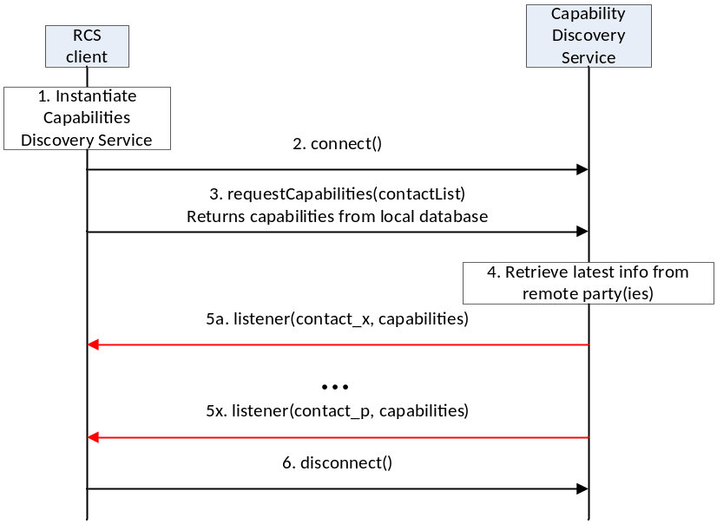
- : Get the capabilities of a list of remote contacts
- The RCS client instantiates a service instance of the Capability Discovery Service. At this time, it also specifies the list of listener functions.
- The RCS client establishes a connection with the Capability Discovery Service. The Capability Discovery Service associates the listener with this RCS client.
- The RCS client constructs a list of contacts for which it wants to get the latest capabilities. It invokes the API to get the capabilities of these contacts by providing the contact list as parameter. The Capability Discovery Service returns the requested information from the local database.
- Additionally, the Capability Discovery Service initiates procedures with the remote parties to retrieve the latest capabilities.
- When the updated capability information is available for a contact, the listener function(s) are invoked to inform all the RCS clients that have installed a listener. This step is repeated for each contact for which updated capability information becomes available.
- Finally, the RCS client, having retrieved the contact information, disconnects from the capability discovery service. At this time, the Capability Service discards all listeners associated with this client.

Package
Package name com.gsma.services.rcs.capability

Methods and Callbacks
Class CapabilityService:
This class offers the main entry point to the Capability service which permits to read capabilities of remote contacts, to initiate capability discovery and to receive capabilities updates. Several applications may connect/disconnect to the API.
A set of capabilities is associated to each MSISDN of a contact.

- Method: connects to the API.
void connect()

- Method: disconnects from the API.
void disconnect()

- Method: returns the capabilities supported by the local end user. The supported capabilities are fixed by the MNO and read during the provisioning.
Capabilities getMyCapabilities()

- Method: returns the capabilities of a given contact from the local database. This method doesn’t request any network update to the remote contact. If no matching contact capabilities is found then null is returned.
Capabilities getContactCapabilities(ContactId contact)

- Method: (depracated) requests capabilities to a remote contact. This method initiates in the background a new capability request to the remote contact by sending a SIP OPTIONS. The result of the capability request is sent asynchronously via callback method of the capabilities listener. A capability refresh is only sent if the timestamp associated to the capability has expired (the expiration value is fixed via MNO provisioning) and a refresh for updated capabilities was not already requested not too long ago for the same contact. The result of the capability refresh request is provided to all the clients that have registered the listener for this event.
void requestContactCapabilities(ContactId contact)

- Method: requests capabilities for a group of remote contacts. This method initiates in the background new capability requests to the remote contact by sending a SIP OPTIONS. The result of the capability request is sent asynchronously via callback method of the capabilities listener. A capability refresh is only sent if the timestamp associated to the capability has expired (the expiration value is fixed via MNO provisioning). The result of the capability refresh request is provided to all the clients that have registered the listener for this event. If the contacts parameter is null, the stacks requests capabilities for all contacts existing in the local address book.
void requestContactCapabilities(Set<ContactId> contacts)

- Method: (depracated) requests capabilities for all contacts existing in the local address book. This method initiates in the background new capability requests for each contact of the address book by sending SIP OPTIONS. The result of a capability request is sent asynchronously via callback method of the capabilities listener. A capability refresh is only sent if the timestamp associated to the capability has expired (the expiration value is fixed via MNO provisioning). The result of the capability refresh request is provided to all the clients that have registered the listener for this event.
void requestAllContactsCapabilities()

- Method: registers a listener for receiving capabilities on any contact.
void addCapabilitiesListener(CapabilitiesListener listener)

- Method: unregisters a capabilities listener.
void removeCapabilitiesListener(CapabilitiesListener listener)

- Method: registers a capabilities listener for receiving capabilities on a list of contacts.
void addCapabilitiesListener(Set<ContactId> contacts, CapabilitiesListener listener)

- Method: unregisters a capabilities listener on a list of contacts.
void removeCapabilitiesListener(Set<ContactId> contacts, CapabilitiesListener listener)

Class CapabilitiesListener:
This class offers callback methods for the listener of capabilities.

- Method: callback called when new capabilities are received for a given contact.
The first argument contact contains the canonical representation of the identity of the contact whose capabilities are indicated by the second argument capabilities
void onCapabilitiesReceived(ContactId contact, Capabilities capabilities)

Class Capabilities:
This class encapsulates the different capabilities which may be supported by the local user or a remote contact.

- Constants: a mask of bit to indicate if capability is supported.
static final int CAPABILITY_FILE_TRANSFER_SUPPORT = 0x00000001
static final int CAPABILITY_IM_SUPPORT = 0x00000002
static final int CAPABILITY_GEOLOC_PUSH_SUPPORT = 0x00000004
static final int CAPABILITY_IMAGE_SHARING_SUPPORT = 0x00000008
static final int CAPABILITY_VIDEO_SHARING_SUPPORT = 0x00000010

- Method: returns true if capabilities are supported, else returns false
boolean hasCapabilities(int capabilties)

- Method: (depracated) returns true if the file transfer is supported, else returns false
boolean isFileTransferSupported()

- Method: (depracated) returns true if IM/Chat is supported, else returns false
boolean isImSessionSupported()

- Method: (depracated) returns true if image sharing is supported, else returns false
boolean isImageSharingSupported()

- Method: (depracated) returns true if video sharing is supported, else returns false
boolean isVideoSharingSupported()

- Method: (depracated) returns true if geoloc push is supported, else returns false
boolean isGeolocPushSupported()

- Method: returns true if the specified feature tag is supported, else returns false. The parameter tag represents the feature tag to be tested.
boolean isExtensionSupported(String tag)

- Method: returns the list of supported RCS extensions
Set<String> getSupportedExtensions()

- Method: returns true if it’s an automata, else returns false
boolean isAutomata()

- Method: returns the timestamp of the last capability refresh.
long getTimestamp()

Content Providers
A content provider is used to store locally the capabilities of each remote contact. In this case the capabilities may be read even if there is no connection to the RCS platform. There is one entry per remote MSISDN Number.

Class CapabilitiesLog:
URI constant to be able to query the provider data (Note that only read operations are supported since exposing write operations would conflict with the fact that the stack is performing write operations internally to keep the data matching the current situation):
static final Uri CONTENT_URI = "content://com.gsma.services.rcs.provider.capability/capability"
The “CONTACT” column below is defined as the unique primary key and can be references with adding a path segment to the CONTENT_URI + “/” + <primary key>
Column name definition constants to be used when accessing this provider:
static final String BASECOLUMN_ID = “_id”
static final String CONTACT = “contact”
static final String CAPABILITY_IMAGE_SHARE = "capability_image_share"
static final String CAPABILITY_VIDEO_SHARE = "capability_video_share"
static final String CAPABILITY_FILE_TRANSFER = "capability_file_transfer"
static final String CAPABILITY_IM_SESSION = "capability_im_session"
static final String CAPABILITY_GEOLOC_PUSH = "capability_geoloc_push"
static final String CAPABILITY_EXTENSIONS = "capability_extensions"
static final String AUTOMATA = “automata”
static final String TIMESTAMP = “timestamp”

The content provider has the following columns:
Data | Data type | Comment
BASECOLUMN_ID | Long (not null) | Unique value
CONTACT | String (primary key not null) | ContactId formatted number of contact associated to the capabilities
CAPABILITY_IMAGE_SHARING | Integer (not null) | Image sharing capability. Values: 1 (true), 0 (false)
CAPABILITY_VIDEO_SHARING | Integer (not null) | Video sharing capability. Values: 1 (true), 0 (false)
CAPABILITY_IM_SESSION | Integer (not null) | IM/Chat capability. Values: 1 (true), 0 (false)
CAPABILITY_FILE_TRANSFER | Integer (not null) | File transfer capability. Values: 1 (true), 0 (false)
CAPABILITY_GEOLOC_PUSH | Integer (not null) | Geolocation push capability. Values: 1 (true), 0 (false)
CAPABILITY_EXTENSIONS | String | Supported RCS extensions. List of features tags semicolon separated (e.g. <TAG1>;<TAG2>;…;TAGn)
AUTOMATA | Integer (not null) | Is an automata. Values: 1 (true), 0 (false).
TIMESTAMP | Long (not null) | Timestamp of when these capabilities was received.

RCS extensions
A MNO/OEM application can create a new RCS/IMS service by defining a new RCS capability (or RCS extension). This new service is identified by an IARI feature tag which is the unique key to identify the service in the RCS API and to trigger the service internally in the device and to route the service on the network side.
Note: How the IARI feature tags are used in the RCS API is for further study
To create a new capability, the MNO/OEM application should declare the new supported feature tag in its Android Manifest file. Then, when the MNO/OEM application is deployed on the device, the RCS service will detect automatically the new installed application and will take into account the new feature tag in the next capability refreshes, via SIP OPTIONS.
When the MNO/OEM application is removed the RCS service will remove the associated capability from the next capability refreshes via SIP OPTIONS.
The role of the RCS service is to manage the extensions and to take into account the new feature tag or not. This may be done by analyzing the certificate of the application supporting the feature tag or by checking the provisioning.
There are two type of extensions:
- Extensions for service provider specific service.
- Extensions for third-party specific service.
For a third-party specific service, the extension should start with the prefix « +g.3gpp.iari-ref=”urn%3Aurn-7%3A3gpp-application.ims.iari.rcs.ext.xxx”, where “xxx“ is a unique service identifier encoded in base64 as per [RFC4648] associated to the application implementing the RCS extension.
See the following API syntax to be added in the Android Manifest file:
<application>
<meta-data
android:name="com.gsma.services.rcs.capability.EXTENSION"
android:value="ext.A5TgS99bJloIUIh1209SJ82B21m87S1B87SBqfS871BS8787SBXBA3P45wjp63tk" />
</application>
For a service provider specific service, the extension should start with the prefix « +g.3gpp.iari-ref=”urn%3Aurn-7%3A3gpp-application.ims.iari.rcs.mnc<mnc>.mcc<mcc>.xxxx », where « mnc » is the Mobile Network Code, where « mcc » is the Mobile Country Code and « xxx » a unique service identifier (string) associated to the application implementing the RCS extension.
See the following API syntax to be added in the Android Manifest file:
<application>
<meta-data
android:name="com.gsma.services.rcs.capability.EXTENSION"
android:value="mnc01.mcc208.xxx"/" />
</application>
Several extensions may be associated per applications, this means the meta-data may contain several tags separated by a semicolon. See the following API syntax:
<application>
<meta-data
android:name="com.gsma.services.rcs.capability.EXTENSION"
android:value="ext.xxx;ext.yyy;ext.zzz"/" />
</application>

Permissions
Access to the Capabilities API and read access to the capabilities provider requires the following permissions:
- com.gsma.services.permission.RCS:
this is a general permission that governs access to RCS services.
android.permission.READ_CONTACTS:
this permission is required by any client using the capabilities service, since use of the API implicitly reveals information about past and current contacts for the device

======================= End of changes================================

