IM Framework Design

Scenario:
Design an Instant Messaging Framework that facilitates the software developers to develop network applications.

Major functions:
- Presence API: to find out who is online and how to contact them
- Messaging API: send/receive messages with contact *

* send/receive messages can have various forms, eg. synchronization mode, group casting mode, and chatting mode.

Top-down Design:

- What does a developer require?
- How simple could it be?
- How easy could it be?
- Cross platform enabled?
- Is it maintainable?

1. What does a developer require?

A developer that develops network applications usually spend a lot of time dealing with the low level network stuff. They will need to find out the other party’s IP on the network, connect to them using sockets, and handle the error-some tcp data. These repeating things cost much time and intelligence, but do not really contribute to the program logic.

Developers are eager for a high level framework that can liberate them from the boring network layer stuff. This framework should consist of essential tools that the user can use to connect to the other parties, and retrieve/send information with. Taking the most boring work from the developers, they can spend more energy on developing the interesting thingy, UI, logics, and consider to add more features.

2. How simple could it be?

It should be as simple as possible. As a framework level product, it should first provide most reliable and essential functions. According to the requirements analyzed in the previous chapter, we try to define some use cases to the developers as:

- One party exchange a text message or small binary blob with the other party
Typical usage: Instant messaging chat, information push service, instant notify.
- One party keep being notified/synchronized to the other party
Typical usage: P2P games, live PPT, document sharing, news updates.
- One party to query the other party and retrieve results
Typical usage: Remote database search, information service, distributed computing.
- One party call the other party to start a session using a specific client tool
Typical usage: used internally only to start applications *

* Here the definition of “party” refers to not only one person/program, but also a group of persons/programs.

The first three are supposed to be open APIs to be used by developers. The last one is used internally only, to launch applications and process service requests.

Based on the use cases, there are three set of public APIs available. Using the modern OOP language, we describe them as three classes:

- class Messenger, ::send(QString message), ::send(QByteArray message), signal ::received(QString message), signal ::replied(QString message, int toMsg);
- virtual class Synchronizable, virtual ::toString(), signal ::updated(QString updates), ::update(), ::broadcast(), ::subscribe(), ::unsubscribe();
- class Query, ::sendQuery(QString message), signal ::result(QStringTable results, int toQuery);

A big task is to define the communication protocols between the developers and the classes. It is not only the definition of API functions, but the format of message, query, results, etc.

3. How easy could it be?

4. Cross platform enabled?

5. Is it maintainable?

Backends

We are not silly enough to write all the backends by ourselves. Existing communication pipes are used, and they can do the job pretty well. Candidate backends include:

- MSN messaging service
- IRC service
- XMPP service
- POP3/SMTP service
- IMAP/SMTP service
- Online storage service
- HTTP service
- FTP service
- Web based SNS web sites
- Soap web services
- SMS/MMS messaging
- SIP service
- Local devices
- Local database
- RSS subscriptions
- BBS (based on Http)
- Blogs (based on Http)
- SVN

For each backend, we consider it as a person with useful information, and communicate to them for information exchange.

Components

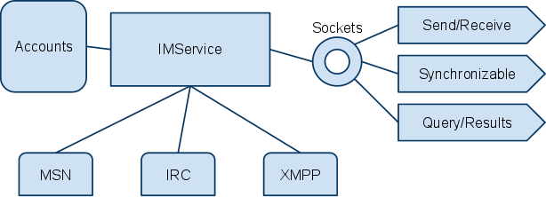
Sample structure of IM Framework

IMService is the central class. It utilizes the backends, eg. msn, irc, xmpp, which are all successors of IMClient. IMAccount is a helper class to manage the accounts. IMService provides the user(or say developers) with three interface classes, for sending/receiving, synchronizing, querying/getting results. The three interface classes are the only open part to the external world. All status, login/logout, error processing, communication channel selection are dealed by IMService itself.

Relationship between application and server

- Application uses services from server via the interface classes
- Interface classes communicate to server using local tcp sockets
- An application is usually bind to something, like a contact, a group of contact, or a service. Therefore the interface class will have a binding property.

Detailed class implementations

- IMService: consists of six components.
  - Account handler: to load/save/alter account information
  - Self raiser: to start the service, make sure only one instance is running, and launch according applications on request
  - Message handler: dispatch the messages, send them to the desired destination, handle replies and queries by their id
  - Interface socket server: to handle the communication between interface and the service using socket communication
  - Presence engine: summarize and maintain the presence information of all available backends
  - Resource management: to register/unregister resources, answer resource requests, send resource requests, etc.
- IMClient: base class for all the IM backends, each backend implements one instance.
- Interface classes: provide higher level for easy access to the service. They can be considered as a wrap of the services for conveniences.

Questions to consider

- When sending a message, there might be more than one available channels, how do we select the best one? Shall we bother user to choose, or choose automatically?
- The resources on each client, or say group varies. When the user request to connect to a group, how do we handle the resources? What to do if the resource is not available? Shall we suggest the other party to install the resource, or return an error?
- How do we maintain a big map of the resources available? How can we retrieve the resource information from each user? Shall we query it actively at start up, or wait until we need to use it?
- What’s the best way to handle errors and delivery failures?

Resource Management

- Resource is the atom item in the model
- Each party or group can have a set of resources
- The resources one have can be disclosed or not
- To disclose a resource, one can register to a resource list server to let others know. The server itself is a resource item too
- One can try knocking whether the other side has a resource type, or find it from the resource list server

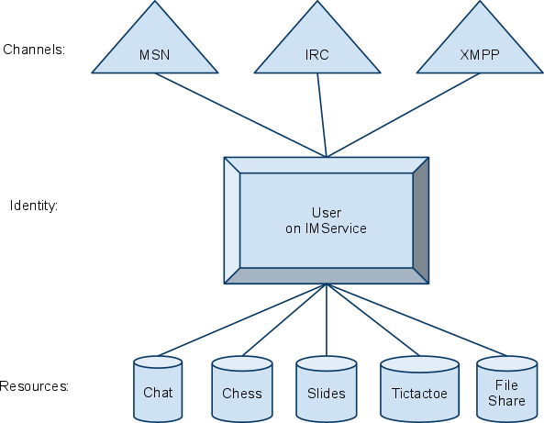

Typical conversations between...

- Service and resource
  - >> <register id=1>vrcats.com.chat</register> //register chat service
  - << <register id=1>ok</register> //reply: ok
  - >> <send id=2><to>a@vrcats.com/vrcats.com.chat, b@vrcats.com/vrcats.com.chat</to><msg>hello how are you</msg></send> //send message
  - << <send id=2>done</send> //reply: send ok
  - << <get id=3><from>a@vrcats.com/vrcats.com.chat</from> i am good, how are you today?</get> //got a message
Format: <index> <reply_to> <receiver> <message>
- Resource and user:

