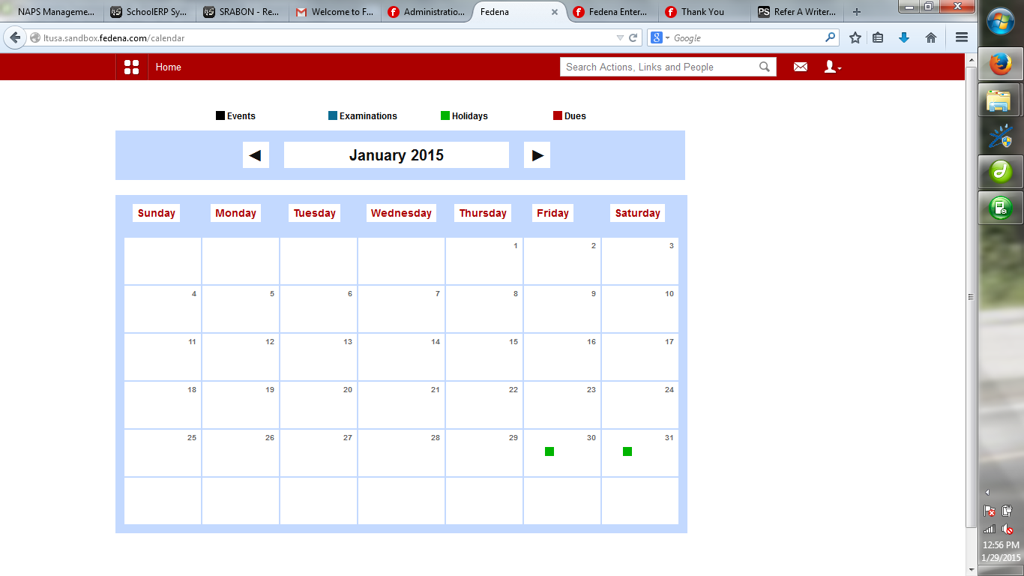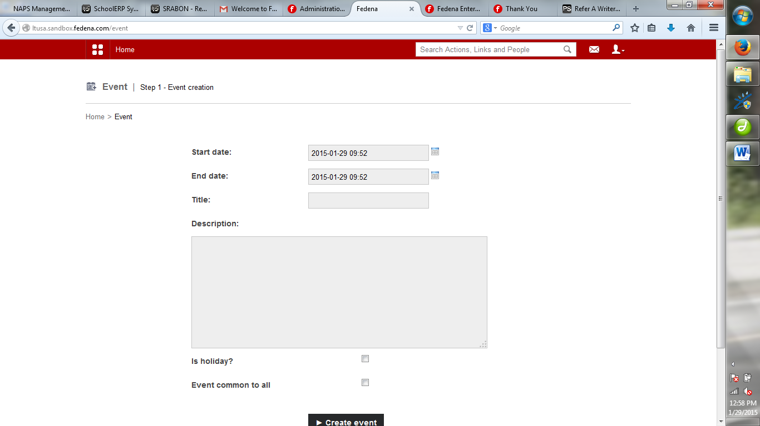

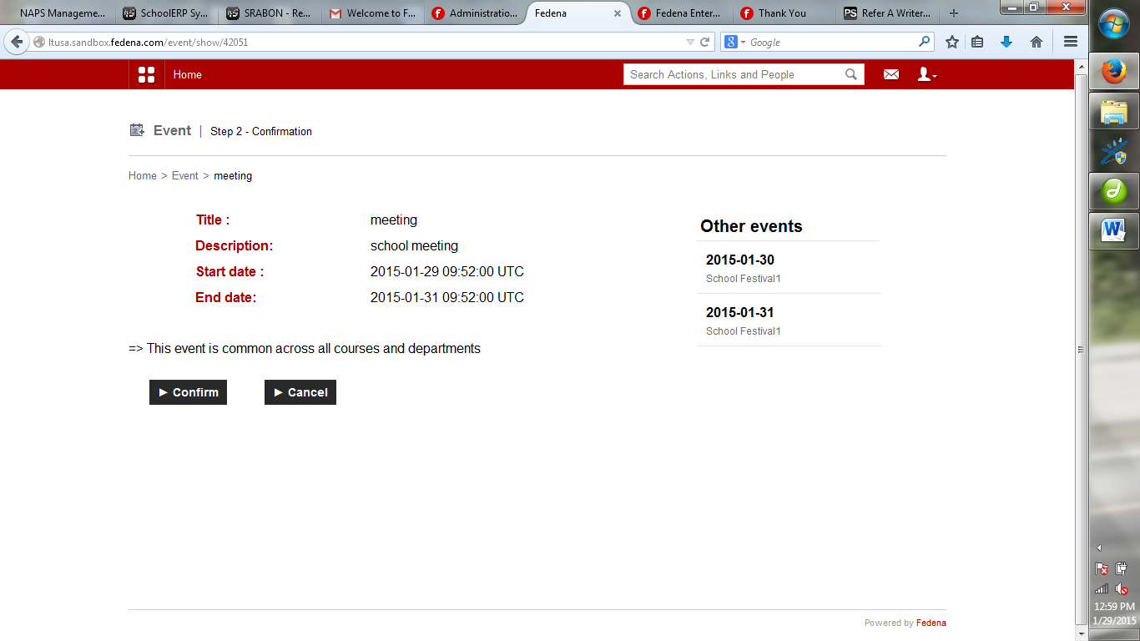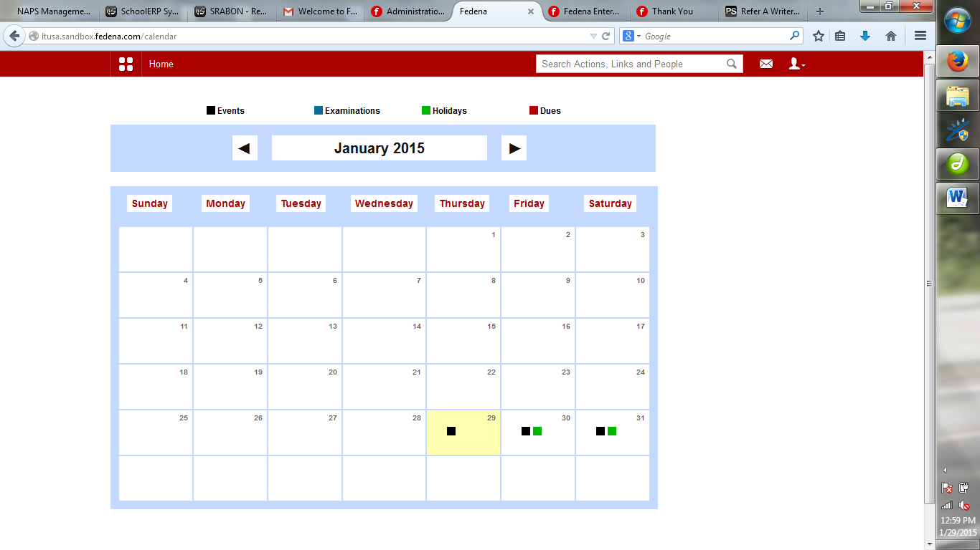

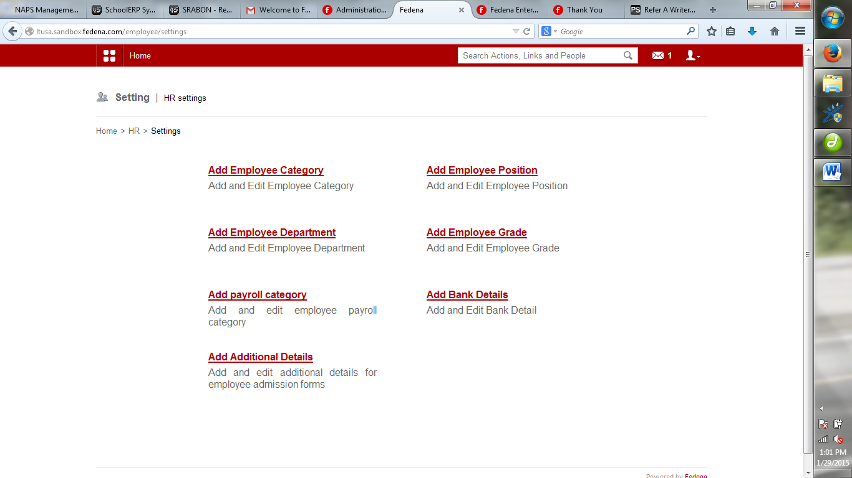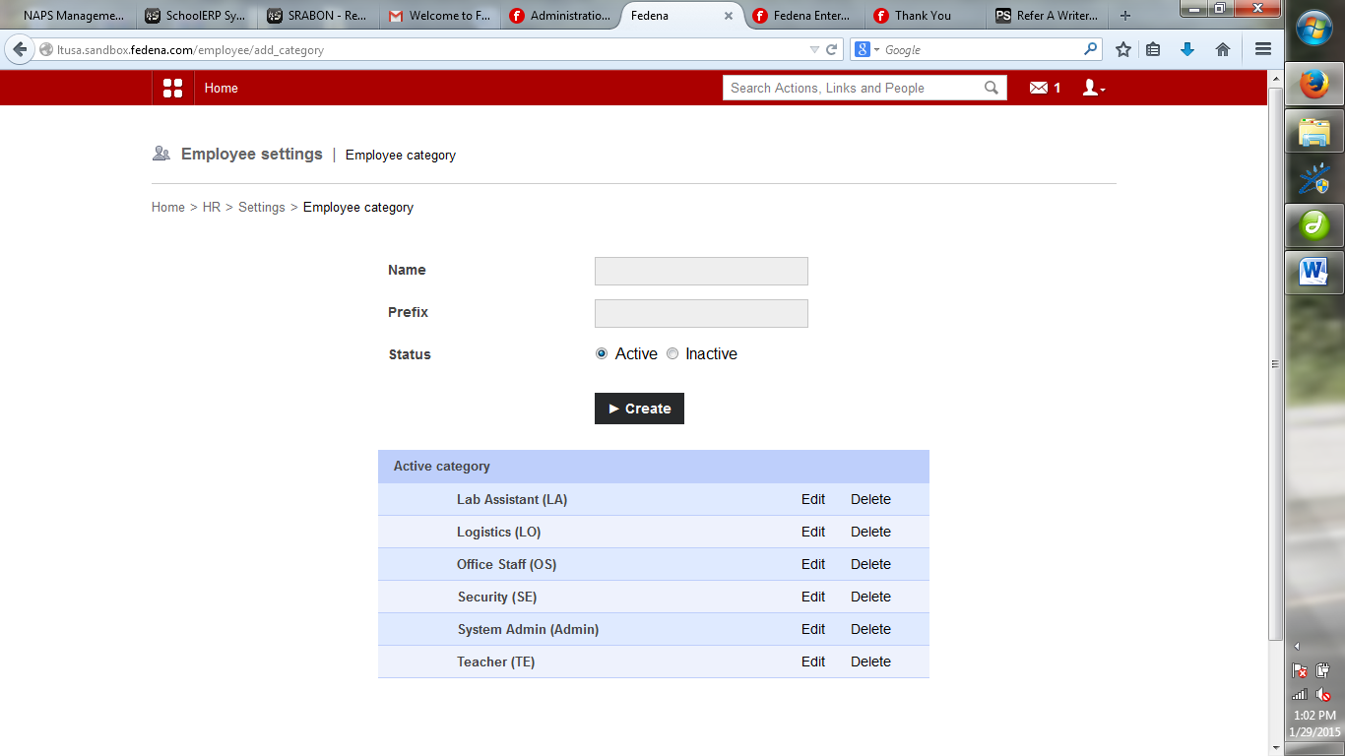

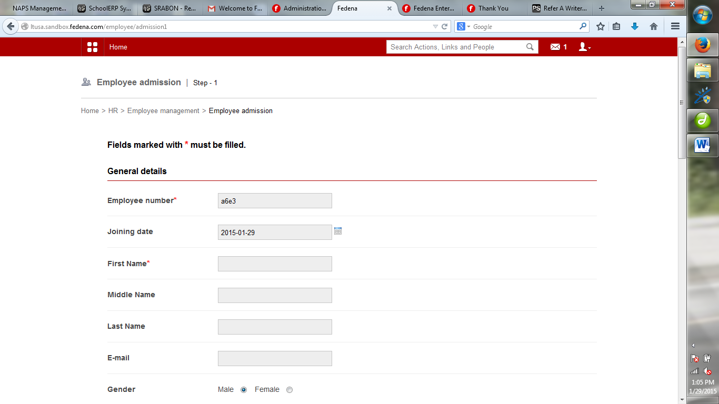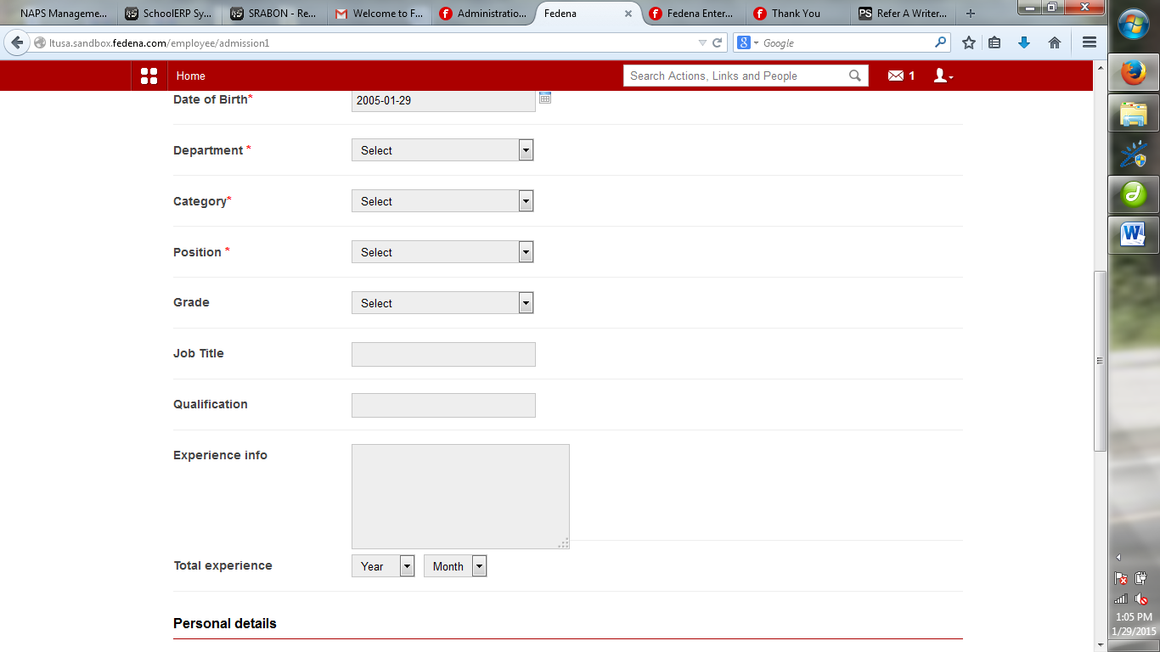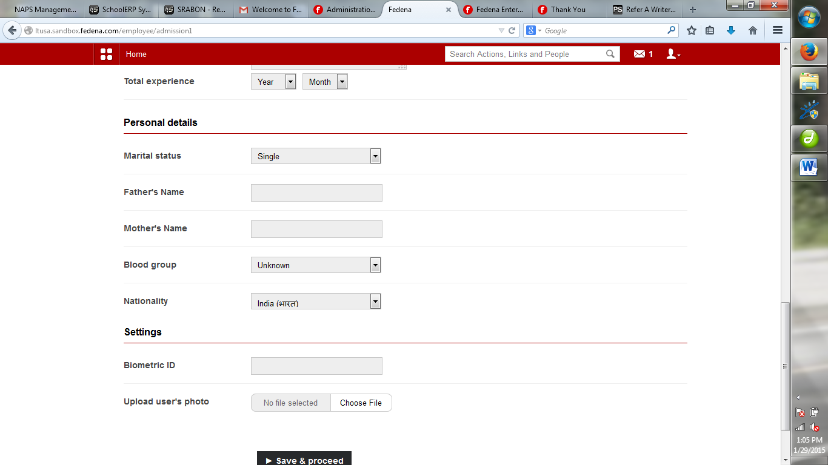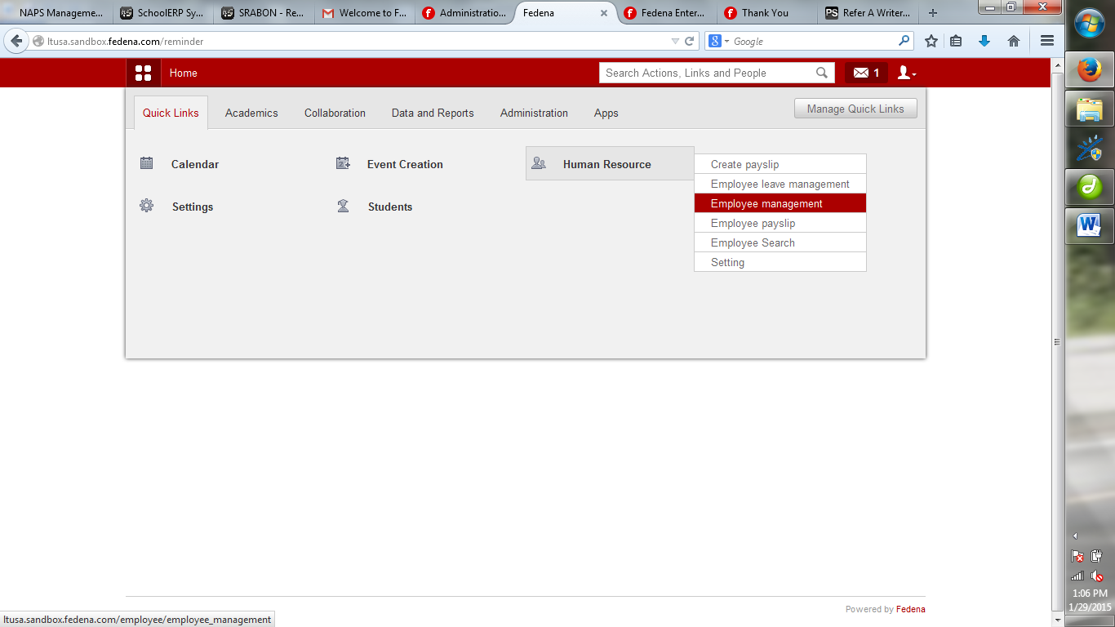

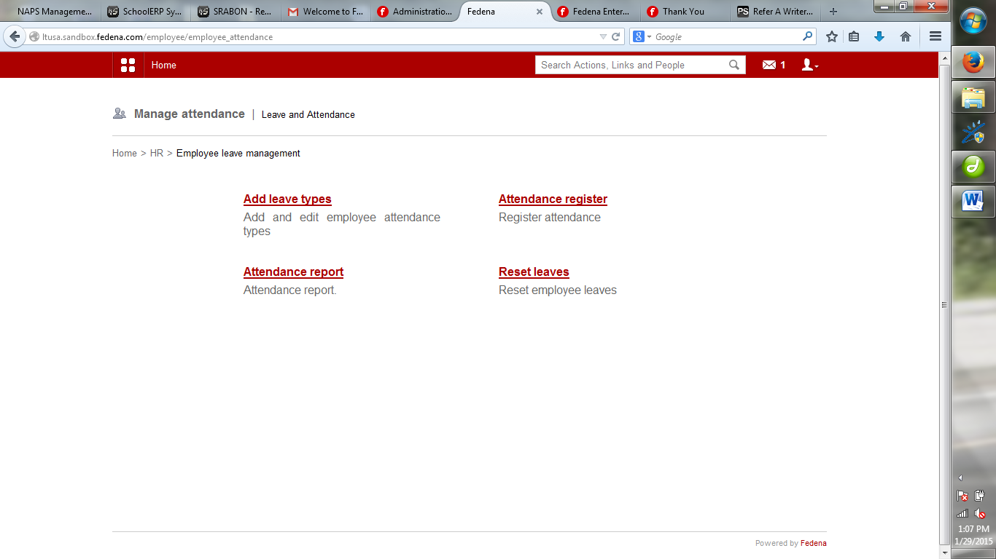

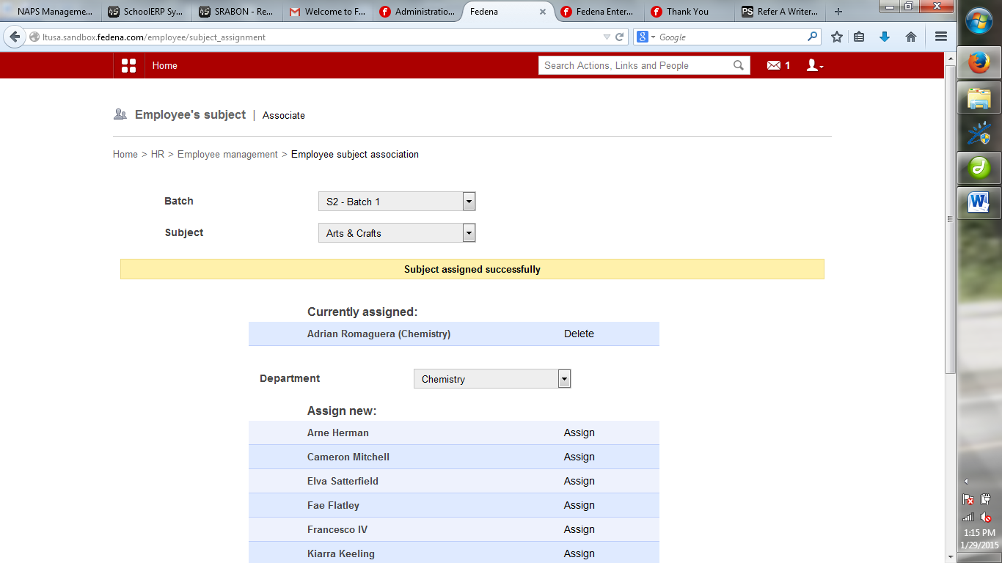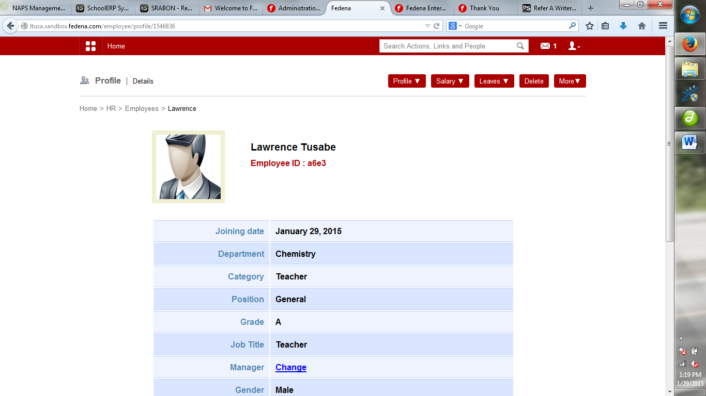

**Core Modules**

* Courses and Batches
* Human Resources
* Student Attendance
* Timetable
* Examination
* Multiple Dashboards
* Student Admission
* News Management
* User Management
* School/Event Calendar
* Finance
* Student Information
* [Employee/Teacher Login](http://www.fedena.com/pricing_and_plans)
* Student/Parent Login
* Messaging System
* SMS Alerts

**Premium Modules**

* Hostel/Dormitory
* Online Examination
* Library
* Transportation
* Poll
* Assignment
* Placement
* Task
* Discussion
* Instant Fee
* Data Management
* Mobile Version
* Blog
* Custom Import
* Custom Report
* Color Theme
* Gallery
* Inventory
* Disciplinary
* Registration
* Fee Import
* Email Integration
* Form Builder

**Integrations**

* Video Conference
* Google Apps
* Moodle
* Tally
* Payment Gateway