Causally Grounded Agentic Macro Intelligence
for Tactical Portfolio Allocation
Research Proposal

1. Motivation
Macroeconomic surprises can affect asset returns through different channels depending on the economic environment. For example, stronger growth may support equities through higher expected cash flows but also create valuation pressure through higher interest rates.
Traditional quantitative models capture average historical relationships, but these may weaken when transmission mechanisms change. LLMs can add context from policy communication, geopolitical events, and other unstructured information, but unconstrained narratives do not establish causality. The proposed framework therefore combines quantitative forecasting with causally structured retrieval and agent-based interpretation.
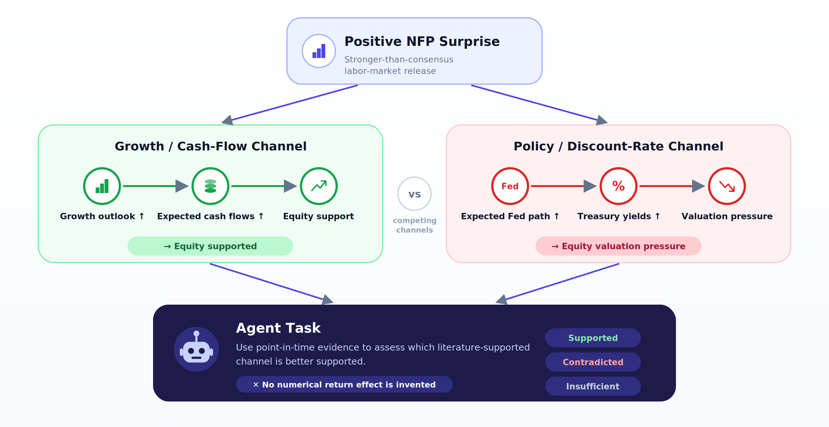

2. Research Design

Research Question
- Can causally structured agentic reasoning improve asset allocation by identifying which macroeconomic transmission mechanisms are active, beyond what is captured by a quant model?
- Does explicit causal structure improve performance beyond conventional RAG when the underlying information set is held constant?

Comparative Research Design
Model | Quant Model | RAG | Causal Graph | Multi-Agent
Quant Baseline | Yes | No | No | No
Quant + Vanilla Multi-Agent RAG | Yes | Yes | No | Yes
Quant + Causal Multi-Agent RAG | Yes | Yes | Yes | Yes

Investment Scope
Item | MVP
Macro Signals | Growth, Inflation, Policy, Financial Conditions (FC), Geopolitical Risk
Assets | U.S. Equity / Treasury / IG Credit
Target | Next 1M return (Monthly Rebalancing)

Data
The study uses point-in-time macroeconomic and market data covering Growth, Inflation, Policy, Financial Conditions, Geopolitical Risk, and asset returns for U.S. Equity, Treasuries, and IG Credit, primarily sourced from Bloomberg, with FRED and other sources. Scheduled macro releases are converted into standardized surprises using Actual − Pre-Release Consensus, allowing shocks across indicators to be compared on a common scale.

3. System Framework

Overall Architecture
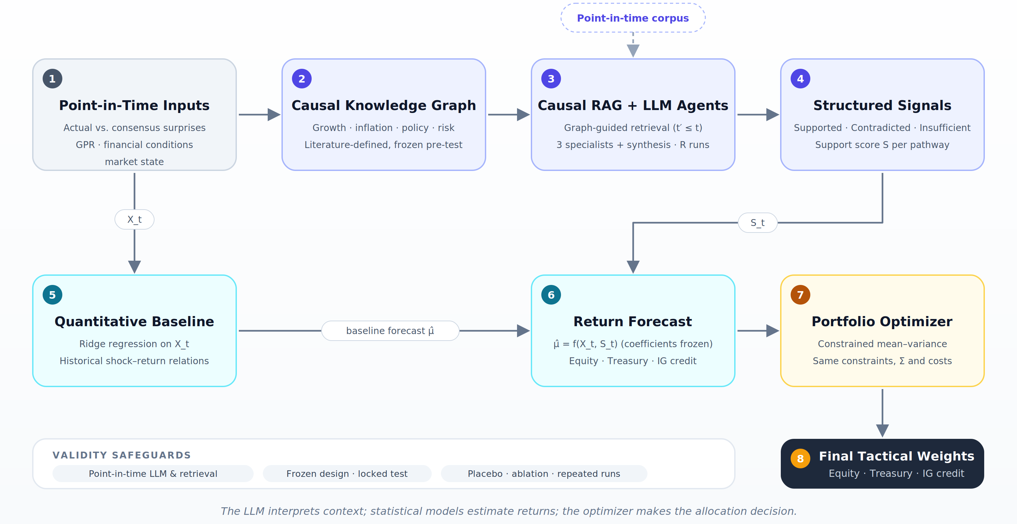

Quantitative Layer
The quantitative layer uses structured macro shocks and market variables to forecast one-month returns for assets. These forecasts are then passed into a common portfolio-allocation framework.

Agentic Layer
The agentic layer uses Causal RAG to retrieve point-in-time textual evidence along literature-based causal pathways. Specialized agents evaluate cash-flow, policy, and risk channels and classify each pathway as Supported, Contradicted, or Insufficient Evidence. To reduce LLM variability, each agent is run multiple times on the same evidence, and the repeated classifications are aggregated into structured signals that augment the quantitative model.
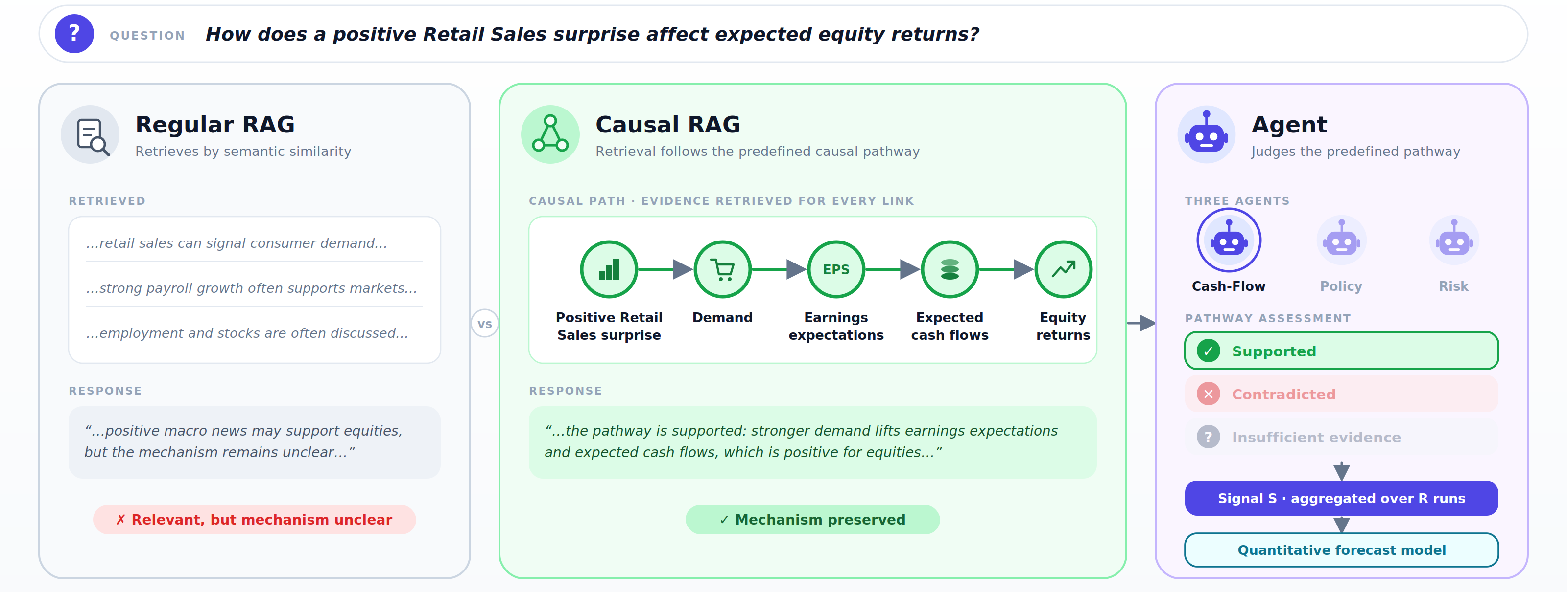

4. Evaluation Framework
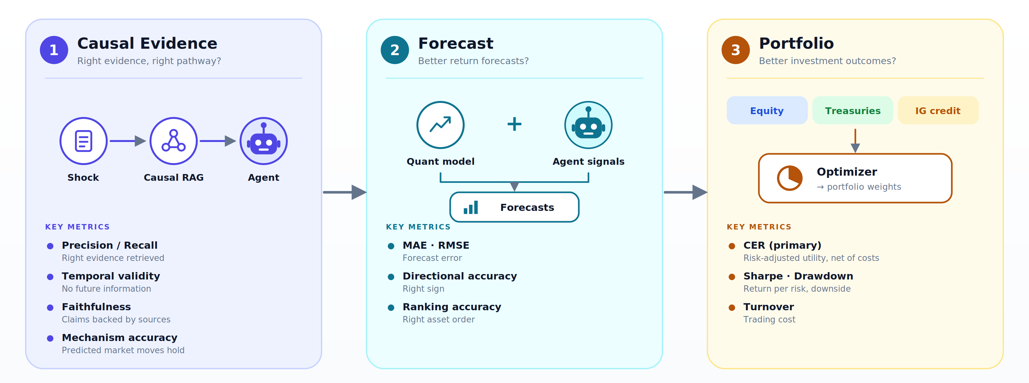
The framework is evaluated at three levels.
Causal evidence evaluation: Tests whether the system retrieves relevant, point-in-time, and faithful evidence for the predefined transmission pathways.
Forecast evaluation: Tests whether the agent-derived signals improve one-month return predictions. Portfolio evaluation Tests whether forecasts translate into better risk-adjusted portfolio outcomes.

5. Timeline & Milestones
Workstream / Activity | M1 | M2 | M3 | M4 | M5 | M6 | M7 | M8
Literature review | ■ | ■
Data Construction | ■ | ■
Quantitative baseline |  | ■
Causal graph |  | ■ | ■
RAG and agent prototype |  | ■ | ■ | ■
Model evaluation |  |  |  | ■ | ■ | ■
Portfolio backtest |  |  |  | ■ | ■ | ■
Validity check |  |  |  |  | ■ | ■ | ■
Final analysis |  |  |  |  |  | ■ | ■ | ■

