Causally Grounded Agentic Macro Intelligence
for Tactical Portfolio Allocation
Research Proposal

1. Motivation
Macroeconomic announcements contain information that can rapidly affect multiple asset classes. However, markets do not respond mechanically to whether an announcement is simply stronger or weaker than expected. Andersen, Bollerslev, Diebold, and Vega (2007) show that stock-market responses to U.S. macroeconomic news vary with the state of the economy, consistent with competing cash-flow and discount-rate effects. Monetary-policy announcements pose a similar problem: Gürkaynak, Sack, and Swanson (2005) show that a single policy-rate surprise is insufficient and distinguish a current-rate factor from a future-policy-path factor, with different implications for asset prices.
These findings motivate a portfolio problem rather than a simple directional market-prediction problem. Investors must determine not only whether a macroeconomic surprise is positive or negative, but how it propagates through growth, inflation, monetary policy, financial conditions, and risk premia before assessing the relative attractiveness of equities, Treasuries, and investment-grade credit.
Traditional quantitative models can estimate historical relationships between macroeconomic surprises and asset returns, but an average historical relationship may become unreliable when the economic transmission mechanism changes. LLMs offer a complementary capability because they can process central-bank communication, policy announcements, geopolitical developments, and other unstructured information. The challenge is that a plausible LLM narrative is not itself evidence of a causal mechanism.
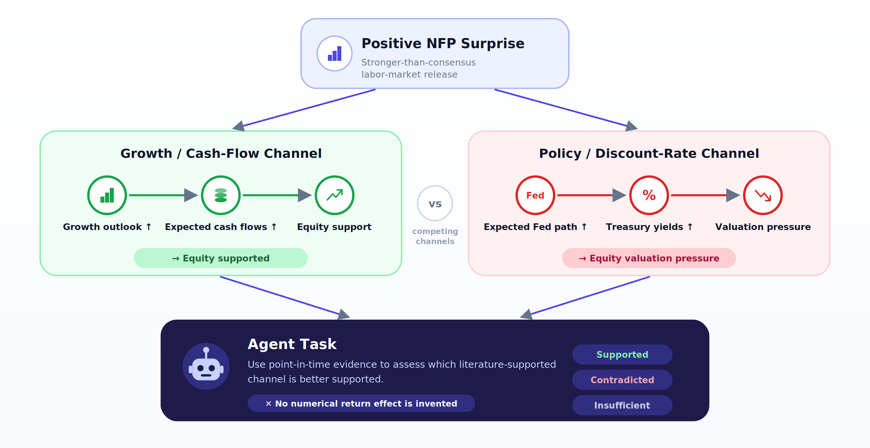
Figure 1. Why Causal Interpretation matters
The proposed design therefore separates interpretation from estimation and portfolio construction. Economic literature and the causal graph define plausible mechanisms; the agents assess which mechanisms are supported by current evidence; statistical models estimate return implications; and a common optimizer determines tactical portfolio weights.

2. Research Question and Hypotheses

2.1 Research Question
Can a causally constrained, point-in-time LLM agent improve tactical allocation across U.S. equities, U.S. Treasuries, and U.S. investment-grade credit by identifying which macroeconomic transmission mechanisms are active, beyond what is captured by a conventional quantitative model?
A secondary question asks whether explicit causal structure adds value beyond conventional retrieval-augmented generation (RAG) when the underlying information set is held constant.

2.2 Hypotheses

H1. Primary Portfolio Hypothesis
Adding causally grounded agent features to the quantitative model improves out-of-sample portfolio allocation relative to a fixed quantitative baseline. The primary portfolio endpoint is transaction-cost-adjusted certainty-equivalent return (CER). Sharpe ratio, maximum drawdown, annualized return, volatility, and turnover are secondary outcomes.
$$CER = μ_{p}- \left(\frac{λ}{2}\right)σ_{p}^{2}$$

H2. Transmission-Mechanism Hypothesis
Conditional on the same point-in-time information, the causally constrained system more accurately predicts the observable market implications of macroeconomic shocks than conventional RAG or placebo causal structures.

H3. Return-Forecast Hypothesis
Causal-agent features improve one-month out-of-sample cross-asset return forecasts and relative asset-ranking accuracy compared with both the quantitative baseline and a quantitative model augmented with conventional RAG. H1 is the primary confirmatory hypothesis; H2 and H3 provide mechanism evidence.

2.3 MVP Investment Scope
Item | MVP
Macro Signals | Growth, Inflation, Policy, Financial Conditions (FC), Geopolitical Risk
Assets | U.S. Equity / Treasury / IG Credit
Target | Next 1M return
Rebalancing | Monthly

3. System Framework

3.1 Overall Architecture
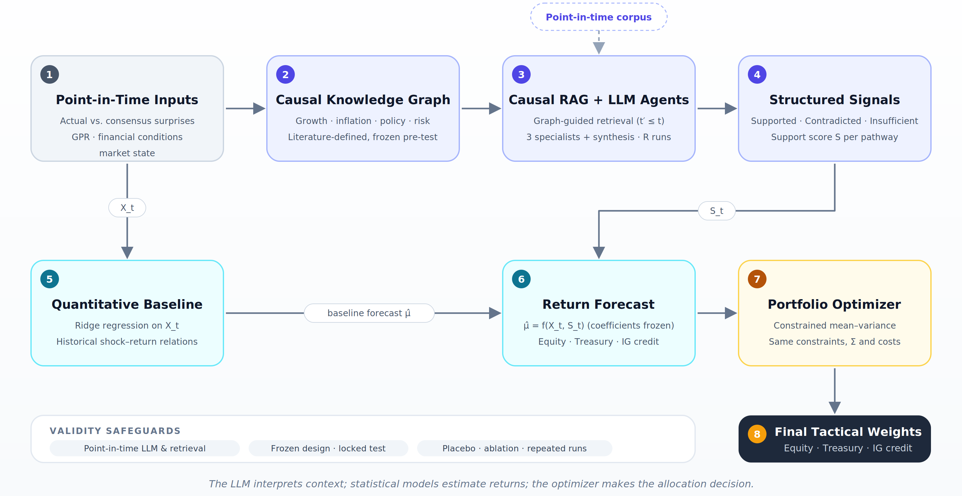
Figure 2. Overall research architecture
The framework combines a quantitative baseline with a causal-agent layer. The quantitative layer uses structured macroeconomic surprises to estimate baseline asset return relationships. In parallel, the causal-agent layer uses a literature-derived causal graph and point-in-time contextual evidence to identify which economic transmission mechanisms are currently supported. These structured agent signals are then added to the quantitative feature set, allowing the asset-specific forecasting models to estimate whether the same macroeconomic shock has different return implications under different causal contexts. The resulting expected returns are passed through a common constrained optimizer to determine tactical portfolio weights.

3.2 Quant Model

Quantitative Baseline
The quantitative baseline uses Growth and Inflation surprises, Policy expectations, Financial Conditions (FC), and Geopolitical Risk (GPR) to predict one-month returns for U.S. Equity, U.S. Treasury, and IG Credit. Ridge regression is used to handle correlated macro variables and a limited number of independent macroeconomic episodes.
The model also includes prespecified interaction terms to capture state-dependent shock transmission:
$$R_{\left\{a,t+1\right\}}=f\left(Growth_{t},Inflation_{t},Policy_{t},FC_{t},GPR_{t},MacroShock_{t}×FC_{t},MacroShock_{t}×GPR_{t}\right)$$
Here, the interaction terms test whether the same macroeconomic surprise has different return implications when financial conditions are tight/loose or geopolitical risk is high/low.

Local Projections
Local projections are used as an auxiliary diagnostic to examine how macroeconomic shocks propagate across assets over different horizons and whether those responses vary with financial conditions or geopolitical risk.
For asset $a$and horizon $h$:
$$R_{\left\{a,t+h\right\}}=α_{\left\{a,h\right\}}+β_{\left\{a,h\right\}Shock_{t}}+θ_{\left\{a,h\right\}State_{t}}+δ_{\left\{a,h\right\}\left(Shock_{t}×State_{t}\right)}+Γ_{\left\{a,h\right\}X_{t}}+ε_{\left\{a,t+h\right\}}$$
Local projection results are not directly fed into the portfolio optimizer; they are used to validate the economic transmission patterns underlying the forecasting frame

3.3 Agent Layer

Knowledge Base
The knowledge base is built in two stages:
Literature-Based Causal Graph: Established macroeconomic and asset-pricing literature is reviewed to identify plausible transmission relationships among macro shocks, growth, inflation, policy expectations, financial conditions, interest rates, credit spreads, cash flows, risk premia, and asset returns.
Point-in-Time Document Corpus: A separate corpus contains contemporaneous news, FOMC communications, Fed speeches, policy announcements, and market commentary, each stored with publication timestamps. At each event date, only documents available within the predefined information window can be retrieved.

Causal RAG & Agent Architecture
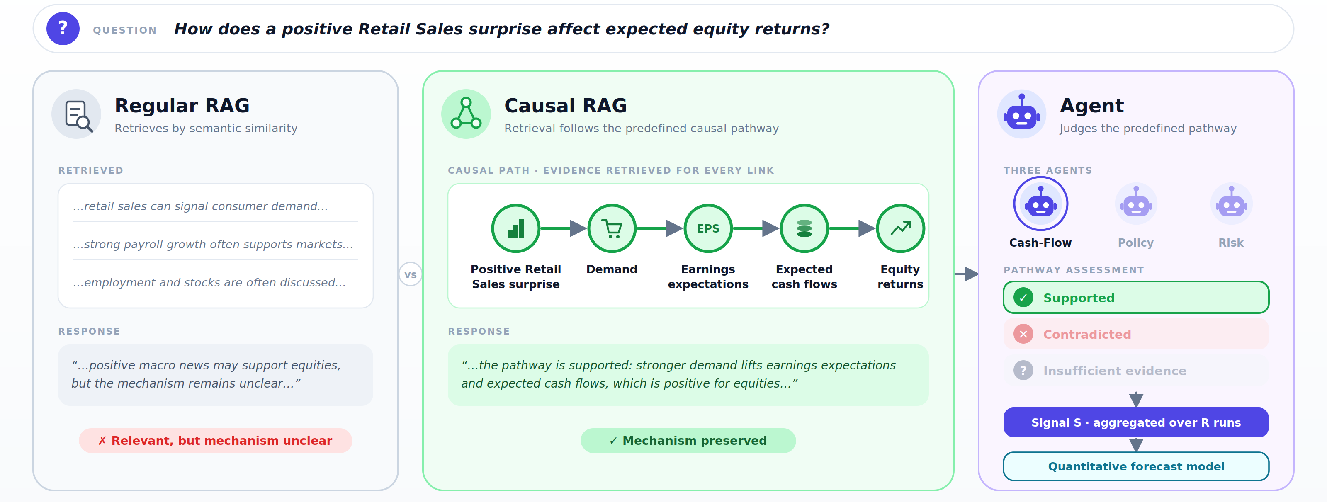
Figure 3. Agentic workflow architecture
Conventional RAG primarily retrieves text through semantic similarity. This can return topically relevant material without preserving the economic relationship needed for a decision. CausalRAG provides methodological motivation for using causal-graph structure to preserve cause-effect context and improve retrieval precision and interpretability (Wang et al., 2025).
In this project, retrieval is constrained by relevant macroeconomic pathways. For example,
Positive Retail Sales Surprise → Demand → Earnings Expectations → Expected Cash Flows → Equity Returns
When a positive growth surprise occurs, the system uses this pathway to determine what evidence to search for, such as changes in consumer demand, business activity, earnings expectations, and expected corporate cash flows.
The proposed system contains three specialized analytical agents:
Cash-Flow Agent: evaluates whether a growth surprise is transmitting through real activity, demand, earnings, and expected corporate cash flows.
Policy Agent: evaluates whether an inflation surprise is transmitting through inflation expectations, monetary-policy expectations, and interest rates.
Risk Agent: evaluates whether the current financial and geopolitical environment is amplifying or dampening the transmission of macroeconomic shocks through liquidity, credit conditions, risk aversion, credit spreads, and risk premia.
Each agent classifies its predefined pathway as Supported, Contradicted, or Insufficient Evidence based on point-in-time retrieved evidence. Repeated runs are then aggregated programmatically into structured pathway signals that are added to the quantitative forecasting model.

Handling LLM Stochasticity
Agent outputs may vary across repeated runs even under an identical information set. Bjarnason, Silva, and Monperrus (2026) document substantial single-run variability in agentic evaluations, motivating the use of repeated independent runs rather than relying on a single output.
For each event and pathway, the agent is run multiple times using the same retrieved evidence and prompt. Each run is classified as Supported, Contradicted, or Insufficient Evidence. These classifications are converted into a structured pathway signal:
$$S_{\left\{p,t\right\}}=\frac{N_{\left\{Supported\right\}}-N_{\left\{Contradicted\right\}}}{R}$$
where $R$ is the total number of repeated runs. Supported classifications contribute +1, Contradicted classifications contribute -1, and Insufficient Evidence contributes 0. The resulting signal ranges from -1 to 1.
Example. Suppose the Cash-Flow Agent is run 10 times for an NFP event and produces:
- Supported: 7
- Contradicted: 2
- Insufficient Evidence: 1
Then:
$$S_{\left\{CashFlow,t\right\}}=\frac{7-2}{10}=0.50$$
A value of 0.5 indicates that repeated agent evaluations lean toward supporting the Cash-Flow pathway. It should be interpreted as a consistency-based pathway signal, not as a probability that the pathway is true.
The number of repeated runs is selected during development based on output stability and fixed before the final evaluation.

Causal Interpretation to Return Forecasts
Structured pathway assessments augment the conventional feature set rather than replacing the quantitative model. If X(t) denotes conventional macro-financial variables and S(t) denotes structured agent outputs, the augmented model is:
$${ExpectedReturn}_{A\left(t+1\right)}=f_{A\left[X\left(t\right),S\left(t\right)\right]}$$
$${ExpectedReturn}_{A\left(t+1\right)}=f_{A\left[X\left(t\right),S\left(t\right),Shock\left(t\right)×S\left(t\right)\right]}$$
To test whether the same macro shock has different asset implications under different transmission contexts, prespecified Shock(t) x S(t) interaction terms are included where economically justified. The coefficients are estimated separately for equities, Treasuries, and investment-grade credit, allowing a common agent signal to map into different asset responses.
All coefficients translating agent signals into expected-return adjustments are estimated statistically using development data and frozen before the final evaluation.

3.4 Portfolio Allocation
The model-generated one-month return forecasts are incorporated into a Black–Litterman framework before portfolio optimization. Black–Litterman combines a market-implied prior with model-based views, allowing the portfolio to reflect forecast information while reducing sensitivity to extreme expected-return estimates.
The main inputs are:
Input | Implementation in This Study
π (Prior Returns) | Derived from prespecified benchmark weights and the asset covariance matrix
Q (Model Views) | One-month Ridge forecasts for Equity, Treasury, and IG Credit
Ω (View Uncertainty) | Estimated from historical out-of-sample forecast errors
Σ (Covariance Matrix) | Rolling covariance matrix for Equity, Treasury, and IG Credit
P (View Matrix) | Identity matrix because each asset receives its own expected-return forecast

The Quant Baseline and Quant + Causal Agent models each generate their own expected-return vector $Q$, while the Black–Litterman specification is held constant across both systems.
The resulting Black–Litterman posterior expected returns are then passed into the same constrained optimizer with long-only weights, prespecified allocation limits, and consistent transaction-cost assumptions.

4. Comparative Research Design
The empirical comparison uses identical decision dates, asset universes, portfolio constraints, and evaluation windows across all systems. The models differ only in the information-processing architecture upstream of the optimizer.
Model | Quant Model | RAG | Causal Graph | Multi-Agent
Quant Baseline | Yes | No | No | No
Quant + Vanilla Multi-Agent RAG | Yes | Yes | No | Yes
Quant + Causal Multi-Agent RAG | Yes | Yes | Yes | Yes
The comparison is sequential. Quant Baseline versus Vanilla Multi-Agent RAG measures the value of incorporating unstructured information and agent-based reasoning. Vanilla Multi-Agent RAG versus Causal Multi-Agent RAG isolates the incremental value of explicitly structuring retrieval and reasoning around predefined causal transmission mechanisms.

Together, the three systems test whether agentic RAG adds value beyond the quantitative baseline and whether causal structure further improves decision quality.

5. Evaluation Framework
Final portfolio performance alone cannot establish why a model works. The system is therefore evaluated at the interfaces between stages.

5.1 Point-in-Time Data Integrity
A manually audited sample verifies first-release economic data, pre-release consensus values, market-data availability, and document timestamps to ensure that no future information enters the system.
Metric | Meaning
Timing Accuracy | Whether each input was available before the portfolio decision date
Vintage Accuracy | Whether first-release macro data are used instead of revised values
Consensus Validity | Whether the consensus was the final pre-release expectation
Timestamp Validity | Whether retrieved documents fall within the allowed information window

5.2 Retrieval Quality
Retrieval is evaluated separately from generation to verify that Causal RAG retrieves relevant, point-in-time evidence for each predefined pathway. RAGAS provides a useful framework for separating retrieval relevance from answer faithfulness (Es et al., 2024).
Metric | Meaning
Context Precision | How much of the retrieved evidence is relevant to the causal pathway
Context Recall | Whether important evidence was successfully retrieved
Temporal Validity | Whether retrieved evidence was available at the event or decision date
Evidence Faithfulness | Whether the agent’s claims are supported by the retrieved documents

5.3 Return Forecasting
The Quant Baseline and Quant + Causal Agent models are evaluated at both the mechanism level and the asset-return level. At the mechanism level, the agent’s pathway assessment is tested against observable intermediate market responses. At the return level, the models are compared on their ability to predict one-month returns for Equity, Treasury, and IG Credit.
Metric | Meaning
MAE | Average absolute difference between predicted and realized asset returns
RMSE | Forecast-error measure that gives more weight to large mistakes
Directional Accuracy | How often the model correctly predicts positive vs. negative returns

5.4 Portfolio Outcomes
The final test evaluates whether improved forecasts translate into better portfolio performance relative to the locked Quant Baseline under the same portfolio-construction framework.
Metric | Meaning
CER | Measures portfolio value after penalizing return volatility
Sharpe Ratio | Return earned relative to portfolio volatility
Maximum Drawdown | Largest peak-to-trough portfolio loss
Annualized Return | Portfolio return expressed on an annual basis
Volatility | Variability of portfolio returns
Turnover | How much portfolio weights change across rebalancing dates
Transaction-Cost-Adjusted Return | Portfolio return after accounting for trading costs

6. Validity Check

6.1 Ablation and Falsification Tests
The study includes falsification tests to assess whether observed performance gains genuinely arise from causal structure and contemporaneous information rather than arbitrary model complexity.
Wrong-graph placebo: Replace the economic causal graph with a permuted or economically incorrect graph of similar complexity. If causal structure contributes meaningful information, performance should deteriorate.
Shuffled-context placebo: Pair each event with point-in-time textual context from a different historical event. If contemporaneous context matters, predictive performance should weaken.
Random-intervention placebo: Replace agent outputs with randomized decisions at a similar intervention frequency. This tests whether gains could arise from arbitrary portfolio adjustments.
Ablation tests compare Quant Baseline, Vanilla Multi-Agent RAG, and Causal Multi-Agent RAG. Quant Baseline versus Vanilla Multi-Agent RAG measures the value of incorporating unstructured information and agent-based reasoning, while Vanilla Multi-Agent RAG versus Causal Multi-Agent RAG isolates the incremental value of explicit causal structure.

6.2 Controlling Look-Ahead Bias
Temporal leakage is a central threat to validity. Restricting RAG to documents published before each decision date prevents retrieval leakage, but it does not eliminate future information that may already be embedded in modern LLM parameters. Levy (2026) documents substantial look-ahead-bias concerns when commercial LLMs are used for historical financial prediction. Therefore, instructing a modern model to “pretend it is 2017” is not treated as a sufficient leakage control.
The preferred historical evaluation uses point-in-time language models together with point-in-time retrieval and market data. Kelly, Malamud, Schwab, and Xu (2026), for example, construct monthly model checkpoints spanning 2013–2024 using chronologically filtered training data specifically to eliminate look-ahead bias by construction.
If a modern commercial model is used for historical periods that may overlap with its training information, those results are classified as exploratory rather than clean evidence of forecasting ability. A prospective shadow-portfolio test after the architecture is frozen provides an additional validation because future realized outcomes could not have been observed at prediction time.

6.3 Preventing Backtest Overfitting
Prompts, causal graphs, agent roles, retrieval settings, trigger rules, stochastic-run counts, portfolio constraints, and evaluation metrics create substantial researcher degrees of freedom. Repeatedly changing these choices after observing historical performance can produce an apparently strong strategy even when no genuine signal exists. Bailey et al. (2015) formalize this problem as the probability of backtest overfitting.

The study therefore separates the historical sample into Development, Validation, and Locked Test periods. During development, prompts, causal graphs, agent roles, retrieval settings, and model parameters may be modified. The final specification is selected during validation. Before the locked test is opened, the architecture, prompts, causal graph, retrieval logic, portfolio constraints, transaction-cost assumptions, primary hypothesis, primary outcome, and planned robustness tests are frozen.
Material development configurations are retained in an experiment registry rather than selectively discarded. This preserves visibility into the number of specifications explored and reduces selective reporting.
The Deflated Sharpe Ratio is reported as a supplementary diagnostic because it adjusts the interpretation of Sharpe ratios for multiple testing, strategy selection, and non-normal returns (Bailey & López de Prado, 2014).

6.4 Statistical Power and Multiple Testing
The effective number of independent observations is smaller than the raw number of market observations. Monthly returns may exhibit serial dependence, and returns across Equity, Treasury, and IG Credit are correlated. Dividing the sample across multiple macro shocks, market regimes, or forecast horizons further reduces statistical power.
The study therefore specifies one primary confirmatory hypothesis and one primary economic outcome before the locked test is evaluated. Regime-specific results, individual shock categories, alternative asset-level outcomes, and three-month forecast horizons are treated as secondary or exploratory unless sufficient power exists for prespecified inference.
Before opening the locked test, a simulation-based power analysis estimates the minimum detectable improvement given the available sample length, return volatility, serial dependence, cross-asset correlation, and intervention frequency. This establishes the size of performance improvement the study is realistically capable of detecting rather than interpreting every observed difference as evidence of superior performance.
Formal secondary hypothesis tests are adjusted for multiplicity where appropriate.

7. Data

7.1 Data Collection
Use only information available at the portfolio decision date.
Group | Series | Definition | Source
Growth | NFP (Nonfarm Payrolls) | Monthly change in U.S. nonfarm employment | Bloomberg (ECO /BLS / Census / Fed / ISM)
 | Retail Sales | Monthly retail spending; proxy for consumer demand | Bloomberg (ECO /BLS / Census / Fed / ISM)
 | Industrial Production | Output of factories, mines, and utilities; production activity | Bloomberg (ECO /BLS / Census / Fed / ISM)
 | ISM Manufacturing | Survey-based manufacturing activity indicator | Bloomberg (ECO /BLS / Census / Fed / ISM)
Inflation | CPI / Core CPI | Consumer price inflation; headline and excluding food & energy | Bloomberg (ECO/ BLS)
 | PPI | Producer price inflation; upstream price pressure | Bloomberg (ECO/ BLS)
 | Average Hourly Earnings | Average hourly wage growth; wage-related inflation pressure | Bloomberg (ECO/ BLS)
Policy | SOFR / Fed Funds Futures | Market-implied expectations for the future Federal Reserve policy path | Bloomberg
Financial Conditions | ANFCI | Adjusted National Financial Conditions Index; measures whether financial conditions are relatively loose or tight | Chicago Fed / FRED
Geopolitical Risk | GPR Index | News-based measure of geopolitical tensions, threats, and adverse geopolitical events | Federal Reserve
Assets | U.S. Equity | Equity market total return | Bloomberg
 | U.S. Treasury | Treasury total return | Bloomberg
 | IG Credit | Investment Grade Credit total return | Bloomberg

7.2 Macro Shock Construction
For scheduled macroeconomic releases, the primary shock measure is the difference between the first-released actual value and the market consensus available immediately before the release:
Because indicators are reported in different units, shocks are standardized using their historical surprise distribution:
$${Shock}_{\left\{i,t\right\}}= {Actual}_{\left\{i,t\right\}}- {Consensus}_{\left\{i,t\right\}}$$
where σᵢ is the historical standard deviation of forecast errors for indicator i.
$$Standardized {Shock}_{i,t}=\frac{{Actual}_{i,t}- {Consensus}_{i,t}}{σ_{i}}$$

This produces comparable shock measures across indicators. For example, a payroll surprise and a CPI surprise can both be expressed in standard-deviation units even though their original measurement scales differ. The direction of each shock is normalized so that a positive value has a consistent economic interpretation within each macro category.

References
Andersen, T. G., Bollerslev, T., Diebold, F. X., & Vega, C. (2007). Real-time price discovery in global stock, bond and foreign exchange markets. Journal of International Economics, 73(2), 251-277. https://doi.org/10.1016/j.jinteco.2007.02.004
Bailey, D. H., Borwein, J. M., López de Prado, M., & Zhu, Q. J. (2015). The probability of backtest overfitting. Journal of Computational Finance.
Bailey, D. H., & López de Prado, M. (2014). The deflated Sharpe ratio: Correcting for selection bias, backtest overfitting and non-normality. Journal of Portfolio Management, 40(5), 94-107.
Bjarnason, B. H., Silva, A., & Monperrus, M. (2026). On Randomness in Agentic Evals. arXiv:2602.07150.
Caldara, D., & Iacoviello, M. (2022). Measuring geopolitical risk. American Economic Review, 112(4), 1194-1225. https://doi.org/10.1257/aer.20191823
Es, S., James, J., Espinosa Anke, L., & Schockaert, S. (2024). RAGAs: Automated Evaluation of Retrieval Augmented Generation. Proceedings of EACL 2024: System Demonstrations, 150-158. https://doi.org/10.18653/v1/2024.eacl-demo.16
Gürkaynak, R. S., Sack, B., & Swanson, E. T. (2005). Do actions speak louder than words? The response of asset prices to monetary policy actions and statements. International Journal of Central Banking, 1(1).
Jordà, Ò. (2005). Estimation and inference of impulse responses by local projections. American Economic Review, 95(1), 161-182. https://doi.org/10.1257/0002828053828518
Kelly, B. T., Malamud, S., Schwab, J., & Xu, T. A. (2026). Scaling Point-in-Time Language Models. NBER Working Paper No. 35247. https://doi.org/10.3386/w35247
Levy, B. (2026). Caution Ahead: Numerical Reasoning and Look-Ahead Bias in AI Models. Journal of Accounting Research, 64(3), 1139-1188. https://doi.org/10.1111/1475-679x.70058
Wang, N., Han, X., Singh, J., Ma, J., & Chaudhary, V. (2025). CausalRAG: Integrating Causal Graphs into Retrieval-Augmented Generation. Findings of ACL 2025, 22680-22693. https://doi.org/10.18653/v1/2025.findings-acl.1165

