Go Mike! Designs

This is the first report from Lighthouse:

I give every images a class in the HTML file and in the CSS give them Height and Width. After I convert every images to webp format.

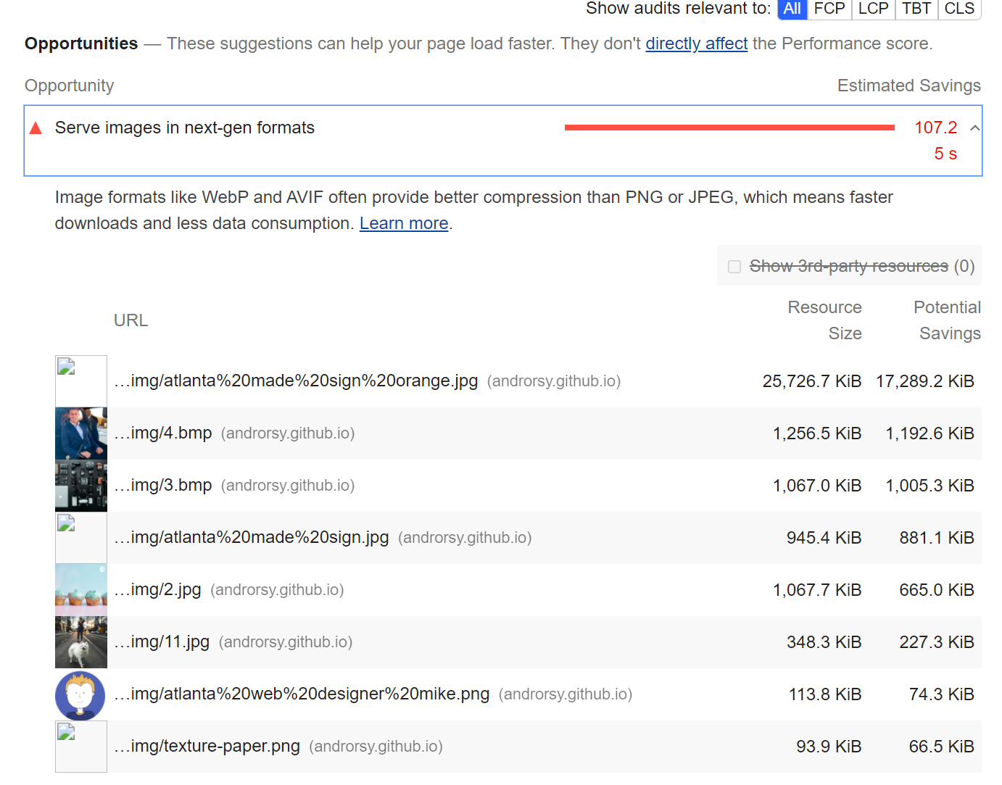
Before:

