SIMATS ENGINEERING
ASSESSMENT TOOL 3

COURSE NAME: INTERNET PROGRAMMING
COURSE CODE: CSA43

COURSE OUTCOME COVERED

CO-2 : Apply CSS layout and styling techniques to create visually appealing and responsive web interfaces, and use JavaScript to enable interactive client-side behavior. (L3)

Assessment Tool : Short Answer Test

Weightage: 10%

QUESTIONS: Total Marks: 50

Code of Conduct:

I I.ANDROW EDISSON(192511136) certify that this submission is my original work and that I have adhered to the guidelines specified for this assessment. I understand that any violation of academic integrity rules will result in disciplinary action.

Signature of the student:
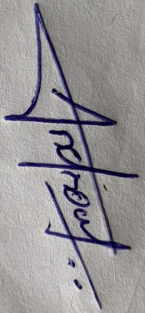

Question 1 (5 marks): Responsive Web Design

Concept and importance
Responsive web design (RWD) is an approach in which one website adjusts its layout, images and text to the size and capability of the device viewing it. It is built on three ideas: fluid grids (widths in percentages or flexible units), flexible images (images that shrink with their container) and media queries (CSS rules that apply only at certain screen sizes).
Reason | Importance for the company
Many devices | Visitors use phones, tablets, laptops and large monitors; one site must suit them all
Better user experience | No pinching, zooming or sideways scrolling, so users stay longer and buy more
Search engine ranking | Search engines prefer mobile-friendly sites
Lower cost | One code base and one URL instead of separate mobile and desktop sites
Future-proof | New screen sizes work without redesign

Key CSS techniques for responsiveness
Technique | Example | Purpose
Viewport meta tag | <meta name='viewport' content='width=device-width, initial-scale=1'> | Makes the page use the device width
Relative units | %, rem, em, vw, fr | Sizes scale with the screen or font
Flexible images | img { max-width:100%; height:auto; } | Images never overflow
Media queries | @media (min-width:768px) { ... } | Change layout at breakpoints
Flexbox | display:flex; flex-wrap:wrap; | Rows that wrap on small screens
CSS Grid | grid-template-columns:repeat(auto-fit,minmax(220px,1fr)) | Columns adjust automatically

Using Flexbox or Grid for adaptive layouts, with a simple example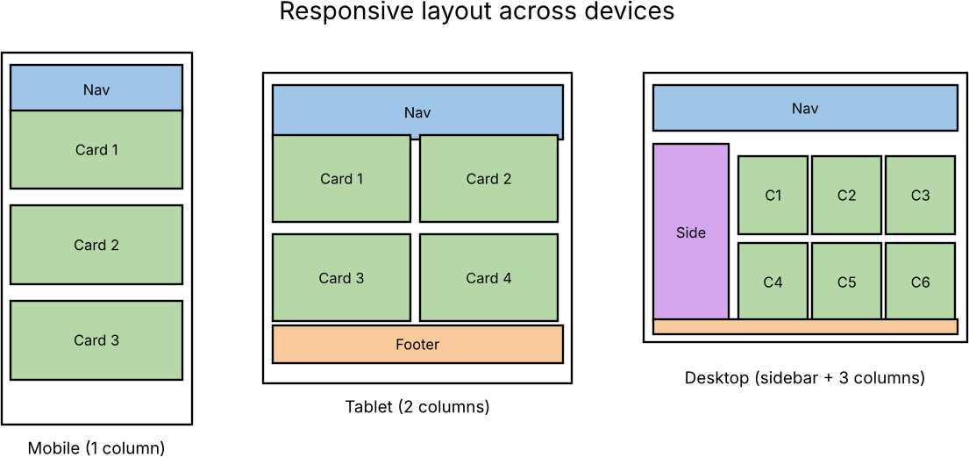
<meta name="viewport" content="width=device-width, initial-scale=1">
<header>Logo and menu</header>
<main class="cards">
<div class="card">1</div><div class="card">2</div><div class="card">3</div><div class="card">4</div>
</main>

.cards { display:grid; gap:16px; grid-template-columns:1fr; } /* mobile: 1 column */ @media (min-width:600px) { .cards { grid-template-columns:repeat(2,1fr); } } /* tablet: 2 columns */ @media (min-width:1024px) { .cards { grid-template-columns:repeat(4,1fr); } } /* desktop: 4 columns */ img { max-width:100%; height:auto; }
/* Flexbox alternative */
.row { display:flex; flex-wrap:wrap; gap:16px; } .row > div { flex:1 1 220px; }

Figure A3-1.1: The same page on mobile, tablet and desktop
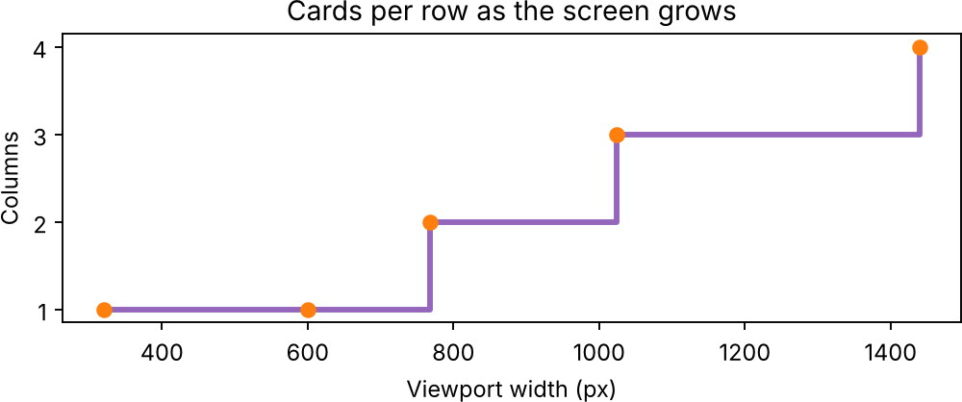

Figure A3-1.2: Number of columns used at each screen widthSS

Improvements for a better experience on all devices
- Use larger touch targets (44 px), readable font sizes and enough spacing on phones.
- Serve smaller images with srcset and loading='lazy' to save data on mobile networks.
- Simplify the mobile menu, keep key actions visible, and test on real devices and different browsers.

Question 2 (5 marks): Client-Side Validation
Concept and purpose. Client-side validation means the browser checks the data typed into a form before it is sent to the server. Its purposes are to give instant feedback, save server requests and help users correct mistakes. It is for convenience only; the server must validate again because users can bypass the browser.

Event handling and regular expressions
Event | Use in validation
submit | Runs all checks; event.preventDefault() stops the form if any field is invalid
input | Checks the field while the user types (live feedback)
blur | Checks the field when the user leaves it
change | Checks selects, checkboxes and files
A regular expression (regex) is a pattern that describes valid text. JavaScript tests it with pattern.test(value). It is used for email addresses, phone numbers, passwords, PIN codes and similar fixed formats.

Field | Regex | Valid example | Invalid example
Email | ^[^\s@]+@[^\s@]+\.[^\s@]+$ | user@mail.com | user@mail
Phone (India) | ^[6-9]\d{9}$ | 9876543210 | 12345
Password (8+, letter and digit) | ^(?=.*[A-Za-z])(?=.*\d).{8,}$ | abc12345 | abcdefgh
PIN code | ^\d{6}$ | 602105 | 60210

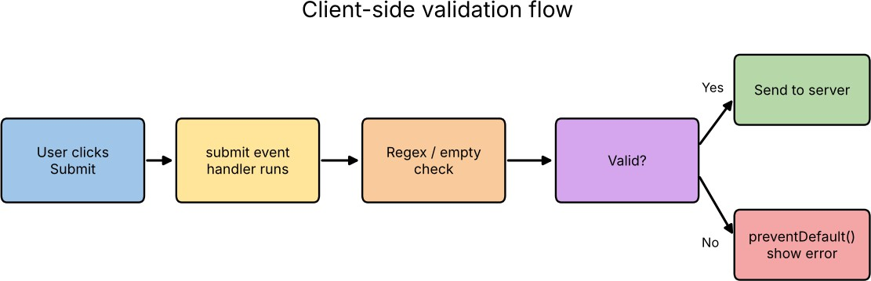
Example
<form id="reg" novalidate>
<input id="email" placeholder="Email"> <span class="err" id="e1"></span>
<input id="phone" placeholder="Phone"> <span class="err" id="e2"></span>
<button>Submit</button>
</form>
const emailRx = /^[^\s@]+@[^\s@]+\.[^\s@]+$/, phoneRx = /^[6-9]\d{9}$/; const form = document.getElementById('reg');

function check(input, rx, msgEl, msg) { const ok = rx.test(input.value.trim()); msgEl.textContent = ok ? '' : msg; return ok;
}
form.addEventListener('submit', e => {
const a = check(form.email, emailRx, e1, 'Enter a valid email');
const b = check(form.phone, phoneRx, e2, 'Enter a 10-digit mobile number'); if (!(a && b)) e.preventDefault(); // block submission
});
form.email.addEventListener('input', () => check(form.email, emailRx, e1, 'Enter a valid email'));

Figure A3-2: Client-side validation flow

Improvements for usability and security
Usability | Security
Show the message next to the field and keep what the user typed | Always validate again on the server
Validate live with input and blur events | Escape or sanitise output to prevent XSS
Use HTML5 attributes: required, type='email', pattern | Use HTTPS and CSRF tokens for form posts
Give examples of the expected format | Do not reveal sensitive details in error messages

Question 3 (5 marks): Box Model, Positioning and Layout Breaking

The CSS box model
Every HTML element is a rectangular box made of four layers from inside to outside: content (text or image), padding (space inside the border), border (line around the padding) and margin (space outside, separating elements). With the default content-box, the real width is width + padding + border; with box-sizing:border-box the width includes padding and border, which makes layouts predictable.
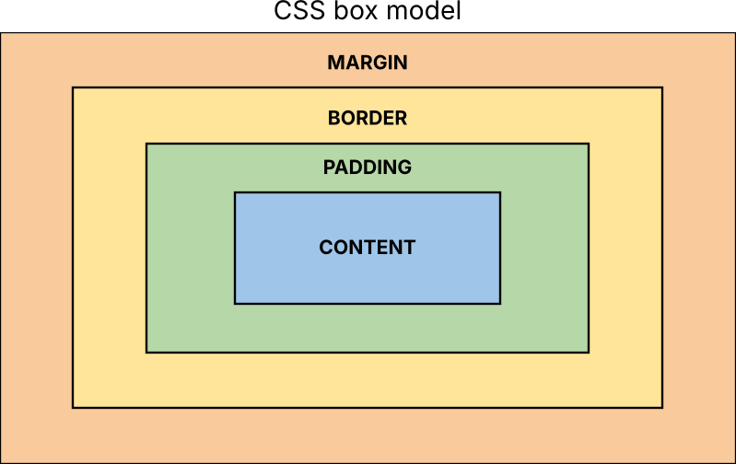
Figure A3-3.1: CSS box model

Layer | Property | Example
Content | width, height | width:300px;
Padding | padding | padding:16px;
Border | border | border:2px solid #333;
Margin | margin | margin:20px auto;

CSS positioning and its effect on layout
Value | Behaviour | Effect on layout structure
static | Default, normal document flow | Elements follow each other; safest for layouts
relative | Offset from its own normal position; space is kept | Used as reference for absolute children
absolute | Removed from flow; placed against nearest positioned ancestor | Other elements move up; may overlap content
fixed | Fixed to the browser window | Stays during scroll; covers content if no space is reserved
sticky | Normal flow until a scroll point, then sticks | Good for headers and table headings

Possible causes of layout breaking and how media queries solve them
Cause | Fix
Fixed pixel widths larger than the screen | Use %, rem, max-width and fr units
Missing viewport meta tag | Add width=device-width
Main content positioned with absolute or float | Use Flexbox or Grid
Padding and border added to the width | box-sizing:border-box
Large images, long words or tables | max-width:100%; overflow-wrap:anywhere; overflow-x:auto
Same layout used for all screens | Media queries change columns, hide extras and resize text
*, *::before, *::after { box-sizing:border-box; }
.wrapper { width:90%; max-width:1100px; margin:0 auto; }
.main { float:left; width:70%; } .side { float:left; width:30%; }
@media (max-width:700px) { .main, .side { float:none; width:100%; } .side { display:none; } }
Best practices: design mobile-first, use relative units and Flexbox/Grid, set box-sizing globally, avoid absolute positioning for page layout, and test by resizing the window and on real devices.

Question 4 (5 marks): DOM and Dynamic Content Updates
Document Object Model (DOM). When a browser loads an HTML page it builds a tree of objects called the DOM. Each tag, attribute and piece of text becomes a node. JavaScript uses the DOM to read and change the page, so content can be updated without reloading it. The DOM is therefore the link between HTML, CSS and JavaScript.
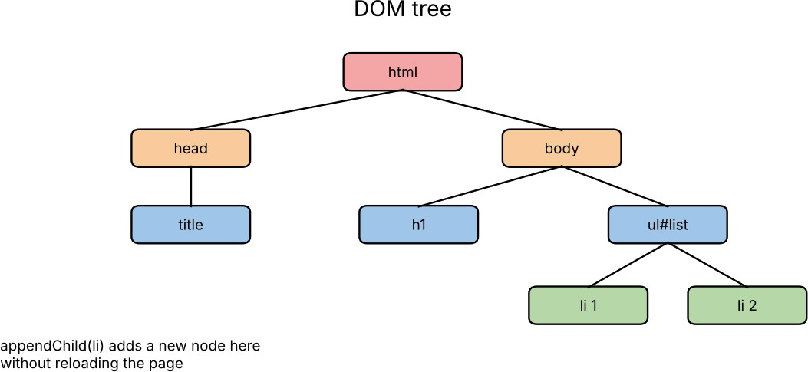

Figure A3-4.1: DOM tree of a small page

Task | DOM method / property
Select elements | getElementById(), querySelector(), querySelectorAll()

Task | DOM method / property
Change content | textContent, innerHTML
Change style | element.style, classList.add/remove/toggle
Create and insert | createElement(), appendChild(), insertBefore()
Remove | remove(), removeChild()
Attributes | setAttribute(), getAttribute()
React to users | addEventListener()

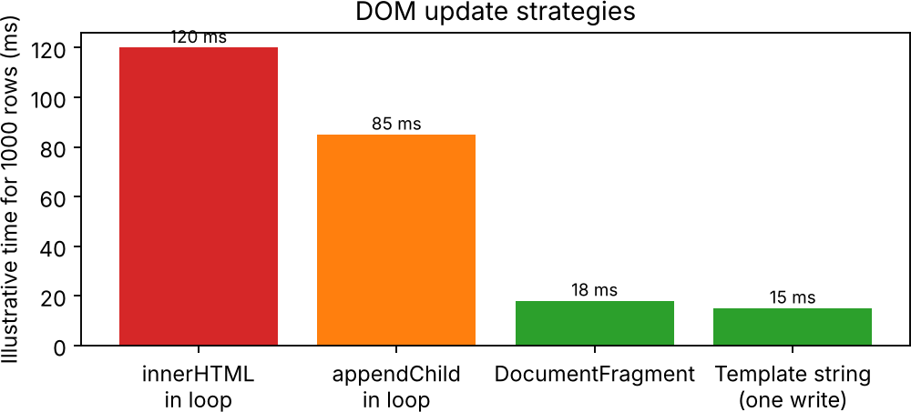
Dynamic update example
<ul id="list"><li>Item 1</li></ul> <input id="txt"> <button id="add">Add</button> <p id="count"></p>

const list = document.getElementById('list'); document.getElementById('add').addEventListener('click', () => {
const value = document.getElementById('txt').value.trim(); if (!value) return;
const li = document.createElement('li');
li.textContent = value; // safe: text, not HTML
list.appendChild(li); // page updates without reload document.getElementById('count').textContent = list.children.length + ' items';
});

Figure A3-4.2: Time taken by different DOM update methods (illustrative values)

Improvements for performance and user experience
- Add many nodes together with DocumentFragment or one template string, because each separate change can trigger reflow.
- Use textContent instead of innerHTML for user input to prevent cross-site scripting.
- Cache selected elements in variables; use event delegation for long lists.
- Use fetch() to load data, and show a loading indicator and an error message.

Question 5 (5 marks): Responsive Layout for a College Website
A college website is viewed on desktops in labs, tablets and mostly on phones. I would build a fluid, mobile-first layout with flexible units and add media queries at the points where the design needs to change.
Device | Screen width | Layout used
Mobile phone | below 600 px | One column; collapsed menu; full-width images
Tablet | 600 - 1023 px | Two columns; sidebar of notices below the content
Desktop | 1024 px and above | Header, left sidebar and content; three-column course cards

<meta name="viewport" content="width=device-width, initial-scale=1">
<div class="page"><header>College Name</header><nav>...</nav>
<main><section>Courses</section><section>Admissions</section><section>Placements</section></main>
<aside>Notices</aside><footer>Contact</footer></div>

.page { display:flex; flex-wrap:wrap; gap:16px; max-width:1200px; margin:auto; padding:0 16px; }
.page > header, .page > nav, .page > footer { flex:1 1 100%; } main { flex:1 1 100%; display:flex; flex-wrap:wrap; gap:16px; } main > section { flex:1 1 100%; }
aside { flex:1 1 100%; }
img { max-width:100%; height:auto; }
@media (min-width:600px) { main > section { flex:1 1 calc(50% - 16px); } } @media (min-width:1024px) {
main { flex:3 1 0; } aside { flex:1 1 0; } main > section { flex:1 1 calc(33% - 16px); }
}
- Flexible layout: percentages and flex-basis, not fixed pixel widths.
- Media queries: change the number of columns at 600 px and 1024 px.
- Flexible images and text: max-width:100% and rem units.
Figure A3-5: Expected layout on mobile, tablet and desktop

Question 6 (5 marks): CSS Styling of Plain Product Cards
Plain cards look flat and hard to separate. CSS colours create hierarchy and brand identity, borders define the card, shadows give depth, and spacing (padding and margin) gives breathing room.
<div class="product"><img src="shoe.jpg" alt="Shoe"><h3>Running Shoe</h3>
<p class="price">Rs 2,499</p><button>Buy now</button></div>

.product { background:#fff; border:1px solid #ddd; border-radius:12px; padding:16px; margin:12px; width:230px; text-align:center; box-shadow:0 4px 10px rgba(0,0,0,.12); transition:transform .3s, box-shadow .3s; }
.product img { width:100%; border-radius:8px; }
.product h3 { color:#222; margin:10px 0 4px; font-size:1.05rem; }
.product .price { color:#c0392b; font-weight:bold; font-size:1.1rem; margin:0 0 10px; }
.product button { background:#2d6cdf; color:#fff; border:0; padding:10px 18px; border-radius:6px; cursor:pointer; }
.product button:hover { background:#1b4fb0; }
.product:hover { transform:translateY(-4px); box-shadow:0 12px 22px rgba(0,0,0,.22); }

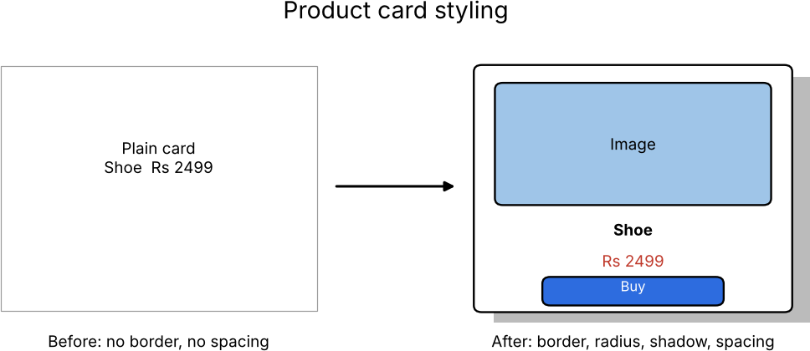

Figure A3-6: Product card before and after styling

Property | Purpose in the product card
background / color | White card on a light page; red price and blue button draw attention
border and border-radius | Defines the card edge and gives a friendly rounded look
box-shadow | Separates the card from the background and gives depth
padding and margin | Space inside and between cards; improves readability
transition and :hover | Gives feedback when the user points at the product

Question 7 (5 marks): Navigation Menu Overlapping Content
Cause. On small screens the menu items do not fit in one line. If the menu uses position:absolute/fixed or fixed heights, it is removed from the normal flow, so the content starts underneath it. Solution. Keep the menu in the normal flow, let items wrap or stack, and reserve space when a fixed header is really needed.
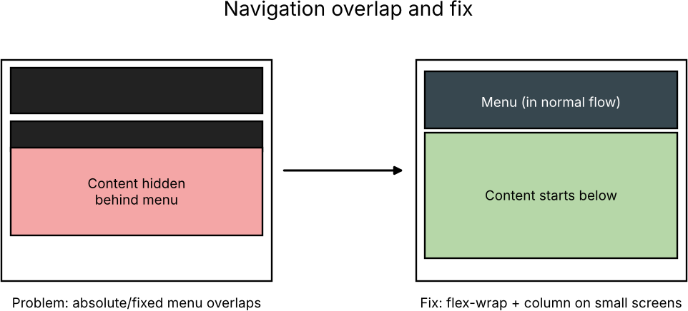
Figure A3-7: Overlapping menu (left) and the corrected layout (right)
nav { position:static; }
.menu { display:flex; flex-wrap:wrap; gap:4px; }
/* stays in normal flow */
.menu a { flex:1 1 auto; padding:10px; text-align:center; }
@media (max-width:600px) { .menu { flex-direction:column; } .menu a { width:100%; } }

/* If a fixed header must be used, reserve its height */
header.fixed { position:fixed; top:0; left:0; right:0; height:56px; } body { padding-top:56px; }

Technique | How it fixes the overlap
Flexbox with flex-wrap | Items move to the next line instead of overflowing
flex-direction:column on mobile | Menu becomes a vertical list that pushes content down
position:static or relative | Menu occupies its own space in the document flow
padding-top equal to fixed header height | Content starts below a fixed header
Hamburger menu | Hides links until needed, saving space

Question 8 (5 marks): JavaScript Validation of Empty Fields
The form should not be submitted when required fields are empty. I would attach a submit event listener, read each field, remove spaces with trim(), and call preventDefault() with an error message if a value is empty.
<form id="reg">
<input id="name" placeholder="Name"> <input id="email" placeholder="Email">
<input id="pass" type="password" placeholder="Password">
<p id="error" style="color:red"></p> <button type="submit">Register</button>
</form>

document.getElementById('reg').addEventListener('submit', function (e) { const fields = { name:'Name', email:'Email', pass:'Password' };
const error = document.getElementById('error'); error.textContent = '';
for (const id in fields) {
const input = document.getElementById(id); if (input.value.trim() === '') {
e.preventDefault();
error.textContent = fields[id] + ' cannot be empty'; input.focus();
return;
// stop the form from submitting
// move cursor to the empty field
}
}
alert('Registration successful');
});

Test input | Result
All fields empty | Blocked: 'Name cannot be empty', focus on Name
Name given, others empty | Blocked: 'Email cannot be empty'
Name and spaces only for email | Blocked because trim() removes spaces
All fields filled | Submitted
Note: adding the HTML5 attribute required gives the same protection without JavaScript, and the server must still validate the data.

Question 9 (5 marks): Button that Displays a Welcome Message
The button needs a click event listener that changes the text of a paragraph. The steps are: (1) give the button and the message area ids, (2) select them with getElementById, (3) add a click listener, (4) set textContent inside the listener.
<button id="welcomeBtn">Start Learning</button>
<p id="msg"></p>

const btn = document.getElementById('welcomeBtn'); const msg = document.getElementById('msg'); btn.addEventListener('click', function () {
msg.textContent = 'Welcome to our e-learning platform!'; msg.style.fontWeight = 'bold';
btn.disabled = true; // optional: prevent repeated clicks
});
// Simple alternative: <button onclick="alert('Welcome to our e-learning platform!')">Start</button>

Step | Code | Explanation
1 | getElementById('welcomeBtn') | Finds the button in the DOM
2 | addEventListener('click', fn) | Waits for the user to click
3 | msg.textContent = '...' | Shows the welcome text without reloading

Question 10 (5 marks): Updating the Total Price when Quantity Changes
The total price is unit price x quantity. An input event listener on the quantity field recalculates the total each time the value changes and writes it into the page using the DOM. The value is converted to a number with parseInt(), and invalid values are replaced by 1.

<label>Quantity: <input type="number" id="qty" value="1" min="1" max="10"></label>
<p>Unit price: Rs <span id="unit">499</span></p>
<p><b>Total: Rs <span id="total">499.00</span></b></p>

const unit = Number(document.getElementById('unit').textContent); const qtyEl = document.getElementById('qty');
const total = document.getElementById('total');
function update() {
let q = parseInt(qtyEl.value, 10); if (isNaN(q) || q < 1) q = 1;
total.textContent = (q * unit).toFixed(2);
}
qtyEl.addEventListener('input', update); update();
// validate quantity
// calculate and display

Quantity | Unit price (Rs) | Total (Rs)
1 | 499 | 499.00
2 | 499 | 998.00
3 | 499 | 1497.00
4 | 499 | 1996.00
5 | 499 | 2495.00
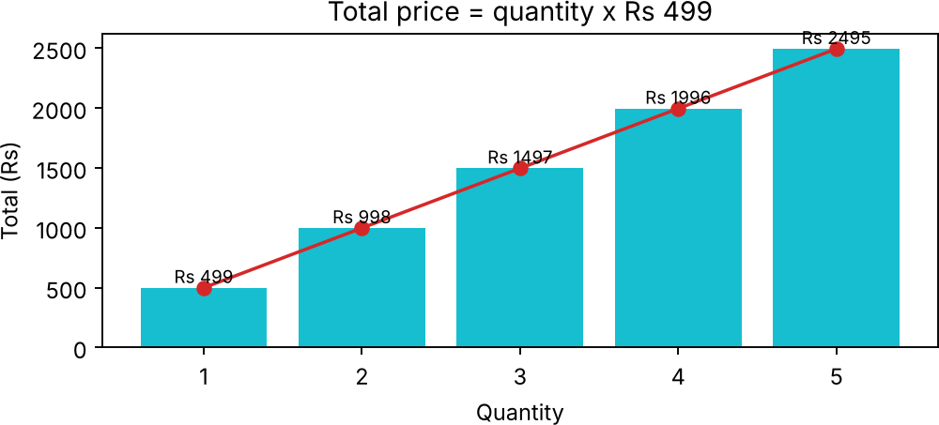
Figure A3-10: Total price for quantities 1 to 5 (unit price Rs 499)
- Show a discount or GST line using the same update() function.
- Limit quantity with min and max and show stock availability for a better experience.

RUBRICS FOR CALCULATION:

Criteria | Weightage | Level 4 – Exemplary (5 Marks) | Level 3 – Proficient (4 Marks) | Level 2 – Developing (2–3 Marks) | Level 1 – Beginning (0–1 Mark)
Conceptual Understanding | 30 | Demonstrates clear and complete understanding of the concept | Good understanding with minor gaps | Basic understanding with some misconceptions | Poor or incorrect understanding
Accuracy of Answer | 25 | Completely correct answer with no errors | Mostly correct with minor errors | Partially correct with noticeable errors | Incorrect or irrelevant answer
Application of Knowledge | 20 | Correctly applies concepts to solve the question/problem | Applies concepts with minor mistakes | Limited or partially correct application | No or incorrect application
Completeness of Response | 15 | Covers all required parts of the question | Covers most parts with minor omissions | Covers only some parts | Incomplete or missing response
Clarity & Presentation | 10 | Clear, concise, and well-organized answer | Understandable with minor issues | Somewhat unclear or poorly structured | Difficult to understand

