SIMATS ENGINEERING
ASSESSMENT TOOL 1

COURSE NAME: INTERNET PROGRAMMING
COURSE CODE: CSA43

COURSE OUTCOME COVERED

CO-2 : Apply CSS layout and styling techniques to create visually appealing and responsive web interfaces, and use JavaScript to enable interactive client-side behavior. (L3)

Assessment Tool : Integrated Experiments

Weightage: 40%

QUESTIONS: Total Marks: 30

Code of Conduct:

I I.ANDROW EDISSON(192511136) certify that this submission is my original work and that I have adhered to the guidelines specified for this assessment. I understand that any violation of academic integrity rules will result in disciplinary action.

Signature of the student:

Experiment 1: Responsive Layout Design
Suppose that a retail website is not responsive across mobile and tablet devices, causing misalignment of content and improper spacing.
(a) Analyze the possible reasons for lack of responsiveness in the existing layout.
(b) Design a responsive webpage layout using CSS Flexbox or Grid, ensuring proper alignment of header, navigation, content, and footer.
(c) Demonstrate how the layout adapts to different screen sizes (mobile, tablet, desktop) using media queries.
(d) Implement spacing, alignment, and distribution techniques to improve visual consistency.
(e) Evaluate the effectiveness of the responsive design and suggest further improvements.
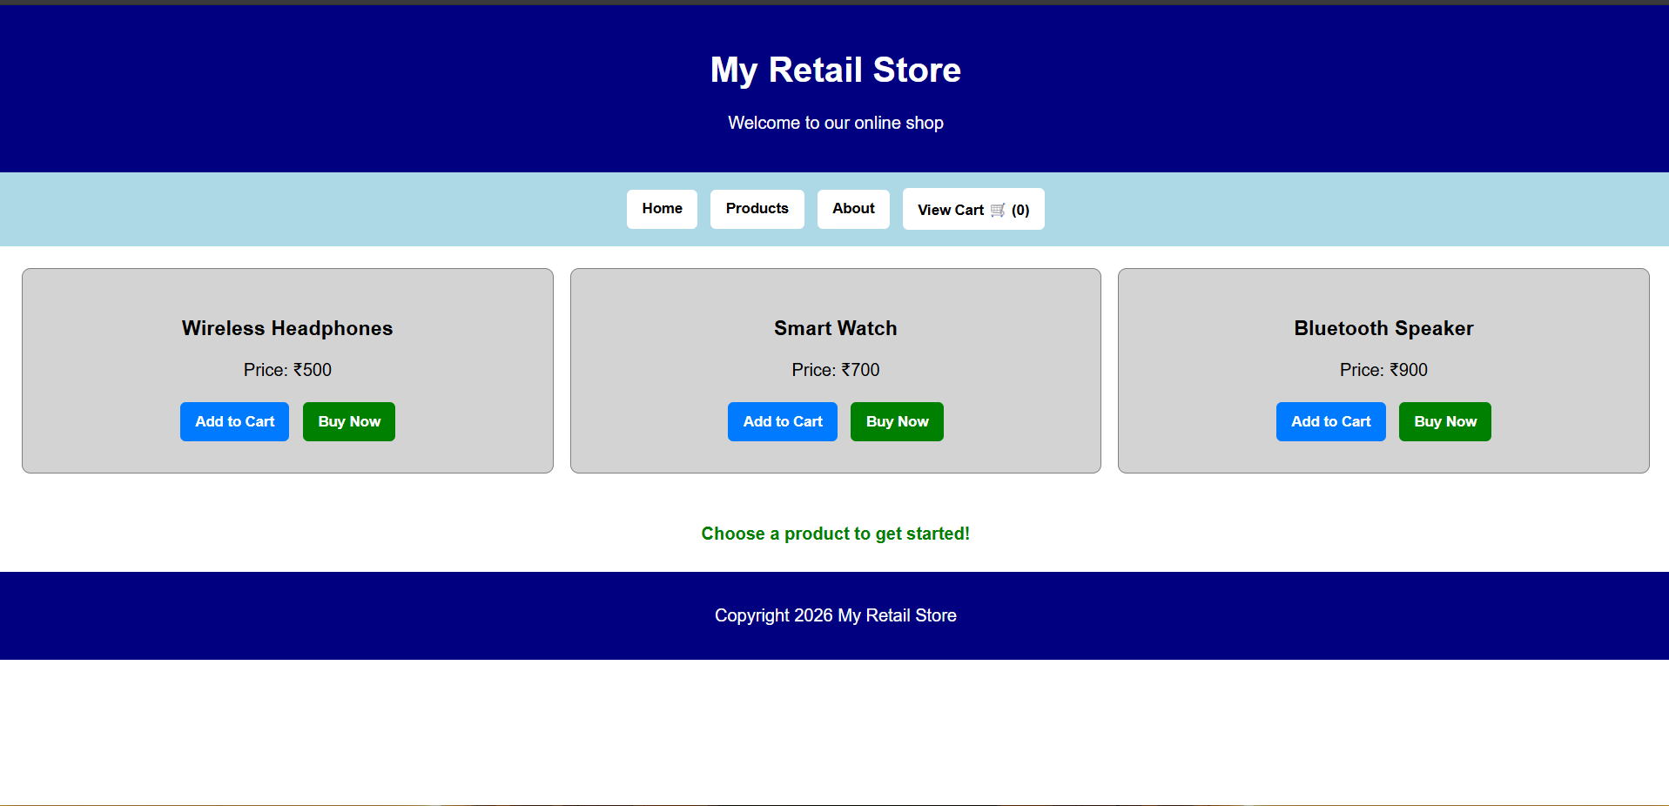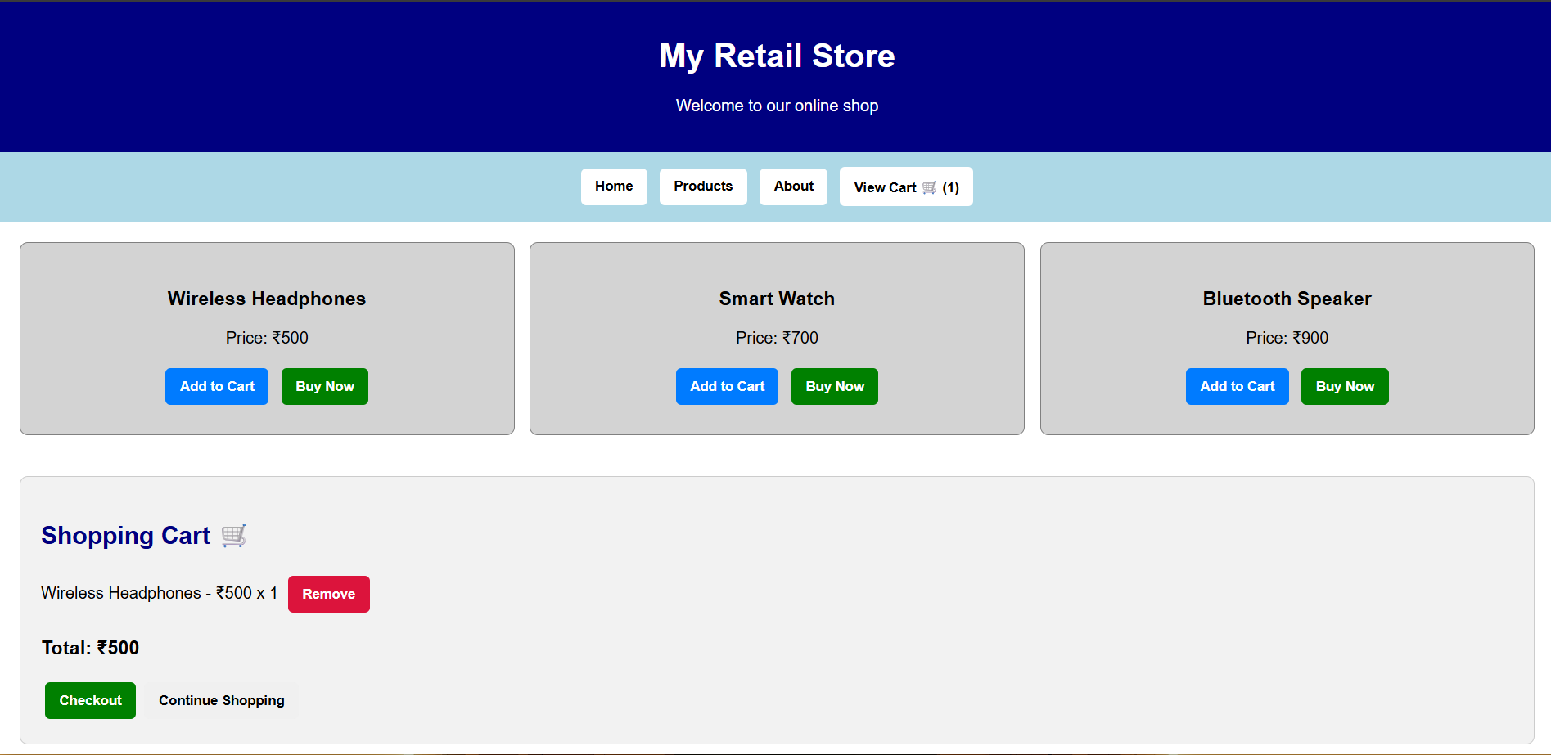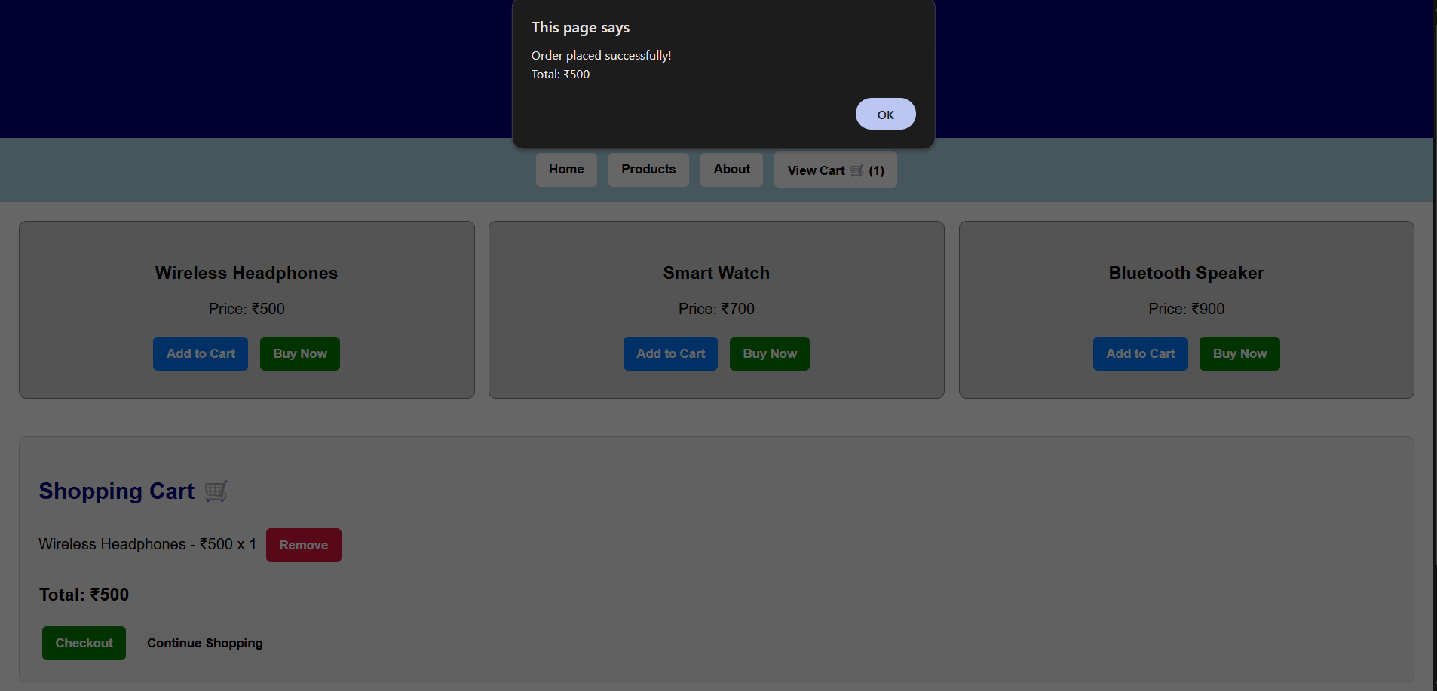

Experiment 2: Form Validation using JavaScript
Suppose that a registration form accepts invalid email and phone number inputs, leading to incorrect data submission.
(a) Analyze the issues in the existing form validation mechanism.
(b) Design input fields for email and phone number with appropriate HTML attributes.
(c) Implement JavaScript validation using Regular Expressions for both email and phone number.
(d) Develop a mechanism to display real-time error messages for invalid inputs.
(e) Evaluate the validation system and suggest enhancements for better user experience and security.

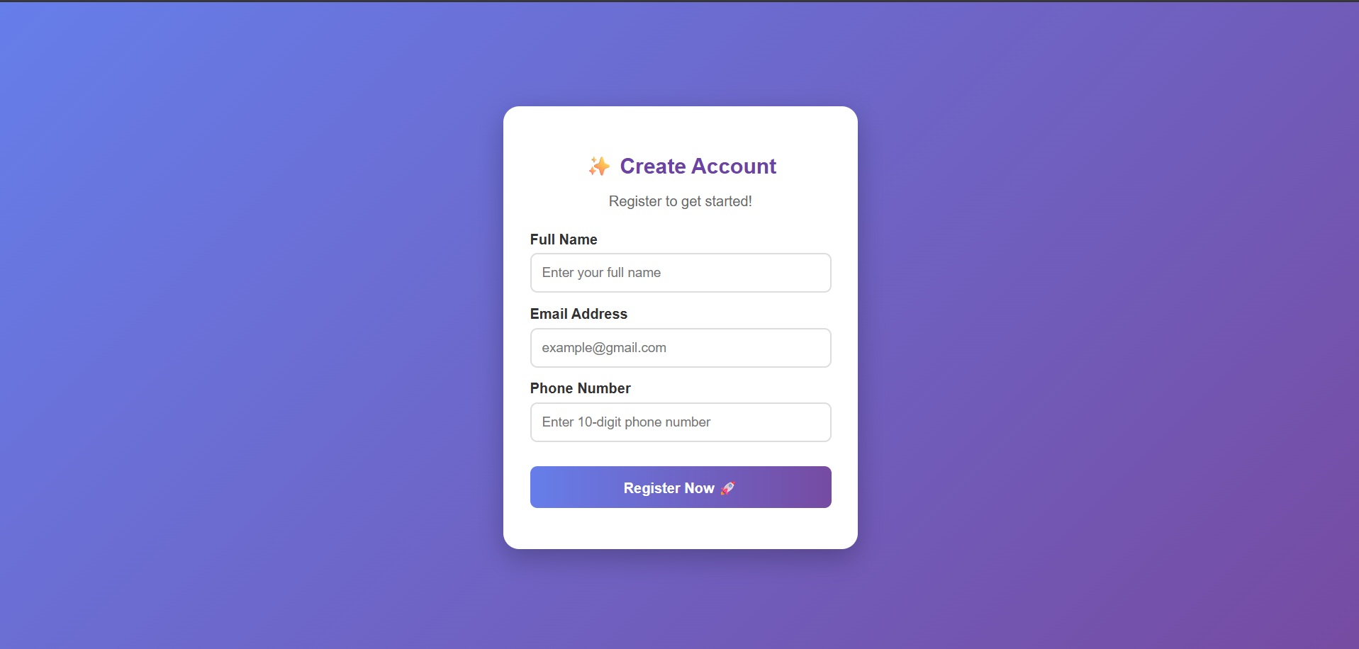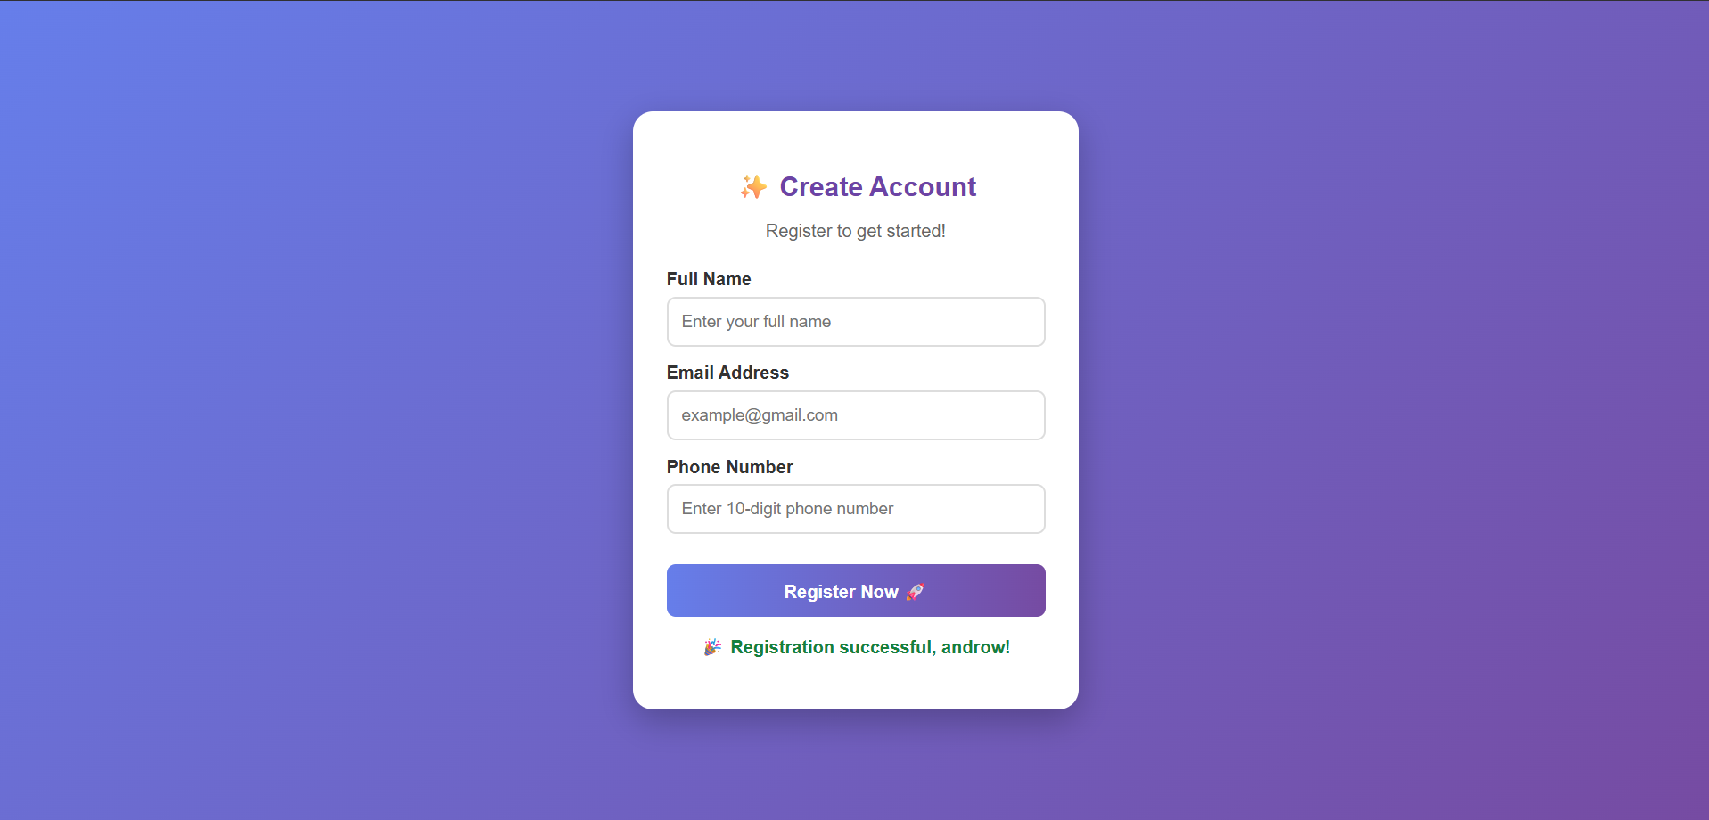

Experiment 3: CSS Layout Debugging
Suppose that a webpage layout overlaps when the browser window is resized, affecting usability.
(a) Analyze the CSS properties responsible for layout overlapping issues.
(b) Examine the role of the CSS box model (margin, border, padding, content) in layout design.
(c) Debug the layout using appropriate positioning techniques (relative, absolute, flex, grid).
(d) Modify the CSS to ensure proper alignment and prevent overlapping during resizing.
(e) Evaluate the corrected layout and suggest best practices for maintaining consistency.
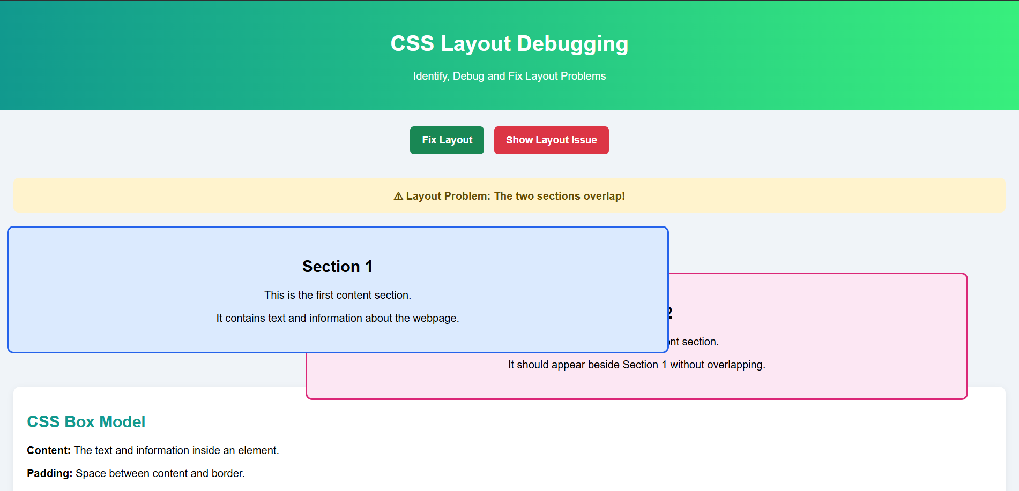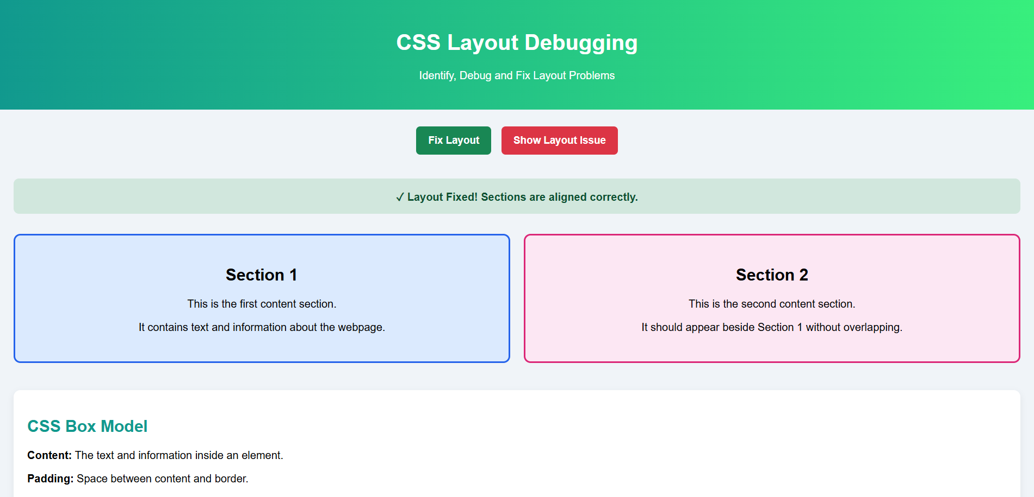

RUBRICS FOR CALCULATION:

Criteria | Weightage | Level 4 – Exemplary | Level 3 – Proficient | Level 2 – Developing | Level 1 – Beginning
Understanding of Concepts | 25 | Demonstrates thorough understanding and effectively integrates multiple concepts/technologies | Good understanding with proper integration of most concepts | Basic understanding; limited or partial integration | Poor understanding; unable to integrate concepts
Experimental Design | 30 | Well-planned, systematic implementation with optimal solution | Correct implementation with minor issues | Basic implementation with errors or inefficiencies | Incorrect or incomplete implementation
Use of Tools | 20 | Effective and advanced use of tools/technologies with proper configuration | Appropriate use of tools with correct execution | Limited or inconsistent use of tools | Incorrect or minimal use of tools
Analysis of Results | 15 | Insightful analysis with accurate interpretation and validation of results | Good analysis with reasonable interpretation | Basic analysis with limited insights | Poor or incorrect analysis of results
Documentation | 10 | Clear, well-structured documentation with diagrams, code, and results | Organized documentation with necessary details | Basic documentation with missing details | Poor or incomplete documentation

