SIMATS ENGINEERING
ASSESSMENT TOOL 2

COURSE NAME: INTERNET PROGRAMMING
COURSE CODE: CSA43

COURSE OUTCOME COVERED

CO -2 : Apply CSS layout and styling techniques to create visually appealing and responsive web interfaces, and use JavaScript to enable interactive client-side behavior. (L3)

Assessment Tool : Design Task

Weightage: 20%

- .

Question 1: Responsive Navigation Bar Design (4 marks)
Scenario. An e-commerce website needs one navigation bar that works on desktop, tablet and mobile. Shoppers use the navigation bar to search, browse categories, reach the cart and log in, so it is the most important control on the site. A responsive navigation bar changes its layout with the screen width while keeping the same HTML.

Key components of an e-commerce navigation bar
Component | Purpose | HTML element used | Priority
Logo / brand name | Brand identity; link back to the home page | <a> with <img> or text | High
Category menu | Quick access to product groups such as Men, Women, Electronics | <nav> with <ul><li><a> | High
Search bar | Fast product search; the most used feature of a shop | <form role='search'> with <input type='search'> | High
Cart icon with item count | Shows what has been added; leads to checkout | <a> with icon and badge <span> | High
Account / login | Orders, wishlist, profile and sign-in | <a> or dropdown | Medium
Deals / offers link | Promotions that increase sales | <a> with highlight class | Medium
Hamburger button | Collapses all links on small screens | <label> or <button aria-expanded> | High (mobile)

Design of the responsive navigation bar
The design is mobile-first: the base CSS is written for phones, and a media query adds the horizontal layout for screens of 768 px and wider. Flexbox arranges the items, and the menu is opened with a CSS-only checkbox trick, so no JavaScript is needed for the basic behaviour.
<header class="navbar">
<a class="brand" href="/">ShopEasy</a>
<input type="checkbox" id="nav-toggle" hidden>
<label for="nav-toggle" class="hamburger" aria-label="Open menu">&#9776;</label>
<form class="search" role="search"><input type="search" placeholder="Search products"></form>
<nav class="menu">
<a href="#">Men</a> <a href="#">Women</a> <a href="#">Electronics</a>
<a href="#">Deals</a> <a href="#">Account</a> <a href="#">Cart (2)</a>
</nav>
</header>

* { box-sizing: border-box; }
.navbar { display:flex; flex-wrap:wrap; align-items:center; justify-content:space-between; gap:8px; padding:10px 16px; background:#222; position:sticky; top:0; z-index:100; }
.brand { color:#fff; font-size:1.4rem; font-weight:bold; text-decoration:none; }
.hamburger { color:#fff; font-size:1.8rem; cursor:pointer; padding:4px 10px; }
.search { order:3; width:100%; } /* search drops to its own row on mobile */
.search input { width:100%; padding:8px; border-radius:6px; border:0; }
.menu { order:4; display:none; flex-direction:column; width:100%; } /* hidden on mobile */
.menu a { color:#fff; text-decoration:none; padding:12px 14px; min-height:44px; }
.menu a:hover, .menu a:focus-visible { background:#444; outline:2px solid #fff; }
#nav-toggle:checked ~ .menu { display:flex; } /* tap on hamburger shows the links */
@media (min-width:768px) {
.hamburger { display:none; }
/* tablet and desktop */
.search { order:2; width:auto; flex:1; max-width:360px; }
.menu { order:3; display:flex; flex-direction:row; width:auto; }
}
@media (min-width:992px) { .navbar { padding:12px 48px; } .menu a { padding:12px 18px; } }
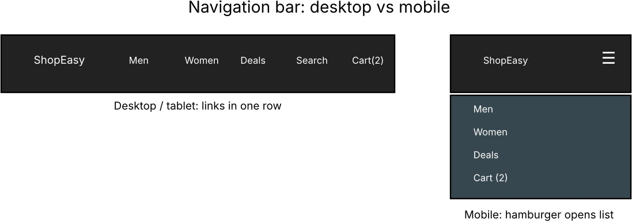
Figure 1.1: Navigation bar wireframe - desktop/tablet (left) and mobile with hamburger menu (right)

CSS technique | Where used | Why it helps
Flexbox (display:flex, flex-wrap) | Navbar and menu | Aligns items in a row and wraps them on small screens
Media queries (min-width) | 768 px and 992 px breakpoints | Switch from stacked mobile layout to horizontal layout
order property | Search and menu | Changes visual order per device without changing HTML
position:sticky | Navbar | Keeps the menu visible while scrolling the product list
:checked sibling selector | Hamburger toggle | Opens and closes the menu without JavaScript
min-height:44px | Links | Touch targets are large enough for fingers

How the navigation adapts to smaller screens
Screen | Width | What the user sees
Mobile | below 768 px | Logo and hamburger icon on one row; search field on its own row; links appear as a vertical list after tapping the hamburger
Tablet | 768 - 991 px | Logo, search and all links in a single horizontal row; hamburger hidden
Desktop | 992 px and above | Same as tablet with wider spacing and larger padding

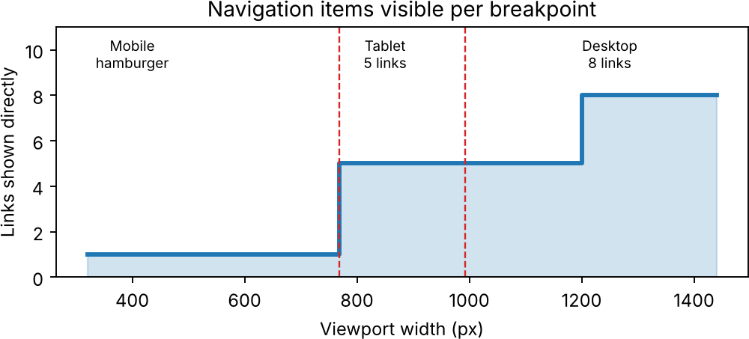
Figure 1.2: Number of navigation links shown directly at each breakpoint
An optional JavaScript enhancement keeps the toggle accessible for screen readers by updating aria-expanded:
const t = document.getElementById('nav-toggle'), h = document.querySelector('.hamburger'); t.addEventListener('change', () => h.setAttribute('aria-expanded', t.checked));

Usability evaluation and suggested improvements
Criterion | Rating | Comment
Ease of use on mobile | Good | Large touch targets (44 px) and a familiar hamburger icon
Visibility of key actions | Average | Cart and search should always be visible; the cart is hidden inside the hamburger on phones
Performance | Excellent | Pure CSS toggle, no scripts or images
Accessibility | Average | Needs aria-expanded, skip link and a visible keyboard focus style (partly added)
Consistency across devices | Good | Same HTML on all devices; only CSS changes
  - Keep the cart icon and search outside the hamburger so they are always visible on phones.
  - Add a cart badge with the number of items and a mega-menu with sub-categories for large catalogues.
  - Highlight the current page, keep text contrast at least 4.5:1, and add a skip-to-content link.
  - Use auto-suggest in the search box and test the bar with keyboard-only and screen-reader users.

Question 2: Product Hover Effect (4 marks)
Scenario. Product cards on an e-commerce page should react when the user points at them. A well-designed hover effect shows that the item is interactive, draws attention to the product and makes browsing more enjoyable without slowing the page.

Suitable CSS properties for hover effects
Property | Effect | Performance
transform: translateY() / scale() | Lifts or zooms the card or image | Excellent (GPU compositor)
opacity | Fades an overlay, badge or image | Excellent
box-shadow | Gives depth when the card is lifted | Good (paint only)
filter: brightness() / grayscale() | Highlights the image | Good
background-color / border-color | Colour change on buttons | Good
transition-property, -duration, -timing-function | Controls how the change happens | Not visual by itself
width / height / top / left | Changes size or position | Poor (forces layout)

Suitable CSS animation or transition
Feature | Transition | @keyframes animation
Trigger | Needs a state change such as :hover or :focus | Can start automatically or on any class
Steps | Only start and end | Many steps (0%, 50%, 100%)
Repeat | No | Yes (animation-iteration-count)
Best use here | Card lift, shadow and image zoom | Pulsing 'Sale' badge or loading skeleton
A transition is the best choice for the product card because the effect is a simple change between two states:
transition: transform .3s ease, box-shadow .3s ease;

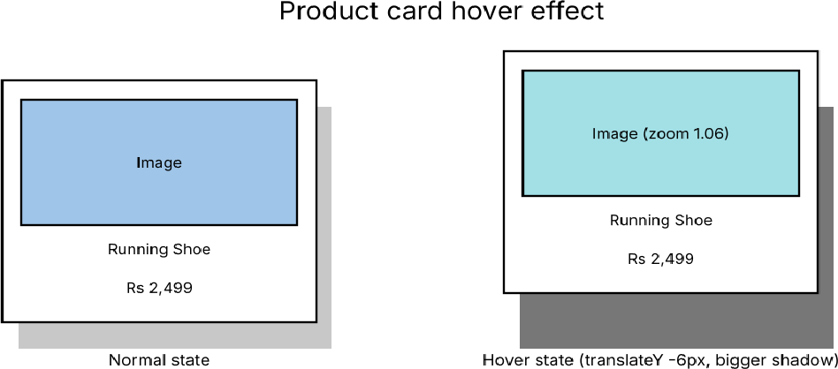
Hover effect design for a product card
<article class="card" tabindex="0">
<img src="shoe.jpg" alt="Blue running shoe">
<h3>Running Shoe</h3>
<p class="price">Rs 2,499</p>
<button>Add to cart</button>
</article>
.card { width:230px; padding:12px; border-radius:12px; background:#fff; overflow:hidden; box-shadow:0 2px 6px rgba(0,0,0,.15);
transition:transform .3s ease, box-shadow .3s ease; }
.card img { width:100%; border-radius:8px; transition:transform .4s ease; }
.card button { opacity:0; transform:translateY(8px); transition:opacity .3s, transform .3s; }
.card:hover, .card:focus-within { transform:translateY(-6px); box-shadow:0 14px 28px rgba(0,0,0,.25); }
.card:hover img { transform:scale(1.06); }
.card:hover button, .card:focus-within button { opacity:1; transform:none; }
@media (hover:none) { .card button { opacity:1; transform:none; } } /* touch screens */ @media (prefers-reduced-motion:reduce) { .card, .card img, .card button { transition:none; } }

Figure 2.1: Product card in normal state (left) and hover state (right)

Performance and user experience evaluation
  - Only transform and opacity are animated by the GPU, so the effect stays at 60 frames per second even on a page with many cards.
  - Animating width, height, top or left forces the browser to recalculate layout for every frame and makes scrolling janky.
  - Duration of 200 to 400 ms feels responsive; longer animations feel slow and annoy repeat visitors.
  - Touch devices have no hover, so the button is always visible with @media (hover:none); keyboard users get the same effect through :focus-within.

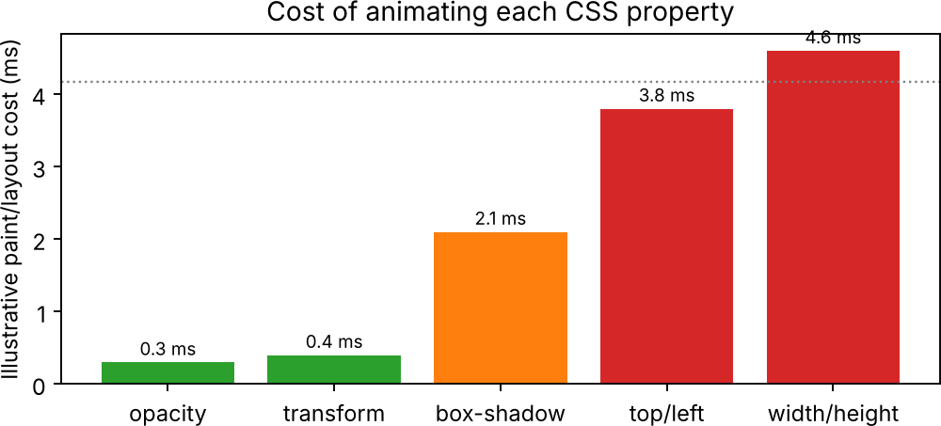
Figure 2.2: Relative cost of animating different CSS properties (illustrative values)
Improvements: use will-change: transform only on the card being animated, lazy-load product images, and respect prefers-reduced-motion for users sensitive to movement.

Question 3: Layout Selection - Flexbox vs Grid (4 marks)
Scenario. A web application dashboard shows a sidebar, header, summary cards (KPIs), charts and tables. The layout must stay tidy on large monitors, tablets and phones.

Layout requirements of a dashboard
Requirement | Description
Rows | Header at the top, main content in the middle, footer at the bottom
Columns | Fixed-width sidebar (about 220 px) and a flexible main area
Different cell sizes | KPI cards of one cell, charts spanning two columns, tables spanning a full row
Alignment | Equal gaps, equal-height cards and centred values
Responsiveness | Collapse to one column on phones; reorder the sidebar below the content
Scalability | New widgets can be added without rewriting the layout

Comparison of Flexbox and Grid
Aspect | Flexbox | CSS Grid
Dimension | One-dimensional (a row or a column at a time) | Two-dimensional (rows and columns together)
Sizing approach | Content-first: items decide their size | Layout-first: container defines the tracks
Spanning cells | Not possible without nesting | grid-column / grid-row: span n, grid-area
Alignment | Excellent along one axis | Excellent on both axes
Gaps | gap supported | gap, row-gap and column-gap supported
Named areas | No | grid-template-areas gives readable layouts
Responsiveness | flex-wrap and flex-basis | repeat(auto-fit, minmax()) and media queries
Best suited for | Navbars, toolbars, button groups, centring | Page layouts, dashboards, galleries

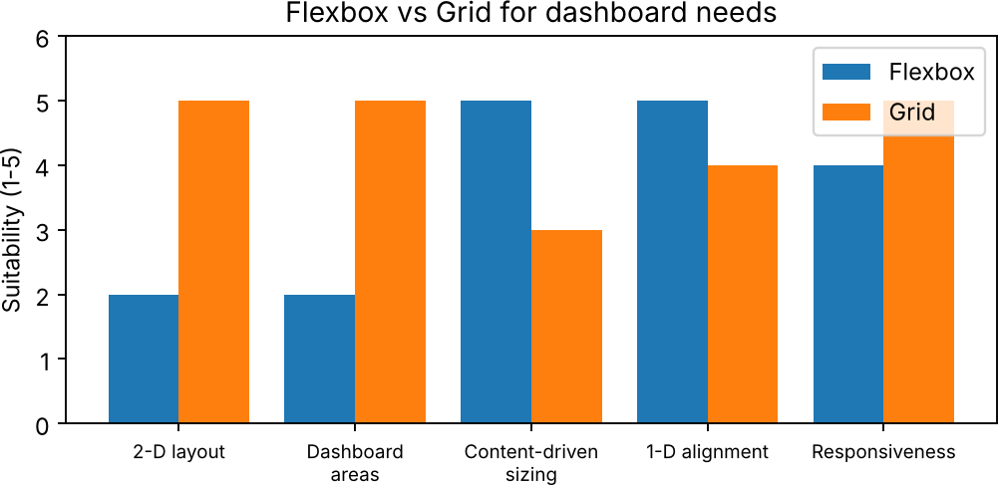
Figure 3.1: Suitability of Flexbox and Grid for dashboard needs (scale of 1 to 5)

Choice of layout technique and justification
CSS Grid is chosen for the overall dashboard because the dashboard has rows and columns that must line up, and widgets of different sizes must span several cells. Grid defines this in one declaration and named areas make the code easy to read. Flexbox is used inside each widget (for example the title and value in a card), because that is a
one-dimensional problem.
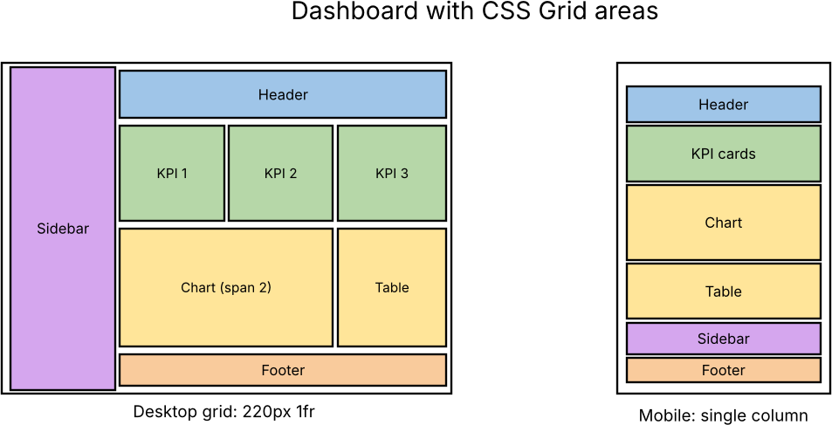
.dashboard { display:grid; gap:16px; min-height:100vh; grid-template-columns:220px 1fr; grid-template-areas: "side head" "side main" "side foot"; }
.side{grid-area:side;} .head{grid-area:head;} .main{grid-area:main;} .foot{grid-area:foot;}
.main { display:grid; gap:16px; grid-template-columns:repeat(auto-fit, minmax(240px, 1fr)); }
.chart { grid-column:span 2; } /* chart is two cells wide */
.card { display:flex; justify-content:space-between; align-items:center; padding:16px; } @media (max-width:700px) {
.dashboard { grid-template-columns:1fr; grid-template-areas:"head" "main" "side" "foot"; }
.chart { grid-column:auto; }
}

Figure 3.2: Dashboard grid areas on desktop (left) and the single-column mobile layout (right)

Scalability and responsiveness
Factor | How Grid handles it
Adding widgets | Add a new element; auto-fit places it in the next free cell
Changing page structure | Edit only grid-template-areas; HTML is unchanged
Different screens | auto-fit with minmax() changes the number of columns automatically; one media query rearranges areas
Maintenance | Layout lives in CSS; named areas document the design
Browser support | Supported by all current browsers

Question 4: Mobile-First Blog Layout (4 marks)
Scenario. A blog page is read mostly on phones, so the design starts with the smallest screen (single column, large readable text) and adds columns and extras only when more space is available. This is called the mobile-first approach.

Key sections of a blog layout
Section | Content | HTML tag
Header / navigation | Blog name, menu, search | <header>, <nav>
Post title area | Title, author, date, reading time | <h1>, <p>
Main article | Text, images, quotes, headings | <main>, <article>
Sidebar | Categories, popular posts, subscription box | <aside>
Comments / related posts | Reader engagement | <section>
Footer | Links, social icons, copyright | <footer>

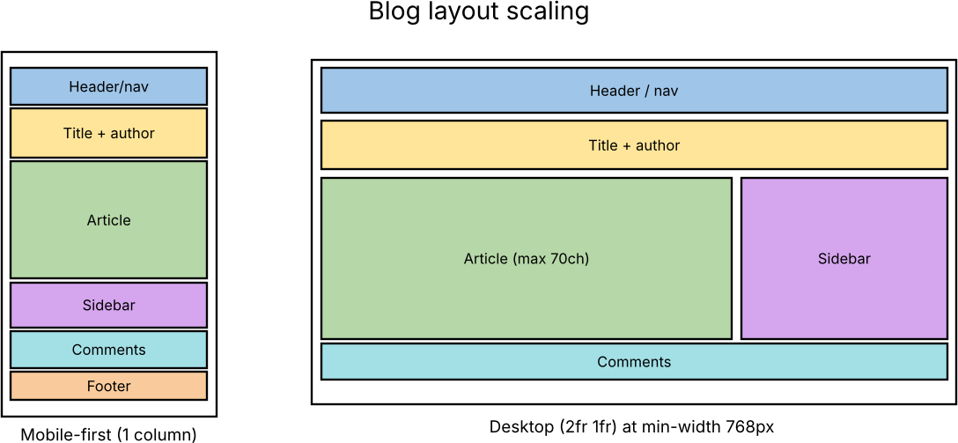
Mobile-first layout using CSS
<body>
<header>...</header>
<main class="layout">
<article><h1>Post title</h1><p class="meta">By Andrew | 5 min read</p><p>...</p></article>
<aside>...</aside>
</main>
<footer>...</footer>
</body>
html { font-size:100%; }
body { margin:0; font:1rem/1.7 Georgia, serif; color:#222; background:#fff; padding:0 16px; }
.layout { display:grid; gap:24px; grid-template-columns:1fr; } /* one column by default */ article { max-width:70ch; } /* comfortable line length */ img { max-width:100%; height:auto; display:block; }
h1 { font-size:1.7rem; line-height:1.25; }
aside { border-top:1px solid #ccc; padding-top:16px; }

Figure 4.1: Blog layout - mobile-first single column (left) and desktop two columns (right)

Scaling to larger screens with media queries
@media (min-width:768px) { .layout { grid-template-columns:2fr 1fr; } h1 { font-size:2.1rem; } aside { border-top:0; border-left:1px solid #ccc; padding-left:16px; } }
@media (min-width:1100px) { .layout { max-width:1100px; margin:0 auto; } body { font-size:1.125rem; } }

Breakpoint | Columns | Changes
Base (phones) | 1 | Stacked sections, 16 px side padding, 1.7rem title
768 px (tablet) | 2 (2fr and 1fr) | Sidebar moves beside the article; larger heading
1100 px (desktop) | 2, centred | Content width limited to 1100 px; slightly larger text

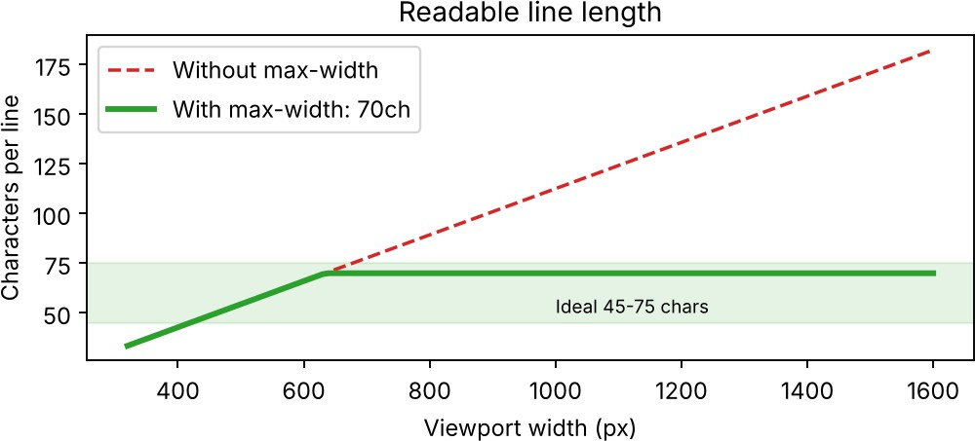
Figure 4.2: Characters per line with and without a max-width limit

Accessibility and readability evaluation
Aspect | Design decision | Benefit
Line length | max-width:70ch gives 45 to 75 characters per line | Easier reading, less eye strain
Font size and spacing | 1rem base with 1.7 line height | Readable without zooming
Semantic HTML | header, nav, main, article, aside, footer | Screen readers can jump between regions
Images | max-width:100% and meaningful alt text | No horizontal scroll; images described
Contrast | #222 text on white (about 16:1) | Passes WCAG AA (4.5:1) and AAA
Relative units | rem and ch instead of px | Text scales with the user's browser settings
- Add a skip-to-content link, visible focus outlines, and a dark-mode option using prefers-color-scheme.
- Use heading levels in order (h1, h2, h3) and keep paragraphs short for easy scanning on phones.

Question 5: JavaScript Event Handling for a Dynamic Menu (4 marks)
Scenario. A website has a dynamic menu: a toggle button opens and closes it, sub-menus open on hover (desktop) or tap (mobile), and the menu closes on Escape or when the user clicks elsewhere. JavaScript events make this interaction possible.

Appropriate JavaScript events
Event | Fires when | Use in the menu
click | Element is clicked or tapped | Toggle button; click outside to close
mouseenter / mouseleave | Pointer enters or leaves an element (no bubbling) | Open and close sub-menu on desktop
keydown | A key is pressed | Escape closes the menu; arrow keys move between items
focusin / focusout | Focus moves in or out of the menu | Keyboard users can open sub-menus
resize | Browser window size changes | Reset the menu when the screen becomes wide
touchstart | Finger touches the screen | Optional faster response on touch screens

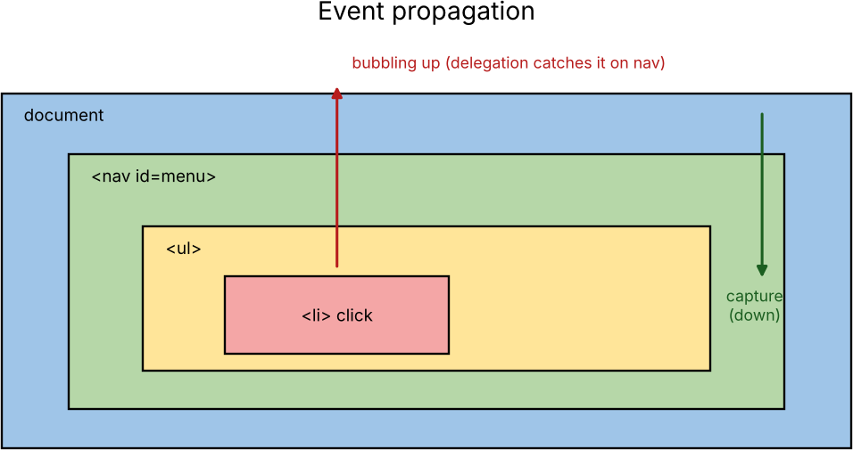

Figure 5.1: Event propagation - a click on an li bubbles up to the nav element

Event handling logic for menu toggle
Step | Logic
1 | Select the button and the menu with querySelector
2 | Create one function setMenu(open) that adds or removes the class 'open' and updates aria-expanded
3 | Attach a click listener to the button that calls setMenu with the opposite of the current state
4 | Attach keydown (Escape) and outside-click listeners that call setMenu(false)
5 | Attach a resize listener to close the menu on large screens

Implementation of click and hover interaction
<button id="menuBtn" aria-expanded="false" aria-controls="menu">Menu</button>
<ul id="menu">
<li class="has-sub"><a href="#">Products</a>
<ul class="sub"><li>Shoes</li><li>Bags</li></ul></li>
</ul>

#menu { display:none; } #menu.open { display:block; }
.sub { display:none; } .has-sub.show > .sub { display:block; }
const btn = document.querySelector('#menuBtn'); const menu = document.querySelector('#menu');

function setMenu(open) { menu.classList.toggle('open', open); btn.setAttribute('aria-expanded', String(open));
}
btn.addEventListener('click', () => setMenu(!menu.classList.contains('open')));
// click toggle
menu.addEventListener('mouseover', e => {
const li = e.target.closest('.has-sub'); if (li) li.classList.add('show');
});
menu.addEventListener('mouseout', e => { const li = e.target.closest('.has-sub');
if (li && !li.contains(e.relatedTarget)) li.classList.remove('show');
});
// hover (delegated)
menu.addEventListener('click', e => { // tap on touch screens const a = e.target.closest('.has-sub > a');
if (a) { e.preventDefault(); a.parentNode.classList.toggle('show'); }
});
document.addEventListener('keydown', e => { if (e.key === 'Escape') setMenu(false); }); document.addEventListener('click', e => {
if (!menu.contains(e.target) && !btn.contains(e.target)) setMenu(false); // click outside
});
window.addEventListener('resize', debounce(() => { if (innerWidth >= 768) setMenu(false); }, 150)); function debounce(fn, ms) {
let t;
return (...a) => { clearTimeout(t); t = setTimeout(() => fn(...a), ms); };
}

- Performance evaluation and improvements
- Event delegation: one listener on the menu handles every item, instead of one listener per item.

- Debouncing: the resize handler runs only after the user stops resizing, avoiding hundreds of calls.
- CSS classes are toggled instead of inline styles, so the browser updates faster and CSS stays in one place.
- Passive listeners: use { passive:true } for touch and scroll events so scrolling is never blocked.
- Accessibility: aria-expanded, Escape key and focus handling make the menu usable without a mouse.
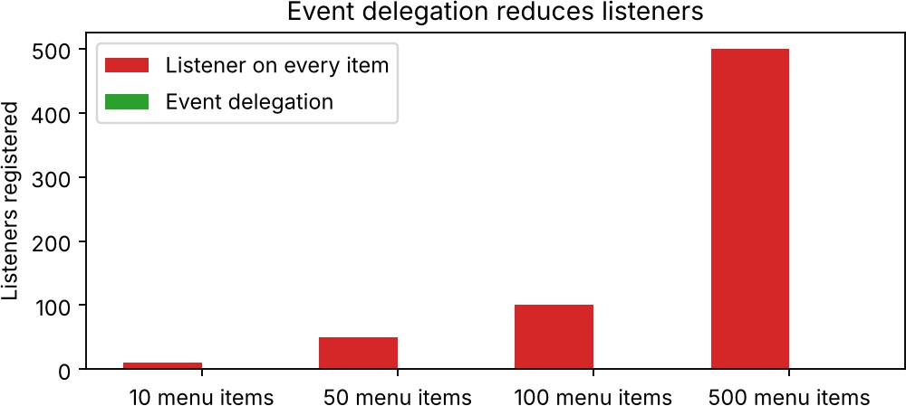
Figure 5.2: Listeners needed with and without event delegation

Code of Conduct:

I I.ANDROW EDISSON(192511136) certify that this submission is my original work and that I have adhered to the guidelines specified for this assessment. I understand that any violation of academic integrity rules will result in disciplinary action.

Signature of the student:
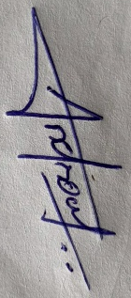

RUBRICS FOR CALCULATION:

Criteria | Weightage (%) | Level 4 – Exemplary (4) | Level 3 – Proficient (3) | Level 2 – Developing (2) | Level 1 – Beginning (1)
Understanding of Concept | 25 | Demonstrates complete understanding of design requirements and concepts | Good understanding with minor gaps | Basic understanding with some errors | Poor understanding or incorrect concepts
Design / Implementation | 30 | Well-structured, efficient, and responsive design implementation | Correct implementation with minor issues | Basic implementation with inconsistencies | Incorrect or incomplete implementation
Use of Tools (CSS/JS) | 20 | Effective and advanced use of tools/techniques | Appropriate use of tools | Limited or inconsistent use | Incorrect or minimal use
Analysis & Evaluation | 15 | Insightful analysis with strong justification and optimization | Good analysis with justification | Basic analysis with limited depth | Poor or no analysis
Documentation / Clarity | 10 | Clear, well-structured, and properly presented solution | Mostly clear with minor issues | Basic clarity, missing details | Poor or unclear documentation

