**Computer project**

**Name:** اندرو سمير مسيحه سعيد

**Geoup:** 2

**Section:** 10

**BN:** 216

**Topic:** Artificial Intelligence

**Links:**

**Screen shots:**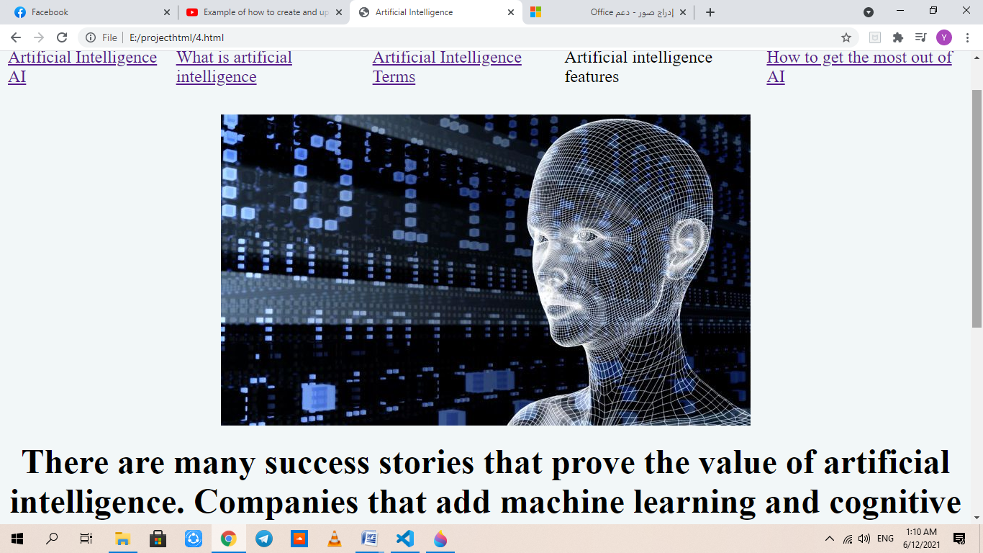

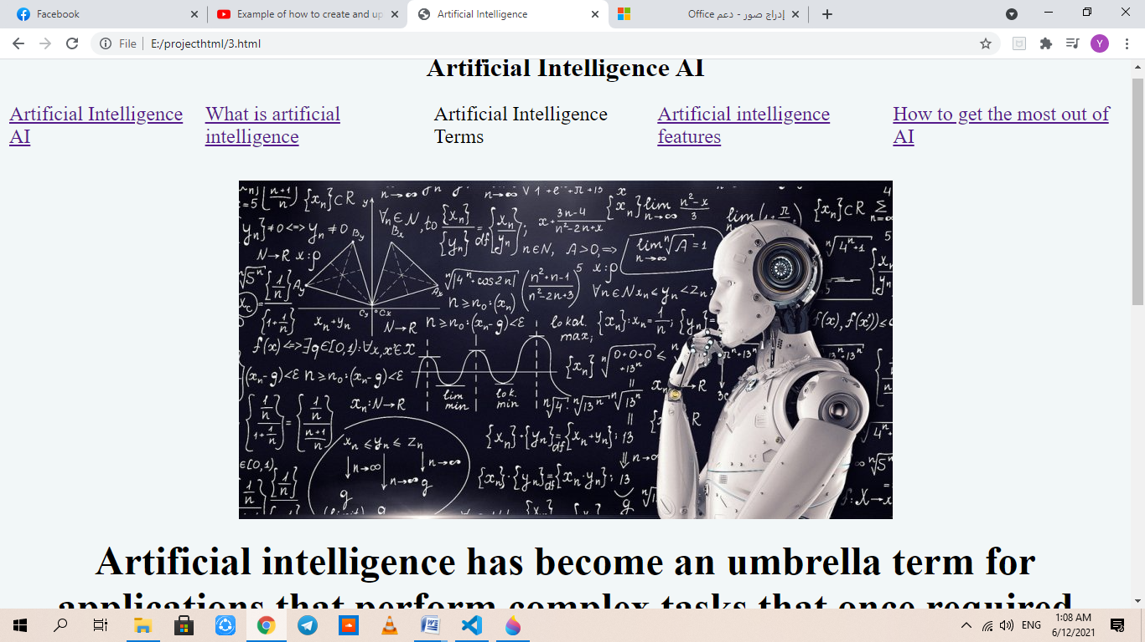

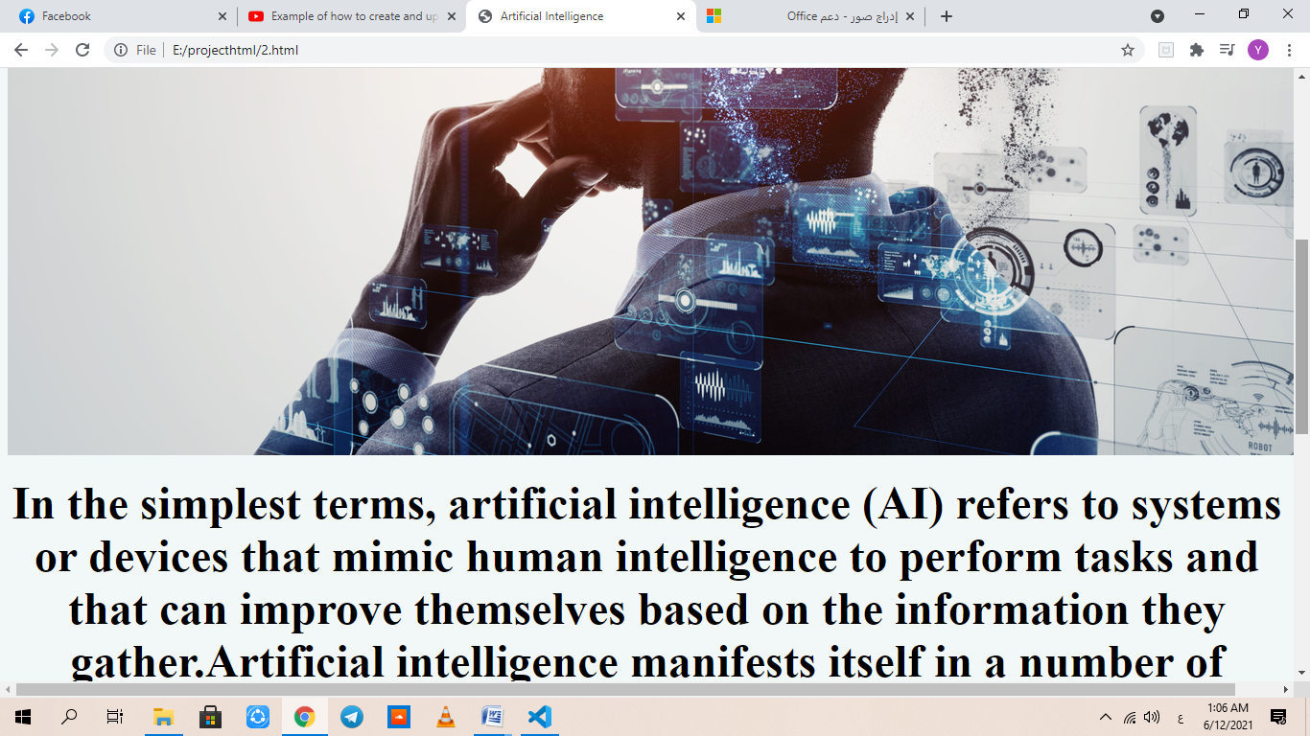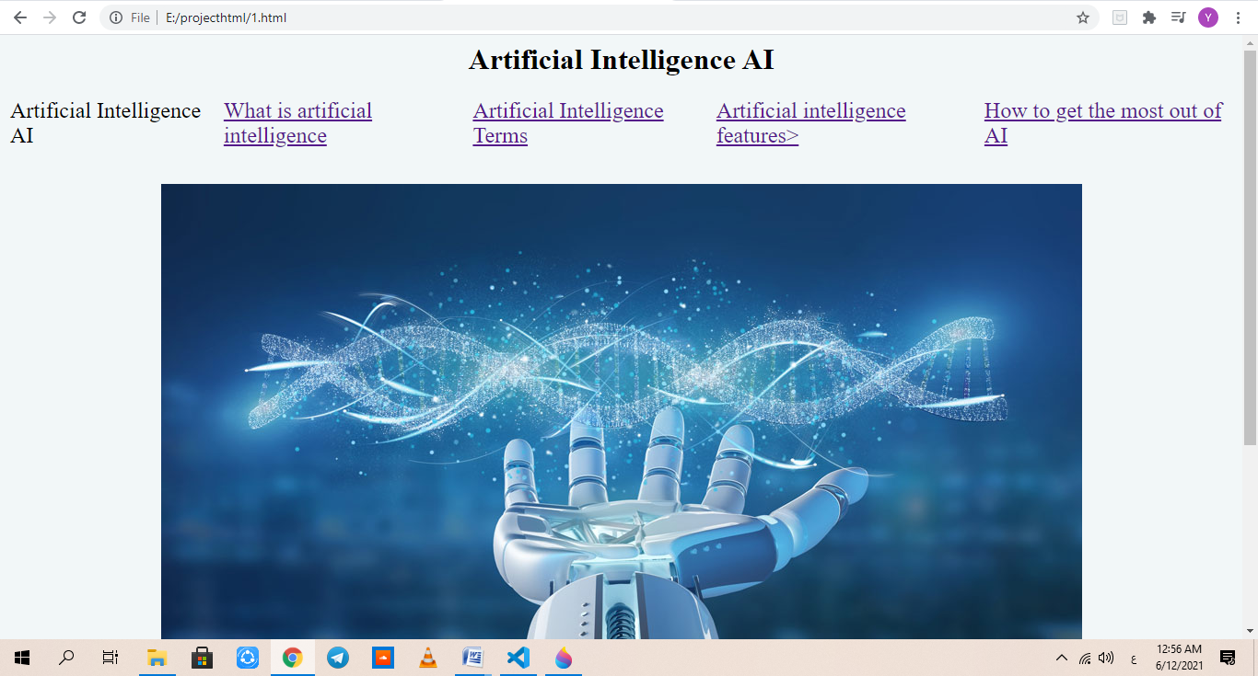

Code source screenshots:

