TeleDirect

Requirements Specification

Version 1.0

August 14, 2015

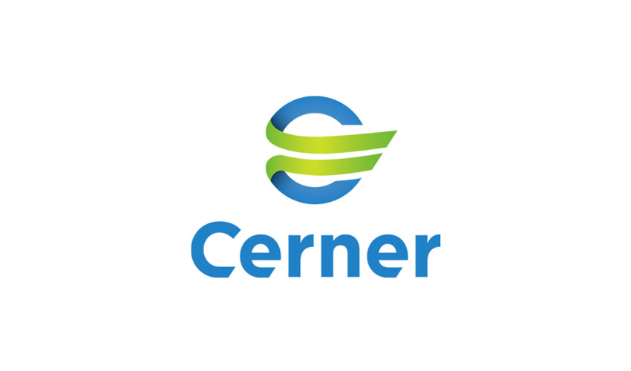
Table of Contents
1. Executive Summary 3
1.1 Project Overview 3
1.2 Purpose and Scope of this Specification 3
2. Product/Service Description 3
2.1 Product Context 3
2.2 User Characteristics 3
2.3 Assumptions 3
2.4 Constraints 3
2.5 Dependencies 3
3. Requirements 4
3.1 Functional Requirements 4
3.2 User Interface Requirements 5
3.3 Usability 5
3.4 Performance 5
3.4.1 Capacity 5
3.4.2 Availability 5
3.4.3 Latency 5
3.5 Manageability/Maintainability 6
3.5.1 Monitoring 6
3.5.2 Maintenance 6
3.5.3 Operations 6
3.6 System Interface/Integration 6
3.6.1 Network and Hardware Interfaces 6
3.7 Security 6
3.7.1 Protection 6
3.7.2 Authorization and Authentication 6
3.8 Data Management 6
3.9 Standards Compliance 7
3.10 Portability 7
4. User Scenarios/Use Cases 7

Executive Summary

Project Overview
This aim of the project is to create a web application that would allow a firm to manage and maintain contact numbers and their details in a secure location on their network.

Purpose and Scope of this Specification
The purpose of this specification is to
In scope
This document addresses the requirements to project TeleDirect:
- Creation of a portal for user authentication.
- Allow user with appropriate priveleges to create, read, update and delete contacts.
- Allow user with appropriate priveleges to create, read and update contact details.

Product/Service Description
In this section, describe the general factors that affect the product and its requirements. This section should contain background information, not state specific requirements (provide the reasons why certain specific requirements are later specified).

Product Context
TeleDirect is a self-contained application and does not rely on other application for its functioning.

User Characteristics
The users for the application are
- Telephone operator
- Contact Manager
- Database Administrator

Assumptions
List any assumptions that affect the requirements, for example, equipment availability, user expertise, etc. For example, a specific operating system is assumed to be available; if the operating system is not available, the Requirements Specification would then have to change accordingly.

Constraints
No constraints as such.

Dependencies
List dependencies that affect the requirements. Examples:
- This new product will require a daily download of data from X,
- Module X needs to be completed before this module can be built.

Requirements

Functional Requirements
Functional Requirement | Value | Priority
Launch the application by signing in | The system can identify the type of user and the user can use the main application | Must Have
Register a new user | A new user can sign up and the administrator can grant access to the user to use the application. | Delighter
View list of contacts | The user is able to browse through the list of contacts saved in the company database. | Must Have
View contact details | The user is able to access the details about the contact | Must Have
Call a contact | The user is able to place calls to a particular contact | Satisfier
Email the contact | The user is able to email the contact | Delighter
Search contact | The user is able to search for a particular contact from the database | Delighter
Dynamic suggestions in search box | The system gives suggestions dynamically as the user types in the search box saving typing time. | Satisfier
Add a new contact | The user is able to add new contacts to the database | Must have
Add contact photo | The user is able to add a photographic alias to associate with the contact. | Delighter
Update contact details | The user is able to make changes to the contact details as when required | Must have
Update the contact photo | The user can change the contact photo. | Delighter
Optimize the uploaded contact photo for storage in the database | The photographs stored in the database are processed for space optimization saving storage space, data fetching time and internet bandwidth. | Satisfier
Prevent mismatch of contact title and gender | There is no conflict between title and gender. | Delighter
Delete a contact | The user is able to remove contacts from the database | Must have
Recover deleted contacts by mistake | Contacts deleted by mistake can be recovered | Delighter
Prompt an error if the database server is down or unavailable | Prompt user if the database is not available | Delighter
Select multiple contacts for deletion | The user can make multiple selections and make deletions faster | Satisfier

User Interface Requirements
In addition to functions required, describe the characteristics of each interface between the product and its users (e.g., required screen formats/organization, report layouts, menu structures, error and other messages, or function keys).

Usability
Include any specific usability requirements, for example,
Learnability
- The user documentation and help should be complete
- The help should be context sensitive and explain how to achieve common tasks
- The system should be easy to learn
(See http://www.usabilitynet.org/)

Performance
Specify static and dynamic numerical requirements placed on the system or on human interaction with the system:
- Static numerical requirements may include the number of terminals to be supported, the number of simultaneous users to be supported, and the amount and type of information to be handled.
- Dynamic numerical requirements may include the number of transactions and tasks and the amount of data to be processed within certain time period for both normal and peak workload conditions.
All of these requirements should be stated in measurable form. For example, "95% of the transactions shall be processed in less than 1 second" rather than “an operator shall not have to wait for the transaction to complete”.

Capacity
Include measurable capacity requirements (e.g., the number of simultaneous users to be supported, the maximum simultaneous user load, per-user memory requirements, expected application throughput)

Availability
Include specific and measurable requirements for:
- Hours of operation
- Level of availability required
- Coverage for geographic areas
- Impact of downtime on users and business operations
- Impact of scheduled and unscheduled maintenance on uptime and maintenance communications procedures
- reliability (e.g., acceptable mean time between failures (MTBF), or the maximum permitted number of failures per hour).

Latency
Include explicit latency requirements, e.g., the maximum acceptable time (or average time) for a service request.

Manageability/Maintainability

Monitoring
Include any requirements for product or service health monitoring, failure conditions, error detection, logging, and correction.

Maintenance
Specify attributes of the system that relate to ease of maintenance. These requirements may relate to modularity, complexity, or interface design. Requirements should not be placed here simply because they are thought to be good design practices.

Operations
Specify any normal and special operations required by the user, including:
- periods of interactive operations and periods of unattended operations
- data processing support functions
- backup and recovery operations
- safety considerations and requirements
- disaster recovery and business resumption

System Interface/Integration
Specify the use of other required products (e.g., a database or operating system), and interfaces with other systems (e.g., UWHires package interfaces with PubCookie and ODS, HEPPS system interfaces with Budget system). For each interface, define the interface in terms of message format and content. For well-documented interfaces, simply provide a reference to the documentation.
Outline each interface between the product and the hardware or network components of the system. This includes configuration characteristics (e.g., number of ports, instruction sets), what devices are to be supported, and protocols (e.g., signal handshake protocols).

Network and Hardware Interfaces
Specify the logical characteristics of each interface between the product and the hardware or network components of the system. This includes configuration characteristics (e.g., number of ports, instruction sets), what devices are to be supported, and protocols (e.g., signal handshake protocols).

Security

Protection
Specify the factors that will protect the system from malicious or accidental access, modification, disclosure, destruction, or misuse. For example:
- encryption
- activity logging, historical data sets
- restrictions on intermodule communications
- data integrity checks

Authorization and Authentication
Specify the Authorization and Authentication factors. Consider using standard tools such as PubCookie.

Data Management
Specify the requirements for any information that is to be placed into a database, including
- types of information used by various functions
- frequency of use
- data access rules
- data entities and relationships
- integrity constraints
- data retention
- valid range, accuracy, and/or tolerance
- units of measure
- data formats
- default or initial values

Standards Compliance
Specify the requirements derived from existing standards, policies, regulations, or laws (e.g., report format, data naming, accounting procedures, audit tracing). For example, this could specify the requirement for software to trace processing activity. Such traces are needed for some applications to meet minimum regulatory or financial standards. An audit trace requirement may, for example, state that all changes to a payroll database must be recorded in a trace file with before and after values.

Portability
If portability is a requirement, specify attributes of the system that relate to the ease of porting the system to other host machines and/or operating systems. For example,
- Percentage of components with host-dependent code;
- Percentage of code that is host dependent;
- Use of a proven portable language;
- Use of a particular compiler or language subset;
- Use of a particular operating system;
- The need for environment-independence - the product must operate the same regardless of operating systems, networks, development or production environments.

User Scenarios/Use Cases
Provide a summary of the major functions that the product will perform. Organize the functions to be understandable to the customer or a first time reader. Include use cases and business scenarios, or provide a link to a separate document (or documents). A business scenario:
- Describes a significant business need
- Identifies, documents, and ranks the problem that is driving the scenario
- Describes the business and technical environment that will resolve the problem
- States the desired objectives
- Shows the “Actors” and where they fit in the business model
- Is specific, and measurable, and uses clear metrics for success

