Exercise 1: Hello World
Write a Bash script that simply echoes "Hello, World!" when executed.

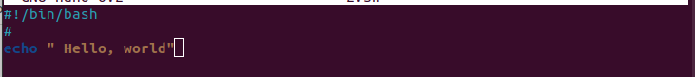
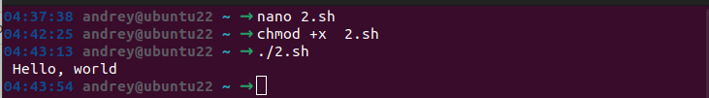

Exercise 2: User Input
Create a script that asks the user for their name and then greets them using that name.

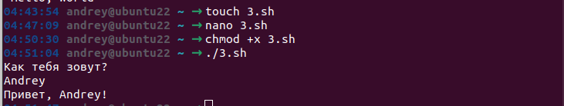

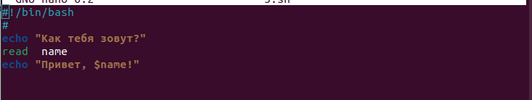

Exercise 3: Conditional Statements
Write a script that checks if a file exists in the current directory. If it does, print a message saying it exists; otherwise, print a message saying it doesn't exist.

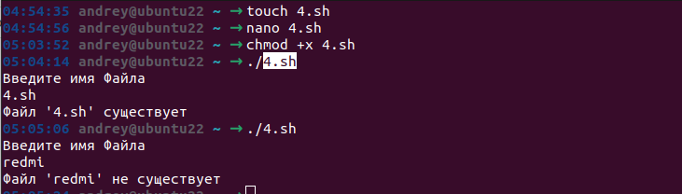

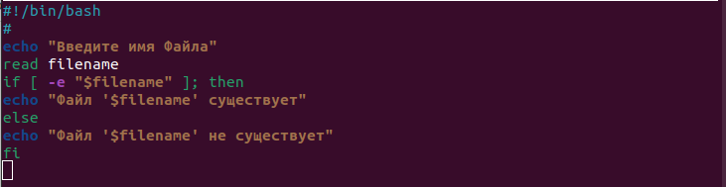

Exercise 4: Looping
Create a script that uses a loop to print numbers from 1 to 10.

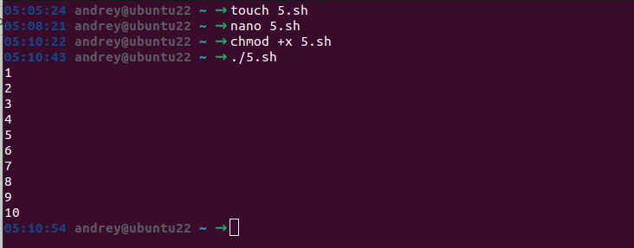

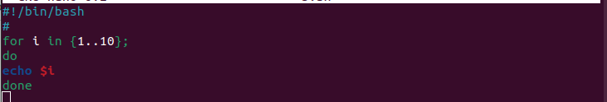

Exercise 5: File Operations
Write a script that copies a file from one location to another. Both localtions should be passed as arguments

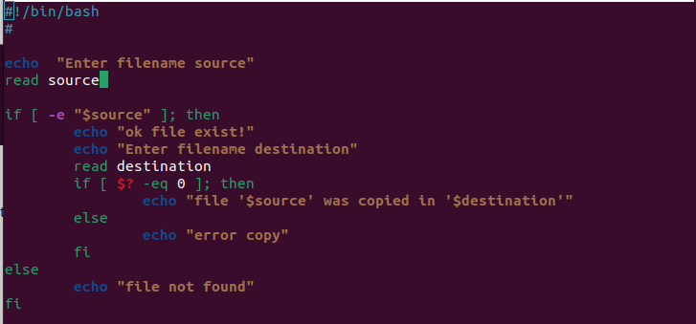

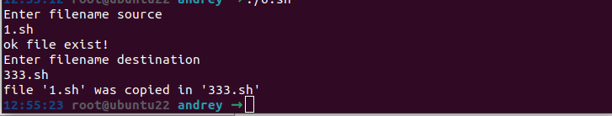

Exercise 6: String Manipulation
Build a script that takes a user's input as a sentence and then reverses the sentence word by word (e.g., "Hello World" becomes "World Hello").

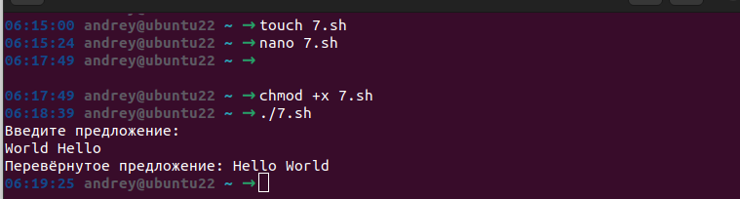

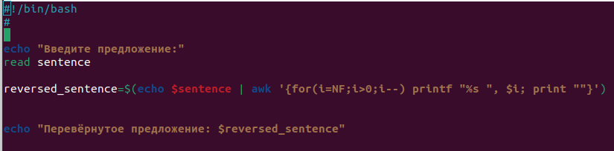

Exercise 7: Command Line Arguments
Develop a script that accepts a filename as a command line argument and prints the number of lines in that file.

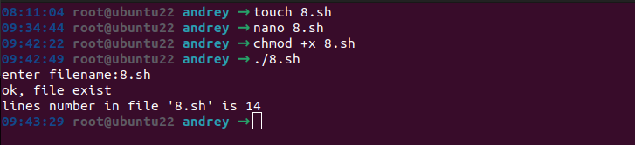

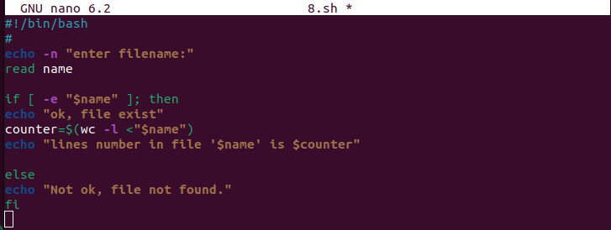

Exercise 8: Arrays
Write a script that uses an array to store a list of fruits. Loop through the array and print each fruit on a separate line.
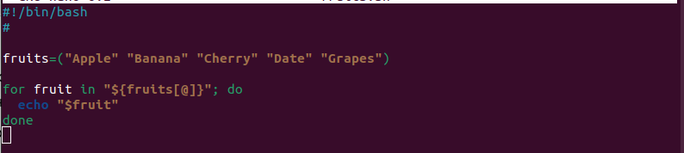
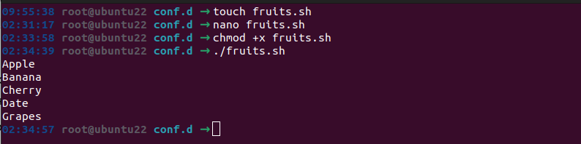

Exercise 9: Error Handling
Develop a script that attempts to read a file and handles errors gracefully. If the file exists, it should print its contents; if not, it should display an error message.

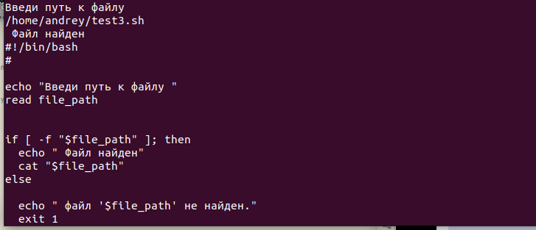

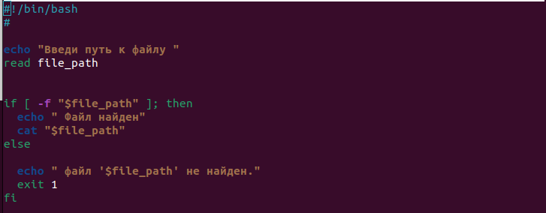

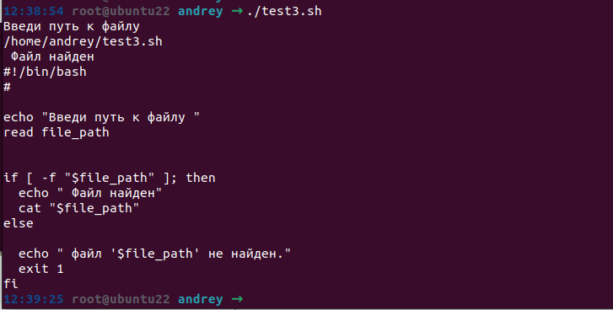

### Systemd service

Write script which watching directory "~/watch". If it sees that there appeared a new file, it prints files content and rename it to *.back

Write SystemD service for this script and make it running

