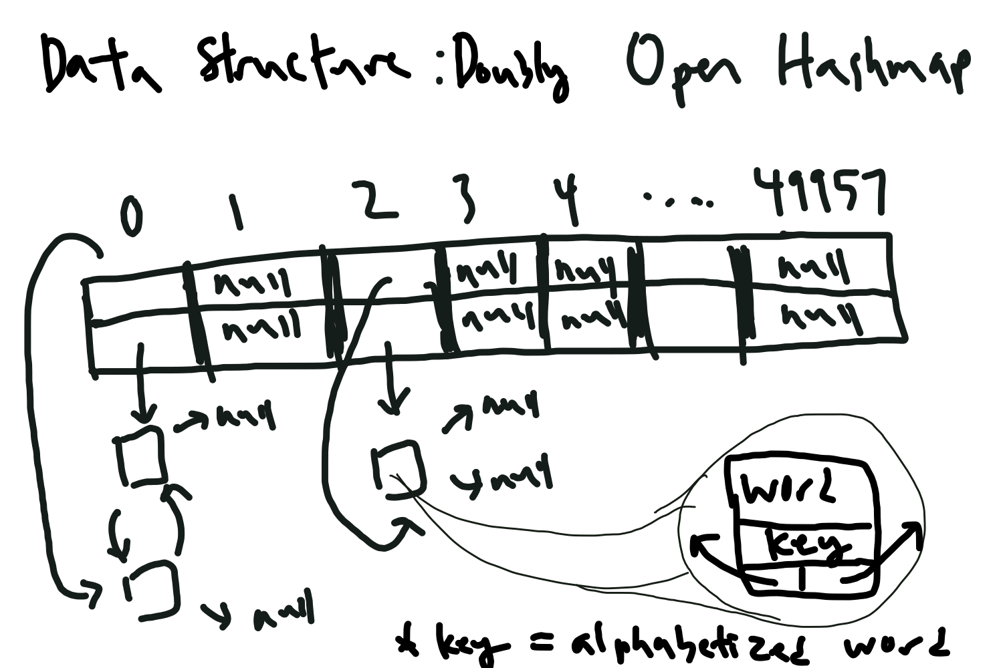

Values are all put in a open hashmap with doubly linked lists instead of the normal linked list. (this just makes more efficient to insert values and delete values). Thus the array is a multidimensional array with 2 rows: one pointer for the tail and one for the head

The buckets themselves store the word, the two pointers (next and prev) as well as an alphabetized version of the word that serves as the key.

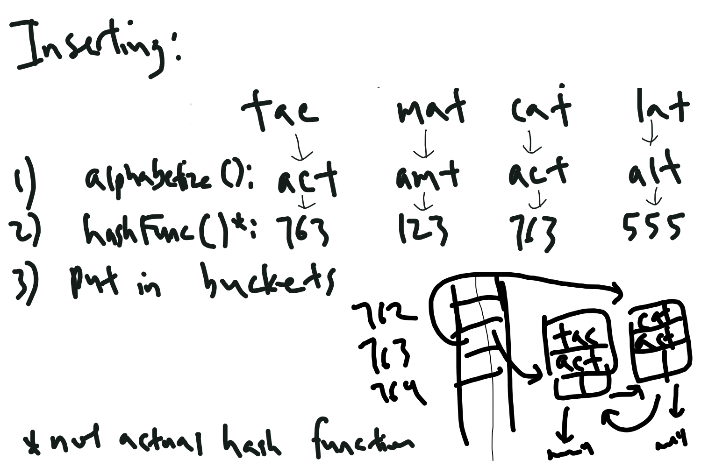

The alphabetized version of the word is put into the hash function so that every anagram will have the same hash value.

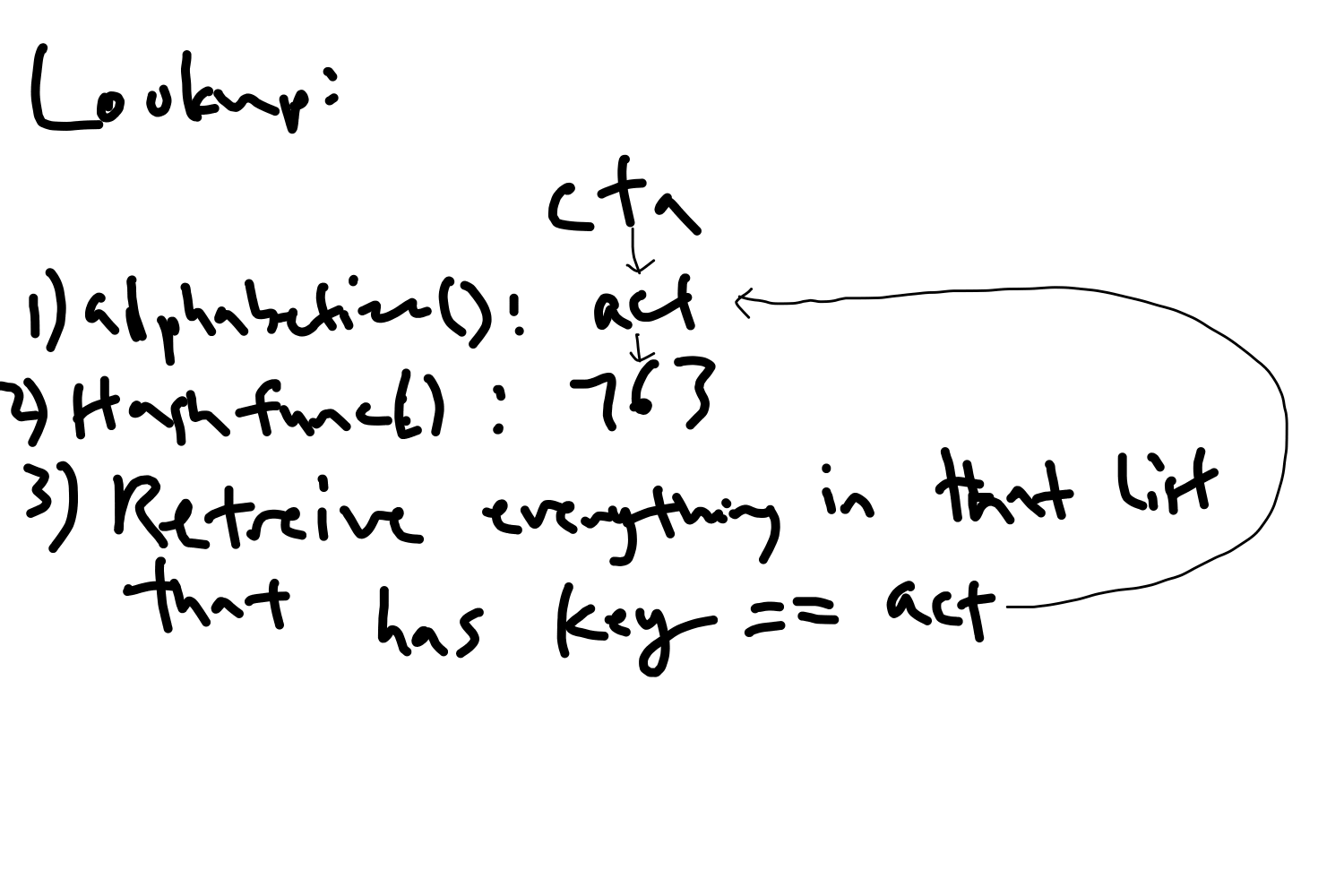

Function checks the key, which is guaranteed to only be the same if the word is an anagram. This is in case collisions exists, and words that are not anagrams are put in the same linked list.